Appendix 2.
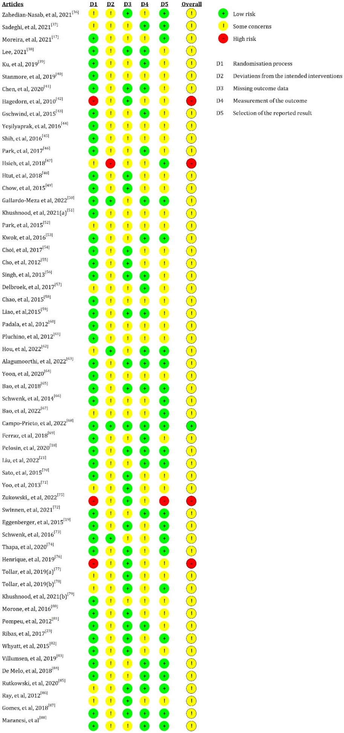
Figure 1. Assessment results of the risk of bias
Table 1. Meta-analysis of the effects of SI versus control groups for outcomes (excluding four articles with a high risk of bias)
Intervention group | No. of trials | I² | p(I²) | MD | 95% CI | p
TUG
All group | 32 | 42.728% | 0.026 | 30.456 | 21.701, 39.210 | 0.000
All group* | 24 | 10.091% | 0.344 | 22.181 | 16.330, 28.031 | 0.000
OPTS | 13 | 52.234% | 0.027 | 37.584 | 21.972, 53.195 | 0.000
OPTS* | 10 | 15.310% | 0.313 | 23.118 | 10.870, 35.366 | 0.000
Normal Gait speed
All group | 15 | 92.457% | 0.000 | 7.815 | 2.787, 12.843 | 0.002
All group* | 10 | 29.826% | 0.154 | 3.707 | 2.371, 5.043 | 0.000
OPTS | 8 | 95.692% | 0.000 | 7.603 | -0.578, 15.785 | 0.069
OPTS* | 7 | 26.103% | 0.220 | 3.205 | 1.425, 4.985 | 0.000
BBS
All group | 20 | 86.451% | 0.000 | 3.113 | 1.990, 4.236 | 0.000
All group* | 17 | 74.584% | 0.000 | 2.111 | 1.162, 3.059 | 0.000
OPTS | 12 | 90.927% | 0.000 | 3.701 | 2.101, 5.302 | 0.000
OPTS* | 10 | 82.457% | 0.000 | 2.299 | 0.889, 3.708 | 0.001
6MWT
All group | 12 | 42.728% | 0.026 | 30.456 | 21.701, 39.210 | 0.000
All group* | 10 | 10.091% | 0.344 | 22.181 | 16.330, 28.031 | 0.000
OPTS | 6 | 52.234% | 0.027 | 37.584 | 21.972, 53.195 | 0.000
OPTS* | 5 | 15.310% | 0.313 | 23.118 | 10.870, 35.366 | 0.000
FES-I
All group | 7 | 58.552% | 0.010 | -1.744 | -2.521, -0.967 | 0.000
All group* | 5 | 0.000% | 0.456 | -1.180 | -1.497, -0.862 | 0.000
OPTS | 3 | 22.346% | 0.277 | -3.445 | -4.719, -2.171 | 0.000
OPTS* | 2 | - | - | - | - | -
Note: *: the control groups with TPEI only; TPEI: traditional physical exercise intervention; OPTS: optical sensor; MD: mean difference

