Supplementary Materials
This supplementary file contains additional graphs related to the training metrics used in our study. Due to space constraints in the main paper, these supplementary materials are provided to offer a comprehensive view of our experimental results. The included graphs complement the analysis presented in the main text and provide further insights into the performance and distribution of data in our study. We encourage readers to refer to these supplementary materials for a more detailed understanding of the experimental findings.

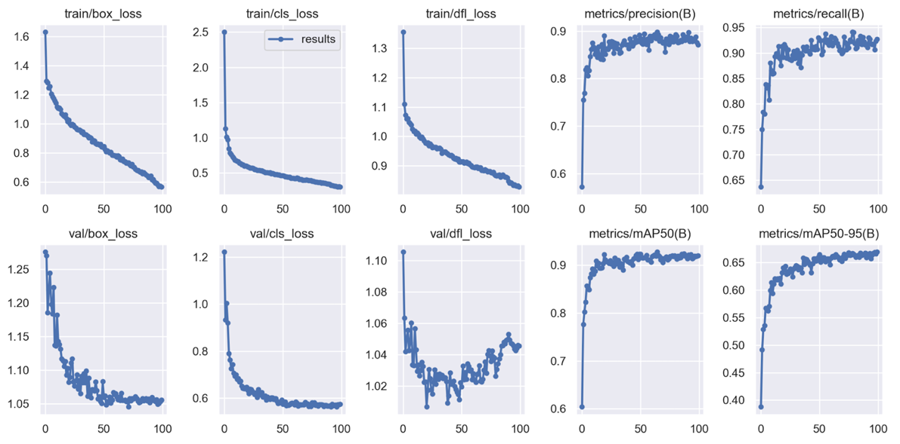
Fig. S1. Range of full output metrics from the YoloV8 model over the 100 epochs.

