SUPPLEMENTARY MATERIALS

This file includes:

- Feature construction
- Table S1 Summary of the features used in the current study
- Table S2 Importance of predictors used in the LRR model
- Table S3 A specific sample with 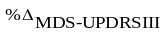=0.267 was predicted with 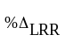=0.307
- Figure S1 Agreement of levodopa response between LR of the classic ALCT and those of the MSE and LRR models (n =42).
- Figure S2 Confusion Matrices for MSE and LRR Models in Classifying Levodopa Response.

Feature construction

Step 1: For forward and backward parameters, subtract the two to represent range of motion (ROM).
Step 2: For each pair of left-sided and right-sided parameters, they have same definition except for different side. In order to reduce the impact of the asymmetry on the overall analysis, each pair left-sided and right-sided parameters were calculated as maximum, minimum and absolute difference between them.
Step 3: standard deviation kind of parameters were excluded from step 1 and step 2.
Step 4: Feature cleaning was performed to reduce redundant features, like features which have same descriptive statistics metrics as the other.

Table S1 Summary of the features used in the current study

Feature domain | Feature number | Feature description
Time domain | 22 per signal | Maximum, minimum, mean, absolute mean, standard deviation, peak to peak value, root mean square, skewness, kurtosis, variance, form factor, crest factor, coefficient of variation, coefficient of skewness, efficient of kurtosis, clearance factor, impulse factor, autocorrelation coefficient, acc axis correlation coefficient, gyro axis correlation coefficient, and angle/velocity.
Frequency domain | 45 per signal | Energy operator, average amplitude, max amplitude, frequency corresponding to maximum amplitude, euclidean amplitude fusion, frequency amplitude peak, the first peak of power spectral density, the second peak of power spectral density frequency, the first peak power of dominant frequency, the first peak of dominant frequency, the second peak power of dominant frequency, the second peak of dominant frequency, average jerk, sample entropy, amplitude percentage of f>4hz and f<=25hz, energy, power of the band, MI mean, MI maximum, and MI minimum.
Kinematic parameters domain | 170 per participant | Velocity (degree/sec), range of motion (rom, degree), peak velocity (degree/sec), and rom (degree) of three anatomical planes, respectively (parameters the same as lumbar), stride velocity (m/s), cadence (step/min), gait cycle (sec), stride length (cm), step length (cm), swing (%), stance (%), peak angular velocity (degree/sec), RoM (degree), velocity asymmetry (%),RoM asymmetry (%), absolute deviation between limbs, walk duration (sec), and turning duration (sec).
Energy operator: 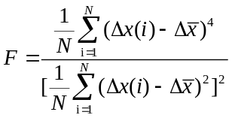 where x corresponds to the window signal data in x, y or z direction
Euclidean amplitude fusion: the Euclidean of the maximum amplitude from x, y, z direction of accelerometer or gyro
Frequency amplitude peak: the maximum value of the absolute value of the amplitude
amplitude percentage of f>4hz and f<=25hz: percentage power if frequencies between 4hz to 25 hz
MI[1]: Mean value of movement intensity
RoM: Range of motion

Table S2 Importance of predictors used in the LRR model

Gain | Cover | Frequency | Feature names | P value | r | Mean  (|SHAP|) | Feature  category
0.397 | 0.010 | 0.008 | Lumbar_gyry_1st PoDF_abs | <.001 | -0.582 | 0.062 | Frequency Domain
0.092 | 0.005 | 0.004 | Thigh_gyrx_CF (max)_rev | <.001 | -0.613 | 0.041 | Complexity
0.022 | 0.013 | 0.013 | Feet_gyrx_1.0-4.0 Hz Band Power (min)_abs | <.001 | -0.625 | 0.027 | Frequency Domain
0.023 | 0.005 | 0.004 | Wrist_accx_5.0-5.5 Hz Band Power (min)_rev | 0.023 | -0.350 | 0.016 | Frequency Domain
0.024 | 0.003 | 0.004 | Shank_gyrz_AC Coefficient (diff)_abs | 0.498 | 0.107 | 0.014 | Asymmetry
0.020 | 0.005 | 0.008 | Feet_accz_3.5-15 Hz Band Power (min)_rev | <.001 | -0.528 | 0.013 | Frequency Domain
0.006 | 0.004 | 0.008 | Thigh_accy_Power of 2nd PoDF (diff)_rev | 0.118 | -0.245 | 0.013 | Asymmetry
0.028 | 0.002 | 0.004 | Feet_gyrx_Amp% Above 4Hz (diff)_rev | 0.16 | 0.221 | 0.013 | Asymmetry
0.033 | 0.003 | 0.004 | Wrist_gyrz_Power of 2nd PoDF (max)_rev | 0.117 | 0.246 | 0.012 | Frequency Domain
0.036 | 0.005 | 0.004 | Thigh_accy_0.5-15.0 Hz Band Power (min)_abs | <.001 | -0.661 | 0.011 | Frequency Domain
0.044 | 0.002 | 0.004 | Shank_accx_5.0-5.5 Hz Band Power(diff)_rev | 0.277 | -0.172 | 0.010 | Asymmetry
0.011 | 0.010 | 0.008 | Thigh_accy_4.0-4.5 Hz Band Power (diff)_abs | 0.069 | -0.283 | 0.009 | Asymmetry
0.004 | 0.002 | 0.004 | Wrist_accz_AC Coefficient (diff)_rev | 0.004 | 0.438 | 0.008 | Asymmetry
0.015 | 0.009 | 0.008 | Wrist_accx_3.0-3.5 Hz Band Power (min)_rev | 0.018 | -0.364 | 0.008 | Frequency Domain
0.002 | 0.004 | 0.004 | Thigh_gyrz_1.0-1.5 Hz Band Power (min)_rev | <.001 | -0.632 | 0.008 | Frequency Domain
0.009 | 0.010 | 0.008 | Thigh_accy_4.0-6.0 Hz Band Power (diff)_abs | 0.159 | -0.221 | 0.007 | Asymmetry
0.006 | 0.015 | 0.013 | Feet_accy_3.0-3.5 Hz Band Power (min)_abs | 0.005 | -0.429 | 0.007 | Frequency Domain
0.022 | 0.003 | 0.004 | Thigh_accy_5.0-5.5 Hz Band Power (min)_rev | <.001 | -0.521 | 0.007 | Frequency Domain
0.008 | 0.004 | 0.004 | Feet_gyrx_2.0-2.5 Hz Band Power (min)_abs | <.001 | -0.685 | 0.006 | Frequency Domain
0.003 | 0.005 | 0.004 | Thigh_accy_MI Max. (min)_abs | 0.009 | -0.399 | 0.005 | Complexity
0.006 | 0.002 | 0.004 | Shank_gyrx_AC Coefficient (diff)_rev | 0.102 | -0.256 | 0.005 | Asymmetry
0.001 | 0.005 | 0.004 | Shank_accz_SD (diff)_abs | 0.2 | 0.202 | 0.005 | Asymmetry
0.001 | 0.004 | 0.004 | Lumbar Transverse RoM Min. Std_abs | 0.043 | 0.313 | 0.004 | Variability
0.002 | 0.001 | 0.004 | Thigh_accy_Absolute Avg. (diff)_rev | 0.934 | -0.013 | 0.003 | Asymmetry
0.002 | 0.005 | 0.004 | Feet_gyry_CF (diff)_abs | 0.593 | -0.085 | 0.003 | Asymmetry
0.020 | 0.002 | 0.004 | Feet_gyrx_P2P (diff)_abs | 0.422 | 0.127 | 0.003 | Asymmetry
0.051 | 0.008 | 0.008 | Thigh_accy_Above 15 Hz Band Power (diff)_abs | 0.103 | -0.255 | 0.003 | Asymmetry
0.001 | 0.002 | 0.004 | Feet_gyrx_Amp% Above 4Hz (min)_rev | 0.738 | -0.053 | 0.002 | Frequency Domain
0.002 | 0.002 | 0.004 | Feet_gyrz_Avg. (min)_rev | 0.038 | -0.321 | 0.002 | Frequency Domain
0.015 | 0.003 | 0.004 | Feet_gyry_Power of 1st PoDF (diff)_rev | 0.166 | 0.218 | 0.002 | Asymmetry
0.004 | 0.005 | 0.004 | Feet_gyry_Max. Amp Frequency (min)_abs | <.001 | -0.506 | 0.002 | Frequency Domain
0.003 | 0.003 | 0.004 | Wrist_accx_Euclidean Amplitude Fusion (diff)_abs | 0.86 | 0.028 | 0.002 | Asymmetry
0.002 | 0.003 | 0.004 | Wrist_accz_P2P (max)_rev | 0.589 | 0.086 | 0.001 | Frequency Domain
0.055 | 0.005 | 0.004 | Feet_gyry_1st PoDF (min)_abs | <.001 | -0.737 | 0.001 | Frequency Domain
0.015 | 0.002 | 0.004 | Swing Std._abs | 0.006 | 0.419 | 0.000 | Variability
The feature names column defines the features used in the LRR model. Features ending with “rev” and “abs” were calculated between ON and OFF medication statuses according to Equation 1.13 and Equation 1.14, respectively. Different domains separated with “_” were used to interpret the features listed: the first domain indicates body parts attached to sensors, the second domain indicates the signal used to calculate the specific feature, and the third domain indicates signal indices calculated with signal data. In addition, for sensors attached to bilateral feet, shanks, thighs, and wrists, signal indices were calculated integrating left and right limbs, with “min” referring to the minimum value between left and right limbs, “max” referring to the maximum value between left and right limbs, and “abs” referring to the absolute difference between left and right limbs. For example, to calculate Thigh_gyrx_clearance factor (max)_rev, leftThigh_gyrx_clearance factor and leftThigh_gyrx_clearance factor were calculated with the signal data of the y-axis of the gyro sensor attached on the left and right thighs, respectively. Then, we calculated the maximum value of the leftThigh_gyrx_clearance factor and leftThigh_gyrx_clearance factor, noting the Thigh_gyrx_clearance factor (max). Finally, the relative difference in the Thigh_gyrx_clearance factor (max) was calculated between the ON and OFF medication statuses according to Equation 1.5. The feature named Swing Std_abs, a kinematic parameter, measured the standard deviation of all the measurements of left swing through the whole test.
Abbreviations: PoDF: peak of dominant frequency, CF: clearance factor, AC Coefficient: autocorrelation coefficient, Amp: amplitude, MI: movement intensity, SD: standard deviation, RoM: range of motion, P2P: peak to peak value.

Table S3 A specific sample with =0.267 was predicted with =0.307
Feature Names | SHAP Value
Lumbar_gyry_1st PoDF_abs | -0.041448686 | Sum of SHAP values = -0.069537109
Thigh_gyrx_CF (max)_rev | -0.045007743 | E(f(x)) = 0.377
Feet_gyry_1st PoDF (min)_abs | -0.001220158 | f(x) = E(f(x))+ Sum of SHAP values  =0.307
Thigh_accy_Above 15 Hz Band Power (diff)_abs | -0.003125415 | f(x) = E(f(x))+ Sum of SHAP values  =0.307
Shank_accx_5.0-5.5 Hz Band Power(diff)_rev | 0.005319624 | f(x) = E(f(x))+ Sum of SHAP values  =0.307
Thigh_accy_0.5-15.0 Hz Band Power (min)_abs | -0.007242883
Wrist_gyrz_Power of 2nd PoDF (max)_rev | 0.031131618
Feet_gyrx_Amp% Above 4Hz (diff)_rev | 0.014647323
Shank_gyrz_AC Coefficient (diff)_abs | -0.014137413
Wrist_accx_5.0-5.5 Hz Band Power (min)_rev | -0.006769995
Feet_gyrx_1.0-4.0 Hz Band Power (min)_abs | 0.026602425
Thigh_accy_5.0-5.5 Hz Band Power (min)_rev | -0.008253571
Feet_accz_3.5-15 Hz Band Power (min)_rev | 0.01044326
Feet_gyrx_P2P (diff)_abs | 0.001928192
Feet_gyry_Power of 1st PoDF (diff)_rev | -0.002571013
Swing Std._abs | 0.000135218
Wrist_accx_3.0-3.5 Hz Band Power (min)_rev | -0.003960548
Thigh_accy_4.0-4.5 Hz Band Power (diff)_abs | -0.00560524
Thigh_accy_4.0-6.0 Hz Band Power (diff)_abs | -0.005806922
Feet_gyrx_2.0-2.5 Hz Band Power (min)_abs | 0.003391591
Shank_gyrx_AC Coefficient (diff)_rev | -0.007741078
Feet_accy_3.0-3.5 Hz Band Power (min)_abs | -0.005197818
Thigh_accy_Power of 2nd PoDF (diff)_rev | 0.011467368
Wrist_accz_AC Coefficient (diff)_rev | -0.009874844
Feet_gyry_Max. Amp Frequency (min)_abs | -0.000672715
Wrist_accx_Euclidean Amp Fusion (diff)_abs | -0.004857071
Thigh_accy_MI Max. (min)_abs | -0.00678059
Thigh_gyrz_1.0-1.5 Hz Band Power (min)_rev | 0.002825332
Feet_gyry_CF (diff)_abs | -0.001524481
Feet_gyrz_Avg. (min)_rev | 0.002917826
Thigh_accy_Absolute Avg. (diff)_rev | 0.000903389
Wrist_accz_P2P (max)_rev | -0.000370944
Lumbar Transverse RoM Min. Std_abs | 0.001920859
Shank_accz_SD (diff)_abs | -0.002384877
Feet_gyrx_Amp% Above 4Hz (min)_rev | 0.001382873
Abbreviations: PoDF: peak of dominant frequency, CF: clearance factor, AC Coefficient: autocorrelation coefficient, Amp: amplitude, MI: movement intensity, SD: standard deviation, RoM: range of motion, P2P: peak to peak value.

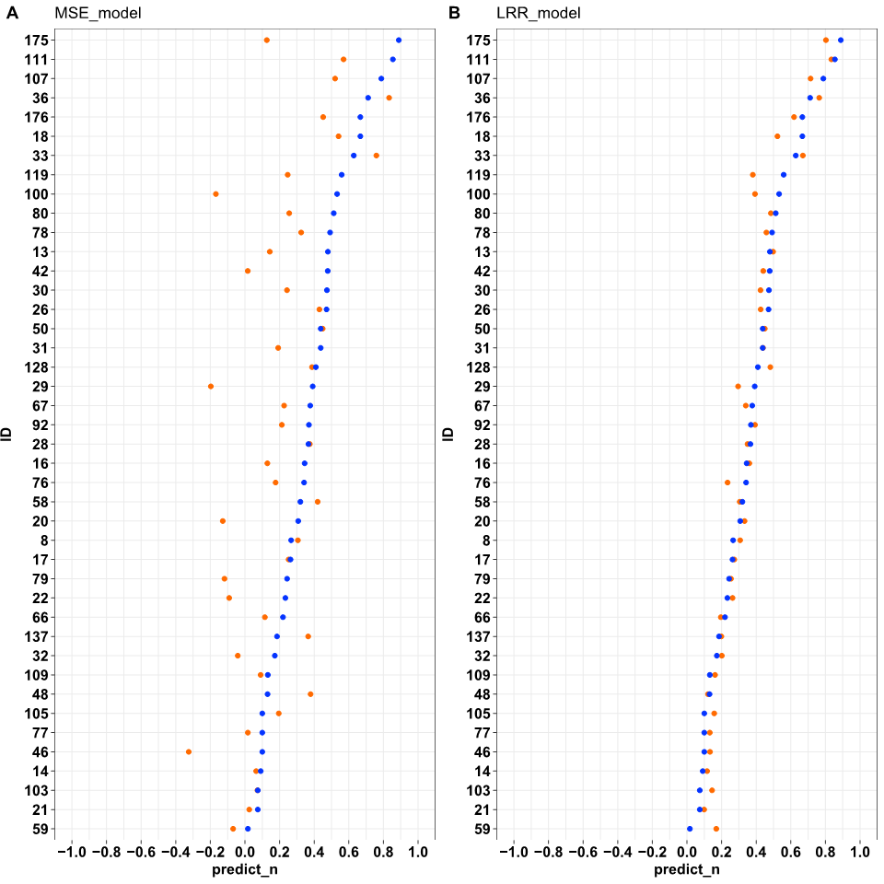
Figure S1 Agreement of levodopa response between LR of the classic ALCT and those of the MSE and LRR models (n =42). The blue circles represent measured in the classic ALCT, while the orange circles refer to those measured by the MSE model (Panel A) and LRR model (Panel B).

A | B
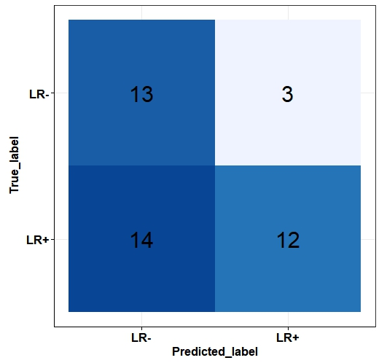 | 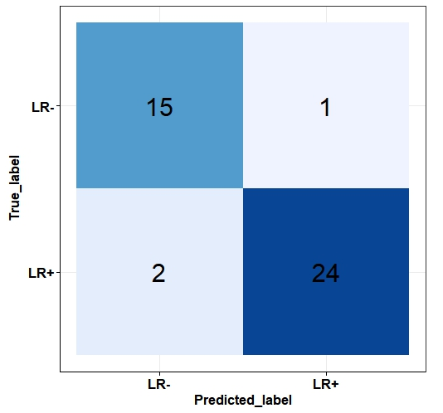
Figure S2: Confusion Matrices for MSE and LRR Models in Classifying Levodopa Response.
Panel A presents the confusion matrix for the Motor Symptom Evaluation (MSE) model, while Panel B shows the matrix for the Levodopa Response Regression (LRR) model. Both models were utilized to classify 42 participants into two groups based on their levodopa response: those with a positive response (LR+) and those with a negative response (LR-). A positive levodopa response indicates that the subjects were classified as being responsive to levodopa treatment, whereas a negative response indicates they were classified as nonresponsive.
In the confusion matrices, 'True labels' refer to the classifications assigned to subjects based on the standard Assessment of Levodopa Response in Clinical Trials (ALCT), whereas 'Predicted labels' denote the classifications made by the LRR or MSE model. The matrices provide a visual representation of the models' accuracy in predicting levodopa response, with rows representing the true classes and columns representing the predicted classes.
Abbreviations: LR+, Positive levodopa response; LR-, Negative levodopa response; ALCT, Assessment of Levodopa Response in Clinical Trials; MSE, Motor Symptom Evaluation model; LRR, Levodopa Response Regression model.

Reference:
1. Zhang M, Lange B, Chang CY, Sawchuk AA, Rizzo AA, editors. Beyond the standard clinical rating scales: Fine-grained assessment of post-stroke motor functionality using wearable inertial sensors. 2012 Annual International Conference of the IEEE Engineering in Medicine and Biology Society; 2012 28 Aug.-1 Sept. 2012.

