Additional files
Additional file 3. Study 4. Pictures of the paper sheets used and filled in by participants with Pot-its reporting their answers.
Group A | Group B
Study 4 - activity 1: focus group
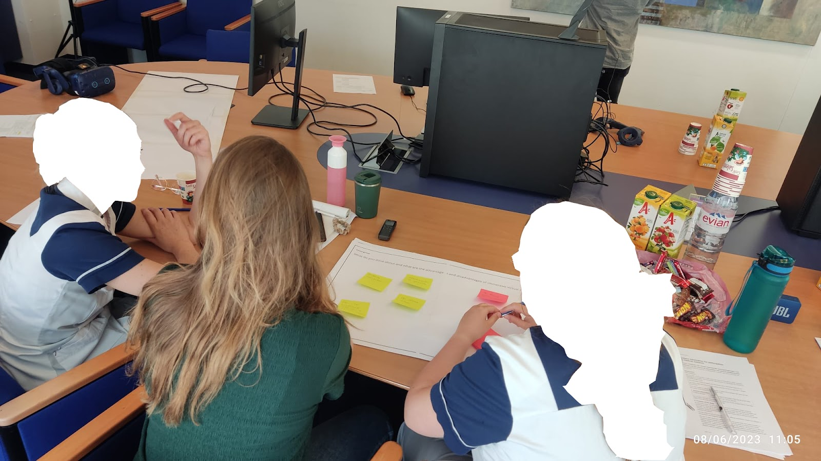
Activity 1 - Focus group. Participants working on the paper sheet used during the focus group. Post-its placed on top of the paper sheet report participants’ ideas.
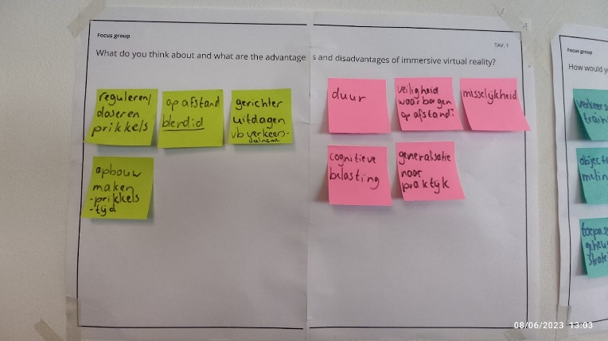 | 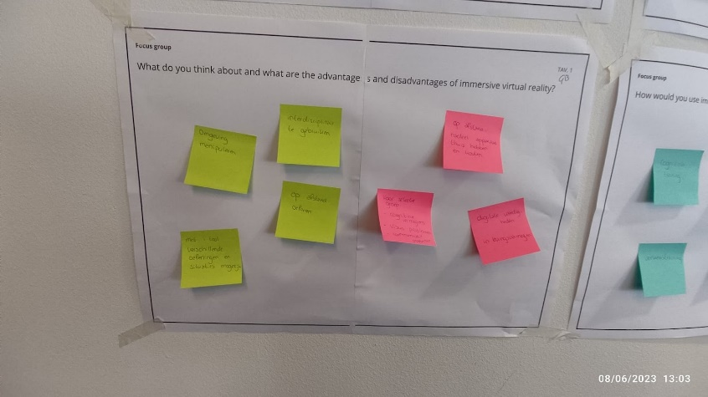
Paper sheet 1. Question 1. What do you think about and what are the advantages and disadvantages of immersive virtual reality?
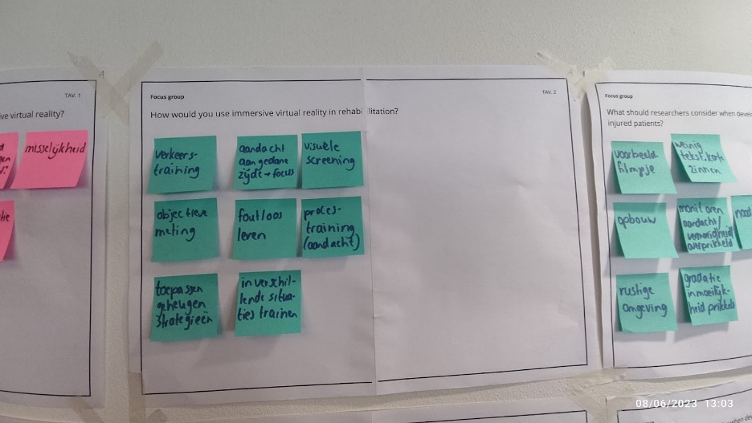 | 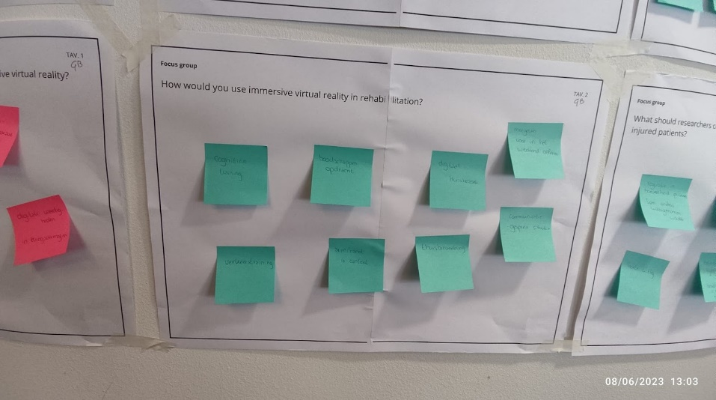
Paper sheet 2. Question 2. How would you use immersive virtual reality in rehabilitation?
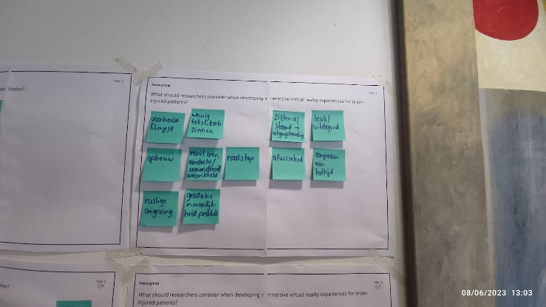 | 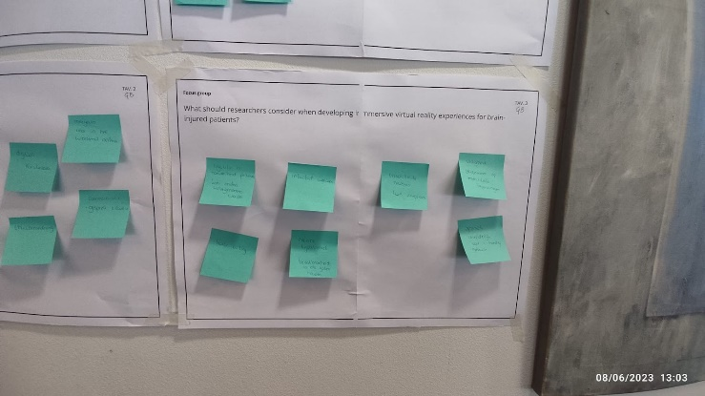
Paper sheet 3. Question 3. What should researchers consider when developing immersive virtual reality experiences for brain-injured patients?

Study 4 - activity 2: ideation session
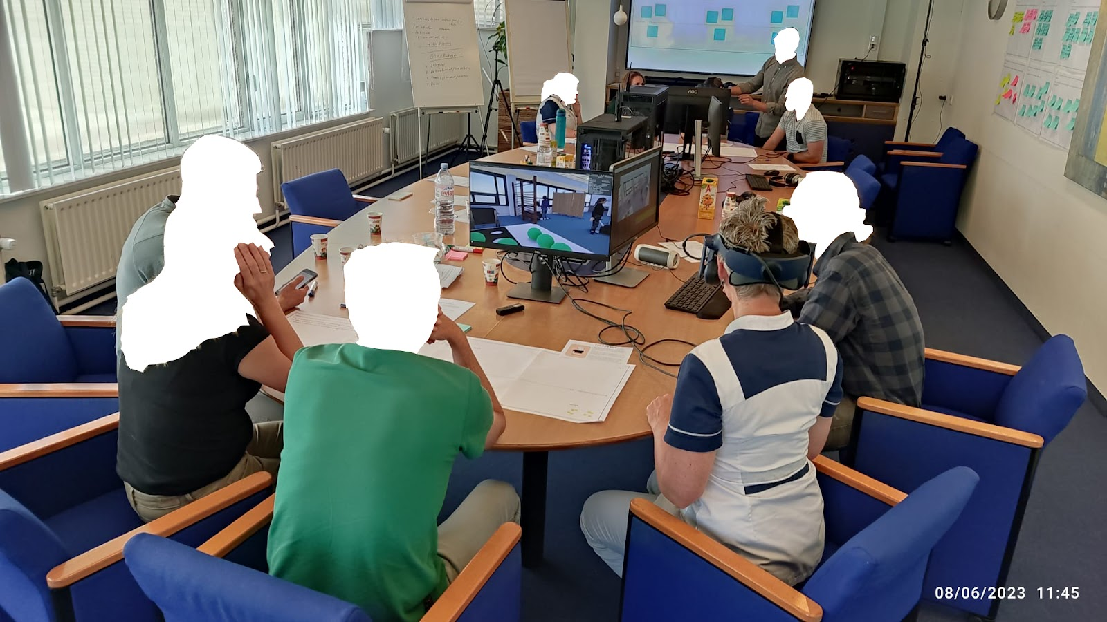
Activity 2 - Ideation session. Participants working on the paper sheet used during the focus group while one is wearing the HMD to explore the immersive virtual environment.
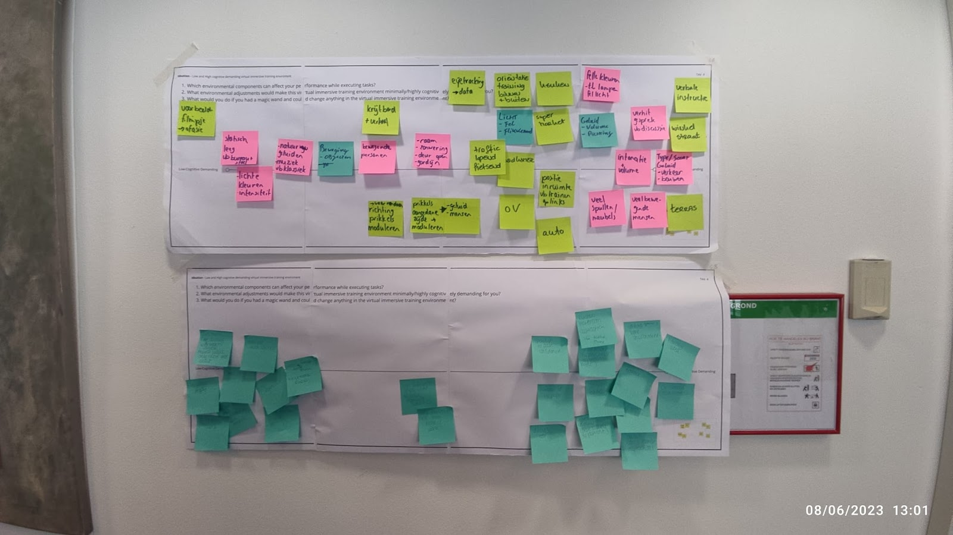
Paper sheet. Top: Group A, Bottom: Group B. Question 1. Which environmental components can affect your performance while executing tasks? Question 2. What environmental adjustments would make this virtual immersive training environment minimally/highly cognitively demanding for you? Question 3. What would you do if you had a magic wand and could change anything in the virtual immersive training environment?

