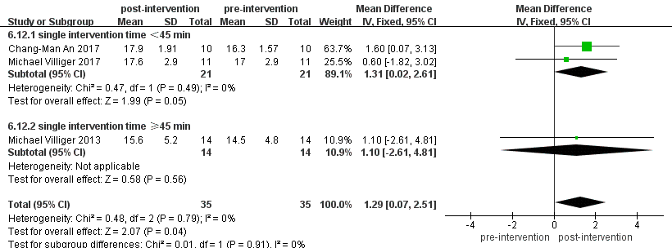
Figure S1. Subgroup Analysis of WISCI Scores Pre- and Post-VR Training Based on Intervention Duration.

