SUPPLEMENTARY MATERIALS

Title: Enhanced Gait Tracking Measures for Individuals with Stroke using Leg-Worn Inertial Sensors

Francesco Lanotte, PhD*
Max Nader Lab for Rehabilitation Technologies and Outcomes Research
Shirley Ryan AbilityLab
Department of Physical Medicine and Rehabilitation
Northwestern University

Shusuke Okita, PhD*
Max Nader Lab for Rehabilitation Technologies and Outcomes Research
Shirley Ryan AbilityLab
Department of Physical Medicine and Rehabilitation
Northwestern University

Megan K. O’Brien, PhD
Max Nader Lab for Rehabilitation Technologies and Outcomes Research
Shirley Ryan AbilityLab
Department of Physical Medicine and Rehabilitation
Northwestern University

Arun Jayaraman, PT, PhD
Max Nader Lab for Rehabilitation Technologies and Outcomes Research
Shirley Ryan AbilityLab
355 E Erie St., Chicago, IL, 60611, USA
Department of Physical Medicine and Rehabilitation
Department of Physical Therapy and Human Movement Sciences
Northwestern University
710 N Lake Shore Dr, Chicago, IL, 60611, USA
Telephone: +1-312-238-6875
Email: a-jayaraman@northwestern.edu

* These authors equally contributed to the work and should be considered co-first authors.

Key methods of the SGSA
First, the SGSA identifies mid-swing, indicated by positive peaks of $ω_{h}$, during maximum rotational extension of the lower leg as it undergoes forward limb movement. To do so, the SGSA identifies whether a positive peak exceeds a threshold of $\max\left(ω_{h}\right)/3$. Since multiple adjacent peaks can result from sensor noise or artifacts such as stumbling or tripping, the SGSA selects the highest amplitude peak within a 700 ms window (Figure 1A). We increased this window from the original value of 500 ms [1] to account for the slower and varied gait patterns observed in our dataset for individuals with stroke, particularly during the 10MWT.
Second, the SGSA identifies FO during the terminal stance phase, when the lower leg undergoes rapid angular deceleration, indicated by the negative velocity peak in $ω_{h}$ as the leg prepares to lift off the ground (Figure 1B). To detect FO, a similar observation window of 700 ms was used to pinpoint the closest local minimum of $ω_{h}$ to mid-swing, either -20 deg/s [1] or one third of minimum value of $ω_{h}$.
Third, the SGSA identifies FC during the initial stance phase, when the leg decelerates to accept weight during foot contact with the ground, indicated by the first negative peak following mid-swing (Figure 1C). To detect FC, an observation window $Δ_{FC}^{SGSA}$ following each mid-swing peak is defined as follows:
 | $$Δ_{FC}^{SGSA}=max⁡(800 ms,0.20· T_{MSw})$$ | (1)
where $T_{MSw}$ is an estimate of the stride time computed as the time between two consecutive mid-swing peaks, scaled by 20% as the terminal swing phase is expected to last 20% of the gait cycle [2]. For each maximum peak of $ω_{h}$, FC is the first local minimum below -20 deg/s within $Δ_{FC}^{SGSA}$.

Key methods of the EGSA
First, to identify mid-swing, the EGSA additionally removes peaks with lower width values (Figure 1A). This is because stroke survivors may have diminished leg control during the swing and restricted foot clearance [3], which can manifest as noise artifacts and spikes in the signal. These spikes exhibit a smaller width compared to the characteristic peaks of maximum swing speed, but their high magnitude means they are often selected during peak detection.
Second, to identify FO, the EGSA employed additional constraints based on the norm of the angular velocity signals (Figure 1B). We defined an additional observation window $Δ_{FO}^{EGSA}$ preceding each maximum speed, whose length was computed as for $Δ_{FC}^{SGSA}$. Similar to the SGSA, if FO remained undetected, all local maxima timings of $ω_{norm}$ within $Δ_{FO}^{EGSA}$, noted as $t_{lm}$, were compared. FO was identified as the timing closest to the maximum speed peak satisfying the following condition:
 | $$ω_{h}\left(t_{lm}\right)<0 ∧ ω_{norm}\left(t_{lm}\right)>median(ω_{norm}(t_{lm}))$$ | (2)
If local maxima were absent in the observation window, the window was incremented by 100 ms, and the process was reiterated until a valid FO event was identified. These changes consider that stroke survivors may have diminished muscle strength, restricting the leg’s propulsive and necessitating compensatory movements for lifting the leg. This leads to reduced speeds and unclear local minima in the gyroscope signals, potentially impacting the SGSA performance. As those compensations are challenging to pre-model, we hypothesized that the norm of the lower leg gyroscope $ω_{norm}$ captures the residual movement, exhibiting a local maximum during the FO event.
Third, to identify a FC, we devised an alternative foot contact detection condition to avoid selecting peaks from impaired, unsmooth movements. Potential FC events are identified as the first instance within $Δ_{FC}^{SGSA}$ after the maximum speed peak reaches a local minimum in the norm of the lower leg acceleration,$a_{norm}$, and $ω_{h}$ becomes negative (Figure 1C). This condition aims to capture the leg’s deceleration for precise foot placement. Additionally, when both the SGSA and EGSA identify two distinct FC events, one additional timing is randomly selected between them to account for undetected contacts. Thus, each gait cycle has three potential FC events.
To determine which FC candidate is selected for gait segmentation, we employed dynamic time warping (DTW), a technique for measuring the similarity between two temporal sequences of different lengths [4]. To integrate DTW, the EGSA leverages a template for normal gait patterns, derived from 51 healthy individuals, and measures the deviation for individuals post-stroke. The healthy participants performed the 10-Meter Walk Test (10MWT) at comfortable and fast speeds while equipped with sensors on their pelvis and lower legs [5]. Here, the angular velocity signals from IMUs on lower legs were segmented into gait cycles using SGSA, given its accuracy with healthy gait. The gait cycles were resampled over 50 samples and averaged for each participant. Following min-max normalization, the template was retrieved by averaging all the subject-specific profiles. By using this template, the EGSA computes the Euclidean distance for each candidate of the segmented gait cycle. We computed the total distance value from the template across each possible segmentation, selecting the optimal segmentation with the minimum distance from the template.

Analysis of temporal gait parameters
Reliability was determined using the intra-class correlation coefficient (ICC [6]) computed between each IMU-derived parameters and the GAITRite, ICC values span from 0 to 1, signifying the degree of reliability from poor to excellent.
Agreement between the two systems was determined using Bland-Altman plots for each parameter. A linear regression analysis examined any proportional relationships between the IMU- and GAITRite-derived parameters, fitting an intercept and slope to the Bland-Altman plots [7]. We also calculated the percentage of footfalls outside the limits of agreement for each parameter and participant.
Accuracy was determined using the median absolute percentage error (MdAPE), computed as the median value of the percentage error (APE) between GAITRite and IMU-derived parameters:
 | $$APE=\left(\frac{\left|GAITRite-IMU\right|}{GAITRite}\right)·100$$ | (7)
To investigate the impact of post-stroke gait impairment on the IMU-derived gait parameters, MdAPE values were computed for each parameter across all the footfalls (overall error), and separately for the footfalls within specific speed range, asymmetry level, or paretic sides. Kruskal-Wallis tests, followed by Wilcoxon signed rank test with Dunn-Sidak correction, were employed to test the null hypothesis that MdAPE did not differ significantly across speed ranges, asymmetry levels, or paresis.

Details of data collection
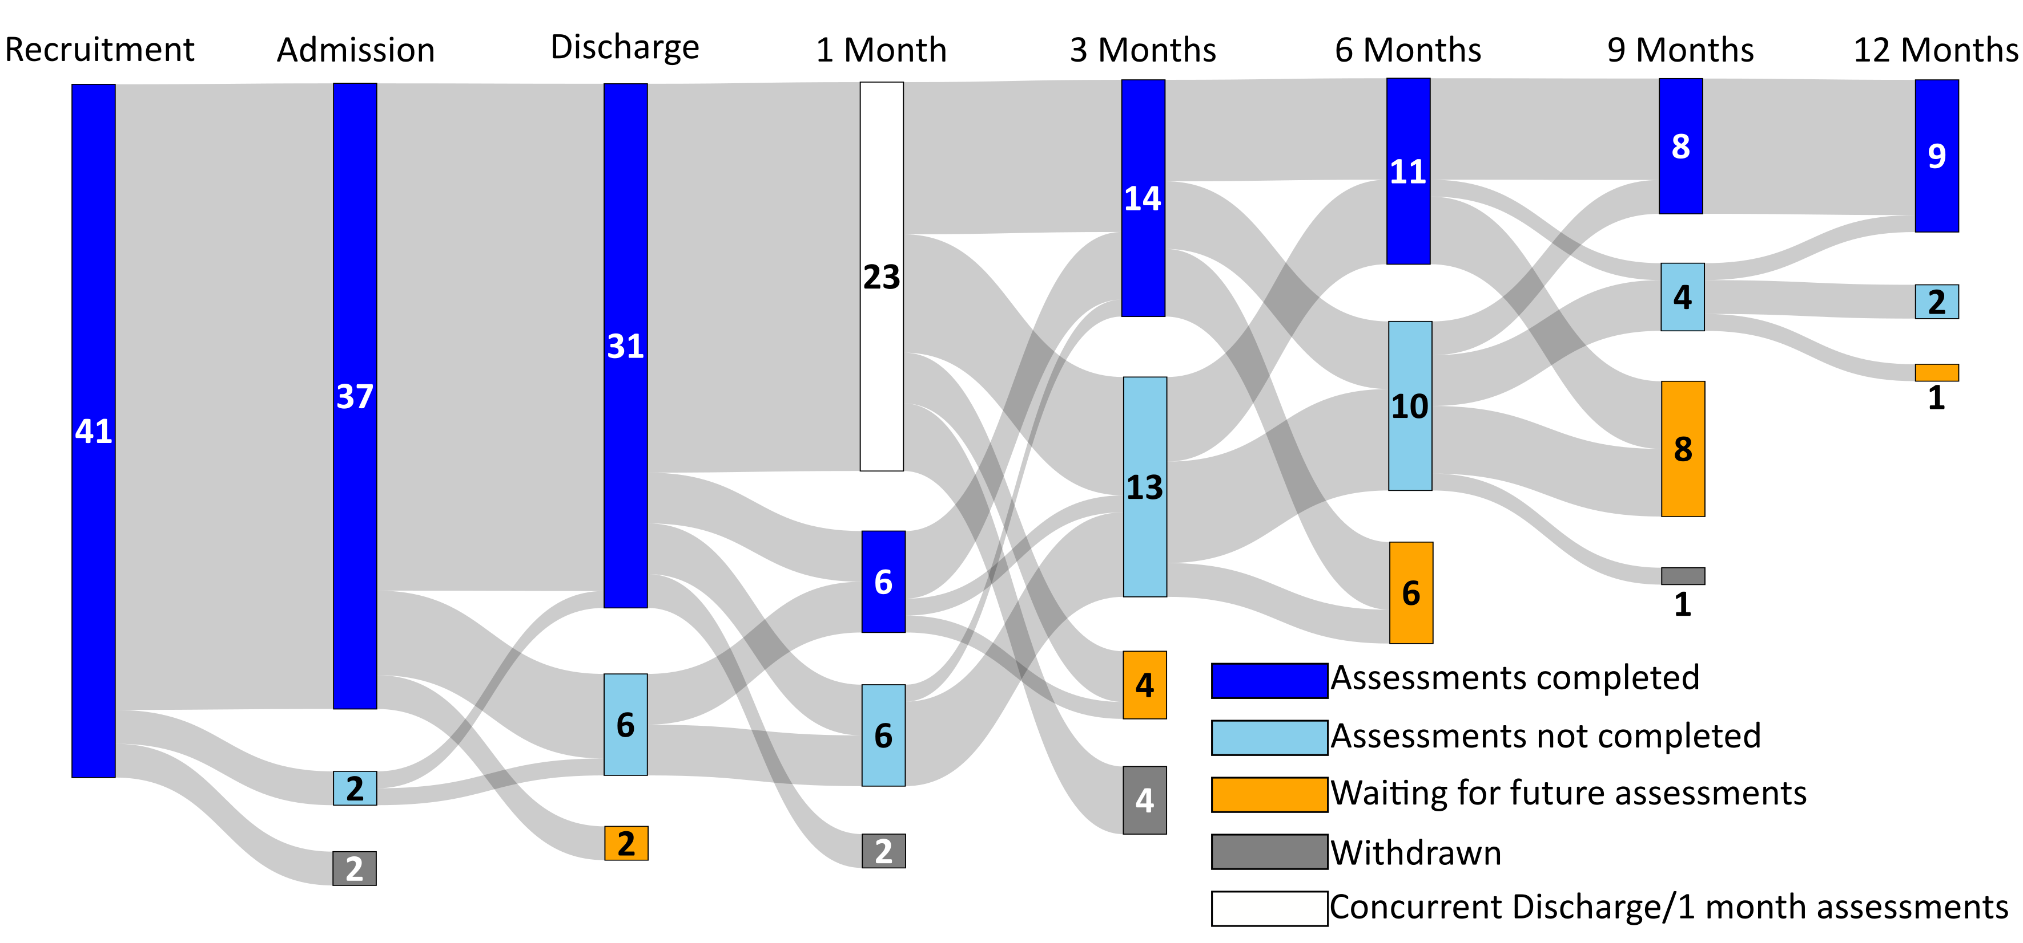
Supplementary Figure 1. Longitudinal gait assessments available for analysis, up to one year post-stroke. Number of gait assessments available at each post-stroke timepoint, illustrating the complete or incomplete assessments across participants. Incomplete assessments are shown if the assessment was scheduled for a future time, for any participants still active in the larger study at the time of analysis (orange nodes), if they missed a timepoint (bright blue nodes), or if they had been withdrawn from the study (grey nodes). Reasons for study withdrawal included out-of-state relocation, medical complications, or voluntary withdrawal.
Of the 116 sessions available for analysis, Supplementary Figure 1 shows the amount of data at each time-point during the one-year longitudinal study period, including the number of assessments at each post-stroke timepoint. For this analysis, we used data from 35 participants who were able to complete at least one trial of the 10-Meter Walking Test (10MWT) at both a comfortable and fast velocity (up to three trials of each), to ensure the dataset captured within-participant differences in gait speed. Of the 557 trials of 10MWT available for these participants, 470 trials were successfully recorded for the analysis, after removing trials with incomplete or corrupted sensor signals, resulting in a total of 4969 events. A total of 1221 events were categorized as Slow speed, 837 events as Medium speed, and 1972 events as Fast speed. The Symmetric, Asymmetric, Paretic, and Non-Paretic subgroups included 2069, 1962, 2498, and 2471 total events, respectively.

List of Abbreviations

10MWT: 10-Meter Walk Test
APE: Absolute Percentage Error
Asym: Asymmetric
CV: Comfortable velocity
DTW: Dynamic time warping
EGSA: Enhanced gait segmentation algorithm
F: Fast
FC: Foot contact
FO: Foot-off
FV: Fast velocity
GR: GAITRite
ICC: Intra-class correlation coefficient
IMU: Inertial Measurement Unit
M: Medium
MdAPE: Median Absolute Percentage Error
S: Slow
SGSA: Salarian gait segmentation algorithm
Sym: Symmetric

Supplementary References
[1] A. Salarian et al., ‘Gait assessment in Parkinson’s disease: toward an ambulatory system for long-term monitoring’, IEEE Trans Biomed Eng, vol. 51, no. 8, pp. 1434–1443, Aug. 2004, doi: 10.1109/TBME.2004.827933.
[2] J. B. Webster and B. J. Darter, ‘Principles of Normal and Pathologic Gait’, Atlas of Orthoses and Assistive Devices, Fifth Edition, pp. 49-62.e1, Jan. 2019, doi: 10.1016/B978-0-323-48323-0.00004-4.
[3] C. J. Winstein et al., ‘Guidelines for Adult Stroke Rehabilitation and Recovery: A Guideline for Healthcare Professionals From the American Heart Association/American Stroke Association.’, Stroke, vol. 47, no. 6, pp. e98–e169, Jun. 2016, doi: 10.1161/STR.0000000000000098.
[4] J. Mantilla, L. Oudre, R. Barrois, Á. Vienne, and D. Ricard, ‘Template-DTW based on inertial signals: Preliminary results for step characterization’, Proceedings of the Annual International Conference of the IEEE Engineering in Medicine and Biology Society, EMBS, pp. 2267–2270, Sep. 2017, doi: 10.1109/EMBC.2017.8037307.
[5] M. K. O’brien et al., ‘Augmenting Clinical Outcome Measures of Gait and Balance with a Single Inertial Sensor in Age-Ranged Healthy Adults’, Sensors 2019, Vol. 19, Page 4537, vol. 19, no. 20, p. 4537, Oct. 2019, doi: 10.3390/S19204537.
[6] P. E. Shrout and J. L. Fleiss, ‘Intraclass correlations: Uses in assessing rater reliability’, Psychol Bull, vol. 86, no. 2, pp. 420–428, Mar. 1979, doi: 10.1037/0033-2909.86.2.420.
[7] D. Giavarina, ‘Understanding Bland Altman analysis’, Biochem Med (Zagreb), vol. 25, no. 2, pp. 141–151, Jun. 2015, doi: 10.11613/BM.2015.015/FULLARTICLE.

Corresponding author

