Supplementary Figure 1. The CONSORT flow chart
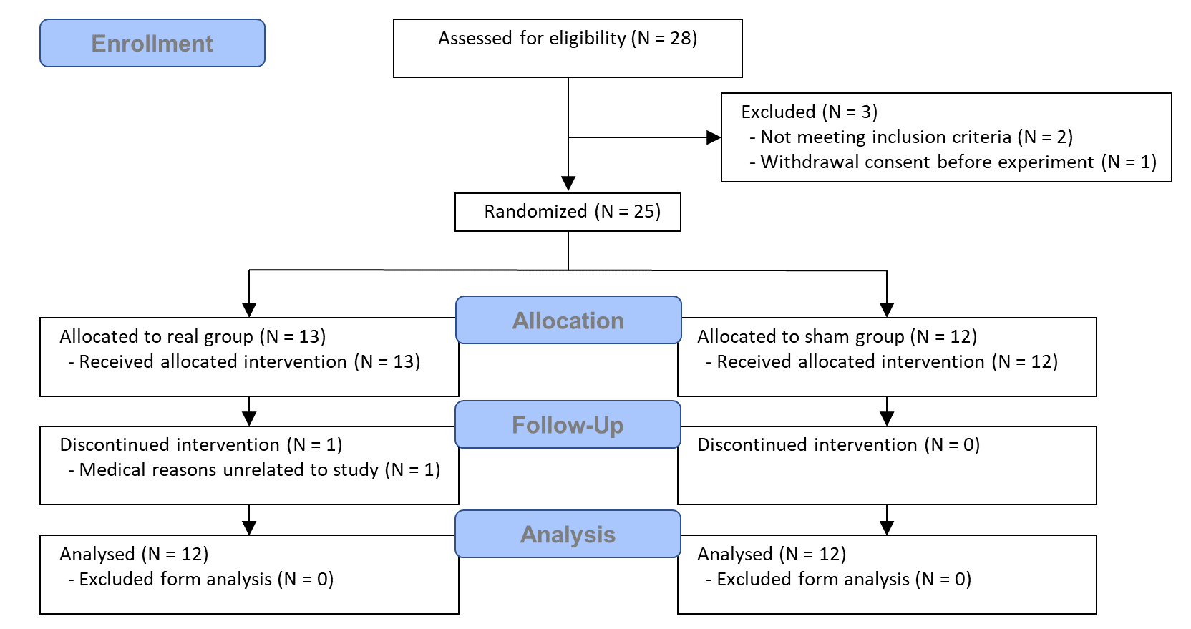

Supplementary Figure 2. System diagram of proposed integrated tDCS-fNIRS modular system implementation
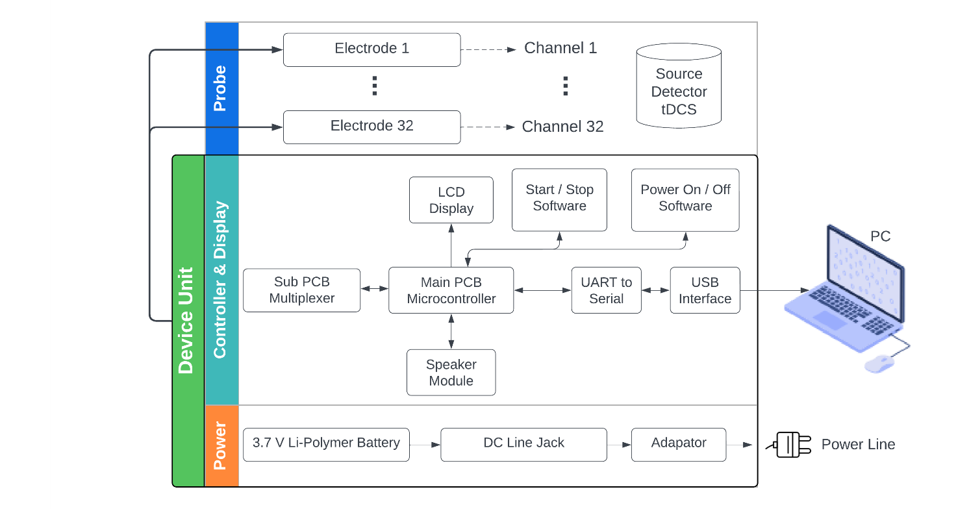

Supplementary Figure 3. Example of numerical integration to assess accumulated oxy-hemoglobin (HbO_{Acc}) from 1 min of resting-state time-series data (shaded areas). (A) a net decrease of HbO_{Acc} (B) a net increase of HbO_{Acc}
Supplementary Table 1. Changes in hemodynamic response after multi-channel tDCS intervention
 | Regions | Group | Time | group $×$ time  (T0 and T1)
HbO_{Acc} | Left MFG | 0.894 | 0.675 | 0.821
HbO_{Acc} | SFG | 0.091 | 0.254 | 0.392
HbO_{Acc} | Right MFG | 0.712 | 0.924 | 0.886
HbO_{Acc} | Left SMG | 0.605 | 0.232 | 0.995
HbO_{Acc} | SPL | 0.033* | 0.11 | 0.028†
HbO_{Acc} | Right SMG | 0.077 | 0.051 | 0.162
Hb_{Acc} | Left MFG | 0.825 | 0.74 | 0.521
Hb_{Acc} | SFG | 0.083 | 0.362 | 0.448
Hb_{Acc} | Right MFG | 0.538 | 0.572 | 0.995
Hb_{Acc} | Left SMG | 0.249 | 0.224 | 0.957
Hb_{Acc} | SPL | 0.216 | 0.073 | 0.053
Hb_{Acc} | Right SMG | 0.006** | 0.013* | 0.031†
Values are presented as the p-value. †, A significant change was identified in the group $×$ time interaction from the two-way repeated measures ANCOVA, with stroke type included as a covariate, p < 0.05. *, Significant difference between real-tDCS and sham-tDCS groups, based on between-group ANCOVA with stroke type as covariates, p < 0.05, **, p < 0.01. T0, before the interventions, and T1, after completing all 10 interventions, MFG; middle frontal gyrus, SFG; superior frontal gyrus, SMG; supramarginal gyrus, SPL; superior parietal lobule.
Supplementary Table 2. Changes in Jebsen-Taylor hand function test after multi-channel tDCS interventions
 | Real-tDCS |  | Sham-tDCS |  | Adjusted  p-value
 | T0 | T1 | T0 | T1 | Adjusted  p-value
Writing | 71.5$±$51.3 | 65.1$±$37.2 | 63.9$±$42.2 | 66.7$±$41.6 | 0.119
Card turning | 30.7$±$41.9 | 32.4$±$41.3 | 50.7$±$53.0 | 53.2$±$51.1 | 0.456
Lifting small objects | 53.2$±$44.3 | 43.8$±$40.1 | 62.9$±$52.3 | 64.3$±$50.9 | 0.161
Feeding | 41.2$±$42.1 | 42.5$±$44.8 | 52.4$±$50.7 | 48.4$±$52.9 | 0.391
Stacking | 30.2$±$42.8 | 29.7$±$42.8 | 45.6$±$55.0 | 44.4$±$55.8 | 0.938
Lifting large light objects | 30.8$±$41.9 | 33.1$±$42.7 | 59.3$±$60.4 | 50.0$±$53.1 | 0.418
Lifting large heavy objects | 30.4$±$42.3 | 30.7$±$42.8 | 48.1$±$53.6 | 47.4$±$54.0 | 0.585
Values are presented as the mean ± standard deviation. Unit, sec. The adjusted p-value represents the group $×$ time interaction from the two-way repeated measures ANCOVA, with stroke type as a covariate. T0, before the interventions, and T1, after completing all 10 interventions.

Supplementary Table 3. Changes in neurophysiological response after multi-channel tDCS interventions
 | Real-tDCS |  | Sham-tDCS |  | Adjusted  p-value
 | T0 | T1 | T0 | T1 | Adjusted  p-value
Resting motor threshold (rMT, %) | 55.4$±$9.9 | 53.6$±$9.1 | 57.4$±$14.0 | 57.6$±$13.0 | 0.346
Amplitude ($μ$V, 120% rMT) | 410.6$±$306.3 | 298.6$±$285.8 | 211.1$±$224.6 | 269.7$±$233.7 | 0.087
Latency (msec, 120% rMT) | 24.0$±$5.1 | 25.5$±$5.3 | 27.6$±$8.9 | 22.0$±$6.3 | 0.209
Values are presented as the mean ± standard deviation. The adjusted p-value represents the group $×$ time interaction from the two-way repeated measures ANCOVA, with stroke type as a covariate. T0, before the interventions, and T1, after completing all 10 interventions.

