Supplementary Materials:
Calculations of block and session length with constraints:
There were four general constraints defined to design the experiment blocks and classifier:

- Maximum EEG experiment duration for participant comfort:
$${T_{session} ≤ T}_{max,session}=45 minutes=2700s$$
- Minimum time for knee flexion-extension for patients with SCI during gait. Determined by observing participants with SCI during gait in (1).
$$T_{move}≥ T_{min,knee} = 3 s$$
- Optimal ratio of datapoints to dimensionality of the feature space is 10:1. We acknowledge that a limitation of this constraint is that it assumes that each datapoint is independent and identically distributed from the same distribution. This is not the case for our data due to the inherent filtering applied and the non-stationary nature of EEG signals. We chose to respect this constraint while acknowledging the potential limitations.
Assuming we reserve one block for testing of the classifier, the total number of datapoints in the training/validation set for each classifier is a sum of the timepoints within rest, focus, and move periods, multiplied by the number of repetitions and the number of blocks used for training, all divided by the width of the time window:
$$N_{dataset} = \frac{\left({T_{rest}+T}_{focus} + T_{move}\right) N_{trials} \left(N_{blocks} - 1\right)}{T_{window}}$$
The dimensionality of the feature space constructed is:
$$d =N_{frequencies}{ N}_{electrodes} N_{lags}=480$$
Therefore, the optimal ratio requires that the total number of datapoints in the training set be 10 times the dimensionality of the feature space. That is:
$$\frac{N_{dataset}}{d} ≥10$$
- The amount of past data the classifier must incorporate into its predictions was determined to be at least 300ms. This is based on a study demonstrating the efficacy of an invasive brain-spine interface for restoration of gait in primates (2). This constraint can be written as:
$$N_{lags} T_{window} ≥ T_{history}= 300ms=0.3s$$

Overall, these four constraints can be written as follows in terms of session design parameters and classifier design:
- $N_{conditions}\left(T_{rest} + T_{focus} + T_{move}\right)N_{trials} N_{blocks} ≤ T_{max,session}$
- $T_{move} ≥ T_{min, knee}$
- $\frac{\left({T_{rest}+ T}_{focus} + T_{move}\right)N_{trials}\left(N_{blocks} - 1\right)}{T_{window } N_{freq} N_{elec }N_{lags}}≥10$
- $N_{lags} T_{window} ≥ T_{history}$
In our design, we chose the following parameters:
$$T_{window} = 0.1 s,$$
$$N_{freq} = 3,$$
$$N_{elec} = 32,$$
$$N_{lags} = 5,$$
$$T_{rest} = 2s,$$
$$T_{focus} =2s,$$
$$T_{move}= 6s,$$
$$N_{trials} = 10,$$
$$N_{blocks} = \left\{\begin{aligned}6 in Phase I \\ 12 in Phase II\end{aligned}\right.$$
$$N_{conditions}=\left\{\begin{aligned}3 in Phase I \\ 2 in Phase II\end{aligned}\right.$$

This leads to a T_{session} = 30 minutes in Phase I and T_{session}= 40 minutes in Phase II, which is below the 45 minutes requirement. The total dataset size of N_{dataset} = 5000 datapoints in Phase I and N_{dataset}= 11,000 datapoints in Phase II, and dimensionality of the feature space d= 480, matches the 10:1 ratio between datapoints and dimensionality of the feature space. For the number of lags, we based our choice on (2), which sets the history size to be 5x100ms = 500ms.

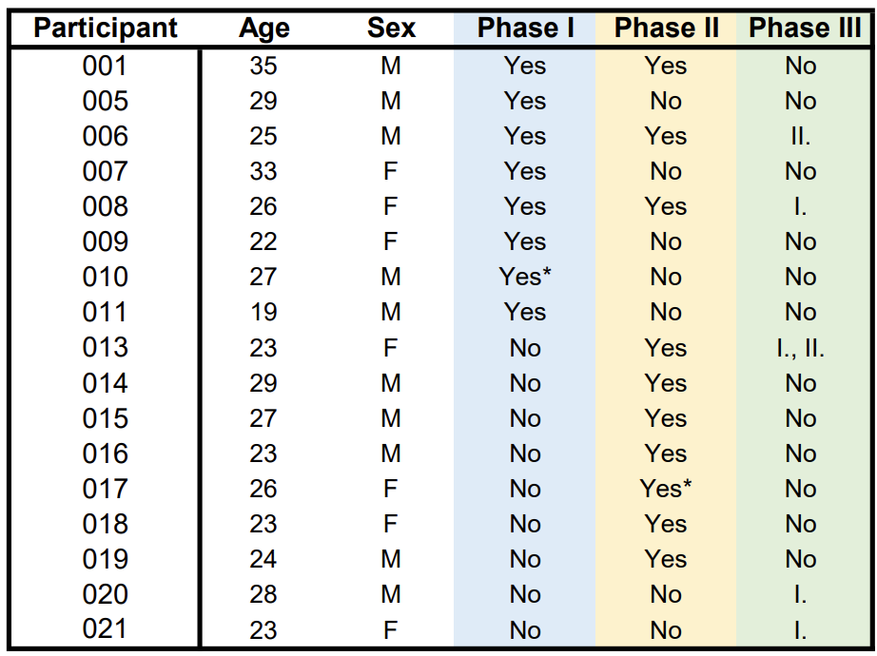
Supplementary Table 1. Participant demographics. In column 3, I. indicates the uncued movement-based decoder experiment, and II. indicates the anthropomorphic vs. bar cue experiment. *Datasets excluded from analysis due to outliers in channel noise.

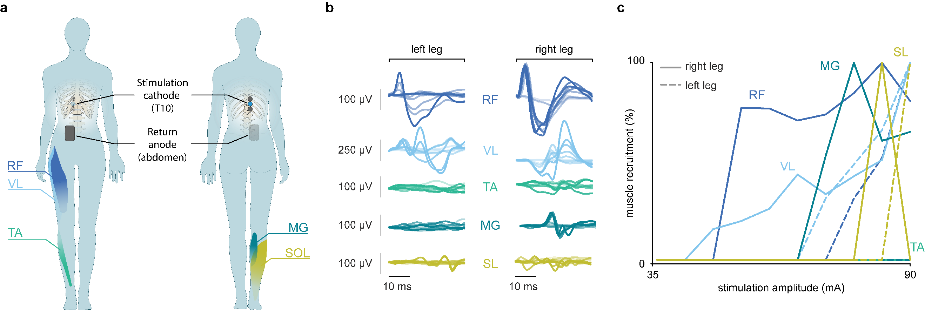
Supplementary Figure 1. Stimulation protocol to selectively target right hip muscles. a. Configuration of tSCS. Placement of the stimulation cathode at spinal segment T10 and return anode to the right of the naval to selectively target right hip muscles. b. Muscle responses. Muscle responses from major leg muscles for pulses of increasing amplitudes. c. Recruitment curves. Muscle response peak-to-peak amplitude as a function of stimulation amplitude. Abbreviations: rectus femoris (RF); vastus lateralis (VL); tibialis anterior (TA); medial gastrocnemius (MG); soleus (SL).

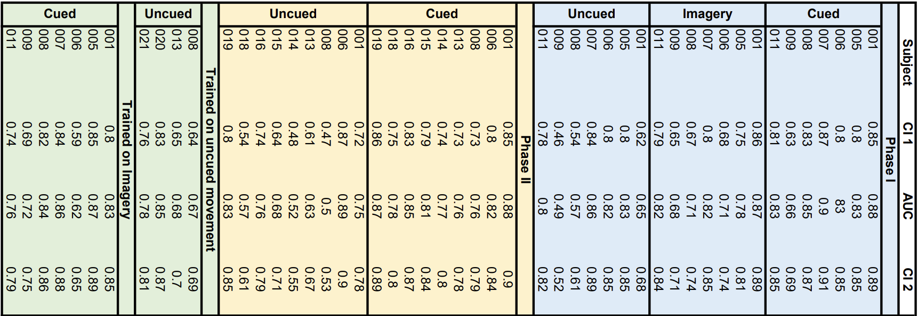
Supplementary Table 2. Decoder AUC and confidence intervals. AUCs for each participant's decoder were calculated from the original test set. The 95% confidence intervals were constructed from bootstrapping.
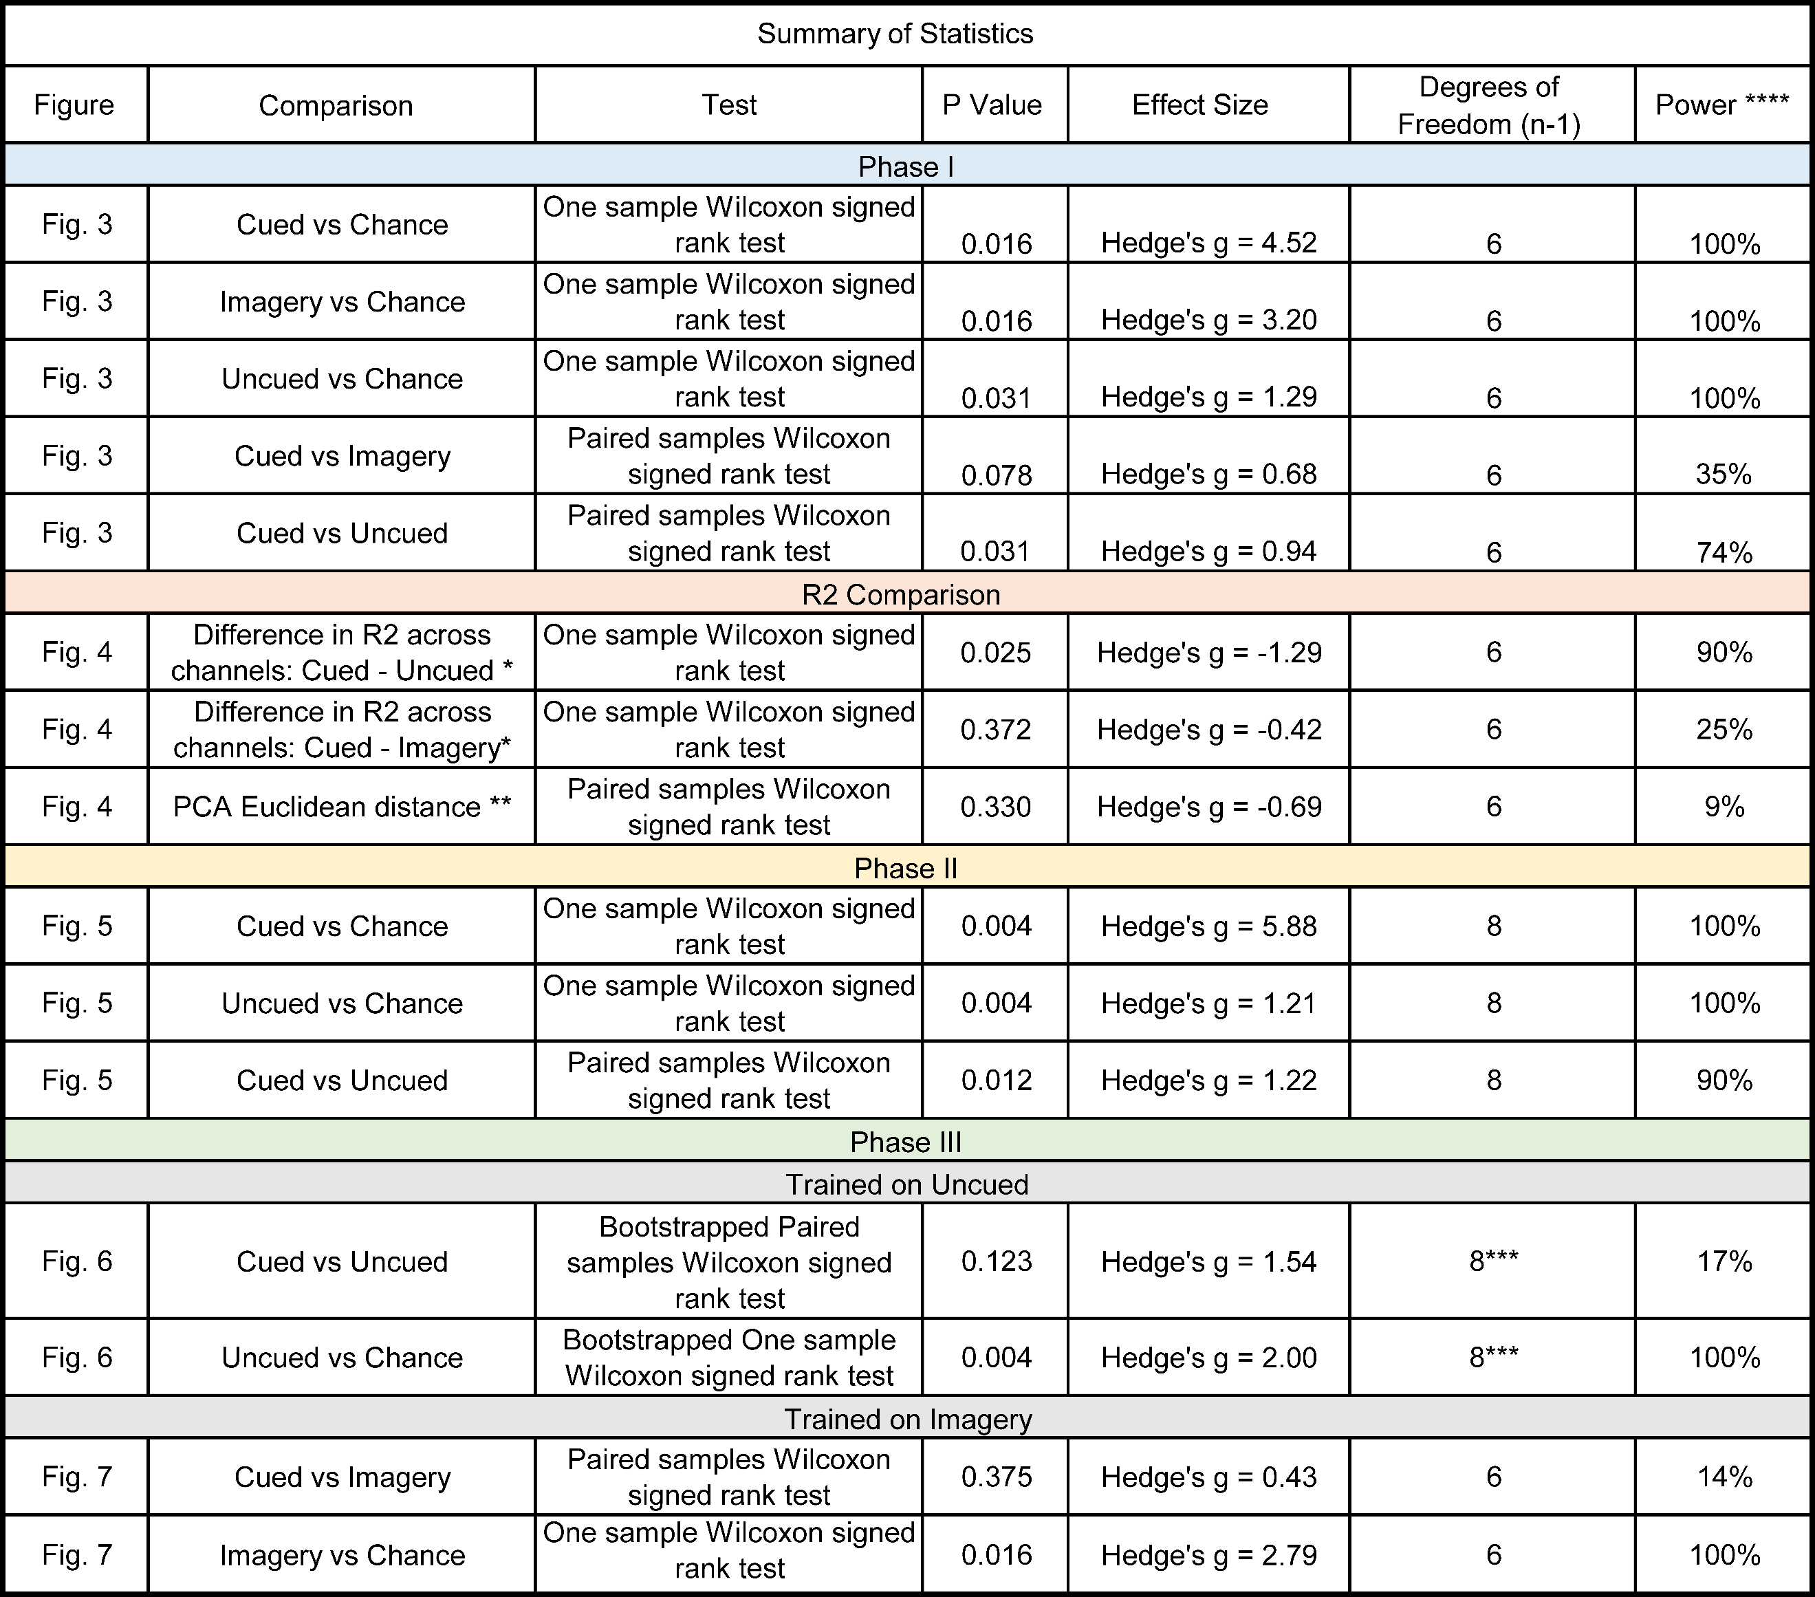
Supplementary Table 3: Summary of statistics.
* P values, effect size, and power is presented here as an average across 32 channels. Individual channels' p values and power can be seen in Supplementary Figure 2.
** P values, effect size, and power is presented here as an average across 3 frequency bands.
*** Populations sampled with replacement to obtain k = 10,000 fictive populations of n = 9 to simulate a distribution.
**** For non-parametric statistical comparisons, power is calculated with Monte Carlo simulation to resample each group over 10,000 iterations and test for a significant difference between groups. Power is calculated as the proportion of significant results over the total number of iterations (3).
**** Power is close to or equal to 1 when the distributions between groups are perfectly non-overlapping. In this case, none of the AUC values are <0.5, and therefore the power is 100% for the comparison to chance.

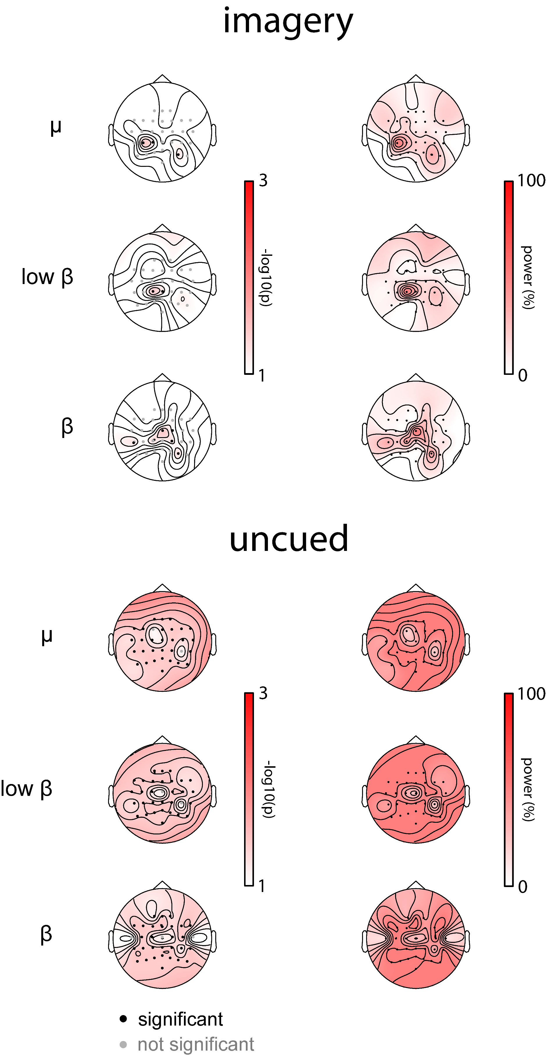
Supplementary Figure 2: Statistics of R² differences analysis shown in Figure 4. P values (left) and power (right) of a one sample Wilcoxon signed rank test in R² difference from cued movement for imagery and uncued movement. Analysis not corrected for multiple comparisons.

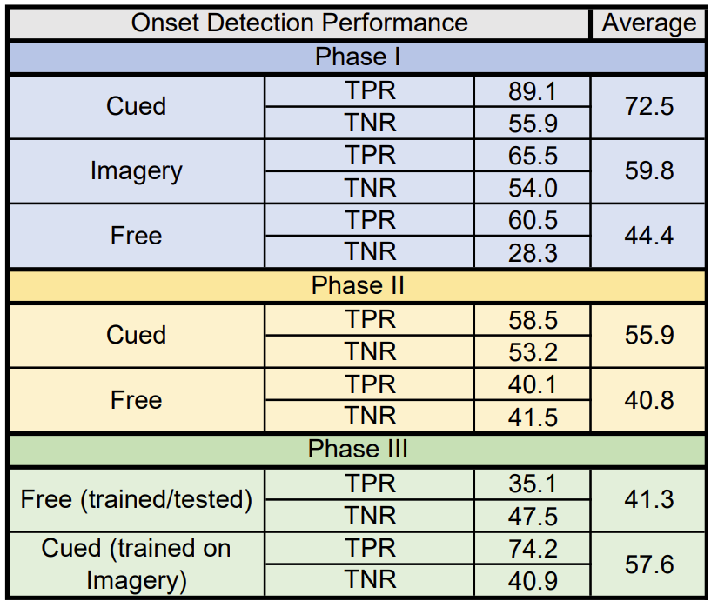
Supplementary Table 4. Onset detection performance comparison at a tolerance window of 0.8 seconds around true onset. This tolerance window was the inflection point of the derivative of the onset detection TPR curve for Phase I cued movement and applied across conditions for comparison of results. Values are presented as percentages.

Supplementary Figure 3. Anthropomorphic cue is not necessary for successful decoder performance. a. Illustration of cue types within the training sets. b. ROC curve for all participants (thin line) and averaged across participants (thick line) when the decoder was trained on the bar and knee cues and tested on cued movements. c. ROC curve for all participants (thin line) and averaged across participants (thick line) when the decoder was trained on bar and knee cues and tested on uncued movement.

Supplementary Materials References:
1. Wagner FB, Mignardot JB, Le Goff-Mignardot CG, Demesmaeker R, Komi S, Capogrosso M, et al. Targeted neurotechnology restores walking in humans with spinal cord injury. Nature. 2018 Nov 1;563(7729):65–71.
2. Capogrosso M, Milekovic T, Borton D, Wagner F, Moraud EM, Mignardot JB, et al. A brain–spine interface alleviating gait deficits after spinal cord injury in primates. Nature. 2016 Nov;539(7628):284–8.
3. Graebner RW. Study Design with SAS®: Estimating Power with Monte Carlo Methods.

