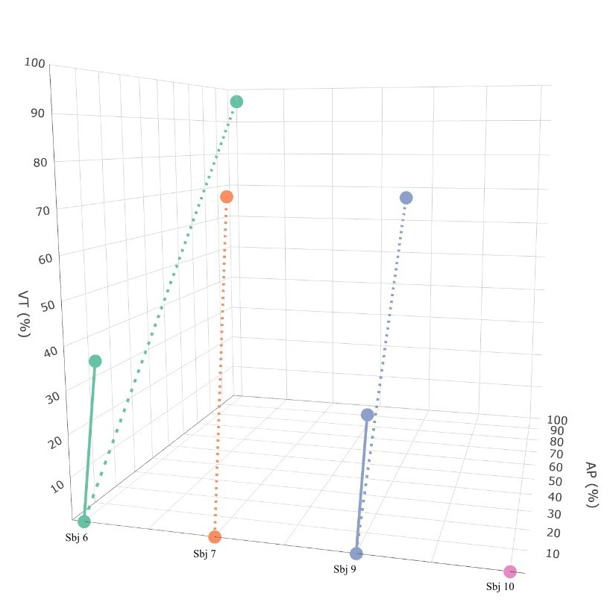
Supplementary Figure 1. Median percentage of the upper limb vertical VT (%) and anteroposterior AP (%) travelled distance in the instrumented item “pinch a ball bearing with 2nd finger and thumb” of the ARAT in the Exoskeleton Unsupported (solid line) and Exoskeleton Supported (dotted line) conditions. VT: Vertical, AP: Anteroposterior, Sbj: Subject, ARAT: Action Research Arm Test.

