Supplementary Table of Contents
Supplementary 1 — Definitions of exercise training interventions 1
Supplementary 2 — Search Strategy 3
Supplementary 3 — Conversion Formulas for Effect Size and SD Estimation 7
Supplementary 4 — Study Characteristics of Included Studies 9
Supplementary 5 — Risk of Bias Assessment (RoB 2.0) 36
Supplementary 6 — GRADE Assessment for Network Evidence 39
Supplementary 7 — Global Inconsistency Test 59
Supplementary 8 — Node-Splitting Results for Local Inconsistency 60
Supplementary 9 — Heterogeneity Assessment (I² Statistics) 70
Supplementary 10 — Network Plots for All Outcomes 73
Supplementary 11 — Network Meta-Analysis Heatmaps (Direct Comparisons) 76
Supplementary 12 — Overall SUCRA Rankings 81
Supplementary 13 — Funnel Plots for Publication Bias 84
Supplementary 14 — Meta-Regression Results 87
Supplementary 15— Network Meta-Regression Bubble Plots 88
Supplementary 16 — Network Meta-Regression Trend Plot 97
Supplementary 17 — Leave-one-out Sensitivity Analysis 106
Supplementary 18 — Analysis Supplementary References 121

Supplementary 1 — Definitions of exercise training interventions
Table S1 Definitions of exercise training interventions included in this systematic review
Abbreviation | Full Name | Definition/Explanation
RC | Routine Care | Usual clinical care without additional structured exercise interventions.
NE | No Exercise | Participants received no exercise or rehabilitation training.
NPF | Neuro/Proprio Facilitation | Techniques focused on enhancing neuromuscular control and proprioceptive input.
ULT | Upper Limb Training | Exercises targeting the strength, coordination, and function of upper extremities.
LLT | Lower Limb Training | Exercises aimed at improving mobility and function of the lower limbs.
CST | Core Stability Training | Exercises to strengthen core muscles and improve trunk control and balance.
BT | Balance Training | Interventions designed to enhance postural stability and reduce fall risk.
ES+EX | Electrical Stimulation + Exercise | Combination of neuromuscular electrical stimulation with physical training.
RAT | Robotic-Assisted Training | Use of robotic devices to facilitate repetitive, task-specific movements.
VRG | Virtual Reality/Gaming | Interactive exercises using virtual environments or motion-based video games.
AE | Aerobic Exercise | Continuous, rhythmic physical activity that increases cardiovascular endurance.
HIIT | High-Intensity Interval Training | Alternating short bursts of intense activity with periods of rest or low-intensity work.
FT | Functional Training | Exercises that mimic real-world tasks to improve daily functional capabilities.
RT | Resistance Training | Strength training using resistance tools like weights or bands.
MBE | Mind–Body Exercise | Integrative practices combining physical movement with mental focus (e.g., Tai Chi).
TOT | Task-Oriented Training | Repetitive practice of specific functional tasks to improve targeted abilities.
CIMT | Constraint-Induced Movement Therapy | Immobilization of the unaffected limb to promote use of the affected limb.
BWSTT | Body Weight–Supported Treadmill Training | Walking training on a treadmill with partial body weight support via harness.
OG | Overground Gait | Walking practice conducted on ground surfaces without mechanical support.
BULT | Bilateral Upper Limb Training | Simultaneous training of both upper limbs to improve coordination and motor function.
BVRG | Bilateral Upper Limb Training + Virtual Reality/Gaming | Bilateral upper limb exercises integrated with VR or gaming environments.
IE | Isokinetic Exercise | Muscle strengthening exercises at constant speed using specialized equipment.
TT | Treadmill Training | Walking or running on a treadmill to improve endurance and gait.

Supplementary 2 — Search Strategy
Table S2.1 Pubmed 2984
Search Number | Search Details
1 | "Stroke"[MeSH Terms]
2 | "Strokes"[Title/Abstract] OR "cerebrovascular accident"[Title/Abstract] OR "brain vascular accident"[Title/Abstract]
3 | "Exercise"[MeSH Terms]
4 | "Exercises"[Title/Abstract] OR "physical activity"[Title/Abstract] OR "physical activities"[Title/Abstract] OR "fitness training"[Title/Abstract] OR "walking"[Title/Abstract] OR "Jogging"[Title/Abstract] OR "Bicycling"[Title/Abstract] OR "high intensity interval training"[Title/Abstract] OR "high intensity interval trainings"[Title/Abstract] OR "high intensity interval training"[Title/Abstract] OR "HIIT"[Title/Abstract] OR "Dancing"[Title/Abstract] OR "Resistance"[Title/Abstract] OR "Strength"[Title/Abstract] OR "aquatic therapy"[Title/Abstract] OR "aquatic exercise therapy"[Title/Abstract] OR "water exercise therapy"[Title/Abstract] OR "ai chi therapy"[Title/Abstract] OR "Swimming"[Title/Abstract] OR "mind body therapies"[Title/Abstract] OR "Yoga"[Title/Abstract] OR "pilates training"[Title/Abstract] OR "tai ji"[Title/Abstract] OR "Qigong"[Title/Abstract] OR "baduanjin"[Title/Abstract] OR "wuqinxi"[Title/Abstract] OR "yijinjing"[Title/Abstract] OR "liuzijue"[Title/Abstract]
5 | "Motor Activity"[MeSH Terms]
6 | "FMA"[Title/Abstract] OR "motor function"[Title/Abstract] OR "Movement"[Title/Abstract] OR "Gait"[Title/Abstract] OR "10MWT"[Title/Abstract] OR "Strength"[Title/Abstract] OR "Balance"[Title/Abstract]
7 | "Randomized Controlled Trials as Topic"[MeSH Terms]
8 | "controlled clinical trial"[Title/Abstract] OR "controlled trial"[Title/Abstract] OR "controlled study"[Title/Abstract] OR "controlled clinical study"[Title/Abstract] OR "RCT"[Title/Abstract] OR "randomiz*"[Title/Abstract] OR "placebo"[Title/Abstract] OR "randomly"[Title/Abstract] OR "trial"[Title/Abstract] OR "groups"[Title/Abstract]
9 | "Stroke"[MeSH Terms] OR "Strokes"[Title/Abstract] OR "cerebrovascular accident"[Title/Abstract] OR "brain vascular accident"[Title/Abstract]
10 | "Exercise"[MeSH Terms] OR "Exercises"[Title/Abstract] OR "physical activity"[Title/Abstract] OR "physical activities"[Title/Abstract] OR "fitness training"[Title/Abstract] OR "walking"[Title/Abstract] OR "Jogging"[Title/Abstract] OR "Bicycling"[Title/Abstract] OR "high intensity interval training"[Title/Abstract] OR "high intensity interval trainings"[Title/Abstract] OR "high intensity interval training"[Title/Abstract] OR "HIIT"[Title/Abstract] OR "Dancing"[Title/Abstract] OR "Resistance"[Title/Abstract] OR "Strength"[Title/Abstract] OR "aquatic therapy"[Title/Abstract] OR "aquatic exercise therapy"[Title/Abstract] OR "water exercise therapy"[Title/Abstract] OR "ai chi therapy"[Title/Abstract] OR "Swimming"[Title/Abstract] OR "mind body therapies"[Title/Abstract] OR "Yoga"[Title/Abstract] OR "pilates training"[Title/Abstract] OR "tai ji"[Title/Abstract] OR "Qigong"[Title/Abstract] OR "baduanjin"[Title/Abstract] OR "wuqinxi"[Title/Abstract] OR "yijinjing"[Title/Abstract] OR "liuzijue"[Title/Abstract]
11 | "Motor Activity"[MeSH Terms] OR "FMA"[Title/Abstract] OR "motor function"[Title/Abstract] OR "Movement"[Title/Abstract] OR "Gait"[Title/Abstract] OR "10MWT"[Title/Abstract] OR "Strength"[Title/Abstract] OR "Balance"[Title/Abstract]
12 | "Randomized Controlled Trials as Topic"[MeSH Terms] OR "controlled clinical trial"[Title/Abstract] OR "controlled trial"[Title/Abstract] OR "controlled study"[Title/Abstract] OR "controlled clinical study"[Title/Abstract] OR "RCT"[Title/Abstract] OR "randomiz*"[Title/Abstract] OR "placebo"[Title/Abstract] OR "randomly"[Title/Abstract] OR "trial"[Title/Abstract] OR "groups"[Title/Abstract]
13 | ("Stroke"[MeSH Terms] OR ("Strokes"[Title/Abstract] OR "cerebrovascular accident"[Title/Abstract] OR "brain vascular accident"[Title/Abstract])) AND ("Exercise"[MeSH Terms] OR ("Exercises"[Title/Abstract] OR "physical activity"[Title/Abstract] OR "physical activities"[Title/Abstract] OR "fitness training"[Title/Abstract] OR "walking"[Title/Abstract] OR "Jogging"[Title/Abstract] OR "Bicycling"[Title/Abstract] OR "high intensity interval training"[Title/Abstract] OR "high intensity interval trainings"[Title/Abstract] OR "high intensity interval training"[Title/Abstract] OR "HIIT"[Title/Abstract] OR "Dancing"[Title/Abstract] OR "Resistance"[Title/Abstract] OR "Strength"[Title/Abstract] OR "aquatic therapy"[Title/Abstract] OR "aquatic exercise therapy"[Title/Abstract] OR "water exercise therapy"[Title/Abstract] OR "ai chi therapy"[Title/Abstract] OR "Swimming"[Title/Abstract] OR "mind body therapies"[Title/Abstract] OR ("Yoga"[Title/Abstract] OR "pilates training"[Title/Abstract]) OR "tai ji"[Title/Abstract] OR "Qigong"[Title/Abstract] OR "baduanjin"[Title/Abstract] OR "wuqinxi"[Title/Abstract] OR "yijinjing"[Title/Abstract] OR "liuzijue"[Title/Abstract])) AND ("Motor Activity"[MeSH Terms] OR ("FMA"[Title/Abstract] OR "motor function"[Title/Abstract] OR "Movement"[Title/Abstract] OR "Gait"[Title/Abstract] OR "10MWT"[Title/Abstract] OR "Strength"[Title/Abstract] OR "Balance"[Title/Abstract])) AND ("Randomized Controlled Trials as Topic"[MeSH Terms] OR ("controlled clinical trial"[Title/Abstract] OR "controlled trial"[Title/Abstract] OR "controlled study"[Title/Abstract] OR "controlled clinical study"[Title/Abstract] OR "RCT"[Title/Abstract] OR "randomiz*"[Title/Abstract] OR "placebo"[Title/Abstract] OR "randomly"[Title/Abstract] OR "trial"[Title/Abstract] OR "groups"[Title/Abstract]))

Table S2.2 Embase 13289
Search Number | Search Details
1 | 'stroke'/exp OR 'strokes' OR 'cerebrovascular accident'/exp OR 'brain vascular accident'
2 | 'exercise'/exp OR 'physical activity'/exp OR 'physical activities' OR 'fitness training' OR 'walking'/exp OR 'jogging'/exp OR 'bicycling'/exp OR 'high-intensity interval training' OR 'high-intensity interval trainings' OR 'high intensity interval training' OR 'hiit' OR 'dancing'/exp OR 'resistance training'/exp OR 'strength training' OR 'aquatic therapy' OR 'aquatic exercise therapy' OR 'water exercise therapy' OR 'ai chi therapy' OR 'swimming'/exp OR 'mind-body therapies' OR 'yoga'/exp OR 'pilates training' OR 'tai ji' OR 'qigong'/exp OR 'baduanjin' OR 'wuqinxi' OR 'yijinjing' OR 'liuzijue'
3 | 'motor activity' OR 'fugl-meyer assessment' OR 'fma' OR 'motor function' OR 'movement'/exp OR 'gait'/exp OR '10mwt' OR 'strength'/exp OR 'balance'/exp
4 | 'randomized controlled trial'/exp OR 'controlled clinical trial' OR 'controlled trial' OR 'controlled study' OR 'controlled clinical study' OR 'rct' OR randomiz* OR 'placebo'/exp OR 'randomly' OR 'trial'/exp OR 'groups'
5 | 1 AND 2 AND 3 AND 4

Table S2.3 Web of Science 9857
Search Details
TS=("stroke" OR "strokes" OR "Cerebrovascular Accident" OR "Brain Vascular Accident")
AND
TS=("exercise" OR "exercises" OR "physical activity" OR "physical activities" OR "fitness training"
OR "walking" OR "jogging" OR "bicycling" OR "High-intensity interval training" OR "High-intensity interval trainings"
OR "high intensity interval training" OR "HIIT" OR "dancing" OR "resistance training" OR "strength training"
OR "Aquatic Therapy" OR "aquatic exercise therapy" OR "water exercise therapy" OR "Ai Chi Therapy"
OR "swimming" OR "Mind-Body Therapies" OR "Yoga or Pilates Training" OR "Tai Ji" OR "Qigong"
OR "baduanjin" OR "wuqinxi" OR "yijinjing" OR "liuzijue")
AND
TS=("Motor Activity" OR "FMA" OR "Fugl-Meyer Assessment" OR "Motor function" OR "movement"
OR "gait" OR "10MWT" OR "10-Meter Walk Test" OR "strength" OR "balance")
AND
TS=("randomized controlled trial" OR "controlled clinical trial" OR "controlled trial" OR "controlled study"
OR "controlled clinical study" OR "RCT" OR randomiz* OR "placebo" OR "randomly" OR "trial" OR "groups")

Table S2.4 Scopus 14207
Search Number | Search Details
1 | TITLE-ABS-KEY ( stroke OR strokes OR "Cerebrovascular Accident" OR "Brain Vascular Accident" )
2 | TITLE-ABS-KEY ( exercise OR exercises OR "Physical Activity" OR "Physical Activities" OR "fitness training" OR walking OR jogging OR bicycling OR "High-intensity interval training" OR "High-intensity interval trainings" OR "high intensity interval training" OR HIIT OR dancing OR resistance OR strength OR "Aquatic Therapy" OR "aquatic exercise therapy" OR "water exercise therapy" OR "Ai Chi Therapy" OR swimming OR "Mind-Body Therapies" OR "Yoga or Pilates Training" OR "Tai Ji" OR Qigong OR baduanjin OR wuqinxi OR yijinjing OR liuzijue )
3 | TITLE-ABS-KEY ( "Motor Activity" OR FMA OR "Motor function" OR movement OR gait OR "10MWT" OR strength OR balance )
4 | TITLE-ABS-KEY ( "randomized controlled trial" OR "controlled clinical trial" OR "controlled trial" OR "controlled study" OR "controlled clinical study" OR RCT OR randomiz* OR placebo OR randomly OR trial OR groups )
5 | 1 AND 2 AND 3 AND 4

Table S2.5 Cochrane Library 5658
Search Number | Search Details
1 | stroke OR strokes OR "Cerebrovascular Accident" OR "Brain Vascular Accident"
2 | exercise OR exercises OR "physical activity" OR "physical activities" OR "fitness training" OR walking OR jogging OR bicycling OR "High-intensity interval training" OR "High-intensity interval trainings" OR "high intensity interval training" OR HIIT OR dancing OR "resistance training" OR "strength training" OR "Aquatic Therapy" OR "aquatic exercise therapy" OR "water exercise therapy" OR "Ai Chi Therapy" OR swimming OR "Mind-Body Therapies" OR "Yoga or Pilates Training" OR "Tai Ji" OR Qigong OR baduanjin OR wuqinxi OR yijinjing OR liuzijue
3 | "Motor Activity" OR FMA OR "Fugl-Meyer Assessment" OR "Motor function" OR movement OR gait OR 10MWT OR "10-Meter Walk Test" OR strength OR balance
4 | "randomized controlled trial" OR "controlled clinical trial" OR "controlled trial" OR "controlled study" OR "controlled clinical study" OR RCT OR randomiz* OR placebo OR randomly OR trial OR groups
5 | 1 AND 2 AND 3 AND 4

Supplementary 3 — Conversion Formulas for Effect Size and SD Estimation

To ensure the consistency and comparability of quantitative data across studies, the following calculation formulas were used to standardize outcome measures and derive effect sizes:

1.Data Transformation Methods for 10-Meter Walk Test (10MWT)
To ensure consistency across studies reporting 10MWT outcomes in different formats, all data were standardized to walking speed (meters per second, m/s) prior to meta-analysis. The following transformation methods were applied:

1.1 For studies reporting walking time (seconds) to complete 10 meters:
The walking speed (m/s) was calculated using:
$$M_{speed}=\frac{10}{M_{time}}$$
The corresponding standard deviation (SD) of walking speed was calculated using error propagation:
$${SD}_{speed}=\frac{10×{SD}_{time}}{{time}^{2}}$$

1.2 For studies reporting walking speed in meters per minute (m/min):
The values were converted to m/s by dividing both the mean and SD by 60.

1.3 For studies directly reporting walking speed in m/s:
No transformation was required.
All 10MWT outcomes were thus expressed in m/s for uniform synthesis in the quantitative analysis.

2.Estimating the Standard Error (SE) from a 95% Confidence Interval
$$SE=\frac{Upper limit-Lower limit}{2×1.96}$$

Used to estimate SE when only 95% CI is available.
Calculation of Mean Change
The change in mean value from baseline to post-intervention was calculated using the formula:
$$∆Mean=Post Mean-Pre Mean$$
In this context, ΔMean refers to the difference between post-intervention and baseline values within the same group.

- Calculation of the Standard Deviation of Change Scores
If the standard deviation (SD) of change is not directly reported, it can be estimated from baseline and post-intervention SDs using the following formula:

$${SD}_{change}=\sqrt{{SD}_{pre}^{2}+{SD}_{post}^{2}-2∙r∙{SD}_{pre}∙{SD}_{post}}$$
In this study, we assumed r=0.5.

4.Calculating Treatment Effect (TE) and Standard Error (SE) for Netmeta
a. Treatment Effect (TE):
$$TE={\overline{X}}_{intervention}-{\overline{X}}_{control}$$
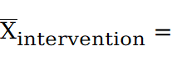 Mean change in the intervention group;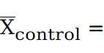 Mean change in the control group
b. Standard Error (SE) of the Treatment Effect:
$$SE=\sqrt{\frac{{SD}_{intervention}^{2}}{n_{intervention}}+\frac{{SD}_{control}^{2}}{n_{control}}}$$
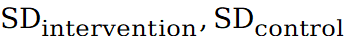:Standard deviations of the change scores; n:samples

Supplementary 4 — Study Characteristics of Included Studies
Table S4 Study Characteristics of Included Studies
ID | Author and Year | Income Status | Sample Size | Injury Location | Type | Stage | Severity | Age | Gender | Category | Diagnostic Criteria | Intervention | Frequency | Duration | Follow-up periods | Outcome
6 | Stacy L. Fritz 2013¹ | High-income | 15 | Lower limb & trunk balance dysf | Mixed | Chronic Phase | Mild to moderate | 67.6±9.3 | Not reported | VRG | Post-stroke >6 months; can stand ≥5 min and walk 3 m (with/without aid) | Nintendo Wii/PS2 EyeToy active gaming (dynamic balance, stepping, weight shifting, speed) | 4×/week, 55 min, 5 weeks. | 5weeks | 3months | 6MWT  BBS
 |  | High-income | 13 | Lower limb & trunk balance dysf | Mixed | Chronic Phase | Mild to moderate | 64.5±10.1 | Not reported | NE |  | N structured intervention; maintained daily activities | None | 5weeks
10 | Jannette Blennerhassett 2004² | High-income | 15 | Lower limb function | 11I + 4H | Subacute Phase | Mild to moderate | 53.9±19.8 | M8/F7 | TOT | Inpatient stroke rehab; can walk 10 m under close supervision | 60-min daily circuit training (cycling, treadmill, stairs, balance, strength, etc.) | 5×/week, 60 min/session, 4weeks | 4weeks | 4weeks | 6MWT
 |  | High-income | 15 | Upper limb function | 11I + 4H | Subacute Phase | Mild to moderate | 56.3±10.5 | M9/F6 | BULT |  | 10 stations: ergometer, grasp tasks, hand–eye coordination, resistance | 5×/week, 60 min/session
11 | Sarah R.Valkenborghs 2019³ | High-income | 9 | Upper limb function | Mixed | Chronic Phase | Severe | 62.1±11.7 | M5/F4 | HIIT | ≥16y; I/H stroke; WMFT<63 or ARAT<52; aerobic training eligible. | AEX + TST group: 30-min aerobic HIIT (4×4min at 85% HRmax + 3×3min at 70% HRmax) before task-specific training | AEX 30×3; TST 60×3. | 10weeks | 6months | 6MWT
 |  | High-income | 11 | Upper limb function | Mixed | Chronic Phase | Moderate | 49.8±17.4 | M6/F5 | TOT |  | TST only (task-specific training), 60 min/session | 60 min × 3/week
12 | H-J Eich 2004⁴ | High-income | 25 | Lower limb function | I | Subacute Phase | Moderate | 62.4±4.8 | M17/F8 | BWSTT | Age 50–75; BI 50–80; walk ≥12m (supervised); CV stable (≥50W ECG test) | Treadmill training (THR=60%HRR); 30 min/session with ECG; + Bobath training 30 min/session | Treadmill 30×5; Bobath 30×5. | 6weeks | 3months | 6MWT  10MWT
 |  | High-income | 25 | Lower limb function | I | Subacute Phase | Moderate | 64.0±6.0 | M17/F8 | NPF |  | Bobath only (walking, stairs, gait, etc.) | 60 min × 5/week | 6weeks
14 | Marijn Mulder 2024⁵ | High-income | 21 | Lower limb & trunk balance dysf | 7H + 14I | Subacute Phase | Moderate | 61.3 | M11/F10 | TOT | WHO stroke; ≤3 mo; no SAH; MoCA >21 | Armed4Stroke: Caregiver-mediated training + telerehabilitation + therapist supervision | Daily 30×5 + periodic therapist sessions | 8weeks | 6months | 6MWT  BBS
 |  | High-income | 20 | Lower limb & trunk balance dysf | 6H + 14I | Subacute Phase | Moderate | 63 | M12/F8 | RC | WHO stroke; ≤3 mo; no SAH; MoCA >21 | Usual care (N structured exercise) | 30 min × 5/week | 8weeks
22 | Stefanie S. L. Lam, 2022⁶ | Middle- and high-income | 47 | Upper limb function | 81%I + 19%H | Subacute Phase | Moderate to severe | 65.1±10.0 | M27/F20 | VRG | Stroke (1week to 6 months); AMT ≥ 7 | BMCG: Bilateral motor computer game (30 min) + 3h conventional rehab | 2 × 30 min/week + 3.5 h rehab × 2/week | 8weeks | 1months | FMA-UE
 |  | Middle- and high-income | 46 | Upper limb function | 81%I + 19%H | Subacute Phase | Moderate to severe | 66.0±9.0 | M28/F18 | MBE | Stroke (1week to 6 months); AMT ≥ 7 | VDE: Video-directed upper limb exercise + 3h rehab | 2 × 30 min/week + 3.5 h rehab × 2/week | 8weeks
23 | Christine T. Shiner, 2014⁷ | High-income | 10 | Upper limb motor deficit | Mixed | Chronic Phase | Moderate to severe | 64.6 ± 15.7 | M6/F4 | BVRG | ≥3 months post-stroke; MMSE ≥24; UL deficit; hemiparetic | 15 min bilateral priming + 60 min Wii-based Movement Therapy (supervised) + 15–180 min home Wii therapy/day | 10×/14 days, 60 min/session | 14 days | 25weeks | FMA-UE
 |  | High-income | 10 | Upper limb motor deficit | Mixed | Chronic Phase | Moderate to severe | 60.5 (22–74) | M6/F4 | VRG |  | 60 min Wii-based Movement Therapy (supervised) + 15–180 min home Wii therapy/day | 10×/14 days, 60 min/session | 14 days
24 | Mialinn A. Lindvall, 2014⁸ | High-income | 24 | Trunk | 67%I + 33%H | Chronic Phase | Mild to moderate | 62.1±11.4 | M12/F12 | MBE | ≥6 months post-stroke; walking ≥100m; balance issues | BAT: Body awareness therapy | 1 × 60 min/week | 9weeks | 5weeks | 6MWT  BBS
 |  | High-income | 22 | Trunk | 82%I + 18%H | Chronic Phase | Mild to moderate | 65.6±9.2 | M15/F7 | NE | ≥6 months post-stroke; walking ≥100m; balance issues | Control group (N exercise) | 0
26 | Addie Middleton, 2014⁹ | High-income | 23 | Primarily lower limb function | Mixed | Chronic Phase | Moderate | 61.4±15.7 | M：61%/F：39% | BWSTT | ≥6 months post-stroke; walk 20 ft; sit/stand 5 min | BWSTT: Body-weight support treadmill + gait + balance + strength | 180 min/day × 5 days/week | 2weeks | 101days | 6MWT  BBS  FMA-LE
 |  | High-income | 20 | Primarily lower limb function | Mixed | Chronic Phase | Moderate | 60.7±11.4 | M：80%/F：20% | TOT | ≥6 months post-stroke; walk 20 ft; sit/stand 5 min | Overground task-oriented gait training | 180 min/day × 5 days/week | 2  weeks
27 | Stephanie A. Combs-Miller, 2014¹⁰ | High-income | 10 | Lower limb (gait) | Mixed | Chronic Phase | Moderate | 56.2 ± 7.6 | M4/F6 | BWSTT | ≥6 months post-stroke; able to walk independently at <1.0 m/s; stable; able to follow two-step commands | Body weight-supported treadmill training (initial 30% BW support, progressively reduced to 0%) | 5×/week, 30 min/session, 2 weeks | 2 weeks | 3months | 6MWT  10MWT
 |  | High-income | 10 | Lower limb (gait) | Mixed | Chronic Phase | Moderate | 65.5 ± 6.2 | M7/F3 | OG |  | Overground walking on indoor track (self-paced, moderate intensity, verbal cues only) | 5×/week, 30 min/session, 2 weeks | 2 weeks
28 | Abhishek Srivastava, 2016¹¹ | High-income | 20 | Upper limb function | Ischemic | Chronic Phase | Mild to moderate | 60.4 ± 8.2 | Not reported | OG | Stroke >6 months; Brunnstrom IV–V; MMSE ≥24 | Participants received task-oriented overground gait training, including mirror-based gait practice, straight-line walking, visual feedback training, and progressive speed increase. Training was performed for 30 minutes per session, 5 times per week. | 3×/week, 40–60 min/session, 4 weeks | 4 weeks | 3months | 6MWT  10MWT
 |  | High-income | 20 | Upper limb function | Ischemic | Chronic Phase | Mild to moderate | 62.2 ± 7.9 | Not reported | TT |  | Participants trained on a treadmill while wearing a safety harness without body weight support. Treadmill speed was gradually increased. Each session lasted 30 minutes, conducted 5 times per week. | 3×/week, 40–60 min/session, 4 weeks | 4 weeks
 |  | High-income | 20 | Upper limb function | Ischemic | Chronic Phase | Mild to moderate | 60.2 ± 7.6 | Not reported | BWSTT |  | Participants used the Biodex Gait Trainer™ with 40% body weight support maintained throughout the training. Treadmill speed was progressively increased. Training was administered for 30 minutes per session, 5 times per week. | 3×/week, 40–60 min/session, 4 weeks | 4 weeks
32 | Kevin Moncion, 2024¹² | High-income | 42 | Lower limb function | 75%I + 17%H + 8%Mixed | Chronic Phase | Mild | 65.4±8.9 | M：27/F：15 | HIIT | Age 40–80; stroke 6–60 months; mRS ≤2 | HIIT: 10×1 min high + 10×1 min low | 3 × 19 min/week | 12weeks | 8weeks | 6MWT 10MWT
 |  | High-income | 40 | Lower limb function | 83%I + 17%H | Chronic Phase | Moderate | 64.4±9.7 | M23/F17 | AE | Age 40–80; stroke 6–60 months; mRS ≤2 | MICT: Moderate continuous training | 3 × 20–30 min/week | 12weeks
40 | Mahnaz Hejazi-Shirmard，2024¹³ | Middle income | 13 | Upper limb function | Mixed | Chronic Phase | Moderate | 61.54±8.93 | M7/F6 | TOT | MCA stroke ≥6 months; MMSE ≥21; Brunnstrom 4–6 | Top-down: CO-OP (Goal-Plan-Do-Check) strategy rehab | 60 min × 2/week | 6weeks | 6weeks | FMA-LE
 |  | Middle income | 13 | Upper limb function | Mixed | Chronic Phase | Moderate | 59.08±16.99 | M11/F2 | MBE | MCA stroke ≥6 months; MMSE ≥21; Brunnstrom 4–6 | Bottom-up: Sensorimotor (strength, endurance, ROM) rehab | 60 min × 2/week | 6weeks
 |  | Middle income | 13 | Upper limb function | Mixed | Chronic Phase | Moderate | 62.29±12.70 | M8/F5 | NPF | MCA stroke ≥6 months; MMSE ≥21; Brunnstrom 4–6 | Control: Brunnstrom + PNF + motor rehab | 60 min × 2/week | 6weeks
66 | Marilyn MacKay-Lyons, 2013¹⁴ | High income | 24 | Lower limb and trunk | I | Subacute Phase | Mild to moderate | 61.5±15.4 | M15/F9 | BWSTT | First-ever I stroke, confirmed by CT or MRI; duration <1 month. Able to walk 5 meters with assistance (walker, AFO, or support). | BWSTT group: Body-weight-supported treadmill training using a Pneu-Weight system. Initial unloading of 20–40% body weight, gradually reduced. Training targeted 40–50% VO2peak at first, increasing to 60–75%. Walking speed progressed from 0.26–0.49 m/s to 0.56–0.87 m/s. Total session: 60 min (25–30 min treadmill + strength/stretching). Sessions: 5x/week inpatient + 3x/week outpatient. | 60 min/session × 5x/week (inpatient) or 3x/week (outpatient) | 12weeks | 12months | 6MWT  10MWT  BBS
 |  | High income | 26 | Lower limb and trunk | I | Subacute Phase | Mild to moderate | 59.0±12.7 | M14/F12 | RC |  | 5–10 min pre-walk balance/weight shift → 20–25 min overground walking (self-selected speed) → remaining time for limb strength/stretch. | 60min/session × 5x/week (inpatient)or3x/week(outpatient) | 12weeks
83 | Oh, 2022¹⁵ | High income | 15 | Lower limb and trunk | Mixed | Chronic Phase | Moderate | 71.20±6.87 | M15/F0 | BWSTT | Chronic stroke patients (onset ≥ 6 months); | Gait training using an anti-gravity treadmill with progressive loading. Sessions began with 30% bodyweight support and gradually increased to 80%. Each session lasted 20 minutes. | 20 min × 5×/week | 4weeks | 8weeks | 10MWT BBS
 |  | High income | 15 | Lower limb and trunk | Mixed | Chronic Phase | Moderate | 74.80±3.67 | M14/F1 | RC | Chronic stroke patients (onset ≥ 6 months); | Conventional gait and balance training led by therapists. Sessions lasted 20 minutes and involved overground walking without special equipment. | 20 min × 5×/week | 4weeks
96 | Melanie K. Fleming, 2015¹⁶ | High income | 16 | Upper limb function | 13I + 3H | Chronic Phase | Moderate | 62.3±9.8 | M13/F3 | ESX | CT/MRI dx; first stroke, ≥3mo; UL dysfunction; MAS ≤3; no severe cognitive/aphasia. | Somatosensory stimulation for the upper limb nerves using electrical input for 2 hours, followed by 30 minutes of task-specific training based on ARAT. | 150 min/session, 3×/week | 4weeks | 6months | FMA-LE
 |  | High income | 17 | Upper limb function | 14I + 3H | Chronic Phase | Moderate | 60.6±13.4 | M7/F10 | TOT |  | Same protocol with sham stimulation (device active but N current), followed by identical task-specific training. | 150 min/session, 3×/week | 4weeks
109 | Hatice İkizler May, 2020¹⁷ | Middle- and high-income | 21 | Lower limb and trunk | 90.5%I + 9.5%H | Acute and subacute | Moderate | 57.2±7.6 | M15/F6 | MBE | WHO criteria + CT/MRI I/H stroke; Brunnstrom 1–4; pre-stroke independent walking. | Mirror therapy for the lower limb using a vertical mirror to reflect Nn-paretic leg movements during ankle exercises. | 30 min (MT) + 60–120 min (rehab)/session,5×/week | 4weeks | 12weeks | 6MWT BBS
 |  | Middle- and high-income | 21 | Lower limb and trunk | 76.2%I + 23.8%H | Acute and subacute | Moderate | 58.8±9.8 | M10/F11 | NPF |  | Standard neurorehabilitation involving sensorimotor retraining, gait, and balance exercises. | 60–120 min (rehab)/session, 5×/week | 4weeks
114 | Asmaa Kamal Lasheen, 2022¹⁸ | Middle income | 40 | Lower limb and trunk | Mixed | Subacute Phase | Moderate | 30-60 | M29/F11 | RC | Meets WHO stroke definition; confirmed by CT or MRI. | Routine hospital care involving general health monitoring without structured rehabilitation or exercise protocols. | 60 min/session, 5×/week | 2weeks | 3months | BBS
 |  | Middle income | 40 | Lower limb and trunk | Mixed | Subacute Phase | Moderate | 30-60 | M25/F15 | TOT | Meets WHO stroke definition; confirmed by CT or MRI. | Strength and task-oriented lower limb exercises, with progressive activities targeting functional recovery. | 30–45 min/session, 4×/week | 2weeks
126 | Sae Hoon Chung, 2019¹⁹ | High income | 18 | Lower limb | 77.8%I + 22.2%H | Subacute Phase | Moderate | 63.1±11.9 | 13M/5F | TOT | Age ≥ 20; stroke duration ≤ 6 months; BBS score 21–40; N stroke history; N severe musculoskeletal or cardiovascular disease. | Task-specific lower extremity training using the 3DBT-12 device, with real-time feedback on bodyweight shifting and knee flexion-extension. Included gamified tasks such as virtual fruit-picking. | 30 min/session, 5×/week；60 min/session, 5×/week | 3weeks | 2weeks | 6MWT 10MWT BBS
 |  | High income | 17 | Lower limb | 70.6%I + 29.4%H | Subacute Phase | Moderate | 62.5±11.3 | 13M/4F | NPF |  | Conventional physiotherapy including trunk stability, balance board, and proprioceptive training. | 30 min/session, 5×/week；60 min/session, 5×/week | 3weeks
138 | Ilona J.M. de Rooij, 2021²⁰ | High income | 28 | Lower limb | 85.7%I + 14.3%H | Subacute Phase | Mild to moderate | 65±7.2 | M18/F10 | VRG | WHO stroke; 2w–6mo; FAC ≥3; limited walking ADLs; community-dwelling; 18–80y. | Virtual reality gait training using GRAIL system with dual-belt treadmill, motion capture, and immersive visual feedback. Included balance, dual-task, and adaptability tasks. | 30 min/session, 2×/week | 6weeks | 3months | 6MWT
 |  | High income | 24 | Lower limb | 83.3%I + 16.7%H | Subacute Phase | Mild to moderate | 61±8.3 | M18/F6 | RC |  | Conventional treadmill and functional gait training involving steps, object retrieval, uneven surfaces, and obstacle crossing. | 30 min/session, 2×/week | 6weeks
144 | Pradeepa Nayak, 2025²¹ | Middle income | 42 | Whole-body function | 57.1%I + 42.9%H | Chronic Phase | Mild to moderate | 57.64±9.63 | M36/F6 | FT | DiagNsed from medical record; stroke duration >6 months; age 18–75; able to walk independently (assistive device allowed). | Multi-phase physical activity promotion program combining behavioral counseling, aerobic and resistance training, balance tasks, and home-based adaptive activities. | ≥30 min/session, ≥5×/week | 45days | 3months | 6MWT 10MWT
 |  | Middle income | 42 | Whole-body function | 69.0%I + 31.0%H | Chronic Phase | Mild to moderate | 59.33±10.43 | M30/F12 | NE |  | virtual reality gait training using GRAIL system with dual-belt treadmill, motion capture, and immersive visual feedback. Included balance, dual-task, and adaptability tasks. | None | 0
162 | Ayça Utkan Karasu, 2018²² | Middle- and high-income | 12 | Lower limb and trunk | 8I + 4H | Subacute Phase | Moderate | 62.3±11.79 | M5/F7 | VRG | Unilateral I or H stroke confirmed by MRI or CT. | Balance games using Wii Fit on a Wii Balance Board, with visual feedback training incorporated into standard rehabilitation. | 20 min/session, 5×/week | 4weeks | 4weeks | BBS
 |  | Middle- and high-income | 11 | Lower limb and trunk | 10I + 1H | Subacute Phase | Moderate | 64.1±12.2 | M5/F6 | RC | Unilateral I or H stroke confirmed by MRI or CT. | Routine multidisciplinary rehabilitation combining NDT, physiotherapy, occupational therapy, cognitive and balance training. | 120–180 min/session, 5×/week
167 | Felix Nindorera, 2023²³ | Low-income | 23 | Whole-body function | 48%I + 48%H性 + 4%Mixed | Chronic Phase | Mild to moderate | 50.9±10.7 | M18/F5 | FT | First or recurrent unilateral stroke diagNsed via imaging or clinical neurology exam. | Combination training involving walking, coordination, resistance exercises, and cycling. Activities were grouped by disability level and supervised. | 120 min/session, 3×/week | 12weeks | 3months | 6MWT 10MWT BBS
 |  | Low-income | 23 | Whole-body function | 35%I8 + 39%H性 + 26%Mixed | Chronic Phase | Mild to moderate | 50.1±11.2 | M18/F5 | NE |  | Participated in Nn-exertional cultural and recreational activities such as games and discussions, without physical training. | 120 min/session, 3×/week | 12weeks
177 | Toh et al., 2024²⁴ | Middle- and high-income | 20 | Upper limb | Mainly I | Chronic Phase | Moderate | 55.45±9.98 | M12/F8 | MBE | FTHUE-HK score 3–6; MAS ≤2; MMSE ≥19; N excessive pain/edema; N major upper limb limiting illness. | Used Smart Reminder wearable system with smartphone app to prompt and monitor upper limb activity. Data were captured via accelerometer and gyroscope. | 60 min/session, 5×/week | 4weeks | 4weeks | FMA-UE
 |  | Middle- and high-income | 20 | Upper limb | Mainly I | Chronic Phase | Moderate | 57.80±9.22 | M13/F7 | BULT |  | Performed the same exercises using paper-based instructions and wore Nn-feedback accelerometers.weekly in-person check-ins were conducted. | 60 min/session, 5×/week | 4weeks
182 | Tobias Braun, 2016²⁵ | High income | 14 | Trunk and lower limb function | 13I + 1H | Subacute Phase | Severe | 61±16 | M7/F7 | VRG | Imaging confirmed stroke <3 months; Nn-ambulatory (FAC ≤2); stable vitals; cognitive ability to follow commands. | Dynamic standing training using Balance-Trainer with 360° platform movement and visual-feedback-based gaming to encourage postural control in all directions. | 30 min/session, 3–5×/week | 5weeks | 2weeks | BBS
 |  | High income | 14 | Trunk and lower limb function | 10I + 4H | Subacute Phase | Severe | 60±14 | M5/F9 | BT |  | Static standing training using a standard frame, focusing on maintaining upright posture without dynamic balance tasks. | 30 min/session, 3–5×/week | 5weeks
185 | Larissa Tavares Aguiar, 2020²⁶ | High income | 11 | Whole-body function | Mixed | Chronic Phase | Moderate | 52±11 | M18/F6 | AE | Stroke (method N/A); ≥20y; >6mo; inactive (CDC); excl: severe cognitive, walk <10min, severe pain/disability. | Treadmill aerobic exercise with warm-up and cool-down, adjusted to maintain target heart rate zone via speed control. | 40 min/session, 3×/week | 12weeks | 16weeks | 6MWT 10MWT
 |  | High income | 11 | Whole-body function | Mixed | Chronic Phase | Moderate | 48±10 | M19/F5 | RC |  | Outdoor walking at comfortable speed with heart rate kept below aerobic threshold. | 40 min/session, 3×/week | 12weeks
202 | Ingrid G L van de Port, 2012²⁷ | High income | 126 | Lower limb | Not reported | Subacute Phase | Mild to moderate | 58±10 | M 57%/F 43% | TOT | WHO-defined stroke, confirmed by CT/MRI; FAC ≥ 3; MMSE ≥ 24; N major comorbidities. | Task-based circuit including gait, step, balance, and ADL simulation across eight workstations. Peer observation and music used to enhance motivation and engagement. | 90 min/session, 2×/week | 12weeks | 12weeks | 6MWT
 |  | High income | 124 | Lower limb | Not reported | Subacute Phase | Mild to moderate | 58±10 | M 61%/F 39% | RC |  | Individualized standard physiotherapy covering gait, strength, and balance, based on Dutch guidelines. | 45 min/session, 3×/week | 12weeks
207 | Saleh M. Aloraini, 2022²⁸ | Middle- and high-income | 19 | Lower limb | 16I + 3H | Chronic Phase | Moderate | 60.1±10.8 | M10/F9 | TOT | Single I/H stroke (CT/MRI); MMSE ≥24; BBS ≥35; walk 10m (±aid); excl: pain >4, MAS ≥3, severe comorbidities. | Training included 3 hours of progressive task-oriented lower limb shaping exercises (e.g., step-ups, knee extensions) and 0.5 hours of Transfer Package for daily life application. N physical restraints were used. | 210 min/session, 5×/week | 2weeks | 3months | 6MWT 10MWT BBS FMA-LE
 |  | Middle- and high-income | 19 | Lower limb | 15I + 4H | Chronic Phase | Moderate | 59.3±11.4 | M9/F10 | RC |  | Participants received conventional rehabilitation including ROM, stretching, gait, balance, and endurance training. N shaping technique or behavioral component was included. | 210 min/session, 5×/week | 2weeks
219 | Patrícia Graef，2016²⁹ | Middle- and high-income | 13 | Upper limb | Mainly I | Chronic Phase | Mild to moderate | 72±12 | M6/F7 | TOT | Hospital stroke; MMSE ≥20; strength-based inclusion; no shoulder contracture/pain. | Performed functional strength tasks such as lifting and placing containers using 60% max resistance, guided by therapists. | 30 min/session, 3×/week | 5weeks | 10months | FMA-UE
 |  | Middle- and high-income | 14 | Upper limb | Mainly I | Chronic Phase | Mild to moderate | 63±11 | M5/F9 | RT |  | Conducted Nn-functional shoulder exercises (abduction, flexion) using dumbbells at 60% max effort. | 30 min/session, 3×/week | 5weeks
228 | Tor Ivar Gjellesvik，2021³⁰ | High income | 36 | Lower limb | 29I + 7H | Chronic Phase | Mild to moderate | 57.6±9.2 | M21/F15 | HIIT | First stroke (I/H, CT/MRI); mRS 0–3; no cardiac/HTN/VO₂ issues; HIIT eligible; brainstem/SAH excl. | Completed 8-week high-intensity interval treadmill walking protocol with 4×4 min high-load bouts interspersed with active recovery. | 40 min/session, 3×/week | 8weeks | 12months | 6MWT 10MWT BBS
 |  | High income | 34 | Lower limb | 28I + 6H | Chronic Phase | Mild to moderate | 58.7±9.2 | M20/F14 | RC |  | Received usual care and general activity advice without structured exercise. | Nn-fixed frequency, revisit at testing time | 8weeks
231 | Hiroyuki Ase，2025³¹ | High income | 7 | Upper limb | 4I + 3H | Chronic Phase | Moderate | 58.0±6.4 | 6M1F | VRG | Unilateral stroke (CT/MRI); MRC ≥2 (UE); Mini-Cog normal; MAS <3; no aphasia/skin/neurological hx | Used VR-based upper limb training with real-time feedback and task simulations like pouring and grasping. | 30 min/session, 5×/week | 4weeks | 4weeks | FMA-UE
 |  | High income | 7 | Upper limb | 1I + 6H | Chronic Phase | Moderate | 51.4±6.7 | 6M1F | RC |  | Followed therapist-prescribed repetitive joint exercises based on daily task goals. | 30 min/session, 5×/week | 4weeks
234 | Lina Bunketorp-Käll，2019³² | High income | 41 | Whole-body function | 34.1%H + 65.9%I | Chronic Phase | Mild to moderate | 62.6±6.5 | F 41.5%/M 58.5% | FT | Stroke (CT/MRI); mRS 2–3; NIHSS 2.7–3.0; Swedish comprehension; no cognitive/language/vision, cardiac, epilepsy. | Participants received real horseback riding therapy guided by certified instructors, focusing on postural control and vestibular stimulation. | 45 min/session, 2×/week | 12weeks | 6months | 6MWT 10MWT
 |  | High income | 41 | Whole-body function | 22.0%H + 78.0%I | Chronic Phase | Mild to moderate | 62.7±6.7 | F 43.9%/M 56.1% | MBE |  | Participants engaged in rhythmic movement to music involving repeated upper/lower limb tasks and balance exercises. | 45 min/session, 2×/week | 12weeks
 |  | High income | 41 | Whole-body function | 32.4%H + 67.6%I | Chronic Phase | Mild to moderate | 63.7±6.7 | F 48.6%/M 51.4% | RC |  | Did Nt receive training during the first 12weeks, then switched to the R-MT group. | 30 min/session, 2×/week | 12weeks
235 | Klas Sandberg，2020³³ | High income | 23 | Whole-body function | I | Acute Phase | Moderate to severe | 72.1±11.7 | M 8 /F 15 | AE | First stroke (CT/MRI); NIHSS 7–42; aerobic training eligible; understands; non-thrombolysis. | Bedside motorized cycling training using MOTOmed Letto2 in the supine position, starting 24–48h post-stroke with passive or active pedaling depending on ability. | 20 min/session, 5×/week | 3weeks | 3months | 6MWT
 |  | High income | 29 | Whole-body function | 79.3%I + 20.7%H | Acute Phase | Moderate to severe | 76.3±6.4 | M 12/F 17 | RC |  | Received routine acute stroke rehabilitation including bedside transfers, sitting, standing, and walking. | Nn-fixed daily physical therapy | 3weeks
237 | Soo-Yeon Kim，2015³⁴ | High income | 13 | Lower limb | Mixed | Subacute Phase | Mild to moderate | 62.4±6.1 | overall:M 22/F30 | RAT | First stroke (CT/MRI); MAS ≤2; no tremor/cognitive/visual/MSK/cardio-pulm. disease; weight ≤135 kg; height ≥150 cm; post-gait restoration phase. | Combined conventional gait training with robotic walking using WALKBOT, with dynamic weight support and adjustable hip/knee guidance. | 40 min/session ×2/day (80 min/day), 5×/week | 4weeks | 4weeks | BBS
 |  | High income | 13 | Lower limb | Mixed | Subacute Phase | Mild to moderate | 63.5±6.3 | overall:M 22/F30 | RC |  | Received conventional therapy including balance, sit-to-stand, walking, and resistance training. | 40 min/session ×2/day (80 min/day), 5×/week | 4weeks
239 | Lorena de Oliveira Vaz，2021³⁵ | Middle- and high-income | 23 | Whole-body function | 61%I + 39%H | Chronic Phase | Mild to moderate | 52±13 | M10/F13 | RT | Stroke (CT/MRI); MIP <-80 cmH₂O; MMSE by education; ambulatory (±aid); excl. smoker, facial paralysis, comorbidities. | Inspiratory muscle training using Powerbreathe Medic Plus at 50% of maximum inspiratory pressure; participants transitioned to home-based training after initial supervision. | 15 min/session ×2/day (30 min/day), 5×/week | 6weeks | 12weeks | 6MWT
 |  | Middle- and high-income | 27 | Whole-body function | 54%I + 46%H | Chronic Phase | Mild to moderate | 56±9 | M11/F16 | RC |  | Performed “sham” IMT using devices with minimal resistance and identical rehabilitation plans. | 15 min/session ×2/day (30 min/day), 5×/week | 6weeks
241 | Umair Ahmed，2021³⁶ | Low- and middle-income | 42 | Trunk | 27I + 15H | Chronic Phase | Mild to moderate | 61.21±7.78 | M20/F22 | TOT | Stroke (clinical/imaging); no cerebellar/basal ganglia balance disorders; walk ≥10 m; MMSE ≥24; BMI ≤31 | High-intensity multidirectional trunk training combined with dual-task challenges and external resistance, guided by experienced therapists. | 45 min/session, 5×/week | 12weeks | 12months | 10MWT BBS
 |  | Low- and middle-income | 42 | Trunk | 24I + 18H | Chronic Phase | Mild to moderate | 62.21±8.20 | M17/F25 | CST |  | Performed conventional sagittal-plane trunk exercises at moderate intensity without dual-task components. | 45 min/session, 5×/week | 12weeks
263 | Kyung Hun Kim，2017³⁷ | High income | 15 | Lower limb | 73.3%H + 26.7%I | Chronic Phase | Moderate to severe | 48.27±16.05 | M11/F4 | BWSTT | Stroke (CT/MRI); FAC 4–5; MMSE >24; no contractures, pain, fractures, hemianopia, neuro/cardiac disease; consented. | PBWSTBWT group received backward treadmill walking with progressive reduction in body weight support and increasing speed. Each session included multiple intervals of walking and rest. | 30 min/session, 5×/week | 4weeks | 4weeks | 6MWT
 |  | High income | 15 | Lower limb | 60.0%H + 40.0%I | Chronic Phase | Moderate to severe | 50.73±13.50 | M7 /F8 | TT |  | Control group received forward treadmill walking without weight support, with speed adjusted to tolerance. | 30 min/session, 5×/week | 4weeks
267 | Kaare Severinsen，2014³⁸ | High income | 13 | Lower limb | Not reported | Chronic Phase | Moderate | 50–80 | M13/F5 | AE | I stroke (CT, 6–36 mo); age 50–80; LL MRC >3; 10MWT <1.4 m/s; aids allowed; excl. MDI >25, MMSE <20, | AT group performed cycle ergometer aerobic training at 75% HRR. | ~45 min/session, 3×/week | 12weeks | 12months | 6MWT 10MWT
 |  | High income | 14 | Lower limb | Not reported | Chronic Phase | Moderate | 57–78 | M11/F6 | RT |  | RT group performed resistance training targeting the lower limbs at 70–80% 1RM. | 60 min/session, 3×/week | 12weeks
 |  | High income | 16 | Lower limb | Not reported | Chronic Phase | Moderate | 52–80 | M12/F6 | NE |  | Sham exercise | 60 min/session, 3×/week | 12weeks
280 | Guanli Xie，2018³⁹ | Middle- and high-income | 120 | Trunk and lower limb function | Mainly I | Chronic Phase | Moderate | 60.9±8.7 | M83/F37 | MBE | Stroke >3 mo (NCCVD/CT/MRI); balance disorder; walk ≥6 m (± aid); MMSE >24; understands; no vestibular, severe AV damage, aphasia, heart disease, GI bleed. | Performed 60-minute sessions (15 min warm-up, 45 min core movement) of Tai Chi “Cloud Hand” training derived from the 24-form standard. | 60 min/session, 5×/week | 12weeks | 6weeks | BBS
 |  | Middle- and high-income | 124 | Trunk and lower limb function | Mainly I | Chronic Phase | Moderate | 60.1±8.6 | M99/F25 | BT |  | Received 60-minute balance training per Chinese Rehabilitation Guidelines, including static/dynamic balance, Bobath, and gait training. Frequency and duration matched the experimental group. | 60 min/session, 5×/week | 12weeks
289 | Muhammad Hamad Haleem，2025⁴⁰ | Low- and middle-income | 22 | Trunk and lower limb function | I | Subacute Phase | Moderate | 57.18±4.66 | M22 | ESX | First MCA territory stroke confirmed by CT/MRI; BBS 21–40; age 45–70; N cognitive, visual/hearing deficits, or neuromuscular disorders affecting lower limbs. | ANdal tDCS was applied to the M1 area (C3/C4) using a 2 mA current, followed by motor relearning practice. Electrodes covered cortical regions for upper/lower limbs and trunk. | 70 min/session, 5×/week | 4weeks | 1month | BBS
 |  | Low- and middle-income | 22 | Trunk and lower limb function | I | Subacute Phase | Moderate | 56.41±4.04 | M22 | MBE |  | Same motor training was conducted, but tDCS was applied in sham mode with N actual stimulation. | 70 min/session, 5×/week | 4weeks
301 | Kerim Kerimov 2021⁴¹ | High-income | 10 | Lower limb gait | Mixed | Subacute Phase | Moderate | 64.9 ± 9.3 | M8/F2 | IE | Stroke with hemiparesis; able to walk ≥10 m with or without aid; FAC ≤3 | Robot-assisted gait training using Welwalk WW-2000; adaptive speed & visual feedback | 5×/week, 60 min/session, 2 weeks | 4weeks | 8weeks
 |  | High-income | 10 | Lower limb gait | Mixed | Subacute Phase | Moderate | 65.0 ± 11.6 | M8/F2 | RT |  | Conventional physical therapy (therapist-assisted gait, sit-to-stand, balance, stairs) | 5×/week, 60 min/session, 2 weeks | 4weeks
309 | Wan-Yun Huang 2022⁴² | Middle- and high-income | 15 | Lower limb | 53%H + 47%I | Chronic Phase | Moderate | 57.0±9.5 | M12/F3 | MBE | DiagNsed by physiatrist via neurological exam and history; excluded Parkinson’s, SCI, severe orthopedic limitations. | The experimental group received 15-minute gait training using a laser-cane equipped with dual laser beams for step guidance, combined with 15 minutes of conventional therapy focusing on strength and balance. | 30 min/session (15 min walking + 15 min PT), 2×/week | 4weeks | 8weeks | BBS
 |  | Middle- and high-income | 15 | Lower limb | 47%H + 53%I | Chronic Phase | Moderate | 66.1±9.0 | M11/F4 | OG |  | The control group received the same conventional therapy and walking training without laser guidance, using a standard quad cane. | 30 min/session (15 min walking + 15 min PT), 2×/week | 4weeks
321 | Suruliraj Karthikbabu 2018⁴³ | Middle income | 36 | Lower limb | 67%I + 33%H | Chronic Phase | Moderate | 57.2±11.5 | M25/F11 | BT | Chronic stroke (≥6 months); first unilateral cortical stroke; with hemiparesis, N pusher syndrome; independent 10m walking; poor trunk control (TIS <21). | The Plinth group performed trunk control exercises on a stable surface, including bridges, single-leg bridges, trunk rotations, seated lateral flexion, and forward reaching. | 60 min/session, 3×/week | 6weeks | 12months | 10MWT
 |  | Middle income | 36 | Lower limb | 56%I + 44%H | Chronic Phase | Moderate | 54.0±14.1 | M26/F10 | CST |  | The Swiss ball group performed the same exercises on an unstable surface to enhance core activation. | 60 min/session, 3×/week | 6weeks
 |  | Middle income | 36 | Lower limb | 58%I + 42%H | Chronic Phase | Moderate | 54.8±12.5 | M23/F13 | RC |  | The control group received standard therapy including spasticity control, lower limb strengthening, balance, and gait training. | 60 min/session, 3×/week | 6weeks
323 | Emma Segura 2024⁴⁴ | High income | 20 | Upper limb | 61.5%I + 38.5%H | Chronic Phase | Moderate | 64.2±12.5 | Not reported | MBE | I/H stroke via CT/MRI; upper limb MRC 1–4; MoCA >21; excluded severe neuropsychiatric disorders. | Engaged in app-based individualized music training using electronic keyboards and percussion instruments, with additional online group music therapy. Activities included rhythm synchronization, upper-limb coordination, and scale playing, adjusted for individual difficulty. | 60 min/session, 4×/week | 10weeks | 3months | FMA-UE
 |  | High income | 20 | Upper limb | 71.9%I + 28.1%H | Chronic Phase | Moderate | 62.2±12 | Not reported | BULT |  | Performed upper limb functional exercises using daily objects, focused on repeated movements and encouraged paretic limb use. Training was conducted at home under therapist supervision via phone. | 60 min/session, 4×/week | 10weeks
324 | Daniel S. Marigold 2005⁴⁵ | High income | 22 | Trunk and lower limb function | Mixed | Chronic Phase | Moderate | 68.1±9.0 | M17/F5 | FT | Clinically diagNsed stroke by physician; single stroke event confirmed by CT/MRI. | Completed multisensory dynamic agility drills, such as rapid step transitions, balance under unstable conditions, quick sit-to-stand, high knee movements, and perturbation response training. | 60 min/session, 3×/week | 10weeks | 1month | BBS
 |  | High income | 26 | Trunk and lower limb function | Mixed | Chronic Phase | Moderate | 67.5±7.2 | M18/F8 | MBE |  | Performed slow weight-shifting and stretching exercises, incorporating tai-chi-like balance drills and transitional floor movements. | 60 min/session, 3×/week | 10weeks
328 | Lamberto Piron 2009⁴⁶ | High income | 18 | Upper limb | I | Chronic Phase | Mild to moderate | 66.0±7.9 | M11/F9 | VRG | I stroke confirmed by CT/MRI; excluded De Renzi <62, Token Test errors >40, neglect, comprehension disorder. | Performed virtual reality upper limb training using VRRS.net® system, with live video guidance and five interactive tasks (trajectory tracing, imitation, etc.). | 60 min/session, 5×/week | 4weeks | 90days | FMA-UE
 |  | High income | 18 | Upper limb | I | Chronic Phase | Mild to moderate | 64.4±7.9 | M10/F8 | BULT |  | Received standard in-person therapy targeting object interaction, movement control, and functional integration. | 60 min/session, 5×/week | 4weeks
335 | Kristen L. Hollands 2015⁴⁷ | High income | 11 | Lower limb function | 17%H + 83%I | Chronic Phase | Mild to moderate | 59±18 | M11/F7 | TT | Adults with post-stroke gait impairment, lower limb paresis, and sufficient mobility were included. Exclusions applied for non-stroke causes, severe comorbidities, or need for palliative care. | Treadmill-based visual cue training targeting gait speed, symmetry, turning, and adaptability. Participants followed projected step targets, with progressive gait speed and step variation training across 16 sessions. No walking aids used. | 60 min/session, 2×/week | 8weeks | 4weeks | 6MWT 10MWT
 |  | High income | 10 | Lower limb function | 10%H + 90%I | Chronic Phase | Mild to moderate | 56.1±12.2 | 14M/5F | OG |  | Overground visual cue training using adhesive step targets. Training focused on symmetrical stepping, turning, and adaptable step patterns. Speed and difficulty progressed gradually. Walking aids were permitted based on clinician judgment. | 60 min/session, 2×/week | 8weeks
 |  | High income | 13 | Lower limb function | 10%H + 90%I | Chronic Phase | Mild to moderate | 63±13.6 | 8M/11F | RC |  | Usual physiotherapy care including task-specific gait practice, strength, balance, and coordination exercises. No visual cue training or step-target walking. Treatment content tailored to clinical judgment and logged per session. | 60 min/session, 2×/week | 8weeks
336 | Ahmad Sahely 2024⁴⁸ | High-income | 10 | Trunk and balance | Mixed | Chronic Phase | Mild to moderate | 70.6 ± 3.2 | Not reported | CST | Stroke >6 months; MMSE ≥24; able to walk ≥10 m | Proprioceptive neuromuscular facilitation (PNF) based core stability training (D1/D2 flexion-extension, bridging) | 3×/week, 30 min/session, 6 weeks | 6 weeks | 6months | 6MWT  10MWT
 |  | High-income | 10 | Trunk and balance | Mixed | Chronic Phase | Mild to moderate | 69.7 ± 4.5 | Not reported | RC | Stroke >6 months; MMSE ≥24; able to walk ≥10 m | Symmetric trunk movement training without PNF (basic bridging and mat exercises) | 3×/week, 30 min/session, 6 weeks | 6 weeks
342 | Susan M. Linder 2019⁴⁹ | High income | 16 | Upper limb | Not reported | Chronic Phase | Mild to moderate | 51±12 | M12/F4 | RAT | Single stroke confirmed by CT/MRI; CPX tested; excluded severe cardiac/respiratory or cognitive limitations. | Conducted assisted cycling at 30% above baseline cadence with target HRR of 60–80%, followed by functional upper limb task training. | 90 min/session (45 min cycling/education + 45 min task repetition), 3×/week | 8weeks | 4weeks | FMA-UE
 |  | High income | 16 | Upper limb | Not reported | Chronic Phase | Mild to moderate | 60±14 | M10/F6 | AE |  | Performed self-paced cycling without motor support; upper limb training was the same. | 90 min/session, 3×/week | 8weeks
 |  | High income | 8 | Upper limb | Not reported | Chronic Phase | Mild to moderate | 58±12 | M7/F1 | BULT |  | Performed self-paced cycling without motor support; upper limb training was the same. | 90 min/session, 3×/week | 8weeks
343 | Susan M. Linder 2023⁵⁰ | High income | 30 | Upper limb | Not reported | Chronic Phase | Moderate | 60.8±11.5 | M7/F3 | RAT | Single stroke confirmed by CT/MRI; eligible for CPX; excluded severe cardiac events in last 3 months or contraindications to exercise. | Performed assisted cycling at ≥75 rpm supported by an electric motor, followed by functional upper limb repetitive training with 3–5 tasks, 60–90 repetitions each. | 90 min/session, 3×/week | 8weeks | 4weeks | 6MWT FMA-UE
 |  | High income | 30 | Upper limb | Not reported | Chronic Phase | Moderate | 60.2±9.8 | M6/F4 | BULT |  | Completed 90 minutes of upper limb repetitive tasks without cycling. | 90 min/session, 3×/week | 8weeks
353 | Maria Bergqvist 2023⁵¹ | High income | 15 | Lower limb | 73%I + 20%H + 7%Mixed | Chronic Phase | Moderate | 59–66 | M10/F5 | RAT | CT/MRI-confirmed stroke per prior RCT; functional gait impairment; excluded severe aphasia (unable to complete MoCA). | Received conventional rehabilitation including weight-bearing, stretching, upper limb strengthening, balance, and neuromuscular stimulation. | 90 min/session, 3×/week | 6weeks | 6months | 6MWT 10MWT BBS
 |  | High income | 16 | Lower limb | 56%I + 44%H | Chronic Phase | Moderate | 58–68 | M10/F6 | RC |  | Underwent 60 minutes of Hybrid Assistive Limb (HAL) treadmill gait training with body weight support and EMG-based control, followed by 30 minutes of conventional therapy. | 90 min/session, 3×/week | 6weeks
 |  | High income | 14 | Lower limb | 71%I + 29%H | Chronic Phase | Moderate | 47–69 | M12/F2 | NE |  | Received 90-minute therapist-guided overground gait training including treadmill, walking aids, and lower limb exercises. | 0 | 6weeks
355 | Elaine Menezes-Oliveira 2024⁵² | Middle income | 21 | Trunk and lower limb function | 61%I + 39%H | Chronic Phase | Moderate | 54.0±12.33 | M52%/F48% | FT | CT/MRI-confirmed stroke (I/H); met rehab screening criteria; excluded surgery, chemical block, severe speech issues. | Received standard physiotherapy without heart rate guidance or intensity tracking. | 150–180 min/session (2.5–3 h), daily | 15days | 15days | 6MWT 10MWT
 |  | Middle income | 21 | Trunk and lower limb function | 76%I + 24%H | Chronic Phase | Moderate | 53.24±13.05 | M33%/F67% | RC |  | Participated in 3-hour daily sessions including a 30-minute behavioral contract and 2.5-hour shaping-based functional task training. | 150–180 min/session, daily | 15days
359 | Michal Katz-Leurer，2006⁵³ | High income | 10 | Lower limb | I | Subacute Phase | Moderate | 59±8 | M8/F2 | RC | First I stroke diagNsed clinically; excluded brainstem/bilateral lesion, poor postural control, cardiac issues, β-blockers, pain, musculoskeletal problems. | Received conventional therapy including stretching, active/passive movement, postural control, and aerobic activities. | 5×/week conventional, time Nt specified | 3weeks | 6weeks | FMA-LE
 |  | High income | 14 | Lower limb | I | Subacute Phase | Moderate | 65±9 | M5/F9 | NPF |  | Received standard rehabilitation including Bobath-based physiotherapy, occupational and speech therapy, and group exercise. | 5×/week conventional, time Nt specified | 3weeks
364 | Ulla-Britt Flansbjer，2012⁵⁴ | High income | 11 | Lower limb | Not reported | Chronic Phase | Moderate | 66±4 | Not reported | RT | Historical stroke (RCT 2005–2006); excluded new disabling events; imaging status Not reported. | Participated in supervised progressive resistance training (PRT) targeting knee extensors and flexors using HUR leg extension/flexion machines (air resistance 10 bar) at 80% of maximal strength. | 30 min/session, 2×/week | 10weeks | 48months | 6MWT 10MWT
 |  | High income | 7 | Lower limb | Not reported | Chronic Phase | Moderate | 66±4 | Not reported | NE |  | Continued daily life activities without additional interventions. | 30 min/session, 5×/week | 10weeks
374 | Kelly P. Westlake，2025⁵⁵ | High income | 22 | Upper limb | Not reported | Subacute and chronic | Mild to moderate | 57.6 | M10/F12 | VRG | I/H stroke ≥3mo; hand motion ≥3 inches; excluded cerebellar stroke, Botox within 3mo; device/internet usage required. | Used a LifeCIT-based web platform to select six personalized daily activities stratified by functional level, with options to add active training and games. The system adjusted training tasksweekly based on performance. | ≥60 min/day, 5×/week | 6weeks | 6weeks | FMA-UE
 |  | High income | 21 | Upper limb | Not reported | Subacute and chronic | Mild to moderate | 58.4 | M11/F10 | RC |  | Received equivalent paper-based materials and followed self-paced practice instructions. Participants could apply to transition to STRONG after training. | ≥60 min/day, 5×/week | 6weeks
376 | Stephen J Page，2008⁵⁶ | High income | 4 | Lower limb | I | Chronic Phase | Moderate | 61.29±12.3 | M3/F1 | FT | Chronic I stroke (>12mo); LE strength ≥MRC 3, full ROM; 10m walking (aids allowed); excluded MAS >4, pain, oxygen need, major comorbidities. | Used NuStep TRS4000 recumbent cross-trainer for alternating upper and lower limb exercise in seated position. Sessions included warm-up, 30-minute main training, and cool-down. Resistance was progressively increased; heart rate, blood pressure, and RPE were monitored throughout. | 30 min/session, 3×/week | 8weeks | 16weeks | BBS FMA-LE
 |  | High income | 3 | Lower limb | I | Chronic Phase | Moderate | 61.29±12.3 | M2/F1 | RC |  | Followed a standard home exercise program including ankle, knee, and hip movements, demonstrated once by a researcher. Participants recorded activity in a training log, with N progressive load adjustment. | 30 min/session, 3×/week | 8weeks
379 | Alex MartiN Cinnera，2024⁵⁷ | High income | 11 | Trunk | I | Chronic Phase | Moderate | 56.45±15.56 | F6/M5 | VRG | CT/MRI-confirmed cortical/subcortical I stroke >180d; age 18–80; supervised standing; excluded neuro/musculoskeletal disease, MMSE<23. | Trained with the RIABLO™ system using IMUs and a force platform to provide audiovisual feedback during game-based tasks. Exercises targeted postural control and gait stability, such as weight shifts and phase transitions. | 30 min/session, 2–3×/week | 4weeks | 1month | BBS
 |  | High income | 10 | Trunk | I | Chronic Phase | Moderate | 58.11±13.16 | F5/M5 | BT |  | Performed traditional balance training involving similar movements but without feedback or sensor techNlogy. Some exercises used unstable surfaces under therapist supervision. | 30 min/session, 2–3×/week | 4weeks
384 | Katherine Hankinson，2022⁵⁸ | High income | 10 | Whole-body function | Not reported | Subacute Phase | Moderate to severe | ≥18 | M5/F5 | MBE | Clinically diagNsed stroke; excluded severe joint pain, Nn-stroke mobility impairments, unstable medical/mental condition; cognitively intact. | Used the “GotRhythm” iOS app for rhythmic limb movement training with personalized BPM pacing and real-time feedback via IMU sensors. Tasks included warm-up, BPM setting, movement execution, and recovery if rhythm deviated. | 20 min/session, 3×/week | 3weeks | 6weeks | FMA-LE FMA-UE
 |  | High income | 12 | Whole-body function | Not reported | Subacute Phase | Moderate to severe |  | M8/F4 | RC |  | Received standard rehabilitation delivered by their usual therapists without music-based components. | 20 min/session, 3×/week | 3weeks
386 | Xiang-Qian Shi，2024⁵⁹ | High income | ?? | Trunk and balance | Ischemic | Subacute Phase | Mild to moderate | 70.4 ± 8.0 | M8/F2 | TOT | First-ever ischemic stroke; MMSE ≥24; onset <6 months | Trunk stabilization training (bridging, side planks, lateral reaching, ball exercises on unstable surface) | 5×/week, 30 min/session, 4 weeks | 4 weeks | 3months | FMA-UE
 |  | High income | ?? | Trunk and balance | Ischemic | Subacute Phase | Mild to moderate | 68.6 ± 6.2 | M7/F3 | RAT | First-ever ischemic stroke; MMSE ≥24; onset <6 months | Conventional rehabilitation only (neurodevelopmental approach, balance and gait exercises) | 5×/week, 30 min/session, 4 weeks | 4 weeks
389 | Susan M. Linder，2024⁶⁰ | High income | 30 | Upper limb | 80%I + 20%H | Chronic Phase | Moderate | 60.8±11.5 | M18/F12 | AE | Single stroke, CPX tested; excluded recent cardiac event, spasticity, contracture, AE contraindications. | Performed forced aerobic cycling using a motor-assisted recumbent bike targeting 60–80% HRR, followed by repetitive upper limb task training involving grasping, transporting, and coordinated movement. | 90 min/session, 3×/week | 8weeks | 4weeks | 6MWT FMA-UE
 |  | High income | 30 | Upper limb | 76.7%I + 23.3%H | Chronic Phase | Moderate | 60.2±9.8 | M17/F13 | ULT |  | Completed the same structure of repetitive task training without aerobic exercise, with session time doubled to match total duration. | 90 min/session, 3×/week | 8weeks
391 | Gozde Iyigun Yatar，2015⁶¹ | Middle- and high-income | 15 | Trunk | I | Chronic Phase | Mild to moderate | 62.80±10.87 | M6/F9 | VRG | Stroke confirmed; excluded epilepsy, MMSE ≤20, BDI ≥30, Rankin >3; MMSE for cognition, BDI for depression. | Each session included 30 minutes of Bobath-based neurodevelopmental therapy followed by 30 minutes of Wii Fit virtual reality training with three games (Soccer Heading, Ski Slalom, Balance Bubble), focusing on weight shift, coordination, and posture control. Each game was repeated three times with brief rest. | 60 min/session, 3×/week | 4weeks | 8weeks | BBS
 |  | Middle- and high-income | 15 | Trunk | I | Chronic Phase | Moderate | 56.60±16.42 | M7/F8 | RC |  | Received 30 minutes of the same neurodevelopmental training, then progressive balance training on the ground, including head-neck mobility, trunk rotation, reach, weight shifting, and single-leg stance. Tasks were adjusted based on functional ability. | 60 min/session, 3×/week | 4weeks
406 | Emília Márcia Gomes de Souza e Silva，2017⁶² | Middle- and high-income | 19 | Lower limb function | 73.7%I + 26.3%H | Subacute Phase | Moderate | 52.0–63.0 | M13/F6 | CIMT | Subacute stroke (~4.5 months); slow gait <0.8 m/s; independent 10 m walking without assistive device. | Conducted 30-minute treadmill walking with 5% body weight ankle load on the Nn-paretic side to promote paretic leg use. Also performed loaded weight-shifting tasks (3×10 reps) with verbal cueing at home. N other exercise training was provided. | 30 min training + home task, 5×/week | 2weeks |  | BBS
 |  | Middle- and high-income | 19 | Lower limb function | 94.7%I + 5.3%H | Subacute Phase | Moderate | 47.0–66.0 | M10/F9 | TT |  | Same treadmill walking without loading, intensity set to 50% HRmax with rest at 10 and 20 minutes. Same home training tasks were performed, without additional interventions. | 30 min training + home task, 5×/week | 2weeks
413 | Letícia Cardoso Rodrigues，2016⁶³ | Middle- and high-income | 8 | Upper limb function | I | Chronic Phase | Moderate | 58.4±8.3 | M4/F4 | MBE | Unilateral I stroke ≥6 months; CT/MRI-confirmed; FMA-UE 30–49; MAS ≤2; excluded neurological comorbidities, severe shoulder pain, neglect, aphasia, ongoing upper limb rehab. | Conducted home-based mirror therapy under therapist guidance. Tasks involved symmetrical bilateral upper limb coordination using common objects (e.g., bottles, balls) with visual feedback from a mirror box. Task difficulty was adjusted based on progress. | 60 min/session, 3×/week (total 4 weeks) | 3weeks | 40days | FMA-UE
 |  | Middle- and high-income | 8 | Upper limb function | I | Chronic Phase | Moderate | 56.6±5.3 | M6/F2 | BULT |  | Performed identical bilateral tasks with the mirror covered, directly observing the affected limb. Therapist feedback and progression matched the experimental group. | 60 min/session, 3×/week (total 4 weeks) | 3weeks
420 | Egger, 2024⁶⁴ | High income | 19 | Upper limb function | Mainly I | Chronic Phase | Moderate | 65.2±10.2 | M9/F6 | ESX | Physician-diagNsed unilateral stroke; SULCS 1–6 (moderate-to-severe upper limb paresis); excluded epilepsy, severe aphasia, cognitive deficits, inability to sit 45 min. | Wore the tipstim® glove for somatosensory stimulation (20 Hz, 2s on/5s off), followed immediately by 45-minute upper limb robot-assisted training using ArmeoPower, Spring, or Amadeo devices. | 90 min/session (RSS + robot), 4×/week | 4weeks | 3weeks | FMA-UE
 |  | High income | 21 | Upper limb function | Mainly I | Chronic Phase | Moderate | 63.6±9.4 | M9/F6 | RAT |  | Used identical-looking gloves with inactive circuits (sham stimulation), followed by the same robotic training protocol. | 90 min/session (RSS + robot), 4×/week | 4weeks
Abbreviations: I, ischemic stroke; H, hemorrhagic stroke; M, Male; F, Female; RC, routine care; NE, no exercise; NPF, neuro/proprioceptive facilitation; ULT, upper limb training; LLT, lower limb training; CST, core stability training; BT, balance training; ES+EX, electrical stimulation plus exercise; RAT, robotic-assisted training; VRG, virtual reality/gaming; AE, aerobic exercise; HIIT, high-intensity interval training; FT, functional training; RT, resistance training; MBE, mind–body exercise; TOT, task-oriented training; CIMT, constraint-induced movement therapy; BWSTT, body weight–supported treadmill training; OG, overground gait; BULT, bilateral upper limb training; BVRG, bilateral upper limb training plus virtual reality/gaming; IE, isokinetic exercise; TT, treadmill training. BBS, Berg Balance Scale; 10MWT, 10-Meter Walk Test; 6MWT, 6-Minute Walk Test; FMA-UE, Fugl–Meyer Assessment for Upper Extremity; FMA-LE, Fugl–Meyer Assessment for Lower Extremi

Supplementary 5 — Risk of Bias Assessment (RoB 2.0)
Table S5 Risk of bias assessment
study | Randomization process | Deviations from intended interventions | Mising outcome data | Measurement of the outcome | Selection of the reported result | Overall
6 | Low risk | Some concerns | Low risk | Low risk | Low risk | Some concerns
10 | Low risk | Some concerns | Low risk | Low risk | Low risk | Some concerns
11 | Low risk | Some concerns | Low risk | Low risk | Low risk | Some concerns
12 | Low risk | Some concerns | Low risk | Low risk | Low risk | Some concerns
14 | Low risk | Some concerns | Low risk | Low risk | Low risk | Some concerns
22 | Low risk | Some concerns | Low risk | Low risk | Low risk | Some concerns
23 | Some concerns | Some concerns | Low risk | Low risk | Some concerns | Some concerns
24 | Low risk | Some concerns | Low risk | Some concerns | Low risk | Some concerns
26 | Low risk | Some concerns | Low risk | Low risk | Low risk | Some concerns
27 | Low risk | Some concerns | Low risk | Low risk | Low risk | Some concerns
28 | Low risk | Some concerns | Low risk | Low risk | Low risk | Some concerns
32 | Low risk | Some concerns | Low risk | Low risk | Low risk | Some concerns
40 | Low risk | Some concerns | Low risk | Low risk | Low risk | Some concerns
66 | Low risk | Low risk | Low risk | Low risk | Low risk | Low risk
83 | Low risk | Some concerns | Low risk | Low risk | Low risk | Some concerns
96 | Low risk | Some concerns | Low risk | Low risk | Low risk | Some concerns
109 | Low risk | Some concerns | Low risk | Low risk | Low risk | Some concerns
114 | Some concerns | Some concerns | Low risk | Low risk | Low risk | Some concerns
126 | Low risk | Low risk | Low risk | Low risk | Low risk | Low risk
138 | Low risk | Some concerns | Low risk | Low risk | Low risk | Some concerns
144 | Low risk | Some concerns | Low risk | Low risk | Low risk | Some concerns
162 | Low risk | Some concerns | Low risk | Low risk | Low risk | Some concerns
167 | Low risk | Some concerns | Low risk | Low risk | Low risk | Some concerns
177 | Low risk | Some concerns | Low risk | Low risk | Low risk | Some concerns
182 | Low risk | Some concerns | Low risk | Low risk | Low risk | Some concerns
185 | Low risk | Some concerns | Low risk | Low risk | Low risk | Some concerns
202 | Low risk | Some concerns | Low risk | Low risk | Low risk | Some concerns
207 | Low risk | Low risk | Low risk | Low risk | Low risk | Low risk
219 | Low risk | Some concerns | Low risk | Low risk | Low risk | Some concerns
228 | Low risk | Some concerns | Low risk | Low risk | Low risk | Some concerns
231 | Low risk | Some concerns | Low risk | Low risk | Low risk | Some concerns
234 | Low risk | Some concerns | Low risk | Low risk | Low risk | Some concerns
235 | Low risk | Some concerns | Low risk | High risk | Low risk | High risk
237 | Low risk | Some concerns | Low risk | Low risk | Low risk | Some concerns
239 | Low risk | Some concerns | Low risk | Low risk | Low risk | Some concerns
241 | Low risk | Some concerns | Low risk | Low risk | Low risk | Some concerns
263 | Low risk | Some concerns | Low risk | Low risk | Low risk | Some concerns
267 | Low risk | Some concerns | Low risk | Low risk | Low risk | Some concerns
280 | Low risk | Some concerns | Low risk | Low risk | Low risk | Some concerns
289 | Low risk | Low risk | Low risk | Low risk | Low risk | Low risk
301 | Low risk | Some concerns | Low risk | Low risk | Low risk | Some concerns
309 | Low risk | Some concerns | Low risk | Low risk | Low risk | Some concerns
321 | Low risk | Some concerns | Low risk | Low risk | Low risk | Some concerns
323 | Low risk | Some concerns | Low risk | Low risk | Low risk | Some concerns
324 | Low risk | Some concerns | Low risk | Low risk | Low risk | Some concerns
328 | Low risk | Some concerns | Low risk | Low risk | Low risk | Some concerns
335 | Low risk | Some concerns | Low risk | Low risk | Low risk | Some concerns
336 | Low risk | Some concerns | Low risk | Low risk | Low risk | Some concerns
342 | Low risk | Some concerns | Low risk | Low risk | Low risk | Some concerns
343 | Low risk | Some concerns | Low risk | Low risk | Low risk | Some concerns
353 | Low risk | Some concerns | Low risk | Low risk | Low risk | Some concerns
355 | Low risk | Some concerns | Low risk | Low risk | Low risk | Some concerns
359 | Low risk | Some concerns | Low risk | Low risk | Low risk | Some concerns
364 | Low risk | Some concerns | Low risk | Low risk | Low risk | Some concerns
374 | Low risk | Some concerns | Low risk | Low risk | Low risk | Some concerns
376 | Low risk | Some concerns | Low risk | Low risk | Low risk | Some concerns
379 | Low risk | Some concerns | Low risk | Low risk | Low risk | Some concerns
384 | Low risk | High risk | Low risk | High risk | Low risk | High risk
386 | Low risk | Some concerns | Low risk | Low risk | Low risk | Some concerns
389 | Low risk | Some concerns | Low risk | Low risk | Low risk | Some concerns
391 | Low risk | Low risk | Low risk | Low risk | Low risk | Low risk
406 | Low risk | Some concerns | Low risk | Low risk | Low risk | Some concerns
413 | Low risk | Some concerns | Low risk | Low risk | Low risk | Some concerns
420 | Low risk | Some concerns | Low risk | Low risk | Low risk | Some concerns

Supplementary 6 — GRADE Assessment for Network Evidence
Table S 6.1 GRADE Assessment for 6MWT
Comparison | Number of studies | Within-study bias | Reporting bias | Indirectness | Imprecision | Heterogeneity | Incoherence | Confidence rating
AE:HIIT | 1 | Some concerns | Low risk | No concerns | No concerns | No concerns | No concerns | Moderate
AE:NE | 1 | Some concerns | Low risk | No concerns | No concerns | No concerns | No concerns | Moderate
AE:RC | 2 | Some concerns | Low risk | No concerns | No concerns | No concerns | No concerns | Moderate
AE:RT | 1 | Some concerns | Low risk | No concerns | No concerns | No concerns | No concerns | Moderate
AE:ULT | 1 | Some concerns | Low risk | No concerns | No concerns | No concerns | No concerns | Moderate
BULT:RAT | 1 | Some concerns | Low risk | No concerns | No concerns | No concerns | No concerns | Moderate
BULT:TOT | 1 | Some concerns | Low risk | No concerns | Some concerns | No concerns | No concerns | Low
BWSTT:NPF | 1 | Some concerns | Low risk | No concerns | Some concerns | No concerns | No concerns | Low
BWSTT:OG | 2 | Some concerns | Low risk | No concerns | Some concerns | Some concerns | No concerns | Very Low
BWSTT:RC | 2 | No concerns | Low risk | No concerns | No concerns | No concerns | No concerns | High
BWSTT:TOT | 1 | No concerns | Low risk | No concerns | No concerns | No concerns | No concerns | High
BWSTT:TT | 2 | Some concerns | Low risk | No concerns | Some concerns | No concerns | No concerns | Low
CST:RC | 1 | Some concerns | Low risk | No concerns | Major concerns | No concerns | No concerns | Very Low
FT:MBE | 1 | Some concerns | Low risk | No concerns | No concerns | No concerns | No concerns | Moderate
FT:NE | 2 | Some concerns | Low risk | No concerns | Some concerns | No concerns | No concerns | Low
FT:RC | 2 | Some concerns | Low risk | No concerns | No concerns | No concerns | No concerns | Moderate
HIIT:RC | 1 | Some concerns | Low risk | No concerns | No concerns | No concerns | No concerns | Moderate
HIIT:TOT | 2 | Some concerns | Low risk | No concerns | No concerns | No concerns | No concerns | Moderate
MBE:NE | 1 | Some concerns | Low risk | No concerns | No concerns | No concerns | No concerns | Moderate
MBE:NPF | 1 | Some concerns | Low risk | No concerns | Some concerns | No concerns | No concerns | Low
MBE:RC | 1 | Some concerns | Low risk | No concerns | No concerns | No concerns | No concerns | Moderate
NE:RAT | 1 | Some concerns | Low risk | No concerns | No concerns | No concerns | No concerns | Moderate
NE:RC | 1 | Some concerns | Low risk | No concerns | No concerns | No concerns | No concerns | Moderate
NE:RT | 3 | Some concerns | Low risk | No concerns | No concerns | No concerns | No concerns | Moderate
NE:VRG | 1 | Some concerns | Low risk | No concerns | Major concerns | No concerns | No concerns | Very Low
NPF:TOT | 1 | Some concerns | Low risk | No concerns | Some concerns | No concerns | No concerns | Low
OG:TT | 1 | Some concerns | Low risk | No concerns | Major concerns | No concerns | No concerns | Very Low
RAT:RC | 1 | Some concerns | Low risk | No concerns | No concerns | No concerns | No concerns | Moderate
RC:RT | 1 | Some concerns | Low risk | No concerns | No concerns | No concerns | No concerns | Moderate
RC:TOT | 3 | No concerns | Low risk | No concerns | No concerns | No concerns | No concerns | Very Low
RC:VRG | 1 | Some concerns | Low risk | No concerns | Major concerns | No concerns | No concerns | Very Low
AE:BULT | 0 | Some concerns | Low risk | No concerns | Some concerns | No concerns | No concerns | Low
AE:BWSTT | 0 | Some concerns | Low risk | No concerns | Some concerns | No concerns | No concerns | Low
AE:CST | 0 | Some concerns | Low risk | No concerns | Major concerns | No concerns | No concerns | Very Low
AE:FT | 0 | Some concerns | Low risk | No concerns | No concerns | No concerns | No concerns | Moderate
AE:MBE | 0 | Some concerns | Low risk | No concerns | No concerns | No concerns | No concerns | Moderate
AE:NPF | 0 | Some concerns | Low risk | No concerns | Some concerns | No concerns | No concerns | Low
AE:OG | 0 | Some concerns | Low risk | No concerns | Some concerns | No concerns | No concerns | Low
AE:RAT | 0 | Some concerns | Low risk | No concerns | No concerns | No concerns | No concerns | Moderate
AE:TOT | 0 | Some concerns | Low risk | No concerns | No concerns | No concerns | No concerns | Moderate
AE:TT | 0 | Some concerns | Low risk | No concerns | Some concerns | No concerns | No concerns | Low
AE:VRG | 0 | Some concerns | Low risk | No concerns | Major concerns | No concerns | No concerns | Very Low
BULT:BWSTT | 0 | Some concerns | Low risk | No concerns | Some concerns | No concerns | No concerns | Low
BULT:CST | 0 | Some concerns | Low risk | No concerns | Major concerns | No concerns | No concerns | Very Low
BULT:FT | 0 | Some concerns | Low risk | No concerns | Some concerns | No concerns | No concerns | Low
BULT:HIIT | 0 | Some concerns | Low risk | No concerns | Some concerns | No concerns | No concerns | Low
BULT:MBE | 0 | Some concerns | Low risk | No concerns | Some concerns | No concerns | No concerns | Low
BULT:NE | 0 | Some concerns | Low risk | No concerns | Some concerns | No concerns | No concerns | Low
BULT:NPF | 0 | Some concerns | Low risk | No concerns | Some concerns | No concerns | No concerns | Low
BULT:OG | 0 | Some concerns | Low risk | No concerns | Major concerns | No concerns | No concerns | Very Low
BULT:RC | 0 | Some concerns | Low risk | No concerns | Some concerns | No concerns | No concerns | Low
BULT:RT | 0 | Some concerns | Low risk | No concerns | Some concerns | No concerns | No concerns | Low
BULT:TT | 0 | Some concerns | Low risk | No concerns | Major concerns | No concerns | No concerns | Very Low
BULT:ULT | 0 | Some concerns | Low risk | No concerns | Some concerns | No concerns | No concerns | Low
BULT:VRG | 0 | Some concerns | Low risk | No concerns | Major concerns | No concerns | No concerns | Very Low
BWSTT:CST | 0 | Some concerns | Low risk | No concerns | Major concerns | No concerns | No concerns | Very Low
BWSTT:FT | 0 | Some concerns | Low risk | No concerns | Some concerns | No concerns | No concerns | Low
BWSTT:HIIT | 0 | Some concerns | Low risk | No concerns | Some concerns | No concerns | No concerns | Low
BWSTT:MBE | 0 | Some concerns | Low risk | No concerns | Some concerns | No concerns | No concerns | Low
BWSTT:NE | 0 | Some concerns | Low risk | No concerns | No concerns | No concerns | No concerns | Moderate
BWSTT:RAT | 0 | Some concerns | Low risk | No concerns | Some concerns | No concerns | No concerns | Low
BWSTT:RT | 0 | Some concerns | Low risk | No concerns | Some concerns | No concerns | No concerns | Low
BWSTT:ULT | 0 | Some concerns | Low risk | No concerns | Some concerns | No concerns | No concerns | Low
BWSTT:VRG | 0 | Some concerns | Low risk | No concerns | Major concerns | No concerns | No concerns | Very Low
CST:FT | 0 | Some concerns | Low risk | No concerns | Major concerns | No concerns | No concerns | Very Low
CST:HIIT | 0 | Some concerns | Low risk | No concerns | Major concerns | No concerns | No concerns | Very Low
CST:MBE | 0 | Some concerns | Low risk | No concerns | Major concerns | No concerns | No concerns | Very Low
CST:NE | 0 | Some concerns | Low risk | No concerns | Major concerns | No concerns | No concerns | Very Low
CST:NPF | 0 | Some concerns | Low risk | No concerns | Major concerns | No concerns | No concerns | Very Low
CST:OG | 0 | Some concerns | Low risk | No concerns | Major concerns | No concerns | No concerns | Very Low
CST:RAT | 0 | Some concerns | Low risk | No concerns | Major concerns | No concerns | No concerns | Very Low
CST:RT | 0 | Some concerns | Low risk | No concerns | Major concerns | No concerns | No concerns | Very Low
CST:TOT | 0 | Some concerns | Low risk | No concerns | Major concerns | No concerns | No concerns | Very Low
CST:TT | 0 | Some concerns | Low risk | No concerns | Major concerns | No concerns | No concerns | Very Low
CST:ULT | 0 | Some concerns | Low risk | No concerns | Major concerns | No concerns | No concerns | Very Low
CST:VRG | 0 | Some concerns | Low risk | No concerns | Major concerns | No concerns | No concerns | Very Low
FT:HIIT | 0 | Some concerns | Low risk | No concerns | Some concerns | No concerns | No concerns | Low
FT:NPF | 0 | Some concerns | Low risk | No concerns | Some concerns | No concerns | No concerns | Low
FT:OG | 0 | Some concerns | Low risk | No concerns | Some concerns | No concerns | No concerns | Low
FT:RAT | 0 | Some concerns | Low risk | No concerns | No concerns | No concerns | No concerns | Moderate
FT:RT | 0 | Some concerns | Low risk | No concerns | No concerns | No concerns | No concerns | Moderate
FT:TOT | 0 | Some concerns | Low risk | No concerns | No concerns | No concerns | No concerns | Moderate
FT:TT | 0 | Some concerns | Low risk | No concerns | Some concerns | No concerns | No concerns | Low
FT:ULT | 0 | Some concerns | Low risk | No concerns | Some concerns | No concerns | No concerns | Low
FT:VRG | 0 | Some concerns | Low risk | No concerns | Major concerns | No concerns | No concerns | Very Low
HIIT:MBE | 0 | Some concerns | Low risk | No concerns | No concerns | No concerns | No concerns | Moderate
HIIT:NE | 0 | Some concerns | Low risk | No concerns | No concerns | Some concerns | No concerns | Low
HIIT:NPF | 0 | Some concerns | Low risk | No concerns | Some concerns | No concerns | No concerns | Low
HIIT:OG | 0 | Some concerns | Low risk | No concerns | Major concerns | No concerns | No concerns | Very Low
HIIT:RAT | 0 | Some concerns | Low risk | No concerns | Some concerns | No concerns | No concerns | Low
HIIT:RT | 0 | Some concerns | Low risk | No concerns | No concerns | No concerns | No concerns | Moderate
HIIT:TT | 0 | Some concerns | Low risk | No concerns | Some concerns | Some concerns | No concerns | Very Low
HIIT:ULT | 0 | Some concerns | Low risk | No concerns | Some concerns | No concerns | No concerns | Low
HIIT:VRG | 0 | Some concerns | Low risk | No concerns | Major concerns | No concerns | No concerns | Very Low
MBE:OG | 0 | Some concerns | Low risk | No concerns | Some concerns | Some concerns | No concerns | Very Low
MBE:RAT | 0 | Some concerns | Low risk | No concerns | Some concerns | No concerns | No concerns | Low
MBE:RT | 0 | Some concerns | Low risk | No concerns | No concerns | No concerns | No concerns | Moderate
MBE:TOT | 0 | Some concerns | Low risk | No concerns | No concerns | No concerns | No concerns | Moderate
MBE:TT | 0 | Some concerns | Low risk | No concerns | Some concerns | No concerns | No concerns | Low
MBE:ULT | 0 | Some concerns | Low risk | No concerns | Some concerns | No concerns | No concerns | Low
MBE:VRG | 0 | Some concerns | Low risk | No concerns | Major concerns | No concerns | No concerns | Very Low
NE:NPF | 0 | Some concerns | Low risk | No concerns | Some concerns | No concerns | No concerns | Low
NE:OG | 0 | Some concerns | Low risk | No concerns | Major concerns | No concerns | No concerns | Very Low
NE:TOT | 0 | Some concerns | Low risk | No concerns | No concerns | No concerns | No concerns | Moderate
NE:TT | 0 | Some concerns | Low risk | No concerns | Major concerns | No concerns | No concerns | Very Low
NE:ULT | 0 | Some concerns | Low risk | No concerns | Some concerns | No concerns | No concerns | Low
NPF:OG | 0 | Some concerns | Low risk | No concerns | Some concerns | No concerns | No concerns | Low
NPF:RAT | 0 | Some concerns | Low risk | No concerns | No concerns | Some concerns | No concerns | Low
NPF:RC | 0 | Some concerns | Low risk | No concerns | Some concerns | No concerns | No concerns | Low
NPF:RT | 0 | Some concerns | Low risk | No concerns | No concerns | No concerns | No concerns | Moderate
NPF:TT | 0 | Some concerns | Low risk | No concerns | Some concerns | No concerns | No concerns | Low
NPF:ULT | 0 | Some concerns | Low risk | No concerns | Major concerns | No concerns | No concerns | Very Low
NPF:VRG | 0 | Some concerns | Low risk | No concerns | Major concerns | No concerns | No concerns | Very Low
OG:RAT | 0 | Some concerns | Low risk | No concerns | Major concerns | No concerns | No concerns | Very Low
OG:RC | 0 | Some concerns | Low risk | No concerns | Major concerns | No concerns | No concerns | Very Low
OG:RT | 0 | Some concerns | Low risk | No concerns | Major concerns | No concerns | No concerns | Very Low
OG:TOT | 0 | Some concerns | Low risk | No concerns | Some concerns | Some concerns | No concerns | Very Low
OG:ULT | 0 | Some concerns | Low risk | No concerns | Some concerns | No concerns | No concerns | Low
OG:VRG | 0 | Some concerns | Low risk | No concerns | Major concerns | No concerns | No concerns | Very Low
RAT:RT | 0 | Some concerns | Low risk | No concerns | No concerns | No concerns | No concerns | Moderate
RAT:TOT | 0 | Some concerns | Low risk | No concerns | No concerns | No concerns | No concerns | Moderate
RAT:TT | 0 | Some concerns | Low risk | No concerns | Some concerns | Some concerns | No concerns | Very Low
RAT:ULT | 0 | Some concerns | Low risk | No concerns | No concerns | No concerns | No concerns | Moderate
RAT:VRG | 0 | Some concerns | Low risk | No concerns | Major concerns | No concerns | No concerns | Very Low
RC:TT | 0 | Some concerns | Low risk | No concerns | Some concerns | No concerns | No concerns | Low
RC:ULT | 0 | Some concerns | Low risk | No concerns | Some concerns | No concerns | No concerns | Low
RT:TOT | 0 | Some concerns | Low risk | No concerns | No concerns | No concerns | No concerns | Moderate
RT:TT | 0 | Some concerns | Low risk | No concerns | Some concerns | No concerns | No concerns | Low
RT:ULT | 0 | Some concerns | Low risk | No concerns | No concerns | No concerns | No concerns | Moderate
RT:VRG | 0 | Some concerns | Low risk | No concerns | Major concerns | No concerns | No concerns | Very Low
TOT:TT | 0 | Some concerns | Low risk | No concerns | Some concerns | No concerns | No concerns | Low
TOT:ULT | 0 | Some concerns | Low risk | No concerns | Some concerns | No concerns | No concerns | Low
TOT:VRG | 0 | Some concerns | Low risk | No concerns | Major concerns | No concerns | No concerns | Very Low
TT:ULT | 0 | Some concerns | Low risk | No concerns | Some concerns | No concerns | No concerns | Low
TT:VRG | 0 | Some concerns | Low risk | No concerns | Major concerns | No concerns | No concerns | Very Low
ULT:VRG | 0 | Some concerns | Low risk | No concerns | Major concerns | No concerns | No concerns | Very Low

Table S 6.2 GRADE Assessment for 10MWT
Comparison | Number of studies | Within-study bias | Reporting bias | Indirectness | Imprecision | Heterogeneity | Incoherence | Confidence rating
AE:HIIT | 1 | Some concerns | Low risk | No concerns | No concerns | Some concerns | No concerns | Low
AE:NE | 1 | Some concerns | Low risk | No concerns | No concerns | No concerns | No concerns | Moderate
AE:RC | 1 | Some concerns | Low risk | No concerns | No concerns | No concerns | No concerns | Moderate
AE:RT | 1 | Some concerns | Low risk | No concerns | No concerns | No concerns | No concerns | Moderate
BT:CST | 2 | Some concerns | Low risk | No concerns | Some concerns | No concerns | Major concerns | Very Low
BT:RC | 2 | Some concerns | Low risk | No concerns | Some concerns | No concerns | Major concerns | Very Low
BWSTT:NPF | 1 | Some concerns | Low risk | No concerns | Some concerns | No concerns | No concerns | Low
BWSTT:OG | 3 | Some concerns | Low risk | No concerns | Major concerns | No concerns | No concerns | Very Low
BWSTT:RC | 3 | No concerns | Low risk | No concerns | No concerns | No concerns | No concerns | High
BWSTT:TT | 1 | Some concerns | Low risk | No concerns | Major concerns | No concerns | No concerns | Very Low
CST:RC | 2 | Some concerns | Low risk | No concerns | Some concerns | No concerns | Some concerns | Very Low
CST:TOT | 1 | Some concerns | Low risk | No concerns | Some concerns | No concerns | Some concerns | Very Low
FT:MBE | 2 | Some concerns | Low risk | No concerns | Some concerns | No concerns | No concerns | Low
FT:NE | 3 | Some concerns | Low risk | No concerns | No concerns | No concerns | No concerns | Moderate
FT:RC | 3 | Some concerns | Low risk | No concerns | Some concerns | No concerns | No concerns | Low
HIIT:RC | 1 | Some concerns | Low risk | No concerns | No concerns | No concerns | No concerns | Moderate
MBE:RC | 4 | Some concerns | Low risk | No concerns | Major concerns | No concerns | No concerns | Very Low
NE:RAT | 1 | Some concerns | Low risk | No concerns | No concerns | No concerns | No concerns | Moderate
NE:RC | 1 | Some concerns | Low risk | No concerns | No concerns | No concerns | No concerns | Moderate
NE:RT | 3 | Some concerns | Low risk | No concerns | No concerns | No concerns | No concerns | Moderate
NPF:TOT | 1 | No concerns | Low risk | No concerns | Some concerns | No concerns | No concerns | Moderate
OG:TT | 1 | Some concerns | Low risk | No concerns | Major concerns | No concerns | No concerns | Very Low
RAT:RC | 1 | Some concerns | Low risk | No concerns | No concerns | No concerns | No concerns | Moderate
RC:TOT | 1 | No concerns | Low risk | No concerns | No concerns | No concerns | Some concerns | Moderate
AE:BT | 0 | Some concerns | Low risk | No concerns | No concerns | No concerns | No concerns | Moderate
AE:BWSTT | 0 | Some concerns | Low risk | No concerns | No concerns | No concerns | No concerns | Moderate
AE:CST | 0 | Some concerns | Low risk | No concerns | No concerns | No concerns | No concerns | Moderate
AE:FT | 0 | Some concerns | Low risk | No concerns | No concerns | No concerns | No concerns | Moderate
AE:MBE | 0 | Some concerns | Low risk | No concerns | Some concerns | No concerns | No concerns | Low
AE:NPF | 0 | Some concerns | Low risk | No concerns | Major concerns | No concerns | No concerns | Very Low
AE:OG | 0 | Some concerns | Low risk | No concerns | Some concerns | No concerns | No concerns | Low
AE:RAT | 0 | Some concerns | Low risk | No concerns | No concerns | No concerns | No concerns | Moderate
AE:TOT | 0 | Some concerns | Low risk | No concerns | No concerns | No concerns | No concerns | Moderate
AE:TT | 0 | Some concerns | Low risk | No concerns | Major concerns | No concerns | No concerns | Very Low
BT:BWSTT | 0 | Some concerns | Low risk | No concerns | Some concerns | No concerns | No concerns | Low
BT:FT | 0 | Some concerns | Low risk | No concerns | Major concerns | No concerns | No concerns | Very Low
BT:HIIT | 0 | Some concerns | Low risk | No concerns | No concerns | No concerns | No concerns | Moderate
BT:MBE | 0 | Some concerns | Low risk | No concerns | Some concerns | No concerns | No concerns | Low
BT:NE | 0 | Some concerns | Low risk | No concerns | Some concerns | Some concerns | No concerns | Very Low
BT:NPF | 0 | Some concerns | Low risk | No concerns | Some concerns | No concerns | No concerns | Low
BT:OG | 0 | Some concerns | Low risk | No concerns | Major concerns | No concerns | No concerns | Very Low
BT:RAT | 0 | Some concerns | Low risk | No concerns | Some concerns | Some concerns | No concerns | Very Low
BT:RT | 0 | Some concerns | Low risk | No concerns | Some concerns | No concerns | No concerns | Low
BT:TOT | 0 | Some concerns | Low risk | No concerns | Some concerns | No concerns | No concerns | Low
BT:TT | 0 | Some concerns | Low risk | No concerns | Major concerns | No concerns | No concerns | Very Low
BWSTT:CST | 0 | Some concerns | Low risk | No concerns | Some concerns | No concerns | No concerns | Low
BWSTT:FT | 0 | Some concerns | Low risk | No concerns | Some concerns | No concerns | No concerns | Low
BWSTT:HIIT | 0 | Some concerns | Low risk | No concerns | Some concerns | No concerns | No concerns | Low
BWSTT:MBE | 0 | Some concerns | Low risk | No concerns | Major concerns | No concerns | No concerns | Very Low
BWSTT:NE | 0 | Some concerns | Low risk | No concerns | Some concerns | No concerns | No concerns | Low
BWSTT:RAT | 0 | Some concerns | Low risk | No concerns | Some concerns | No concerns | No concerns | Low
BWSTT:RT | 0 | Some concerns | Low risk | No concerns | Some concerns | Some concerns | No concerns | Very Low
BWSTT:TOT | 0 | No concerns | Low risk | No concerns | No concerns | No concerns | No concerns | High
CST:FT | 0 | Some concerns | Low risk | No concerns | Major concerns | No concerns | No concerns | Very Low
CST:HIIT | 0 | Some concerns | Low risk | No concerns | No concerns | No concerns | No concerns | Moderate
CST:MBE | 0 | Some concerns | Low risk | No concerns | Some concerns | No concerns | No concerns | Low
CST:NE | 0 | Some concerns | Low risk | No concerns | No concerns | No concerns | No concerns | Moderate
CST:NPF | 0 | Some concerns | Low risk | No concerns | Some concerns | No concerns | No concerns | Low
CST:OG | 0 | Some concerns | Low risk | No concerns | Major concerns | No concerns | No concerns | Very Low
CST:RAT | 0 | Some concerns | Low risk | No concerns | Some concerns | No concerns | No concerns | Low
CST:RT | 0 | Some concerns | Low risk | No concerns | Some concerns | No concerns | No concerns | Low
CST:TT | 0 | Some concerns | Low risk | No concerns | Major concerns | No concerns | No concerns | Very Low
FT:HIIT | 0 | Some concerns | Low risk | No concerns | No concerns | No concerns | No concerns | Very Low
FT:NPF | 0 | Some concerns | Low risk | No concerns | Some concerns | No concerns | No concerns | Low
FT:OG | 0 | Some concerns | Low risk | No concerns | Major concerns | No concerns | No concerns | Very Low
FT:RAT | 0 | Some concerns | Low risk | No concerns | Some concerns | No concerns | No concerns | Low
FT:RT | 0 | Some concerns | Low risk | No concerns | Some concerns | No concerns | No concerns | Low
FT:TOT | 0 | Some concerns | Low risk | No concerns | Some concerns | No concerns | No concerns | Low
FT:TT | 0 | Some concerns | Low risk | No concerns | Major concerns | No concerns | No concerns | Very Low
HIIT:MBE | 0 | Some concerns | Low risk | No concerns | Major concerns | No concerns | No concerns | Very Low
HIIT:NE | 0 | Some concerns | Low risk | No concerns | No concerns | No concerns | No concerns | Moderate
HIIT:NPF | 0 | Some concerns | Low risk | No concerns | Major concerns | No concerns | No concerns | Very Low
HIIT:OG | 0 | Some concerns | Low risk | No concerns | Some concerns | No concerns | No concerns | Low
HIIT:RAT | 0 | Some concerns | Low risk | No concerns | No concerns | No concerns | No concerns | Moderate
HIIT:RT | 0 | Some concerns | Low risk | No concerns | No concerns | No concerns | No concerns | Moderate
HIIT:TOT | 0 | Some concerns | Low risk | No concerns | No concerns | Some concerns | No concerns | Low
HIIT:TT | 0 | Some concerns | Low risk | No concerns | Major concerns | No concerns | No concerns | Very Low
MBE:NE | 0 | Some concerns | Low risk | No concerns | Some concerns | No concerns | No concerns | Low
MBE:NPF | 0 | Some concerns | Low risk | No concerns | Major concerns | No concerns | No concerns | Very Low
MBE:OG | 0 | Some concerns | Low risk | No concerns | Major concerns | No concerns | No concerns | Very Low
MBE:RAT | 0 | Some concerns | Low risk | No concerns | Some concerns | No concerns | No concerns | Low
MBE:RT | 0 | Some concerns | Low risk | No concerns | Major concerns | No concerns | No concerns | Very Low
MBE:TOT | 0 | Some concerns | Low risk | No concerns | Major concerns | No concerns | No concerns | Very Low
MBE:TT | 0 | Some concerns | Low risk | No concerns | Major concerns | No concerns | No concerns | Very Low
NE:NPF | 0 | Some concerns | Low risk | No concerns | Some concerns | No concerns | No concerns | Low
NE:OG | 0 | Some concerns | Low risk | No concerns | Major concerns | No concerns | No concerns | Very Low
NE:TOT | 0 | Some concerns | Low risk | No concerns | Some concerns | No concerns | No concerns | Low
NE:TT | 0 | Some concerns | Low risk | No concerns | Major concerns | No concerns | No concerns | Very Low
NPF:OG | 0 | Some concerns | Low risk | No concerns | Some concerns | Some concerns | No concerns | Very Low
NPF:RAT | 0 | Some concerns | Low risk | No concerns | No concerns | Some concerns | No concerns | Low
NPF:RC | 0 | No concerns | Low risk | No concerns | Some concerns | No concerns | No concerns | Moderate
NPF:RT | 0 | Some concerns | Low risk | No concerns | Some concerns | No concerns | No concerns | Low
NPF:TT | 0 | Some concerns | Low risk | No concerns | Major concerns | No concerns | No concerns | Very Low
OG:RAT | 0 | Some concerns | Low risk | No concerns | Major concerns | No concerns | No concerns | Very Low
OG:RC | 0 | Some concerns | Low risk | No concerns | Major concerns | No concerns | No concerns | Very Low
OG:RT | 0 | Some concerns | Low risk | No concerns | Major concerns | No concerns | No concerns | Very Low
OG:TOT | 0 | No concerns | Low risk | No concerns | Major concerns | No concerns | No concerns | Very Low
RAT:RT | 0 | Some concerns | Low risk | No concerns | Some concerns | No concerns | No concerns | Low
RAT:TOT | 0 | Some concerns | Low risk | No concerns | No concerns | Some concerns | No concerns | Low
RAT:TT | 0 | Some concerns | Low risk | No concerns | Major concerns | No concerns | No concerns | Very Low
RC:RT | 0 | Some concerns | Low risk | No concerns | No concerns | No concerns | No concerns | Moderate
RC:TT | 0 | Some concerns | Low risk | No concerns | Major concerns | No concerns | No concerns | Very Low
RT:TOT | 0 | Some concerns | Low risk | No concerns | No concerns | No concerns | No concerns | Moderate
RT:TT | 0 | Some concerns | Low risk | No concerns | Major concerns | No concerns | No concerns | Very Low
TOT:TT | 0 | No concerns | Low risk | No concerns | Major concerns | No concerns | No concerns | Very Low

Table S 6.3 GRADE Assessment for BBS
Comparison | Number of studies | Within-study bias | Reporting bias | Indirectness | Imprecision | Heterogeneity | Incoherence | Confidence rating
BT:MBE | 1 | Some concerns | Low risk | No concerns | No concerns | Major concerns | No concerns | Very Low
BT:VRG | 2 | Some concerns | Low risk | No concerns | No concerns | Major concerns | No concerns | Very Low
BWSTT:RC | 3 | Some concerns | Low risk | No concerns | Some concerns | No concerns | No concerns | Very Low
BWSTT:TOT | 1 | Some concerns | Low risk | No concerns | Some concerns | Some concerns | No concerns | Very Low
CIMT:TT | 1 | Some concerns | Low risk | No concerns | Major concerns | No concerns | Major concerns | Very Low
CST:TOT | 2 | Some concerns | Low risk | No concerns | No concerns | Major concerns | Major concerns | Very Low
ESX:MBE | 1 | No concerns | Low risk | No concerns | Major concerns | No concerns | Major concerns | Very Low
FT:MBE | 1 | Some concerns | Low risk | No concerns | No concerns | No concerns | Some concerns | Very Low
FT:NE | 1 | Some concerns | Low risk | No concerns | No concerns | No concerns | Some concerns | Very Low
FT:RC | 1 | Some concerns | Low risk | No concerns | No concerns | No concerns | No concerns | Very Low
HIIT:RC | 1 | Some concerns | Low risk | No concerns | Some concerns | Some concerns | Major concerns | Very Low
MBE:NE | 1 | Some concerns | Low risk | No concerns | Some concerns | No concerns | No concerns | Very Low
MBE:NPF | 1 | Some concerns | Low risk | No concerns | Some concerns | Some concerns | No concerns | Very Low
MBE:OG | 1 | Some concerns | Low risk | No concerns | Major concerns | No concerns | No concerns | Very Low
NE:RAT | 1 | Some concerns | Low risk | No concerns | Some concerns | Some concerns | No concerns | Very Low
NE:RC | 1 | Some concerns | Low risk | No concerns | Some concerns | Some concerns | No concerns | Very Low
NE:VRG | 1 | Some concerns | Low risk | No concerns | Some concerns | Some concerns | No concerns | Very Low
NPF:TOT | 1 | No concerns | Low risk | No concerns | Some concerns | No concerns | No concerns | Very Low
OG:RC | 1 | Some concerns | Low risk | No concerns | Some concerns | Some concerns | No concerns | Very Low
OG:TT | 1 | Some concerns | Low risk | No concerns | Some concerns | Some concerns | No concerns | Very Low
RAT:RC | 2 | Some concerns | Low risk | No concerns | Some concerns | Some concerns | No concerns | Very Low
RC:TOT | 3 | Some concerns | Low risk | No concerns | No concerns | Some concerns | No concerns | Very Low
RC:TT | 1 | Some concerns | Low risk | No concerns | Major concerns | No concerns | No concerns | Very Low
RC:VRG | 2 | Some concerns | Low risk | No concerns | Some concerns | Some concerns | No concerns | Very Low
BT:BWSTT | 0 | Some concerns | Low risk | No concerns | Some concerns | Some concerns | Major concerns | Very Low
BT:CIMT | 0 | Some concerns | Low risk | No concerns | Major concerns | No concerns | Major concerns | Very Low
BT:CST | 0 | Some concerns | Low risk | No concerns | Some concerns | Some concerns | Major concerns | Very Low
BT:ESX | 0 | Some concerns | Low risk | No concerns | Major concerns | No concerns | Major concerns | Very Low
BT:FT | 0 | Some concerns | Low risk | No concerns | No concerns | No concerns | Major concerns | Very Low
BT:HIIT | 0 | Some concerns | Low risk | No concerns | Major concerns | No concerns | Major concerns | Very Low
BT:NE | 0 | Some concerns | Low risk | No concerns | Some concerns | Some concerns | Major concerns | Very Low
BT:NPF | 0 | Some concerns | Low risk | No concerns | Some concerns | Some concerns | Major concerns | Very Low
BT:OG | 0 | Some concerns | Low risk | No concerns | Some concerns | Some concerns | Major concerns | Very Low
BT:RAT | 0 | Some concerns | Low risk | No concerns | Major concerns | No concerns | Major concerns | Very Low
BT:RC | 0 | Some concerns | Low risk | No concerns | Some concerns | Some concerns | Major concerns | Very Low
BT:TOT | 0 | Some concerns | Low risk | No concerns | Some concerns | Some concerns | Major concerns | Very Low
BT:TT | 0 | Some concerns | Low risk | No concerns | Major concerns | No concerns | Major concerns | Very Low
BWSTT:CIMT | 0 | Some concerns | Low risk | No concerns | Major concerns | No concerns | Major concerns | Very Low
BWSTT:CST | 0 | Some concerns | Low risk | No concerns | Some concerns | Some concerns | Major concerns | Very Low
BWSTT:ESX | 0 | Some concerns | Low risk | No concerns | Major concerns | No concerns | Major concerns | Very Low
BWSTT:FT | 0 | Some concerns | Low risk | No concerns | No concerns | No concerns | Major concerns | Very Low
BWSTT:HIIT | 0 | Some concerns | Low risk | No concerns | Some concerns | Some concerns | Major concerns | Very Low
BWSTT:MBE | 0 | Some concerns | Low risk | No concerns | Some concerns | Some concerns | Major concerns | Very Low
BWSTT:NE | 0 | Some concerns | Low risk | No concerns | Major concerns | No concerns | Major concerns | Very Low
BWSTT:NPF | 0 | Some concerns | Low risk | No concerns | Some concerns | Some concerns | Major concerns | Very Low
BWSTT:OG | 0 | Some concerns | Low risk | No concerns | Some concerns | Some concerns | Major concerns | Very Low
BWSTT:RAT | 0 | Some concerns | Low risk | No concerns | Major concerns | No concerns | Major concerns | Very Low
BWSTT:TT | 0 | Some concerns | Low risk | No concerns | Major concerns | No concerns | Major concerns | Very Low
BWSTT:VRG | 0 | Some concerns | Low risk | No concerns | Some concerns | Some concerns | Major concerns | Very Low
CIMT:CST | 0 | Some concerns | Low risk | No concerns | Major concerns | No concerns | Major concerns | Very Low
CIMT:ESX | 0 | Some concerns | Low risk | No concerns | Major concerns | No concerns | Major concerns | Very Low
CIMT:FT | 0 | Some concerns | Low risk | No concerns | No concerns | No concerns | Major concerns | Very Low
CIMT:HIIT | 0 | Some concerns | Low risk | No concerns | Major concerns | No concerns | Major concerns | Very Low
CIMT:MBE | 0 | Some concerns | Low risk | No concerns | Major concerns | No concerns | Major concerns | Very Low
CIMT:NE | 0 | Some concerns | Low risk | No concerns | Major concerns | No concerns | Major concerns | Very Low
CIMT:NPF | 0 | Some concerns | Low risk | No concerns | Major concerns | No concerns | Major concerns | Very Low
CIMT:OG | 0 | Some concerns | Low risk | No concerns | Major concerns | No concerns | Major concerns | Very Low
CIMT:RAT | 0 | Some concerns | Low risk | No concerns | Major concerns | No concerns | Major concerns | Very Low
CIMT:RC | 0 | Some concerns | Low risk | No concerns | Major concerns | No concerns | Major concerns | Very Low
CIMT:TOT | 0 | Some concerns | Low risk | No concerns | Major concerns | No concerns | Major concerns | Very Low
CIMT:VRG | 0 | Some concerns | Low risk | No concerns | Major concerns | No concerns | Major concerns | Very Low
CST:ESX | 0 | Some concerns | Low risk | No concerns | Some concerns | Some concerns | Major concerns | Very Low
CST:FT | 0 | Some concerns | Low risk | No concerns | No concerns | No concerns | Major concerns | Very Low
CST:HIIT | 0 | Some concerns | Low risk | No concerns | Some concerns | Some concerns | Major concerns | Very Low
CST:MBE | 0 | Some concerns | Low risk | No concerns | Some concerns | Some concerns | Major concerns | Very Low
CST:NE | 0 | Some concerns | Low risk | No concerns | Major concerns | No concerns | Major concerns | Very Low
CST:NPF | 0 | Some concerns | Low risk | No concerns | Some concerns | Some concerns | Major concerns | Very Low
CST:OG | 0 | Some concerns | Low risk | No concerns | Some concerns | Some concerns | Major concerns | Very Low
CST:RAT | 0 | Some concerns | Low risk | No concerns | Some concerns | Some concerns | Major concerns | Very Low
CST:RC | 0 | Some concerns | Low risk | No concerns | Some concerns | Some concerns | Major concerns | Very Low
CST:TT | 0 | Some concerns | Low risk | No concerns | Major concerns | No concerns | Major concerns | Very Low
CST:VRG | 0 | Some concerns | Low risk | No concerns | Some concerns | Some concerns | Major concerns | Very Low
ESX:FT | 0 | Some concerns | Low risk | No concerns | No concerns | No concerns | Major concerns | Very Low
ESX:HIIT | 0 | Some concerns | Low risk | No concerns | Major concerns | No concerns | Major concerns | Very Low
ESX:NE | 0 | Some concerns | Low risk | No concerns | Some concerns | Some concerns | Major concerns | Very Low
ESX:NPF | 0 | Some concerns | Low risk | No concerns | Major concerns | No concerns | Major concerns | Very Low
ESX:OG | 0 | Some concerns | Low risk | No concerns | Major concerns | No concerns | Major concerns | Very Low
ESX:RAT | 0 | Some concerns | Low risk | No concerns | Major concerns | No concerns | Major concerns | Very Low
ESX:RC | 0 | Some concerns | Low risk | No concerns | Major concerns | No concerns | Major concerns | Very Low
ESX:TOT | 0 | Some concerns | Low risk | No concerns | Some concerns | Some concerns | Major concerns | Very Low
ESX:TT | 0 | Some concerns | Low risk | No concerns | Major concerns | No concerns | Major concerns | Very Low
ESX:VRG | 0 | Some concerns | Low risk | No concerns | Major concerns | No concerns | Major concerns | Very Low
FT:HIIT | 0 | Some concerns | Low risk | No concerns | No concerns | No concerns | Major concerns | Very Low
FT:NPF | 0 | Some concerns | Low risk | No concerns | No concerns | No concerns | Major concerns | Very Low
FT:OG | 0 | Some concerns | Low risk | No concerns | No concerns | No concerns | Major concerns | Very Low
FT:RAT | 0 | Some concerns | Low risk | No concerns | No concerns | No concerns | Major concerns | Very Low
FT:TOT | 0 | Some concerns | Low risk | No concerns | No concerns | No concerns | Major concerns | Very Low
FT:TT | 0 | Some concerns | Low risk | No concerns | No concerns | No concerns | Major concerns | Very Low
FT:VRG | 0 | Some concerns | Low risk | No concerns | No concerns | No concerns | Major concerns | Very Low
HIIT:MBE | 0 | Some concerns | Low risk | No concerns | Major concerns | No concerns | Major concerns | Very Low
HIIT:NE | 0 | Some concerns | Low risk | No concerns | Some concerns | Some concerns | Major concerns | Very Low
HIIT:NPF | 0 | Some concerns | Low risk | No concerns | Major concerns | No concerns | Major concerns | Very Low
HIIT:OG | 0 | Some concerns | Low risk | No concerns | Major concerns | No concerns | Major concerns | Very Low
HIIT:RAT | 0 | Some concerns | Low risk | No concerns | Some concerns | Some concerns | Major concerns | Very Low
HIIT:TOT | 0 | Some concerns | Low risk | No concerns | Some concerns | Some concerns | Major concerns | Very Low
HIIT:TT | 0 | Some concerns | Low risk | No concerns | Major concerns | No concerns | Major concerns | Very Low
HIIT:VRG | 0 | Some concerns | Low risk | No concerns | Some concerns | Some concerns | Major concerns | Very Low
MBE:RAT | 0 | Some concerns | Low risk | No concerns | Some concerns | Some concerns | Major concerns | Very Low
MBE:RC | 0 | Some concerns | Low risk | No concerns | Some concerns | Some concerns | Major concerns | Very Low
MBE:TOT | 0 | Some concerns | Low risk | No concerns | Some concerns | No concerns | Major concerns | Very Low
MBE:TT | 0 | Some concerns | Low risk | No concerns | Major concerns | No concerns | Major concerns | Very Low
MBE:VRG | 0 | Some concerns | Low risk | No concerns | Some concerns | Some concerns | Major concerns | Very Low
NE:NPF | 0 | Some concerns | Low risk | No concerns | Some concerns | Some concerns | Major concerns | Very Low
NE:OG | 0 | Some concerns | Low risk | No concerns | Some concerns | Some concerns | Major concerns | Very Low
NE:TOT | 0 | Some concerns | Low risk | No concerns | Some concerns | Some concerns | Major concerns | Very Low
NE:TT | 0 | Some concerns | Low risk | No concerns | Major concerns | No concerns | Major concerns | Very Low
NPF:OG | 0 | Some concerns | Low risk | No concerns | Major concerns | No concerns | Major concerns | Very Low
NPF:RAT | 0 | Some concerns | Low risk | No concerns | Some concerns | Some concerns | Major concerns | Very Low
NPF:RC | 0 | Some concerns | Low risk | No concerns | Some concerns | Some concerns | Major concerns | Very Low
NPF:TT | 0 | Some concerns | Low risk | No concerns | Major concerns | No concerns | Major concerns | Very Low
NPF:VRG | 0 | Some concerns | Low risk | No concerns | Some concerns | Some concerns | Major concerns | Very Low
OG:RAT | 0 | Some concerns | Low risk | No concerns | Some concerns | Some concerns | Major concerns | Very Low
OG:TOT | 0 | Some concerns | Low risk | No concerns | Some concerns | Some concerns | Major concerns | Very Low
OG:VRG | 0 | Some concerns | Low risk | No concerns | Some concerns | Some concerns | Major concerns | Very Low
RAT:TOT | 0 | Some concerns | Low risk | No concerns | Some concerns | Some concerns | Major concerns | Very Low
RAT:TT | 0 | Some concerns | Low risk | No concerns | Major concerns | No concerns | Major concerns | Very Low
RAT:VRG | 0 | Some concerns | Low risk | No concerns | Major concerns | No concerns | Major concerns | Very Low
TOT:TT | 0 | Some concerns | Low risk | No concerns | Major concerns | No concerns | Major concerns | Very Low
TOT:VRG | 0 | Some concerns | Low risk | No concerns | Some concerns | Some concerns | Major concerns | Very Low
TT:VRG | 0 | Some concerns | Low risk | No concerns | Major concerns | No concerns | Major concerns | Very Low

Table S 6.4 GRADE Assessment for FMA-LE
Comparison | Number of studies | Within-study bias | Reporting bias | Indirectness | Imprecision | Heterogeneity | Incoherence | Confidence rating
BWSTT:TOT | 1 | Some concerns | Low risk | No concerns | Major concerns | No concerns | No concerns | Very Low
ESX:TOT | 2 | Some concerns | Low risk | No concerns | Some concerns | Some concerns | No concerns | Very Low
FT:RC | 1 | Some concerns | Low risk | No concerns | Major concerns | No concerns | No concerns | Very Low
MBE:NPF | 1 | Some concerns | Low risk | No concerns | Major concerns | No concerns | No concerns | Very Low
MBE:RC | 1 | Some concerns | Low risk | No concerns | Major concerns | No concerns | Major concerns | Very Low
MBE:TOT | 1 | Some concerns | Low risk | No concerns | Some concerns | Some concerns | Some concerns | Very Low
NPF:RC | 1 | Some concerns | Low risk | No concerns | Major concerns | No concerns | No concerns | Very Low
NPF:TOT | 1 | Some concerns | Low risk | No concerns | Major concerns | No concerns | No concerns | Very Low
OG:RC | 1 | Some concerns | Low risk | No concerns | Major concerns | No concerns | No concerns | Very Low
OG:TT | 1 | Some concerns | Low risk | No concerns | Major concerns | No concerns | No concerns | Very Low
RC:TOT | 1 | No concerns | Low risk | No concerns | Some concerns | Some concerns | No concerns | Very Low
RC:TT | 1 | Some concerns | Low risk | No concerns | Major concerns | No concerns | No concerns | Very Low
BWSTT:ESX | 0 | Some concerns | Low risk | No concerns | Major concerns | No concerns | No concerns | Very Low
BWSTT:FT | 0 | Some concerns | Low risk | No concerns | Major concerns | No concerns | No concerns | Very Low
BWSTT:MBE | 0 | Some concerns | Low risk | No concerns | Major concerns | No concerns | No concerns | Very Low
BWSTT:NPF | 0 | Some concerns | Low risk | No concerns | Major concerns | No concerns | No concerns | Very Low
BWSTT:OG | 0 | Some concerns | Low risk | No concerns | Major concerns | No concerns | No concerns | Very Low
BWSTT:RC | 0 | Some concerns | Low risk | No concerns | Major concerns | No concerns | No concerns | Very Low
BWSTT:TT | 0 | Some concerns | Low risk | No concerns | Major concerns | No concerns | No concerns | Very Low
ESX:FT | 0 | Some concerns | Low risk | No concerns | Major concerns | No concerns | No concerns | Very Low
ESX:MBE | 0 | Some concerns | Low risk | No concerns | Some concerns | Some concerns | No concerns | Very Low
ESX:NPF | 0 | Some concerns | Low risk | No concerns | Major concerns | No concerns | No concerns | Very Low
ESX:OG | 0 | Some concerns | Low risk | No concerns | Major concerns | No concerns | No concerns | Very Low
ESX:RC | 0 | Some concerns | Low risk | No concerns | Some concerns | Some concerns | No concerns | Very Low
ESX:TT | 0 | Some concerns | Low risk | No concerns | Major concerns | No concerns | No concerns | Very Low
FT:MBE | 0 | Some concerns | Low risk | No concerns | Major concerns | No concerns | No concerns | Very Low
FT:NPF | 0 | Some concerns | Low risk | No concerns | Major concerns | No concerns | No concerns | Very Low
FT:OG | 0 | Some concerns | Low risk | No concerns | Major concerns | No concerns | No concerns | Very Low
FT:TOT | 0 | Some concerns | Low risk | No concerns | Major concerns | No concerns | No concerns | Very Low
FT:TT | 0 | Some concerns | Low risk | No concerns | Major concerns | No concerns | No concerns | Very Low
MBE:OG | 0 | Some concerns | Low risk | No concerns | Major concerns | No concerns | No concerns | Very Low
MBE:TT | 0 | Some concerns | Low risk | No concerns | Major concerns | No concerns | No concerns | Very Low
NPF:OG | 0 | Some concerns | Low risk | No concerns | Major concerns | No concerns | No concerns | Very Low
NPF:TT | 0 | Some concerns | Low risk | No concerns | Major concerns | No concerns | No concerns | Very Low
OG:TOT | 0 | Some concerns | Low risk | No concerns | Major concerns | No concerns | No concerns | Very Low
TOT:TT | 0 | Some concerns | Low risk | No concerns | Major concerns | No concerns | No concerns | Very Low

Table S 6.5 GRADE Assessment for FMA-UE
Comparison | Number of studies | Within-study bias | Reporting bias | Indirectness | Imprecision | Heterogeneity | Incoherence | Confidence rating
AE:BULT | 1 | Some concerns | Low risk | No concerns | Major concerns | No concerns | No concerns | Very Low
AE:RAT | 1 | Some concerns | Low risk | No concerns | Some concerns | Some concerns | No concerns | Very Low
AE:ULT | 1 | Some concerns | Low risk | No concerns | Some concerns | No concerns | No concerns | Moderate
BULT:MBE | 3 | Some concerns | Low risk | No concerns | No concerns | Some concerns | No concerns | Low
BULT:RAT | 2 | Some concerns | Low risk | No concerns | Some concerns | No concerns | No concerns | Low
BULT:VRG | 1 | Some concerns | Low risk | No concerns | No concerns | Major concerns | No concerns | Very Low
BVRG:VRG | 1 | Some concerns | Low risk | No concerns | Some concerns | Some concerns | No concerns | Very Low
ESX:RAT | 1 | Some concerns | Low risk | No concerns | Some concerns | Some concerns | No concerns | Very Low
IE:RT | 1 | Some concerns | Low risk | No concerns | Major concerns | No concerns | No concerns | Very Low
MBE:RC | 1 | Some concerns | Low risk | No concerns | Major concerns | No concerns | No concerns | Very Low
MBE:VRG | 1 | Some concerns | Low risk | No concerns | No concerns | No concerns | No concerns | Moderate
RAT:TOT | 1 | Some concerns | Low risk | No concerns | Some concerns | Some concerns | No concerns | Very Low
RC:VRG | 2 | Some concerns | Low risk | No concerns | Some concerns | Some concerns | No concerns | Very Low
RT:TOT | 1 | Some concerns | Low risk | No concerns | Major concerns | No concerns | No concerns | Very Low
AE:BVRG | 0 | Some concerns | Low risk | No concerns | Major concerns | No concerns | No concerns | Very Low
AE:ESX | 0 | Some concerns | Low risk | No concerns | Major concerns | No concerns | No concerns | Very Low
AE:IE | 0 | Some concerns | Low risk | No concerns | Major concerns | No concerns | No concerns | Very Low
AE:MBE | 0 | Some concerns | Low risk | No concerns | Major concerns | No concerns | No concerns | Very Low
AE:RC | 0 | Some concerns | Low risk | No concerns | Major concerns | No concerns | No concerns | Very Low
AE:RT | 0 | Some concerns | Low risk | No concerns | Major concerns | No concerns | No concerns | Very Low
AE:TOT | 0 | Some concerns | Low risk | No concerns | Major concerns | No concerns | No concerns | Very Low
AE:VRG | 0 | Some concerns | Low risk | No concerns | Major concerns | No concerns | No concerns | Very Low
BULT:BVRG | 0 | Some concerns | Low risk | No concerns | Some concerns | Some concerns | No concerns | Very Low
BULT:ESX | 0 | Some concerns | Low risk | No concerns | Major concerns | No concerns | No concerns | Very Low
BULT:IE | 0 | Some concerns | Low risk | No concerns | Major concerns | No concerns | No concerns | Very Low
BULT:RC | 0 | Some concerns | Low risk | No concerns | Major concerns | No concerns | No concerns | Very Low
BULT:RT | 0 | Some concerns | Low risk | No concerns | Major concerns | No concerns | No concerns | Very Low
BULT:TOT | 0 | Some concerns | Low risk | No concerns | Major concerns | No concerns | No concerns | Very Low
BULT:ULT | 0 | Some concerns | Low risk | No concerns | Major concerns | No concerns | No concerns | Very Low
BVRG:ESX | 0 | Some concerns | Low risk | No concerns | Major concerns | No concerns | No concerns | Very Low
BVRG:IE | 0 | Some concerns | Low risk | No concerns | Major concerns | No concerns | No concerns | Very Low
BVRG:MBE | 0 | Some concerns | Low risk | No concerns | Some concerns | Some concerns | No concerns | Very Low
BVRG:RAT | 0 | Some concerns | Low risk | No concerns | Some concerns | Some concerns | No concerns | Very Low
BVRG:RC | 0 | Some concerns | Low risk | No concerns | Major concerns | No concerns | No concerns | Very Low
BVRG:RT | 0 | Some concerns | Low risk | No concerns | Major concerns | No concerns | No concerns | Very Low
BVRG:TOT | 0 | Some concerns | Low risk | No concerns | Major concerns | No concerns | No concerns | Very Low
BVRG:ULT | 0 | Some concerns | Low risk | No concerns | Major concerns | No concerns | No concerns | Very Low
ESX:IE | 0 | Some concerns | Low risk | No concerns | Major concerns | No concerns | No concerns | Very Low
ESX:MBE | 0 | Some concerns | Low risk | No concerns | Major concerns | No concerns | No concerns | Very Low
ESX:RC | 0 | Some concerns | Low risk | No concerns | Major concerns | No concerns | No concerns | Very Low
ESX:RT | 0 | Some concerns | Low risk | No concerns | Major concerns | No concerns | No concerns | Very Low
ESX:TOT | 0 | Some concerns | Low risk | No concerns | Major concerns | No concerns | No concerns | Very Low
ESX:ULT | 0 | Some concerns | Low risk | No concerns | Major concerns | No concerns | No concerns | Very Low
ESX:VRG | 0 | Some concerns | Low risk | No concerns | Major concerns | No concerns | No concerns | Very Low
IE:MBE | 0 | Some concerns | Low risk | No concerns | Major concerns | No concerns | No concerns | Very Low
IE:RAT | 0 | Some concerns | Low risk | No concerns | Major concerns | No concerns | No concerns | Very Low
IE:RC | 0 | Some concerns | Low risk | No concerns | Major concerns | No concerns | No concerns | Very Low
IE:TOT | 0 | Some concerns | Low risk | No concerns | Major concerns | No concerns | No concerns | Very Low
IE:ULT | 0 | Some concerns | Low risk | No concerns | Major concerns | No concerns | No concerns | Very Low
IE:VRG | 0 | Some concerns | Low risk | No concerns | Major concerns | No concerns | No concerns | Very Low
MBE:RAT | 0 | Some concerns | Low risk | No concerns | Some concerns | Some concerns | No concerns | Very Low
MBE:RT | 0 | Some concerns | Low risk | No concerns | Major concerns | No concerns | No concerns | Very Low
MBE:TOT | 0 | Some concerns | Low risk | No concerns | Major concerns | No concerns | No concerns | Very Low
MBE:ULT | 0 | Some concerns | Low risk | No concerns | Major concerns | No concerns | No concerns | Very Low
RAT:RC | 0 | Some concerns | Low risk | No concerns | Major concerns | No concerns | No concerns | Very Low
RAT:RT | 0 | Some concerns | Low risk | No concerns | Major concerns | No concerns | No concerns | Very Low
RAT:ULT | 0 | Some concerns | Low risk | No concerns | Some concerns | Some concerns | No concerns | Very Low
RAT:VRG | 0 | Some concerns | Low risk | No concerns | Some concerns | Some concerns | No concerns | Very Low
RC:RT | 0 | Some concerns | Low risk | No concerns | Major concerns | No concerns | No concerns | Very Low
RC:TOT | 0 | Some concerns | Low risk | No concerns | Major concerns | No concerns | No concerns | Very Low
RC:ULT | 0 | Some concerns | Low risk | No concerns | Major concerns | No concerns | No concerns | Very Low
RT:ULT | 0 | Some concerns | Low risk | No concerns | Major concerns | No concerns | No concerns | Very Low
RT:VRG | 0 | Some concerns | Low risk | No concerns | Major concerns | No concerns | No concerns | Very Low
TOT:ULT | 0 | Some concerns | Low risk | No concerns | Major concerns | No concerns | No concerns | Very Low
TOT:VRG | 0 | Some concerns | Low risk | No concerns | Major concerns | No concerns | No concerns | Very Low
ULT:VRG | 0 | Some concerns | Low risk | No concerns | Major concerns | No concerns | No concerns | Very Low

Supplementary 7 — Global Inconsistency Test
Table S 7 Comparison of goodness of fit between consistent and inconsistent models
Outcome | Model Type | Dbar | pD | DIC | Data Points | Ratio | I² (%) | DIC Difference | Model
6MWT | Consistent | 68.30494 | 50.01119 | 118.31613 | 72 | 0.9487 | 0 | 0.02380 | Fixed
 | Inconsistent | 68.31671 | 50.02323 | 118.33993 | 72 | 0.9488 | 0
10MWT | Consistent | 52.03564 | 13.12197 | 93.04027 | 61 | 0.853 | 0 | -0.04562 | Fixed
 | Inconsistent | 52.01337 | 40.98128 | 92.99465 | 61 | 0.8527 | 0
BBS | Consistent | 44.44491 | 14.98776 | 59.43267 | 30 | 1.481 | 35 | 0.07209 | Fixed
 | Inconsistent | 44.48096 | 15.02379 | 59.50476 | 30 | 1.483 | 35
FMA-LE | Consistent | 8.438171 | 7.993274 | 16.431446 | 11 | 0.7671 | 0 | 0.0358 | Fixed
 | Inconsistent | 8.456097 | 8.011153 | 16.46725 | 11 | 0.7687 | 0
FMA-UE | Consistent | 13.11631 | 10.97186 | 24.08817 | 17 | 0.7715 | 0 | 0.0114 | Fixed
 | Inconsistent | 13.12197 | 10.9776 | 24.09957 | 17 | 0.7719 | 0

Supplementary 8 — Node-Splitting Results for Local Inconsistency
Table S8.1 Node-splitting inconsistency results for 6MWT
comparison | direct.t1 | direct.t2 | direct.pe | direct.ci.l | direct.ci.u | indirect.t1 | indirect.t2 | indirect.pe | indirect.ci.l | indirect.ci.u | consistency.t1 | consistency.t2 | consistency.pe | consistency.ci.l | consistency.ci.u | p.value.t1 | p.value.t2 | p.value.p
t1 | AE | HIIT | 6.365472 | -24.0562 | 37.11358 | AE | HIIT | 11.441 | -49.1734 | 69.66372 | AE | HIIT | 7.819686 | -19.3257 | 33.3454 | AE | HIIT | 0.88515
t11 | AE | NE | 18.13721 | -6.3113 | 43.01466 | AE | NE | 4.665283 | -48.6423 | 56.19638 | AE | NE | 17.68616 | -2.32421 | 36.13792 | AE | NE | 0.631
t12 | AE | RC | -23.3424 | -88.4862 | 44.64034 | AE | RC | 13.19066 | -12.0221 | 34.82034 | AE | RC | 9.819137 | -16.0231 | 30.02506 | AE | RC | 0.3201
t13 | AE | RT | 36.41521 | 11.34595 | 61.23323 | AE | RT | 7.13499 | -45.2172 | 60.69072 | AE | RT | 32.65517 | 10.56849 | 50.24844 | AE | RT | 0.3018
t14 | BULT | RAT | 6.031899 | -24.7531 | 35.80714 | BULT | RAT | 8.845754 | -99.9716 | 116.1156 | BULT | RAT | 6.039759 | -22.8902 | 34.90771 | BULT | RAT | 0.96395
t15 | BULT | TOT | -14.5862 | -121.088 | 92.03815 | BULT | TOT | -15.7629 | -58.7991 | 24.20292 | BULT | TOT | -15.5018 | -54.1129 | 20.35834 | BULT | TOT | 0.9821
t16 | BWSTT | NPF | -27.1224 | -74.4603 | 21.51503 | BWSTT | NPF | -16.8493 | -70.2832 | 35.09831 | BWSTT | NPF | -22.7104 | -57.6627 | 11.55149 | BWSTT | NPF | 0.7635
t17 | BWSTT | RC | 3.261034 | -36.9753 | 42.56597 | BWSTT | RC | -11.8605 | -53.7825 | 28.35981 | BWSTT | RC | -5.03811 | -32.9401 | 23.33542 | BWSTT | RC | 0.60985
t18 | BWSTT | TOT | -11.0398 | -60.0734 | 38.3351 | BWSTT | TOT | -3.35503 | -39.6972 | 34.05761 | BWSTT | TOT | -6.0791 | -34.5537 | 22.95765 | BWSTT | TOT | 0.79395
t19 | FT | MBE | 5.968823 | -24.719 | 36.87816 | FT | MBE | -4.45585 | -68.4026 | 60.45523 | FT | MBE | 7.243294 | -18.8504 | 33.46791 | FT | MBE | 0.7698
t110 | FT | NE | 38.4185 | -5.77923 | 84.12771 | FT | NE | 10.54853 | -23.0422 | 45.28812 | FT | NE | 19.69838 | -5.57299 | 48.65265 | FT | NE | 0.31895
t111 | FT | RC | 2.77971 | -25.7806 | 31.43332 | FT | RC | 33.57346 | -14.4224 | 84.65191 | FT | RC | 11.70866 | -11.8966 | 35.94826 | FT | RC | 0.27755
t112 | HIIT | RC | 1.981481 | -76.7722 | 81.33507 | HIIT | RC | 1.352542 | -35.6488 | 33.76419 | HIIT | RC | 1.926593 | -30.1687 | 31.27137 | HIIT | RC | 0.9879
t113 | HIIT | TOT | -9.35793 | -82.5763 | 64.94278 | HIIT | TOT | 2.774506 | -36.8393 | 38.24705 | HIIT | TOT | 0.952331 | -33.6114 | 31.92107 | HIIT | TOT | 0.78
t114 | MBE | NE | 13.15048 | -75.2766 | 98.59976 | MBE | NE | 12.63415 | -14.434 | 47.75138 | MBE | NE | 12.50476 | -13.2615 | 43.30408 | MBE | NE | 0.9907
t115 | MBE | NPF | 0.683797 | -43.2769 | 45.68256 | MBE | NPF | -31.4344 | -85.285 | 20.63698 | MBE | NPF | -13.0573 | -46.3303 | 18.91758 | MBE | NPF | 0.35475
t116 | MBE | RC | -2.05017 | -30.6229 | 26.69515 | MBE | RC | 25.49066 | -27.9177 | 75.42712 | MBE | RC | 4.448239 | -17.7867 | 28.0155 | MBE | RC | 0.362
t117 | NE | RAT | 13.5276 | -19.4651 | 46.52353 | NE | RAT | 5.717622 | -112.889 | 116.3646 | NE | RAT | 12.66096 | -14.7701 | 36.96515 | NE | RAT | 0.896
t118 | NE | RC | -6.34767 | -38.92 | 26.70235 | NE | RC | -10.3193 | -41.9304 | 12.41805 | NE | RC | -7.94212 | -29.1207 | 9.470338 | NE | RC | 0.83595
t119 | NE | RT | 18.44216 | -4.38387 | 41.2708 | NE | RT | 0.472301 | -39.1437 | 35.8674 | NE | RT | 14.89687 | -4.1917 | 31.06849 | NE | RT | 0.35035
t120 | NE | VRG | -31.8167 | -165.729 | 100.7302 | NE | VRG | 2.839563 | -68.0248 | 74.2378 | NE | VRG | -4.45746 | -67.2319 | 55.60267 | NE | VRG | 0.65095
t121 | NPF | TOT | 45.81767 | -27.6185 | 117.8004 | NPF | TOT | 9.488215 | -29.6808 | 48.45695 | NPF | TOT | 16.47582 | -16.9587 | 51.95464 | NPF | TOT | 0.3969
t122 | OG | TT | -2.61423 | -60.8864 | 56.3429 | OG | TT | 1.362947 | -108.796 | 105.92 | OG | TT | -7.6552 | -56.7677 | 41.03206 | OG | TT | 0.93985
t123 | RAT | RC | -20.038 | -49.0311 | 9.190286 | RAT | RC | -18.3164 | -130.544 | 94.80991 | RAT | RC | -20.4306 | -44.3383 | 1.628016 | RAT | RC | 0.9793
t124 | RC | RT | 14.03907 | -12.5424 | 40.47923 | RC | RT | 34.66809 | 6.943439 | 66.58199 | RC | RT | 22.64815 | 4.934255 | 43.2735 | RC | RT | 0.2503
t125 | RC | TOT | -1.05321 | -20.2211 | 15.49413 | RC | TOT | 1.81214 | -38.3634 | 42.94642 | RC | TOT | -0.90236 | -16.0816 | 13.03148 | RC | TOT | 0.87855
t126 | RC | VRG | 11.16323 | -56.1087 | 80.32706 | RC | VRG | -23.5946 | -161.516 | 118.4761 | RC | VRG | 3.589128 | -55.663 | 62.70284 | RC | VRG | 0.62905

Table S8.2 Node-splitting inconsistency results for 10MWT
comparison | direct.t1 | direct.t2 | direct.pe | direct.ci.l | direct.ci.u | indirect.t1 | indirect.t2 | indirect.pe | indirect.ci.l | indirect.ci.u | consistency.t1 | consistency.t2 | consistency.pe | consistency.ci.l | consistency.ci.u | p.value.t1 | p.value.t2 | p.value.p
t1 | AE | HIIT | 0.009173 | -0.10069 | 0.117963 | AE | HIIT | 0.117146 | -0.17886 | 0.408786 | AE | HIIT | 0.019886 | -0.0789 | 0.121749 | AE | HIIT | 0.49385
t11 | AE | NE | 0.159875 | 0.076469 | 0.244357 | AE | NE | 0.079618 | -0.09743 | 0.27066 | AE | NE | 0.152016 | 0.071214 | 0.215099 | AE | NE | 0.4187
t12 | AE | RC | 0.07114 | -0.12312 | 0.267499 | AE | RC | 0.116456 | -0.0142 | 0.213539 | AE | RC | 0.109919 | 0.002919 | 0.192297 | AE | RC | 0.70375
t13 | AE | RT | 0.12995 | 0.042638 | 0.217617 | AE | RT | 0.165483 | -0.20552 | 0.542291 | AE | RT | 0.12812 | 0.050435 | 0.205395 | AE | RT | 0.8575
t14 | BWSTT | NPF | -0.07921 | -0.25671 | 0.09526 | BWSTT | NPF | -0.12306 | -0.38521 | 0.140907 | BWSTT | NPF | -0.09342 | -0.23739 | 0.05248 | BWSTT | NPF | 0.7814
t15 | BWSTT | RC | -0.00264 | -0.10058 | 0.093086 | BWSTT | RC | 0.041774 | -0.27153 | 0.335054 | BWSTT | RC | 0.00063 | -0.09122 | 0.091284 | BWSTT | RC | 0.78
t16 | CST | RC | -0.12016 | -0.24557 | 0.006 | CST | RC | 0.007586 | -0.1228 | 0.131206 | CST | RC | -0.04976 | -0.15195 | 0.033906 | CST | RC | 0.14965
t17 | CST | TOT | 1.18E-05 | -0.10117 | 0.101698 | CST | TOT | -0.12898 | -0.26868 | 0.013234 | CST | TOT | -0.04143 | -0.13034 | 0.042761 | CST | TOT | 0.1328
t18 | FT | MBE | -0.04431 | -0.27362 | 0.176636 | FT | MBE | -0.11266 | -0.32986 | 0.110352 | FT | MBE | -0.07886 | -0.23076 | 0.072019 | FT | MBE | 0.6728
t19 | FT | NE | 0.03142 | -0.07844 | 0.146806 | FT | NE | -0.0409 | -0.18928 | 0.115913 | FT | NE | 0.004698 | -0.08283 | 0.096894 | FT | NE | 0.45215
t110 | FT | RC | -0.08564 | -0.22569 | 0.051938 | FT | RC | 0.000176 | -0.14184 | 0.143747 | FT | RC | -0.03721 | -0.12882 | 0.053991 | FT | RC | 0.3794
t111 | HIIT | RC | 0.004531 | -0.27754 | 0.284857 | HIIT | RC | 0.106906 | -0.05119 | 0.243117 | HIIT | RC | 0.089529 | -0.05174 | 0.208633 | HIIT | RC | 0.5224
t112 | NE | RC | -0.01027 | -0.10935 | 0.086965 | NE | RC | -0.10259 | -0.2276 | 0.017481 | NE | RC | -0.04109 | -0.12376 | 0.029048 | NE | RC | 0.22045
t113 | NPF | TOT | 0.127024 | -0.10852 | 0.362135 | NPF | TOT | 0.086371 | -0.12363 | 0.311024 | NPF | TOT | 0.103796 | -0.05024 | 0.263162 | NPF | TOT | 0.79575
t114 | RC | TOT | -0.01013 | -0.08648 | 0.067411 | RC | TOT | 0.107795 | -0.0331 | 0.248287 | RC | TOT | 0.007003 | -0.05057 | 0.092726 | RC | TOT | 0.13675

Table S8.3 Node-splitting inconsistency results for BBS
comparison | direct.t1 | direct.t2 | direct.pe | direct.ci.l | direct.ci.u | indirect.t1 | indirect.t2 | indirect.pe | indirect.ci.l | indirect.ci.u | consistency.t1 | consistency.t2 | consistency.pe | consistency.ci.l | consistency.ci.u | p.value.t1 | p.value.t2 | p.value.p
t1 | BT | MBE | 0.076924 | -0.84118 | 0.985129 | BT | MBE | 0.077004 | -1.24887 | 1.341337 | BT | MBE | 0.076925 | -0.61635 | 0.76016 | BT | MBE | 0.99805
t11 | BT | VRG | 0.238112 | -0.62035 | 1.087122 | BT | VRG | 0.230238 | -1.09364 | 1.606754 | BT | VRG | 0.230282 | -0.44183 | 0.926057 | BT | VRG | 0.99675
t12 | BWSTT | RC | -0.13994 | -0.77036 | 0.486101 | BWSTT | RC | -0.22483 | -1.44008 | 1.039092 | BWSTT | RC | -0.15903 | -0.68464 | 0.380089 | BWSTT | RC | 0.90615
t13 | BWSTT | TOT | -0.17738 | -1.29359 | 0.939543 | BWSTT | TOT | -0.10339 | -0.9634 | 0.718194 | BWSTT | TOT | -0.1238 | -0.77882 | 0.499455 | BWSTT | TOT | 0.91345
t14 | FT | MBE | 0.445026 | -0.29608 | 1.18643 | FT | MBE | 2.756608 | 1.74776 | 3.768988 | FT | MBE | 1.305803 | 0.568516 | 2.135366 | FT | MBE | 0.00075
t15 | FT | NE | 2.706192 | 1.776364 | 3.622544 | FT | NE | 0.535537 | -0.31655 | 1.459984 | FT | NE | 1.672064 | 0.888543 | 2.534251 | FT | NE | 0.00295
t16 | FT | RC | 2.563998 | -0.36453 | 5.44635 | FT | RC | 1.45473 | 0.521913 | 2.467291 | FT | RC | 1.560938 | 0.692226 | 2.543832 | FT | RC | 0.47935
t17 | MBE | NE | 0.045129 | -0.96513 | 1.074115 | MBE | NE | 0.604044 | -0.25979 | 1.511373 | MBE | NE | 0.362595 | -0.28813 | 1.024144 | MBE | NE | 0.38105
t18 | MBE | NPF | -0.18787 | -1.15429 | 0.779055 | MBE | NPF | 0.932623 | -0.42882 | 2.268709 | MBE | NPF | 0.186624 | -0.61393 | 0.999987 | MBE | NPF | 0.1664
t19 | MBE | OG | -0.06566 | -1.1716 | 1.035917 | MBE | OG | 0.482252 | -0.92075 | 1.904987 | MBE | OG | 0.141341 | -0.69921 | 0.991575 | MBE | OG | 0.52135
t110 | NE | RAT | 0.102018 | -1.04152 | 1.236577 | NE | RAT | -0.18552 | -1.66577 | 1.367929 | NE | RAT | -0.01408 | -0.85673 | 0.845114 | NE | RAT | 0.7533
t111 | NE | RC | 0.12487 | -0.85539 | 1.100232 | NE | RC | -0.28658 | -1.23137 | 0.710002 | NE | RC | -0.11055 | -0.76977 | 0.568244 | NE | RC | 0.5148
t112 | NE | VRG | 0.06567 | -1.05316 | 1.172174 | NE | VRG | -0.40129 | -1.35595 | 0.534667 | NE | VRG | -0.20398 | -0.90913 | 0.488963 | NE | VRG | 0.5033
t113 | NPF | TOT | -0.30122 | -1.30856 | 0.705211 | NPF | TOT | 0.807553 | -0.51468 | 2.127984 | NPF | TOT | 0.100506 | -0.72831 | 0.922649 | NPF | TOT | 0.16775
t114 | OG | RC | -0.11637 | -1.06835 | 0.823244 | OG | RC | 0.420743 | -0.91776 | 1.82011 | OG | RC | 0.109988 | -0.74363 | 0.979557 | OG | RC | 0.49
t115 | RC | TOT | 0.173654 | -0.41649 | 0.707618 | RC | TOT | -0.3772 | -1.34891 | 0.580721 | RC | TOT | 0.035574 | -0.48172 | 0.50273 | RC | TOT | 0.3062
t116 | RC | VRG | -0.24919 | -1.04952 | 0.545355 | RC | VRG | 0.165558 | -0.94456 | 1.236796 | RC | VRG | -0.09788 | -0.73977 | 0.523575 | RC | VRG | 0.52425

Table S8.4 Node-splitting inconsistency results for FMA-LE
comparison | direct.t1 | direct.t2 | direct.pe | direct.ci.l | direct.ci.u | indirect.t1 | indirect.t2 | indirect.pe | indirect.ci.l | indirect.ci.u | consistency.t1 | consistency.t2 | consistency.pe | consistency.ci.l | consistency.ci.u | p.value.t1 | p.value.t2 | p.value.p
t1 | MBE | NPF | -0.18064 | -1.35527 | 0.997596 | MBE | NPF | -0.46548 | -2.36455 | 1.392534 | MBE | NPF | -0.28759 | -1.17853 | 0.630178 | MBE | NPF | 0.75865
t11 | MBE | RC | -0.65019 | -1.88937 | 0.574607 | MBE | RC | -0.52483 | -1.81653 | 0.803434 | MBE | RC | -0.59622 | -1.41504 | 0.237405 | MBE | RC | 0.87625
t12 | MBE | TOT | -0.30031 | -1.61038 | 1.018346 | MBE | TOT | -0.28962 | -2.09258 | 1.53173 | MBE | TOT | -0.29108 | -1.181 | 0.606929 | MBE | TOT | 0.9918
t13 | NPF | RC | -0.18632 | -1.37981 | 1.018915 | NPF | RC | -0.47899 | -1.75754 | 0.825173 | NPF | RC | -0.3098 | -1.12343 | 0.500284 | NPF | RC | 0.7115
t14 | NPF | TOT | -0.12897 | -1.43133 | 1.187637 | NPF | TOT | 0.186064 | -1.61666 | 1.954235 | NPF | TOT | -0.00298 | -0.90132 | 0.864815 | NPF | TOT | 0.73985
t15 | RC | TOT | 0.358706 | -0.74839 | 1.454459 | RC | TOT | 0.200668 | -1.13216 | 1.537529 | RC | TOT | 0.303594 | -0.46332 | 1.060894 | RC | TOT | 0.8335

Table S8.5 Node-splitting inconsistency results for FMA-UE
comparison | direct.t1 | direct.t2 | direct.pe | direct.ci.l | direct.ci.u | indirect.t1 | indirect.t2 | indirect.pe | indirect.ci.l | indirect.ci.u | consistency.t1 | consistency.t2 | consistency.pe | consistency.ci.l | consistency.ci.u | p.value.t1 | p.value.t2 | p.value.p
t1 | BULT | MBE | -0.03227 | -0.50883 | 0.452642 | BULT | MBE | -0.0044 | -0.95964 | 0.933587 | BULT | MBE | -0.0323 | -0.44274 | 0.401257 | BULT | MBE | 0.95835
t11 | BULT | VRG | -0.02984 | -0.79967 | 0.735687 | BULT | VRG | -0.06365 | -0.77491 | 0.658128 | BULT | VRG | -0.05533 | -0.55899 | 0.461221 | BULT | VRG | 0.9435
t12 | MBE | RC | 0.021544 | -0.89688 | 0.972366 | MBE | RC | 0.06451 | -0.7983 | 0.935842 | MBE | RC | 0.054881 | -0.59418 | 0.681028 | MBE | RC | 0.95145
t13 | MBE | VRG | -0.02521 | -0.61773 | 0.56926 | MBE | VRG | -0.02004 | -0.75526 | 0.708505 | MBE | VRG | -0.02374 | -0.46295 | 0.419437 | MBE | VRG | 0.9881
t14 | RC | VRG | -0.08411 | -0.79678 | 0.622358 | RC | VRG | -0.05626 | -1.08305 | 0.971401 | RC | VRG | -0.07695 | -0.65399 | 0.525562 | RC | VRG | 0.9637

Supplementary 9 — Heterogeneity Assessment (I² Statistics)
Table S9.1 Heterogeneity Assessment for 6MWT Network Meta-Analysis
 | t1 | t2 | i2.pair | i2.cons | incons.p
1 | AE | HIIT | NA | 0 | 0.9812802
2 | AE | NE | NA | 0 | 0.9833182
3 | AE | RC | 18.02796 | 13.3526 | 0.3366344
4 | AE | RT | NA | 0 | 0.8782495
5 | AE | ULT | NA | NA | NA
6 | BULT | RAT | NA | 0 | 0.9821136
7 | BULT | TOT | NA | 0 | 0.9586746
8 | BWSTT | NPF | NA | 0 | 0.8345636
9 | BWSTT | OG | 0 | 0 | NA
10 | BWSTT | RC | 0 | 0 | 0.7507765
11 | BWSTT | TOT | NA | 0 | 0.885508
12 | BWSTT | TT | 0 | 0 | NA
13 | CST | RC | NA | NA | NA
14 | FT | MBE | NA | 0 | 0.9751763
15 | FT | NE | 91.16077 | 83.1243 | 0.3736185
16 | FT | RC | 0 | 0 | 0.6315672
17 | HIIT | RC | NA | 0 | 0.9478115
18 | HIIT | TOT | 0 | 0 | 0.8033228
19 | MBE | NE | NA | 0 | 0.9854218
20 | MBE | NPF | NA | 0 | 0.6323453
21 | MBE | RC | NA | 0 | 0.7838486
22 | NE | RAT | NA | 0 | 0.9591236
23 | NE | RC | NA | 0 | 0.9682838
24 | NE | RT | 0 | 0 | 0.8558811
25 | NE | VRG | NA | 0 | 0.6520633
26 | NPF | TOT | NA | 0 | 0.4944563
27 | OG | TT | NA | 0 | 0.8786407
28 | RAT | RC | NA | 0 | 0.9861075
29 | RC | RT | NA | 0 | 0.7559115
30 | RC | TOT | 0 | 0 | 0.9647269
31 | RC | VRG | NA | 0 | 0.8566452

Table S9.2 Heterogeneity Assessment for 10MWT Network Meta-Analysis
t1 | t2 | i2.p | air | i2.cons | incons.p
1 | AE | HIIT | NA | 0 | 0.7522418
2 | AE | NE | NA | 0 | 0.7728821
3 | AE | RC | NA | 0 | 0.6386623
4 | AE | RT | NA | 0 | 0.9455721
5 | BT | CST | 0 | 0 | NA
6 | BT | RC | 0 | 0 | NA
7 | BWSTT | NPF | NA | 0 | 0.7877304
8 | BWSTT | OG | 0 | 0 | NA
9 | BWSTT | RC | 0 | 0 | 0.7668334
10 | BWSTT | TT | NA | NA | NA
11 | CST | RC | 0 | 0 | 0.2574835
12 | CST | TOT | NA | 53.24775 | 0.2009853
13 | FT | MBE | 0 | 0 | 0.5963377
14 | FT | NE | 48.05215 | 29.55785 | 0.5451893
15 | FT | RC | 0 | 0 | 0.3603768
16 | HIIT | RC | NA | 0 | 0.5090631
17 | MBE | RC | 0 | 0 | NA
18 | NE | RAT | NA | NA | NA
19 | NE | RC | NA | 0 | 0.4793057
20 | NE | RT | 0 | 0 | NA
21 | NPF | TOT | NA | 0 | 0.7933762
22 | OG | TT | NA | NA | NA
23 | RAT | RC | NA | NA | NA
24 | RC | TOT | NA | 33.88956 | 0.4888314

Table S9.3 Heterogeneity Assessment for BBS Network Meta-Analysis
 | t1 | t2 | i2.pair | i2.cons | incons.p
1 | BT | MBE | NA | NA | NA
2 | BT | VRG | 0 | 0 | 9.26E-01
3 | BWSTT | RC | 0 | 0 | NA
4 | BWSTT | TOT | NA | 0 | 7.93E-01
5 | CIMT | TT | NA | NA | NA
6 | CST | TOT | 0 | 0 | NA
7 | ESX | MBE | NA | NA | NA
8 | FT | MBE | NA | 97.12119 | 2.41E-08
9 | FT | NE | NA | 93.790542 | 1.67E-04
10 | FT | RC | NA | 0 | 4.49E-01
11 | HIIT | RC | NA | NA | NA
12 | MBE | NE | NA | 43.562124 | 2.57E-01
13 | MBE | NPF | NA | 93.66339 | 1.02E-04
14 | MBE | OG | NA | 6.888019 | 3.34E-01
15 | NE | RAT | NA | 0 | 7.32E-01
16 | NE | RC | NA | 0 | 5.35E-01
17 | NE | VRG | NA | 0 | 4.17E-01
18 | NPF | TOT | NA | 87.892154 | 5.69E-03
19 | OG | RC | NA | 0 | 5.01E-01
20 | OG | TT | NA | NA | NA
21 | RAT | RC | 0 | 0 | NA
22 | RC | TOT | 74.43939 | 78.581247 | NA
23 | RC | TT | NA | NA | NA
24 | RC | VRG | 0 | 0 | 2.90E-01

Table S9.4 Heterogeneity Assessment for FMA-LE Network Meta-Analysis
 | t1 | t2 | i2.pair | i2.cons | incons.p
1 | BWSTT | TOT | NA | NA | NA
2 | ESX | TOT | 0 | 0 | NA
3 | FT | RC | NA | NA | NA
4 | MBE | NPF | NA | 0 | 0.84105
5 | MBE | RC | NA | 0 | 0.942561
6 | MBE | TOT | NA | 0 | 0.999457
7 | NPF | RC | NA | 0 | 0.819889
8 | NPF | TOT | NA | 0 | 0.828385
9 | OG | RC | NA | NA | NA
10 | OG | TT | NA | NA | NA
11 | RC | TOT | NA | 0 | 0.912192
12 | RC | TT | NA | NA | NA
Table S9.5 Heterogeneity Assessment for FMA-UE Network Meta-Analysis
 | t1 | t2 | i2.pair | i2.cons | incons.p
1 | AE | BULT | NA | NA | NA
2 | AE | RAT | NA | NA | NA
3 | AE | ULT | NA | NA | NA
4 | BULT | MBE | 0 | 0 | 0.960432
5 | BULT | RAT | 0 | 0 | NA
6 | BULT | VRG | NA | 0 | 0.938654
7 | BVRG | VRG | NA | NA | NA
8 | ESX | RAT | NA | NA | NA
9 | IE | RT | NA | NA | NA
10 | MBE | RC | NA | 0 | 0.976777
11 | MBE | VRG | NA | 0 | 0.941393
12 | RAT | TOT | NA | NA | NA
13 | RC | VRG | 0 | 0 | 0.93421
14 | RT | TOT | NA | NA | NA

Supplementary 10 — Network Plots for All Outcomes
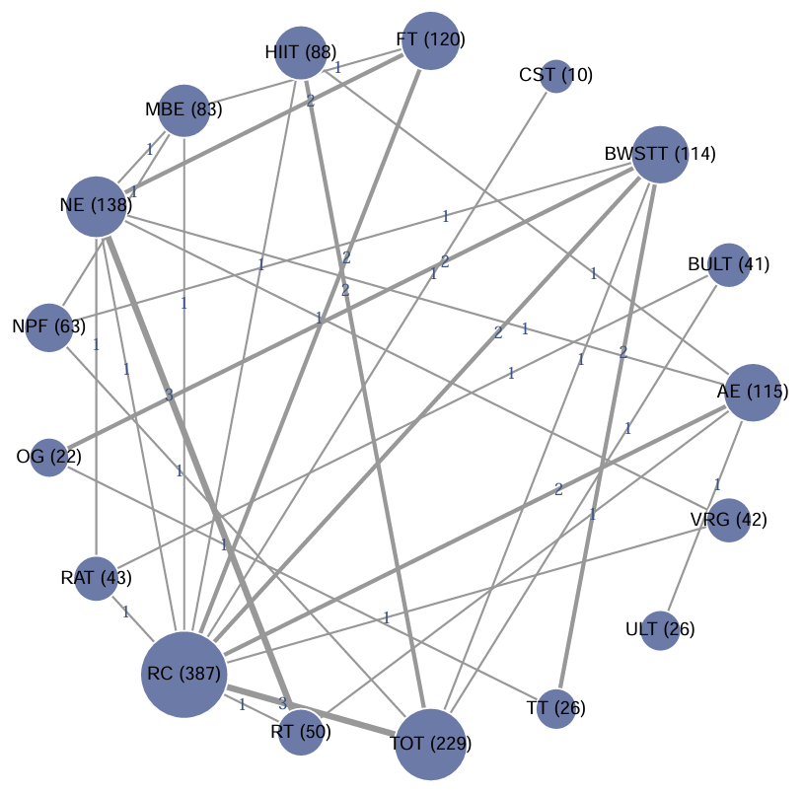
Figure S10.1 Network plot for 6MWT

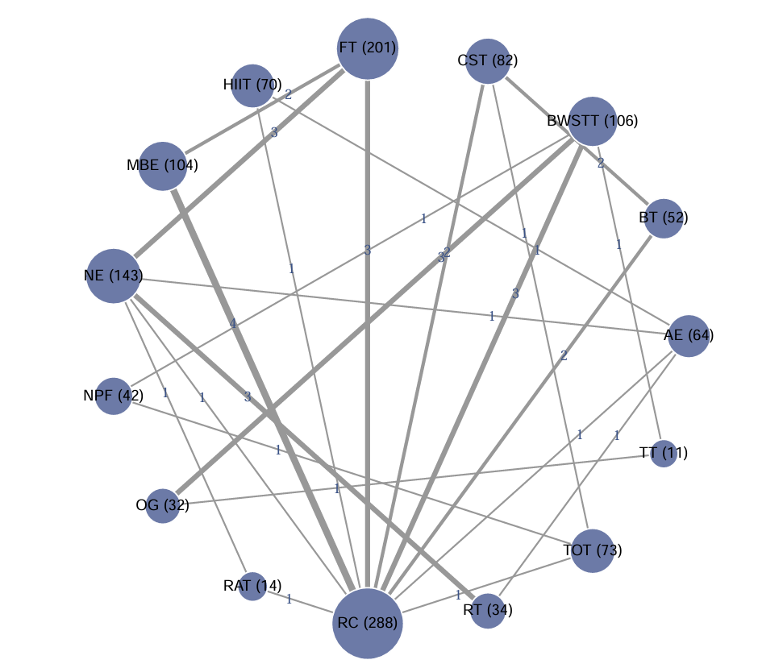
Figure S10.2 Network plot for 10MWT

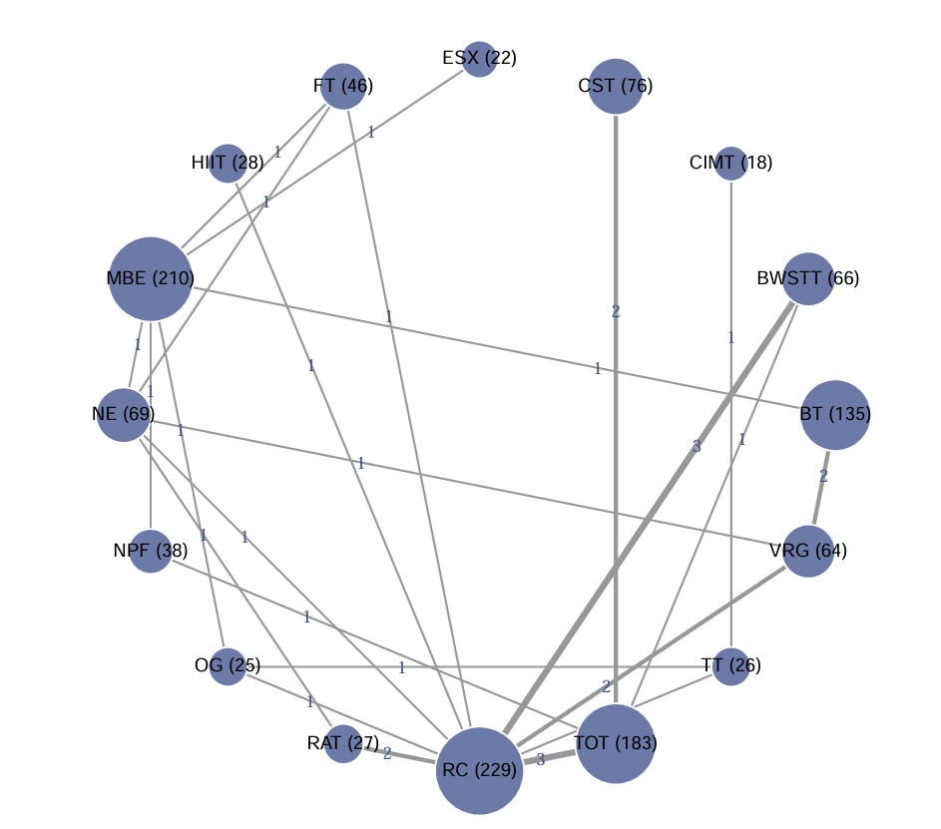
Figure S10.3 Network plot for BBS

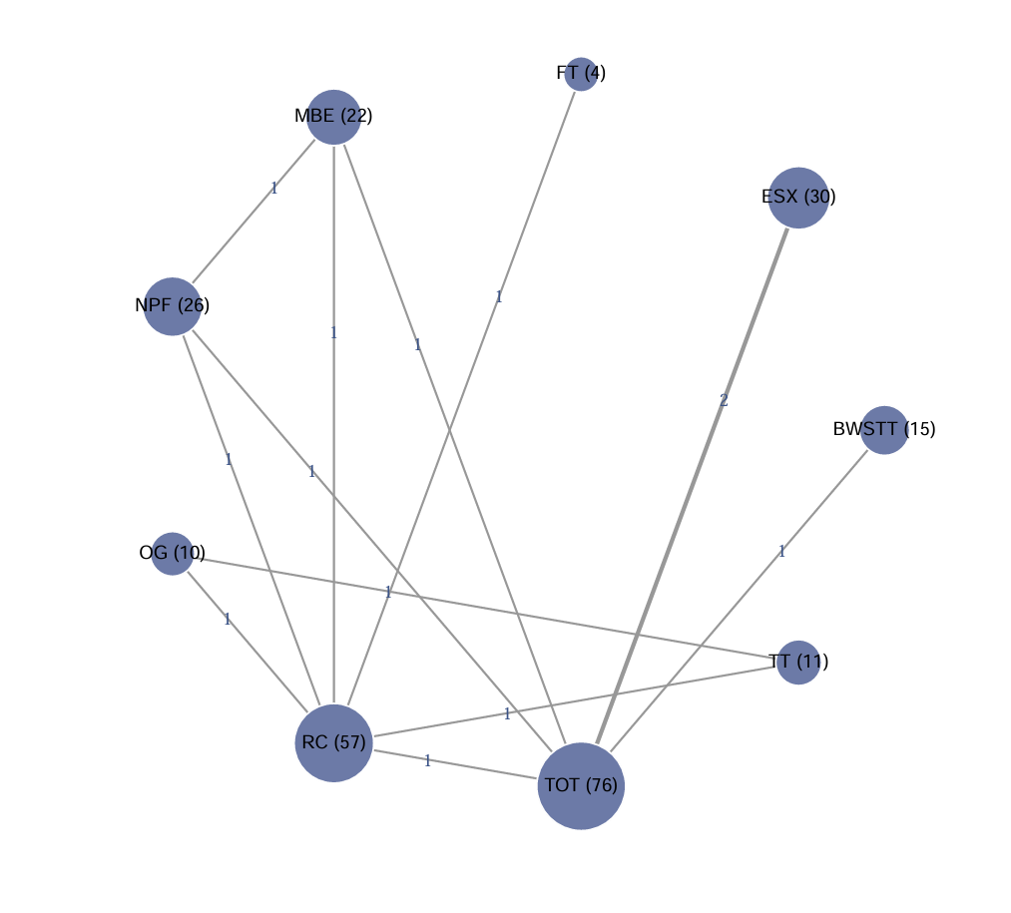
Figure S10.4 Network plot for FMA-LE
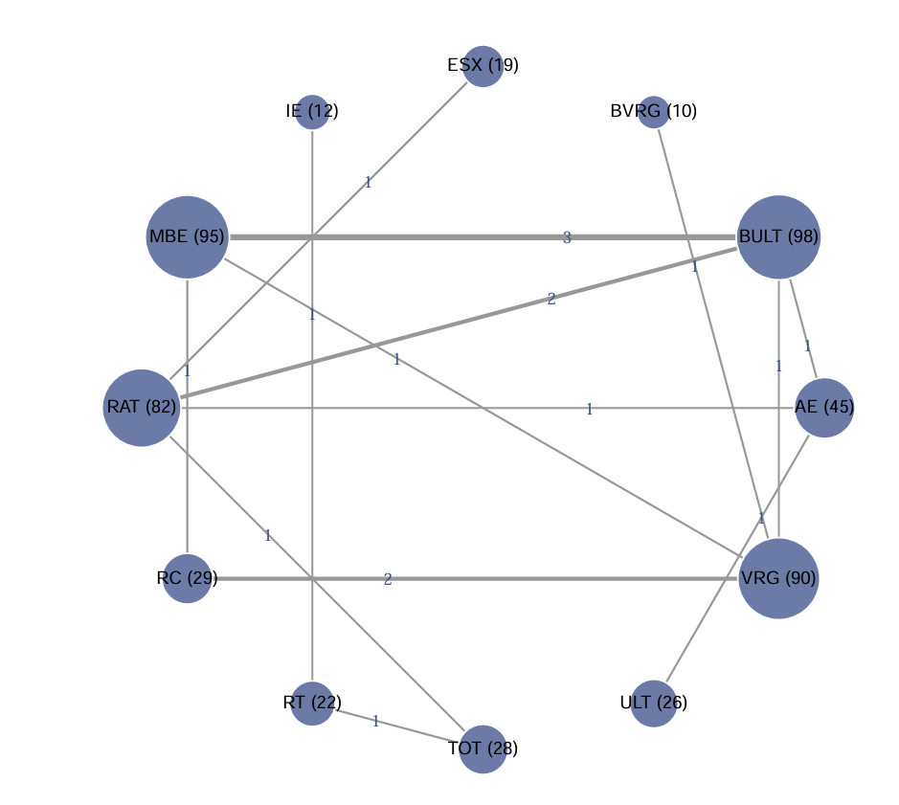
Figure S10.5 Network plot for FMA-UE

Supplementary 11 — Network Meta-Analysis Heatmaps (Direct Comparisons)
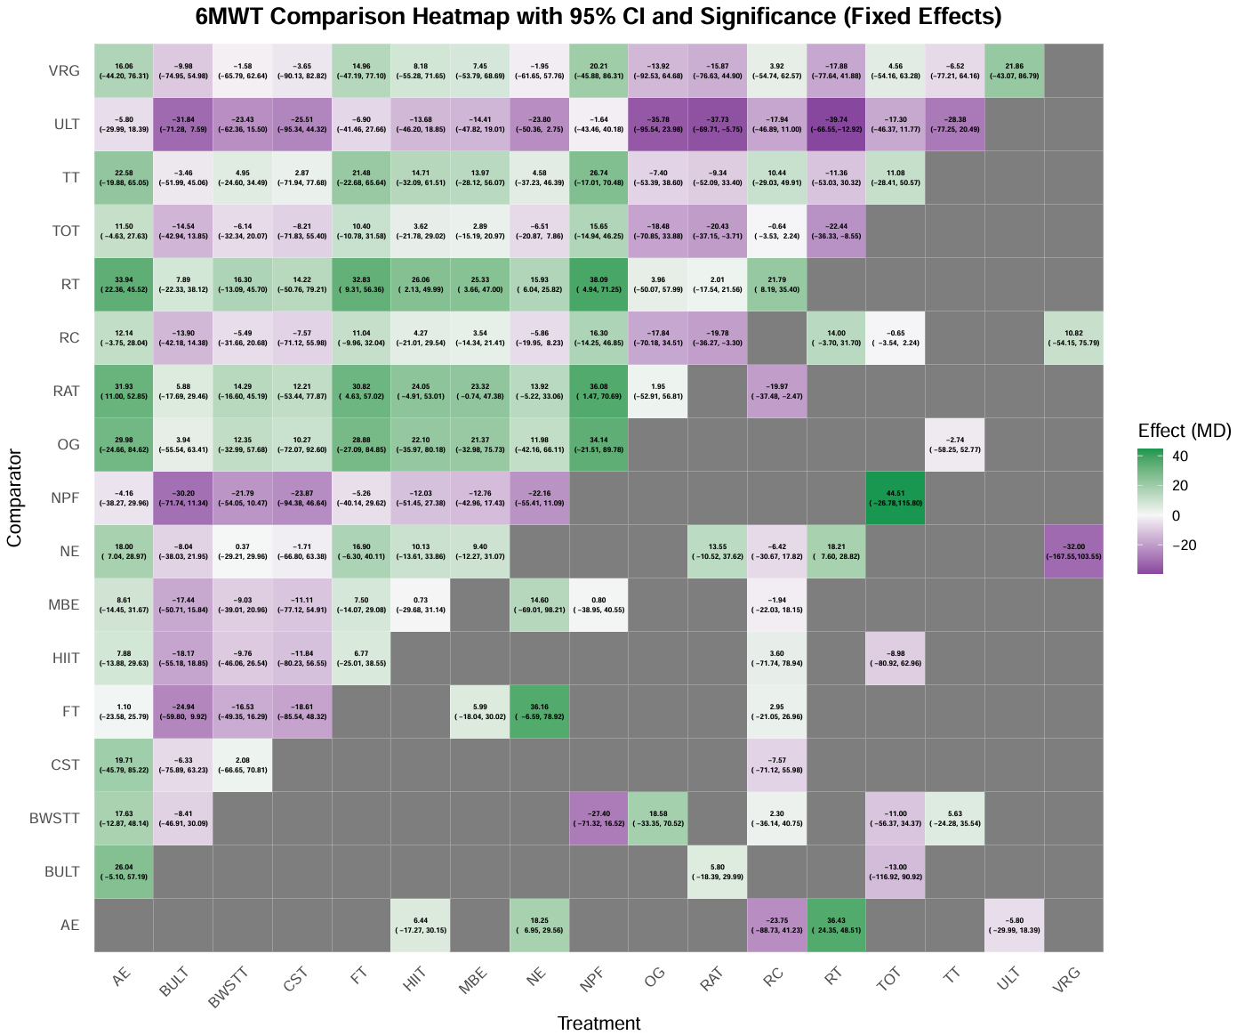
Figure S11.1 Network meta-analysis comparison heatmap for 6MWT
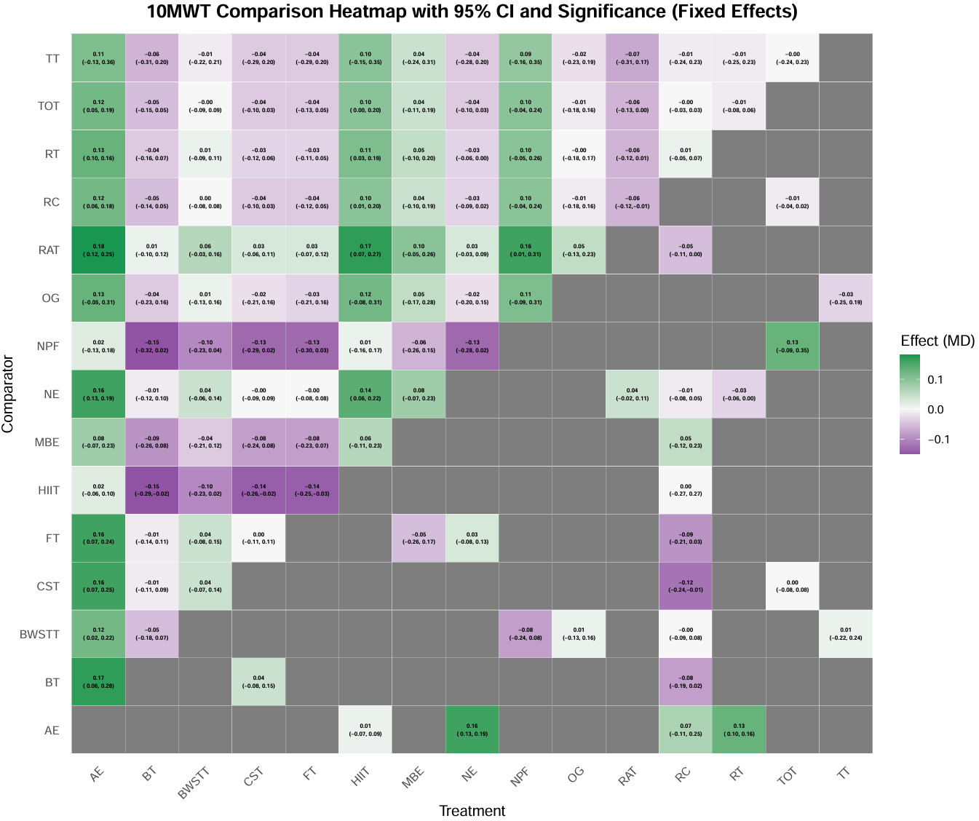
Figure S11.2 Network meta-analysis comparison heatmap for 10MWT
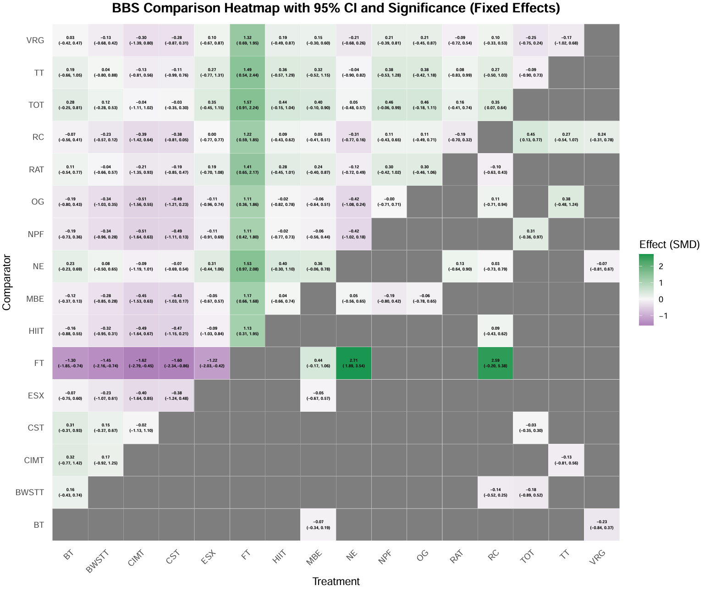
Figure S11.3 Network meta-analysis comparison heatmap for BBS
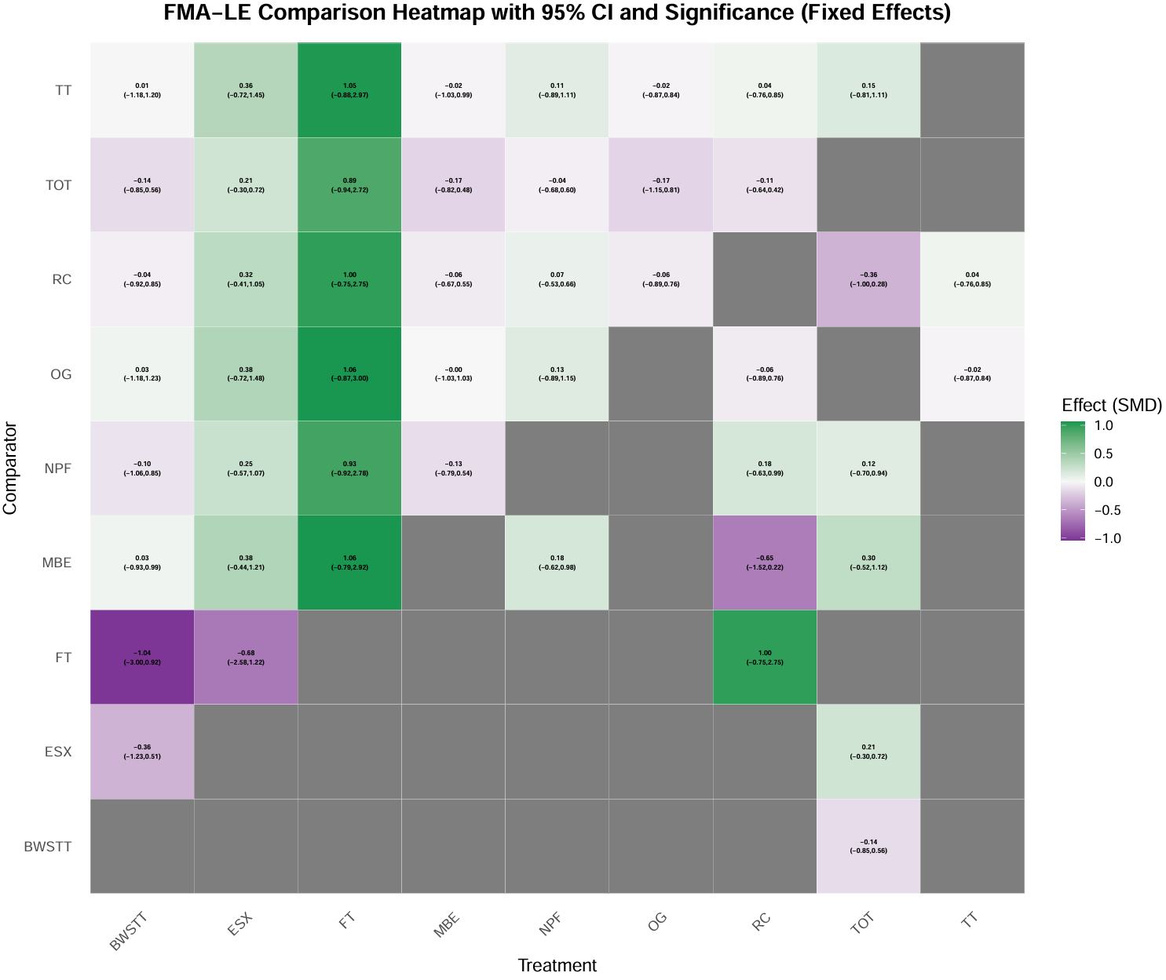
Figure S11.4 Network meta-analysis comparison heatmap for FMA-LE
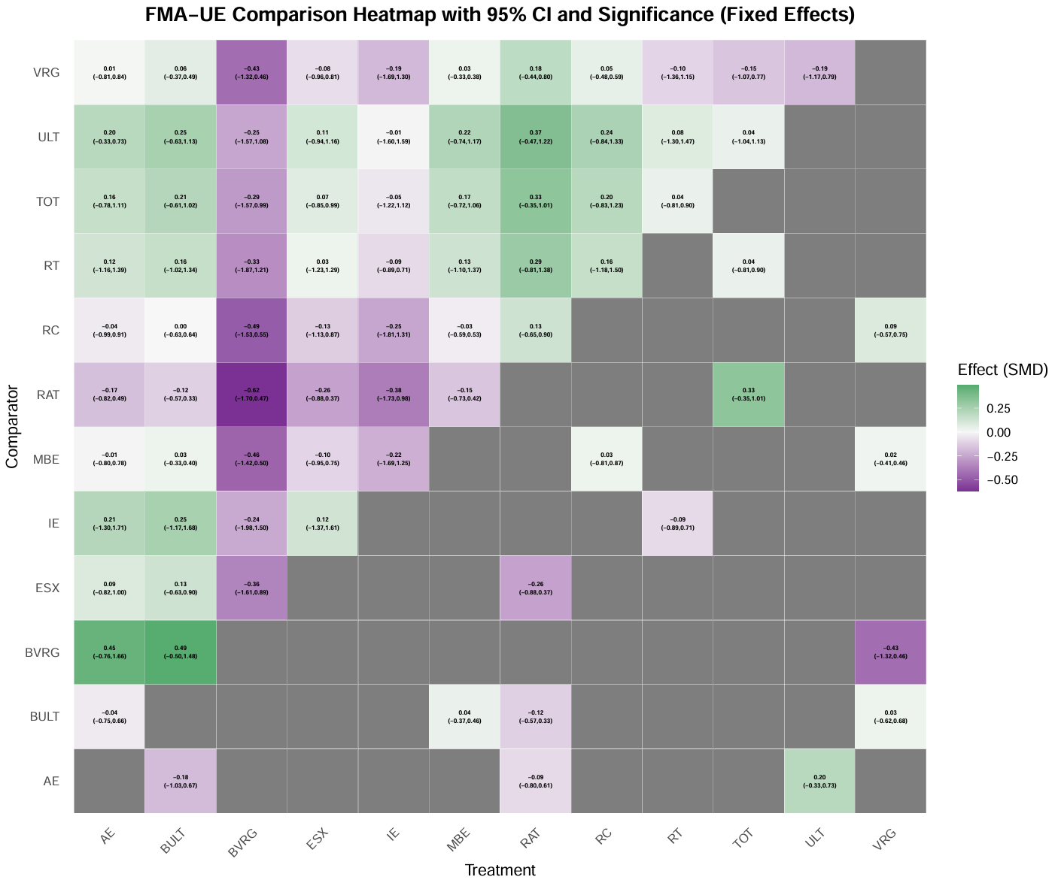
Figure S11.5 Network meta-analysis comparison heatmap for FMA-UE

Supplementary 12 — Overall SUCRA Rankings
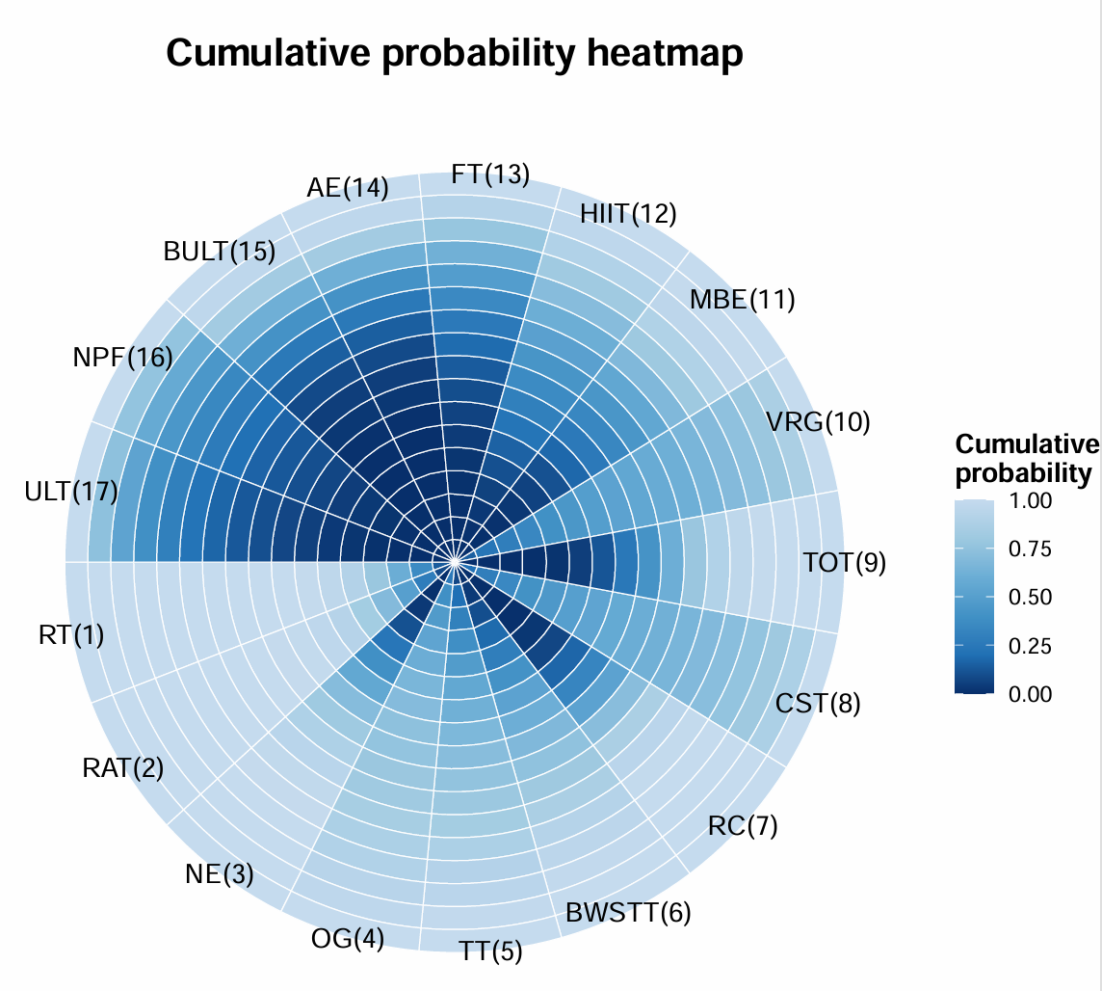
Figure S12.1 Overall SUCRA Rankings for 6MWT
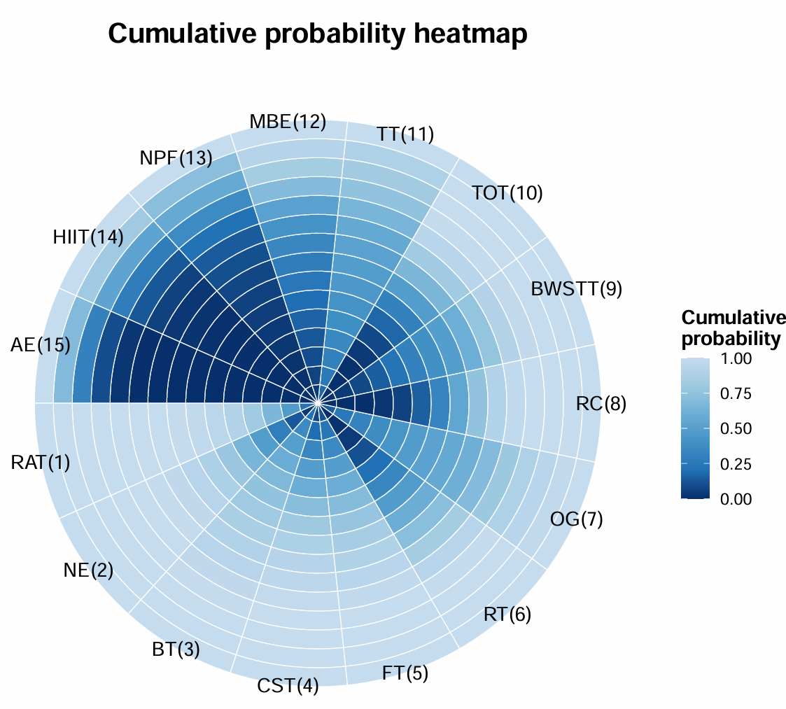
Figure S12.2 Overall SUCRA Rankings for 10MWT
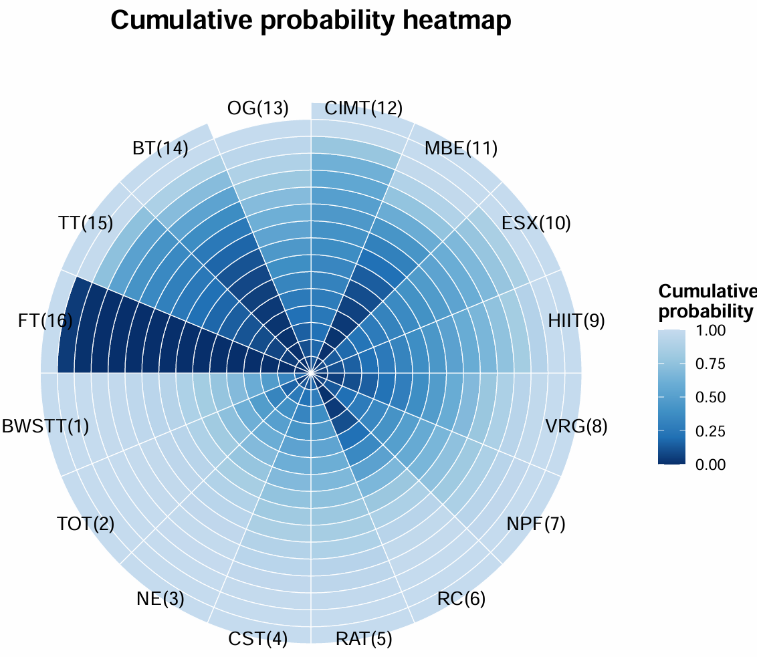
Figure S12.3 Overall SUCRA Rankings for BBS
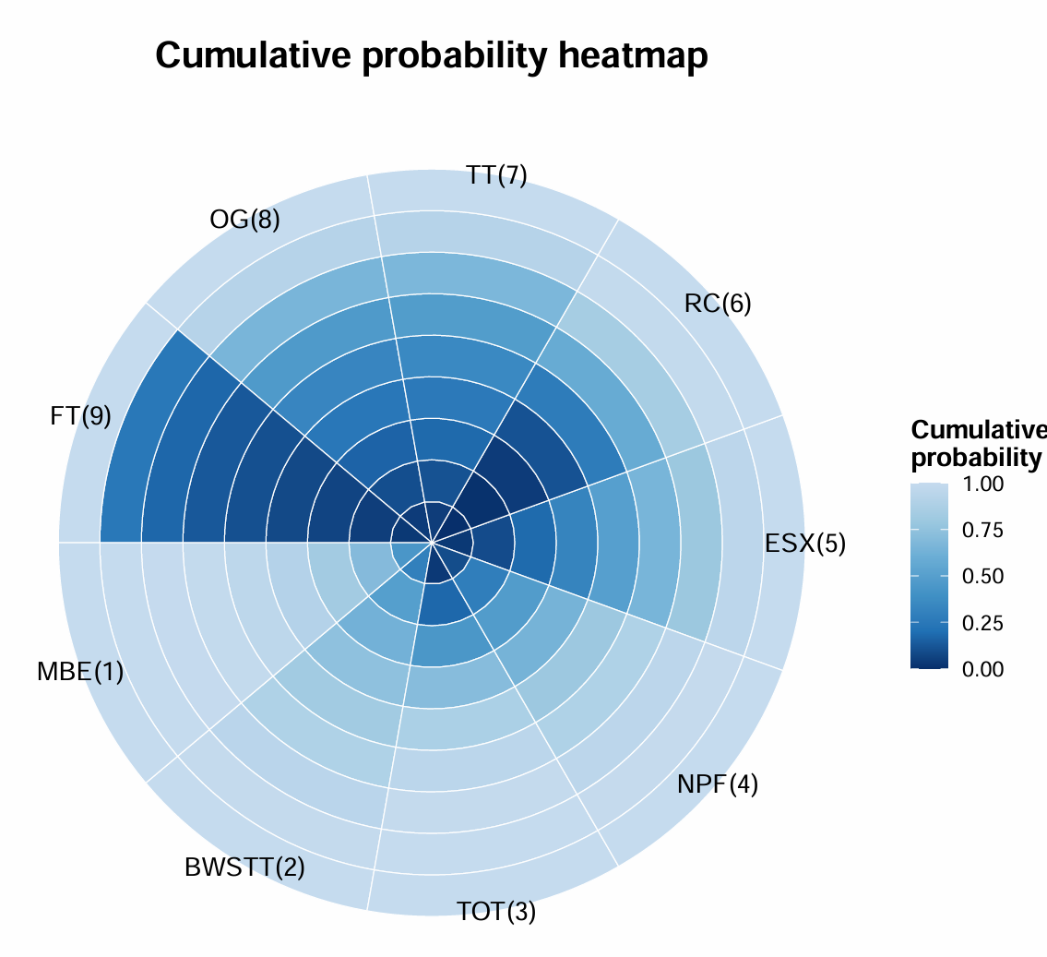
Figure S12.4 Overall SUCRA Rankings for FMA-LE
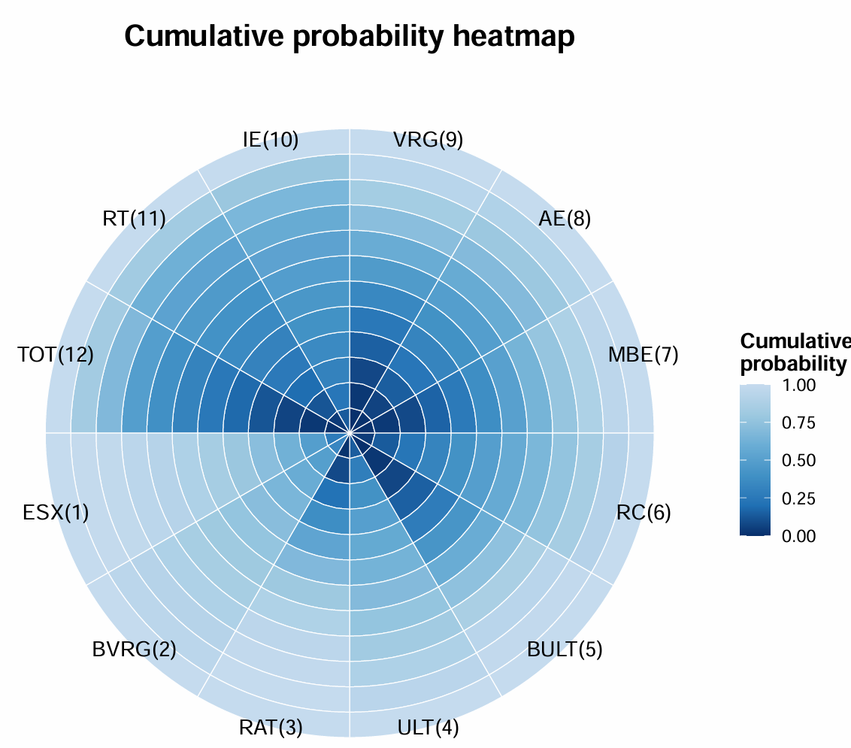
Figure S12.5 Overall SUCRA Rankings for FMA-UE

Supplementary 13 — Funnel Plots for Publication Bias
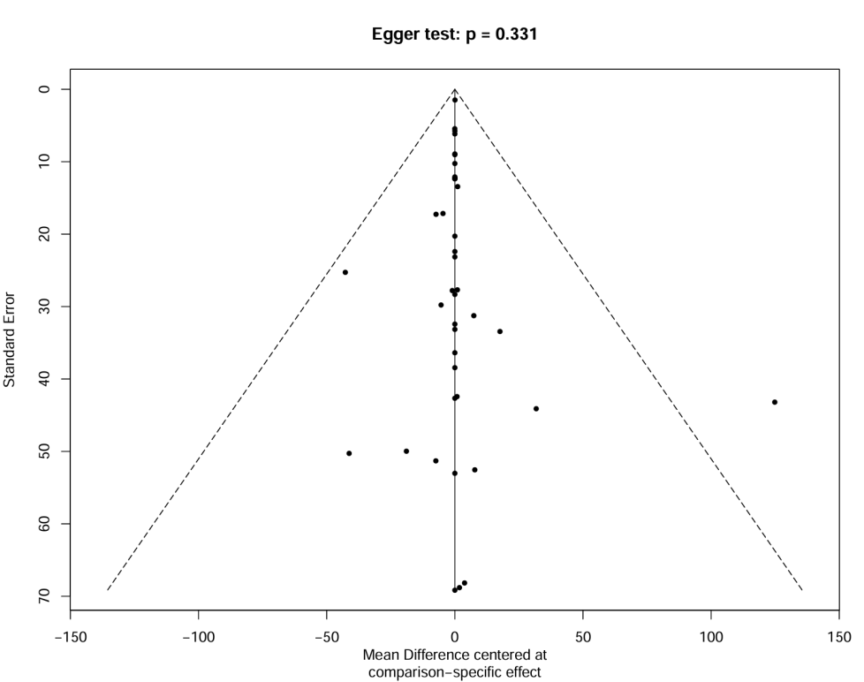

Figure S13.1 Funnel Plots of 6MWT
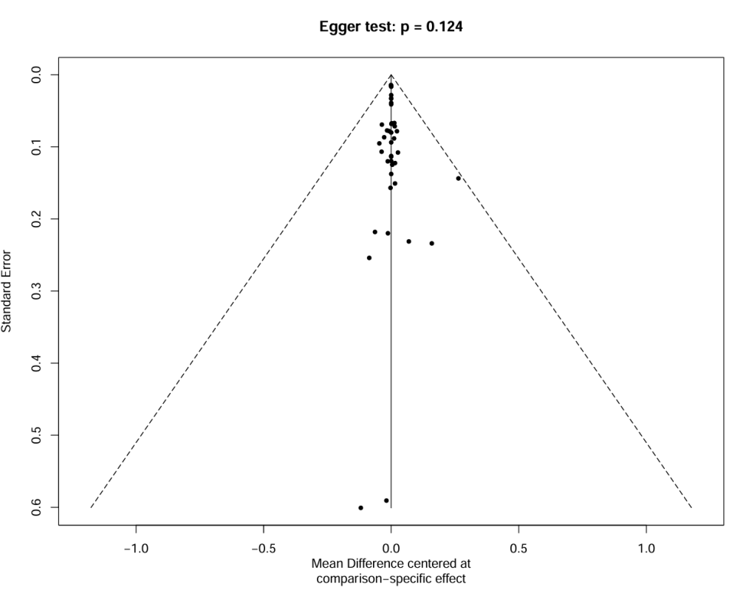
Figure S13.2 Funnel Plots of 10MWT

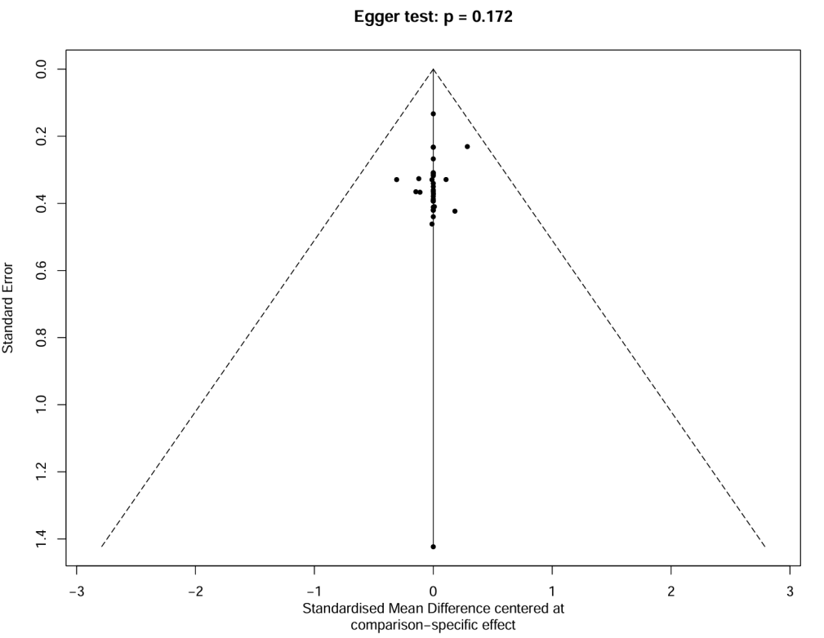
Figure S13.3 Funnel Plots of BBS

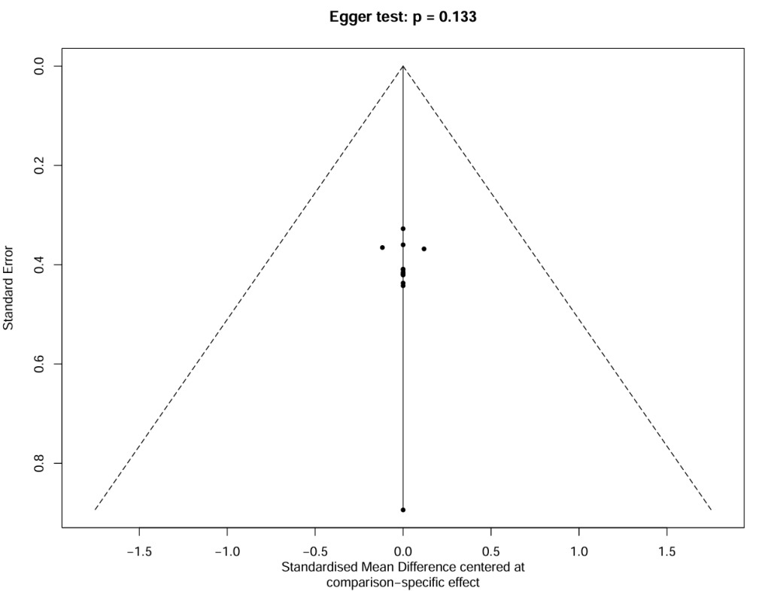
Figure S13.4 Funnel Plots of FMA-LE
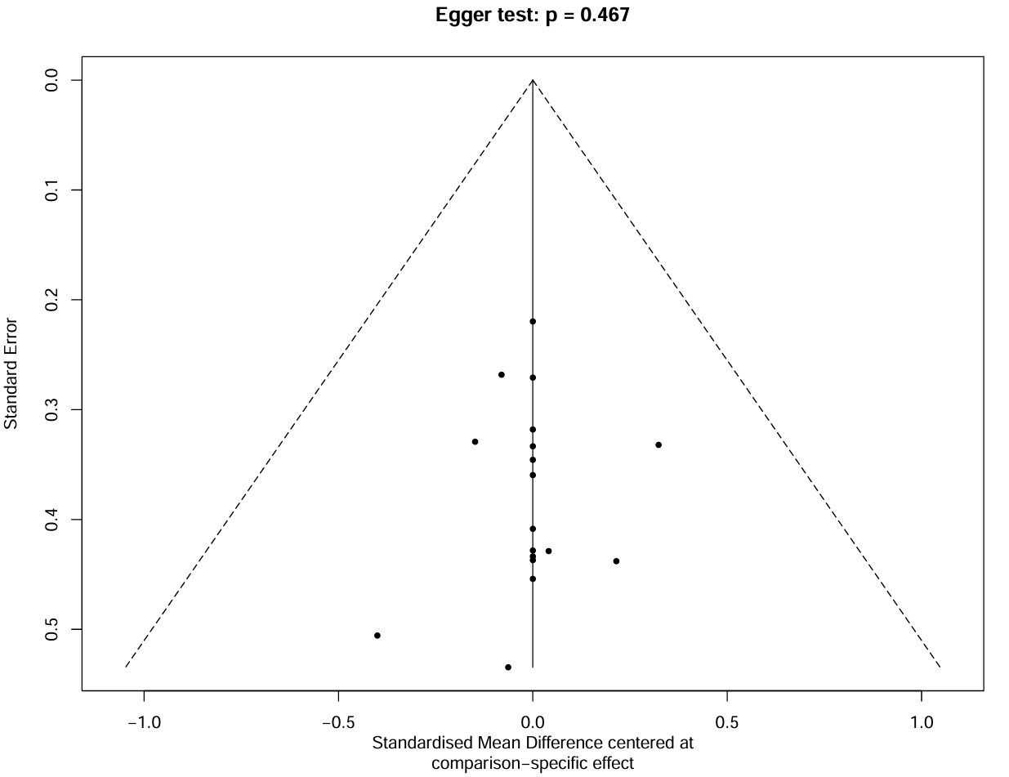
Figure S13.5 Funnel Plots of FMA-UE

Supplementary 14 — Meta-Regression Results
Table S 14 Meta-Regression Results
Outcome | Covariate | Beta | SE | P-value
6MWT | AGE | 397.2628 | 375.8218 | 0.2905
 | Intervention cycle | -89.9668 | 68.4749 | 0.1889
 | Follow | 48.0381 | 81.9841 | 0.5579
 | GDP | 23.8275 | 63.2516 | 0.7064
 | Sample size | -11.9581 | 61.3191 | 0.8454
10MWT | AGE | 1.4753 | 34.003 | 0.7125
 | Intervention cycle | 0.07 | 0.0938 | 0.4553
 | Follow | 0.131 | 0.2362 | 0.5791
 | GDP | 0.0949 | 0.1445 | 0.5113
 | Sample size | 0.0924 | 0.1385 | 0.5049
BBS | AGE | 4.9917 | 14.6791 | 0.7338
 | Intervention cycle | -0.5602 | 2.8444 | 0.8439
 | Follow | -0.4444 | 0.8989 | 0.6211
 | GDP | -0.5077 | 1.2465 | 0.6838
 | Sample size | -1.8083 | 3.1069 | 0.5606
Note (GTP):PPP-adjusted GDP per capita in 2023 (10,000 international dollars):
China (2.21), Denmark (6.48), Israel (5.74), Iran (1.43), Canada (6.48), India (0.99), Turkey (4.15), Nigeria (1.05), Pakistan (0.59), Brazil (1.88), Germany (6.41), Italy (5.53), Norway (8.69), Japan (4.15), France (5.04), Poland (4.76), Thailand (2.18), Australia (6.68), Sweden (6.63), Myanmar (0.09), United States (7.46), Finland (6.30), United Kingdom (5.78), Netherlands (7.07), Spain (5.29), South Korea (5.88), Lebanon (2.18).

Supplementary 15— Network Meta-Regression Bubble Plots
6MWT
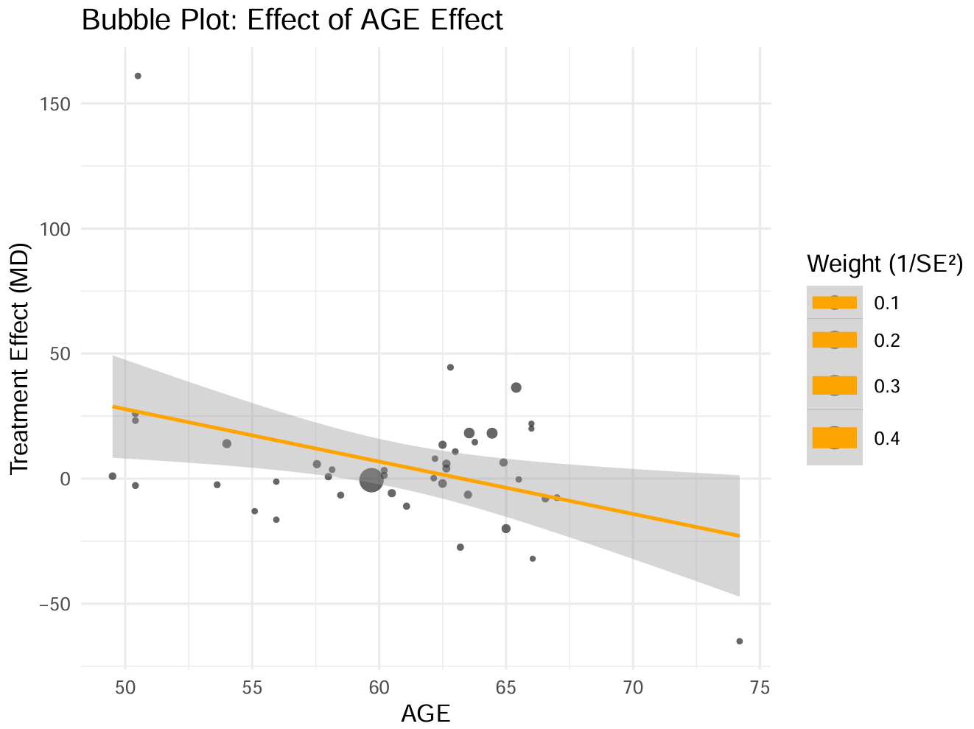
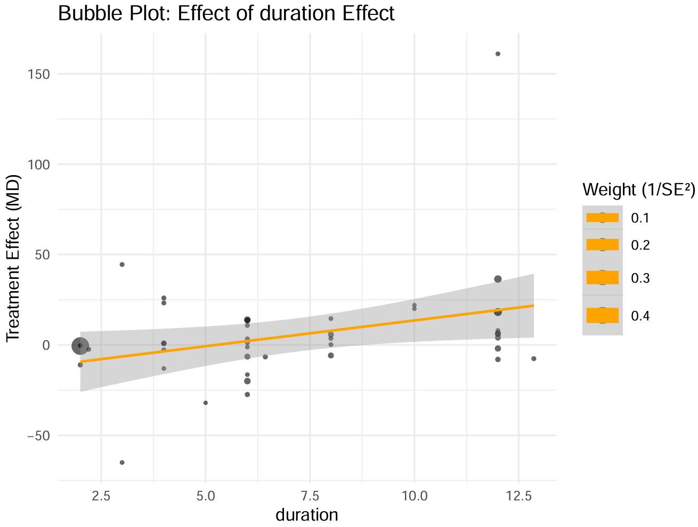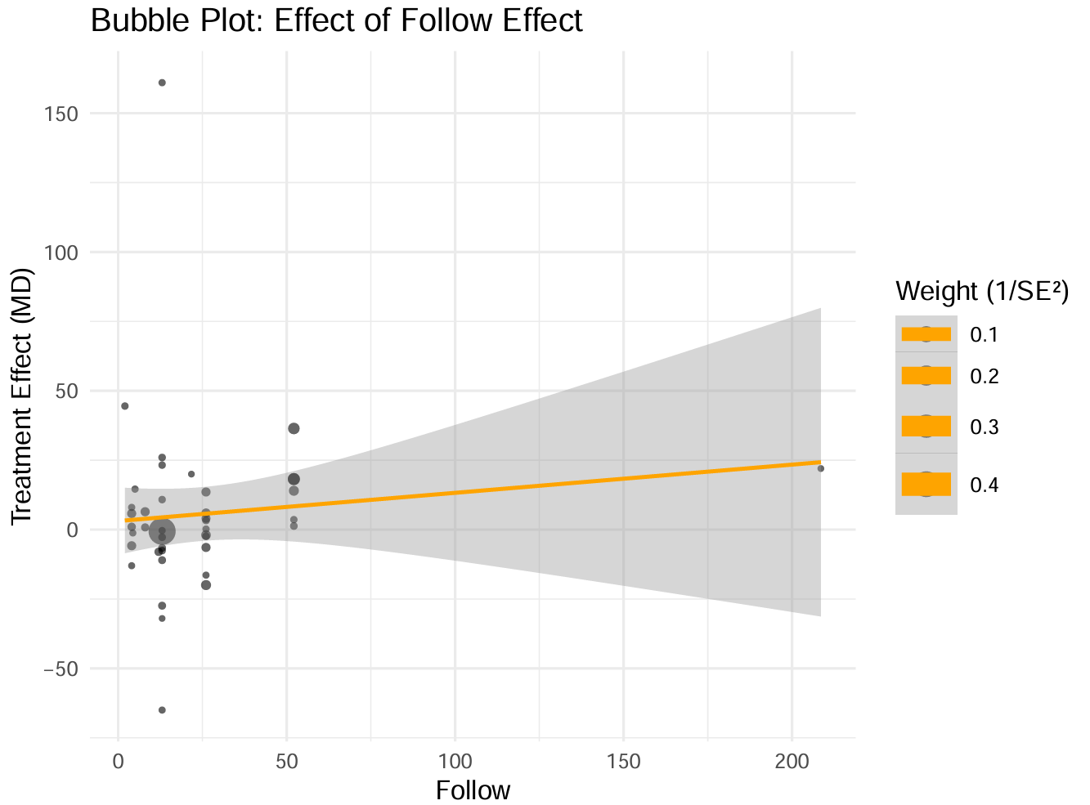
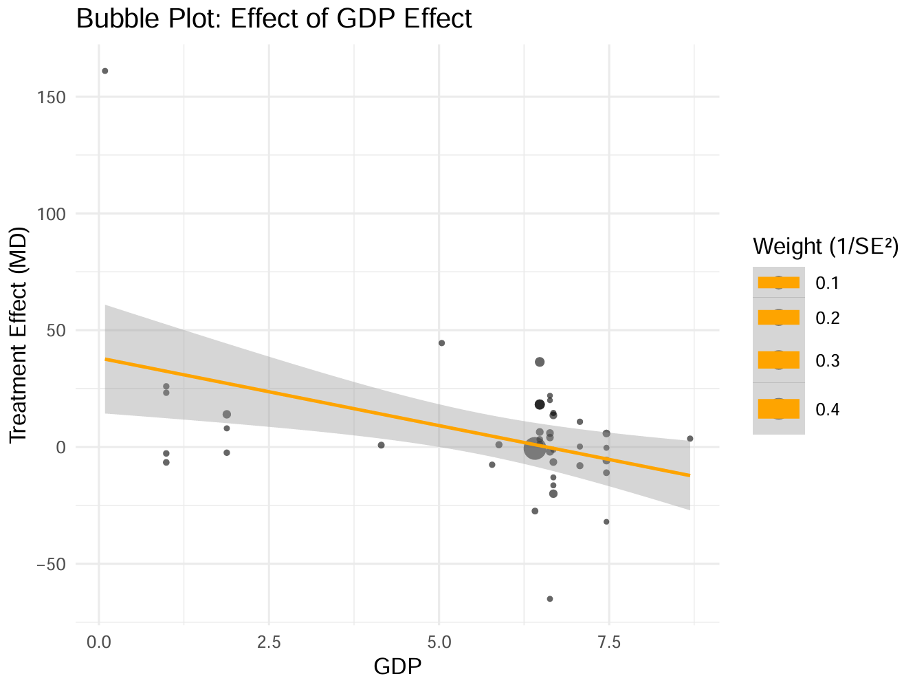
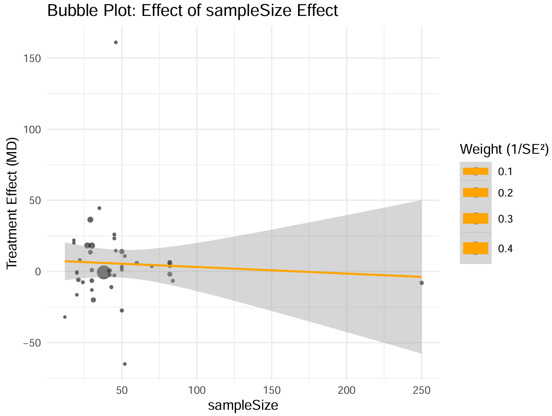

10MWT
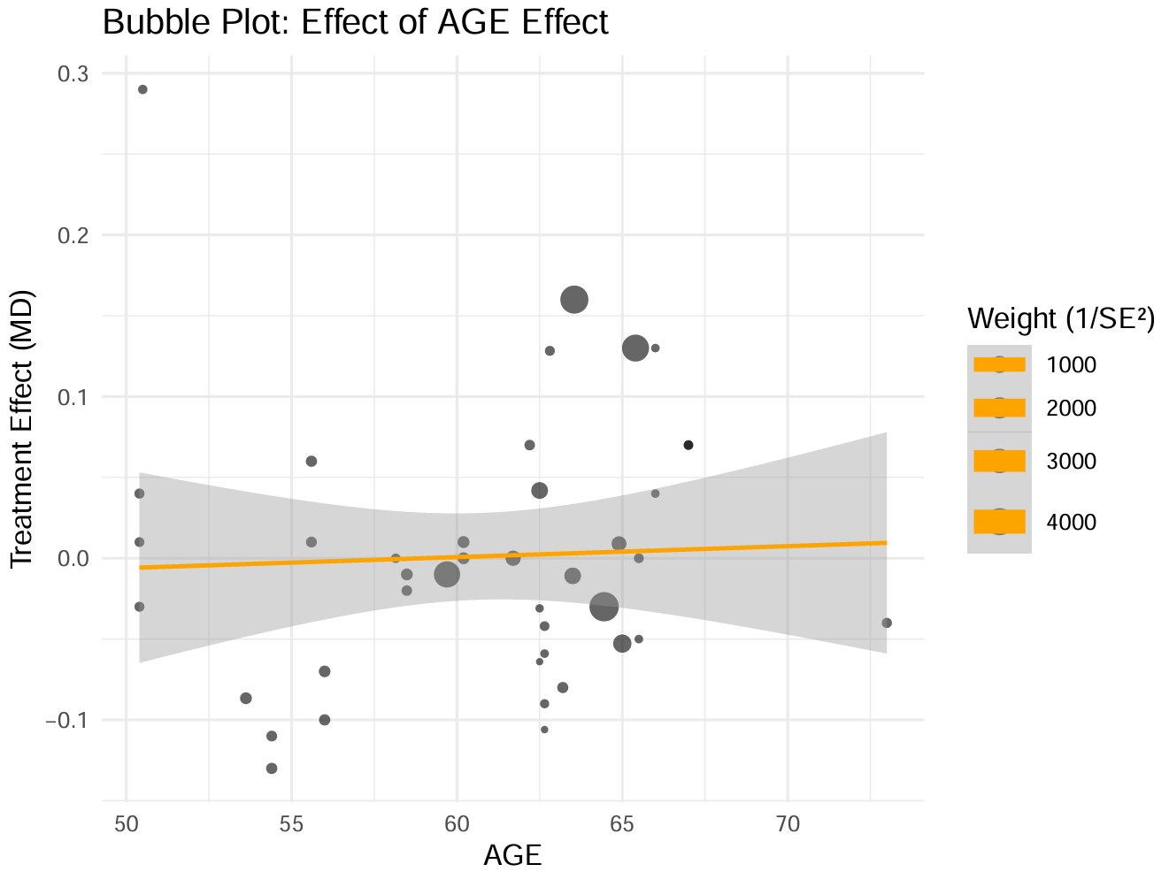
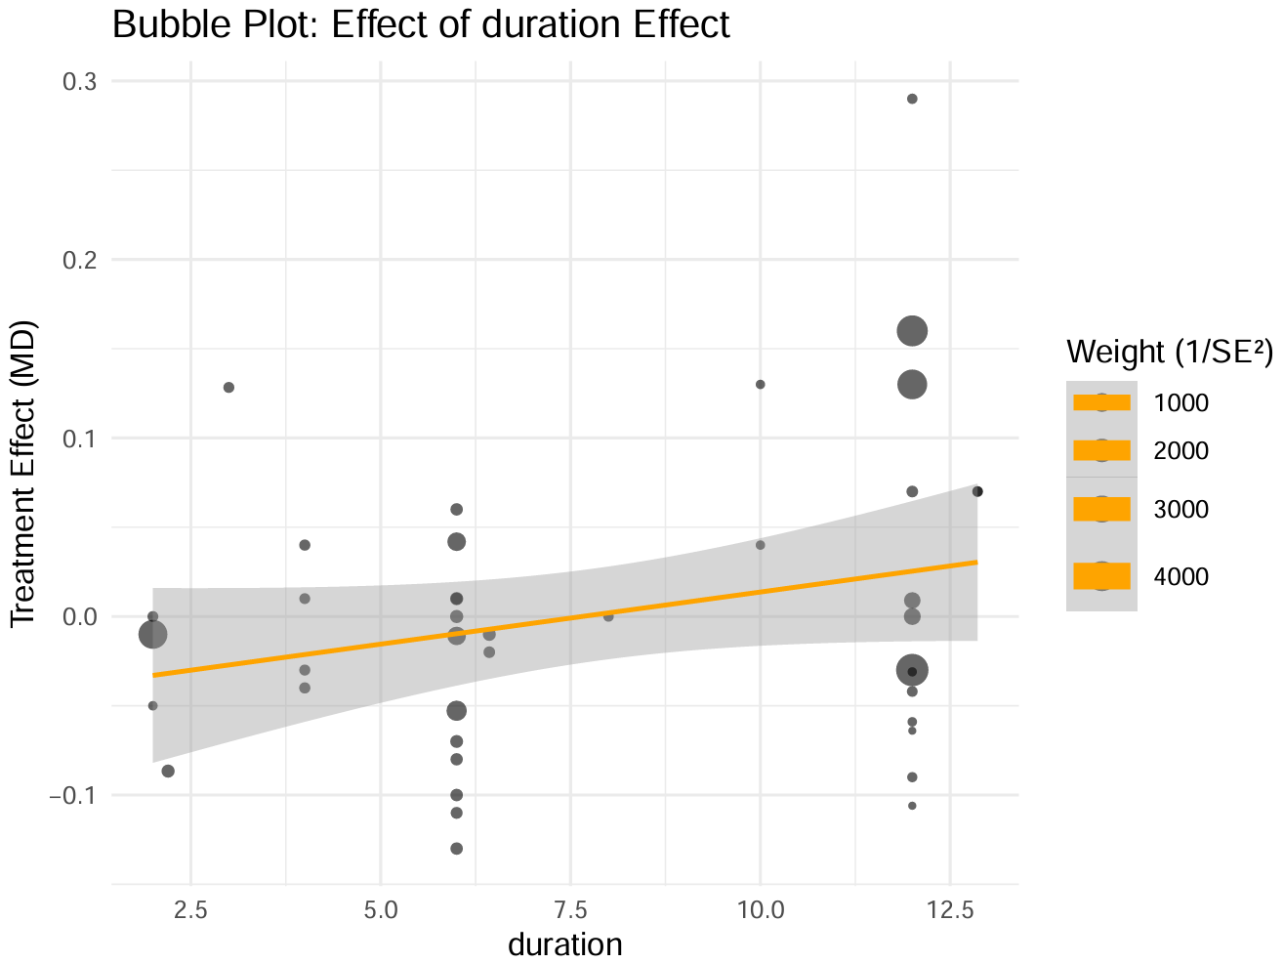
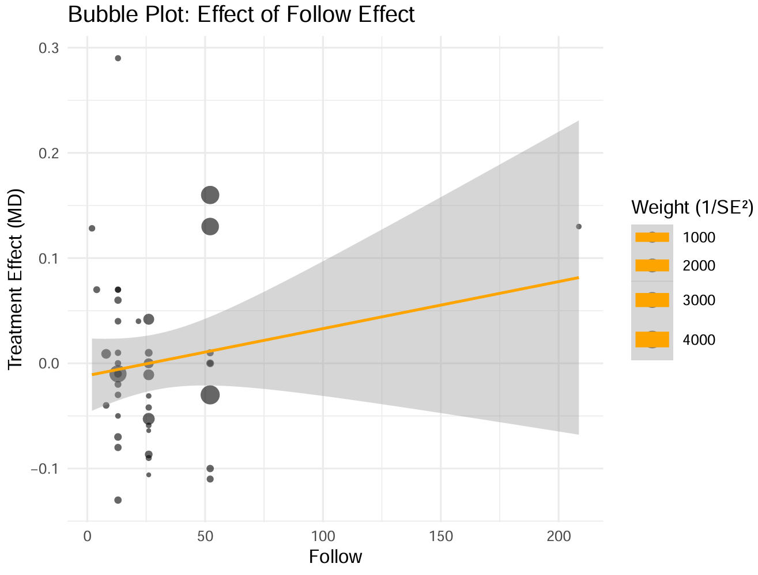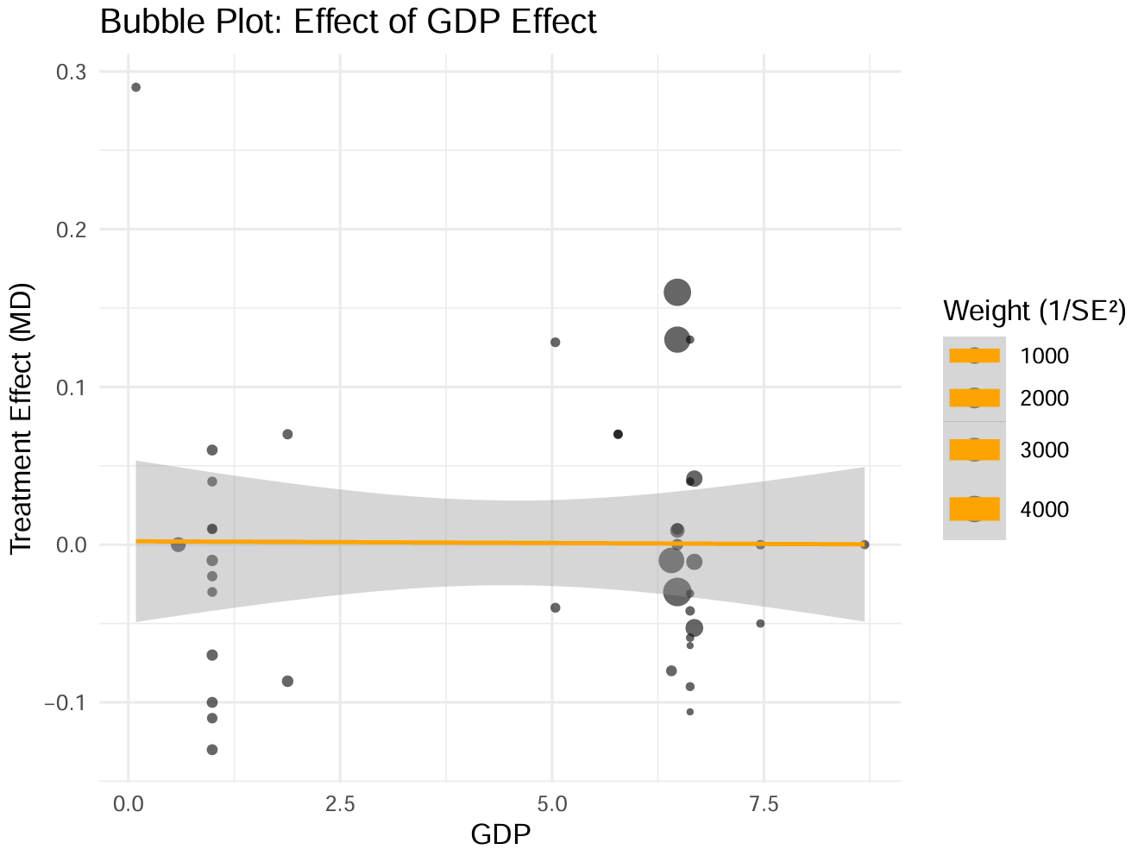
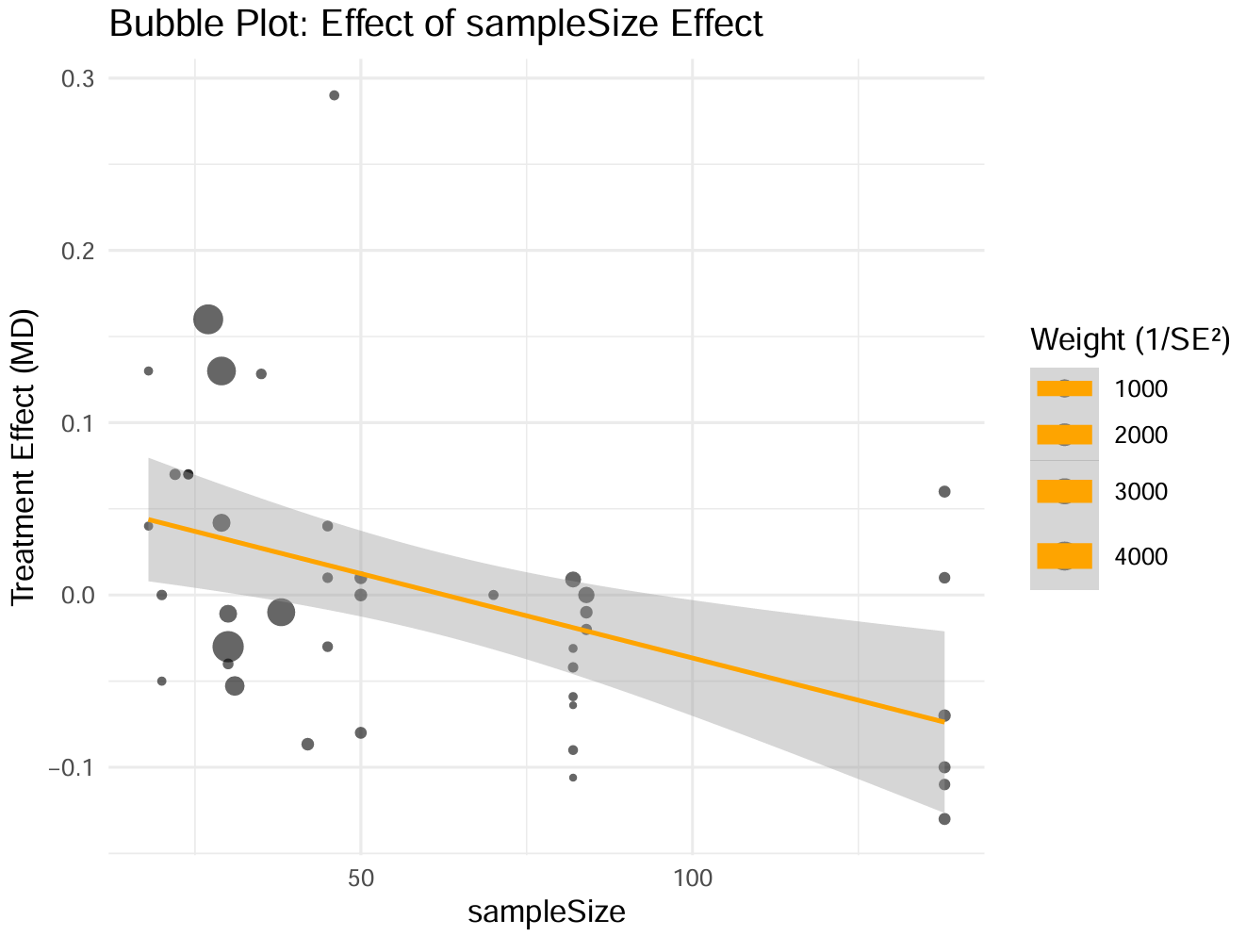

BBS
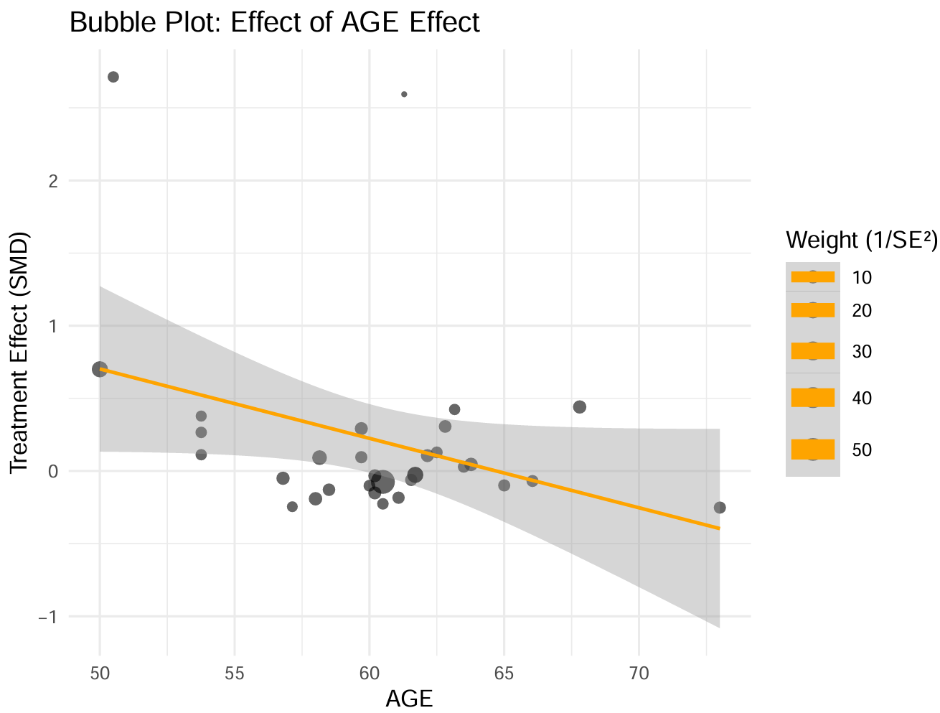
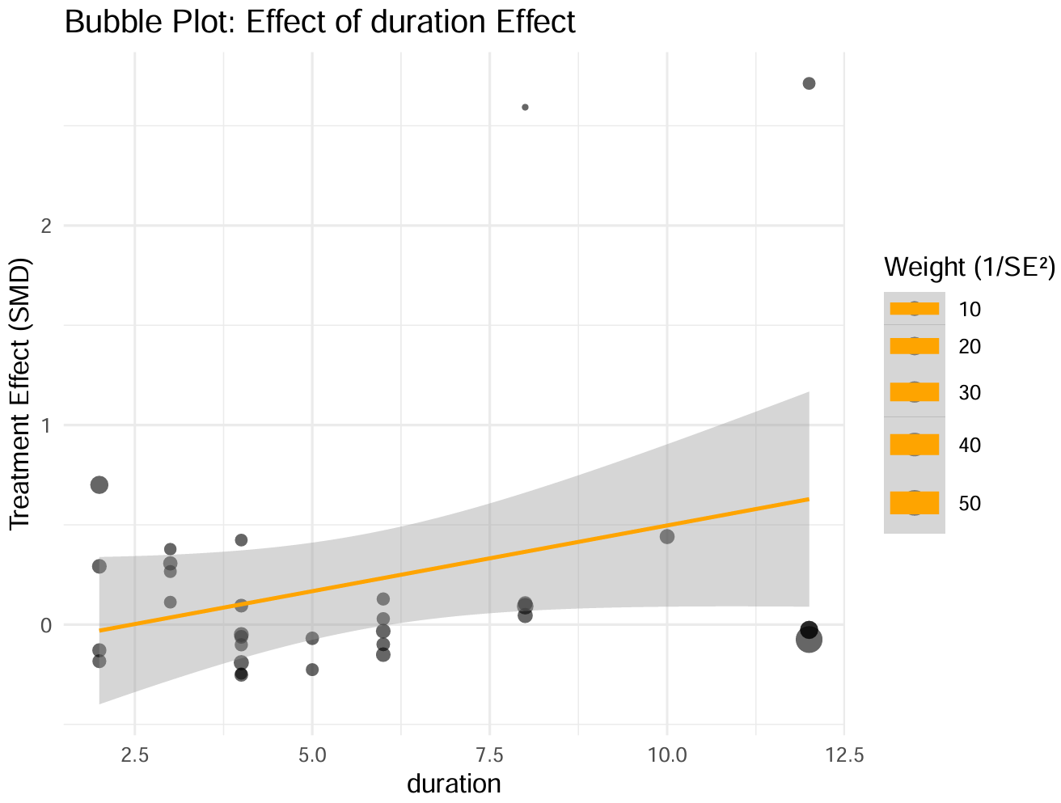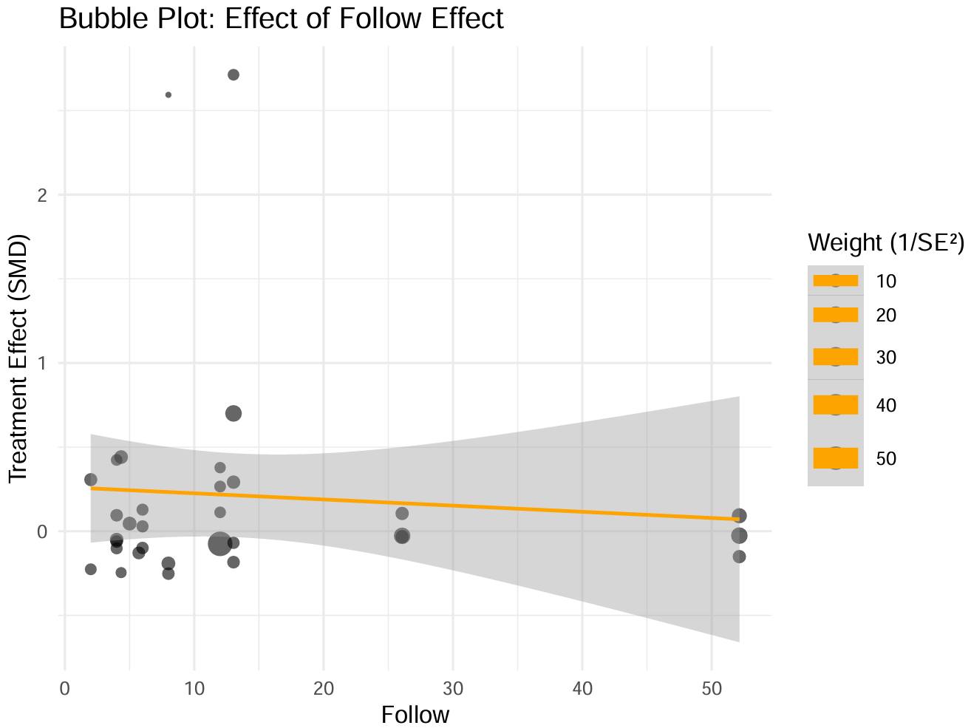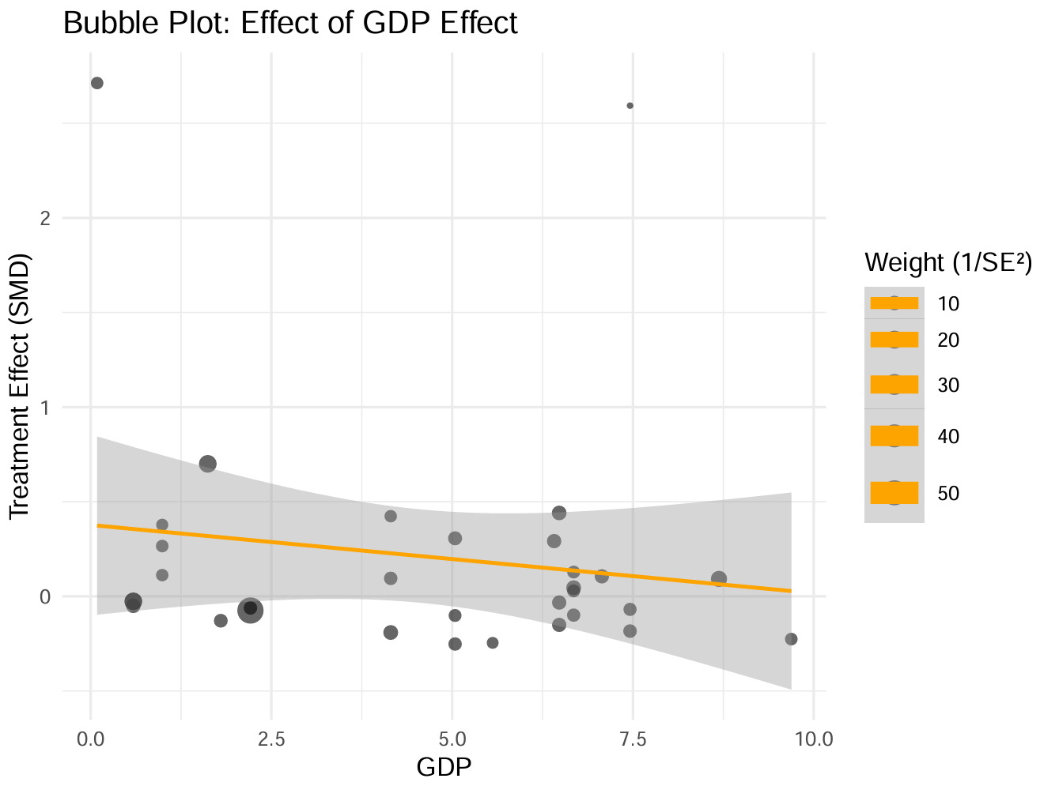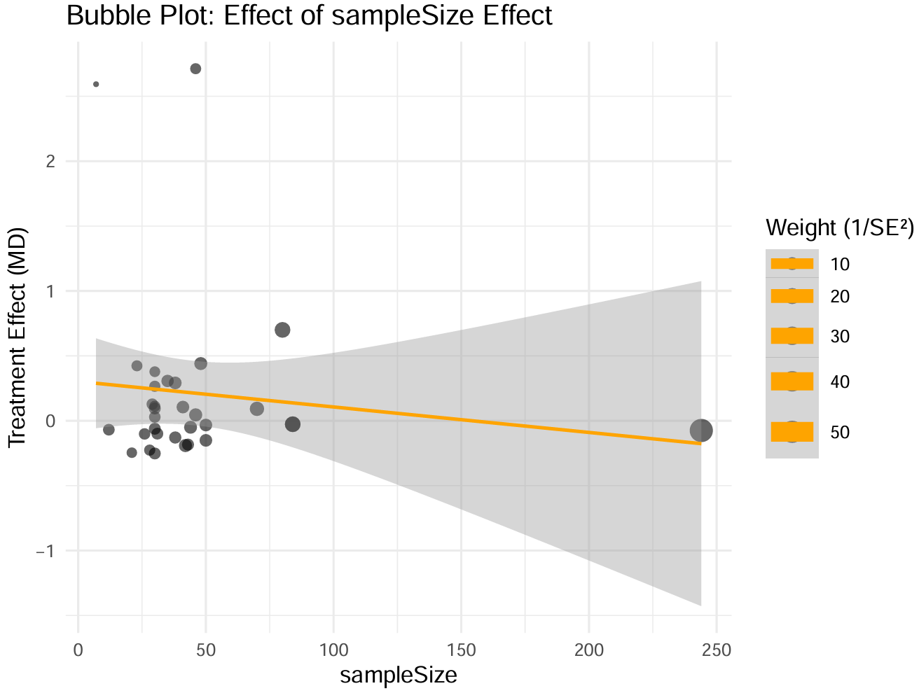

Supplementary 16 — Network Meta-Regression Trend Plot
6MWT
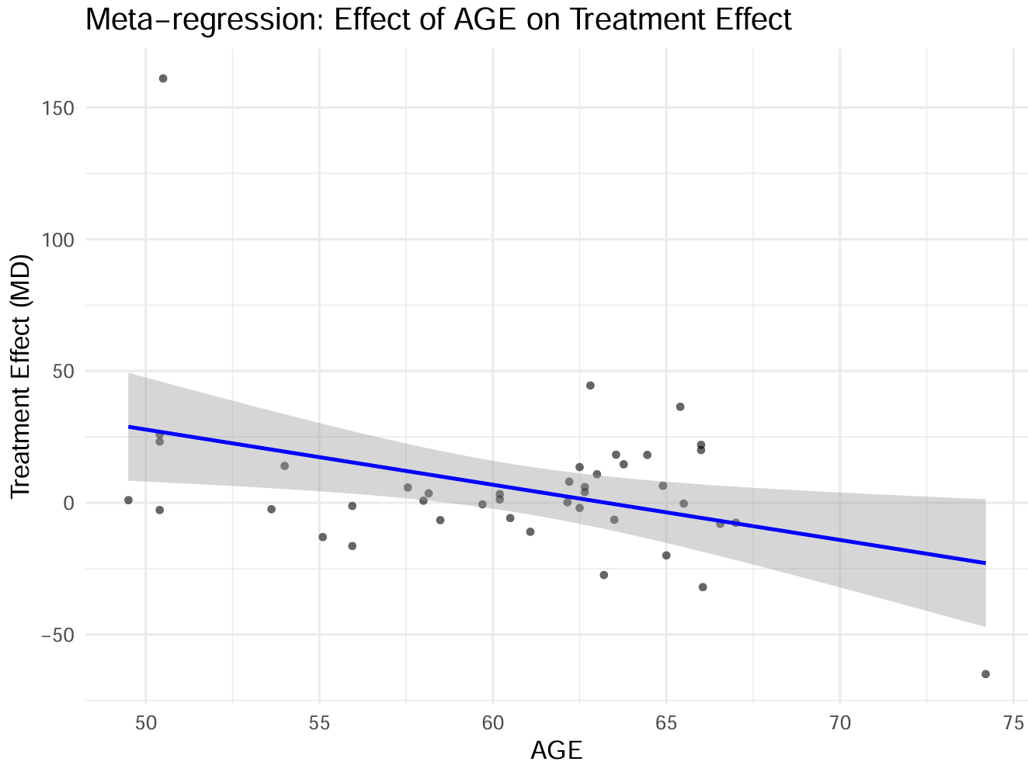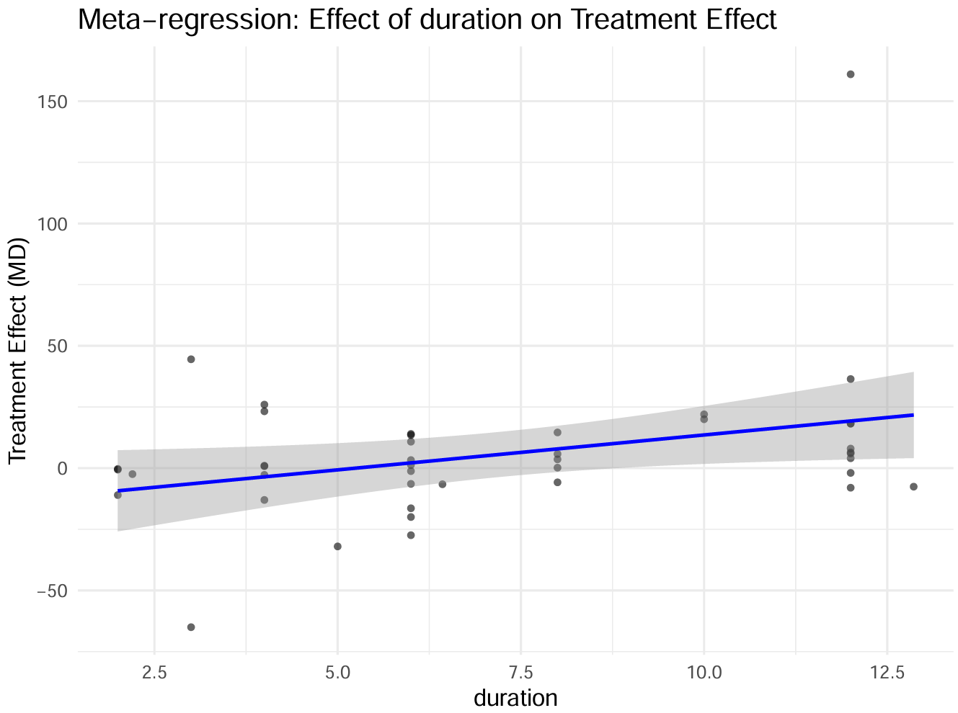
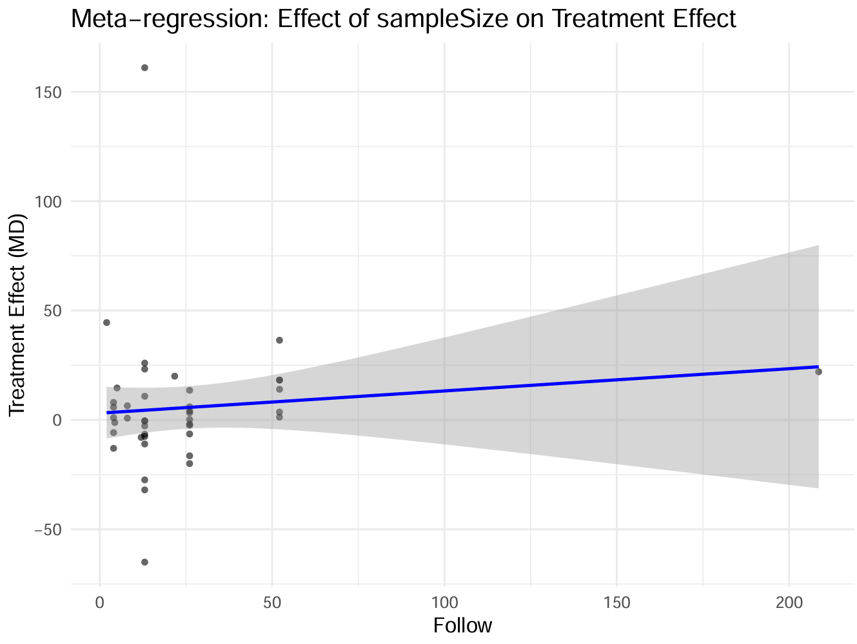
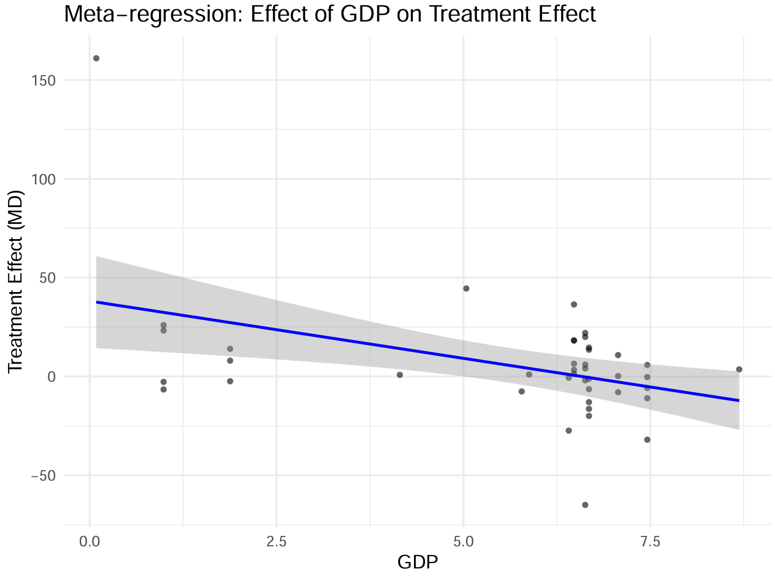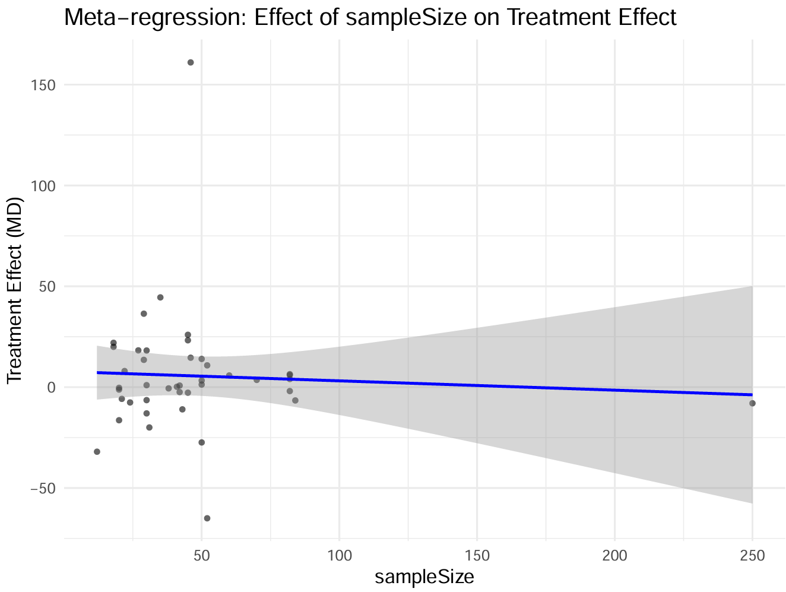

10MWT
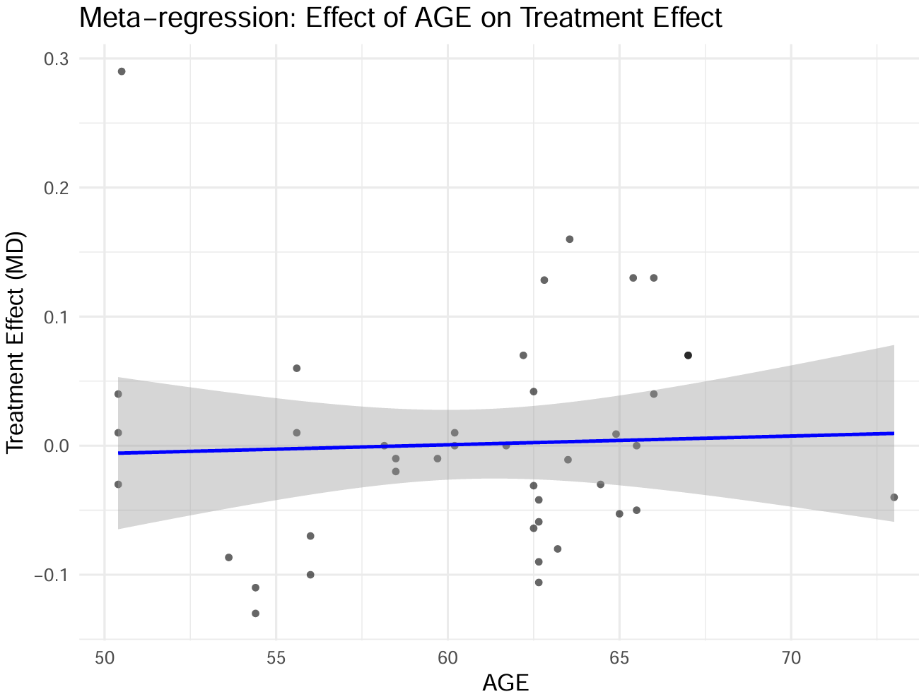
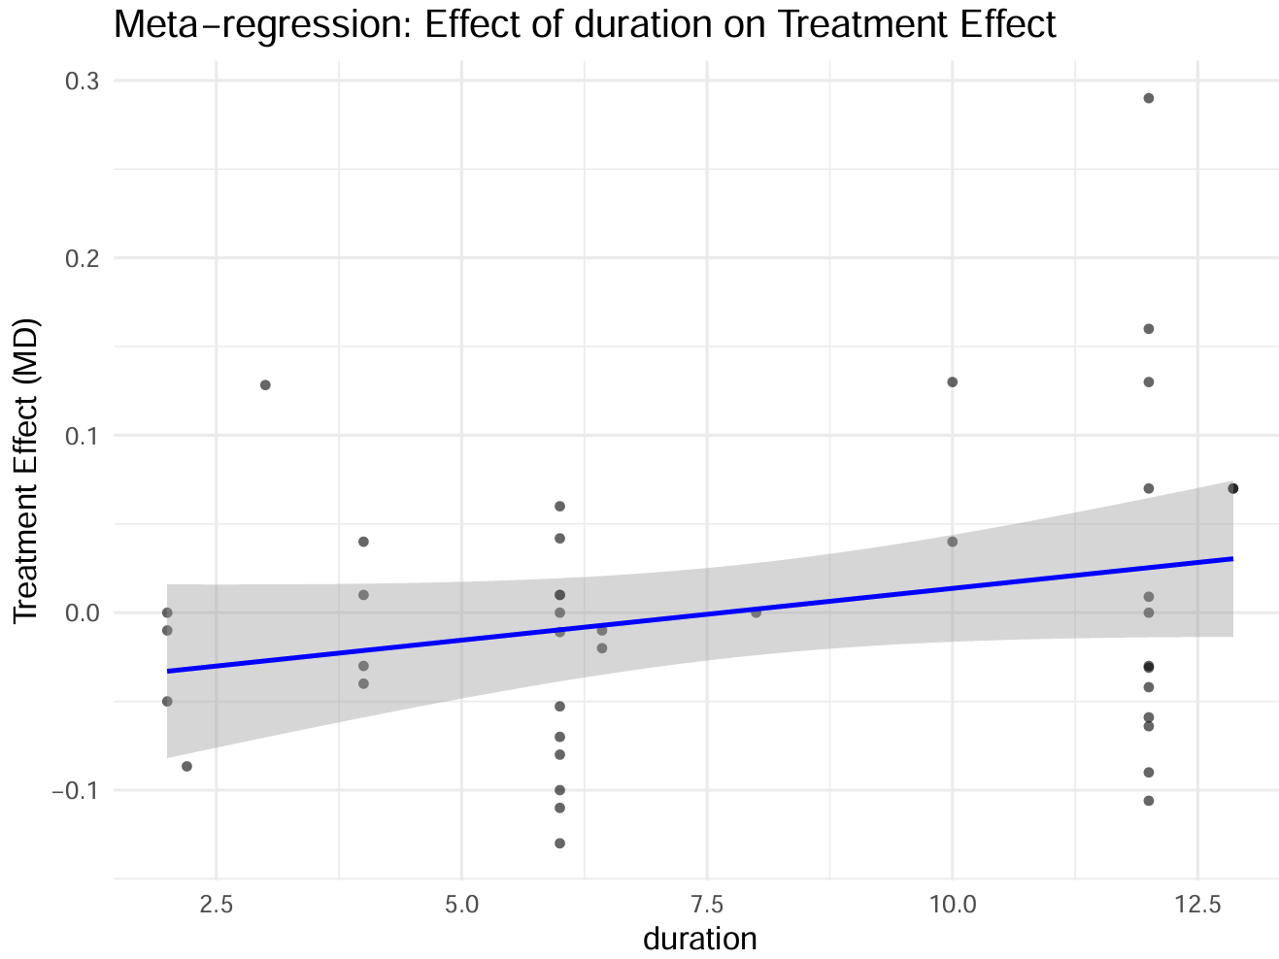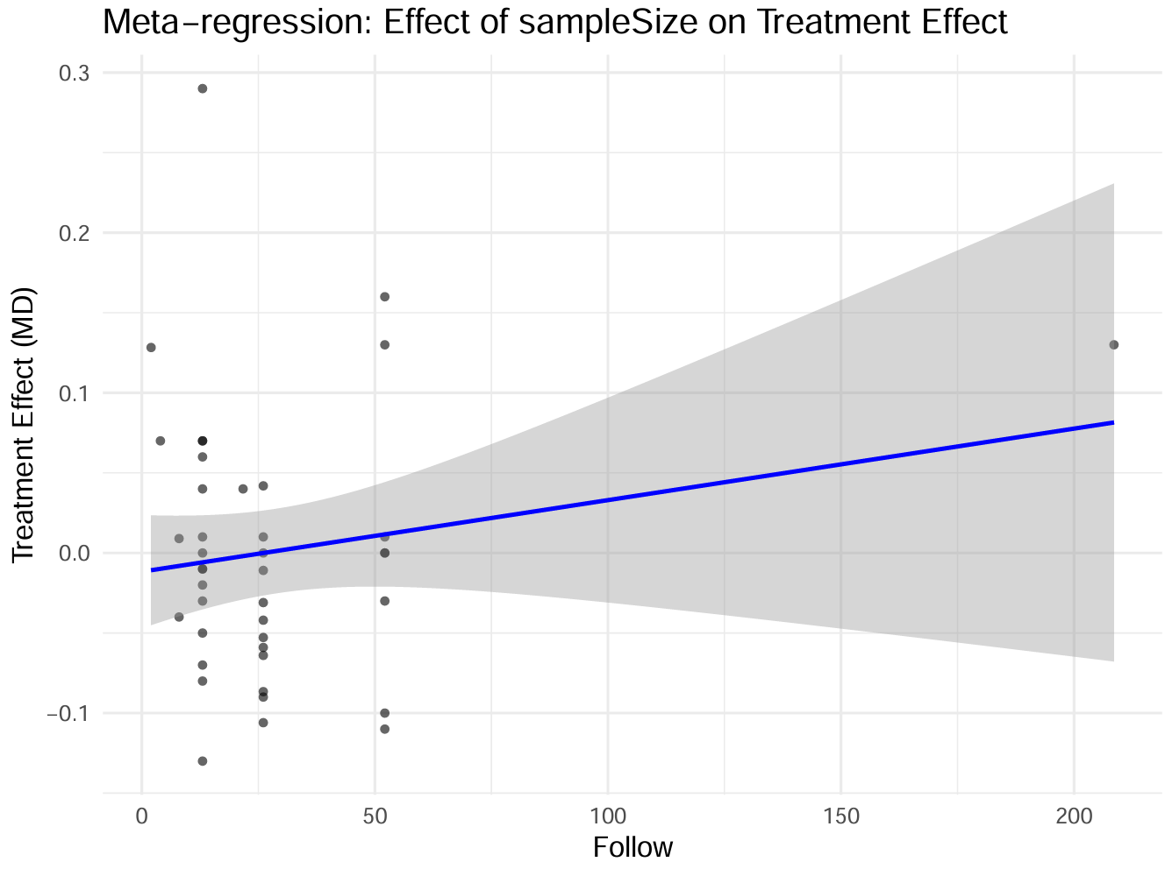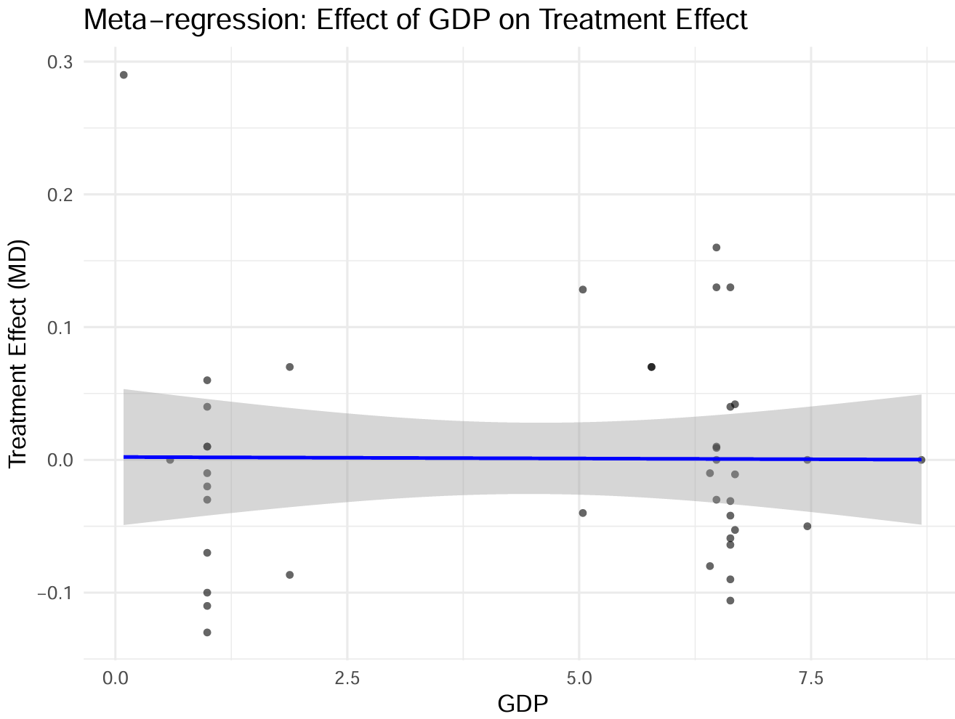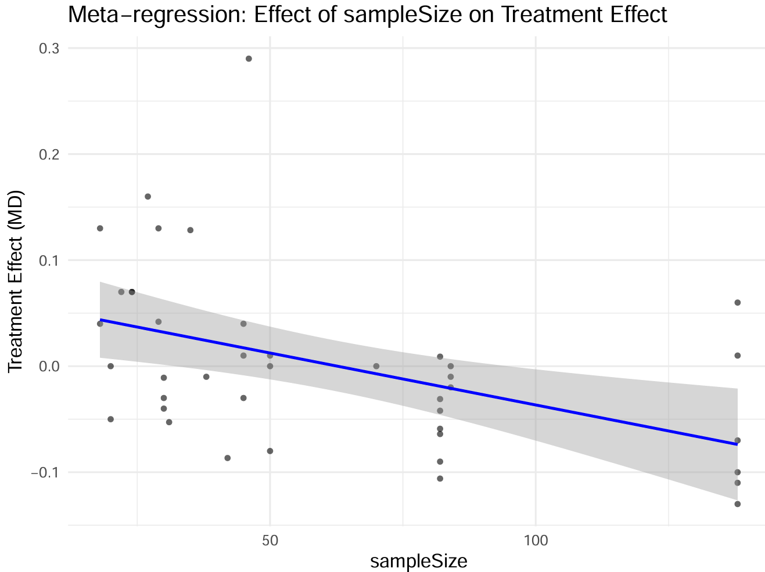

BBS
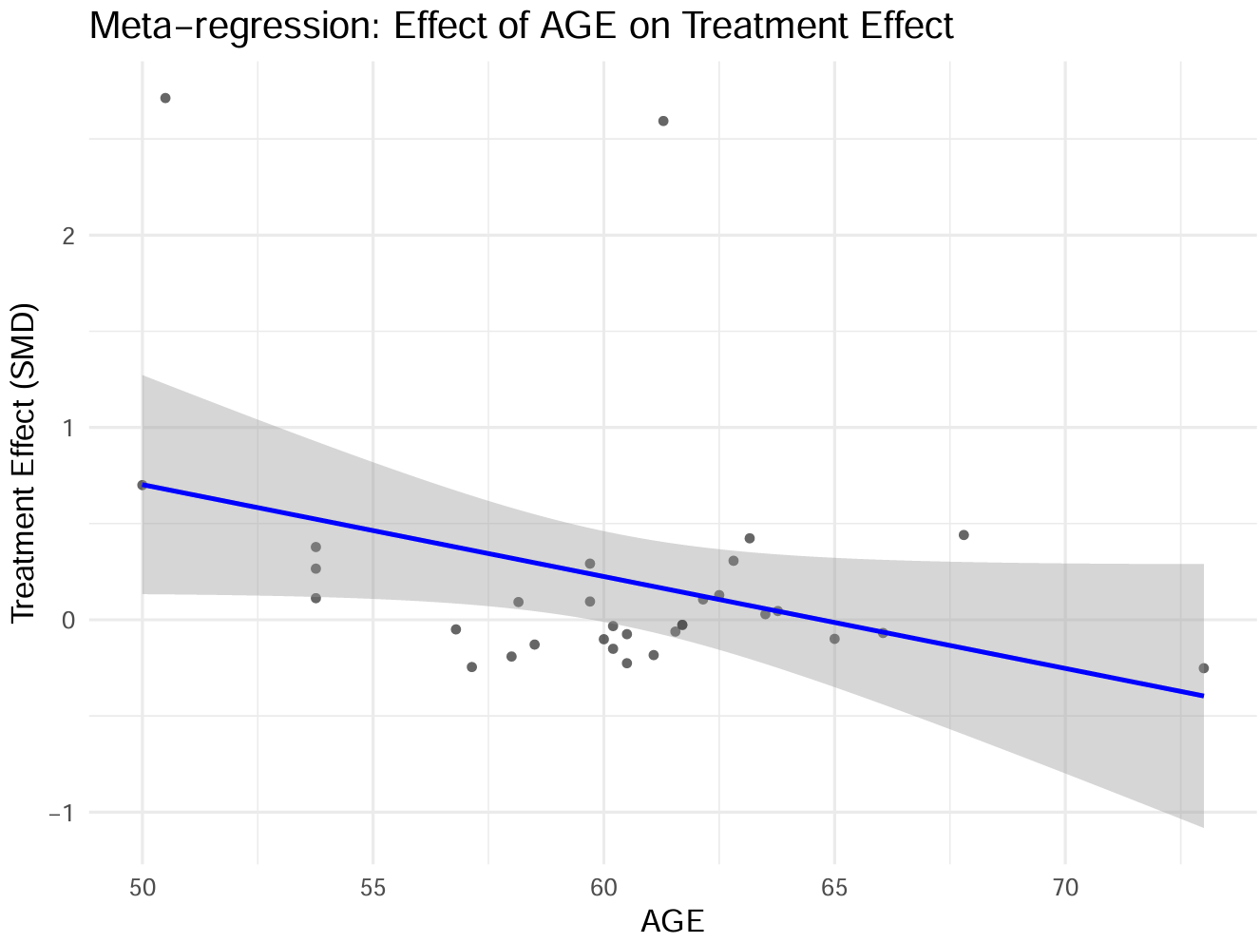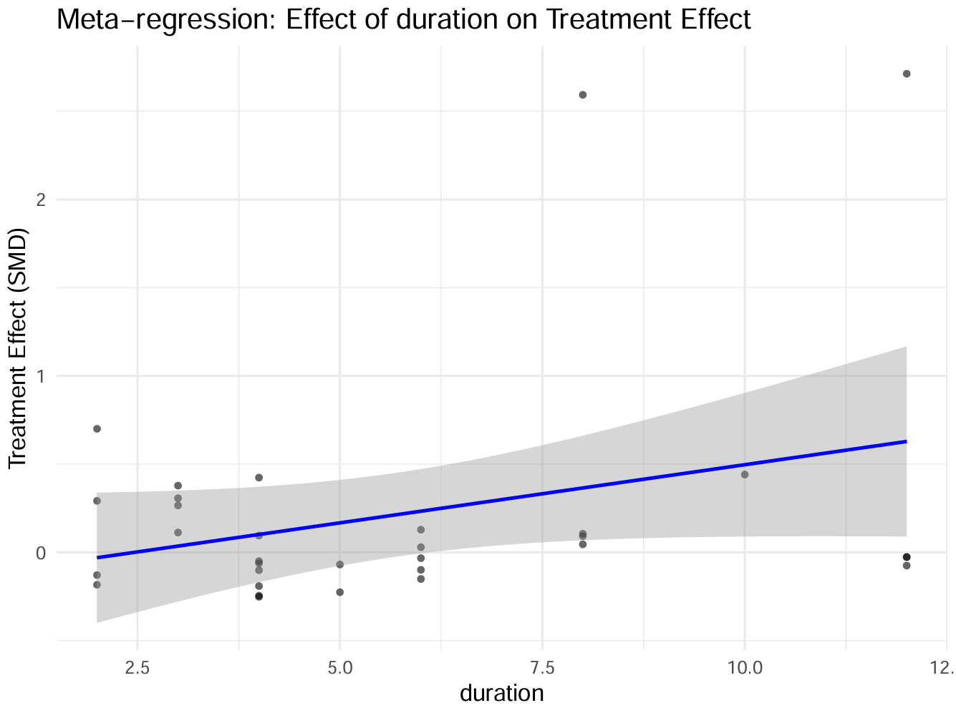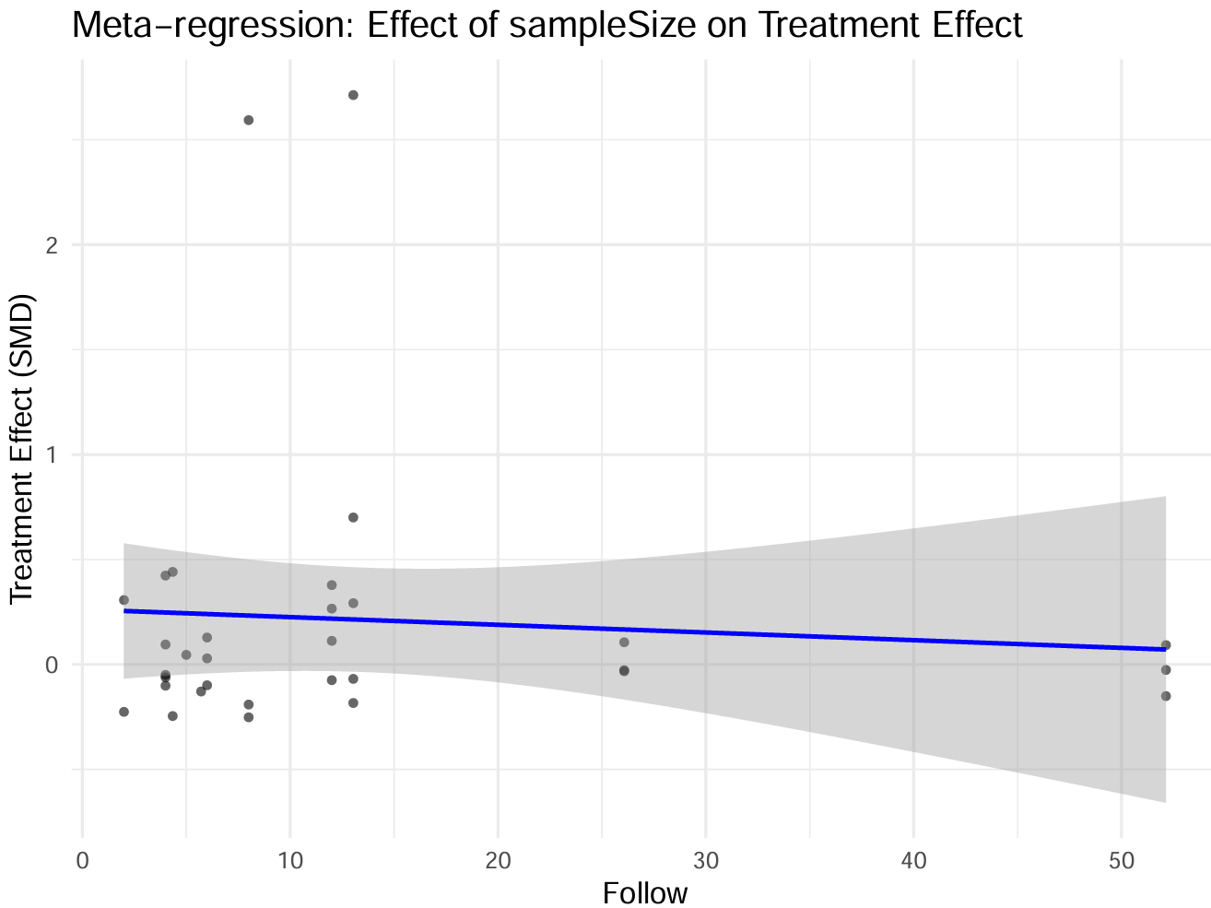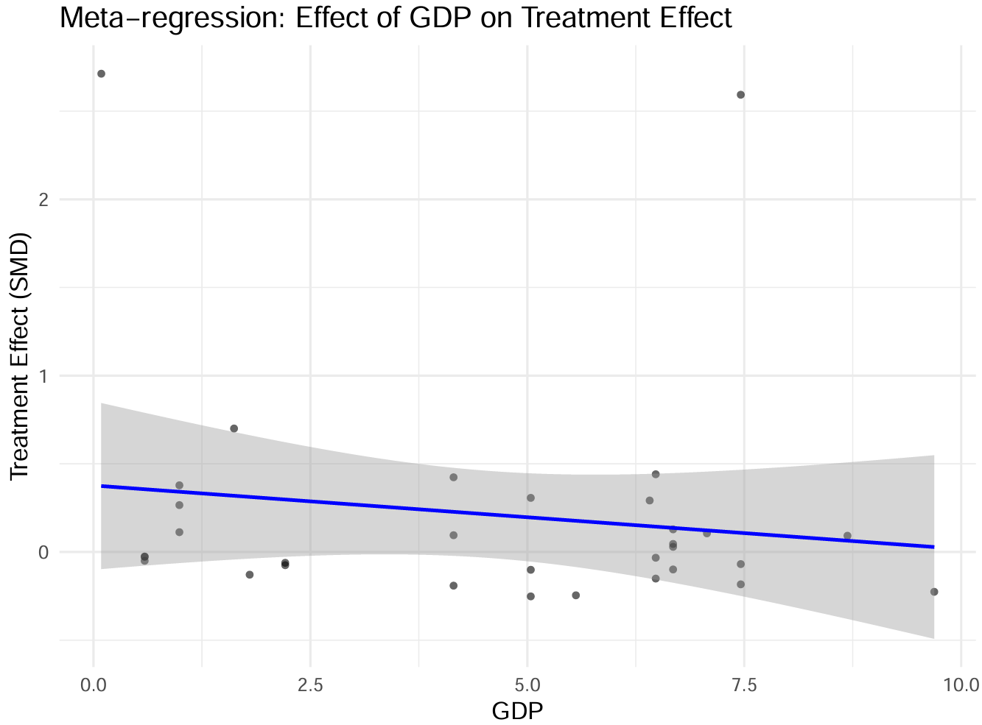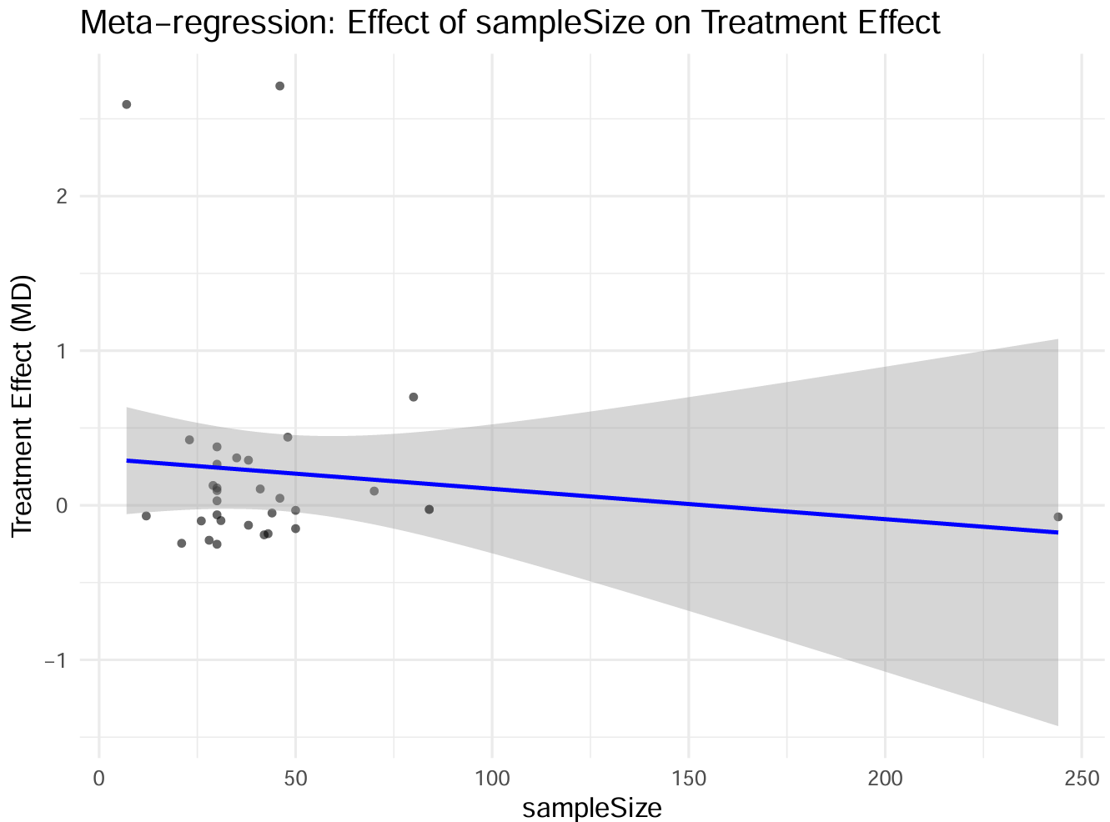

Supplementary 17 — Leave-one-out Sensitivity Analysis
6MWT
Table S 17.1 Leave-one-out sensitivity analysis of AGE
excluded_study | beta | se_beta | z | p_value
6 | 397.2628 | 375.8218 | 1.057051 | 0.290488
10 | 397.2628 | 375.8218 | 1.057051 | 0.290488
11 | 397.5256 | 376.1431 | 1.056846 | 0.290582
12 | 397.2628 | 375.8218 | 1.057051 | 0.290488
14 | 397.3105 | 375.8224 | 1.057176 | 0.290431
24 | 397.2628 | 375.8218 | 1.057051 | 0.290488
26 | 397.2628 | 375.8218 | 1.057051 | 0.290488
27 | 397.2628 | 375.8218 | 1.057051 | 0.290488
28 | 397.2628 | 375.8218 | 1.057051 | 0.290488
32 | 386.3833 | 377.1896 | 1.024374 | 0.305659
66 | 397.2628 | 375.8218 | 1.057051 | 0.290488
109 | 397.2628 | 375.8218 | 1.057051 | 0.290488
110 | 391.6344 | 376.1672 | 1.041118 | 0.297821
126 | 397.2628 | 375.8218 | 1.057051 | 0.290488
138 | 397.2628 | 375.8218 | 1.057051 | 0.290488

Table S 17.2 Leave-one-out sensitivity analysis of Intervention cycle
excluded_study | beta | se_beta | z | p_value
6 | -89.9668 | 68.47492 | -1.31387 | 0.188891
10 | -89.9668 | 68.47492 | -1.31387 | 0.188891
11 | -90.2107 | 68.50375 | -1.31687 | 0.187881
12 | -89.9668 | 68.47492 | -1.31387 | 0.188891
14 | -89.9543 | 68.47499 | -1.31368 | 0.188954
24 | -89.9668 | 68.47492 | -1.31387 | 0.188891
26 | -89.9668 | 68.47492 | -1.31387 | 0.188891
27 | -89.9668 | 68.47492 | -1.31387 | 0.188891
28 | -89.9668 | 68.47492 | -1.31387 | 0.188891
32 | -89.3333 | 68.62123 | -1.30183 | 0.192974
66 | -89.9668 | 68.47492 | -1.31387 | 0.188891
109 | -89.9668 | 68.47492 | -1.31387 | 0.188891
110 | -89.4531 | 68.50602 | -1.30577 | 0.191631
126 | -89.9668 | 68.47492 | -1.31387 | 0.188891
138 | -89.9668 | 68.47492 | -1.31387 | 0.188891
144 | -89.9668 | 68.47492 | -1.31387 | 0.188891
167 | -89.9668 | 68.47492 | -1.31387 | 0.188891
185 | -96.1596 | 81.275 | -1.18314 | 0.236754
202 | -90.0653 | 68.49335 | -1.31495 | 0.188527
207 | -89.9561 | 68.539 | -1.31248 | 0.189358
228 | -89.3333 | 68.62123 | -1.30183 | 0.192974
234 | -89.9668 | 68.47492 | -1.31387 | 0.188891
235 | 9.90049 | 42.00891 | 0.235676 | 0.813684
239 | -89.9668 | 68.47492 | -1.31387 | 0.188891
263 | -89.9668 | 68.47492 | -1.31387 | 0.188891
267 | -89.9668 | 68.47492 | -1.31387 | 0.188891
336 | -89.9668 | 68.47492 | -1.31387 | 0.188891
343 | -89.9668 | 68.47492 | -1.31387 | 0.188891
353 | -89.9668 | 68.47492 | -1.31387 | 0.188891
355 | -89.9668 | 68.47492 | -1.31387 | 0.188891
364 | -89.9668 | 68.47492 | -1.31387 | 0.188891
389 | -89.9668 | 68.47492 | -1.31387 | 0.188891
660 | -89.9668 | 68.47492 | -1.31387 | 0.188891
3640 | -89.9668 | 68.47492 | -1.31387 | 0.188891

Table S 17.3 Leave-one-out sensitivity analysis of Follow
excluded_study | beta | se_beta | z | p_value
6 | 48.03815 | 81.98405 | 0.585945 | 0.557912
10 | 48.03815 | 81.98405 | 0.585945 | 0.557912
11 | 40.28655 | 91.95677 | 0.438103 | 0.661311
12 | 48.03815 | 81.98405 | 0.585945 | 0.557912
14 | 47.95338 | 88.68208 | 0.540734 | 0.588691
24 | 48.03815 | 81.98405 | 0.585945 | 0.557912
26 | 47.16141 | 92.87295 | 0.507806 | 0.61159
27 | 48.03815 | 81.98405 | 0.585945 | 0.557912
28 | 48.03815 | 81.98406 | 0.585945 | 0.557912
32 | 40.31876 | 93.26163 | 0.432319 | 0.66551
66 | 47.16141 | 92.87295 | 0.507806 | 0.61159
109 | 48.03815 | 81.98405 | 0.585945 | 0.557912
110 | 47.858 | 89.85619 | 0.532607 | 0.594306
126 | 48.03815 | 81.98405 | 0.585945 | 0.557912
138 | 48.03815 | 81.98405 | 0.585945 | 0.557912
144 | 48.5656 | 64.59032 | 0.751902 | 0.45211
167 | 48.5656 | 64.59032 | 0.751902 | 0.45211
185 | 111.554 | 227.6292 | 0.490069 | 0.624085
202 | 46.06215 | 94.63968 | 0.486711 | 0.626463
207 | 47.54941 | 95.78872 | 0.496399 | 0.619613
228 | 48.37531 | 89.20793 | 0.542276 | 0.587628
234 | 48.03815 | 81.98406 | 0.585945 | 0.557912
235 | 12.80288 | 145.4924 | 0.087997 | 0.929879
239 | 48.03815 | 81.98405 | 0.585945 | 0.557912
263 | 48.03815 | 81.98405 | 0.585945 | 0.557912
267 | 48.03815 | 81.98406 | 0.585945 | 0.557912
336 | 48.03815 | 81.98405 | 0.585945 | 0.557912
343 | 48.03815 | 81.98405 | 0.585945 | 0.557912
353 | 48.03815 | 81.98406 | 0.585945 | 0.557912
355 | 48.03815 | 81.98405 | 0.585945 | 0.557912
364 | 48.03815 | 81.98405 | 0.585945 | 0.557912
389 | 48.03815 | 81.98405 | 0.585945 | 0.557912
660 | 47.16141 | 92.87295 | 0.507806 | 0.61159
3640 | 48.03815 | 81.98405 | 0.585945 | 0.557912

Table S 17.4 Leave-one-out sensitivity analysis of GDP
excluded_study | beta | se_beta | z | p_value
6 | 23.82755 | 63.25155 | 0.376711 | 0.706389
10 | 23.82755 | 63.25155 | 0.376711 | 0.706389
11 | 28.59393 | 63.64401 | 0.449279 | 0.65323
12 | 23.82755 | 63.25155 | 0.376711 | 0.706389
14 | 23.74454 | 63.25452 | 0.375381 | 0.707377
24 | 23.82755 | 63.25155 | 0.376711 | 0.706389
26 | 23.82755 | 63.25155 | 0.376711 | 0.706389
27 | 23.82755 | 63.25155 | 0.376711 | 0.706389
28 | 23.82755 | 63.25155 | 0.376711 | 0.706389
32 | 36.89263 | 64.69714 | 0.570236 | 0.568518
66 | 23.82755 | 63.25155 | 0.376711 | 0.706389
109 | 23.82755 | 63.25155 | 0.376711 | 0.706389
110 | 26.32094 | 63.67191 | 0.413384 | 0.679325
126 | 23.82755 | 63.25155 | 0.376711 | 0.706389
138 | 23.82755 | 63.25155 | 0.376711 | 0.706389
144 | 23.82755 | 63.25155 | 0.376711 | 0.706389
167 | 23.82755 | 63.25155 | 0.376711 | 0.706389
185 | 2793.461 | 2883.713 | 0.968703 | 0.332693
202 | 25.34667 | 63.35241 | 0.40009 | 0.68909
207 | 36.89263 | 64.69714 | 0.570236 | 0.568518
228 | 36.89263 | 64.69714 | 0.570236 | 0.568518
234 | 23.82755 | 63.25155 | 0.376711 | 0.706389
235 | 11.404 | 64.56006 | 0.176642 | 0.85979
239 | 23.82755 | 63.25155 | 0.376711 | 0.706389
263 | 23.82755 | 63.25155 | 0.376711 | 0.706389
267 | 23.82755 | 63.25155 | 0.376711 | 0.706389
336 | 23.82755 | 63.25155 | 0.376711 | 0.706389
343 | 23.82755 | 63.25155 | 0.376711 | 0.706389
353 | 23.82755 | 63.25155 | 0.376711 | 0.706389
355 | 23.82755 | 63.25155 | 0.376711 | 0.706389
364 | 23.82755 | 63.25155 | 0.376711 | 0.706389
389 | 23.82755 | 63.25155 | 0.376711 | 0.706389
660 | 23.82755 | 63.25155 | 0.376711 | 0.706389
3640 | 23.82755 | 63.25155 | 0.376711 | 0.706389

Table S 17.5 Leave-one-out sensitivity analysis of Sample size
excluded_study | beta | se_beta | z | p_value
6 | -11.9581 | 61.31914 | -0.19501 | 0.845382
10 | -11.9581 | 61.31914 | -0.19501 | 0.845382
11 | -12.4481 | 61.46104 | -0.20254 | 0.839498
12 | -11.9581 | 61.31914 | -0.19501 | 0.845382
14 | -11.958 | 61.31914 | -0.19501 | 0.845383
24 | -11.9581 | 61.31914 | -0.19501 | 0.845382
26 | -11.9581 | 61.31914 | -0.19501 | 0.845382
27 | -11.9581 | 61.31914 | -0.19501 | 0.845382
28 | -11.9581 | 61.31914 | -0.19501 | 0.845382
32 | 61.53333 | 84.87358 | 0.725 | 0.468452
66 | -11.9581 | 61.31914 | -0.19501 | 0.845382
109 | -11.9581 | 61.31914 | -0.19501 | 0.845382
110 | -10.6457 | 61.47517 | -0.17317 | 0.862517
126 | -11.9581 | 61.31914 | -0.19501 | 0.845382
138 | -11.9581 | 61.31914 | -0.19501 | 0.845382
144 | -11.9581 | 61.31914 | -0.19501 | 0.845382
167 | -11.9581 | 61.31914 | -0.19501 | 0.845382
185 | -200.315 | 162.4189 | -1.23333 | 0.217454
202 | 3.570629 | 66.81329 | 0.053442 | 0.95738
207 | -11.4449 | 61.55878 | -0.18592 | 0.852509
228 | 61.53333 | 84.87358 | 0.725 | 0.468452
234 | -11.9581 | 61.31914 | -0.19501 | 0.845382
235 | 6.142245 | 62.99937 | 0.097497 | 0.922332
239 | -11.9581 | 61.31914 | -0.19501 | 0.845382
263 | -11.9581 | 61.31914 | -0.19501 | 0.845382
267 | -11.9581 | 61.31914 | -0.19501 | 0.845382
336 | -11.9581 | 61.31914 | -0.19501 | 0.845382
343 | -11.9581 | 61.31914 | -0.19501 | 0.845382
353 | -11.9581 | 61.31914 | -0.19501 | 0.845382
355 | -11.9581 | 61.31914 | -0.19501 | 0.845382

10MWT
Table S 17.6 Leave-one-out sensitivity analysis of AGE
excluded_study | beta | se_beta | z | p_value
12 | 1.475259 | 4.002983 | 0.36854 | 0.712471
27 | 1.475259 | 4.002983 | 0.36854 | 0.712471
28 | 1.475259 | 4.002983 | 0.36854 | 0.712471
32 | 0.07 | 0.093762 | 0.74657 | 0.455323
66 | 1.475259 | 4.002983 | 0.36854 | 0.712471
83 | 1.475259 | 4.002983 | 0.36854 | 0.712471
126 | 1.475259 | 4.002983 | 0.36854 | 0.712471
144 | 1.475259 | 4.002983 | 0.36854 | 0.712471
167 | 1.475259 | 4.002983 | 0.36854 | 0.712471
185 | 0.009 | 0.143605 | 0.062672 | 0.950028
207 | 1.475259 | 4.002983 | 0.36854 | 0.712471
228 | 0.07 | 0.093762 | 0.74657 | 0.455323
234 | 1.475259 | 4.002983 | 0.36854 | 0.712471
241 | 1.475259 | 4.002983 | 0.36854 | 0.712471
267 | 1.475259 | 4.002983 | 0.36854 | 0.712471
270 | 1.475259 | 4.002983 | 0.36854 | 0.712471
321 | 1.475259 | 4.002983 | 0.36854 | 0.712471
336 | 1.475259 | 4.002983 | 0.36854 | 0.712471
353 | 1.475259 | 4.002983 | 0.36854 | 0.712471
355 | 1.475259 | 4.002983 | 0.36854 | 0.712471
364 | 1.475259 | 4.002983 | 0.36854 | 0.712471
660 | 1.475259 | 4.002983 | 0.36854 | 0.712471
1440 | 1.475259 | 4.002983 | 0.36854 | 0.712471
2340 | 1.475259 | 4.002983 | 0.36854 | 0.712471
3210 | 1.475259 | 4.002983 | 0.36854 | 0.712471
3360 | 1.475259 | 4.002983 | 0.36854 | 0.712471
3640 | 1.475259 | 4.002983 | 0.36854 | 0.712471

Table S 17.7 Leave-one-out sensitivity analysis of Intervention cycle
excluded_study | beta | se_beta | z | p_value
12 | 0.07 | 0.093762 | 0.74657 | 0.455323
27 | 0.07 | 0.093762 | 0.74657 | 0.455323
28 | 0.07 | 0.093762 | 0.74657 | 0.455323
32 | 0.07 | 0.093762 | 0.74657 | 0.455323
66 | 0.07 | 0.093762 | 0.74657 | 0.455323
83 | 0.07 | 0.093762 | 0.74657 | 0.455323
126 | 0.07 | 0.093762 | 0.74657 | 0.455323
144 | 0.07 | 0.093762 | 0.74657 | 0.455323
167 | 0.07 | 0.093762 | 0.74657 | 0.455323
185 | 0.009 | 0.143605 | 0.062672 | 0.950028
207 | 0.07 | 0.093762 | 0.74657 | 0.455323
228 | 0.07 | 0.093762 | 0.74657 | 0.455323
234 | 0.07 | 0.093762 | 0.74657 | 0.455323
241 | 0.07 | 0.093762 | 0.74657 | 0.455323
267 | 0.07 | 0.093762 | 0.74657 | 0.455323
270 | 0.07 | 0.093762 | 0.74657 | 0.455323
321 | 0.07 | 0.093762 | 0.74657 | 0.455323
336 | 0.07 | 0.093762 | 0.74657 | 0.455323
353 | 0.07 | 0.093762 | 0.74657 | 0.455323
355 | 0.07 | 0.093762 | 0.74657 | 0.455323
364 | 0.07 | 0.093762 | 0.74657 | 0.455323
660 | 0.07 | 0.093762 | 0.74657 | 0.455323
1440 | 0.07 | 0.093762 | 0.74657 | 0.455323
2340 | 0.07 | 0.093762 | 0.74657 | 0.455323
3210 | 0.07 | 0.093762 | 0.74657 | 0.455323
3360 | 0.07 | 0.093762 | 0.74657 | 0.455323
3640 | 0.07 | 0.093762 | 0.74657 | 0.455323

Table S 17.8 Leave-one-out sensitivity analysis of Follow
excluded_study | beta | se_beta | z | p_value
12 | 0.131 | 0.236194 | 0.554628 | 0.579149
27 | 0.131 | 0.236194 | 0.554628 | 0.579149
28 | 0.131 | 0.236194 | 0.554628 | 0.579149
32 | 0.07 | 0.093762 | 0.74657 | 0.455323
66 | 0.131 | 0.236194 | 0.554628 | 0.579149
83 | 0.131 | 0.236194 | 0.554628 | 0.579149
126 | 0.131 | 0.236194 | 0.554628 | 0.579149
144 | 0.131 | 0.236194 | 0.554628 | 0.579149
167 | 0.131 | 0.236194 | 0.554628 | 0.579149
185 | 0.009 | 0.143605 | 0.062672 | 0.950028
207 | 0.131 | 0.236194 | 0.554628 | 0.579149
228 | 0.07 | 0.093762 | 0.74657 | 0.455323
234 | 0.131 | 0.236194 | 0.554628 | 0.579149
241 | 0.131 | 0.236194 | 0.554628 | 0.579149
267 | 0.131 | 0.236194 | 0.554628 | 0.579149
270 | 0.131 | 0.236194 | 0.554628 | 0.579149
321 | 0.131 | 0.236194 | 0.554628 | 0.579149
336 | 0.131 | 0.236194 | 0.554628 | 0.579149
353 | 0.131 | 0.236194 | 0.554628 | 0.579149
355 | 0.131 | 0.236194 | 0.554628 | 0.579149
364 | 0.131 | 0.236194 | 0.554628 | 0.579149
660 | 0.131 | 0.236194 | 0.554628 | 0.579149
1440 | 0.131 | 0.236194 | 0.554628 | 0.579149
2340 | 0.131 | 0.236194 | 0.554628 | 0.579149
3210 | 0.131 | 0.236194 | 0.554628 | 0.579149
3360 | 0.131 | 0.236194 | 0.554628 | 0.579149
3640 | 0.131 | 0.236194 | 0.554628 | 0.579149

Table S 17.9 Leave-one-out sensitivity analysis of GDP
excluded_study | beta | se_beta | z | p_value
12 | 0.09493 | 0.144535 | 0.656799 | 0.51131
27 | 0.09493 | 0.144535 | 0.656799 | 0.51131
28 | 0.09493 | 0.144535 | 0.656799 | 0.51131
32 | 0.07 | 0.093762 | 0.74657 | 0.455323
66 | 0.09493 | 0.144535 | 0.656799 | 0.51131
83 | 0.09493 | 0.144535 | 0.656799 | 0.51131
126 | 0.09493 | 0.144535 | 0.656799 | 0.51131
144 | 0.09493 | 0.144535 | 0.656799 | 0.51131
167 | 0.09493 | 0.144535 | 0.656799 | 0.51131
185 | 0.009 | 0.143605 | 0.062672 | 0.950028
207 | 0.09493 | 0.144535 | 0.656799 | 0.51131
228 | 0.07 | 0.093762 | 0.74657 | 0.455323
234 | 0.09493 | 0.144535 | 0.656799 | 0.51131
241 | 0.09493 | 0.144535 | 0.656799 | 0.51131
267 | 0.09493 | 0.144535 | 0.656799 | 0.51131
270 | 0.09493 | 0.144535 | 0.656799 | 0.51131
321 | 0.09493 | 0.144535 | 0.656799 | 0.51131
336 | 0.09493 | 0.144535 | 0.656799 | 0.51131
353 | 0.09493 | 0.144535 | 0.656799 | 0.51131
355 | 0.09493 | 0.144535 | 0.656799 | 0.51131
364 | 0.09493 | 0.144535 | 0.656799 | 0.51131
660 | 0.09493 | 0.144535 | 0.656799 | 0.51131
1440 | 0.09493 | 0.144535 | 0.656799 | 0.51131
2340 | 0.09493 | 0.144535 | 0.656799 | 0.51131
3210 | 0.09493 | 0.144535 | 0.656799 | 0.51131
3360 | 0.09493 | 0.144535 | 0.656799 | 0.51131
3640 | 0.09493 | 0.144535 | 0.656799 | 0.51131

Table S 17.10 Leave-one-out sensitivity analysis of Sample size
excluded_study | beta | se_beta | z | p_value
12 | 0.092367 | 0.138538 | 0.666723 | 0.504949
27 | 0.092367 | 0.138538 | 0.666723 | 0.504949
28 | 0.092367 | 0.138538 | 0.666723 | 0.504949
32 | 0.07 | 0.093762 | 0.74657 | 0.455323
66 | 0.092367 | 0.138538 | 0.666723 | 0.504949
83 | 0.092367 | 0.138538 | 0.666723 | 0.504949
126 | 0.092367 | 0.138538 | 0.666723 | 0.504949
144 | 0.092367 | 0.138538 | 0.666723 | 0.504949
167 | 0.092367 | 0.138538 | 0.666723 | 0.504949
185 | 0.009 | 0.143605 | 0.062672 | 0.950028
207 | 0.092367 | 0.138538 | 0.666723 | 0.504949
228 | 0.07 | 0.093762 | 0.74657 | 0.455323
234 | 0.092367 | 0.138538 | 0.666723 | 0.504949
241 | 0.092367 | 0.138538 | 0.666723 | 0.504949
267 | 0.092367 | 0.138538 | 0.666723 | 0.504949
270 | 0.092367 | 0.138538 | 0.666723 | 0.504949
321 | 0.092367 | 0.138538 | 0.666723 | 0.504949
336 | 0.092367 | 0.138538 | 0.666723 | 0.504949
353 | 0.092367 | 0.138538 | 0.666723 | 0.504949
355 | 0.092367 | 0.138538 | 0.666723 | 0.504949
364 | 0.092367 | 0.138538 | 0.666723 | 0.504949
660 | 0.092367 | 0.138538 | 0.666723 | 0.504949
1440 | 0.092367 | 0.138538 | 0.666723 | 0.504949
2340 | 0.092367 | 0.138538 | 0.666723 | 0.504949
3210 | 0.092367 | 0.138538 | 0.666723 | 0.504949
3360 | 0.092367 | 0.138538 | 0.666723 | 0.504949
3640 | 0.092367 | 0.138538 | 0.666723 | 0.504949

BBS
Table S 17.11 Leave-one-out sensitivity analysis of AGE
excluded_study | beta | se_beta | z | p_value
6 | 4.991722 | 14.67914 | 0.340056 | 0.733815
14 | 4.991722 | 14.67914 | 0.340056 | 0.733815
24 | 4.991722 | 14.67914 | 0.340056 | 0.733815
26 | 4.991722 | 14.67914 | 0.340056 | 0.733815
66 | 4.991722 | 14.67914 | 0.340056 | 0.733815
83 | 4.991722 | 14.67914 | 0.340056 | 0.733815
109 | 4.991722 | 14.67914 | 0.340056 | 0.733815
114 | 4.991722 | 14.67914 | 0.340056 | 0.733815
126 | 4.991722 | 14.67914 | 0.340056 | 0.733815
162 | -0.67744 | 10.8529 | -0.06242 | 0.950229
167 | 4.991722 | 14.67914 | 0.340056 | 0.733815
182 | -0.80456 | 19.09897 | -0.04213 | 0.966398
207 | 4.991722 | 14.67914 | 0.340056 | 0.733815
228 | 4.991722 | 14.67914 | 0.340056 | 0.733815
237 | 4.991722 | 14.67914 | 0.340056 | 0.733815
241 | 4.991722 | 14.67914 | 0.340056 | 0.733815
280 | 4.991722 | 14.67914 | 0.340056 | 0.733815
289 | 4.991722 | 14.67914 | 0.340056 | 0.733815
309 | 4.991722 | 14.67914 | 0.340056 | 0.733815
324 | 4.991722 | 14.67914 | 0.340056 | 0.733815
353 | 4.991722 | 14.67914 | 0.340056 | 0.733815
376 | 4.991722 | 14.67914 | 0.340056 | 0.733815
379 | -0.39692 | 0.506374 | -0.78386 | 0.433124
391 | -1.006 | 10.85501 | -0.09268 | 0.926161
406 | 4.991722 | 14.67914 | 0.340056 | 0.733815
660 | 4.991722 | 14.67914 | 0.340056 | 0.733815
2410 | 4.991722 | 14.67914 | 0.340056 | 0.733815

Table S 17.12 Leave-one-out sensitivity analysis of Intervention cycle
excluded_study | beta | se_beta | z | p_value
6 | -0.56025 | 2.844398 | -0.19696 | 0.843855
14 | -0.56025 | 2.844398 | -0.19696 | 0.843855
24 | -0.56025 | 2.844398 | -0.19696 | 0.843855
26 | -0.56025 | 2.844398 | -0.19696 | 0.843855
66 | -0.56025 | 2.844398 | -0.19696 | 0.843855
83 | -0.56025 | 2.844398 | -0.19696 | 0.843855
109 | -0.56025 | 2.844398 | -0.19696 | 0.843855
114 | -0.56025 | 2.844398 | -0.19696 | 0.843855
126 | -0.56025 | 2.844398 | -0.19696 | 0.843855
162 | -0.41995 | 2.854403 | -0.14712 | 0.883036
167 | -0.56025 | 2.844398 | -0.19696 | 0.843855
182 | -7.41003 | 3.040578 | -2.43705 | 0.014808
207 | -0.56025 | 2.844398 | -0.19696 | 0.843855
228 | -0.56025 | 2.844398 | -0.19696 | 0.843855
237 | -0.56025 | 2.844398 | -0.19696 | 0.843855
241 | -0.56025 | 2.844398 | -0.19696 | 0.843855
280 | -0.56025 | 2.844398 | -0.19696 | 0.843855
289 | -0.56025 | 2.844398 | -0.19696 | 0.843855
309 | -0.56025 | 2.844398 | -0.19696 | 0.843855
324 | -0.56025 | 2.844398 | -0.19696 | 0.843855
353 | -0.56025 | 2.844398 | -0.19696 | 0.843855
376 | -0.56025 | 2.844398 | -0.19696 | 0.843855
379 | -10.3456 | 4.25074 | -2.43385 | 0.014939
391 | -0.74851 | 2.862386 | -0.2615 | 0.793708
406 | -0.56025 | 2.844398 | -0.19696 | 0.843855
660 | -0.56025 | 2.844398 | -0.19696 | 0.843855
2410 | -0.56025 | 2.844398 | -0.19696 | 0.843855

Table S 17.13 Leave-one-out sensitivity analysis of Follow
excluded_study | beta | se_beta | z | p_value
6 | -0.44437 | 0.898902 | -0.49435 | 0.621059
14 | -0.44437 | 0.898902 | -0.49435 | 0.621059
24 | -0.44437 | 0.898902 | -0.49435 | 0.621059
26 | -0.44437 | 0.898902 | -0.49435 | 0.621059
66 | -0.44437 | 0.898902 | -0.49435 | 0.621059
83 | -0.44548 | 0.918413 | -0.48506 | 0.627636
109 | -0.44437 | 0.898902 | -0.49435 | 0.621059
114 | -0.44437 | 0.898902 | -0.49435 | 0.621059
126 | -0.44437 | 0.898902 | -0.49435 | 0.621059
162 | -0.30407 | 0.941848 | -0.32285 | 0.746812
167 | -0.44437 | 0.898902 | -0.49435 | 0.621059
182 | 1.512832 | 1.90043 | 0.796047 | 0.426005
207 | -0.44437 | 0.898902 | -0.49435 | 0.621059
228 | -0.44437 | 0.898902 | -0.49435 | 0.621059
237 | -0.44437 | 0.898902 | -0.49435 | 0.621059
241 | -0.44437 | 0.898902 | -0.49435 | 0.621059
280 | -0.44437 | 0.898902 | -0.49435 | 0.621059
289 | -0.44437 | 0.898902 | -0.49435 | 0.621059
309 | -0.44437 | 0.898902 | -0.49435 | 0.621059
324 | -0.44437 | 0.898902 | -0.49435 | 0.621059
353 | -0.44437 | 0.898902 | -0.49435 | 0.621059
376 | -0.44437 | 0.898902 | -0.49435 | 0.621059
379 | 0.245267 | 0.834438 | 0.29393 | 0.768811
391 | -0.63264 | 0.965774 | -0.65506 | 0.512432
406 | -0.44437 | 0.898902 | -0.49435 | 0.621059
660 | -0.44538 | 0.916532 | -0.48594 | 0.62701
2410 | -0.44437 | 0.898902 | -0.49435 | 0.621059

Table S 17.14 Leave-one-out sensitivity analysis of GDP
excluded_study | beta | se_beta | z | p_value
6 | -0.50771 | 1.24655 | -0.40729 | 0.683795
14 | -0.50771 | 1.24655 | -0.40729 | 0.683795
24 | -0.50771 | 1.24655 | -0.40729 | 0.683795
26 | -0.50771 | 1.24655 | -0.40729 | 0.683795
66 | -0.50771 | 1.24655 | -0.40729 | 0.683795
83 | -0.50771 | 1.24655 | -0.40729 | 0.683795
109 | -0.50771 | 1.24655 | -0.40729 | 0.683795
114 | -0.50771 | 1.24655 | -0.40729 | 0.683795
126 | -0.50771 | 1.24655 | -0.40729 | 0.683795
162 | -0.36741 | 1.269211 | -0.28948 | 0.772217
167 | -0.50771 | 1.24655 | -0.40729 | 0.683795
182 | 8.922016 | 5.639875 | 1.581953 | 0.11366
207 | -0.50771 | 1.24655 | -0.40729 | 0.683795
228 | -0.50771 | 1.24655 | -0.40729 | 0.683795
237 | -0.50771 | 1.24655 | -0.40729 | 0.683795
241 | -0.50771 | 1.24655 | -0.40729 | 0.683795
280 | -0.50771 | 1.24655 | -0.40729 | 0.683795
289 | -0.50771 | 1.24655 | -0.40729 | 0.683795
309 | -0.50771 | 1.24655 | -0.40729 | 0.683795
324 | -0.50771 | 1.24655 | -0.40729 | 0.683795
353 | -0.50771 | 1.24655 | -0.40729 | 0.683795
376 | -0.50771 | 1.24655 | -0.40729 | 0.683795
379 | 6.852519 | 4.383091 | 1.563399 | 0.117959
391 | -0.69597 | 1.287066 | -0.54074 | 0.588685
406 | -0.50771 | 1.24655 | -0.40729 | 0.683795
660 | -0.50771 | 1.24655 | -0.40729 | 0.683795
2410 | -0.50771 | 1.24655 | -0.40729 | 0.683795

Table S 17.15 Leave-one-out sensitivity analysis of Sample size
excluded_study | beta | se_beta | z | p_value
6 | -1.80828 | 3.106888 | -0.58202 | 0.560551
14 | -1.80828 | 3.106888 | -0.58202 | 0.560551
24 | -1.80828 | 3.106888 | -0.58202 | 0.560551
26 | -1.80828 | 3.106888 | -0.58202 | 0.560551
66 | -1.80828 | 3.106888 | -0.58202 | 0.560551
83 | -1.80828 | 3.106888 | -0.58202 | 0.560551
109 | -1.80828 | 3.106888 | -0.58202 | 0.560551
114 | -1.80828 | 3.106888 | -0.58202 | 0.560551
126 | -1.80828 | 3.106888 | -0.58202 | 0.560551
162 | -0.40015 | 2.248179 | -0.17799 | 0.858733
167 | -1.80828 | 3.106888 | -0.58202 | 0.560551
182 | -24.4854 | 6.790268 | -3.60595 | 0.000311
207 | -1.80828 | 3.106888 | -0.58202 | 0.560551
228 | -1.80828 | 3.106888 | -0.58202 | 0.560551
237 | -1.80828 | 3.106888 | -0.58202 | 0.560551
241 | -1.80828 | 3.106888 | -0.58202 | 0.560551
280 | -1.80828 | 3.106888 | -0.58202 | 0.560551
289 | -1.80828 | 3.106888 | -0.58202 | 0.560551
309 | -1.80828 | 3.106888 | -0.58202 | 0.560551
324 | -1.80828 | 3.106888 | -0.58202 | 0.560551
353 | -1.80828 | 3.106888 | -0.58202 | 0.560551
376 | -1.80828 | 3.106888 | -0.58202 | 0.560551
379 | -33.0243 | 9.300974 | -3.55062 | 0.000384
391 | -0.72871 | 2.258307 | -0.32268 | 0.746937
406 | -1.80828 | 3.106888 | -0.58202 | 0.560551
660 | -1.80828 | 3.106888 | -0.58202 | 0.560551

Supplementary 18 — Analysis Supplementary References
1. Fritz SL, Peters DM, Merlo AM, Donley J. Active Video-Gaming Effects on Balance and Mobility in Individuals with Chronic Stroke: A Randomized Controlled Trial. Topics in Stroke Rehabilitation. 2013;20(3):218-25.
2. Blennerhassett J, Dite W. Additional task-related practice improves mobility and upper limb function early after stroke: a randomised controlled trial. Australian journal of physiotherapy. 2004;50(4):219-24.
3. Valkenborghs SR, van Vliet P, Nilsson M, Zalewska K, Visser MM, Erickson KI, et al. Aerobic exercise and consecutive task-specific training (AExaCTT) for upper limb recovery after stroke: A randomized controlled pilot study. Physiotherapy research international : the journal for researchers and clinicians in physical therapy. 2019;24(3):e1775-e.
4. Eich HJ, Mach H, Werner C, Hesse S. Aerobic treadmill plus Bobath walking training improves walking in subacute stroke: a randomized controlled trial. Clinical Rehabilitation. 2004;18(6):640-51.
5. Mulder M, Nikamp CDM, Prinsen EC, Nijland RHM, van Dorp M, Buurke J, et al. Allied rehabilitation using caregiver-mediated exercises combined with telerehabilitation for stroke (ARMed4Stroke): A randomised controlled trial. Clinical Rehabilitation. 2024;38(10):1321-32.
6. Lam SSL, Liu TW, Ng SSM, Lai CWK, Woo J. BILATERAL MOVEMENT-BASED COMPUTER GAMES IMPROVE SENSORIMOTOR FUNCTIONS IN SUBACUTE STROKE SURVIVORS: A RANDOMIZED CONTROLLED TRIAL. Journal of Rehabilitation Medicine. 2022;54.
7. Shiner CT, Byblow WD, McNulty PA. Bilateral Priming Before Wii-based Movement Therapy Enhances Upper Limb Rehabilitation and Its Retention After Stroke: A Case-Controlled Study. Neurorehabilitation and Neural Repair. 2014;28(9):828-38.
8. Lindvall MA, Forsberg A. Body awareness therapy in persons with stroke: a pilot randomized controlled trial. Clinical Rehabilitation. 2014;28(12):1180-8.
9. Middleton A, Merlo-Rains A, Peters DM, Greene JV, Blanck EL, Moran R, et al. Body Weight-Supported Treadmill Training Is No Better Than Overground Training for Individuals with Chronic Stroke: A Randomized Controlled Trial. Topics in Stroke Rehabilitation. 2014;21(6):462-76.
10. Combs-Miller SA, Parameswaran AK, Colburn D, Ertel T, Harmeyer A, Tucker L, et al. Body weight-supported treadmill training vs. overground walking training for persons with chronic stroke: a pilot randomized controlled trial. Clinical Rehabilitation. 2014;28(9):873-84.
11. Srivastava A, Taly AB, Gupta A, Kumar S, Murali T. Bodyweight-supported treadmill training for retraining gait among chronic stroke survivors: A randomized controlled study. Annals of Physical and Rehabilitation Medicine. 2016;59(4):235-41.
12. Moncion K, Rodrigues L, de las Heras B, Noguchi KS, Wiley E, Eng JJ, et al. Cardiorespiratory Fitness Benefits of High-Intensity Interval Training After Stroke: A Randomized Controlled Trial. Stroke. 2024;55(9):2202-11.
13. Hejazi-Shirmard M, Taghizadeh G, Rassafiani M, Cheraghifard M, Yousefi M, Hosseini SH, et al. Bottom-up versus Top-down designed rehabilitation sessions in chronic stroke survivors: a pilot randomized controlled trial. Disability and Rehabilitation. 2025;47(7):1807-16.
14. MacKay-Lyons M, McDonald A, Matheson J, Eskes G, Klus M-A. Dual Effects of Body-Weight Supported Treadmill Training on Cardiovascular Fitness and Walking Ability Early After Stroke: A Randomized Controlled Trial. Neurorehabilitation and Neural Repair. 2013;27(7):644-53.
15. Oh K, Im N, Lee Y, Lim N, Cho T, Ryu S, et al. Effect of Antigravity Treadmill Gait Training on Gait Function and Fall Risk in Stroke Patients. Annals of rehabilitation medicine. 2022;46(3):114-21.
16. Fleming MK, Sorinola IO, Roberts-Lewis SF, Wolfe CD, Wellwood I, Newham DJ. The Effect of Combined Somatosensory Stimulation and Task-Specific Training on Upper Limb Function in Chronic Stroke: A Double-Blind Randomized Controlled Trial. Neurorehabilitation and Neural Repair. 2015;29(2):143-52.
17. May HI, Ozdolap S, Mengi A, Sarikaya S. The effect of mirror therapy on lower extremity motor function and ambulation in post-stroke patients: A prospective, randomized-controlled study. Turkish Journal of Physical Medicine and Rehabilitation. 2020;66(2):154-60.
18. Bahgat F. Effect of Nursing Intervention by Using Physical Exercises Modules on Gait and Balance for Stroke Patients. NeuroQuantology. 2022;20(20):615-30.
19. Chung SH, Kim JH, Yong SY, Lee YH, Park JM, Kim SH, et al. Effect of Task-Specific Lower Extremity Training on Cognitive and Gait Function in Stroke Patients: A Prospective Randomized Controlled Trial. Annals of rehabilitation medicine. 2019;43(1):1-10.
20. de Rooij IJM, van de Port IGL, Punt M, Abbink-van Moorsel PJM, Kortsmit M, van Eijk RPA, et al. Effect of Virtual Reality Gait Training on Participation in Survivors of Subacute Stroke: A Randomized Controlled Trial. Physical Therapy. 2021;101(5).
21. Nayak P, Kumaran SD, Mahmood A, Natarajan M, Unnikrishnan B, Solomon JM. Effectiveness of a comprehensive physical activity promotion program on physical activity levels, mobility and quality of life in community-dwelling stroke survivors: a preliminary cluster randomised controlled trial. Disability and Rehabilitation. 2025.
22. Utkan Karasu A, Balevi Batur E, Kaymak Karatas G. EFFECTIVENESS OF WII-BASED REHABILITATION IN STROKE: A RANDOMIZED CONTROLLED STUDY. Journal of Rehabilitation Medicine. 2018;50(5):406-12.
23. Nindorera F, Nduwimana I, Sinzakaraye A, Havyarimana E, Bleyenheuft Y, Thonnard J-L, et al. Effect of mixed and collective physical activity in chronic stroke rehabilitation: A randomized cross-over trial in low-income settings. Annals of Physical and Rehabilitation Medicine. 2023;66(4).
24. Toh FM, Lam WWT, Cruz Gonzalez P, Fong KNK. Effects of a Wearable-Based Intervention on the Hemiparetic Upper Limb in Persons With Stroke: A Randomized Controlled Trial. Neurorehabilitation and Neural Repair. 2025;39(1):31-46.
25. Braun T, Marks D, Thiel C, Zietz D, Zutter D, Grueneberg C. Effects of additional, dynamic supported standing practice on functional recovery in patients with sub-acute stroke: a randomized pilot and feasibility trial. Clinical Rehabilitation. 2016;30(4):374-82.
26. Aguiar LT, Nadeau S, Britto RR, Teixeira-Salmela LF, Martins JC, Ribeiro Samora GA, et al. Effects of aerobic training on physical activity in people with stroke: A randomized controlled trial. Neurorehabilitation. 2020;46(3):391-401.
27. van de Port IGL, Wevers LEG, Lindeman E, Kwakkel G. Effects of circuit training as alternative to usual physiotherapy after stroke: randomised controlled trial. Bmj-British Medical Journal. 2012;344.
28. Aloraini SM. Effects of constraint-induced movement therapy for the lower extremity among individuals post-stroke: A randomized controlled clinical trial. Neurorehabilitation. 2022;51(3):421-31.
29. Graef P, Michaelsen SM, Dadalt MLR, Rodrigues DAMS, Pereira F, Pagnussat AS. Effects of functional and analytical strength training on upper-extremity activity after stroke: a randomized controlled trial. Brazilian Journal of Physical Therapy. 2016;20(6):543-52.
30. Gjellesvik TI, Becker F, Tjonna AE, Indredavik B, Lundgaard E, Solbakken H, et al. Effects of High-Intensity Interval Training After Stroke (The HIIT Stroke Study) on Physical and Cognitive Function: A Multicenter Randomized Controlled Trial. Archives of Physical Medicine and Rehabilitation. 2021;102(9):1683-91.
31. Ase H, Honaga K, Tani M, Takakura T, Wada F, Murakami Y, et al. Effects of home-based virtual reality upper extremity rehabilitation in persons with chronic stroke: a randomized controlled trial. Journal of Neuroengineering and Rehabilitation. 2025;22(1).
32. Bunketorp-Kall L, Pekna M, Pekny M, Blomstrand C, Nilsson M. Effects of horse-riding therapy and rhythm and music-based therapy on functional mobility in late phase after stroke. Neurorehabilitation. 2019;45(4):483-92.
33. Sandberg K, Kleist M, Wijkman M, Enthoven P. Effects of In-Bed Cycle Exercise in Patients With Acute Stroke: A Randomized Controlled Trial. Archives of rehabilitation research and clinical translation. 2020;2(4):100085-.
34. Kim S-Y, Yang L, Park IJ, Kim EJ, JoshuaPark MS, You SH, et al. Effects of Innovative WALKBOT Robotic-Assisted Locomotor Training on Balance and Gait Recovery in Hemiparetic Stroke: A Prospective, Randomized, Experimenter Blinded Case Control Study With a Four-Week Follow-Up. Ieee Transactions on Neural Systems and Rehabilitation Engineering. 2015;23(4):636-42.
35. Vaz LdO, Almeida JdC, Froes KSdSO, Dias C, Pinto EB, Oliveira-Filho J. Effects of inspiratory muscle training on walking capacity of individuals after stroke: A double-blind randomized trial. Clinical Rehabilitation. 2021;35(9):1247-56.
36. Ahmed U, Karimi H, Amir S, Ahmed A. Effects of intensive multiplanar trunk training coupled with dual-task exercises on balance, mobility, and fall risk in patients with stroke: a randomized controlled trial. Journal of International Medical Research. 2021;49(11).
37. Kim KH, Lee KB, Bae Y-H, Fong SSM, Lee SM. Effects of progressive backward body weight suppoted treadmill training on gait ability in chronic stroke patients: A randomized controlled trial. Technology and Health Care. 2017;25(5):867-76.
38. Severinsen K, Jakobsen JK, Pedersen AR, Overgaard K, Andersen H. Effects of Resistance Training and Aerobic Training on Ambulation in Chronic Stroke. American Journal of Physical Medicine & Rehabilitation. 2014;93(1):29-42.
39. Xie G, Rao T, Lin L, Lin Z, Xiao T, Yang Mg, et al. Effects of Tai Chi Yunshou exercise on community-based stroke patients: a cluster randomized controlled trial. European Review of Aging and Physical Activity. 2018;15.
40. Haleem MH, Baig MO, Abualait T, Yoo W-K, Obaid S, Bashir S. Effects of transcranial direct current stimulation combined with motor relearning program on strength and balance in stroke patients. Peerj. 2025;13.
41. Kerimov K, Benlidayi IC, Ozdemir C, Gunasti O. The Effects of Upper Extremity Isokinetic Strengthening in Post-Stroke Hemiplegia: A Randomized Controlled Trial. Journal of Stroke & Cerebrovascular Diseases. 2021;30(6).
42. Huang W-Y, Tuan S-H, Li M-H, Hsu P-T. Efficacy of a novel walking assist device with auxiliary laser illuminator in stroke Patients~ a randomized control trial. Journal of the Formosan Medical Association. 2022;121(3):592-603.
43. Karthikbabu S, Chakrapani M, Ganesan S, Ellajosyula R, Solomon JM. Efficacy of Trunk Regimes on Balance, Mobility, Physical Function, and Community Reintegration in Chronic Stroke: A Parallel-Group Randomized Trial. Journal of Stroke and Cerebrovascular Diseases. 2018;27(4):1003-11.
44. Segura E, Grau-Sanchez J, Cerda-Company X, Porto MF, de la Cruz-puebla M, Sanchez-Pinsach D, et al. Enriched music-supported therapy for individuals with chronic stroke: a randomized controlled trial. Journal of Neurology. 2024;271(10):6606-17.
45. Marigold DS, Eng JJ, Dawson AS, Inglis JT, Harris JE, Gylfadóttir S. Exercise leads to faster postural reflexes, improved balance and mobility, and fewer falls in older persons with chronic stroke. Journal of the American Geriatrics Society. 2005;53(3):416-23.
46. Piron L, Turolla A, Agostini M, Zucconi C, Cortese F, Zampolini M, et al. EXERCISES FOR PARETIC UPPER LIMB AFTER STROKE: A COMBINED VIRTUAL-REALITY AND TELEMEDICINE APPROACH. Journal of Rehabilitation Medicine. 2009;41(12):1016-20.
47. Hollands KL, Pelton TA, Wimperis A, Whitham D, Tan W, Jowett S, et al. Feasibility and Preliminary Efficacy of Visual Cue Training to Improve Adaptability of Walking after Stroke: Multi-Centre, Single-Blind Randomised Control Pilot Trial. Plos One. 2015;10(10).
48. Sahely A, Sintler C, Soundy A, Rosewilliam S. Feasibility of a self-management intervention to improve mobility in the community after stroke (SIMS): A mixed-methods pilot study. Plos One. 2024;19(8).
49. Linder SM, Rosenfeldt AB, Davidson S, Zimmerman N, Penko A, Lee J, et al. Forced, Not Voluntary, Aerobic Exercise Enhances Motor Recovery in Persons With Chronic Stroke. Neurorehabilitation and Neural Repair. 2019;33(8):681-90.
50. Linder S, Davidson S, Bischof-Bockbrader A, Li Y, Lapin B, Singh T, et al. Forced-Rate Aerobic Cycling Enhances Motor Recovery in Persons With Chronic Stroke: A Randomized Clinical Trial. Stroke. 2024;55.
51. Bergqvist M, Moller MC, Bjorklund M, Borg J, Palmcrantz S. The impact of visuospatial and executive function on activity performance and outcome after robotic or conventional gait training, long-term after stroke-as part of a randomized controlled trial. Plos One. 2023;18(3).
52. Menezes-Oliveira E, Matuti GdS, de Oliveira CB, de Freitas SF, Kawamura CM, Fernandes Lopes JA, et al. Improvement of gait and balance function in chronic post-stroke patients induced by <i>Lower Extremity - Constraint Induced Movement Therapy</i>: a randomized controlled clinical trial. Brain Injury. 2024;38(7):559-68.
53. Katz-Leurer M, Sender I, Keren O, Dvir Z. The influence of early cycling training on balance in stroke patients at the subacute stage. Results of a preliminary trial. Clinical Rehabilitation. 2006;20(5):398-405.
54. Flansbjer U-B, Lexell J, Brogardh C. LONG-TERM BENEFITS OF PROGRESSIVE RESISTANCE TRAINING IN CHRONIC STROKE: A 4-YEAR FOLLOW-UP. Journal of Rehabilitation Medicine. 2012;44(3):218-21.
55. Westlake KP, Waller SM, Magdar L, Akinsolotu R, Udo J, Burridge J, et al. Rehabilitation your way: A randomized trial comparing home-based and self-managed web versus paper programs to improve arm and hand function after stroke. 2025:2025.01. 14.25320542.
56. Page SJ, Levine P, Teepen J, Hartman EC. Resistance-based, reciprocal upper and lower limb locomotor training in chronic stroke: a randomized, controlled crossover study. Clinical Rehabilitation. 2008;22(7):610-7.
57. Cinnera AM, Ciancarelli I, Marrano S, Palagiano M, Federici E, Bisirri A, et al. Sensor-Based Balance Training with Exergaming Feedback in Subjects with Chronic Stroke: A Pilot Randomized Controlled Trial. Brain Sciences. 2024;14(9).
58. Hankinson K, Shaykevich A, Vallence A-M, Rodger J, Rosenberg M, Etherton-Beer C. A Tailored Music-Motor Therapy and Real-Time Biofeedback Mobile Phone App ('GotRhythm') to Promote Rehabilitation Following Stroke: A Pilot Study. Neuroscience insights. 2022;17:26331055221100587-.
59. Shi X-Q, Ti C-HE, Lu H-Y, Hu C-P, Xie D-S, Yuan K, et al. Task-Oriented Training by a Personalized Electromyography-Driven Soft Robotic Hand in Chronic Stroke: A Randomized Controlled Trial. Neurorehabilitation and Neural Repair. 2024;38(8):595-606.
60. Linder SM, Bischof-Bockbrader A, Davidson S, Li Y, Lapin B, Singh T, et al. The Utilization of Forced-Rate Cycling to Facilitate Motor Recovery Following Stroke: A Randomized Clinical Trial. Neurorehabilitation and Neural Repair. 2024;38(4):291-302.
61. Yatar GI, Yildirim SA. Wii Fit balance training or progressive balance training in patients with chronic stroke: a randomised controlled trial. Journal of Physical Therapy Science. 2015;27(4):1145-51.
62. Gomes de Souza e Silva EM, Ribeiro TS, Chaves da Silva TC, Pereira Costa MF, da Costa Cavalcanti FA, Rodrigues Lindquist AR. Effects of constraint-induced movement therapy for lower limbs on measurements of functional mobility and postural balance in subjects with stroke: a randomized controlled trial. Topics in Stroke Rehabilitation. 2017;24(8):555-61.
63. Rodrigues LC, Farias NC, Gomes RP, Michaelsen SM. Feasibility and effectiveness of adding object-related bilateral symmetrical training to mirror therapy in chronic stroke: A randomized controlled pilot study. Physiotherapy Theory and Practice. 2016;32(2):83-91.
64. Egger M, Bergmann J, Krewer C, Jahn K, Mueller F. Sensory Stimulation and Robot-Assisted Arm Training After Stroke: A Randomized Controlled Trial. Journal of Neurologic Physical Therapy. 2024;48(4):178-87.

