Supplementary
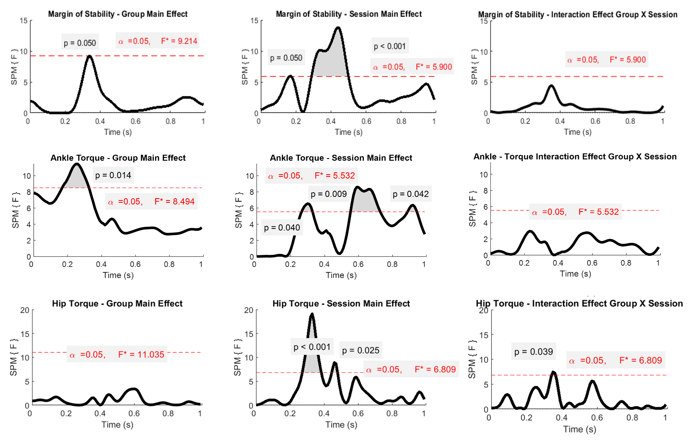
Figure S1. Two-way repeated measures ANOVA results using Statistical Parametric Mapping (SPM) for Margin of Stability, ankle torque, and hip torque during the 1-second perturbation, analysing group, session, and interaction effects. The x-axis represents time (0–1 s), with the F-statistic plotted over time. The significance threshold (α = 0.05) is indicated by the red dashed line, and F* critical values for each analysis are highlighted.

