Arm Position Matching (APM) task instructions:
When I start the task, the robot will move your hand. What I would like you to do is wait for the robot to stop moving your hand and then mirror match the position with your other arm. You will do this without being able to see your arms or hands [if vision condition, skip this line]. Once you have mirror matched the position as best you can please say; 'ok', 'there', 'done' or something similar. I will then advance to the next trial.

Supplemental Table 1. Linear mixed model statistics. NV = no vision condition; V = vision condition; bolded cells are p < 0.05.

Coefficient Name | mean difference (95% CI lower bound, 95% CI upper bound), p value
 | Variability | C/E | Shift
2 weeks NV*2 weeks V | 1.13 (0.85, 1.41), 1.06x10⁻¹⁴ | 0.88 (0.62, 1.13), 3.80x10⁻¹¹ | 0.45 (0.16, 0.73), 2.28x10⁻³
6 weeks NV*6 weeks V | 1.13 (0.85, 1.41), 1.22x10⁻¹⁴ | 0.66 (0.40, 0.91), 6.15x10⁻⁷ | 0.36 (0.07, 0.64), 0.01
12 weeks NV*12 weeks V | 0.85 (0.57, 1.13), 4.81x10⁻⁹ | 0.53 (0.27, 0.78), 5.99x10⁻⁵ | 0.45 (0.17, 0.74), 1.82x10⁻³
26 weeks NV*26 weeks V | 1.02 (0.74, 1.30), 2.83x10⁻¹² | 0.40 (0.14, 0.65), 2.25x10⁻³ | 0.25 (-0.03, 0.54), 0.08
2 weeks NV*6 weeks NV | 0.87 (0.49, 1.25), 1.07x10⁻⁸ | 0.65 (0.30, 0.99), 4.69x10⁻⁶ | 0.49 (0.10, 0.87), 0.01
6 weeks NV*12 weeks NV | 0.39 (0.01, 0.76), 0.041 | 0.13 (-0.22, 0.47), 1.00 | -0.10 (-0.48, 0.28), 1.00
12 weeks NV*26 weeks NV | 0.10 (-0.28,0.48), 1.00 | 0.05 (-0.29, 0.40), 1.00 | 0.19 (-0.20, 0.57), 1.00
2 weeks V*6 weeks V | 0.87 (0.49, 1.25), 1.20x10⁻⁸ | 0.43 (0.09, 0.77), 6.18x10⁻³ | 0.40 (0.16, 0.78), 0.04
6 weeks V*12 weeks V | 0.11 (-0.27, 0.48), 1.00 | -3.73x10⁻⁴ (-0.34, 0.34), 1.00 | -1.82x10⁻³ (-0.39, 0.38), 1.00
12 weeks V*26 weeks V | 0.27 (-0.11, 0.65), 0.37 | -0.07 (-0.42, 0.27), 1.00 | -0.01 (-0.40, 0.37), 1.00

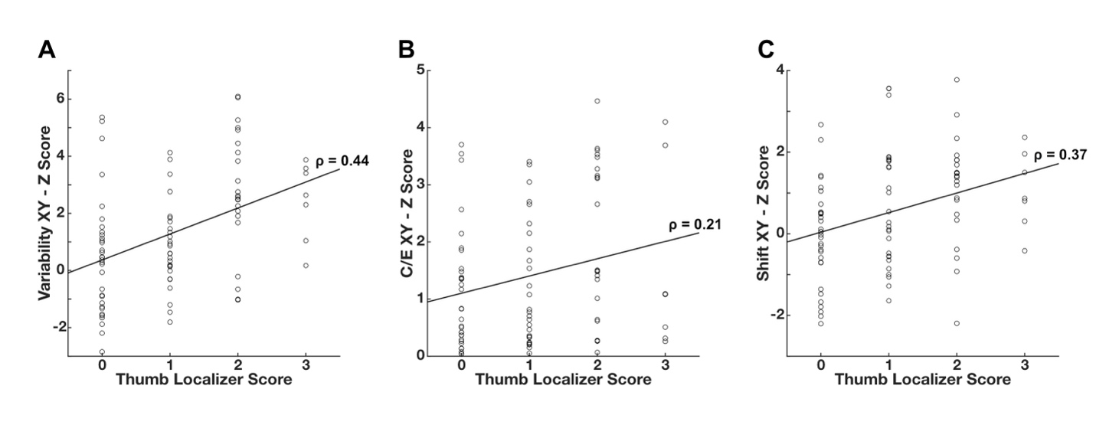
Supplemental Figure 1. Correlations between the Thumb Localizer Test (TLT) and Z Scores at 2 weeks post-stroke. (A) Variability XY Z Scores related to the TLT. (B) C/E XY Z Scores related to the TLT. (C) Shift XY Z Scores related to the TLT. Spearman Correlation rho values are reported in each figure.
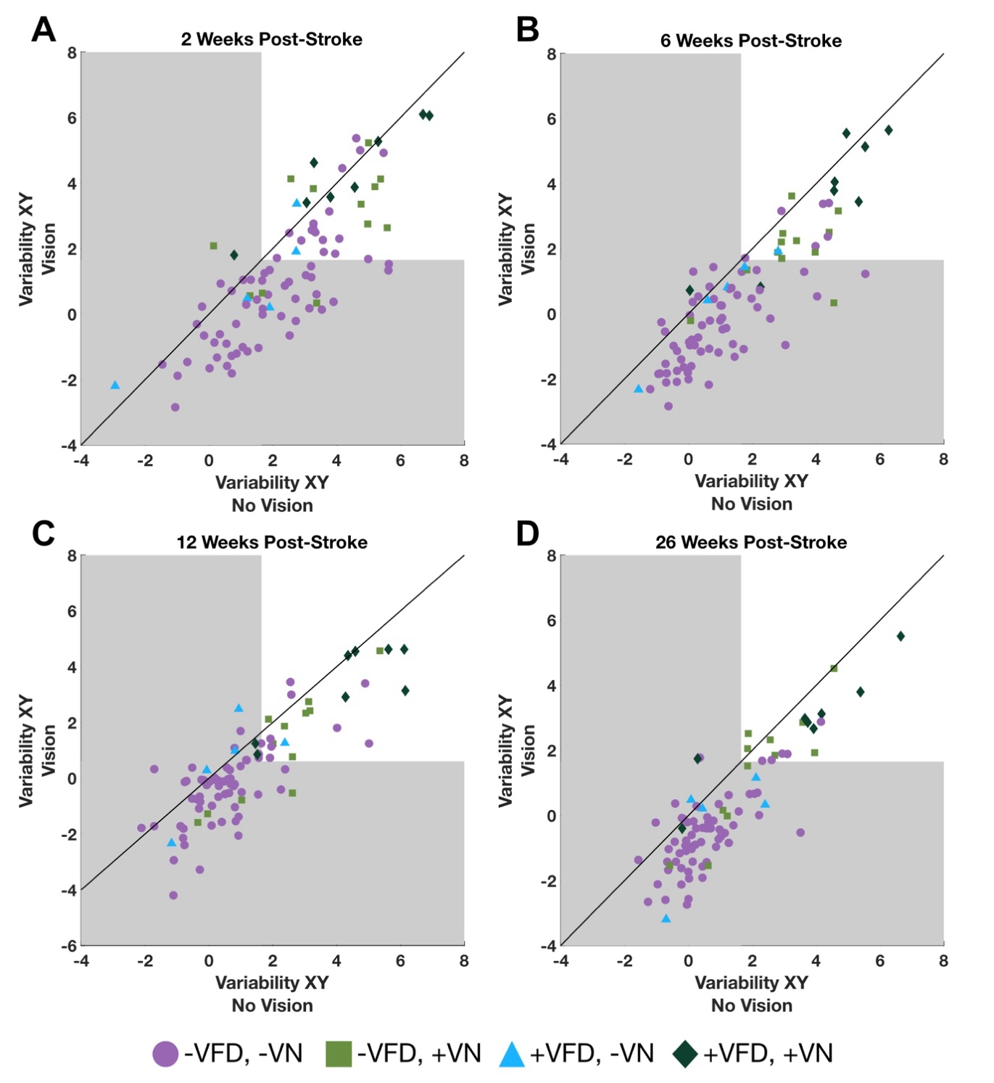
Supplemental Figure 2. Impairment groupings in the Variability measure Z scores over time based on clinical assessments at 2 weeks post-stroke. (A) Scatter plot of individual arm position matching task performance in the no vision and vision conditions at 2 weeks post-stroke. (B) Scatter plot of individual arm position matching task performance in the no vision and vision conditions at 6 weeks post-stroke. (C) Scatter plot of individual arm position matching task performance in the no vision and vision conditions at 12 weeks post-stroke. (D) Scatter plot of individual arm position matching task performance in the no vision and vision conditions at 26 weeks post-stroke. For all scatterplots, the grey area indicates the normal range for the no vision APM task. Purple circles indicate no visual field deficits (VFD) or visuospatial neglect (VN), green squares indicate no VFD but presence of VN, blue triangles indicate presence of VFD but no VN, and dark green diamonds indicate presence of both VFD and VN.

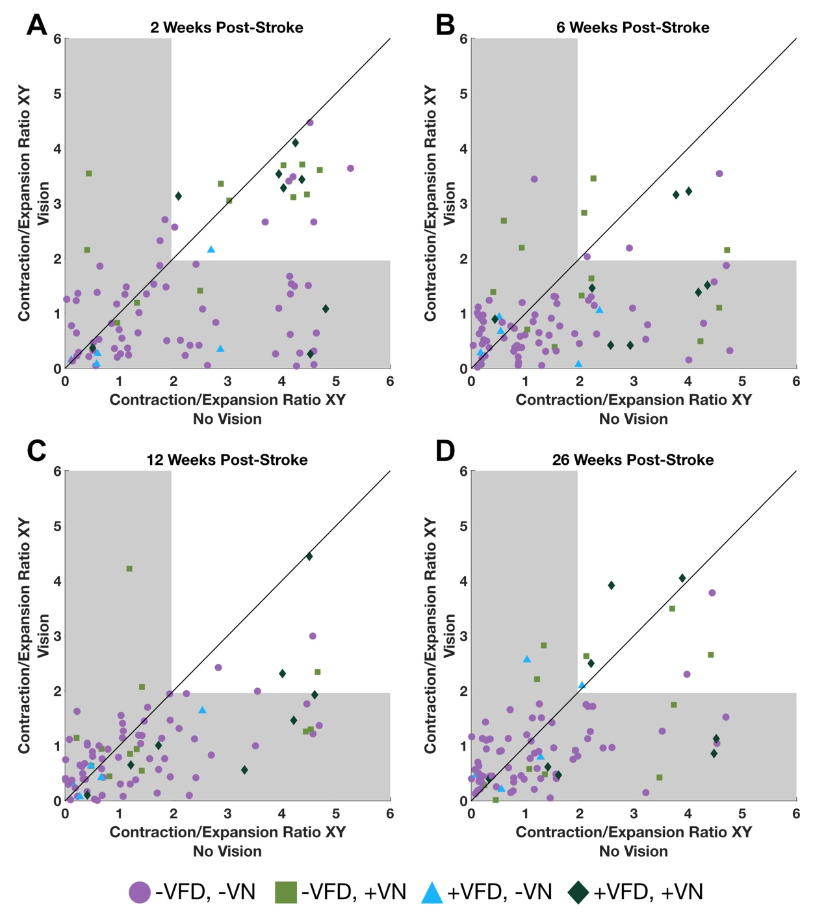
Supplemental Figure 3. Impairment groupings in the Contraction/Expansion measure Z scores over time based on clinical assessments at 2 weeks post-stroke. (A) Scatter plot of individual arm position matching task performance in the no vision and vision conditions at 2 weeks post-stroke. (B) Scatter plot of individual arm position matching task performance in the no vision and vision conditions at 6 weeks post-stroke. (C) Scatter plot of individual arm position matching task performance in the no vision and vision conditions at 12 weeks post-stroke. (D) Scatter plot of individual arm position matching task performance in the no vision and vision conditions at 26 weeks post-stroke. For all scatterplots, the grey area indicates the normal range for the no vision APM task. C/E Z scores are absolute values. Purple circles indicate no visual field deficits (VFD) or visuospatial neglect (VN), green squares indicate no VFD but presence of VN, blue triangles indicate presence of VFD but no VN, and dark green diamonds indicate presence of both VFD and VN.

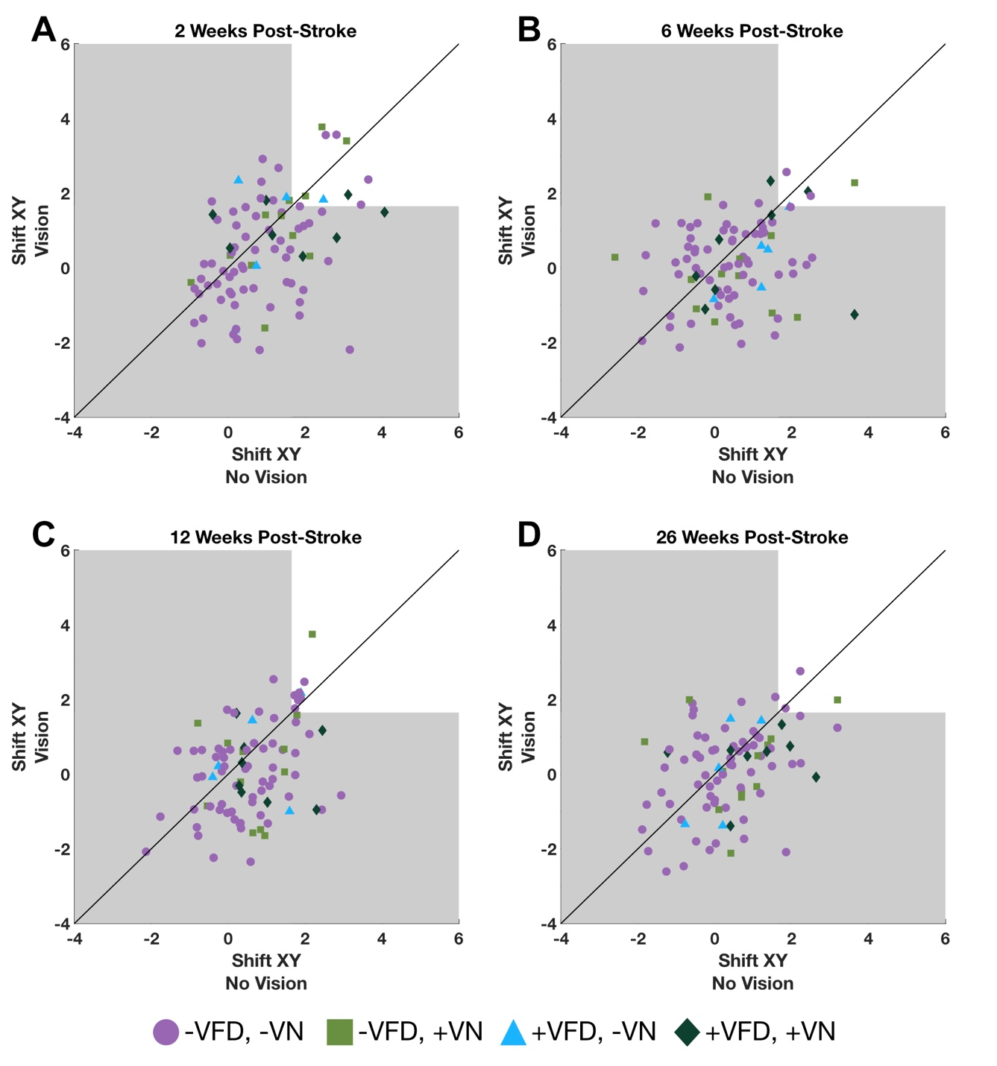
Supplemental Figure 4. Impairment groupings in the Shift measure Z scores over time based on clinical assessments at 2 weeks post-stroke. (A) Scatter plot of individual arm position matching task performance in the no vision and vision conditions at 2 weeks post-stroke. (B) Scatter plot of individual arm position matching task performance in the no vision and vision conditions at 6 weeks post-stroke. (C) Scatter plot of individual arm position matching task performance in the no vision and vision conditions at 12 weeks post-stroke. (D) Scatter plot of individual arm position matching task performance in the no vision and vision conditions at 26 weeks post-stroke. For all scatterplots, the grey area indicates the normal range for the no vision APM task. Purple circles indicate no visual field deficits (VFD) or visuospatial neglect (VN), green squares indicate no VFD but presence of VN, blue triangles indicate presence of VFD but no VN, and dark green diamonds indicate presence of both VFD and VN.

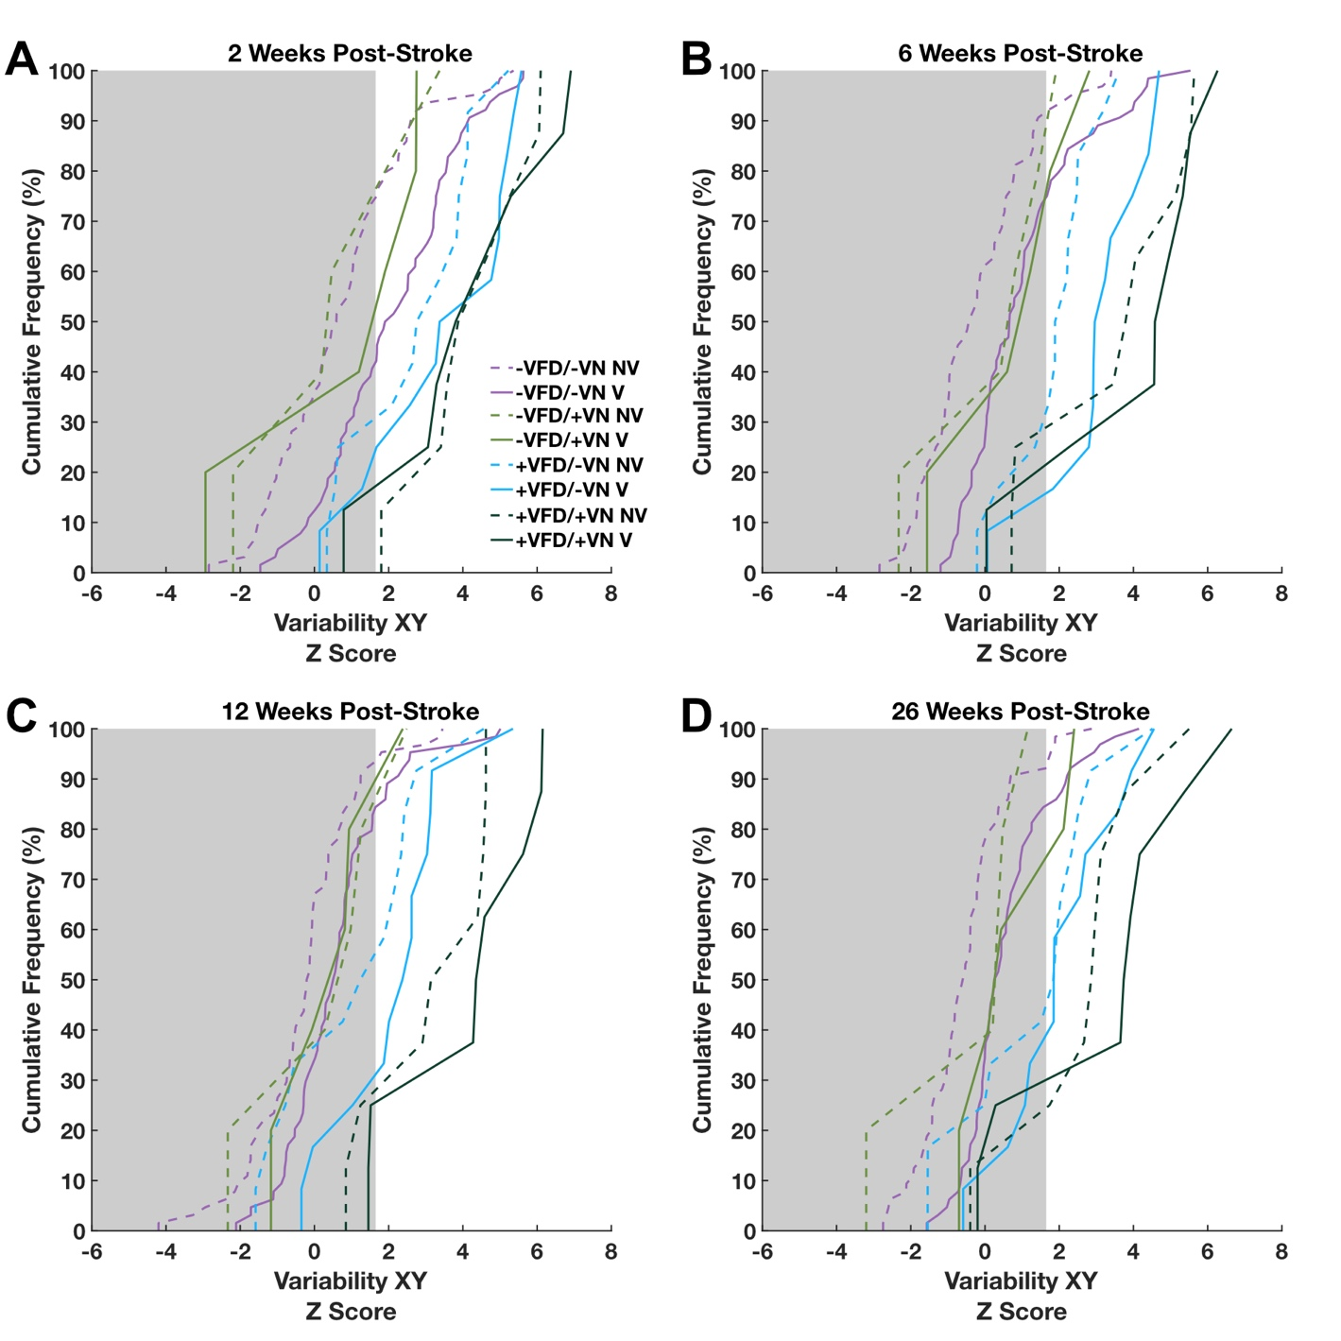
Supplemental Figure 5. Cumulative sum plots in the Variability measure Z scores over time based on clinical assessments at 2 weeks post-stroke. (A) Cumulative sum plot of arm position matching task performance at 2 weeks post-stroke. (B) Cumulative sum plot of arm position matching task performance at 6 weeks post-stroke. (C) Cumulative sum plot of arm position matching task performance at 12 weeks post-stroke. (D) Cumulative sum plot of arm position matching task performance at 26 weeks post-stroke. For all graphs, the grey area indicates the normal range for the no vision APM task. Purple lines indicate no visual field deficits (VFD) or visuospatial neglect (VN), green lines indicate no VFD but presence of VN, blue lines indicate presence of VFD but no VN, and dark green lines indicate presence of both VFD and VN. NV = no vision condition, V = vision condition.
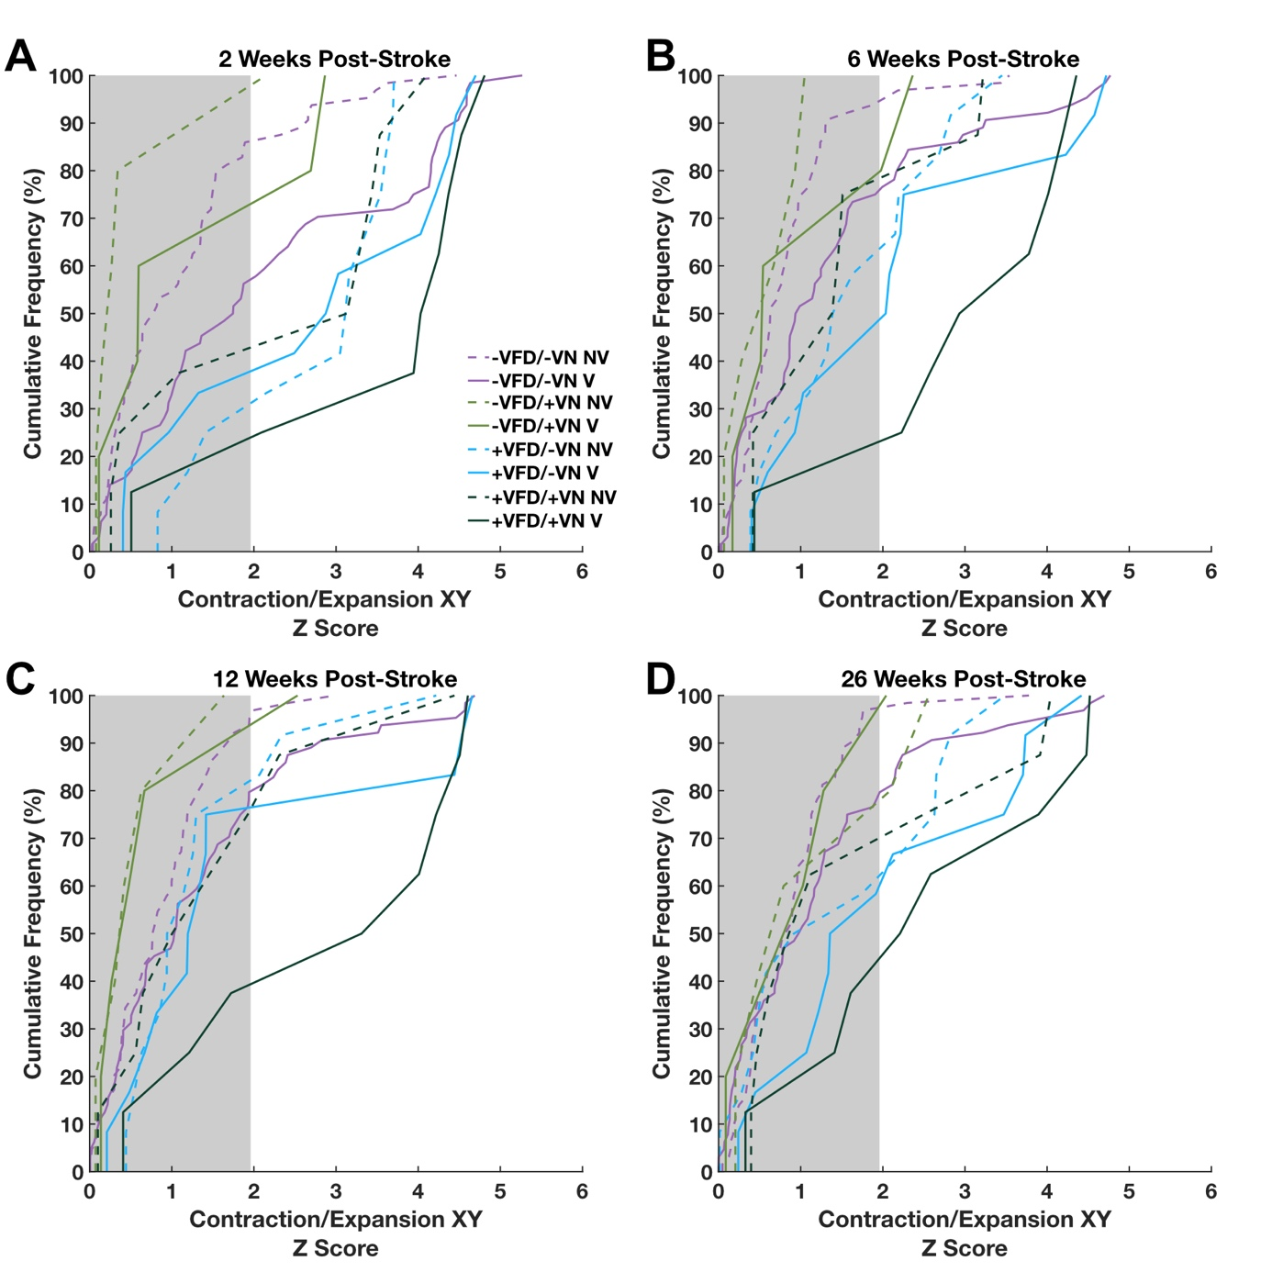

Supplemental Figure 6. Cumulative sum plots in the Contraction/Expansion measure Z scores over time based on clinical assessments at 2 weeks post-stroke. (A) Cumulative sum plot of arm position matching task performance at 2 weeks post-stroke. (B) Cumulative sum plot of arm position matching task performance at 6 weeks post-stroke. (C) Cumulative sum plot of arm position matching task performance at 12 weeks post-stroke. (D) Cumulative sum plot of arm position matching task performance at 26 weeks post-stroke. For all graphs, the grey area indicates the normal range for the no vision APM task. Purple lines indicate no visual field deficits (VFD) or visuospatial neglect (VN), green lines indicate no VFD but presence of VN, blue lines indicate presence of VFD but no VN, and dark green lines indicate presence of both VFD and VN. NV = no vision condition, V = vision condition.

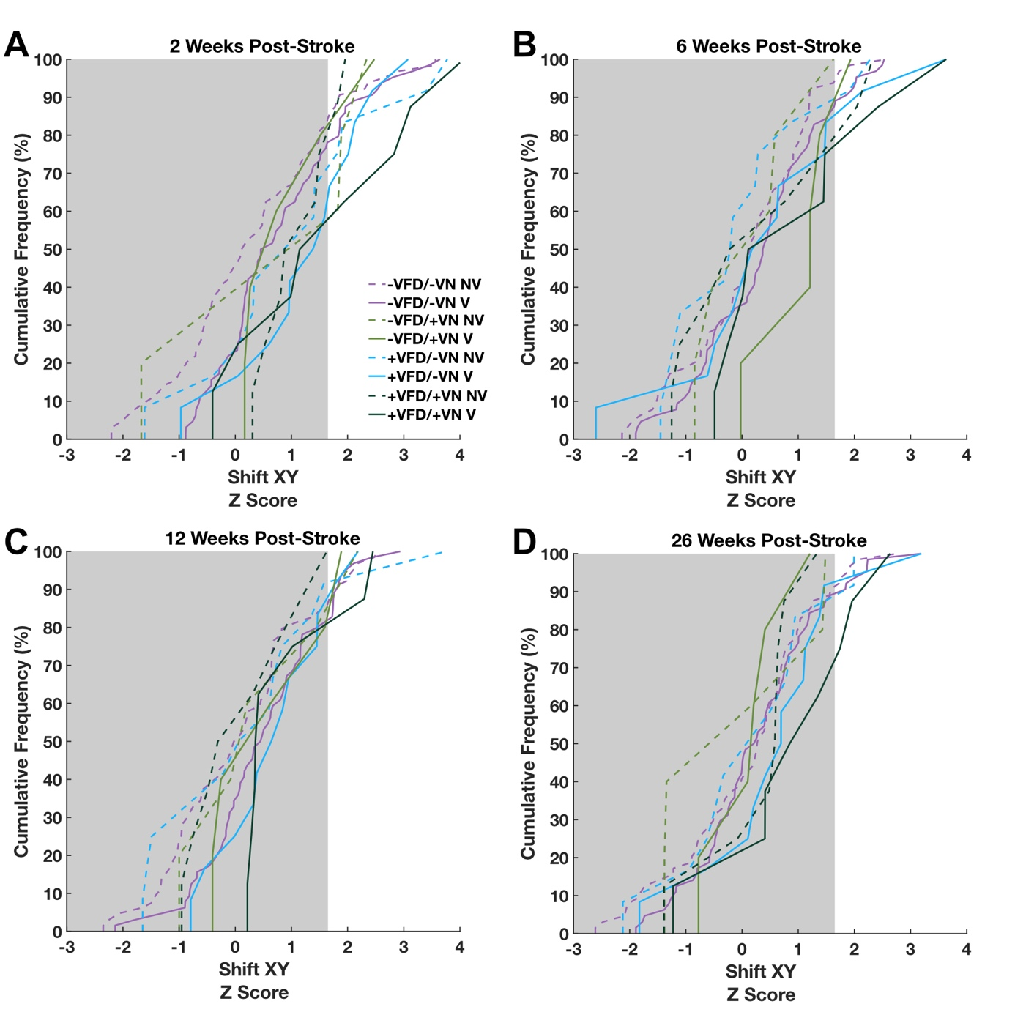Supplemental Figure 7. Cumulative sum plots in the Shift measure Z scores over time based on clinical assessments at 2 weeks post-stroke. (A) Cumulative sum plot of arm position matching task performance at 2 weeks post-stroke. (B) Cumulative sum plot of arm position matching task performance at 6 weeks post-stroke. (C) Cumulative sum plot of arm position matching task performance at 12 weeks post-stroke. (D) Cumulative sum plot of arm position matching task performance at 26 weeks post-stroke. For all graphs, the grey area indicates the normal range for the no vision APM task. Purple lines indicate no visual field deficits (VFD) or visuospatial neglect (VN), green lines indicate no VFD but presence of VN, blue lines indicate presence of VFD but no VN, and dark green lines indicate presence of both VFD and VN. NV = no vision condition, V = vision condition.

Supplemental Table 2. Compensation group proportions fluctuations between adjacent timepoints.
Measure | Timepoint
Variability | 2 weeks  6 weeks | # Normal | # Full | # Partial | # Absent | # Maladaptive
 | # Normal | 26 (90%) | 15 (63%) | 3 (23%) | 7 (33%) | 1 (50%)
 | # Full | 3 (10%) | 7 (29%) | 2 (15%) | 3 (14%) | 0 (0%)
 | # Partial | 0 (0%) | 0 (0%) | 3 (23%) | 4 (19%) | 1 (50%)
 | # Absent | 0 (0%) | 2 (8%) | 5 (38%) | 7 (33%) | 0 (0%)
 | # Maladaptive | 0 (0%) | 0 (0%) | 0 (0%) | 0 (0%) | 0 (0%)
6 weeks
12 weeks
 | # Normal | 50 (96%) | 8 (53%) | 1 (13%) | 2 (14%) | 0 (0%)
 | # Full | 2 (4%) | 4 (26%) | 2 (25%) | 2 (14%) | 0 (0%)
 | # Partial | 0 (0%) | 1 (7%) | 2 (25%) | 3 (21%) | 0 (0%)
 | # Absent | 0 (0%) | 0 (0%) | 3 (38%) | 7 (50%) | 0 (0%)
 | # Maladaptive | 0 (0%) | 2 (13%) | 0 (0%) | 0 (0%) | 0 (0%)
 | 12 weeks  26 weeks |  |  | 6
 | # Normal | 58 (95%) | 3 (30%) | 0 (0%) | 0 (0%) | 0 (0%)
 | # Full | 1 (2%) | 3 (30%) | 1 (17%) | 1 (10%) | 2 (100%)
 | # Partial | 0 (0%) | 2 (20%) | 4 (66%) | 4 (40%) | 0 (0%)
 | # Absent | 1 (2%) | 1 (10%) | 1 (17%) | 5 (50%) | 0 (0%)
 | # Maladaptive | 1 (2%) | 1 (10%) | 0 (0%) | 0 (0%) | 0 (0%)
C/E | 2 weeks  6 weeks | # Normal | # Full | # Partial | # Absent | # Maladaptive
 | # Normal | 37 (93%) | 10 (40%) | 2 (33%) | 3 (21%) | 2 (50%)
 | # Full | 3 (8%) | 12 (48%) | 2 (33%) | 7 (50%) | 0 (0%)
 | # Partial | 0 (0%) | 1 (4%) | 2 (33%) | 0 (0%) | 0 (0%)
 | # Absent | 0 (0%) | 1 (4%) | 0 (0%) | 4 (29%) | 0 (0%)
 | # Maladaptive | 0 (0%) | 1 (4%) | 0 (0%) | 0 (0%) | 2 (50%)
6 weeks
12 weeks
 | # Normal | 51 (94%) | 10 (42%) | 1 (33%) | 1 (20%) | 2 (67%)
 | # Full | 2 (4%) | 13 (54%) | 0 (0%) | 1 (20%) | 0 (0%)
 | # Partial | 0 (0%) | 0 (0%) | 2 (67%) | 0 (0%) | 1 (33%)
 | # Absent | 1 (2%) | 0 (0%) | 0 (0%) | 2 (40%) | 0 (0%)
 | # Maladaptive | 0 (0%) | 1 (4%) | 0 (0%) | 1 (20%) | 0 (0%)
12 weeks
26 weeks
 | # Normal | 58 (89%) | 3 (19%) | 0 (0%) | 0 (0%) | 0 (0%)
 | # Full | 4 (6%) | 8 (50%) | 2 (67%) | 2 (67%) | 0 (0%)
 | # Partial | 0 (0%) | 1 (6%) | 1 (33%) | 0 (0%) | 0 (0%)
 | # Absent | 1 (2%) | 4 (25%) | 0 (0%) | 1 (33%) | 1 (50%)
 | # Maladaptive | 2 (3%) | 0 (0%) | 0 (0%) | 0 (0%) | 1 (50%)
Shift | 2 weeks  6 weeks | # Normal | # Full | # Partial | # Absent | # Maladaptive
 | # Normal | 49 (89%) | 9 (60%) | 1 (25%) | 3 (60%) | 10 (100%)
 | # Full | 3 (5%) | 4 (27%) | 1 (25%) | 1 (20%) | 0 (0%)
 | # Partial | 0 (0%) | 0 (0%) | 0 (0%) | 1 (20%) | 0 (0%)
 | # Absent | 1 (2%) | 1 (7%) | 1 (25%) | 0 (0%) | 0 (0%)
 | # Maladaptive | 2 (4%) | 1 (7%) | 1 (25%) | 0 (0%) | 0 (0%)
6 weeks
12 weeks
 | # Normal | 58 (81%) | 6 (67%) | 0 (0%) | 2 (67%) | 3 (75%)
 | # Full | 5 (7%) | 2 (22%) | 1 (100%) | 1 (33%) | 0 (0%)
 | # Partial | 0 (0%) | 0 (0%) | 0 (0%) | 0 (0%) | 0 (0%)
 | # Absent | 6 (8%) | 1 (11%) | 0 (0%) | 0 (0%) | 1 (25%)
 | # Maladaptive | 3 (4%) | 0 (0%) | 0 (0%) | 0 (0%) | 0 (0%)
12 weeks
26 weeks
 | # Normal | 63 (91%) | 5 (56%) | 0 (0%) | 4 (50%) | 1 (33%)
 | # Full | 4 (6%) | 3 (33%) | 0 (0%) | 1 (13%) | 0 (0%)
 | # Partial | 0 (0%) | 0 (0%) | 0 (0%) | 0 (0%) | 0 (0%)
 | # Absent | 0 (0%) | 1 (11%) | 0 (0%) | 2 (25%) | 0 (0%)
 | # Maladaptive | 2 (3%) | 0 (0%) | 0 (0%) | 1 (13%) | 2 (67%)

