Supplementary Table 1. Descriptions of ExerGame programs using Dividat Senso

Category | Name of the exergame | In-Game Screen | Training goal | Training direction
Reaction training |  |  | Attention and  reaction speed training | All direction
Reaction training |  |  | Simultaneous visual and auditory reaction training. | All direction
Reaction training |  | 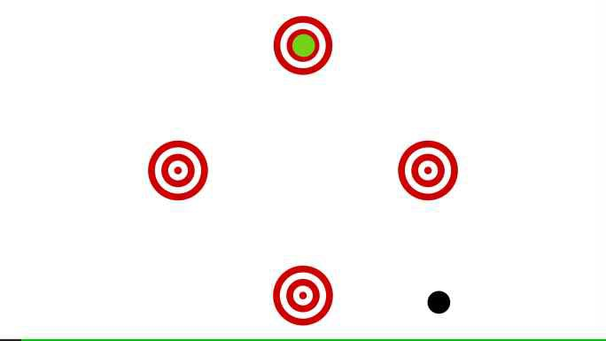 | Goal-oriented reaction training | All direction
Attention and memory training |  |  | Selective attention training | All direction
Attention and memory training |  |  | Selective / divided attention training | All direction
Attention and memory training |  |  | Working memory training | All direction
Spatiotemporal ability training |  | 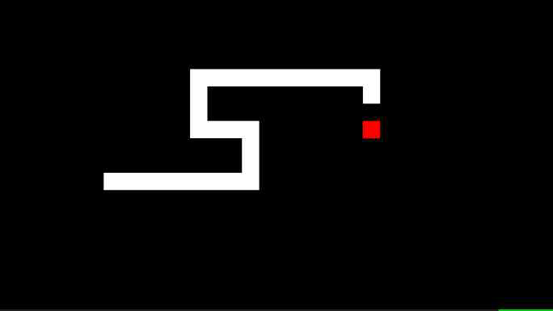 | Spatiotemporal processing ability | All direction
Spatiotemporal ability training |  |  | Spatial awareness, spatiotemporal reasoning and orientation, mental object rortation training | Left and right

Supplementary Table 1. Descriptions of ExerGame programs using Dividat Senso (continued)

Category | Name of the exergame | In-Game Screen | Training goal | Training direction
Balance training |  |  | Static balance, weight-shifting, and movement controll training | Left and right
Balance training |  | 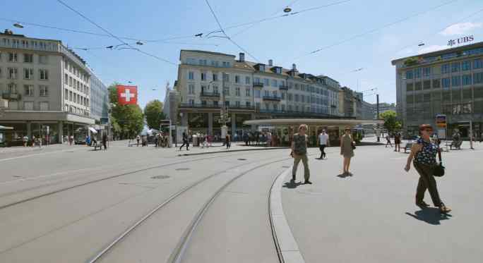 | Dynamic balance, endurance, walking training for physical and mental health | Walking in place
Balance training |  | 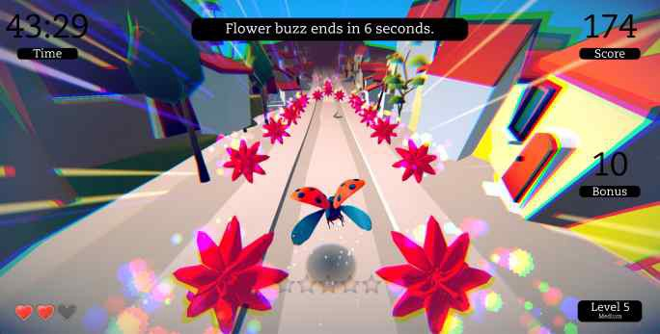 | Static balance control and selective attention | Left and right
Balance training |  |  | Dynamic balance control, virtual environment processing ability, goal-oriented and weight-shifting training | All direction
Other training | 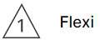 | 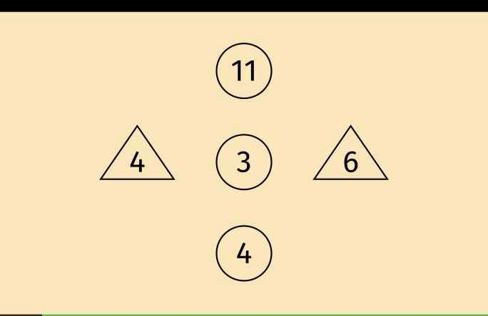 | Cognitive flexibility training | All direction
Other training |  | 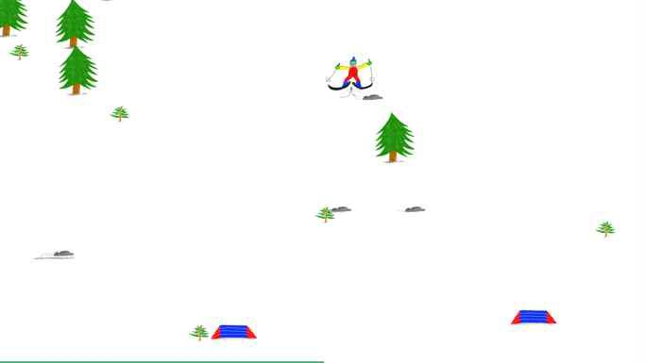 | Static balance training | Left and right
Other training |  |  | Cardiovasuclar training | Walking or running in place
Other training |  | 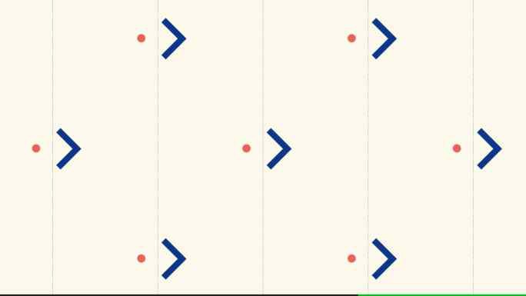 | Concentration, inhibition, and task switching training | All direction

