Supplementary material for

Does transcranial direct current stimulation enhance sensorimotor recovery in chronic ankle instability? A systematic review and meta-analysis
- Zhaohong Zeng ¹, Zhen Xu ¹, Bin Shen ¹, Xin Liang ¹, Xuekai Zong ¹, Jiaxin Luo ¹, Junhong Zhou ^{2 3 *}, Weijie Fu ^{4 *}
¹ Key Laboratory of Exercise and Health Sciences of Ministry of Education, School of Exercise and Health, Shanghai University of Sport, Shanghai 200438, China
² The Hinda and Arthur Marcus Institute for Aging Research, Hebrew SeniorLife, Boston, MA 02131, United States
³ Harvard Medical School, Boston, MA 02115, United States
⁴ School of Intelligent Sports Engineering, Shanghai University of Sport, Shanghai 200438, China

* Corresponding author:
Weijie Fu, Ph.D., School of Intelligent Sports Engineering, Shanghai University of Sport, Shanghai 200438, China, Tel.: +86-21-51253239; Fax: +86-21-51253242, fuweijie@sus.edu.cn; fuweijie315@163.com
Junhong Zhou, Ph.D., The Hinda and Arthur Marcus Institute for Aging Research, Hebrew SeniorLife, Boston, MA 02131, United States; Harvard Medical School, Boston, MA 02115, United States; Email: junhongzhou@hsl.harvard.edu

This file includes:

Supplementary Table
Supplementary Figure

Supplementary Table S1. PRISMA 2020 checklist
Section and Topic | Item # | Checklist item | Location where item is reported
Does transcranial direct current stimulation enhance sensorimotor recovery in chronic ankle instability? A systematic review and meta-analysis
Title | 1 | Identify the report as a systematic review, meta-analysis, or both. | 1
ABSTRACT
Structured summary | 2 | Provide a structured summary including, as applicable: background; objectives; data sources; study eligibility criteria, participants, and interventions; study appraisal and synthesis methods; results; limitations; conclusions and implications of key findings; systematic review registration number. | 1
INTRODUCTION
Rationale | 3 | Describe the rationale for the review in the context of what is already known. | 2
Objectives | 4 | Provide an explicit statement of questions being addressed with reference to participants, interventions, comparisons, outcomes, and study design (PICOS). | 2
METHODS
Protocol and registration | 5 | Indicate if a review protocol exists, if and where it can be accessed (e.g., Web address), and, if available, provide registration information including registration number. | 2
Eligibility criteria | 6 | Specify study characteristics (e.g., PICOS, length of follow-up) and report characteristics (e.g., years considered, language, publication status) used as criteria for eligibility, giving rationale. | 3, 4
Information sources | 7 | Describe all information sources (e.g., databases with dates of coverage, contact with study authors to identify additional studies) in the search and date last searched. | 2
Search strategy | 8 | Present full electronic search strategy for at least one database, including any limits used, such that it could be repeated. | 3
Study selection | 9 | State the process for selecting studies (i.e., screening, eligibility, included in systematic review, and, if applicable, included in the meta-analysis). | 3
Data collection process | 10 | Describe method of data extraction from reports (e.g., piloted forms, independently, in duplicate) and any processes for obtaining and confirming data from investigators. | 3, 4
Data items | 11 | List and define all variables for which data were sought (e.g., PICOS, funding sources) and any assumptions and simplifications made. | 3, 4
Risk of bias in individual studies | 12 | Describe methods used for assessing risk of bias of individual studies (including specification of whether this was done at the study or outcome level), and how this information is to be used in any data synthesis. | 4
Summary measures | 13 | State the principal summary measures (e.g., risk ratio, difference in means). | 3, 4
Synthesis of results | 14 | Describe the methods of handling data and combining results of studies, if done, including measures of consistency (e.g., I²) for each meta-analysis. | 3, 4
Risk of bias across studies | 15 | Specify any assessment of risk of bias that may affect the cumulative evidence (e.g., publication bias, selective reporting within studies). | 4
Additional analyses | 16 | Describe methods of additional analyses (e.g., sensitivity or subgroup analyses, meta-regression), if done, indicating which were pre-specified. | 4
RESULTS
Study selection | 17 | Give numbers of studies screened, assessed for eligibility, and included in the review, with reasons for exclusions at each stage, ideally with a flow diagram. | 4, 5
Study characteristics | 18 | For each study, present characteristics for which data were extracted (e.g., study size, PICOS, follow-up period) and provide the citations. | 5
Risk of bias within studies | 19 | Present assessments of risk of bias for each included study. | 6
Results of individual studies | 20 | Present data on risk of bias of each study and, if available, any outcome level assessment (see item 12). | 8
Synthesis of results | 21 | Present results of each meta-analysis done, including confidence intervals and measures of consistency. | 5, 6
Risk of bias across studies | 22 | Present results of any assessment of risk of bias across studies (see Item 15). | 8
Additional analysis | 23 | Give results of additional analyses, if done (e.g., sensitivity or subgroup analyses, meta-regression [see Item 16]). | 6-9
DISCUSSION
Summary of evidence | 24 | Provide a general interpretation of the results in the context of other evidence. | 9
Limitations | 25 | Discuss limitations at study and outcome level (e.g., risk of bias), and at review-level (e.g., incomplete retrieval of identified research, reporting bias). | 10, 11
Conclusions | 26 | Provide a general interpretation of the results in the context of other evidence, and implications for future research. | 11
FUNDING
Funding | 27 | Describe sources of funding for the systematic review and other support (e.g., supply of data); role of funders for the systematic review. | 11

Supplement Table S2. Search Strategy
Database | Search strategy | Total
PubMed | #1=("Ankle Injuries"[Mesh] OR Injury, Ankle OR Ankle Sprains OR Sprains, Ankle OR chronic ankle instability OR ankle instability OR ankle sprain OR functional ankle instability OR mechanical ankle instability OR Ankle)  #2=("Transcranial Direct Current Stimulation"[Mesh] OR tDCS OR Cathodal Stimulation OR anodal Stimulation) OR ("Transcranial electrical stimulation" OR TES)  "#1" AND "#2" | 101
Web of Science | #1=TS=(Ankle Injuries OR Ankle Sprains OR chronic ankle instability OR ankle instability OR functional ankle instability OR mechanical ankle instability OR ankle)  #2=TS=(Transcranial Direct Current Stimulation OR tDCS OR Cathodal Stimulation OR anodal Stimulation OR Transcranial electrical stimulation OR TES)  #1" AND "#2" | 157
Embase | #1='ankle injuries':ti,ab,kw OR 'ankle sprains':ti,ab,kw OR 'chronic ankle instability':ti,ab,kw OR 'ankle instability':ti,ab,kw OR 'functional ankle instability':ti,ab,kw OR 'mechanical ankle instability':ti,ab,kw OR 'ankle':ti,ab,kw  #2='transcranial direct current stimulation':ti,ab,kw OR 'tDCS':ti,ab,kw OR 'Cathodal Stimulation':ti,ab,kw OR 'anodal Stimulation':ti,ab,kw OR 'transcranial electrical stimulation':ti,ab,kw OR 'TES':ti,ab,kw  "#1" AND "#2" | 118
SPORTDiscus | #1=TI ((Ankle Injuries OR Ankle Sprains OR chronic ankle instability OR ankle instability OR functional ankle instability OR mechanical ankle instability OR ankle) AND (Transcranial Direct Current Stimulation OR tDCS OR Cathodal Stimulation OR anodal Stimulation OR Transcranial electrical stimulation OR TES))  #2=AB ((Ankle Injuries OR Ankle Sprains OR chronic ankle instability OR ankle instability OR functional ankle instability OR mechanical ankle instability OR ankle) AND (Transcranial Direct Current Stimulation OR tDCS OR Cathodal Stimulation OR anodal Stimulation OR Transcranial electrical stimulation OR TES))  "#1" OR "#2" | 20
Scopus | #1=TITLE-ABS-KEY ("Ankle Injuries" OR "Ankle Sprains" OR "chronic ankle instability" OR "ankle instability" OR "functional ankle instability" OR "mechanical ankle instability" OR "ankle")  #2=TITLE-ABS-KEY ("Transcranial Direct Current Stimulation" OR "tDCS" OR "Cathodal Stimulation" OR "anodal Stimulation" OR " Transcranial Electrical Stimulation " OR "TES")  "#1" AND "#2" | 119

Supplement Table S3. Methodological quality assessment [PEDro]
Methodological quality assessment [PEDro]
Study | A | B | C | D | E | F | G | H | I | J | K | Overall
Beyraghi 2025-1 | 1 | 1 | 1 | 1 | 1 | 0 | 0 | 1 | 0 | 1 | 1 | 7
Beyraghi 2025-2 | 1 | 1 | 1 | 1 | 1 | 0 | 0 | 1 | 0 | 1 | 1 | 7
Bruce 2020 | 1 | 1 | 0 | 1 | 1 | 0 | 1 | 0 | 0 | 1 | 1 | 6
Gao 2025 | 1 | 1 | 0 | 1 | 1 | 0 | 0 | 0 | 0 | 1 | 1 | 5
Ge 2025 | 1 | 1 | 0 | 1 | 1 | 0 | 0 | 0 | 0 | 1 | 1 | 5
Huang 2024 | 1 | 1 | 1 | 1 | 1 | 0 | 0 | 0 | 0 | 1 | 1 | 6
Kim 2024 | 1 | 1 | 0 | 1 | 0 | 0 | 0 | 1 | 1 | 1 | 1 | 6
Ma 2024 | 1 | 1 | 1 | 1 | 1 | 1 | 1 | 1 | 0 | 1 | 1 | 9
Needle 2025 | 1 | 1 | 1 | 1 | 1 | 1 | 1 | 0 | 1 | 1 | 1 | 9
Zhang 2025-1 | 1 | 1 | 1 | 1 | 0 | 0 | 1 | 0 | 0 | 1 | 1 | 6
Zhang 2025-2 | 1 | 1 | 1 | 1 | 1 | 1 | 1 | 1 | 0 | 1 | 1 | 9
A = eligibility criteria were specified (not included in the total score)
B = subjects were randomly allocated to groups (in a crossover study, subjects were randomly allocated an order in which treatments were received)
C = allocation was concealed
D = the groups were similar at baseline regarding the most important prognostic indicators
E = there was blinding of all subjects
F = there was blinding of all therapists who administered the therapy
G = there was blinding of all assessors who measured at least one key outcome
H = measures of at least one key outcome were obtained from more than 85% of the subjects initially allocated to groups
I = all subjects for whom outcome measures were available received the treatment or control condition as allocated or, where this was not the case, data for at least one key outcome was analysed by “intention to treat”
J = the results of between-group statistical comparisons are reported for at least one key outcome
K = the study provides both point measures and measures of variability for at least one key outcome.

Supplement Table S4. Data extracted from figures using WebPlotDigitizer

Study name | Outcome | Timepoint | Exp pre mean | Exp pre sd | Exp post mean | Exp post sd | Exp sample size | Con pre mean | Con pre sd | Con post mean | Con post sd | Con sample size
Ma et al., 2020 | YBT | Pre_1w | 95.686 | 10.034 | 96.2376 | 8.504 | 14 | 96.9587 | 7.313 | 96.3739 | 7.314 | 14
Ma et al., 2020 | YBT | Pre_2w | 95.686 | 10.034 | 100.107 | 6.974 | 14 | 96.9587 | 7.313 | 95.5166 | 6.803 | 14
Ma et al., 2020 | YBT | Pre_3w | 95.686 | 10.034 | 100.523 | 3.229 | 14 | 96.9587 | 7.313 | 96.1592 | 7.48 | 14
Ma et al., 2020 | YBT | Pre_4w | 95.686 | 10.034 | 100.165 | 4.254 | 14 | 96.9587 | 7.313 | 96.0744 | 2.041 | 14
Ma et al., 2020 | YBT | Pre_5w | 95.686 | 10.034 | 101.99 | 3.229 | 14 | 96.9587 | 7.313 | 95.8988 | 1.871 | 14
Ma et al., 2020 | YBT | Pre_6w | 95.686 | 10.034 | 100.905 | 4.932 | 14 | 96.9587 | 7.313 | 96.3141 | 6.123 | 14
Ma et al., 2020 | SOT1 | Pre_1w | 94.02 | 2.5 | 94.79 | 1.6 | 14 | 95.19 | 2 | 94.64 | 2.5 | 14
Ma et al., 2020 | SOT1 | Pre_2w | 94.02 | 2.5 | 92.91 | 2.8 | 14 | 95.19 | 2 | 93.95 | 2 | 14
Ma et al., 2020 | SOT1 | Pre_3w | 94.02 | 2.5 | 93.91 | 2.7 | 14 | 95.19 | 2 | 94.22 | 2.1 | 14
Ma et al., 2020 | SOT1 | Pre_4w | 94.02 | 2.5 | 93.79 | 2.4 | 14 | 95.19 | 2 | 94.26 | 2.9 | 14
Ma et al., 2020 | SOT1 | Pre_5w | 94.02 | 2.5 | 94.69 | 2.1 | 14 | 95.19 | 2 | 95.05 | 1.7 | 14
Ma et al., 2020 | SOT1 | Pre_6w | 94.02 | 2.5 | 95.39 | 1 | 14 | 95.19 | 2 | 94.45 | 1.9 | 14
Ma et al., 2020 | SOT2 | Pre_1w | 93.12 | 3.2 | 93.24 | 3 | 14 | 93.81 | 2.3 | 94.83 | 1.4 | 14
Ma et al., 2020 | SOT2 | Pre_2w | 93.12 | 3.2 | 92.95 | 3.1 | 14 | 93.81 | 2.3 | 94.84 | 1.2 | 14
Ma et al., 2020 | SOT2 | Pre_3w | 93.12 | 3.2 | 93.41 | 2.5 | 14 | 93.81 | 2.3 | 94.62 | 1.7 | 14
Ma et al., 2020 | SOT2 | Pre_4w | 93.12 | 3.2 | 94.37 | 2.3 | 14 | 93.81 | 2.3 | 95.11 | 1 | 14
Ma et al., 2020 | SOT2 | Pre_5w | 93.12 | 3.2 | 93.53 | 2.9 | 14 | 93.81 | 2.3 | 94.73 | 1.5 | 14
Ma et al., 2020 | SOT2 | Pre_6w | 93.12 | 3.2 | 94.1 | 2 | 14 | 93.81 | 2.3 | 94.36 | 1.6 | 14
Ma et al., 2020 | SOT3 | Pre_1w | 93.31 | 2.6 | 94.29 | 1.8 | 14 | 94.47 | 1.2 | 93.43 | 2.9 | 14
Ma et al., 2020 | SOT3 | Pre_2w | 93.31 | 2.6 | 93.6 | 3.1 | 14 | 94.47 | 1.2 | 94.14 | 2.5 | 14
Ma et al., 2020 | SOT3 | Pre_3w | 93.31 | 2.6 | 94.26 | 2.6 | 14 | 94.47 | 1.2 | 93.83 | 2.9 | 14
Ma et al., 2020 | SOT3 | Pre_4w | 93.31 | 2.6 | 93.88 | 2.2 | 14 | 94.47 | 1.2 | 94.29 | 2.1 | 14
Ma et al., 2020 | SOT3 | Pre_5w | 93.31 | 2.6 | 93.64 | 2.1 | 14 | 94.47 | 1.2 | 94.6 | 1.7 | 14
Ma et al., 2020 | SOT3 | Pre_6w | 93.31 | 2.6 | 94.31 | 1.9 | 14 | 94.47 | 1.2 | 93.48 | 2.3 | 14
Ma et al., 2020 | SOT | Pre_1w | 85.33 | 5.4 | 83.1 | 6.7 | 14 | 87.86 | 4 | 86.34 | 1.8 | 14
Ma et al., 2020 | SOT | Pre_2w | 85.33 | 5.4 | 86.14 | 3.5 | 14 | 87.86 | 4 | 88.87 | 1.7 | 14
Ma et al., 2020 | SOT | Pre_3w | 85.33 | 5.4 | 86.74 | 4 | 14 | 87.86 | 4 | 87.26 | 2.2 | 14
Ma et al., 2020 | SOT | Pre_4w | 85.33 | 5.4 | 88.39 | 2.7 | 14 | 87.86 | 4 | 86.33 | 3.8 | 14
Ma et al., 2020 | SOT | Pre_5w | 85.33 | 5.4 | 88.14 | 3.5 | 14 | 87.86 | 4 | 86.48 | 3.8 | 14
Ma et al., 2020 | SOT | Pre_6w | 85.33 | 5.4 | 88.38 | 2.9 | 14 | 87.86 | 4 | 85.95 | 4.6 | 14
Ma et al., 2020 | SOT5 | Pre_1w | 77.08 | 8 | 81.55 | 5.2 | 14 | 81.46 | 1.1 | 81.01 | 3.9 | 14
Ma et al., 2020 | SOT5 | Pre_2w | 77.08 | 8 | 80.45 | 3.4 | 14 | 81.46 | 1.1 | 82.38 | 4.4 | 14
Ma et al., 2020 | SOT5 | Pre_3w | 77.08 | 8 | 82.23 | 2.4 | 14 | 81.46 | 1.1 | 83.83 | 2.6 | 14
Ma et al., 2020 | SOT5 | Pre_4w | 77.08 | 8 | 82.74 | 3.8 | 14 | 81.46 | 1.1 | 84.67 | 3.5 | 14
Ma et al., 2020 | SOT5 | Pre_5w | 77.08 | 8 | 84.62 | 4.6 | 14 | 81.46 | 1.1 | 80.24 | 8.7 | 14
Ma et al., 2020 | SOT5 | Pre_6w | 77.08 | 8 | 82.29 | 3.8 | 14 | 81.46 | 1.1 | 83.14 | 5.7 | 14
Ma et al., 2020 | SOT6 | Pre_1w | 77.24 | 7.4 | 78.43 | 2.1 | 14 | 78.12 | 6 | 81.14 | 3.7 | 14
Ma et al., 2020 | SOT6 | Pre_2w | 77.24 | 7.4 | 80.41 | 3.5 | 14 | 78.12 | 6 | 81.09 | 3.7 | 14
Ma et al., 2020 | SOT6 | Pre_3w | 77.24 | 7.4 | 82.12 | 5 | 14 | 78.12 | 6 | 81.61 | 3.7 | 14
Ma et al., 2020 | SOT6 | Pre_4w | 77.24 | 7.4 | 84.64 | 3 | 14 | 78.12 | 6 | 83.89 | 1.8 | 14
Ma et al., 2020 | SOT6 | Pre_5w | 77.24 | 7.4 | 83.87 | 1.2 | 14 | 78.12 | 6 | 84.49 | 1.5 | 14
Ma et al., 2020 | SOT6 | Pre_6w | 77.24 | 7.4 | 85.47 | 3.1 | 14 | 78.12 | 6 | 80.98 | 7.4 | 14
Huang et al., 2024 | ankle inversion | Pre_Post | 19.57 | 6.48 | 16.52 | 3.69 | 18 | 19.83 | 3.56 | 15.25 | 5.59 | 16
Huang et al., 2024 | ankle inversion vel | Pre_Post | 236.97 | 114.28 | 85.71 | 25.21 | 18 | 210.08 | 122.69 | 134.45 | 52.1 | 16
Huang et al., 2024 | plantarflestion | Pre_Post | 10.67 | 4.62 | 4.03 | 3.53 | 18 | 10.84 | 5.12 | 7.98 | 4.45 | 16
Huang et al., 2024 | time | Pre_Post | 116.45 | 26.58 | 85.43 | 21.53 | 18 | 101.89 | 18.99 | 89.24 | 20.25 | 16
Gao et al., 2025 | ankle inversion angles | Pre_Psot | 31.358 | 5.2123 | 25.9529 | 6.1272 | 18 | 31.358 | 4.5724 | 29.0123 | 7.6818 | 16
Gao et al., 2025 | Internal rotation angles | Pre_Psot | 10.1426 | 2.9115 | 6.4047 | 1.2294 | 18 | 9.8399 | 3.0408 | 8.2856 | 1.9406 | 16
Gao et al., 2025 | jumping displacement | Pre_Psot | 0.679 | 0.0367 | 0.7125 | 0.0373 | 18 | 0.6688 | 0.0404 | 0.6983 | 0.024 | 16
Gao et al., 2025 | push-off impulse | Pre_Psot | 0.3996 | 0.0836 | 0.4488 | 0.0818 | 18 | 0.42 | 0.072 | 0.4428 | 0.0658 | 16
Gao et al., 2025 | take-off velocity | Pre_Psot | 2.6719 | 0.4099 | 2.7984 | 0.3398 | 18 | 2.6324 | 0.2752 | 2.664 | 0.2928 | 16

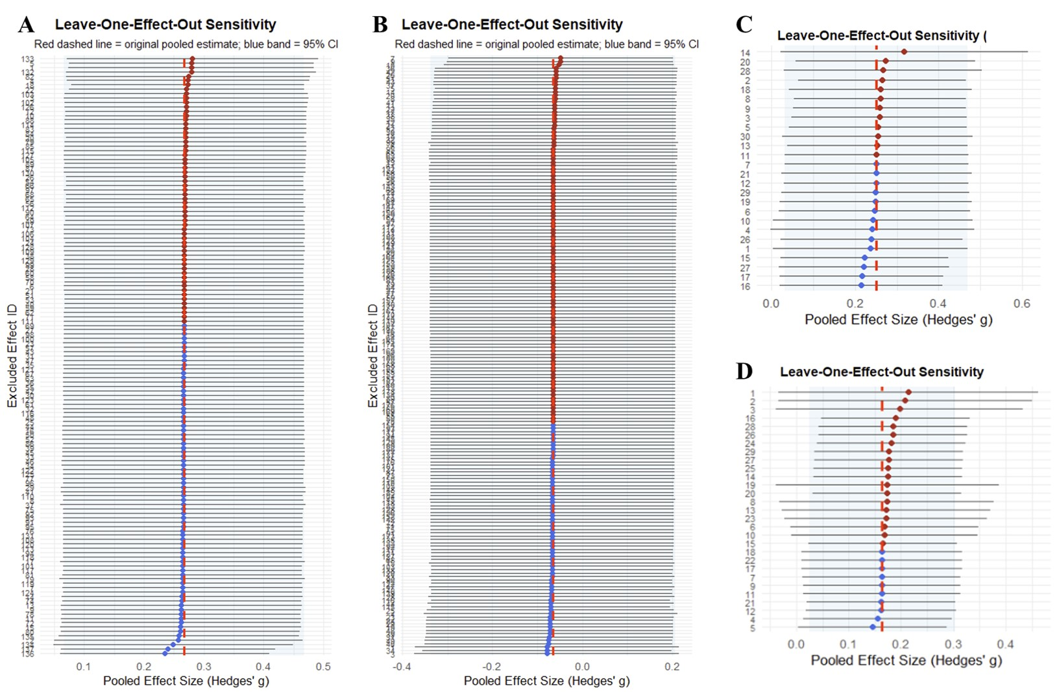
Supplementary Figure. S1 leave-one-out sensitivity analyses. (A) balance control, (B) neural excitability, (C) sensorimotor functional performance, (D) kinematics.

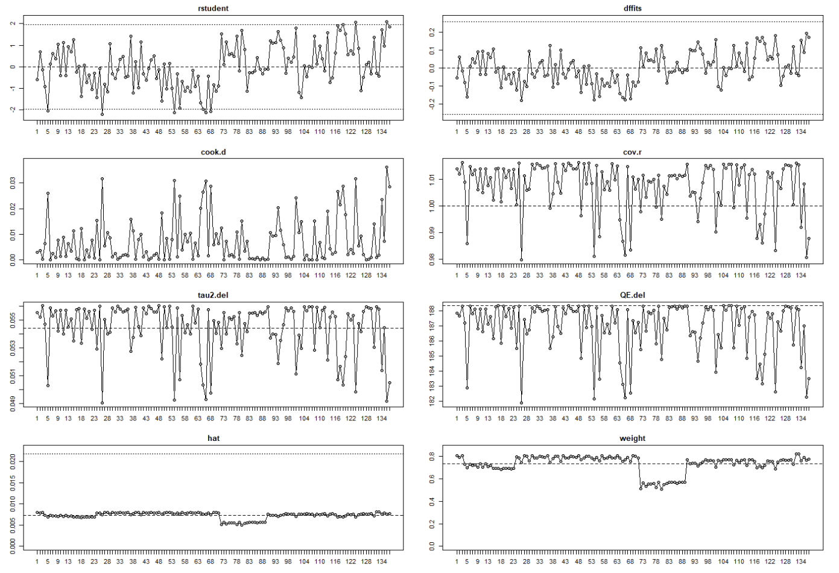
Supplementary Fig. S2 balance control influence analysis.

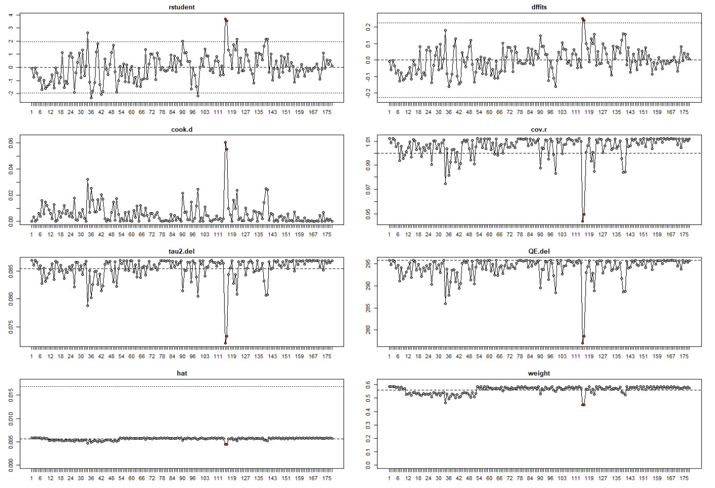
Supplementary Fig. S3 neural excitability influence analysis.

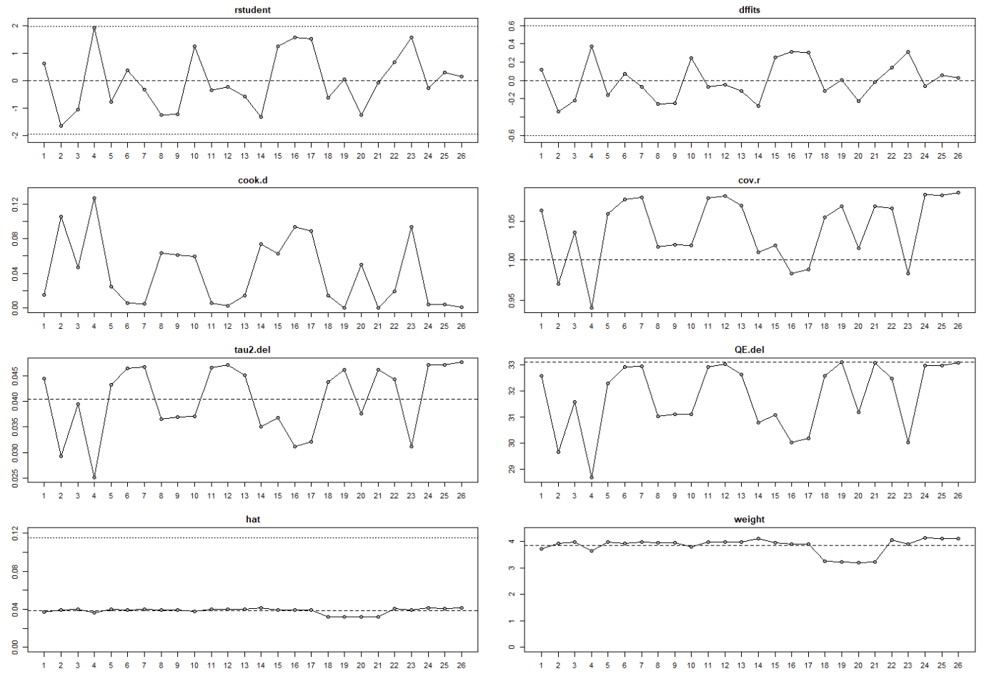
Supplementary Fig. S4 sensorimotor functional performance influence analysis.

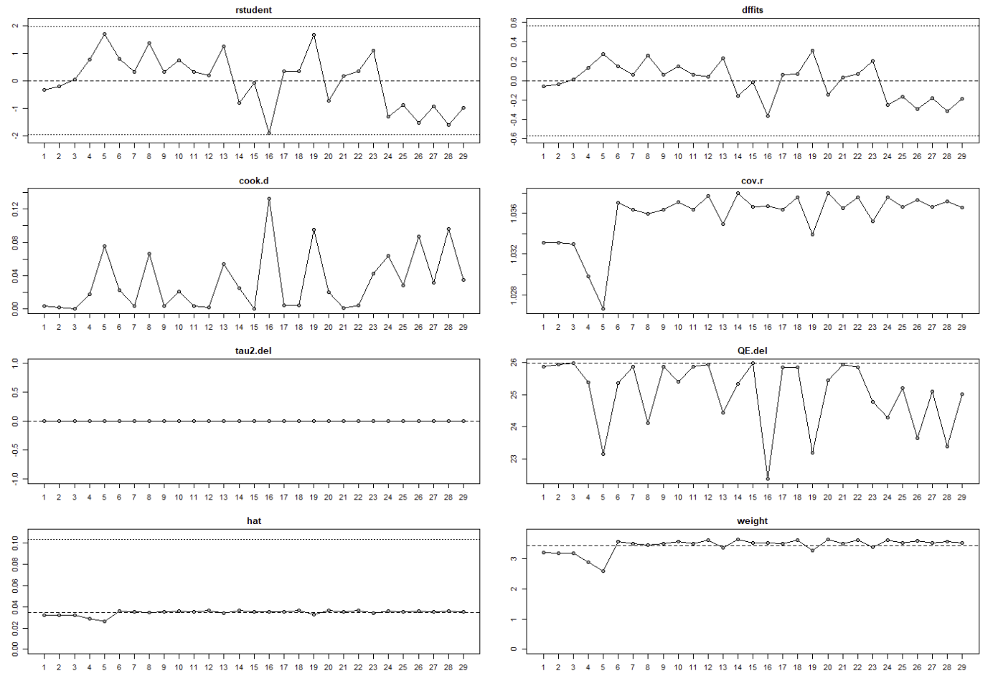
Supplementary Fig. S5 kinematics influence analysis.

