SUPPLEMENTARY MATERIALS

Additional File 1: Search strategies

Supplementary Table 1: Literature Search Strategy Across Databases

Description of the database-specific search strategies used to identify eligible studies, including search terms, Boolean operators, and filters applied (e.g., language, study design, date limits).

Database | Search strategy
Pubmed | - exp Stroke/ OR exp Cerebrovascular Disorders/ OR exp Brain Ischemia/ OR exp Intracranial Hemorrhages/ OR exp Cerebral Hemorrhage/ OR stroke.tw. OR cerebrovascular accident.tw. OR brain ischemia.tw. OR intracranial hemorrhage.tw. OR cerebral hemorrhage.tw.  - exp Robotics/ OR robot*.tw. OR robot assisted.tw. OR electromechani*.tw. OR electro-mechani*.tw. OR exp Exoskeleton Device/ OR Exoskelet*.tw. OR end effector*.tw. OR exp Wearable Electronic Devices/ OR wearable device*.tw. OR wearable electronic device*.tw.  - exp Muscle Spasticity/ OR spasticity.tw. OR Ashworth scale.tw. OR Modified Ashworth scale.tw. OR Tardieu scale.tw.  - randomized controlled trial.pt. OR controlled clinical trial.pt. OR randomized.tw. OR placebo.tw. OR exp clinical trials as topic/ OR randomly.tw. OR trial.ti.  - exp animals/ NOT exp humans/  - #1 AND #2 AND #3 AND #4 NOT #5
Embase (via Embase.com) | - stroke[pt] OR cerebrovascular[pt] OR brain ischemia[pt] OR intracranial hemorrhage[pt] OR cerebral hemorrhage[pt] OR stroke[tiab] OR cerebrovascular accident[tiab] OR brain ischemia[tiab] OR intracranial hemorrhage[tiab] OR cerebral hemorrhage[tiab]  - robotics[pt] OR robot*[tiab] OR robot assisted[tiab] OR electromechani*[tiab] OR electro mechani*[tiab] OR exoskeleton device[pt] OR exoskelet*[tiab] OR end effector*[tiab] OR wearable electronic devices[pt] OR wearable device*[tiab] OR wearable electronic device*[tiab]  - muscle spasticity[pt] OR spasticity[tiab] OR ashworth scale[tiab] OR modified ashworth scale[tiab] OR tardieu scale[tiab]  - randomized controlled trial[pt] OR controlled clinical trial[pt] OR randomized[tiab] OR placebo[tiab] OR clinical trials as topic[mh] OR randomly[tiab] OR trial[ti]  - animals[mh] NOT humans[mh]  - #1 AND #2 AND #3 AND #4 NOT #5
Web of Science | - TI=(stroke OR cerebrovascular accident OR brain ischemia OR intracranial hemorrhage OR cerebral hemorrhage)  - AB=(stroke OR cerebrovascular accident OR brain ischemia OR intracranial hemorrhage OR cerebral hemorrhage)  - TS=(stroke OR cerebrovascular accident OR brain ischemia OR intracranial hemorrhage OR cerebral hemorrhage)  - #1 OR #2 OR #3  - TI=(robot* OR robot assisted OR electromechani* OR electro-mechani* OR exoskelet* OR end effector* OR wearable electronic device* OR wearable device*)  - AB=(robot* OR robot assisted OR electromechani* OR electro-mechani* OR exoskelet* OR end effector* OR wearable electronic device* OR wearable device*)  - TS=(robot* OR robot assisted OR electromechani* OR electro-mechani* OR exoskelet* OR end effector* OR wearable electronic device* OR wearable device*)  - #5 OR #6 OR #7  - TI=(muscle spasticity OR spasticity OR Ashworth scale OR Modified Ashworth scale OR Tardieu scale)  - AB=(muscle spasticity OR spasticity OR Ashworth scale OR Modified Ashworth scale OR Tardieu scale)  - TS=(muscle spasticity OR spasticity OR Ashworth scale OR Modified Ashworth scale OR Tardieu scale)  - #9 OR #10 OR #11  - TS=(random* OR RCT OR RCTs)  - TS=(controlled NEAR/5 (trial$ OR stud*))  - TS=(clinical* NEAR/5 trial*)  - TS=((control OR treatment OR experiment* OR intervention) NEAR/5 (group$ OR subject$ OR patient$))  - TS=(quasi-random* OR quasi random* OR pseudo-random* OR pseudo random*)  - TS=((control$ OR experiment* OR conservative) NEAR/5 (treatment OR therapy OR manage* OR procedure))  - TS=((singl$ OR doubl* OR tripl* OR trebl*) NEAR/5 (blind* OR mask*))  - TS=(cross-over OR cross over OR crossover)  - TS=(placebo* OR sham)  - TI=trial  - TS=(assign* OR allocat*)  - TS=controls  - #13 OR #14 OR #15 OR #16 OR #17 OR #18 OR #19 OR #20 OR #21 OR #22 OR #23 OR #24  - #4 AND #8 AND #12 AND #25
Scopus | - TITLE-ABS-KEY(stroke OR cerebrovascular accident OR brain ischemia OR intracranial hemorrhage OR cerebral hemorrhage)  - TITLE-ABS-KEY(robot* OR robot assisted OR electromechani* OR electro-mechani* OR exoskelet* OR (end PRE/2 effector*) OR ((wearable electronic OR wearable) PRE/2 device*))  - TITLE-ABS-KEY(muscle spasticity OR spasticity OR Ashworth scale OR Modified Ashworth scale OR Tardieu scale)  - TITLE-ABS-KEY({Clinical-trial} OR {controlled-trial} OR randomi* OR randomly OR (random W/4 (allocat* OR distribut* OR assign*)) OR {placebo} OR {trial} OR {groups} OR {subgroups}) OR TITLE(rct)  - TITLE-ABS-KEY(animals) AND NOT TITLE-ABS-KEY(humans)  - #1 AND #2 AND #3 AND #4 NOT #5
Cochrane Library | - [mh Stroke]  - [mh "Cerebrovascular Disorders"]  - [mh "Brain Ischemia"]  - [mh "Intracranial Hemorrhages"]  - [mh "Cerebral Hemorrhage"]  - stroke:ti,ab  - "cerebrovascular accident":ti,ab  - "brain ischemia":ti,ab  - "intracranial hemorrhage":ti,ab  - "cerebral hemorrhage":ti,ab  - #1 OR #2 OR #3 OR #4 OR #5 OR #6 OR #7 OR #8 OR #9 OR #10  - [mh Robotics]  - robot*:ti,ab  - "robot assisted":ti,ab  - electromechani*:ti,ab  - electro-mechani*:ti,ab  - [mh "Exoskeleton Device"]  - Exoskelet*:ti,ab  - ("end" NEXT effector*):ti,ab  - [mh "Wearable Electronic Devices"]  - ("wearable" NEXT device*):ti,ab  - ("wearable electronic" NEXT device*):ti,ab  - #12 OR #13 OR #14 OR #15 OR #16 OR #17 OR #18 OR #19 OR #20 OR #21 OR #22  - [mh "Muscle Spasticity"]  - spasticity:ti,ab  - "Ashworth scale":ti,ab  - "Modified Ashworth scale":ti,ab  - "Tardieu scale":ti,ab  - #24 OR #25 OR #26 OR #27 OR #28  - "randomized controlled trial":pt  - "controlled clinical trial":pt  - randomized:ti,ab  - placebo:ti,ab  - [mh ^"clinical trials as topic"]  - randomly:ti,ab  - trial:ti  - #30 OR #31 OR #32 OR #33 OR #34 OR #35 OR #36  - [mh animals]  - [mh humans]  - #38 NOT #39  - #11 AND #23 AND #29 AND #37 NOT #40
CINAHL | S1 MH Stroke+  S2 MH "Cerebrovascular Disorders+"  S3 MH "Brain Ischemia+"  S4 MH "Intracranial Hemorrhages+"  S5 MH "Cerebral Hemorrhage+"  S6 TI stroke OR AB stroke  S7 TI "cerebrovascular accident" OR AB "cerebrovascular accident"  S8 TI "brain ischemia" OR AB "brain ischemia"  S9 TI "intracranial hemorrhage" OR AB "intracranial hemorrhage"  S10 TI "cerebral hemorrhage" OR AB "cerebral hemorrhage"  S11 S1 OR S2 OR S3 OR S4 OR S5 OR S6 OR S7 OR S8 OR S9 OR S10  S12 MH Robotics+  S13 TI robot* OR AB robot*  S14 TI "robot assisted" OR AB "robot assisted"  S15 TI electromechani* OR AB electromechani*  S16 TI electro-mechani* OR AB electro-mechani*  S17 MH "Exoskeleton Device+"  S18 TI Exoskelet* OR AB Exoskelet*  S19 TI "end effector*" OR AB "end effector*"  S20 MH "Wearable Electronic Devices+"  S21 TI "wearable device*" OR AB "wearable device*"  S22 TI "wearable electronic device*" OR AB "wearable electronic device*"  S23 S12 OR S13 OR S14 OR S15 OR S16 OR S17 OR S18 OR S19 OR S20 OR S21 OR S22  S24 MH "Muscle Spasticity+"  S25 TI spasticity OR AB spasticity  S26 TI "Ashworth scale" OR AB "Ashworth scale"  S27 TI "Modified Ashworth scale" OR AB "Modified Ashworth scale"  S28 TI "Tardieu scale" OR AB "Tardieu scale"  S29 S24 OR S25 OR S26 OR S27 OR S28  S30 PT "randomized controlled trial"  S31 PT "controlled clinical trial"  S32 TI randomized OR AB randomized  S33 TI placebo OR AB placebo  S34 MH "clinical trials as topic"  S35 TI randomly OR AB randomly  S36 TI trial  S37 S30 OR S31 OR S32 OR S33 OR S34 OR S35 OR S36  S38 MH animals+  S39 MH humans+  S40 S38 NOT S39  S41 S11 AND S23 AND S29 AND S37 NOT S40
ClinicalTrials.gov | #1 CONDITION: (stroke OR cerebrovascular accident OR brain ischemia OR intracranial hemorrhage OR cerebral hemorrhage)  #2 OUTCOME: (muscle spasticity OR spasticity OR Ashworth scale OR Modified Ashworth scale OR Tardieu scale)  #3 INTERVENTION: (robot* OR robot assisted OR electromechani* OR electro-mechani* OR exoskelet* OR end effector* OR wearable electronic device* OR wearable device*)  #4 #1 AND #2 AND #3
WHO ICTRP | #1 IN TITLE: stroke OR cerebrovascular accident OR brain ischemia OR intracranial hemorrhage OR cerebral hemorrhage  #2 IN INTERVENTION: robot* OR robot assisted OR electromechani* OR electro-mechani* OR exoskelet* OR end effector* OR wearable electronic device* OR wearable device*  #3 #1 AND #2

Additional File 2: Full-text exclusions and reasons

Supplementary Table S2. List of full-text articles excluded after eligibility assessment, with detailed reasons for exclusion.
TITLE | YEAR | AUTHORS | MOTIVATION
An Exoneuromusculoskeleton for Self-Help Upper Limb Rehabilitation after Stroke | 2022 | Nam, C. and Rong, W. and Li, W. and Cheung, C. and Ngai, W. and Cheung, T. and Pang, M. and Li, L. and Hu, J. and Wai, H. and Hu, X. | not study design of interest
Is the robotic rehabilitation that is added to intensive body rehabilitation effective for maximization of upper extremity motor recovery following a stroke? A randomized controlled study | 2023 | Şenocak, E. and Korkut, E. and Aktürk, A. and Ozer, A.Y. | not outcome of interest
Combined effects of cerebellar transcranial direct current stimulation and transcutaneous spinal direct current stimulation on robot-assisted gait training in patients with chronic brain stroke: A pilot, single blind, randomized controlled trial | 2018 | Picelli, A. and Chemello, E. and Castellazzi, P. and Filippetti, M. and Brugnera, A. and Gandolfi, M. and Waldner, A. and Saltuari, L. and Smania, N. | not comparison of interest
Combined effects of robot-assisted gait training and botulinum toxin type A on spastic equinus foot in patients with chronic stroke: a pilot, single blind, randomized controlled trial | 2016 | Picelli, A and Bacciga, M and Melotti, C and LA Marchina, E and Verzini, E and Ferrari, F and Pontillo, A and Corradi, J and Tamburin, S and Saltuari, L and et al. | not intervention of interest
How could robotic training and botolinum toxin be combined in chronic post stroke upper limb spasticity? A pilot study | 2015 | Pennati, GV and Da Re, C and Messineo, I and Bonaiuti, D | not comparison of interest
Effects of Transcranial Direct Current Stimulation (tDCS) Combined With Wrist Robot-Assisted Rehabilitation on Motor Recovery in Subacute Stroke Patients: a Randomized Controlled Trial | 2019 | Mazzoleni, S and Tran, VD and Dario, P and Posteraro, F | not comparison of interest
Gait recovery with an overground powered exoskeleton: a randomized controlled trial on subacute stroke subjects | 2021 | Molteni, F and Guanziroli, E and Goffredo, M and Calabrò, RS and Pournajaf, S and Gaffuri, M and Gasperini, G and Filoni, S and Baratta, S and Galafate, D and et al. | not intervention of interest
Feasibility and efficacy of a robotic device for hand rehabilitation in hemiplegic stroke patients: a randomized pilot controlled study | 2017 | Vanoglio, F and Bernocchi, P and Mulè, C and Garofali, F and Mora, C and Taveggia, G and Scalvini, S and Luisa, A | not study design of interest
New Artificial Intelligence-Integrated Electromyography-Driven Robot Hand for Upper Extremity Rehabilitation of Patients With Stroke: A Randomized, Controlled Trial | 2023 | Murakami, Y and Honaga, K and Kono, H and Haruyama, K and Yamaguchi, T and Tani, M and Isayama, R and Takakura, T and Tanuma, A and Hatori, K and et al. | not comparison of interest
Robot-Assisted Training as Self-Training for Upper-Limb Hemiplegia in Chronic Stroke: a Randomized Controlled Trial | 2022 | Takebayashi, T and Takahashi, K and Amano, S and Gosho, M and Sakai, M and Hashimoto, K and Hachisuka, K and Uchiyama, Y and Domen, K | not outcome of interest
Effect of therapist-based versus robot-assisted bilateral arm training on motor control, functional performance, and quality of life after chronic stroke: a clinical trial | 2012 | Wu, CY and Yang, CL and Chuang, LL and Lin, KC and Chen, HC and Chen, MD and Huang, WC | not outcome of interest
Robot-Assisted Rehabilitation of Hand Paralysis After Stroke Reduces Wrist Edema and Pain: a Prospective Clinical Trial | 2017 | Borboni, A and Villafañe, JH and Mullè, C and Valdes, K and Faglia, R and Taveggia, G and Negrini, S | not comparison of interest
Prospective, blinded, randomized crossover study of gait rehabilitation in stroke patients using the Lokomat gait orthosis | 2007 | Mayr, A and Kofler, M and Quirbach, E and Matzak, H and Fröhlich, K and Saltuari, L | not comparison of interest
A comparison between electromyography-driven robot and passive motion device on wrist rehabilitation for chronic stroke | 2009 | Hu, XL and Tong, KY and Song, R and Zheng, XJ and Leung, WW | not comparison of interest
Treadmill training with partial body weight support and an electromechanical gait trainer for restoration of gait in subacute stroke patients: a randomized crossover study | 2002 | Werner, C and Von Frankenberg, S and Treig, T and Konrad, M and Hesse, S | not comparison of interest
Training of reaching in stroke survivors with severe and chronic upper limb paresis using a novel nonrobotic device: a randomized clinical trial | 2008 | Barker, RN and Brauer, SG and Carson, RG | not intervention of interest
Effect of robotic erigo tilt table exercise on neurological parameters in hemiplegic patients: a pilot study | 2018 | Yadav, R and Kumar, S and Aafreen, and Yadav, S | not study design of interest
Wearable vibrotactile stimulation for upper extremity rehabilitation in chronic stroke: clinical feasibility trial using the VTS Glove | 2021 | Seim, CE and Wolf, SL and Starner, TE | not intervention of interest
A Pilot Randomized Controlled Trial of Botulinum Toxin Treatment Combined with Robot-Assisted Therapy, Mirror Therapy, or Active Control Treatment in Patients with Spasticity Following Stroke | 2022 | Hung, JW and Yen, CL and Chang, KC and Chiang, WC and Chuang, IC and Pong, YP and Wu, WC and Wu, CY | not intervention of interest
Is two better than one? Muscle vibration plus robotic rehabilitation to improve upper limb spasticity and function: a pilot randomized controlled trial | 2017 | Calabrò, RS and Naro, A and Russo, M and Milardi, D and Leo, A and Filoni, S and Trinchera, A and Bramanti, P | not comparison of interest
Evidence of neuroplasticity with robotic hand exoskeleton for post-stroke rehabilitation: a randomized controlled trial | 2021 | Singh, N and Saini, M and Kumar, N and Srivastava, MVP and Mehndiratta, A | not study design of interest
Effects of combining robot-assisted therapy with neuromuscular electrical stimulation on motor impairment, motor and daily function, and quality of life in patients with chronic stroke: a double-blinded randomized controlled trial | 2015 | Lee, YY and Lin, KC and Cheng, HJ and Wu, CY and Hsieh, YW and Chen, CK | not comparison of interest
Robotic Rehabilitation and Multimodal Instrumented Assessment of Post-stroke Elbow Motor Functions-A Randomized Controlled Trial Protocol | 2020 | Pilla, A and Trigili, E and McKinney, Z and Fanciullacci, C and Malasoma, C and Posteraro, F and Crea, S and Vitiello, N | protocol stage (publication is a protocol)
A comparison of the rehabilitation effectiveness of neuromuscular electrical stimulation robotic hand training and pure robotic hand training after stroke: a randomized controlled trial | 2020 | Huang, Y and Nam, C and Li, W and Rong, W and Xie, Y and Liu, Y and Qian, Q and Hu, X | not comparison of interest
Effectiveness of robot-assisted upper limb training on spasticity, function and muscle activity in chronic stroke patients treated with botulinum toxin: a randomized single-blinded controlled trial | 2019 | Gandolfi, M and Vale, N and Dimitrova, EK and Mazzoleni, S and Battini, E and Filippetti, M and Picelli, A and Santamato, A and Gravina, M and Saltuari, L and et al. | not intervention of interest
The Effects of Distributed vs. Condensed Schedule for Robot-Assisted Training with Botulinum Toxin A Injection for Spastic Upper Limbs in Chronic Post-Stroke Subjects | 2021 | Hung, JW and Chen, YW and Chen, YJ and Pong, YP and Wu, WC and Chang, KC and Wu, CY | not intervention of interest
Comparative Assessment of Two Robot-Assisted Therapies for the Upper Extremity in People With Chronic Stroke | 2019 | Hung, CS and Hsieh, YW and Wu, CY and Lin, KC and Lin, JC and Yeh, LM and Yin, HP | not study design of interest
Distal versus proximal - an investigation on different supportive strategies by robots for upper limb rehabilitation after stroke: a randomized controlled trial | 2019 | Qian, Q and Nam, C and Guo, Z and Huang, Y and Hu, X and Ng, SC and Zheng, Y and Poon, W | not comparison of interest
Effects of robot (SUBAR)-assisted gait training in patients with chronic stroke: randomized controlled trial | 2021 | Kang, CJ and Chun, MH and Lee, J and Lee, JY | not intervention of interest
Effects of Combination of Functional Electric Stimulation and Robotic Leg Movement Using Dynamic Tilt Table on Walking Characteristics in Post-Stroke Patients with Spastic Hemiplegia: a Randomized Crossover-Controlled Trial | 2022 | Ueda, K and Umemoto, Y and Kamijo, YI and Sakurai, Y and Araki, S and Ise, M and Yoshioka, I and Banno, M and Mochida, S and Iwahashi, T and et al. | not comparison of interest
Effects of Robot-Aided Rehabilitation on the Ankle Joint Properties and Balance Function in Stroke Survivors: a Randomized Controlled Trial | 2021 | Zhai, X and Wu, Q and Li, X and Xu, Q and Zhang, Y and Fan, S and Zhang, LQ and Pan, Y | not intervention of interest
Randomized controlled trial of robot-assisted gait training with dorsiflexion assistance on chronic stroke patients wearing ankle-foot-orthosis | 2018 | Yeung, LF and Ockenfeld, C and Pang, MK and Wai, HW and Soo, OY and Li, SW and Tong, KY | not intervention of interest
Effects of robot therapy on upper body kinematics and arm function in persons post stroke: a pilot randomized controlled trial | 2020 | Carpinella, I and Lencioni, T and Bowman, T and Bertoni, R and Turolla, A and Ferrarin, M and Jonsdottir, J | not study design of interest
Feasibility and outcomes of supplemental gait training by robotic and conventional means in acute stroke rehabilitation | 2023 | Talaty, M and Esquenazi, A | not study design of interest
Transcutaneous Auricular Vagus Nerve Stimulation (tAVNS) Delivered During Upper Limb Interactive Robotic Training Demonstrates Novel Antagonist Control for Reaching Movements Following Stroke | 2021 | Chang, JL and Coggins, AN and Saul, M and Paget-Blanc, A and Straka, M and Wright, J and Datta-Chaudhuri, T and Zanos, S and Volpe, BT | not comparison of interest
The Influence of EMG-Triggered Robotic Movement on Walking, Muscle Force and Spasticity after an Ischemic Stroke | 2021 | Lewandowska-Sroka, P and Stabrawa, R and Kozak, D and Poswiata, A and Lyson-Uklanska, B and Bienias, K and Roksela, A and Klis, M and Mikulski, M | not intervention of interest
Robotic gait training and botulinum toxin injection improve gait in the chronic post-stroke phase: a randomized controlled trial | 2024 | Cotinat, M and Celerier, M and Arquillière, C and Flipo, M and Prieur-Blanc, N and Viton, JM and Bensoussan, L | not intervention of interest
Abnormal synergistic gait mitigation in acute stroke using an innovative ankle-knee-hip interlimb humanoid robot: a preliminary randomized controlled trial | 2021 | Park, C and Oh-Park, M and Bialek, A and Friel, K and Edwards, D and You, JSH | not study design of interest
Influences of the biofeedback content on robotic post-stroke gait rehabilitation: electromyographic vs joint torque biofeedback | 2019 | Tamburella, F and Moreno, JC and Herrera Valenzuela, DS and Pisotta, I and Iosa, M and Cincotti, F and Mattia, D and Pons, JL and Molinari, M | not study design of interest
Combining transcranial direct current stimulation with hand robotic rehabilitation in chronic stroke patients: a double blind randomized clinical trial | 2024 | Bernal-Jimenez, JJ and Dileone, M and Mordillo-Mateos, L and Martin-Conty, JL and Durantez-Fernandez, C and Vinuela, A and Martin-Rodriguez, F and Lerin-Calvo, A and Alcantara-Porcuna, V and Polonio-Lopez, B | not comparison of interest
Effects of Therapist Intervention during Upper-Extremity Robotic Rehabilitation in Patients with Stroke. | 2023 | Kim, Si-Yun and Kim, Yu-Mi and Koo, See-Won and Park, Hyun-Bin and Yoon, Yong-Soon | not comparison of interest
Robot-assisted reaching exercise promotes arm movement recovery in chronic hemiparetic stroke: A randomized controlled pilot study | 2006 | Kahn, L.E. and Zygman, M.L. and Rymer, W.Z. and Reinkensmeyer, D.J. | not outcome of interest
Pilot Test of Dosage Effects in HEXORR II for Robotic Hand Movement Therapy in Individuals With Chronic Stroke | 2021 | Chen, J. and Black, I. and Nichols, D. and Chen, T. and Sandison, M. and Casas, R. and Lum, P.S. | not comparison of interest
Robotic therapy for the hemiplegic shoulder pain: A pilot study | 2020 | Serrezuela, R.R. and Quezada, M.T. and Zayas, M.H. and Pedrón, A.M. and Hermosilla, D.M. and Zamora, R.S. | not study design of interest
The responsiveness and correlation between Fugl-Meyer Assessment, Motor Status Scale, and the Action Research Arm Test in chronic stroke with upper-extremity rehabilitation robotic training | 2011 | Wei, XJ and Tong, KY and Hu, XL | not comparison of interest
Pilot Comparative Study of Unilateral and Bilateral Robot-Assisted Training on Upper-Extremity Performance in Patients With Stroke. | 2012 | Chieh-Ling Yang and Keh-Chung Lin and Hsieh-Ching Chen and Ching-Yi Wu and Chia-Ling Chen | not comparison of interest
Effects of robotic therapy on motor impairment and recovery in chronic stroke. | 2003 | Fasoli SE and Krebs HI and Stein J and Frontera WR and Hogan N | not comparison of interest
Robot-mediated upper limb physiotherapy for patients with spastic hemiparesis: a preliminary study. | 2007 | Fazekas G and Horvath M and Troznai T and Toth A | not study design of interest
Upper limb bilateral symmetric training with robotic assistance and clinical outcomes for stroke: A pilot study | 2016 | Simkins, M. and Byl, N. and Kim, H. and Abrams, G. and Rosen, J. | not study design of interest
Treatment of severe hand impairment following stroke by combining assisted movement, muscle vibration, and biofeedback | 2013 | Cordo, P. and Wolf, S. and Lou, J.-S. and Bogey, R. and Stevenson, M. and Hayes, J. and Roth, E. | not comparison of interest
Robot-assisted practice of gait and stair climbing in nonambulatory stroke patients | 2012 | Hesse, S. and Tomelleri, C. and Bardeleben, A. and Werner, C. and Waldner, A. | not study design of interest
Efficacy of end-effector Robot-Assisted Gait Training in subacute stroke patients: Clinical and gait outcomes from a pilot bi-centre study | 2019 | Aprile, I. and Iacovelli, C. and Goffredo, M. and Cruciani, A. and Galli, M. and Simbolotti, C. and Pecchioli, C. and Padua, L. and Galafate, D. and Pournajaf, S. and Franceschini, M. | not study design of interest
Efficacy of Robotic-Assisted Gait Training in chronic stroke patients: Preliminary results of an Italian bi-centre study | 2017 | Aprile, I. and Iacovelli, C. and Padua, L. and Galafate, D. and Criscuolo, S. and Gabbani, D. and Cruciani, A. and Germanotta, M. and Di Sipio, E. and De Pisi, F. and Franceschini, M. | not study design of interest
Effects of robot-assisted gait training in chronic stroke patients treated by botulinum toxin-a: a pivotal study | 2018 | Erbil, D and Tugba, G and Murat, TH and Melike, A and Merve, A and Cagla, K and Mehmetali, ÇC and Akay, Ö and Nigar, D | not intervention of interest
Effects of anodal and cathodal transcranial direct current stimulation combined with robotic therapy on severely affected arms in chronic stroke patients | 2013 | Ochi, M and Saeki, S and Oda, T and Matsushima, Y and Hachisuka, K | not comparison of interest
Randomized trial of a robotic assistive device for the upper extremity during early inpatient stroke rehabilitation | 2014 | Masiero, S and Armani, M and Ferlini, G and Rosati, G and Rossi, A | not aim of interest (feasibility, applicability, etc.)
Effects of intensive arm training with an electromechanical orthosis in chronic stroke patients: a preliminary study | 2011 | de Araújo, RC and Junior, FL and Rocha, DN and Sono, TS and Pinotti, M | not study design of interest
Robotic-assisted rehabilitation of the upper limb after acute stroke | 2007 | Masiero, S and Celia, A and Rosati, G and Armani, M | not comparison of interest
Individual finger synchronized robot-assisted hand rehabilitation in subacute to chronic stroke: a prospective randomized clinical trial of efficacy | 2012 | Hwang, CH and Seong, JW and Son, DS | not outcome of interest
Effects of Treatment Intensity in Upper Limb Robot-Assisted Therapy for Chronic Stroke: A Pilot Randomized Controlled Trial. | 2011 | Hsieh, Yu-wei and Wu, Ching-yi and Liao, Wan-wen and Lin, Keh-chung and Wu, Kuen-yuh and Lee, Chia-yi | not study design of interest
Multicenter randomized trial of robot-assisted rehabilitation for chronic stroke: methods and entry characteristics for VA ROBOTICS. | 2009 | Lo AC and Guarino P and Krebs HI and Volpe BT and Bever CT and Duncan PW and Ringer RJ and Wagner TH and Richards LG and Bravata DM and Haselkorn JK and Wittenberg GF and Federman DG and Corn BH and Maffucci AD and Peduzzi P | not outcome of interest
Upper-limb robot-assisted therapy in rehabilitation of acute stroke patients: Focused review and results of new randomized controlled trial. | 2011 | Masiero, Stefano and Armani, Mario and Rosati, Giulio | not study design of interest
Graded repetitive arm supplementary programme (GRASP) and virtual reality to improve upper limb function in patients with acute stroke-An experimental study | 2023 | Dhanusia, S. and Rajalaxmi, V. and Suriya, N. and Bharath Kumar, P. | not intervention of interest
Effects of a Virtual Reality–Based Mirror Therapy Program on Improving Sensorimotor Function of Hands in Chronic Stroke Patients: A Randomized Controlled Trial | 2022 | Hsu, H.-Y. and Kuo, L.-C. and Lin, Y.-C. and Su, F.-C. and Yang, T.-H. and Lin, C.-W. | not study design of interest
Efficacy of Daoyin combined with lower limb robot as a comprehensive rehabilitation intervention for stroke patients: a randomized controlled trial | 2024 | Tian, H. and Yang, Y. and Zhang, H. and Zhao, W. and Zhou, J. and Tian, J. and He, L. and Li, X. and Shen, Q. and Shuai, M. | not study design of interest
Effects of a remote-handling-concept–based task-oriented arm training (ReHab-TOAT) on arm-hand skill performance in chronic stroke: a study protocol for a two-armed randomized controlled trial | 2023 | Elmanowski, J. and Seelen, H. and Geers, R. and Kleynen, M. and Verbunt, J. | protocol stage (publication is a protocol)
The effect of adding robot-assisted hand rehabilitation to conventional rehabilitation program following stroke: A randomized-controlled study | 2022 | Bayındır, O. and Akyüz, G. and Sekban, N. | not outcome of interest
The effect of mirror therapy can be improved by simultaneous robotic assistance | 2022 | Schrader, M. and Sterr, A. and Kettlitz, R. and Wohlmeiner, A. and Buschfort, R. and Dohle, C. and Bamborschke, S. | not outcome of interest
A usability study in patients with stroke using MERLIN, a robotic system based on serious games for upper limb rehabilitation in the home setting | 2021 | Guillén-Climent, S. and Garzo, A. and Muñoz-Alcaraz, M.N. and Casado-Adam, P. and Arcas-Ruiz-Ruano, J. and Mejías-Ruiz, M. and Mayordomo-Riera, F.J. | not comparison of interest
Exoskeletal wearable robot on ambulatory function in patients with stroke: A protocol for an international, multicentre, randomised controlled study | 2023 | Chang, W.H. and Kim, T.-W. and Kim, H.S. and Hanapiah, F.A. and Kim, D.H. and Kim, D.Y. | protocol stage (publication is a protocol)
Phase-II clinical validation of a powered exoskeleton for the treatment of elbow spasticity | 2017 | Crea, S. and Cempini, M. and Mazzoleni, S. and Carrozza, M.C. and Posteraro, F. and Vitiello, N. | not study design of interest
Effects of robotic-assisted gait training with motor imagery on gait impairments in patients with stroke | 2015 | Wang, J. and Liao, L. and Yang, Z. | not study design of interest
Hybrid Rehabilitation Therapies on Upper-Limb Function and Goal Attainment in Chronic Stroke | 2019 | Hung, C.-S. and Hsieh, Y.-W. and Wu, C.-Y. and Chen, Y.-J. and Lin, K.-C. and Chen, C.-L. and Yao, K.G. and Liu, C.-T. and Horng, Y.-S. | not comparison of interest
Technology-Assisted Ankle Rehabilitation Improves Balance and Gait Performance in Stroke Survivors: A Randomized Controlled Study With 1-Month Follow-Up | 2018 | Yoo, D and Son, Y and Kim, DH and Seo, KH and Lee, BC | not intervention of interest
"Remind-to-Move" for Promoting Upper Extremity Recovery Using Wearable Devices in Subacute Stroke: A Multi-Center Randomized Controlled Study | 2019 | Wei, W.X.J. and Fong, K.N.K. and Chung, R.C.K. and Cheung, H.K.Y. and Chow, E.S.L. | not intervention of interest
Technology-Assisted Ankle Rehabilitation Improves Balance and Gait Performance in Stroke Survivors: A Randomized Controlled Study With 1-Month Follow-Up | 2018 | Yoo, D and Son, Y and Kim, DH and Seo, KH and Lee, BC | not intervention of interest
Changes in motoneuron excitability in hemiplegic subjects after passive exercise when using a robotic arm | 2006 | Patel, S and Ho, JT and Kumar, R and Lai, K and Ahangar, B and Burgar, CG and Scremin, AE | not comparison of interest
Hand rehabilitation following stroke: A pilot study of assisted finger extension training in a virtual environment | 2007 | Fischer, HC and Stubblefield, K and Kline, T and Luo, X and Kenyon, RV and Kamper, DG | not study design of interest
Progressive Abduction Loading Therapy with Horizontal-Plane Viscous Resistance Targeting Weakness and Flexion Synergy to Treat Upper Limb Function in Chronic Hemiparetic Stroke: A Randomized Clinical Trial | 2018 | Ellis, MD and Carmona, C and Drogos, J and Dewald, JPA | not outcome of interest
A Cost-Efficient Tele-rehabilitation Device for Training Distal Upper Limb Functions After Stroke | 2015 | Weiss, P and Gabrecht, A and Heldmann, M and Schweikard, A and Maehle, E | not study design of interest

Additional File 3 - Baseline Spasticity Characteristics of Included Studies

Supplementary Table S3. Baseline MAS severity by study, group, and joint/muscle, preserving original reporting format (frequency / mean±SD or SEM / median[IQR]).
Study | Group | Joint/Muscle | Metric Type | Baseline_Spasticity
Abd El-Kafy et al., 2022 | Control | Elbow | Frequency | MAS: 0 n=NR; 1 n=5; 1+ n=10; 2 n=5; 3 n=NR; 4 n=NR
Abd El-Kafy et al., 2022 | Control | Wrist | Frequency | MAS: 0 n=NR; 1 n=6; 1+ n=11; 2 n=3; 3 n=NR; 4 n=NR
Abd El-Kafy et al., 2022 | Experimental | Elbow | Frequency | MAS: 0 n=NR; 1 n=4; 1+ n=13; 2 n=3; 3 n=NR; 4 n=NR
Abd El-Kafy et al., 2022 | Experimental | Wrist | Frequency | MAS: 0 n=NR; 1 n=6; 1+ n=10; 2 n=4; 3 n=NR; 4 n=NR
Adomavičienė et al., 2019 | Experimental | Shoulder | Frequency | MAS: 0 n=14; 1 n=2; 1+ n=1; 2 n=NR; 3 n=NR; 4 n=NR
Adomavičienė et al., 2019 | Experimental | Elbow | Frequency | MAS: 0 n=12; 1 n=1; 1+ n=2; 2 n=NR; 3 n=NR; 4 n=NR
Adomavičienė et al., 2019 | Experimental | Wrist | Frequency | MAS: 0 n=12; 1 n=2; 1+ n=3; 2 n=NR; 3 n=NR; 4 n=NR
Adomavičienė et al., 2019 | Control | Shoulder | Frequency | MAS: 0 n=21; 1 n=3; 1+ n=1; 2 n=NR; 3 n=NR; 4 n=NR
Adomavičienė et al., 2019 | Control | Elbow | Frequency | MAS: 0 n=15; 1 n=5; 1+ n=2; 2 n=NR; 3 n=NR; 4 n=NR
Adomavičienė et al., 2019 | Control | Wrist | Frequency | MAS: 0 n=15; 1 n=4; 1+ n=3; 2 n=NR; 3 n=NR; 4 n=NR
Ahn et al., 2024 | Experimental | Upper limb | Not Reported | Not reported
Ahn et al., 2024 | Control | Upper limb | Not Reported | Not reported
Bhattacharjee et al., 2024 | Experimental | Elbow flexion | Mean±SD | 1.82 ± 0.45
Bhattacharjee et al., 2024 | Experimental | Elbow extension | Mean±SD | 0.59 ± 0.80
Bhattacharjee et al., 2024 | Experimental | Wrist flexion | Mean±SD | 1.80 ± 0.30
Bhattacharjee et al., 2024 | Experimental | Wrist extension | Mean±SD | 0.27 ± 0.46
Bhattacharjee et al., 2024 | Control | Elbow flexion | Mean±SD | 1.86 ± 0.44
Bhattacharjee et al., 2024 | Control | Elbow extension | Mean±SD | 0.50 ± 0.80
Bhattacharjee et al., 2024 | Control | Wrist flexion | Mean±SD | 1.73 ± 0.37
Bhattacharjee et al., 2024 | Control | Wrist extension | Mean±SD | 0.18 ± 0.39
Burgar et al., 2011 | Experimental | Upper limb | Mean±SEM | 0.44 ± 0.10
Burgar et al., 2011 | Experimental | Upper limb | Mean±SEM | 0.31 ± 0.08
Burgar et al., 2011 | Control | Upper limb | Mean±SEM | 0.33 ± 0.08
Chang et al., 2024 | Experimental | Elbow flexion | Mean±SD | 0.57 ± 0.56
Chang et al., 2024 | Experimental | Elbow extension | Mean±SD | 1.10 ± 0.66
Chang et al., 2024 | Experimental | Wrist flexion | Mean±SD | 0.63 ± 0.55
Chang et al., 2024 | Experimental | Wrist extension | Mean±SD | 1.23 ± 0.62
Chang et al., 2024 | Control | Elbow flexion | Mean±SD | 0.57 ± 0.56
Chang et al., 2024 | Control | Elbow extension | Mean±SD | 1.37 ± 0.35
Chang et al., 2024 | Control | Wrist flexion | Mean±SD | 0.87 ± 0.88
Chang et al., 2024 | Control | Wrist extension | Mean±SD | 1.40 ± 0.89
Franceschini et al., 2020 | Control | Shoulder | Median[IQR] | 1.0 [0.3; 2.0]
Franceschini et al., 2020 | Control | Elbow | Median[IQR] | 1.0 [0.0; 1.8]
Franceschini et al., 2020 | Experimental | Shoulder | Median[IQR] | 1.0 [0.0; 2.0]
Franceschini et al., 2020 | Experimental | Elbow | Median[IQR] | 1.0 [0.0; 2.0]
Guo et al., 2022 | Control | Elbow | Mean±SD | 1.10 ± 0.66
Guo et al., 2022 | Control | Wrist | Mean±SD | 2.70 ± 3.50
Guo et al., 2022 | Control | Finger | Mean±SD | 2.70 ± 3.53
Guo et al., 2022 | Experimental | Elbow | Mean±SD | 1.03 ± 0.45
Guo et al., 2022 | Experimental | Wrist | Mean±SD | 0.68 ± 0.59
Guo et al., 2022 | Experimental | Finger | Mean±SD | 0.68 ± 0.69
Guo et al., 2022 | Experimental | Elbow | Mean±SD | 0.95 ± 0.69
Guo et al., 2022 | Experimental | Wrist | Mean±SD | 0.65 ± 0.71
Guo et al., 2022 | Experimental | Finger | Mean±SD | 0.80 ± 0.86
Hesse et al., 2005 | Experimental | Total | Median[IQR] | 0 [0–2.5]
Hesse et al., 2005 | Experimental | Proximal | Mean±SD | 0.8 ± 1.1
Hesse et al., 2005 | Experimental | Distal | Mean±SD | 0.7 ± 1.6
Hesse et al., 2005 | Control | Total | Median[IQR] | 0 [0–1]
Hesse et al., 2005 | Control | Proximal | Mean±SD | 0.4 ± 0.6
Hesse et al., 2005 | Control | Distal | Mean±SD | 0.4 ± 0.5
Hesse et al., 2008 | Experimental | Sum score | Sum score | 1.9 ± 2.4
Hesse et al., 2008 | Control | Sum score | Sum score | 2.2 ± 2.6
Hesse et al., 2014 | Experimental | Sum score | Sum score | 2.6 ± 3.2
Hesse et al., 2014 | Control | Sum score | Sum score | 2.3 ± 3.5
Hsu et al., 2021 | Experimental | Upper limb | Mean±SD | 1.06 ± 0.77
Hsu et al., 2021 | Control | Upper limb | Mean±SD | 1.53 ± 0.69
Jiang et al., 2021 | Experimental | Upper limb | Frequency | MAS: 0 n=4; 1 n=11; 1+ n=7; 2 n=1; 3 n=0; 4 n=0
Jiang et al., 2021 | Control | Upper limb | Frequency | MAS: 0 n=6; 1 n=6; 1+ n=8; 2 n=2; 3 n=0; 4 n=0
Kim et al., 2021 | Control | Upper limb | Mean±SD | 0.60 ± 0.85
Kim et al., 2021 | Experimental | Upper limb | Mean±SD | 0.52 ± 0.76
Kim et al., 2023 | Experimental | Shoulder flex/ext/add/int rot | Median (as reported) | 1.00
Kim et al., 2023 | Experimental | Shoulder abd/ext rot | Median (as reported) | 2.00
Kim et al., 2023 | Control | Shoulder flex/ext/add/int rot/ext rot | Median (as reported) | 2.00
Kim et al., 2023 | Control | Shoulder abd | Median (as reported) | 2.00
Klamroth-Marganska, 2014 | Experimental | Upper limb | Median (quartiles as reported) | 0.8 (0.4)
Klamroth-Marganska, 2014 | Control | Upper limb | Median (quartiles as reported) | 0.6 (0.4)
Kuo et al., 2022 | Experimental | Upper limb | Mean±SD | 0.1 ± 0.3
Kuo et al., 2022 | Control | Upper limb | Mean±SD | 0.1 ± 0.3
Lee et al., 2016 | Experimental | Elbow flexion | Mean±SD | 1.91 ± 0.92
Lee et al., 2016 | Experimental | Shoulder adduction | Mean±SD | 1.77 ± 0.81
Lee et al., 2016 | Control | Elbow flexion | Mean±SD | 2.09 ± 0.61
Lee et al., 2016 | Control | Shoulder adduction | Mean±SD | 1.82 ± 0.73
Li et al., 2024 | Experimental | Upper limb | Frequency | MAS: 0 n=10; 1 n=6; 1+ n=4; 2 n=0; 3 n=0; 4 n=0
Li et al., 2024 | Control | Upper limb | Frequency | MAS: 0 n=8; 1 n=10; 1+ n=2; 2 n=0; 3 n=0; 4 n=0
Lo et al., 2010 | Experimental | Upper limb | Mean±SD | 0.8 ± 0.8
Lo et al., 2010 | Control | Upper limb | Mean±SD | 1.0 ± 0.7
Lo et al., 2010 | Control | Upper limb | Mean±SD | 1.0 ± 0.7
Lum et al., 2006 | Experimental | Proximal | Mean±SEM | 1.1 ± 0.6
Lum et al., 2006 | Control | Proximal | Mean±SEM | 2.2 ± 0.9
Rémy-Néris et al., 2021 | Control | Sum score | Sum score median [quartiles] | 3.0 [2.0–6.0]
Rémy-Néris et al., 2021 | Experimental | Sum score | Sum score median [quartiles] | 3.5 [2.0–5.0]
Sale et al., 2014 (JNER) | Control | Shoulder | Mean±SD | 1.19 ± 1.0
Sale et al., 2014 (JNER) | Control | Elbow | Mean±SD | 0.85 ± 0.91
Sale et al., 2014 (JNER) | Experimental | Shoulder | Mean±SD | 1.15 ± 1.16
Sale et al., 2014 (JNER) | Experimental | Elbow | Mean±SD | 1.12 ± 1.07
Sale et al., 2014 (IJRR) | Control | Upper limb | Ashworth (original) Mean±SD | 3.125 ± 3.796
Sale et al., 2014 (IJRR) | Experimental | Upper limb | Ashworth (original) Mean±SD | 6.364 ± 3.957
Straudi et al., 2020 | Experimental | Upper limb | Median[IQR] | 1 [1–4]
Straudi et al., 2020 | Control | Upper limb | Median[IQR] | 1.5 [1–3]
Taravati et al., 2022 | Experimental | Shoulder | Mean±SD | 0.76 ± 0.75
Taravati et al., 2022 | Experimental | Elbow | Mean±SD | 0.88 ± 0.93
Taravati et al., 2022 | Experimental | Wrist | Mean±SD | 0.76 ± 0.90
Taravati et al. 2022 | Experimental | Finger | Mean±SD | 0.71 ± 0.77
Taravati et al., 2022 | Control | Shoulder | Mean±SD | 0.90 ± 0.91
Taravati et al., 2022 | Control | Elbow | Mean±SD | 0.80 ± 0.77
Taravati et al., 2022 | Control | Wrist | Mean±SD | 0.80 ± 0.70
Taravati et al., 2022 | Control | Finger | Mean±SD | 0.75 ± 0.91
Taveggia et al., 2016 | Experimental | Upper limb | Mean±SD | 5.6 ± 1.3
Taveggia et al., 2016 | Control | Upper limb | Mean±SD | 5.4 ± 1.5
Villafañe et al., 2018 | Experimental | Upper limb | Mean±SD | 0.1 ± 0.3
Villafañe et al., 2018 | Control | Upper limb | Mean±SD | 0.1 ± 0.3
Volpe et al., 2008 | Experimental | Upper limb | Mean±SEM | 8.18 ± 1.4
Volpe et al., 2008 | Control | Upper limb | Mean±SEM | 7.40 ± 1.5

Abbreviations: IQR = interquartile range; MAS = Modified Ashworth Scale; Mean±SD = mean ± standard deviation; Mean±SEM = mean ± standard error of the mean; Median[IQR] = median [interquartile range]; NR = not reported; Sum score = summed spasticity score across assessed joints (as reported); n = number of participants; abd = abduction; add = adduction; ext = extension; flex = flexion; int rot = internal rotation; rot = rotation; vs = versus.

Additional File 4 – Experimental Intervention Description
Supplementary Table S4: Detailed Intervention Protocols according to TIDieR Checklist
Study | Brief name | Procedures | Who provided | When & how much | Tailoring
Adomavičienė 2019 | Armeo Spring robot-assisted UL vs Kinect-based VR, both + conventional inpatient rehab | Session prep: clinician checked arm impairment/pain; patient seated (chair/wheelchair) with belts. Armeo Spring arm: device fitted to arm length; suspension/starting posture set (reported target angles); workspace measured; tasks selected; evaluation exercises and recalibration performed. Training: supervised repetitive goal-directed upper-limb movements in VR tasks with brief rest breaks; patient instructed to actively attempt the movement goal. Kinect arm: Kinect-based exergames emphasizing upper-limb movement; tasks progressed according to performance; supervised by OT. | OT supervised; clinician check at session start (qualifications NA) | Conventional: 3–4 h/day, 5 d/wk; add-on: 45 min/day × 10 sessions | Individual program; OT-adjusted progression; device calibration used
Ahn 2024 | InMotion 2.0 robot + conventional OT vs conventional therapy alone | SOP-driven delivery: therapists trained; conventional OT delivered per standardized SOP (details mostly in supplements). Robot positioning: seated aligned to robot midline; forearm supported; workstation height adjusted so forearm parallel to floor; patient holds handle. Training: primarily active-assistive reaching practice in game-like tasks; robot provides assistance if target not reached; resistance/assistance tuned using robot adaptive-mode outputs. Control: time-matched conventional therapy per SOP. | Therapists trained to SOP (credentials NA) | RATG: 30 min robot 2×/day + 30 min OT daily (90 min/day), 5 d/wk × 4 wks; Control 90 min/day conventional | SOP by impairment; robot assistance/resistance adapted
Bhattacharjee 2024 | ArmeoSpring RAT + immediate ADL vs CRT + immediate ADL | RAT arm (ArmeoSpring): 30-min sessions using modular games targeting shoulder/elbow/forearm/wrist/hand (used singly or integrated); tasks selected by capacity; therapist present providing feedback. CRT arm: 30-min conventional UL activities using specified tools (pulley, sanding, ladder, skateboard, rocker, pegboard) with therapist guidance. ADL block (both groups): immediately after RAT/CRT, 30-min therapist-assisted ADL task practice (typically 2 tasks/session; unilateral hemiparetic emphasis; bimanual allowed with non-paretic assist). Between sessions: bedside practice encouraged ≥2×/day; family taught home exercises day 1. | Experienced OT + physician oversight; PT taught family day 1 | 60 min/day supervised × 15 sessions over 3 wks (5 d/wk) + advised home practice | Tasks/ADLs progressed by capacity/dominance
Burgar 2011 | MIME robot therapy (low/high dose) vs additional conventional therapy | Core structure: additional paretic-arm therapy beyond usual care. Robot arms: goal-directed training with physical targets; progression across modes (passive → active-assisted → resisted; plus bimanual/bilateral components). Control arm: progressive individualized conventional therapy (mobilization, neuromuscular re-ed, strengthening, ADL retraining) plus brief “no-force” MIME exposure (tracking/reaching ROM without robot forces) to control novelty. Standardization: identical session “bookends” described across groups. | PT/OT trained across sites | Planned up to 15h (low), 30h (high), 15h control; mean hours delivered reported | Progressive difficulty tailored to deficits
Chang 2024 | Rebless® robotic elbow/wrist training vs Motomed® UL ergometer training | Robot arm: per session trained elbow flex/ext and wrist flex/ext for set time blocks (7.5 min each reported); Visit 1 started in active mode without assist/resist; resistance increased stepwise to max tolerated, or assistance added if needed. Visits 2–9 adjusted parameters using defined rule (add 1 resistance level or remove 2 assistance levels). ROM measured and parameters set each visit; device logged training. Control arm (Motomed): UL ergometer exercise for the same session time (detailed ergometer task parameters NA). | NA | 10 sessions in 4 weeks; 30 min/session | Assistance/resistance adjusted per tolerance; ROM measured each visit; training parameters recorded
El-Kafy 2022 | ArmeoSpring robot-mediated VR gaming + conventional PT vs conventional PT | Control: conventional PT delivered in two 1-hour blocks separated by a 15-min break; included spasticity control, strengthening, ROM, arm/hand activities and ADL-focused training; paper describes structured blocks of general exercises and functional task practice with intensity progression across weeks. Experimental: first block matched general exercises; second block replaced conventional functional block with ArmeoSpring VR-based functional task training (reaching/arm-hand/forearm/manipulation/grasp-release tasks) with planned intensity progression over 12 weeks. | NA | 12 wks, 3 sessions/wk; session structure included 2 blocks with break | Support adjustable; pre-specified intensity progression
Franceschini 2020 | InMotion2 robot + conventional PT vs traditional UL PT + conventional PT | Robot arm (InMotion2): planar center-out reaching (center ↔ 8 targets, fixed radius reported). Per session: initial unassisted series per target; then multiple large assisted blocks using adaptive assistance; unassisted series repeated after each assisted block; session capped (45 min). Control arm: traditional UL PT designed to match movement types/amount (assisted stretching, shoulder/arm exercises, functional reaching). Scheduling rules: missed sessions rescheduled; predefined discontinuation if interruptions exceeded threshold. | Senior PTs; therapists randomized; blinded evaluators | 30 sessions; 5 d/wk × 6 wks; robot capped 45 min | Adaptive assistance; conventional PT individualized
Guo 2022 | SSVEP-BCI soft robotic glove vs glove-only vs conventional therapy (+ rehab) | Overall: both groups continued conventional rehab; added daily 1-h study session. BCI-glove: setup/prep then two training blocks separated by rest; SSVEP visual stimulation used to decode intention; decoded command triggered glove-assisted hand movements; training content matched glove-only arm. Glove-only: same glove session schedule without BCI control. Dose structure: each 1-h session split into prep + training + rest + training as specified; attendance threshold defined for withdrawal. | Provider discipline NA | 2 wks; 10×1h glove sessions (5/wk) | Glove adjustable; BCI accuracy recorded
Hesse 2005 | Bi-Manu-Track distal trainer vs EMG-triggered ES | Bi-Manu-Track arm trainer: seated at adjustable table, elbows ~90°; performed high-repetition bilateral forearm pro-supination and wrist flex/ext using device modes (passive-passive and active-passive; optional active-active against resistance). ES arm: electrical stimulation to wrist extensors for prescribed repetitions; switched to EMG-triggered stimulation when voluntary activation emerged; intensity set to maximal tolerated; thresholds adjusted near maximal effort. Supervision: therapist set-up then nearby rather than continuous hands-on supervision. | Same therapists; same room | 6 wks; 30 sessions; 20 min/session | Progression across AT modes; EMG threshold adjusted
Hesse 2008 | Reha-Slide mechanical arm trainer vs EMG-triggered ES (+ standard rehab) | Reha-Slide arm trainer: seated at height-adjustable table, elbows ~90°; paretic arm supported; straps/harness as needed. Per session followed a fixed high-repetition sequence: linear forward/back reaches (horizontal then inclined), then circular movements both directions (horizontal and inclined), metronome-paced; friction increased over weeks; inclination set to shoulder height; ended with short motivational computer game. Comparator (ES): EMG-triggered ES protocol described in paper (details beyond this summary = NA here). | Trained therapists; minimal supervision after setup | 6 wks; 30 sessions | Progression via friction/incline/game
Hesse 2014 | Robot-assisted group therapy + individual arm therapy vs double individual arm therapy | Robot arm: “arm studio” circuit with multiple mechanized/robotic workstations; each group session consisted of two 15-min station blocks per patient (total 30 min net), with assistant handling setup, safety, and rotation; device selection/mode determined by impairment subgroup. IAT: additional 30-min individual therapy each workday (or 60 min in control arm) based on motor relearning/impairment-oriented principles. Logistics: extra time allocated for setup/removal. | Therapy assistant (group) + therapists (IAT) | 60 min/day × 20 days | Station choice/mode by impairment group
Hsu 2021 | TIGER exoskeleton + task-specific training vs OT + task-specific training | Session split: 40 min total. Common (both arms): 20 min task-specific motor training (reaching, grasping, releasing; ~3 activities; high repetitions). Experimental add-on: 20 min TIGER tenodesis-based training combining repeated wrist flex/ext (continuous passive) plus functional peg gripping at fixed cadence; standardized chair/table setup and reach distance reported. Control add-on: 20 min traditional OT (sensorimotor approach including PNF/passive ROM + repetitive ADL skill-building). | Two OTs trained by senior therapist | 9 wks; 2 sessions/wk | Standardized reps/distances; other tailoring NA
Jiang 2021 | Armeo Spring + conventional rehab vs conventional rehab alone | Conventional rehab (both groups): twice-daily sessions including neurodevelopmental techniques, functional tasks, strengthening; OT included fine motor/ADL practice. Robot arm: additional twice-daily ArmeoSpring training: device adjusted to arm length and weight support; max joint mobility established; therapist selected training plan; VR games used with audiovisual feedback; difficulty updated based on daily performance. | Rehab therapists/OTs (NA credentials) | 2 wks; 5 d/wk; RT adds 60 min/day | Plan/difficulty adjusted daily
Kim 2021 | Camillo® electromechanical UL training vs conventional OT | Device arm: OT selected device positioning mode (horizontal/vertical/inclined) based on strength/neurologic status; patient strapped/held handle; game programs chosen considering preference and cognitive function; practiced repeated goal-directed movements on screen. Control arm: conventional OT UL program (ROM, strengthening, functional goal-directed exercises) tailored to ability. | OTs >3 yrs | 4 wks | Program/mode tailored by cognition/strength
Kim 2023 | HEXO-UR30A shoulder exoskeleton vs UL ergometer ROM | Robot arm: each 30-min session = warm-up (5) + main training (20) + cool-down (5). Main training cycled through shoulder flex/ext, abd/add, IR/ER; velocity fixed (slow isokinetic setting reported); ROM set to maximum achievable without pain/discomfort. Control: 30-min UL ROM exercise using ergometer. | NA | 10 sessions in 3 wks | ROM optimized to tolerance
Klamroth-Marganska 2014 | ARMin 3D exoskeleton robot vs conventional OT/PT | Robot arm: ≥45 min/session; included at least three components each session: mobilisation, games, and ADL-oriented tasks (≥10 min each). Training used patient-cooperative control (assistance as needed) with 3D task practice. Control: conventional OT/PT of similar duration (mobilisation/games/ADL often included), but prohibited automated technical devices. | OT/PT trained; engineer-assisted robot training | 8 wks; reschedule ≤4 missed (≤9 wks total) | Difficulty/speed/assistance adjusted
Kuo 2023 | Home IoT TIGER vs home task-specific training (crossover) + usual care | Robot arm: twice-daily 30-min sessions; fixed per-session repetition targets (wrist cycles + tenodesis grips). Patients performed deliberate wrist movements on specified days to inform therapist; IoT data used to remotely adjust wrist start position, flex/ext arc ratio, and motion magnitude. Home TSMT: reaching/grasp/release home tasks; weekly therapist phone calls for progression/reminders; compliance self-rated. Design: 4-week period, washout, then crossover. | Therapist guided TSMT; remote monitoring implied | 4 wks/period | IoT-based parameter tuning; compliance tracking
Lee 2016 | Neuro-X robot + conventional vs conventional only | Robot arm: seated, arm supported at end-effector; therapist monitored shoulder posture; harness if needed. 10 min continuous passive motion followed by 20 min active-assisted isokinetic training (CAM). Thresholds for assist determined at start of each session via isokinetic test; movement speed and ROM constraints specified; game-like feedback used. Control: conventional UE rehab sessions (content not fully itemized beyond standard OT practice). | OTs/therapists | 2 wks; 2 sessions/day; 30 min each; 20 sessions total | Threshold setting; harness PRN
Li 2024 | Task-oriented training + SEM™ Glove vs therapist-assisted task-oriented | Robot arm therapist demonstrated grasp; participant imitated with non-paretic hand; then practiced grasp tasks wearing SEM™ Glove (force-feedback assistance proportional to grip force). Tasks included cylindrical/spherical grasps (peg insertion, ball transfer, drinking task). Because glove did not assist finger extension, therapist manually assisted release when required. Control: identical task set/time but therapist provided manual assistance for finger flexion/extension as needed. Conventional UL rehab delivered to both arms. | Experienced OT-qualified therapists | 4 wks | Task difficulty adjusted by object/distance/time
Lo 2010 | MIT–Manus robot therapy vs intensive comparison vs usual care | Robot arm: 36×1-h sessions organized into four 3-week blocks: (1) planar shoulder–elbow, (2) antigravity shoulder + hand module, (3) wrist module, (4) integrated proximal-to-distal training. High-repetition task-oriented practice; robot assisted movement initiation/completion when needed. Intensive comparison therapy: time- and intensity-matched conventional techniques (stretching, stabilization, functional reaching/exercises). | Therapists/research staff | 12 wks; 36 sessions | Robot assists as needed
Lum 2006 | MIME robot (uni/bilateral/combined) vs conventional | All arms: 15×1-h sessions; each session included 5 min tone/positioning at start and end. Robot arms: ~50 min robot-mediated reaching in assigned mode (unilateral, bilateral mirroring, or combined) using targets within passive ROM; robot provided passive/active-assist/active-constrained support depending on mode. Control: ~50 min conventional therapy in same dose and same supervised setting. | Single OT supervised | 15 sessions/4 wks | ROM constrained per subject; mode by group
Rémy-Néris 2021 | ArmeoSpring self-rehab vs poster-guided self-exercises (+ usual rehab) | Self-rehab structure: two 30-min self-rehab sessions/day, 5 days/week. Robot arm: therapist present for first 4 sessions; thereafter therapist set up device, adjusted workspace, chose/updated game program, then patient trained independently; progression described as systematic (details mostly in supplement). Control arm: first 4 sessions supervised; thereafter therapist checked attendance and encouraged, but did not supervise; exercises followed poster: 10 min stretching (short holds) + 20 min active exercises (set reps). | Physio/OT trained (2-day program) | 4 wks | Workspace personalized + progression
Sale 2014 (Amadeo hand) | Amadeo robot hand + standard rehab vs intensive hand OT + standard rehab | Robot arm: 40-min session including ~30 min robot hand training + ~10 min passive UL mobilization. Training sequence: CPM → assisted mode (limits individualized) → active VR task (“balloon”-type target task). Rest allowed as needed; speed/difficulty increased session-to-session; per-finger ROM limits adjustable and fingers could be excluded if needed. Control: 40-min 1:1 hand-focused OT with purposeful uni-/bimanual tasks and ADL practice; therapist selected passive/assist/active components; missed sessions retrieved. | OTs; blinded OT assessor | 20 sessions; 4–5 d/wk | Speed/difficulty/module tailored
Sale 2014b (IM2 arm) | IM2/InMotion2 robot arm + standard rehab vs time-matched conventional + standard | Robot arm: daily add-on session (up to 45 min) for 30 sessions: planar reaching center→8 targets; initial unassisted trials then large assisted blocks (adaptive) with additional unassisted series after each assisted block. Control: time-matched conventional UL therapy (stretching, shoulder/arm exercises, functional reaching). Scheduling: missed sessions caught up; exclusion if therapy interruption exceeded threshold. | PT supervised; blinded assessors | 6 wks; 30 sessions; ~45 min each | Adaptive assistance; conventional individualized
Straudi 2020 | Proximal arm robot + hand FES vs intensive conventional | Robot arm: combined approach each session—hand FES (H200) during functional grasp/open tasks for set duration plus proximal robot reaching training (Reo Therapy System) for set duration; robot used guided or active reaching. Control: intensive conventional arm therapy for the same total session time, incorporating passive/active/sensory/functional task practice. Both: continued multidisciplinary individualized inpatient rehab. | Therapist set up activities (credentials NA) | 30 sessions; 5/wk × 6 wks | FES intensity set to effective grasp; tasks individualized
Taravati 2022 | ReoGo™ robot + conventional vs conventional | Robot arm: patient’s arm strapped to device; practiced reaching to virtual targets and simulated ADL-like tasks (e.g., carrying objects, opening doors) in modes ranging from guided/assist to freer movement; device provided assistance when voluntary force insufficient; therapist adjusted mode, repetitions, resistance, speed, scaling, and task difficulty. Control: conventional comprehensive rehab (ROM, strengthening, balance/mobility, ADL, Bobath-based exercises; plus cognitive rehab when indicated). | Physiotherapist; psychologist if needed | 4 wks; 30–45 min robot, 5 d/wk | Adjustable modes/parameters
Taveggia 2016 | ArmeoSpring + conventional vs conventional | Robot arm: each therapy day split into 30 min ArmeoSpring + 30 min conventional UL rehab. First session included device fitting and verification of safe functional workspace/position; subsequent sessions used Armeo tasks (assistive/passive mobilization and interactive training) plus conventional therapy. Control: 60 min/day conventional program (passive/active-assisted UL mobilization plus Bobath-based facilitation and whole-body rehab elements). | Therapists blinded to aim; independent blinded assessor | 6 wks; 5 d/wk | Device fit/workspace adjusted
Villafañe 2018 | Gloreha passive hand robot + usual PT/OT vs extra PT/OT time + usual | Robot arm: passive finger flex–ext mobilization using glove robot with visual feedback; standard movement patterns (“number,” “fist,” “pinch,” “synchronous”), with cable length adjusted per finger and clinical status (spasticity/pain/goal). Control: additional time in PT/OT instead of robotic mobilization. Both: usual PT + OT (1 h each, 5 days/week). (Paper reports inconsistent number of robot sessions; reported schedule should be checked when finalizing.) | PT/OT therapists; treating therapist blinded | 3 wks; add-on dose as above | Cable length adjustable; usual rehab individualized
Volpe 2008 | Intensive therapist-mediated arm training vs planar robot training | Control arm: standardized intensive sensorimotor program: stretching; bilateral active-assisted arm exercise; scapular stabilization; tabletop goal-directed figure-eights and point-to-point reaching; facilitation/inhibition techniques; progressed within/between sessions. Robot arm: affected limb strapped to planar robot; practiced repeated planar reaching movements in a structured protocol (full task parameters not fully specified in the extracted summary). Both: identical frequency/duration (1 h, 3×/wk, 6 wks). | Trained therapists; masked assessors | 18 sessions | Therapist adapted activities; robot assist details NA
Abbreviations: ADL = activities of daily living; AT = arm-trainer modes (as described in the study); BCI = brain–computer interface; CAM = “CAM” mode (active-assisted isokinetic training, as termed by the authors); CPM = continuous passive motion; CRT = conventional rehabilitation therapy; EMG = electromyography; ES = electrical stimulation; FES = functional electrical stimulation; H200 = hand FES device (H200); IAT = individual arm therapy; IM2 = InMotion2; IoT = Internet of Things; IR/ER = internal rotation/external rotation; NA = not available/not applicable; OT = occupational therapy; PNF = proprioceptive neuromuscular facilitation; PRN = as needed; PT = physical therapy; RAGT = robot-assisted group therapy; RAT = robot-assisted therapy; ROM = range of motion; SOP = standard operating procedure; SSVEP = steady-state visually evoked potential; SSVEP-BCI = steady-state visually evoked potential brain–computer interface; TSMT = task-specific movement training/therapy; UE = upper extremity; UL = upper limb; VR = virtual reality; 1:1 = one-to-one (individual) therapy; d = days; d/wk = days/week; h = hours; h/day = hours/day; min = minutes; wk = week(s); wks = weeks; vs = versus; × = times; ≥ = greater than or equal to; ~ = approximately.

Additional File 5 - GRADE
Supplementary Table S5.1: Summary of findings Robotic rehabilitation compared to Conventional rehabilitation for spasticity in stroke - MAS
Robotic rehabilitation compared to Conventional rehabilitation for spasticity in stroke
Patient or population: spasticity in stroke
Intervention: Robotic rehabilitation
Comparison: Conventional rehabilitation or other treatments
Outcomes | Anticipated absolute effects* (95% CI) |  | Relative effect  (95% CI) | № of participants  (studies) | Certainty of the evidence  (GRADE) | Comments
Outcomes | Risk with Conventional rehabilitation | Risk with Robotic rehabilitation
MAS wrist flexors (chronic)  assessed with: MAS |  | MD 0.25 SD lower  (0.39 lower to 0.1 lower) | - | 221  (7 RCTs) | ⨁⨁◯◯  Lowª | Downgraded for risk of bias and imprecision
MAS elbow flexors |  | MD 0.25 lower  (0.4 lower to 0.1 lower) | - | 402  (10 RCTs) | ⨁⨁⨁◯  Moderate^{b}
  Downgraded for risk of bias only.
MAS shoulder adductors |  | MD 0.13 lower  (0.28 lower to 0.03 higher) | - | 299  (7 RCTs) | ⨁⨁◯◯  Low^{a,b}
  Downgraded for risk of bias and imprecision.
MAS shoulder-elbow-wirst devices | - | SMD 0.26 lower  (0.43 lower to 0.08 lower) | - | 519  (13 RCTs) | ⨁⨁◯◯  Low^{b,c} | Downgraded for risk of bias, indirectness
MAS dose-matched | - | SMD 0.17 lower  (0.32 lower to 0.02 lower) | - | 693  (14 RCTs) | ⨁⨁◯◯  Low^{b,c} | Downgraded for risk of bias, indirectness
MAS hand devices | - | SMD 0.22 lower  (0.6 lower to 0.17 higher) | - | 130  (5 RCTs) | ⨁◯◯◯  Very low^{a,b,c} | Downgraded for risk of bias, indirectness (non-specific MAS), and imprecision.
MAS (unspecified district or score) | - | SMD 0.13 lower  (0.28 lower to 0.01 higher) | - | 709  (15 RCTs) | ⨁◯◯◯  Very low^{b,c,d} | Downgraded for risk of bias, indirectness (composite scores), and imprecision.
*The risk in the intervention group (and its 95% confidence interval) is based on the assumed risk in the comparison group and the relative effect of the intervention (and its 95% CI).
CI: confidence interval; MD: mean difference; SMD: standardised mean difference
GRADE Working Group grades of evidence
High certainty: we are very confident that the true effect lies close to that of the estimate of the effect.
Moderate certainty: we are moderately confident in the effect estimate: the true effect is likely to be close to the estimate of the effect, but there is a possibility that it is substantially different.
Low certainty: our confidence in the effect estimate is limited: the true effect may be substantially different from the estimate of the effect.
Very low certainty: we have very little confidence in the effect estimate: the true effect is likely to be substantially different from the estimate of effect.

Explanations
a. Sample size < 400
b. Unblinded trials; unclear allocation concealment.
c. The composite/mean score spans multiple muscles/regions, not a single, direct measure.
d. 95 % CI crosses null (−0.28 to 0.01); optimal information size not reached.

Supplementary Table S5.2: Summary of findings Robotic rehabilitation compared to Conventional rehabilitation for spasticity in stroke – other outcomes
Robotic rehabilitation compared to Conventional rehabilitation for spasticity in stroke
Patient or population: spasticity in stroke
Intervention: Robotic rehabilitation
Comparison: Conventional rehabilitation
Outcomes | Anticipated absolute effects* (95% CI) |  | Relative effect  (95% CI) | № of participants  (studies) | Certainty of the evidence  (GRADE) | Comments
Outcomes | Risk with Conventional rehabilitation | Risk with Robotic rehabilitation
Motricity Index |  | MD 3.23 higher  (0.54 lower to 7 higher) | - | 289  (7 RCTs) | ⨁⨁◯◯  Low^{a,b}
Box and block |  | MD 0.89 higher  (0.05 higher to 1.74 higher) | - | 274  (8 RCTs) | ⨁⨁◯◯  Low^{a,b}
Barthel Index |  | MD 1.35 SD higher  (1.24 lower to 3.93 higher) | - | 230  (6 RCTs) | ⨁⨁◯◯  Low^{a,b}
FMA-UE |  | MD 1.97 SD higher  (0.83 higher to 3.12 higher) | - | 726  (15 RCTs) | ⨁⨁◯◯  Low^{b,c}
Adverse events | 99 per 1.000 | 115 per 1.000  (55 to 227) | OR 1.18  (0.53 to 2.66) | 1413  (23 RCTs) | ⨁◯◯◯  Very low^{a,b,d,e}
*The risk in the intervention group (and its 95% confidence interval) is based on the assumed risk in the comparison group and the relative effect of the intervention (and its 95% CI).
CI: confidence interval; MD: mean difference; SMD: standardised mean difference
GRADE Working Group grades of evidence
High certainty: we are very confident that the true effect lies close to that of the estimate of the effect.
Moderate certainty: we are moderately confident in the effect estimate: the true effect is likely to be close to the estimate of the effect, but there is a possibility that it is substantially different.
Low certainty: our confidence in the effect estimate is limited: the true effect may be substantially different from the estimate of the effect.
Very low certainty: we have very little confidence in the effect estimate: the true effect is likely to be substantially different from the estimate of effect.

Additional File 6 - Sensitivity analyses
Supplementary Table 6.1: Sensitivity analysis Comparison: RAT vs conventional, outcome: MAS elbow flexors.

Removed Study | Total N (Exp / Con) | Total N (Combined) | MD [95% CI] | Overall Z-score | Overall P-value | Overall I² (%)
Baseline (All Studies) | 196 / 206 | 402 | -0.25 [-0.40, -0.10] | 3.21 | 0.001 | 24%
Franceschini 2020 | 180 / 183 | 363 | -0.25 [-0.41, -0.08] | 3.01 | 0.003 | 31%
Bhattacharjee 2024 | 174 / 184 | 358 | -0.32 [-0.47, -0.18] | 4.46 | < .00001 | 0%
Lee 2016 | 171 / 183 | 354 | -0.24 [-0.41, -0.07] | 2.94 | 0.003 | 32%
Adomavičienė 2019 | 174 / 184 | 358 | -0.27 [-0.44, -0.09] | 2.77 | 0.006 | 31%
Sale 2014 | 170 / 179 | 349 | -0.25 [-0.42, -0.09] | 2.96 | 0.003 | 32%
Chang 2024 | 181 / 191 | 372 | -0.21 [-0.36, -0.06] | 2.66 | 0.008 | 16%
El-Kafy 2022 | 176 / 186 | 362 | -0.20 [-0.35, -0.04] | 2.52 | 0.01 | 10%
Guo 2022 | 186 / 196 | 382 | -0.24 [-0.39, -0.10] | 3.24 | 0.001 | 21%
Kim 2021 | 173 / 182 | 355 | -0.26 [-0.43, -0.09] | 2.98 | 0.003 | 32%
Taravati 2022 | 179 / 186 | 365 | -0.27 [-0.43, -0.10] | 3.17 | 0.002 | 29%

Supplementary table 6.2: Sensitivity analysis of comparison: RAT vs conventional therapy, outcome: MAS – unspecified joint
Removed Study | Total N (Exp / Con) | Total N (Combined) | Std. Mean Difference (SMD) | 95% CI (SMD) | Overall Z-score | Overall P-value | Overall I² (%)
Baseline (All Studies) | 360 / 349 | 709 | -0.13 | [-0.28, 0.01] | 1.77 | 0.08 | 0%
Bargar 2011 | 341 / 331 | 672 | -0.12 | [-0.28, 0.03] | 1.6 | 0.11 | 0%
Hesse 2005 | 338 / 327 | 665 | -0.16 | [-0.31, -0.01] | 2.07 | 0.04 | 0%
Hesse 2008 | 333 / 322 | 655 | -0.13 | [-0.28, 0.03] | 1.61 | 0.11 | 0%
Hesse 2014 | 335 / 324 | 659 | -0.14 | [-0.29, 0.01] | 1.77 | 0.08 | 0%
Hsu 2021 | 343 / 334 | 677 | -0.11 | [-0.26, 0.04] | 1.38 | 0.17 | 0%
Jiang 2020 | 337 / 327 | 664 | -0.13 | [-0.28, 0.02] | 1.68 | 0.09 | 0%
Kuo 2023 | 351 / 340 | 691 | -0.12 | [-0.27, 0.03] | 1.56 | 0.12 | 0%
Li 2024 | 340 / 329 | 669 | -0.14 | [-0.29, 0.02] | 1.75 | 0.08 | 0%
Lum 2006 | 351 / 343 | 694 | -0.12 | [-0.27, 0.03] | 1.52 | 0.13 | 0%
Remy-Neris 2021 | 255 / 246 | 501 | -0.17 | [-0.35, 0.00] | 1.92 | 0.06 | 0%
Sale 2014b | 349 / 340 | 689 | -0.13 | [-0.28, 0.02] | 1.74 | 0.08 | 0%
Straudi 2020 | 341 / 329 | 670 | -0.13 | [-0.28, 0.02] | 1.68 | 0.09 | 0%
Taveggia 2016 | 333 / 322 | 655 | -0.13 | [-0.28, 0.03] | 1.6 | 0.11 | 0%
Villafane 2018 | 344 / 333 | 677 | -0.15 | [-0.30, -0.00] | 1.97 | 0.05 | 0%
Volpe 2008 | 349 / 339 | 688 | -0.14 | [-0.29, 0.01] | 1.82 | 0.07 | 0%

Supplementary table 6.3: Sensitivity analysis of comparison: RAT vs conventional therapy, outcome: MAS – shoulder-elbow-wrist devices.
Removed Study | Total N (Exp / Con) | Total N (Combined) | Std. Mean Difference (SMD) | 95% CI (SMD) | Overall Z-score | Overall P-value | Overall I² (%)
Baseline (All Studies) | 257 / 262 | 519 | -0.26 | [-0.43, -0.08] | 2.9 | 0.004 | 0%
Adomavičienė 2019 | 243 / 241 | 484 | -0.25 | [-0.43, -0.07] | 2.76 | 0.006 | 0%
Bhattacharjee 2024 | 235 / 240 | 475 | -0.28 | [-0.46, -0.10] | 3.03 | 0.002 | 0%
El-Kafy 2022 | 237 / 242 | 479 | -0.21 | [-0.39, -0.03] | 2.3 | 0.02 | 0%
Jiang 2020 | 234 / 240 | 474 | -0.27 | [-0.45, -0.08] | 2.86 | 0.004 | 0%
Taveggia 2016 | 230 / 235 | 465 | -0.26 | [-0.45, -0.08] | 2.78 | 0.005 | 0%
Bargar 2011 | 240 / 244 | 484 | -0.29 | [-0.47, -0.11] | 3.16 | 0.002 | 0%
Franceschini 2020 | 232 / 239 | 471 | -0.24 | [-0.43, -0.06] | 2.6 | 0.009 | 0%
Kim 2021 | 234 / 238 | 472 | -0.24 | [-0.43, -0.06] | 2.62 | 0.009 | 0%
Lee 2016 | 235 / 240 | 475 | -0.24 | [-0.42, -0.06] | 2.59 | 0.01 | 0%
Lum 2006 | 247 / 256 | 503 | -0.27 | [-0.45, -0.10] | 3.03 | 0.002 | 0%
Sale 2014 | 231 / 235 | 466 | -0.24 | [-0.43, -0.06] | 2.61 | 0.009 | 0%
Taravati 2022 | 240 / 242 | 482 | -0.26 | [-0.44, -0.08] | 2.83 | 0.005 | 0%
Volpe 2008 | 246 / 252 | 498 | -0.27 | [-0.45, -0.09] | 2.99 | 0.003 | 0%

Supplementary table 6.4: Sensitivity analysis of comparison: RAT delivery mode, outcome: MAS – RAT alone/conventional therapy vs RAT +conventional therapy/conventional therapy.

Removed Study | Total N  (Exp / Con) | Total N  (Combined) | SMD [95% CI] | Overall  Z-score | Overall  P-value | Overall  I² (%)
Baseline (All Studies) | 570 / 568 | 1138 | -0.24 [-0.36, -0.12] | 4.04 | 0.0001 | 24%
Adomaviciene 2019 | 556 / 547 | 1103 | -0.24 [-0.36, -0.12] | 3.94 | 0.0001 | 27%
Burgar 2011 | 551 / 550 | 1101 | -0.24 [-0.36, -0.12] | 3.93 | 0.0001 | 27%
Chang 2024 | 555 / 553 | 1108 | -0.22 [-0.34, -0.10] | 3.68 | 0.0002 | 17%
Guo 2022 | 560 / 558 | 1118 | -0.23 [-0.35, -0.11] | 3.85 | 0.0001 | 24%
Hesse 2005 | 548 / 546 | 1094 | -0.26 [-0.38, -0.14] | 4.30 | <0.0001 | 20%
Hesse 2008 | 543 / 541 | 1084 | -0.24 [-0.36, -0.12] | 3.96 | 0.0001 | 27%
Hesse 2014 | 545 / 543 | 1088 | -0.25 [-0.37, -0.13] | 4.08 | <0.0001 | 26%
Hsu 2021 | 553 / 553 | 1106 | -0.23 [-0.35, -0.11] | 3.75 | 0.0002 | 23%
Kim 2023 | 555 / 553 | 1108 | -0.21 [-0.33, -0.10] | 3.53 | 0.0004 | 0%
Kuo 2023 | 561 / 559 | 1120 | -0.24 [-0.36, -0.12] | 4.02 | 0.0001 | 27%
Lee 2016 | 548 / 546 | 1094 | -0.23 [-0.35, -0.11] | 3.83 | 0.0001 | 26%
Li 2024 | 550 / 548 | 1098 | -0.25 [-0.37, -0.13] | 4.06 | <0.0001 | 27%
Taveggia 2016 | 543 / 541 | 1084 | -0.24 [-0.36, -0.12] | 3.96 | 0.0001 | 27%
Volpe 2008 | 559 / 558 | 1117 | -0.25 [-0.37, -0.13] | 4.10 | <0.0001 | 26%
Bhattacharjee 2024 | 548 / 546 | 1094 | -0.25 [-0.37, -0.13] | 4.12 | <0.0001 | 26%
El-Kafy 2022 | 550 / 548 | 1098 | -0.22 [-0.34, -0.10] | 3.64 | 0.0003 | 19%
Franceschini 2020 | 545 / 545 | 1090 | -0.24 [-0.36, -0.12] | 3.84 | 0.0001 | 27%
Jiang 2021 | 547 / 546 | 1093 | -0.25 [-0.37, -0.13] | 4.00 | 0.0001 | 27%
Kim 2021 | 547 / 544 | 1091 | -0.24 [-0.36, -0.12] | 3.85 | 0.0001 | 27%
Lum 2006 | 560 / 562 | 1122 | -0.25 [-0.37, -0.13] | 4.13 | <0.0001 | 25%
Remy-Neris 2021 | 465 / 465 | 930 | -0.29 [-0.42, -0.16] | 4.34 | <0.0001 | 21%
Sale 2014 | 544 / 541 | 1085 | -0.24 [-0.36, -0.12] | 3.84 | 0.0001 | 27%
Sale 2014b | 559 / 559 | 1118 | -0.24 [-0.36, -0.13] | 4.03 | 0.0001 | 27%
Straudi 2020 | 551 / 548 | 1099 | -0.24 [-0.36, -0.12] | 4.00 | 0.0001 | 27%
Taravati 2022 | 553 / 548 | 1101 | -0.24 [-0.36, -0.12] | 3.96 | 0.0001 | 27%
Villafane 2018 | 554 / 552 | 1106 | -0.26 [-0.38, -0.14] | 4.22 | <0.0001 | 23%

Supplementary table 6.5: Sensitivity analysis of comparison: RAT vs conventional therapy, outcome: function – FMA - UE
Removed Study | Total N (Exp / Con) | Total N (Combined) | Mean Difference (MD) | 95% CI (MD) | Overall Z-score | Overall P-value | Overall I² (%)
Baseline (All Studies) | 362 / 364 | 728 | 1.97 | [0.83, 3.12] | 3.37 | 0.0008 | 0%
Bhattacharjee 2024 | 340 / 342 | 684 | 1.86 | [0.58, 3.14] | 2.85 | 0.004 | 0%
Burgar 2011 | 345 / 346 | 691 | 2.00 | [0.84, 3.15] | 3.38 | 0.0007 | 0%
Franceschini 2020 | 337 / 341 | 680 | 2.01 | [0.86, 3.17] | 3.41 | 0.0006 | 0%
Hesse 2008 | 335 / 337 | 674 | 1.89 | [0.71, 3.07] | 3.14 | 0.002 | 0%
Jiang 2020 | 339 / 342 | 683 | 2.02 | [0.83, 3.21] | 3.34 | 0.0008 | 0%
Remy-Neris 2021 | 255 / 256 | 513 | 2.22 | [0.91, 3.54] | 3.32 | 0.0009 | 0%
Sale 2014 | 337 / 337 | 676 | 2.00 | [0.84, 3.16] | 3.37 | 0.0008 | 0%
Straudi 2020 | 343 / 344 | 689 | 2.63 | [1.37, 3.89] | 4.11 | < 0.0001 | 0%
Chang 2024 | 347 / 349 | 698 | 2.05 | [0.88, 3.22] | 3.44 | 0.0006 | 0%
Guo 2022 | 352 / 354 | 708 | 1.96 | [0.80, 3.13] | 3.30 | 0.0010 | 0%
Hsu 2021 | 345 / 349 | 696 | 2.01 | [0.85, 3.17] | 3.40 | 0.0007 | 0%
Kim 2021 | 339 / 340 | 681 | 2.21 | [0.95, 3.47] | 3.43 | 0.0006 | 0%
Kim 2023 | 347 / 346 | 695 | 2.07 | [0.91, 3.22] | 3.50 | 0.0005 | 0%
Kuo 2023 | 345 / 346 | 693 | 2.08 | [0.91, 3.24] | 3.50 | 0.0005 | 0%

Additional File 7 - Meta – Analyses Secondary Outcomes
Figure S7.1 Forest plot of comparison: RAT vs conventional therapy, outcome: function – FMA - UE

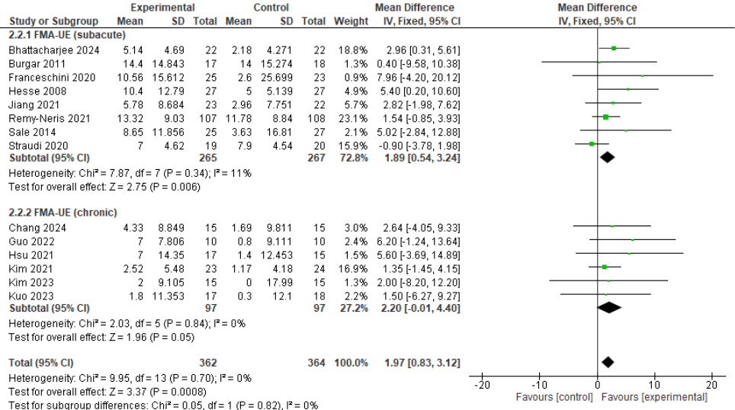

Figure S7.2 Forest plot of comparison: RAT vs conventional therapy, outcome: function – Box and Blocks

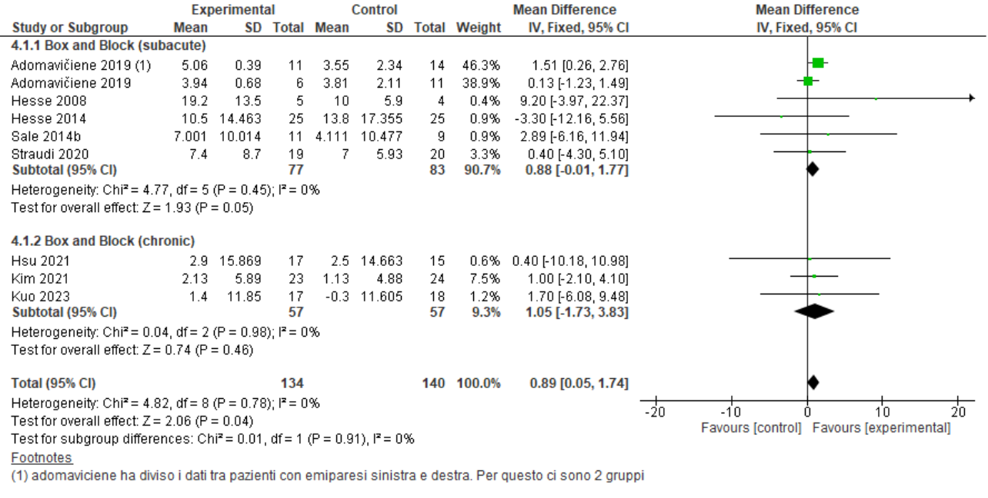
Figure S7.3 Forest plot of comparison: RAT vs conventional therapy, outcome: Barthel Index
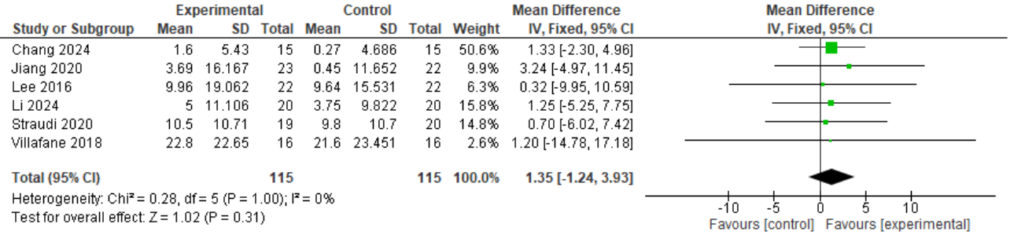
Figure S7.4 Forest plot of comparison: RAT vs conventional therapy, outcome: Activity – Motricity Index.
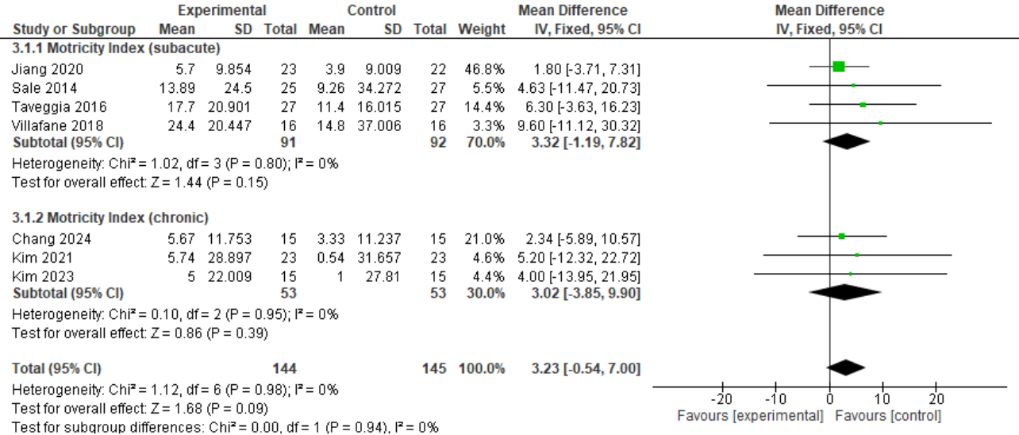

Additional file 8 - Funnel plots
Supplementary figure S8.1 : Funnel plot of comparison: RAT vs conventional therapy, outcome: MAS – elbow flexors.

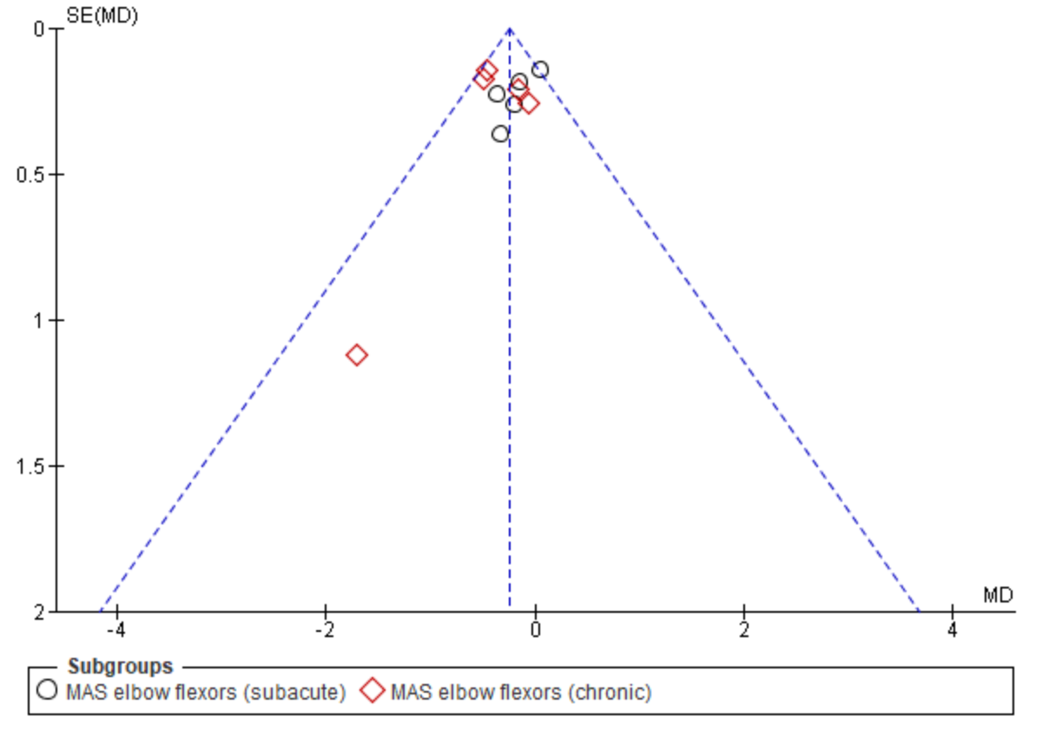
Supplementary figure S8.2 Funnel plot for unspecified MAS score

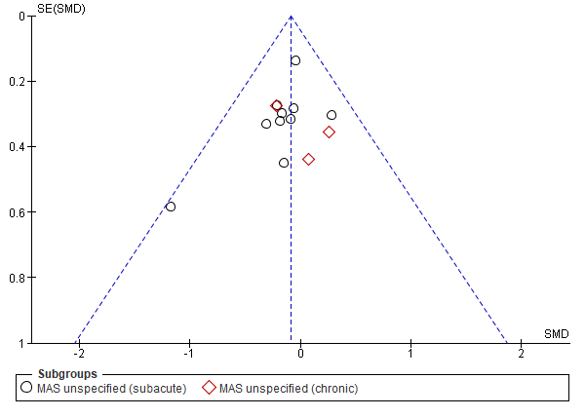
Supplementary figure S8.3 Funnel plot of comparison: RAT vs conventional therapy, outcome: MAS – shoulder-elbow-wrist devices.

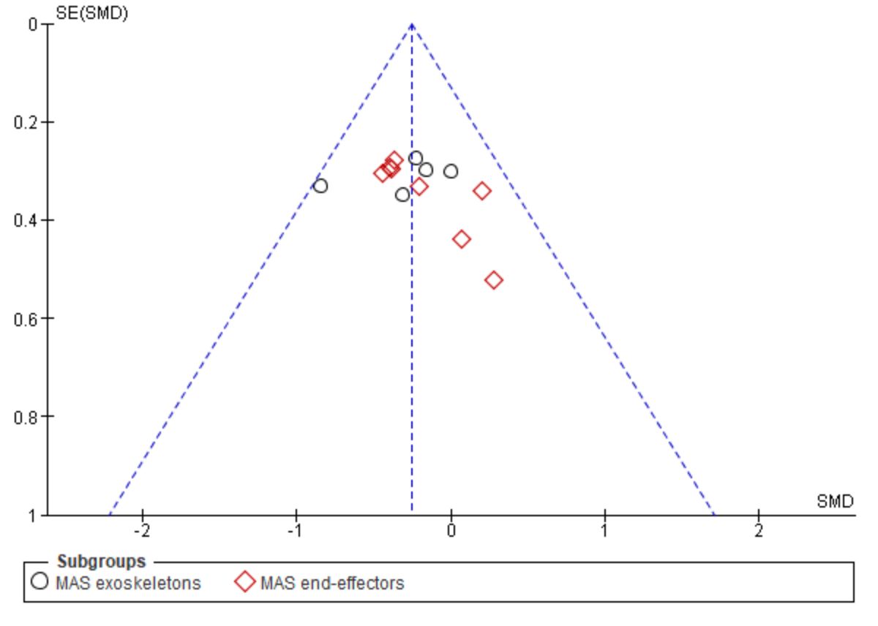

Supplementary figure S8.4 Funnel plot of comparison: RAT vs conventional therapy, outcome: MAS – dose matched.

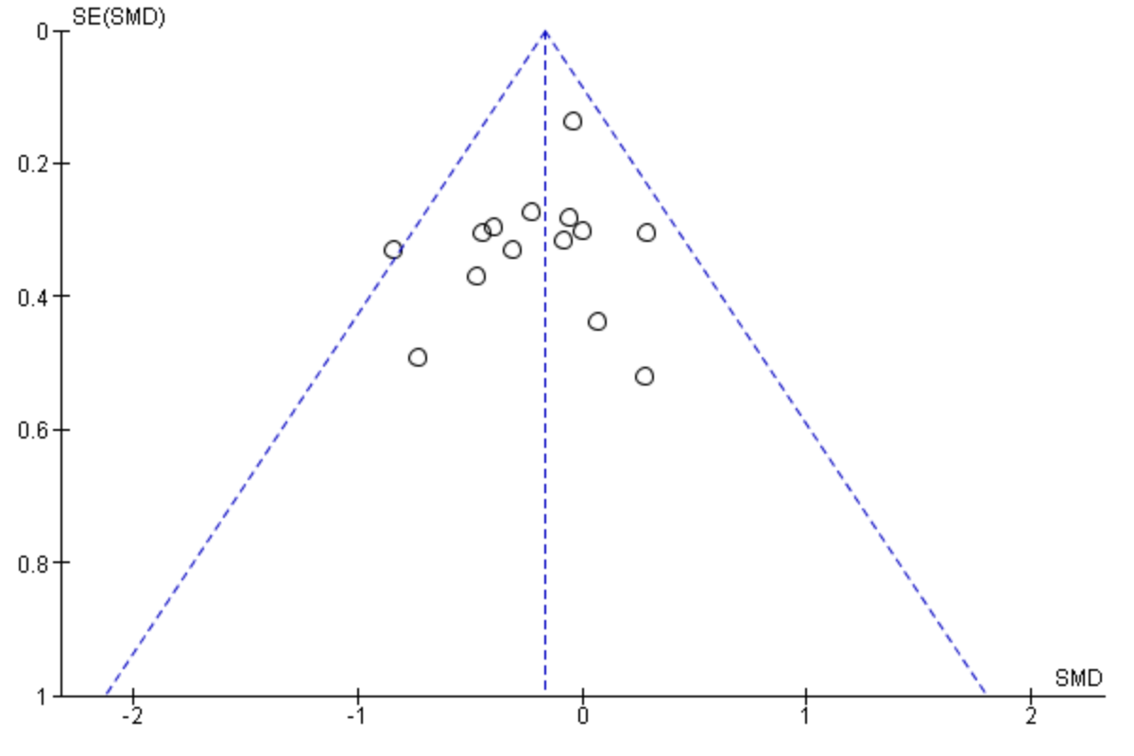

Supplementary figure 8.5 Funnel plot of comparison: RAT delivery mode, outcome: MAS – RAT alone vs CT; RAT+CT vs CT.

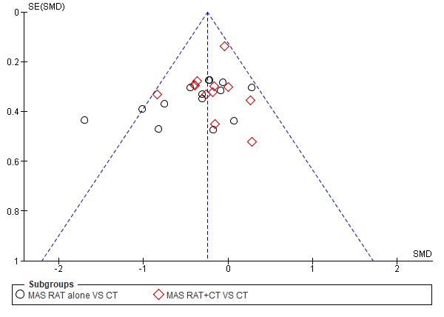

Supplementary figure 8.6 Funnel plot of comparison: RAT vs conventional therapy, outcome: function – FMA - UE

