Table S1 Search Strategy
Database | Search Strategy | Platform | Date Searched | Filters | Records
PubMed | ("CP"[Title/Abstract] OR "Cerebral Palsy"[MeSH Terms]) AND ("Virtual Reality"[MeSH Terms] OR ("virtual reality therapy"[Title/Abstract] OR "robot-assisted"[Title/Abstract]) OR "Robotics"[MeSH Terms]) AND "Rehabilitation"[Title/Abstract] | PubMed (NCBI) | 2025-9-10 | Randomized Controlled Trial;  2016-2025 | 192
Embase | ('virtual reality'/exp OR 'virtual reality' OR 'robotics'/exp OR robotics OR 'virtual reality therapy':ab,ti OR 'robot-assisted':ab,ti) AND ('cerebral palsy'/exp OR 'cp':ab,ti) AND 'rehabilitation':ab,ti AND ('randomized controlled trial'/exp OR 'randomized':ab,ti OR 'rct':ab,ti) | Embase.com (Elsevier) | 2025-9-10 | Randomized Controlled Trial;  2016-2025 | 645
Web of Science | TS=(robotics OR "virtual reality" OR "robot-assisted therapy" OR VR) AND TS=("Cerebral Palsy" OR CP) AND TS=(rehabilitation) AND TS=("randomized controlled trial" OR RCT OR randomized) | Web of Science Core Collection (Clarivate) | 2025-9-10 | Articles;  2016-2025 | 235
Cochrane Library | #1: MeSH descriptor: [Virtual Reality] explode all trees; #2: MeSH descriptor: [Robotics] explode all trees  #3: (virtual reality therapy):ti,ab,kw OR (robot-assisted):ti,ab,kw; #4: #1 OR #2 OR #3  #5: MeSH descriptor: [Cerebral Palsy] explode all trees; #6: (CP):ti,ab,kw; #7: #5 OR #6  #8: #4 AND #7 | Wiley Online Library | 2025-9-10 | Trials;  2016-2025 | 164
CINAHL | (SU ("Virtual Reality" OR Robotics OR "robot-assisted therapy" OR "virtual reality therapy")) AND (SU ("cerebral palsy" OR "cp")) AND (SU (Rehabilitation)) | EBSCOhost | 2025-9-10 | Randomized Controlled Trials;  2016-2025 | 265
ClinicalTrials.gov | AREA[ConditionSearch](Cerebral Palsy \(CP\)) AND AREA[InterventionSearch](Virtual Reality OR robot-assisted therapy or robot) | clinicaltrials.gov | 2025-9-10 | None | 89
WHO ICTRP | ('cerebral palsy' OR CP) AND ('virtual reality' OR VR OR 'robot-assisted therapy' OR robot) AND (rehabilitation OR therapy) | trialsearch.who.int | 2025-9-10 | None | 102
Grey Literature | Open Grey: ('cerebral palsy' OR CP) AND ('virtual reality' OR VR OR 'robot-assisted therapy' OR robot) AND (rehabilitation OR therapy)  Grey Net: Searched manually using keywords: cerebral palsy, CP, virtual reality, VR, robot-assisted therapy, robot, rehabilitation, therapy | opengrey.eu: (phys-techsciences.datastations.nl)  greynet.org | 2025-9-10 | None | 28
Note: (1) Open Grey:Search performed using simple search box. The platform does not support complex Boolean operators; terms were entered as a single string. All results screened manually.
- Grey Net: GreyNet is primarily a document repository; searched by browsing categories and using basic keyword search.

Figure S1: Summary Figure of Risk of Bias Assessed by ROB-1 and ROB-2
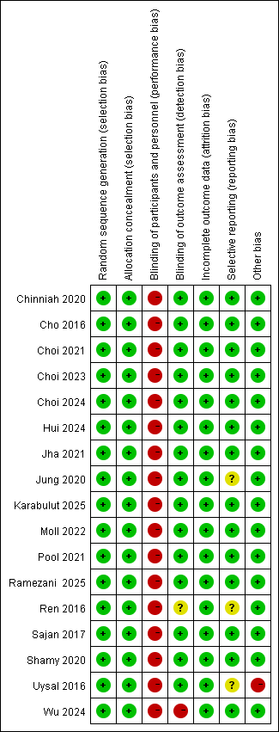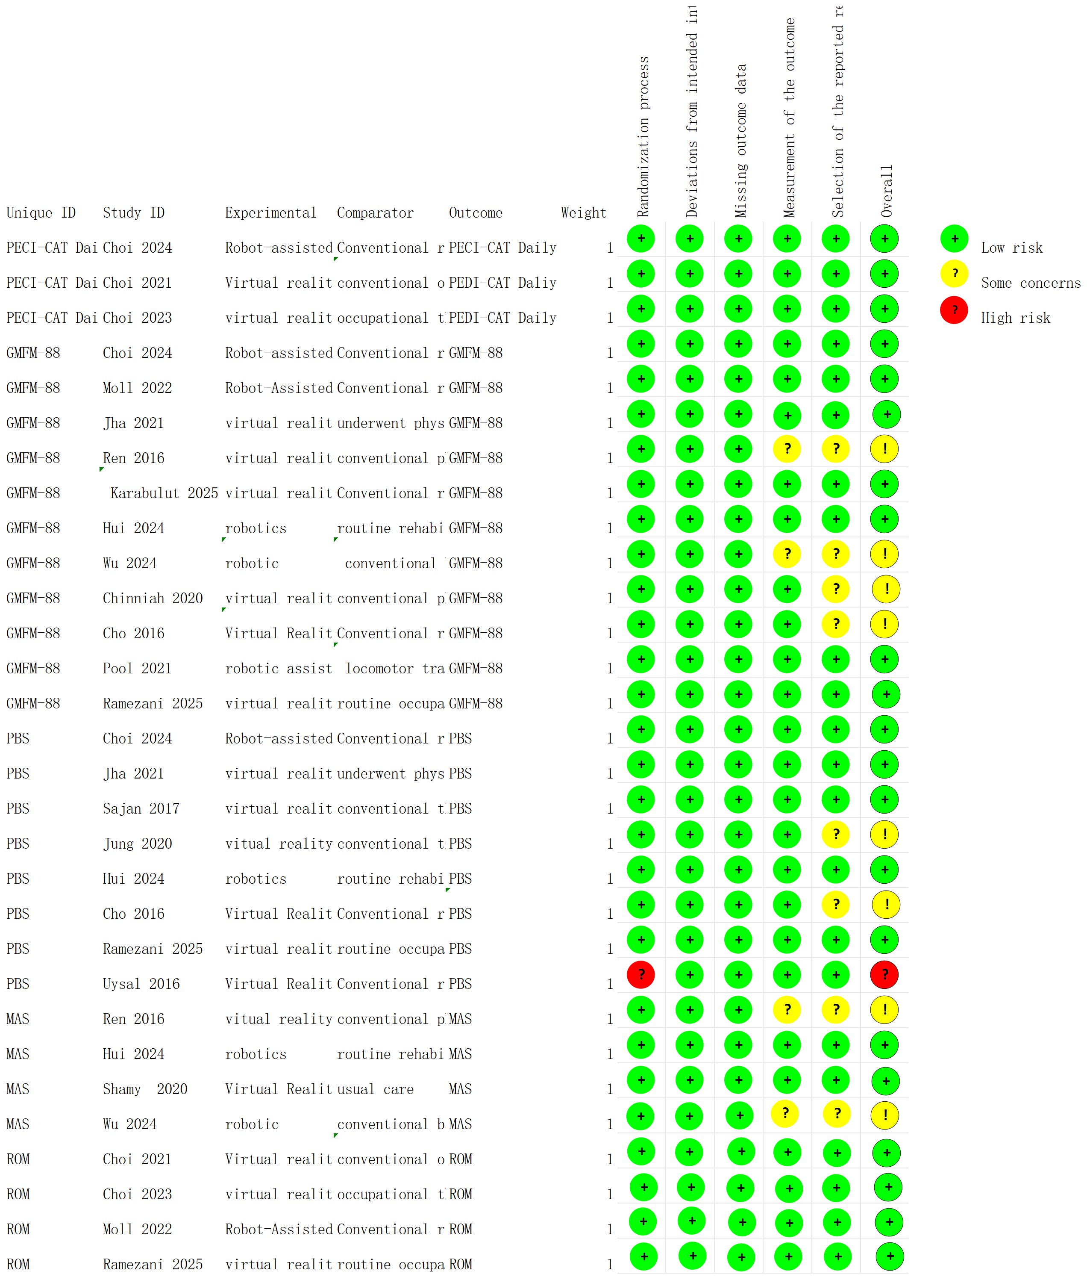

Figure S2: Figure of the GRADE Assessment

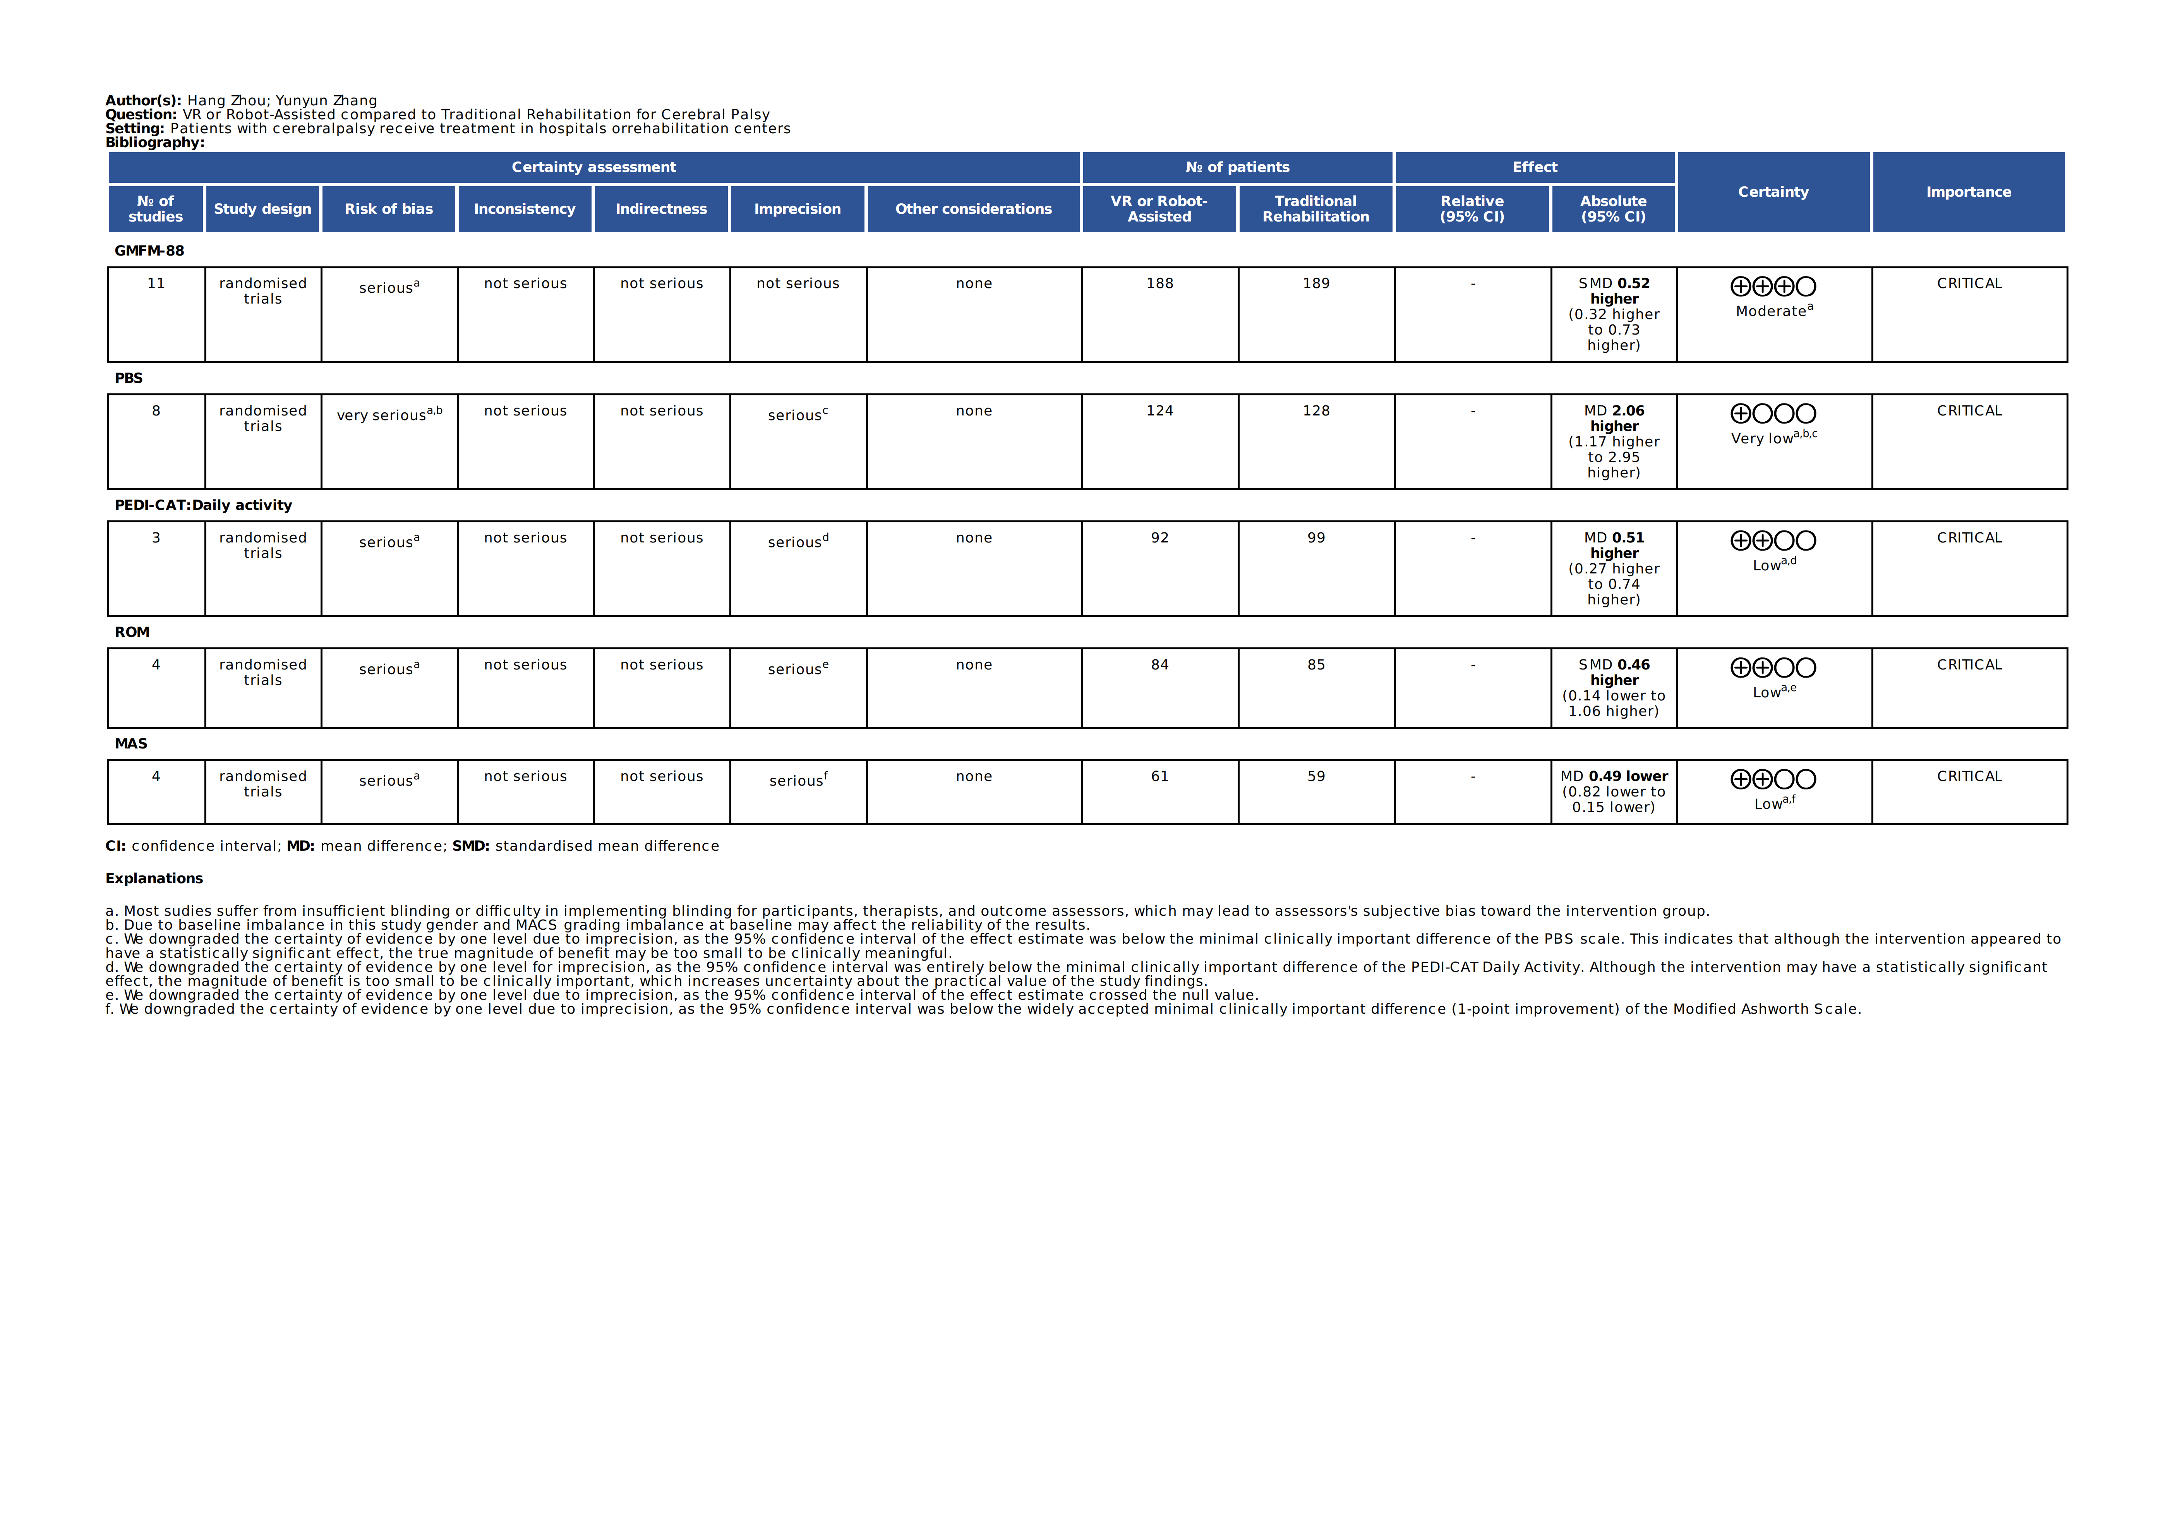
Multimedia Appendix : Leave-One-Out procedures
Table S2: Leave-One-Out Sensitivity for GMFM-88 (VR Subgroup, k=5)
Model Pooled SMD 95%CI Change from Overall
Full (k=5) |  |  | 0.49 |  | (0.17, 0.81) |  | -
Ren 2016 |  |  | 0.48 |  | (0.11, 0.85) |  | -0.01
Cho 2016 |  |  | 0.52 |  | (0.18, 0.86) |  | 0.03
Jha 2021 |  |  | 0.53 |  | (0.16, 0.90) |  | 0.04
Ramezani 2025 |  |  | 0.47 |  | (0.11, 0.83) |  | -0.02
Karabulut 2025 |  |  | 0.45 |  | (0.09,0.81) |  | -0.04

GMFM-88 (Robot-assisted Subgroup, k=6)
Model Pooled SMD 95%CI Change from Overall
Full (k=6) |  |  | 0.64 |  | (0.23, 1.05) |  | -
Chinniah 2020 |  |  | 0.42 |  | (0.24, 0.67) |  | -0.22
Pool 2021 |  |  | 0.76 |  | (0.28, 1.23) |  | 0.12
Moll 2022 |  |  | 0.66 |  | (0.16, 1.16) |  | 0.02
Choi 2024 |  |  | 0.77 |  | (0.29, 1.25) |  | 0.13
Wu 2024 |  |  | 0.63 |  | (0.18,1.09) |  | -0.01
Hui 2024 |  |  | 0.62 |  | (0.13, 1.11) |  | -0.02

Leave-One-Out Sensitivity for GMFM-88 (Spastic Subgroup, k=7)
Model Pooled SMD 95%CI Change from Overall
Full (k=7) |  |  | 0.44 |  | (0.20, 0.69) |  | -
Cho 2016 |  |  | 0.46 |  | (0.20, 0.71) |  | 0.02
Choi 2024 |  |  | 0.52 |  | (0.23, 0.82) |  | 0.08
Hui 2024 |  |  | 0.39 |  | (0.13, 0.65) |  | -0.05
Karabulut 2025 |  |  | 0.42 |  | (0.15, 0.68) |  | -0.02
Moll 2022 |  |  | 0.42 |  | (0.16,0.68) |  | -0.02
Pool 2021 |  |  | 0.49 |  | (0.22, 0.76) |  | 0.05
Ramezani 2025 |  |  | 0.42 |  | (0.16, 0.69) |  | -0.02

Leave-One-Out Sensitivity for GMFM-88 ( Bilatera Spastic Subgroup, k=2)
Model Pooled SMD 95%CI Change from Overall
Full (k=2) |  |  | 0.46 |  | (-0.12, 1.04) |  | -
Jha 2021 |  |  | 0.83 |  | NA |  | 0.37
Wu 2024 |  |  | 0.37 |  | NA |  | -0.09

Leave-One-Out Sensitivity for GMFM-88 ( Diplegia Subgroup, k=2)
Model Pooled SMD 95%CI Change from Overall
Full (k=2) |  |  | 1.04 |  | (-0.02, 2.09) |  | -
Chinniah 2020 |  |  | 0.53 |  | NA |  | -0.51
Ren 2016 |  |  | 1.60 |  | NA |  | 0.56
Table S2: Leave-One-Out Sensitivity for PBS (VR Subgroup, k=5)
Model Pooled MD 95%CI Change from Overall
Full (k=5) |  |  | 2.75 |  | (-0.16, 5.66) |  | -
Cho 2016 |  |  | 2.91 |  | (-0.71, 6.52) |  | 0.16
Jung 2020 |  |  | 1.87 |  | (0.94, 2.80) |  | -0.88
Sajan 2017 |  |  | 3.07 |  | (0.09, 6.05) |  | 0.32
Ramezani 2025 |  |  | 3.45 |  | (-2.22, 9.12) |  | 0.7
Uysal 2016 |  |  | 4.34 |  | (-1.47, 10.15) |  | 1.59

PBS (Robot-assisted Subgroup, k=3)
Model Pooled MD 95%CI Change from Overall
Full (k=3) |  |  | 3.36 |  | (0.05, 6.68) |  | -
Choi 2024 |  |  | 3.49 |  | (-0.05, 7.03) |  | 0.13
Hui 2024 |  |  | 3.45 |  | (0.03, 6.86) |  | 0.09
Jha 2021 |  |  | 2.31 |  | (-5.47,10.08) |  | -1.05

Table S3: Leave-One-Out Sensitivity for MAS (MD)
Model Pooled MD 95%CI Change from Overall
Full (k=4) |  |  | -0.49 |  | (-0.82, -0.15) |  | -
Ren 2016 |  |  | -0.36 |  | (-0.60, -0.12) |  | 0.13
Shamy 2020 |  |  | -0.54 |  | (-1.19, 0.11) |  | -0.05
Hui 2024 |  |  | -0.59 |  | (-0.98,-0.20) |  | -0.1
Wu 2024 |  |  | -0.49 |  | (-0.87, -0.10) |  | 0
Table S3: Leave-One-Out Sensitivity for PEDI-CAT Daily Activity (MD)

Model Pooled MD 95%CI Change from Overall
Full (k=3) |  |  | 0.51 |  | (0.27, 0.74) |  | -
Choi 2021 |  |  | 0.31 |  | (-1.68, 2.29) |  | -0.2
Choi 2023 |  |  | 0.51 |  | (0.27, 0.75) |  | 0
Choi 2024 |  |  | 0.51 |  | (0.27, 0.74) |  | 0

Table S3: Leave-One-Out Sensitivity for ROM (SMD)

Model Pooled SMD 95%CI Change from Overall
Full (k=4) |  |  | 0.46 |  | (-0.14, 1.06) |  | -
Choi 2021 |  |  | 0.34 |  | (-0.53, 1.21) |  | -0.12
Choi 2023 |  |  | 0.61 |  | (-0.11, 1.33) |  | 0.15
Moll 2022 |  |  | 0.64 |  | (0.00, 1.28) |  | 0.18
Ramezani 2025 |  |  | 0.23 |  | (-0.38, 0.84) |  | -0.23

