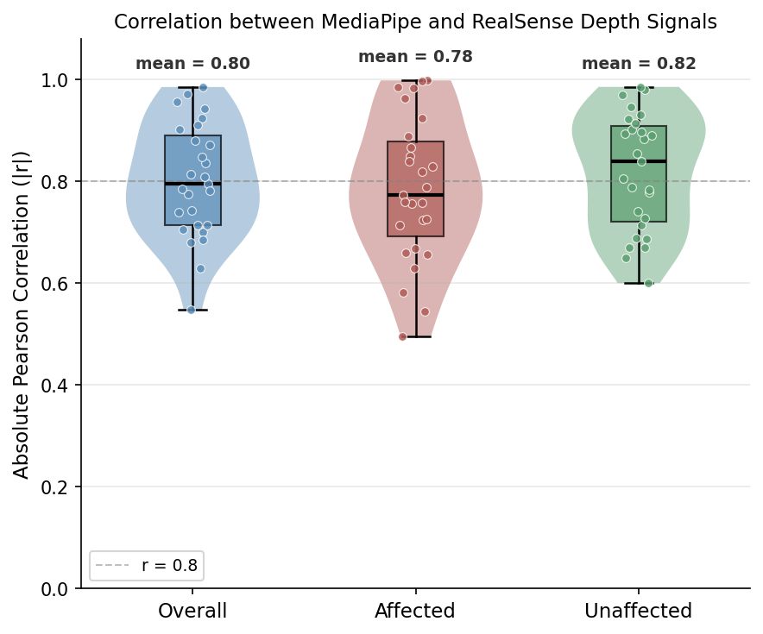
Supplementary Figure 1. Distribution of Pearson correlation coefficients between MediaPipe-based and RealSense-based depth signals across all trials. Violin plots with embedded boxplots illustrate the distributions for overall, affected, and unaffected conditions.

Supplementary Table 1. Smart Board Task Performance Metrics
Task | Length (m) |  | Speed (m/s) |  | Duration (s)
Task | FB group | NFB group | FB group | NFB group | FB group | NFB group
Task1 (Affected Triangle) | 2.352 | 2.216 | 0.270 | 0.238 | 11.842 | 13.874
Task2 (Unaffected Triangle) | 2.365 | 2.357 | 0.249 | 0.238 | 12.182 | 14.747
Task3 (Affected Front-Back) | 0.956 | 0.916 | 0.208 | 0.179 | 5.259 | 6.983
Task4 (Middle Front-Back) | 1.035* | 0.943 | 0.212 | 0.173 | 5.777 | 9.928
Task5 (Diagonal) | 3.305** | 4.002 | 0.247 | 0.191 | 17.088** | 29.833
FB, Feedback; NFB, Non-Feedback. *p < 0.05, **p < 0.01, ***p < 0.001

Supplementary Table 2. The usability assessment questionnaire
Usability Assessment Questionnaire
Smartphone-Based Real-Time Feedback System for Trunk Compensation Monitoring
Please rate each item on a scale from 1 (Strongly Disagree) to 5 (Strongly Agree) by marking the appropriate circle.
For open-ended questions, please write your response in the space provided.
Name |  | Age |  | Sex |  | Date
No. | Item |  |  | Strongly agree | Agree | Neutral | Disagree | Strongly disagree
Usability of the Rehabilitation System
1 | Do you think the rehabilitation system is suitable for independent use? |  |  | ⑤ | ④ | ③ | ② | ①
2 | Do you feel that the rehabilitation system was helpful for your treatment? |  |  | ⑤ | ④ | ③ | ② | ①
Effectiveness and Convenience
3 | Was the feedback provided via the mobile device (visual and auditory) easy to understand and helpful? |  |  | ⑤ | ④ | ③ | ② | ①
4 | Did you experience difficulty monitoring both the training screen and mobile feedback simultaneously during rehabilitation? |  |  | ⑤ | ④ | ③ | ② | ①
5 | Did the posture feedback provided by the mobile system (visual and auditory) help you correct your posture during rehabilitation? |  |  | ⑤ | ④ | ③ | ② | ①
6 | Do you feel that your motor ability or posture improved after using the rehabilitation system? |  |  | ⑤ | ④ | ③ | ② | ①
7 | Did you find the mobile feedback system to be immediate and clear? |  |  | ⑤ | ④ | ③ | ② | ①
Errors and Usability Issues
8 | Did you encounter any factors that caused mistakes while using the rehabilitation system? |  |  | ⑤ | ④ | ③ | ② | ①
9 | Did you experience any interruptions or malfunctions while using the system? |  |  | ⑤ | ④ | ③ | ② | ①
10 | If you felt any aspects of the rehabilitation system need improvement, please describe them.
Applicability
11 | If this system were to be applied to other types of therapy, what kind of treatment do you think it would be suitable for?
Open-Ended Questions
12 | Please provide any additional comments or suggestions.
* This questionnaire was developed by the authors specifically for evaluating the usability of the smartphone-based trunk compensation feedback system used in this study.
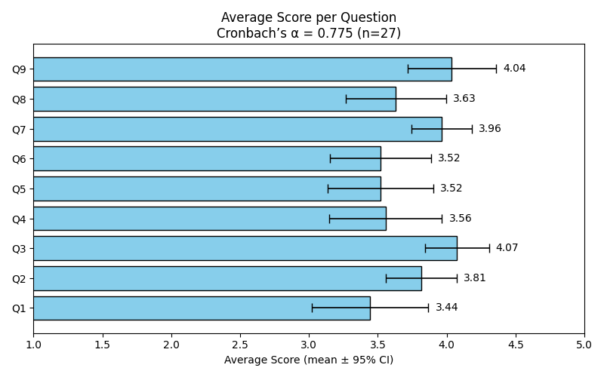
Supplementary Figure 2. Average Survey Score per Question
Mean usability survey scores (5-point Likert scale) for each question in the Feedback group.

Supplementary Table 3. Item-level results of the usability assessment questionnaire (n = 27)
Item | Mean ± SD | Strongly Agree (5) |  | Agree (4) |  | Neutral (3) |  | Disagree (2) |  | Strongly Disagree (1)
Q1 | 3.44 ± 1.12 | 18.5% | 37.0% |  | 14.8% |  | 29.6% |  | 0.0%
Q2 | 3.81 ± 0.68 | 11.1% | 63.0% |  | 22.2% |  | 3.7% |  | 0.0%
Q3 | 4.07 ± 0.62 | 18.5% | 74.1% |  | 3.7% |  | 3.7% |  | 0.0%
Q4 | 3.56 ± 1.09 | 14.8% | 55.6% |  | 0.0% |  | 29.6% |  | 0.0%
Q5 | 3.52 ± 1.01 | 14.8% | 44.4% |  | 18.5% |  | 22.2% |  | 0.0%
Q6 | 3.52 ± 0.98 | 14.8% | 40.7% |  | 25.9% |  | 18.5% |  | 0.0%
Q7 | 3.96 ± 0.59 | 11.1% | 77.8% |  | 7.4% |  | 3.7% |  | 0.0%
Q8 | 3.63 ± 0.97 | 11.1% | 63.0% |  | 3.7% |  | 22.2% |  | 0.0%
Q9 | 4.04 ± 0.85 | 25.9% | 63.0% |  | 0.0% |  | 11.1% |  | 0.0%
Values are presented as mean ± standard deviation. Percentages indicate the proportion of responses for each Likert scale category (5 = strongly agree to 1 = strongly disagree).

