Clinical and instrumental gait phenotyping in subjects with Cri du Chat syndrome

Supplementary material
Trunk acceleration – derived indexes calculation
Gait data processing
To calculate the trunk acceleration-derived gait indexes, gait trials with at least 20 consecutive accurately recorded strides were included in the analysis. To determine initial contacts, the vertical acceleration signal was first detrended and then low-pass filtered using a FIR filter at 3.2 Hz. After numerically integrating and differentiating the resulting signal through a Gaussian continuous wavelet transformation (scale 9, gauss 1), the initial contacts were identified as the positive peaks between the zero-crossing (Mico-Amigo et al., 2023). To ensure a steady-state walking assessment, we removed the first and last two strides of each 30-meter walk.
We then calculated harmonic ratios (HR), the short-term largest Lyapunov’s exponent (sLLE), the log-dimensionless jerk of acceleration signals (LDLJa) and the recurrence quantification analysis percent determinism (RQA-det) in the three spatial directions, finally, we also calculated the CV of stride length.
HRs calculation
Based on stride time, 20 harmonics were computed for each subject to calculate HR in the antero-posterior (HR_{AP}), medio-lateral (HR_{ML}), and vertical (HR_{V}) directions. A discrete Fourier transform was applied to convert the trunk accelerations of each stride into single sinusoidal waveforms. The sum of the first ten even harmonics was divided by the sum of the first ten odd harmonics to calculate HR_{AP} and HR_{V}.HR_{ML} was calculated by adding the amplitudes of the odd harmonics and dividing them by the amplitudes of the even harmonics. To remove noise signals, a high-pass filter with a cutoff of 20 Hz was used. HRs were calculated for each stride and averaged over a steady walk to obtain the mean HR as follows:

$${HR}_{AP, V }=\frac{{\sum_{i}{A}}_{i*2}}{\sum_{i}{A_{i*2-1}}}$$

$${HR}_{ML }=\frac{\sum_{i}{A_{i*2-1}}}{{\sum_{i}{A}}_{i*2}}$$
where $A_{i}$indicates the amplitude of the first 20 even harmonics, and A2i–1 represents the amplitude of the first 20 odd harmonics.
Short-term Largest Lyapunov Exponent (sLLE) calculation
The sLLE assesses gait stability as the average logarithmic rate of divergence between the system's trajectory and its nearest neighbouring trajectory. Convergent trajectories indicate local dynamic stability, and divergent trajectories indicate local dynamic instability. Using a fixed number of strides per subject (n = 20), accelerations were segmented using predefined initial contacts, with each segment representing a gait stride, and the data were time-normalized to obtain 100 data points per stride. To preserve spatiotemporal fluctuations and nonlinearities, the acceleration signals were not filtered. The recorded one-dimensional time-series data was transformed into a multidimensional state space by juxtaposing original and delayed copies. The dimensions of the reconstructed state space were determined using the False Nearest Neighbor (FNN) method, considering a range of embedding dimension 2 - 10. The time delay was calculated using the first minimum of the Average Mutual Information (AMI) function, exploring a range from 7 to 18 samples. Rosenstein's algorithm for short time series, implemented with the "lyap_r" function from Python's "nolds" library, was used to calculate the sLLE for each stride and acceleration direction.
Log-dimensionless jerk of accelerations (LDLJa) calculation
LDLJ of acceleration signals reflects the smoothness of acceleration data. It is specifically designed for use with IMU-derived acceleration signals. Unlike other smoothness measures, such as spectral arc length or velocity-based log dimensionless jerk, it does not integrate the reconstructed acceleration signal, avoiding errors caused by drift in the reconstructed velocity. To calculate LDLJa in each direction, the acceleration data were first filtered using a low-pass Butterworth filter with a cutoff frequency of 20 Hz and a sampling frequency of 100 Hz to remove high-frequency noise. Then, the LDLJ was computed according to the formula:

$$λ_{L}^{a}\left(a\right)≜-\ln\left(\frac{\left({\text{t}}_{\text{2}}-{\text{t}}_{\text{1}}\right)}{a_{\text{peak}}^{2}}\int_{{\text{t}}_{\text{1}}}^{{\text{t}}_{\text{2}}}{\left.|\frac{d^{2}}{d{\text{t}}^{\text{2}}}a\left(\text{t}\right)\right.|_{2}^{2}}\right)$$

$$a_{\text{peak}}≜\max_{t∈\left[t_{1},t_{2}\right]}{|}a\left(t\right)|_{2}$$
where $a(t)$ denotes the acceleration movement in the time domain, a normalization factor based on the peak of the acceleration profile $a_{peak}$, and $t_{1}$,$t_{2}$ represent the start and stop times of the movement, respectively.

Percent determinism in Recurrence quantification (RQA_{det}) calculation
Based on the reconstruction of recurrence plots, RQA_{det} was calculated for each acceleration direction through the nearest-neighbor method by embedding accelerations in a range of embedding dimension (m) 2-10. False neighbors’ analysis was performed using values of Rtol = 17 and Atol = 2. The first minimum of the AMI function was used to calculate time delay in a range 7-18. Percent determinism in RQA was calculated as follows:
$$\%\det{=\frac{ \sum_{l=lmin}^{N}{lP(l)}}{\sum_{l=1}^{N}{lP(l)}}}$$
Where P(l) is the frequency distribution of the lengths l of the diagonal lines in the recurrence matrix (i.e., it counts how many patterns have length l).
Step length CV calculation
CV was calculated as the ratio of the standard deviation to the mean step length over all step lengths for each subject, as follows:
$$CV={100SD}/{mean}$$

Optimal data matching procedure
Propensity score difference method

The matching procedure was carried out using a dataset of 92 walking trials from 42 healthy subjects prospectively recorded at self-selected pace and slow speeds. A 1:1 optimal matching procedure using the propensity score difference method was implemented. Propensity scores were computed using logistic regression analysis, with age and speed as covariates. Gait parameters were adjusted for age and height. The adjustment was carried out using linear regression models, where age and height served as covariates in the model for each gait variable. For each variable of interest a separate linear regression model was fitted, specified as:
$Variable = β₀ + β₁ × Age + β₂ × Height + ε$₍₁₎
where β₀ is the intercept of the regression equation, β₁ and β₂ are the coefficients for age and height, respectively, representing the effect of these variables on the dependent variable, and ε represents the error term, capturing the variation in variable not explained by age and height.

Supplementary figure 1 - spatio-temporal parameters in CdCS and HS groups
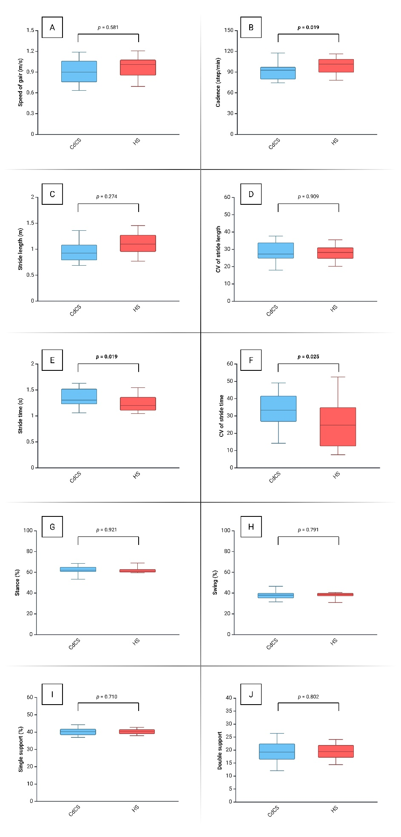
Legend: CdCS: Cri du Chat participants (blue); HS: healthy subjects (red). CV: coefficient of variation. In bold: statistically significant comparisons.

Supplementary figure 2 – pelvic dynamic during gait in CdCS and HS groups
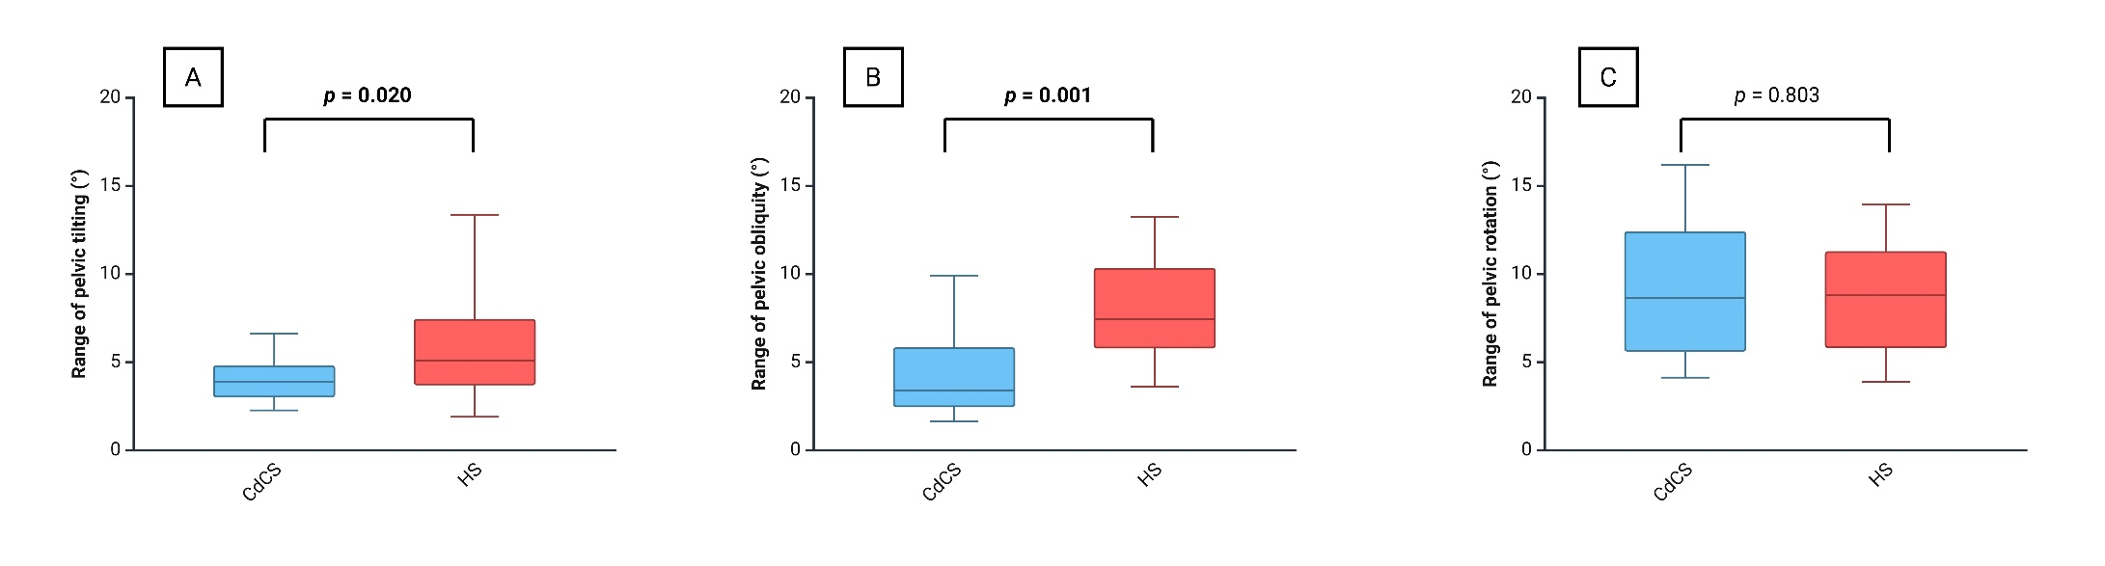
Legend: CdCS: Cri du Chat participants (blue); HS: healthy subjects (red). CV: coefficient of variation. In bold: statistically significant comparisons.

Supplementary table 1 – parameters of the logistic regression analysis
 | B | E.S. | Wald | df | p-value | Exp(B) | 95% CI for Exp(B)
 |  |  |  |  |  |  | Lower | Upper
Male | 0.258 | 0.911 | 0.080 | 1 | 0.777 | - | - | -
Age (years) | 0.150 | 0.065 | 5.327 | 1 | 0.021 | 1.162 | 1.023 | 1.320
Speed of gait (m/s) | 1.158 | 1.930 | 0.360 | 1 | 0.549 | - | - | -
RQA_{AP} | -0.070 | 0.027 | 6.788 | 1 | 0.009 | 0.933 | 0.885 | 0.983
HR_{AP} | -3.775 | 1.182 | 10.201 | 1 | 0.001 | 0.023 | 0.002 | 0.233
Pelvic obliquity (°) | -0.398 | 0.167 | 5.686 | 1 | 0.017 | 0.672 | 0.484 | 0.932
Constant | 10.082 | 3.538 | 8.122 | 1 | 0.004 | 23897.179 | - | -
Legend: CdCS: Cri du Chat participants; HS: healthy subjects. HR: harmonic ratio; RQA: percent determinism in recurrence quantification analysis. AP: antero-posterior plane. The coefficients (B) express the log-odds of predicting whether a case is CdCS versus HS based on independent variables. The standard errors (S.E.) associated with each coefficient, the Wald chi-square values indicating the significance of the coefficients, and the degrees of freedom (df) are also provided. The odds ratios (Exp(B)), calculated by exponentiating the coefficients, along with their 95% confidence intervals (C.I.), are listed to reflect the likelihood of each outcome.

