Supplementary Materials
Table S1: CONSORT 2025 Expanded Checklist for Submission
Title and Abstract
Checklist | Description | Where in paper
1a | Identified as randomised trial | Page 1
1b | Structured summary of the trial design, methods, results, and conclusions | Page 1
Open Science
2 | Trial registration | Page 12
3 | Protocol and statistical analysis plan | Page 11-13
4 | Data sharing | Page 27
5a | Sources of funding and other support (e.g., supply of drugs), and role of funders in the design, conduct, analysis and reporting of the trial | Page 27
5b | Financial and other conflicts of interest of the manuscript authors | Page 27
Introduction
6 | Scientific background and rationale | Page 2-4
7 | Specific objectives related to benefits and harms | Page 4
Methods
8 | Details of patient or public involvement in the design, conduct and reporting of the trial | Page 13
9 | Description of trial design including type of trial (e.g., parallel group, crossover), allocation ratio, and framework (e.g., superiority, equivalence, non-inferiority, exploratory) | Page 5
10 | Important changes to the trial after it commenced including any outcomes or analyses that were not prespecified, with reason | Page 13
11 | Settings (e.g., community, hospital) and locations (e.g., countries, sites) where the trial was conducted | Page 5
12a | Eligibility criteria for participants | Page 5-6
12b | If applicable, eligibility criteria for sites and for individuals delivering the interventions (e.g., surgeons, physiotherapists) | Not applicable
13 | Intervention and comparator with sufficient details to allow replication. If relevant, where additional materials describing the intervention and comparator (e.g., intervention manual) can be accessed | Page 6-8
14 | Pre-specified primary and secondary outcomes, including the specific measurement variable (e.g., systolic blood pressure), analysis metric (e.g., change from baseline, final value, time to event), method of aggregation (e.g., median, proportion), and time point for each outcome | Page 8
15 | How harms were defined and assessed (e.g., systematically, non-systematically) | Pages 10 and 19
16a | How sample size was determined, including all assumptions supporting the sample size calculation | Page 9
16b | Explanation of any interim analyses and stopping guidelines | Not applicable
17a | Who generated the random allocation sequence and the method used | Page 6
17b | Type of randomisation and details of any restriction (e.g., stratification, blocking and block size) | Page 6
18 | Mechanism used to implement the random allocation sequence (e.g., central computer/telephone; sequentially numbered, opaque, sealed containers), describing any steps to conceal the sequence until interventions were assigned | Page 6
19 | Whether the personnel who enrolled and those who assigned participants to the interventions had access to the random allocation sequence. | Page 6
20a | Who was blinded after assignment to interventions (e.g., participants, care providers, outcome assessors, data analysts) | Page 6
20b | If blinded, how blinding was achieved and description of the similarity of interventions | Page 6
21a | Statistical methods used to compare groups for primary and secondary outcomes, including harms | Page 9-10
21b | Definition of who is included in each analysis (e.g., all randomised participants), and in which group | Page 9-10
21c | How missing data were handled in the analysis | Page 9-10
21d | Methods for any additional analyses (e.g., subgroup and sensitivity analyses), distinguishing prespecified from post-hoc | Page 9-10
Results
22a | For each group, the numbers of participants who were randomly assigned, received intended intervention, and were analysed for the primary outcome | Page 15-16, Figure 2
22b | For each group, losses and exclusions after randomisation, together with reasons | Page 15-16
23a | Dates defining the periods of recruitment and follow-up for outcomes of benefits and harms | Page 5
23b | If relevant, why the trial ended or was stopped | Page 14 and 24
24a | Intervention and comparator as they were actually administered (e.g., where appropriate, who delivered the intervention/comparator, whether participants adhered, whether they were delivered as intended [fidelity]) | Page 8-10 and Page 16
24b | Concomitant care received during the trial for each group | Page 6-8
25 | A table showing baseline demographic and clinical characteristics for each group | Page 17-19, Table 1
26 | For each primary and secondary outcome, by group. | Page 19-22
27 | All harms or unintended events in each group | Page 22
28 | Any other analyses performed, including subgroup and sensitivity analyses, distinguishing pre-specified from post-hoc | Page 21-22
Discussion
29 | Interpretation consistent with results, balancing benefits and harms, and considering other relevant evidence | Page 22-26
30 | Trial limitations, addressing sources of potential bias, imprecision, generalisability, and, if relevant, multiplicity of analyses | Page 25-26

Table S2: Linear mixed model analysis of time effects on primary and secondary outcomes: Time main effect

Outcome | F(df) | p
- All participants (modified intention to treat)
FMA-UE Total | 10.34(1, 50.6) | 0.002
SULCS | 13.48(1, 49.9) | 0.001
SIS-16 | 27.13(1, 48.4) | <0.001
DHI | 21.18(1, 49.8) | <0.001
- Subgroup: number of intervention sessions ≥10 and baseline FMA-UE total <35

FMA-UE Total | 4.58 (1, 33.6) | 0.040
SULCS | 12.16 (1, 33.2) | 0.001
SIS-16 | 17.65 (1, 33.0) | <0.001
DHI | 13.94 (1, 33.5) | 0.001
Abbreviations: FMA-UE, Fugl-Meyer Assessment of Upper Extremity; SULCS, Stroke Upper Limb Capacity Scale; SIS-16, Stroke Impact Scale-16; DHI, DuruÖz Hand Index; df, degrees of freedom.

Table S3: Sensitivity Analysis for mITT vs IT

Outcome Measure | mITT (n = 58) |  | ITT (n = 61)
 | F | p | F | p
FMA-UE proximal | 0.60 | 0.443 | 0.89 | 0.350
FMA-UE distal | 0.03 | 0.866 | 0.12 | 0.729
FMA-UE coordination | 2.46 | 0.123 | 2.04 | 0.159
FMA-UE Total | 0.08 | 0.776 | 0.22 | 0.641
SULCS | 0.04 | 0.846 | 0.09 | 0.769
SIS-16 | 0.54 | 0.465 | 0.50 | 0.481
DHI | 0.30 | 0.585 | 0.25 | 0.622
Abbreviations: FMA-UE, Fugl-Meyer Assessment of Upper Extremity; SULCS, Stroke Upper Limb Capacity Scale; SIS-16, Stroke Impact Scale-16; DHI, DuruÖz Hand Index; df, degrees of freedom.

Figure S1. Between-group differences in selected outcome measures
- All participants (modified intention to treat)
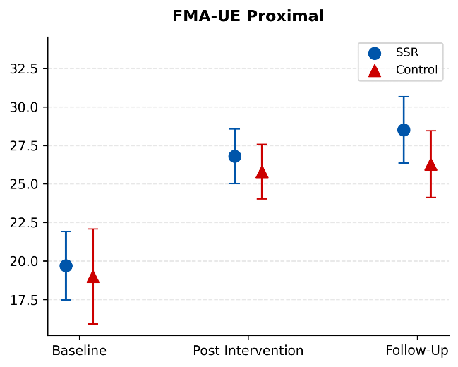 | 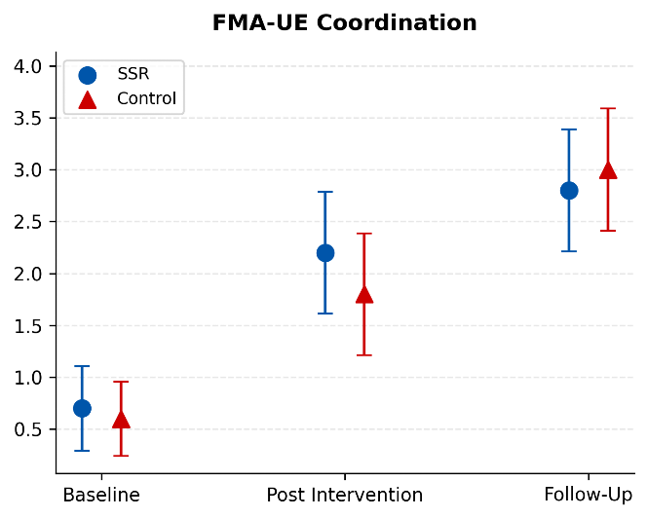
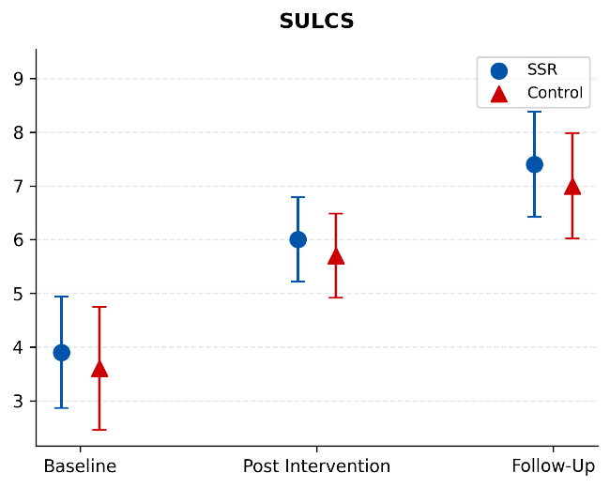 | 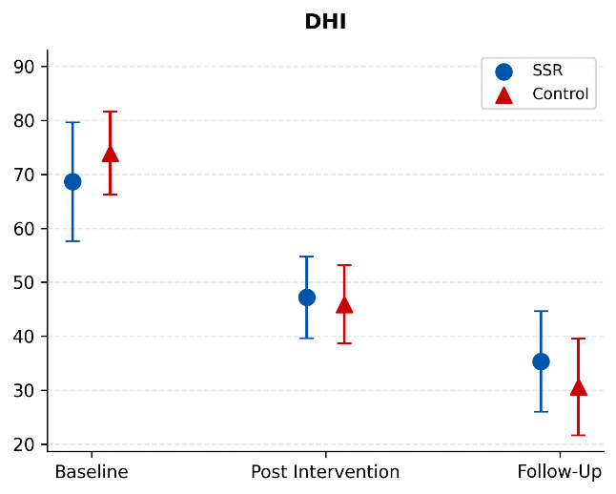
- Subgroup: number of intervention sessions ≥10 and baseline FMA-UE total <35
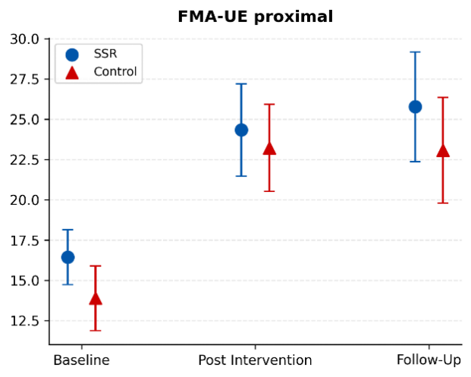 | 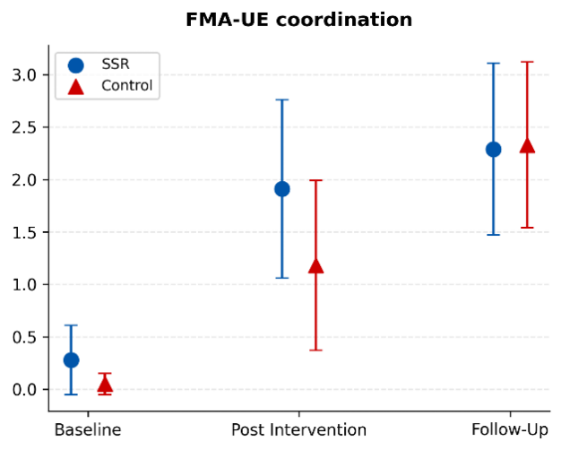
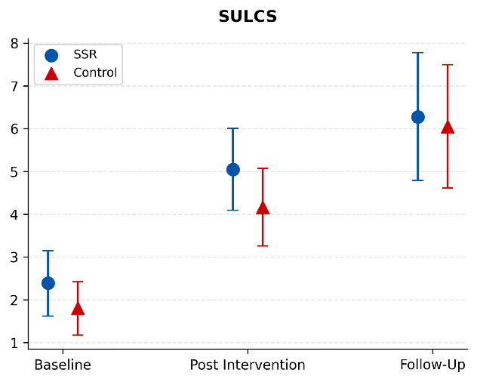 | 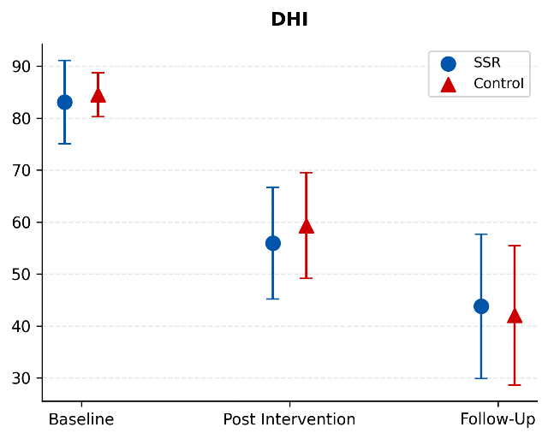
Baseline scores were unadjusted means while those at post-intervention and follow-up were least square means from the linear mixed-effects model. Error bars represent 95% confidence interval.
Abbreviations: SSR, sensor-assisted soft robotic exoskeleton; FMA-UE, Fugl-Meyer Assessment of Upper Extremity; SULCS, Stroke Upper Limb Capacity Scale; DHI, DuruÖz Hand Index

