Supplementary Materials
Overall score calculations
To calculate the overall score ($s$), the process began by assessing the absolute angular difference between each joint ($j$) in the target and actual posture. Joint angles were calculated for fourteen joints in total per hand, comprising the metacarpophalangeal, distal interphalangeal, and proximal interphalangeal joints for the index, middle, ring and little finger (i.e., three angles each) and the metacarpophalangeal and interphalangeal joints for the thumb. Then, the differences were averaged for each individual finger ($f$) separately, only including joints belonging to that finger ($J_{f}$; see Figure 3, panel B). This was expressed as the ${AvgError}_{f}$ (Eq.1):
${AvgError}_{f}=\frac{1}{N_{f}}\sum_{j∈J_{f}}{\left|a_{actual, j}-a_{target, j}\right|}$ (1)
where $N_{f}$ is the number of joints in finger $f$, $a_{actual, j}$​ is the actual angle of joint $j$, and $a_{target, j}$ is the target angle for joint $j$. Further, the score also considered that for different grasps, different joints are more important or contribute more to the overall grasp than other joints. For example, while for the cylindrical grasp all fingers contribute to the overall grasp, for the tip-to-tip pinch only index finger and thumb contribute. To account for these grasp specific differences, the average error for each finger was multiplied by a grasp-specific weighting factor ${(w}_{f})$. These weighted average finger errors were then summed across all fingers ($F$) to yield $E_{total_weighted_avg}$ (Eq.2):
$E_{total_weighted_avg}=\sum_{f∈F}{w_{f}∙{AvgError}_{f}}$ (2)
Specifically, for the cylindrical grasp the average error for each finger was weighted equally (i.e., 0.2). For the lateral key pinch, the index finger and thumb positions are more important to the grasp then the positions of the other fingers. Therefore, the average error from the thumb and index finger were weighted at 0.35 each and the average error from the middle, ring and little fingers were weighted at 0.1 each. For the tip-to-tip pinch, only average errors from the index finger and thumb were included and weighted equally (i.e., 0.5 each). A 5-degree error tolerance was also included so that if the $E_{total_weighted_avg}$ was below 5 degrees, this resulted in error of 0. This tolerance was included to make it more likely for a participant to achieve 100 even if their posture did not exactly match the target posture. Finally, the $E_{total_weighted_avg}$​ was normalized to a pre-defined overall maximum average error ($E_{upper}$​). The maximum error was set at 35 degrees, based on approximate differences in joint angles when the hand was in full extension. The overall score ($s$) was then derived from this normalized error, ensuring that lower errors correspond to higher scores with 100 representing a perfect match (Eq.3):
$s=100\left(1-\frac{E_{total_weighted_avg}}{E_{upper}}\right)$ (3)

Additional application features
Additional features of the application were described and shown to participants but were not included in the version that they tested. Specifically, the application included a custom target posture feature and a level of guidance and feedback feature. The custom target posture feature allows a therapist to create a custom target posture and save it to the set of postures that can be called upon. Further, participants could toggle the guidance and feedback levels between low, medium and high, which altered how often the target posture screen or feedback screen would be presented to the participant (e.g., medium guidance = target posture screen on every other repetition; default = high guidance; (54)).
Exploratory Analyses
Exploratory analyses were conducted to examine potential relationships between age and time since injury with the structured questionnaire data. Specifically, age and time since injury were correlated with mean custom questionnaire responses and overall SUS scores using four separate Spearman’s rank-order correlations.
Only the correlations between age and mean questionnaire responses reached significance ($r$_{s} (13) = 0.54, p = 0.036; see Supplemental Figure 1). Correlations between age and overall SUS score, time since injury and mean questionnaire responses, and time since injury and overall SUS score did not reach significance (all ps > 0.05).
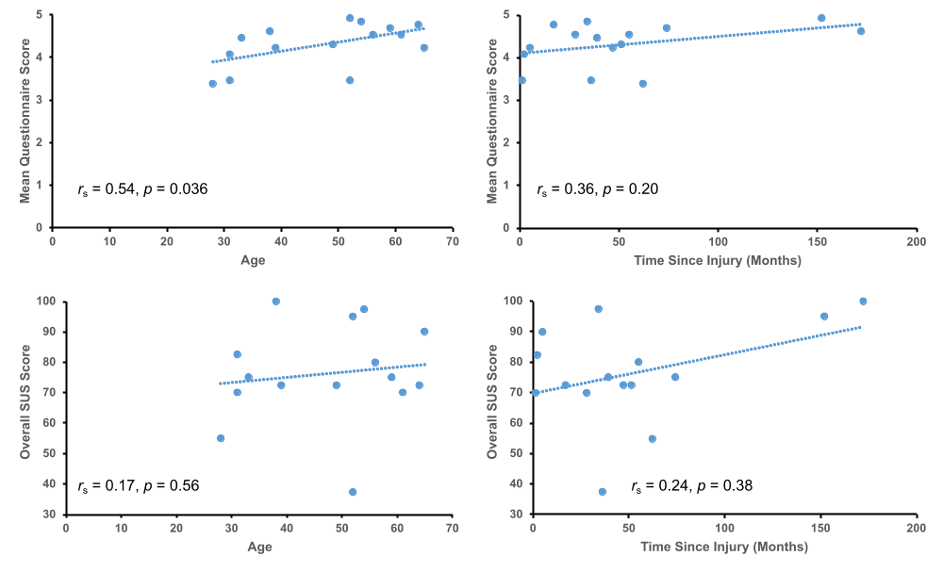
Supplemental Figure 1. Significant correlation between age and mean questionnaire score (top left), and insignificant correlations between age and overall SUS score (bottom left), time since injury and mean questionnaire score (top right), and time since injury and overall SUS score (bottom right).
Full Questionnaire Response Breakdowns
Supplemental Table 1. Means (M) and standard deviations (SD) for Likert Scale responses to the custom questionnaire statements. 1 – Strongly Disagree, 2 – Disagree, 3 – Neutral, 4 – Agree, 5 – Strongly Agree.
Custom Questionnaire Statements | M | SD
The system would improve my compliance with my treatment plans | 4.53 | 0.64
The system would increase my motivation in my exercises | 4.67 | 0.62
The repetition counting would be helpful to track my performance over time | 4.4 | 0.91
The repetition counting was helpful | 4 | 1.07
The feedback helped me focus better on my movements | 4.2 | 1.21
The quality score was helpful | 4.47 | 0.83
The quality score was easy to understand | 4.4 | 0.99
It was easy to understand if I was using the correct posture | 4 | 1
The target hand posture was helpful | 4.4 | 0.51
The target hand posture was clear | 4.07 | 0.59
The hand tracking was helpful | 4.33 | 0.62
The hand tracking seemed accurate | 3.93 | 0.8
This technology can provide useful feedback on rehab exercise at home | 4.53 | 0.52
Supplemental Table 2. Means (M) and standard deviations (SD) for Likert Scale responses to the SUS. 1 – Strongly Disagree, 2 – Disagree, 3 – Neutral, 4 – Agree, 5 – Strongly Agree.
SUS Statements | M | SD
I felt very confident using the product | 4.07 | 0.88
I imagine that most people would learn to use this product very quickly | 4.4 | 0.63
I found the various functions in the product were well integrated | 3.67 | 0.9
I thought the product was easy to use | 4.2 | 1.01
I think that I would like to use this product frequently | 4.33 | 0.62
I needed to learn a lot of things before I could get going with this product | 2.13 | 1.06
I found the product very awkward to use | 1.8 | 0.86
I thought there was too much inconsistency in this product | 1.93 | 1.03
I think that I would need the support of a technical person to use this product | 2.33 | 0.98
I found the product unnecessarily complex | 1.93 | 0.8

Questionnaires and Semi-structured Interview Guide
Custom Questionnaire
- This technology can provide useful feedback on rehab exercise at home
- The hand tracking seemed accurate
- The hand tracking was helpful
- The target hand posture was clear
- The target hand posture was helpful
- It was easy to understand if I was using the correct posture
- The quality score was easy to understand
- The quality score was helpful
- The feedback helped me focus better on my movements
- The repetition counting was helpful
- The repetition counting would be helpful to track my performance over time
- The system would increase my motivation in my exercises
- The system would improve my compliance with my treatment plans
System Usability Scale Questionnaire
- I think that I would like to use this product frequently
- I found the product unneseccarily complex
- I thought the product was easy to use
- I think that I would need the support of a techincal person to use this product
- I found the various functions in the product were well integrated
- I thought there was too much inconsistency in this product
- I imagine that most people would learn to use this product very quickly
- I found the product very awkward to use
- I felt very confident using the product
- I needed to learn a lot of things before I could get going with this product
Semi-structured Interview Guide
- Do you think you would be able to use this type of technology at home if it was available to you? Why or why not?
  - What obstacles would you anticipate, and would these be small or big problems?
  - In what ways is this most different from rehab you have done at home in the past?
  - What are you most unsure about in terms of using this at home without therapist supervision?
- How helpful do you think this type of technology would be to your rehabilitation goals?
  - Does this address any of the problems or limitations that you have encountered with rehab exercises at home in the past?
  - How could this make a difference in your recovery?
  - To what extent do you think this type of technology can provide useful supervision and feedback on rehab exercises at home?
- What did you think of the feedback that was provided by the device?
  - Did the hand tracking seem accurate?
  - How was hand tracking helpful?
  - Was the target hand posture clear?
  - How was the target hand posture helpful?
  - How easy was it to understand whether you were using the target posture and what you should be doing differently?
  - How understandable was the quality score?
  - Was the quality score helpful?
  - What did you think about the repetition counting?
- What impact would this technology have on your motivation and engagement during rehab exercises at home?
  - How does the feedback impact your focus on your movements?
  - Do you think the repetition counting would help to track your performance over time?
  - How would this impact your motivation?
  - Do you think you would comply better with your treatment plans if you had feedback?

- What changes would you suggest to the system’s interface to make it easier to use or more useful?
  - Would you prefer to see the information presented differently?
  - What other information would you have liked to see?
- Any other thoughts or comments before we close out the interview?

