Supplementary Tables
Supplementary Table S1. The custom-made acceptability questionnaire
Part 1. Your thoughts on the sensors | Strongly disagree |  |  |  | Strongly agree
 | 1 | 2 | 3 | 4 |  | 5
1.The sensors were easy to put on and take off
2.I would be able to use the sensors on my own
3.Wearing the sensors did not limit my ability to move or perform physical activities
4.The sensors did not interfere with washing or going to the toilet
5. The sensors were comfortable to wear
6.I did not experience any itchiness or skin irritations while wearing the sensors
7.I found the appearance of the sensors to be appealing
8.I found the design of the sensors to be practical
9.I would feel comfortable wearing the sensors even if they were visible to family members/close friends
10.I would feel comfortable wearing the sensors even if they were visible to acquaintances
11.I did not feel anxious while wearing the sensors

12.I would find it easy to integrate the sensors into my daily life
13.I would be willing to wear the sensors continuously for long term use if beneficial for my rehabilitation
14.I would be willing to wear the sensors in my daily life if recommended by a therapist

Part 2
- What do you like about the sensors?
- What do you dislike about the sensors?
- Do you have any ideas for improving the sensors?
- Which sensors were annoying? Why?
- Which sensors were comfortable and did not limit your movements?
Supplementary Table S2. Acceptability subthemes and total score across participants
Participant | Usability | Wearability | Psychological comfort | Willingness to wear | Total acceptability
P10 | 18 | 20 | 20 | 10 | 68
P4 | 18 | 20 | 20 | 10 | 68
P9 | 15 | 20 | 19 | 7 | 61
P8 | 11 | 20 | 19 | 8 | 58
P5 | 12 | 20 | 16 | 10 | 58
P6 | 12 | 15 | 20 | 10 | 57
P7 | 9 | 18 | 20 | 4 | 51
P2 | 8 | 17 | 17 | 9 | 51
P3 | 7 | 14 | 17 | 8 | 46
P1 | 8 | 16 | 16 | 4 | 44
P11 | 5 | 8 | 11 | 4 | 28

Supplementary Table S3. How much time each participant spend attaching the sensors. All numbers are in seconds. S1=sternum sensor. S2=shoulder affected sensors. S3=shoulder non-affected sensor. S4=upper arm affected sensor. S5=upper arm non-affected sensor. S6=forearm affected sensor. S7=forearm non-affected sensor. S8=hand affected sensor. S9=hand non-affected sensor. TT=Total time *= Did not attempt attaching / time used before participant gave up attaching. 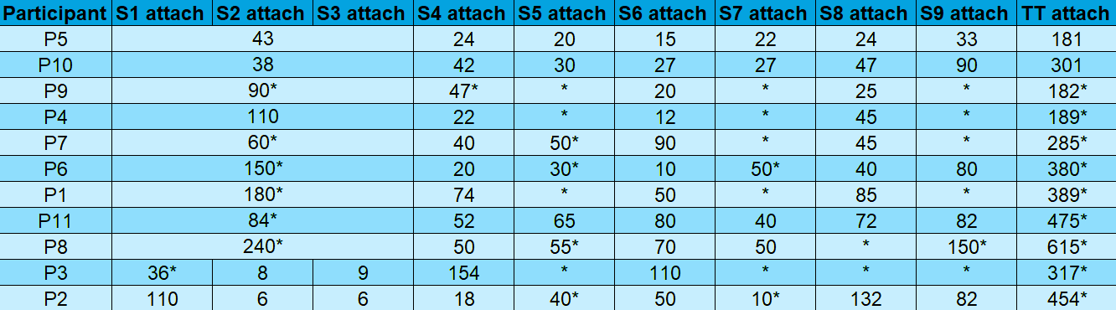
Supplementary Table S4. How much time each participant spend detaching the sensors. All numbers are in seconds. S1=sternum sensor. S2=shoulder affected sensors. S3=shoulder non-affected sensor. S4=upper arm affected sensor. S5=upper arm non-affected sensor. S6=forearm affected sensor. S7=forearm non-affected sensor. S8=hand affected sensor. S9=hand non-affected sensor. TT=Total time *= Did not attempt detaching / time used before participant gave up detaching.
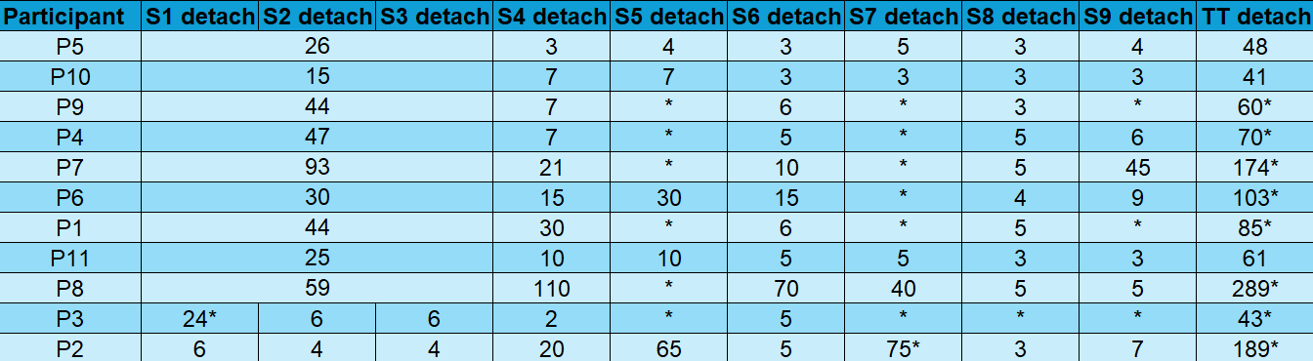

Supplementary Table S5. Distribution of answer themes on the open-ended items in the custom-made acceptability questionnaire. Providing details and examples behind the various themes. N = Number of participants mentioning the theme. The details are written in a descending order of frequency, with the most common response listed first.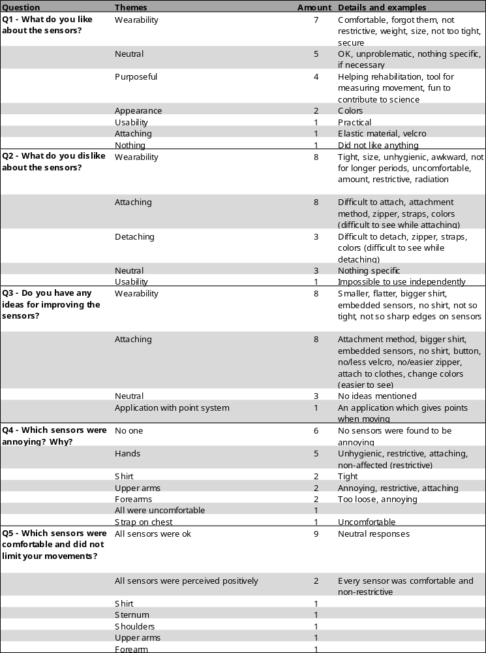
Supplementary Table S6. Absolute and Z-score of entropy for all the participants across the different sensor configurations. Full (Full configuration): nine sensors; WSh (Without Shoulders configuration): seven sensors – sternum, non-affected and affected hands, forearms, upper arms; WH (Without Hands configuration): five sensors – sternum, non-affected and affected forearms, upper arms; WNaUA (Without Non-affected Upper Arm configuration): four sensors – sternum, non-affected and affected forearms, affected upper arm; WAUA (Without Affected Upper Arm configuration): three sensors – sternum, non-affected and affected forearms; WSt (Without Sternum configuration): two sensors – non-affected and affected forearms; NaFA (Non-affected Forearm configuration): one sensor – non-affected forearm; AFA (Affected Forearm configuration): one sensor – affected forearm.
 | Absolute Entropy
 | Full | WSh | WH | WNaUA | WAUA | WSt | NaFA | AFA
P1 | 18,072 | 17,963 | 17,712 | 17,498 | 17,150 | 16,596 | 15,358 | 12,477
P2 | 18,129 | 18,039 | 17,756 | 17,468 | 16,817 | 15,304 | 13,093 | 10,472
P3 | 18,095 | 18,028 | 17,567 | 17,033 | 16,233 | 15,057 | 13,879 | 9,823
P4 | 18,185 | 18,176 | 18,137 | 18,064 | 17,904 | 17,275 | 15,980 | 14,886
P5 | 18,194 | 18,194 | 18,191 | 18,183 | 18,169 | 18,107 | 17,718 | 16,355
P6 | 18,185 | 18,171 | 18,113 | 18,016 | 17,867 | 17,337 | 16,201 | 13,963
P7 | 18,164 | 18,130 | 18,040 | 17,980 | 17,677 | 16,380 | 11,968 | 13,753
P8 | 18,192 | 18,190 | 18,177 | 18,162 | 18,119 | 17,984 | 17,445 | 16,824
P9 | 18,139 | 18,086 | 17,997 | 17,880 | 17,566 | 16,385 | 14,613 | 10,406
P10 | 18,144 | 18,098 | 17,930 | 17,734 | 17,519 | 16,710 | 15,643 | 11,323
P11 | 18,185 | 18,176 | 18,129 | 18,069 | 17,971 | 17,508 | 16,110 | 13,768
 | Entropy Z-Score
 | Full | WSh | WH | WNaUA | WAUA | WSt | NaFA | AFA
P1 | -1,957 | -1,942 | -1,255 | -0,913 | -0,662 | -0,192 | 0,048 | -0,257
P2 | -0,581 | -0,963 | -1,046 | -0,996 | -1,220 | -1,497 | -1,239 | -1,092
P3 | -1,402 | -1,105 | -1,941 | -2,207 | -2,199 | -1,746 | -0,793 | -1,362
P4 | 0,770 | 0,802 | 0,756 | 0,662 | 0,602 | 0,494 | 0,402 | 0,745
P5 | 0,987 | 1,034 | 1,012 | 0,993 | 1,046 | 1,335 | 1,389 | 1,357
P6 | 0,770 | 0,738 | 0,643 | 0,528 | 0,540 | 0,557 | 0,527 | 0,361
P7 | 0,263 | 0,210 | 0,297 | 0,428 | 0,222 | -0,410 | -1,879 | 0,274
P8 | 0,939 | 0,983 | 0,945 | 0,935 | 0,963 | 1,211 | 1,234 | 1,552
P9 | -0,340 | -0,357 | 0,094 | 0,150 | 0,036 | -0,405 | -0,375 | -1,119
P10 | -0,219 | -0,203 | -0,223 | -0,256 | -0,043 | -0,077 | 0,210 | -0,738
P11 | 0,770 | 0,802 | 0,718 | 0,676 | 0,715 | 0,730 | 0,475 | 0,280

Supplementary Figures
Supplementary Fig. S1. Overview of the nine-sensor configuration and sensor placement.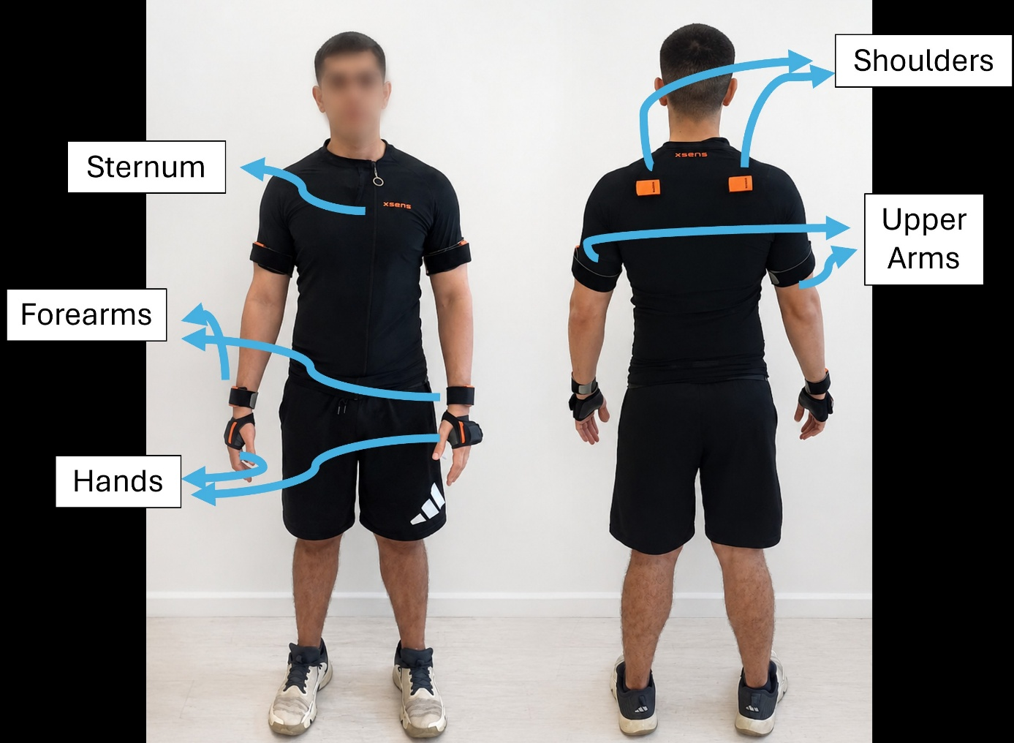

Supplementary Fig. S2. Correlation heatmap of all the items in the custom-made acceptability questionnaire. Item 11 is not included, as it had no variance.
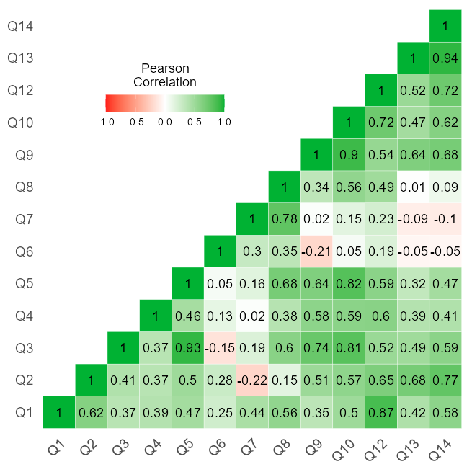

Supplementary Fig. S3. Z-score of entropy for all the participants across the different sensor configurations. Full (Full configuration): nine sensors; WSh (Without Shoulders configuration): seven sensors – sternum, non-affected and affected hands, forearms, upper arms; WH (Without Hands configuration): five sensors – sternum, non-affected and affected forearms, upper arms; WNaUA (Without Non-affected Upper Arm configuration): four sensors – sternum, non-affected and affected forearms, affected upper arm; WAUA (Without Affected Upper Arm configuration): three sensors – sternum, non-affected and affected forearms; WSt (Without Sternum configuration): two sensors – non-affected and affected forearms; NaFA (Non-affected Forearm configuration): one sensor – non-affected forearm; AFA (Affected Forearm configuration): one sensor – affected forearm.
