Muscle Synergy Extraction
Muscle synergies were computed using Non-negative Matrix Factorization (NMF). NMF is a linear decomposition technique that factorizes a non-negative data matrix into two low-rank non-negative matrices, formulated as:
$$V_{m×n}≈W_{m×k}⋅H_{k×n}$$
where $V$ represents the original data matrix, constructed from the preprocessed EMG signals. Here, $m$ is the number of recorded muscles, and $n$ is the number of time points per sample (uniformly resampled to 300 points). The matrix $W$ is the muscle synergy matrix, with each column corresponding to a synergy pattern that indicates the relative activation weights of the muscles. The matrix $H$ is the activation coefficient matrix, with each row representing the temporal activation of the corresponding synergy. The number of synergies $k$ ($k$ < $m$) was determined based on the Variance Accounted For (VAF).
VAF is a common metric to evaluate model fit, defined as the proportion of the total variance in the original data explained by the decomposition. Given the original data matrix $V$ and its reconstruction $V^{'}=W×H$, VAF is calculated as:
$$VAF = 1−\frac{{(V−V^{'})}^{2}}{V^{2}}$$
VAF ranges from 0 to 1, with values closer to 1 indicating a higher proportion of variance explained by the NMF model.

Muscle Synergy Clustering
To obtain representative muscle synergy structures for healthy subjects and stroke patients under different training modes, and to quantify group differences in synergy vectors (WWW), k-means clustering was applied to the extracted synergy vectors. The procedure consisted of the following steps:
- Reference Dataset Construction: To objectively determine the optimal number of clusters, reference datasets were first generated. These datasets were designed to simulate data distributions without inherent clustering structure. Values were sampled uniformly within the range of each dimension of the original synergy vectors, producing reference datasets of comparable size to the original data. In this study, 100 reference datasets were generated to enhance statistical stability.
- K-means Clustering: K-means clustering was performed separately on the original synergy vectors and each reference dataset, with the number of clusters kkk ranging from 2 to 20. Squared Euclidean distance was used as the similarity measure, and initial centroids were randomly selected from the vectors to be clustered. To mitigate the sensitivity of k-means to initial values and reduce the risk of local minima, clustering for each kkk was repeated 50 times, and the result with the smallest within-cluster sum of squares was selected as the final clustering outcome.
- Optimal Cluster Number Determination: The Gap statistic was used to select the optimal number of clusters. The Gap statistic compares the clustering compactness of the original data with that of the reference datasets (without inherent structure) to evaluate the marginal gain of increasing the number of clusters. Specifically, the Gap statistic is calculated as follows:
$$Gap(k)=E_{n}^{∗}\left\{logW_{k}\right\}−logW_{k}$$
Here, $W_{k}$ denotes the within-cluster dispersion for the original data when partitioned into $k$ clusters (i.e., the sum of squared distances from each point to its cluster centroid), and $E_{n}^{∗}\left\{logW_{k}\right\}$ represents the expected $logW_{k}$ over the reference datasets, estimated as the average across multiple reference datasets. The optimal number of clusters, $k^{∗}$, was chosen as the smallest $k$ satisfying the following criterion:
$$Gap(k)≥Gap(k+1)−sd(k+1)$$
Here, $Gap(k)$represents the gap statistic at $k$ clusters, and $sd(k)$ denotes the standard deviation of $logW_{k}$ across the reference datasets. This criterion ensures that the selected number of clusters effectively captures the underlying data structure while avoiding overfitting.
- Representative synergy extraction: After determining the optimal cluster number, the original synergy vectors were reclustered using k-means (50 repetitions, selecting the clustering with the lowest within-cluster dispersion). The centroid of each cluster was taken as the representative muscle synergy vector for the corresponding subject group and training mode.
This clustering approach, combining k-means and the gap statistic, has several advantages: k-means is computationally efficient, and repeated initializations reduce the risk of local optima; the gap statistic does not require a predefined cluster number threshold and objectively evaluates the significance of clustering by comparing to reference datasets, avoiding subjective bias; the reference datasets are generated by uniform sampling within the original data bounds, simulating the absence of clustering and making the gap statistic sensitive to true cluster structures. This method provides a reliable foundation for subsequent cross-group comparisons of synergy patterns.

Muscle Synergy Merging and Fractionation
In studies of post-stroke motor dysfunction, muscle synergy analysis has revealed a neural reorganization phenomenon: the affected limb's muscle synergies may exhibit merging or fractionation relative to the synergies of the unaffected limb. This phenomenon arises from adaptive adjustments in the central nervous system following injury and is closely related to the severity of the lesion, the stage of recovery, and the rehabilitation intervention.
Merging refers to the situation where a synergy vector of the affected limb can be represented as a linear combination of multiple synergies from the unaffected limb. This reflects a simplification or fusion of post-stroke neural control strategies, where tasks originally executed by multiple independent synergies are integrated into fewer synergies due to limited neural input. Mathematically, this can be described as:
$$w_{i}^{s}=\sum_{k=1}^{N_{c}}{m_{k}^{i}w_{k}^{c}, }m_{k}^{i}≥0, i = 1,.....,N_{s}$$
Here, $w_{i}^{s}$ denotes the $i$-th synergy vector of the affected limb, $w_{k}^{c}$ denotes the$k$-th synergy vector of the unaffected limb, $N_{c}$ and$N_{s}$ represent the number of synergies in the unaffected and affected limbs, respectively. The merging coefficient $m_{k}^{i}$ indicates the contribution weight of the k-th healthy synergy to the i-th affected synergy. Typically, if the merging coefficient of a given healthy synergy exceeds a predefined threshold (e.g., 0.3), this synergy is considered to participate in the merging process.
Fractionation, in contrast, refers to the situation where a synergy vector from the unaffected limb can be decomposed into a linear combination of multiple synergies in the affected limb. In this case, a single healthy synergy is fractionated into several finer synergies on the affected side, potentially reflecting compensatory neural differentiation or functionally reorganized synergies induced by rehabilitation training. Mathematically, this can be expressed as:
$$w_{k}^{c}=\sum_{k=1}^{N_{s}}{f_{i}^{k}w_{i}^{s}, }f_{i}^{k}≥0, i = 1,.....,N_{c}$$
Here, the fractionation coefficient $f_{i}^{k}$represents the contribution of the iii-th affected synergy to the linear combination reconstructing the k-th healthy synergy. By calculating the merging and fractionation coefficients, the variability of affected-limb synergies relative to healthy-limb synergies can be quantitatively assessed, thereby revealing patterns of neural control reorganization following cortical injury.

Data Quality Control
Data quality control was implemented to ensure the accuracy and reliability of kinematic signals. Since the UE-RAT system’s training trajectory data could not be directly exported due to interface restrictions, wearable devices were used to synchronously record patients’ kinematics during training. The recorded trajectories were then manually compared with the real-time trajectories displayed by the UE-RAT system. Trajectories showing overall consistency were considered valid, while those with significant deviations or distortions were discarded.
Distortions in kinematic signals primarily originated from electromagnetic interference in the experimental environment. Strong electromagnetic fields could affect the wearable devices, leading to abnormal or highly fluctuating trajectories. Additional data anomalies were related to operational factors and device status, including slippage of the wearable device during task execution, sensor power interruptions, and unstable or interrupted data transmission, all of which could result in signal loss or distortion.
Similarly, EMG signal quality was affected by the experimental environment and device conditions. Key issues included electromagnetic interference, particularly when electrode connections were unstable or electrode wires were worn, which could contaminate specific channels. Large movement amplitudes during training could also cause electrode detachment, loosening of electrode cables at the acquisition interface, or unexpected device power loss, all of which were observed during the experiment and impacted signal continuity and reliability.
All anomalies caused by the above factors were identified and excluded during the preprocessing stage to ensure the accuracy and consistency of data used in subsequent analyses.

Synergy Matching Type Analysis and Recruitment Frequency Statistics
Building on single-trial synergy matching, muscle synergy vectors extracted for each movement direction were aggregated across all participants and training sessions. Specifically, each participant generated K synergy vectors per movement direction per training session via NNMF, forming an overall dataset of participant × session × movement direction × K synergies. These vectors were then grouped by “training mode × movement direction” and compared to the corresponding healthy reference synergy centroids using cosine similarity, with a threshold of L≥0.8 defining successful matches.
Synergies were classified into four types based on their matching patterns: (1) One-to-One Match: matches a single reference centroid; (2) Synergy Merging: multiple patient synergies match a single reference centroid and can be reconstructed from multiple reference centroids using non-negative least squares with coefficients ≥ 0.3; (3) Unmatched: does not match any reference centroid; (4) Synergy Fractionation: a single synergy matches multiple reference centroids and can be linearly reconstructed from them using least squares with coefficients ≥ 0.3. For merging events, the structure and proportion of involved synergies were quantified and compared across training modes and participant groups, providing insights into how different task modalities elicit distinct neural control strategies.

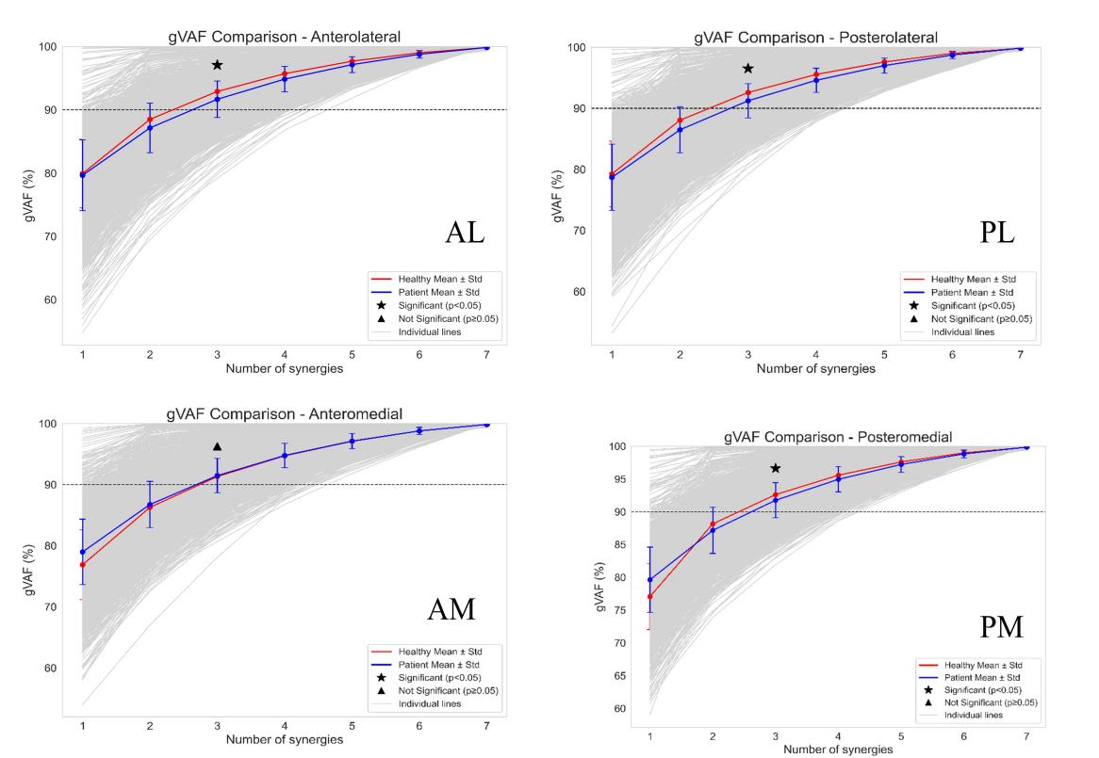
Fig. S1 Determination of the optimal number of muscle synergies (${\text{n}}_{\text{std}}$). Convergence curves of VAF with increasing number of synergies for AL, PL, AM, and PM movements in the assistive mode are shown. Solid red and blue lines represent the group means of healthy participants and patients, respectively, while gray dotted lines depict individual observations. Statistical analysis revealed significant differences between patients and healthy participants in the minimum number of synergies required to meet the VAF ≥ 90% criterion (★, p < 0.05; Mann-Whitney U test).
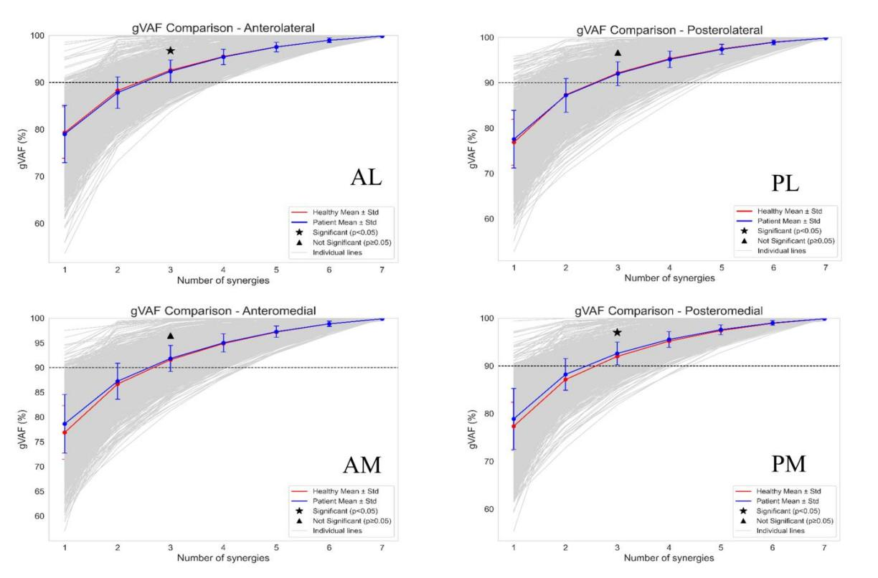
Fig. S2 Determination of the optimal number of muscle synergies (${\text{n}}_{\text{std}}$). Convergence curves of VAF with increasing number of synergies for AL, PL, AM, and PM movements in the active mode are shown. Solid red and blue lines represent the group means of healthy participants and patients, respectively, while gray dotted lines depict individual observations. Statistical analysis revealed significant differences between patients and healthy participants in the minimum number of synergies required to meet the VAF ≥ 90% criterion (★, p < 0.05; Mann-Whitney U test).
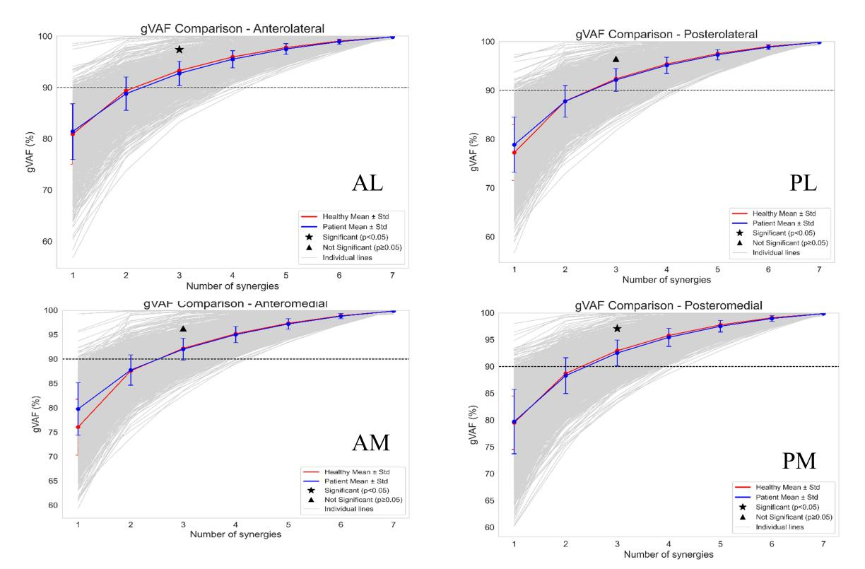
Fig. S3 Determination of the optimal number of muscle synergies (${\text{n}}_{\text{std}}$). Convergence curves of VAF with increasing number of synergies for AL, PL, AM, and PM movements in the resistive mode are shown. Solid red and blue lines represent the group means of healthy participants and patients, respectively, while gray dotted lines depict individual observations. Statistical analysis revealed significant differences between patients and healthy participants in the minimum number of synergies required to meet the VAF ≥ 90% criterion (★, p < 0.05; Mann-Whitney U test).
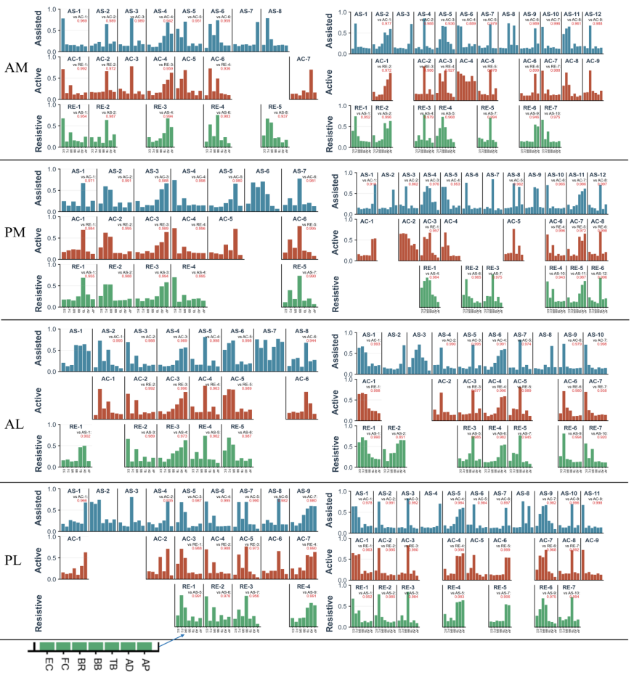
Fig. S4 Clustering Results of Muscle Synergies.
The distributions of clustered synergy centroids extracted from the four movement directions (AM, AL, PM, PL) are compared between healthy participants (left) and patients (right) across assisted, active, and resistive training modes.
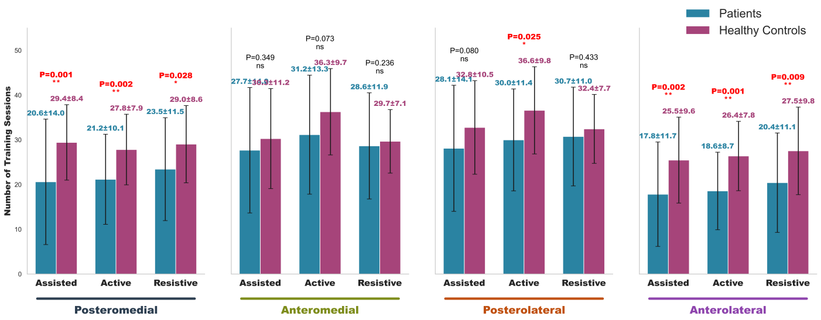
Fig. S5 Comparison of the occurrence frequency of the four movement segments during training tasks. Blue and purple bars indicate decomposed trajectories for patients and healthy participants, respectively. Red asterisks (*) denote significant deviations in movement consistency between groups
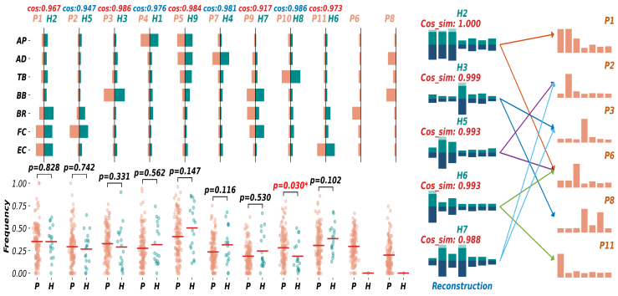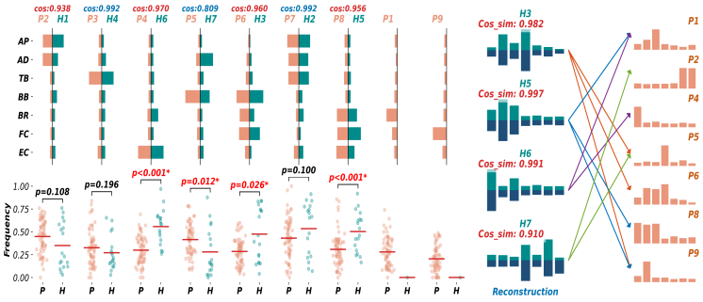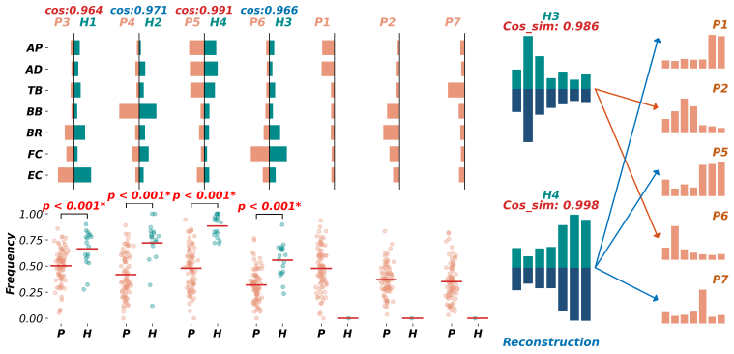
Assistive
Active
Resistive
Fig. S6 Matching and reconstruction of muscle synergy cluster centroids between post-stroke patients and healthy controls (PL movements).
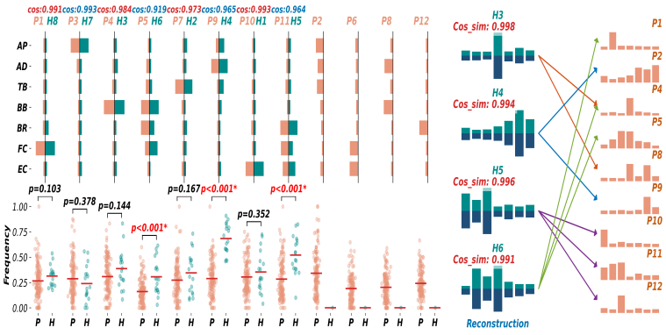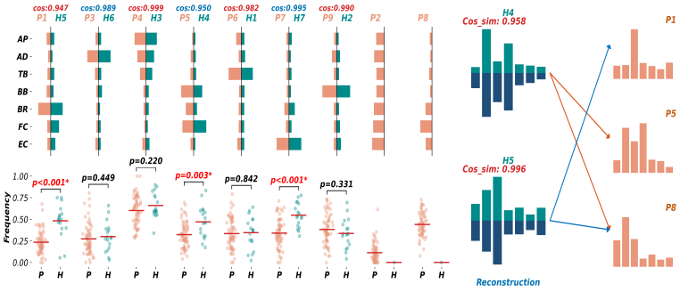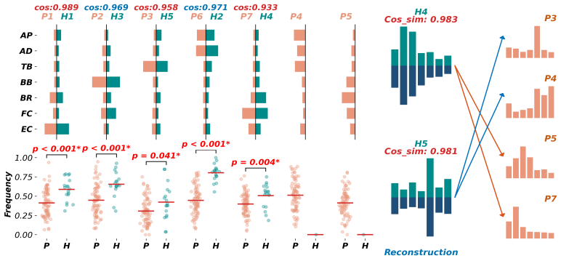
Assistive
Active
Resistive
Fig. S7 Matching and reconstruction of muscle synergy cluster centroids between patients and healthy subjects in the active mode (AM movements).

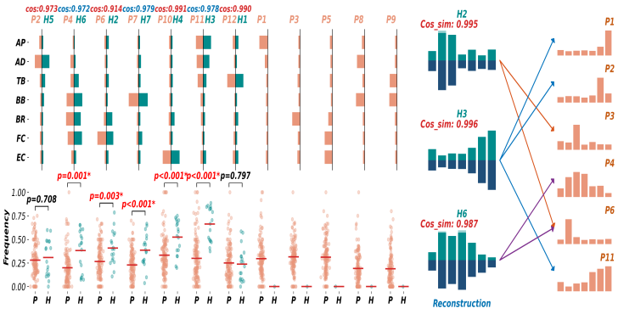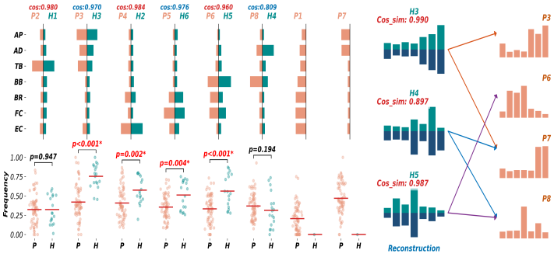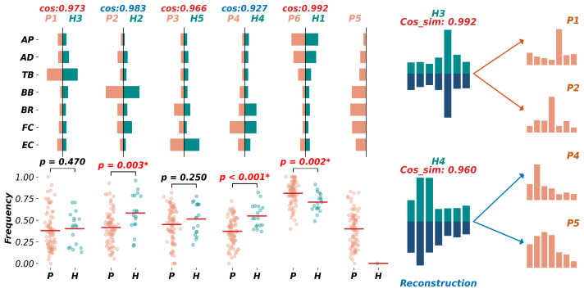
Assistive
Active
Resistive
Fig. S8 Matching and reconstruction of muscle synergy cluster centroids between patients and healthy subjects in the resistive mode (PM movements).

Synergy Recruitment Frequency
In terms of synergy recruitment frequency, significant differences were observed between patients and healthy controls, exhibiting clear task- and mode-specific patterns. For example, in the AL direction, patients in the assisted mode recruited biceps brachii-radialis-dominated synergies (P4, P7) more frequently than healthy controls; this abnormal recruitment pattern persisted partially in the active mode. In contrast, during the resistive mode, patients showed significantly lower recruitment frequencies for forearm-dominated (P1) and shoulder-dominated (P5) synergies compared to healthy participants. Notably, redundant expression of synergies was observed within the patient group-for instance, both P2 and P5 were shoulder-dominated but differed in structure-indicating that patients had not yet developed a stable and focused shoulder control strategy and were switching between multiple variant patterns. This phenomenon was consistent across other movement directions, although the involved synergies varied by task. For PM movements, in the assisted mode, patients exhibited significantly higher recruitment of triceps-dominated synergy (P10) than healthy controls. This feature was partially retained in the active mode, while patients relied more on biceps-dominated (P5) and proximal muscle-dominated (P2) synergies to execute the task. In the resistive mode, patients additionally engaged patient-specific synergies (P1, P2, P7) not present in healthy controls, resulting in relatively reduced recruitment of corresponding healthy-template synergies. These results suggest that as functional capacity improves, patients gradually reduce reliance on pathological patterns but have not yet fully converged to healthy templates, instead exploring alternative control strategies compatible with their current neural remodeling status.

Synergy Merging and Fractionation
Muscle synergy matching patterns (one-to-one matching, merging, fractionation, and non-matched synergies) were classified for each patient subgroup based on healthy-derived clustering templates (Fig. S9). Across all subgroups, the proportion of one-to-one matching was consistently lower than that observed in healthy controls. Patients with severe baseline impairment receiving assisted UE-RAT (MMT 0–1) showed one-to-one matching ratios that were, in certain movement directions, comparable to healthy controls (e.g., P-PM vs. H-PM: 0.53 vs. 0.52). However, this subgroup also exhibited a significantly higher proportion of non-matched synergies, suggesting that partially preserved functional synergy patterns coexisted with additional patient-specific or unmatched synergy activations.
Patients with moderate baseline impairment receiving active UE-RAT (MMT 2–3) and those with relatively preserved motor function receiving resistive UE-RAT (MMT ≥4) generally demonstrated higher one-to-one matching ratios than the severe impairment subgroup, although both remained below healthy control levels. Direction-specific alterations were further observed. During AL movements, patients with severe impairment showed a higher probability of synergy fractionation (0.12), whereas increased synergy merging was observed during PL (0.39), AM (0.36), and AL (0.38) movements. Analysis of merged synergy vectors revealed significant differences between patients and healthy controls in PM and AM tasks (Fisher’s Exact Test, p < 0.05). Specifically, this subgroup exhibited abnormal merging of specific baseline synergies, including increased merging between Synergy 3 (deltoid-dominant) and Synergy 8 (anterior deltoid-dominant), accompanied by loss of some healthy-template combinations during AL movements (e.g., Synergy 1+5 and Synergy 11+4).
Patients with moderate impairment receiving active UE-RAT exhibited distinct merged synergy patterns, including combinations not observed in healthy controls (e.g., Synergy 6+7 and Synergy 2+4+7). These patterns may represent alternative synergy organizations during voluntary force generation. In patients with higher baseline function receiving resistive UE-RAT, differences were mainly reflected by altered distribution of specific merged patterns, such as a significantly higher proportion of the Synergy 4+5 combination compared with controls. Across the active and resistive subgroups, AL and PL movements were mainly characterized by altered recruitment preferences among specific merged synergies, whereas severe impairment patients exhibited more pronounced loss of healthy-template patterns.

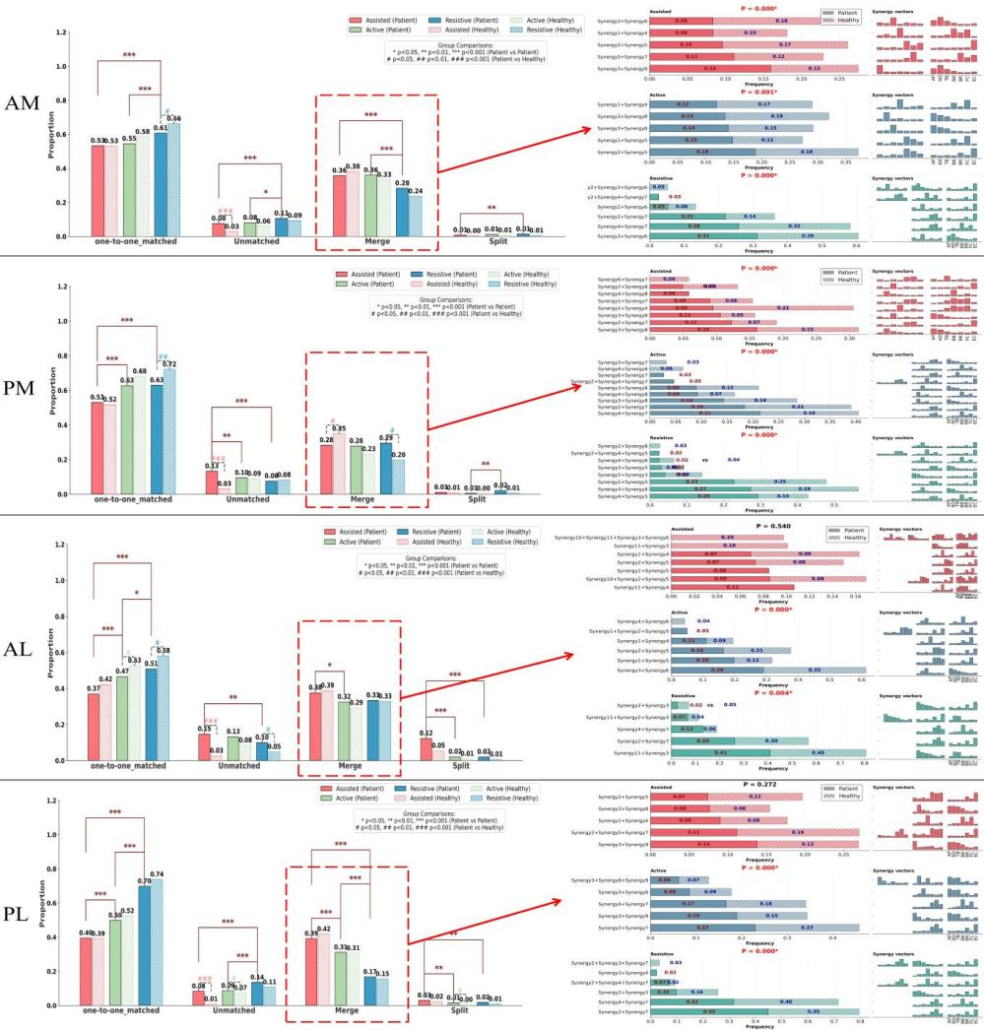
Fig. S9 Classification of Muscle Synergy Mapping and Statistics of Merging Patterns.
Left panel: Distribution of muscle synergy matching states during single training trials for stroke patients and healthy controls, including one-to-one matching, unmatched, merging, and fractionation (splitting) categories. Right panel: Probability of occurrence for specific merged muscle synergy combinations in the patient group. Solid lines represent the patient group, while dashed lines indicate the healthy control group.
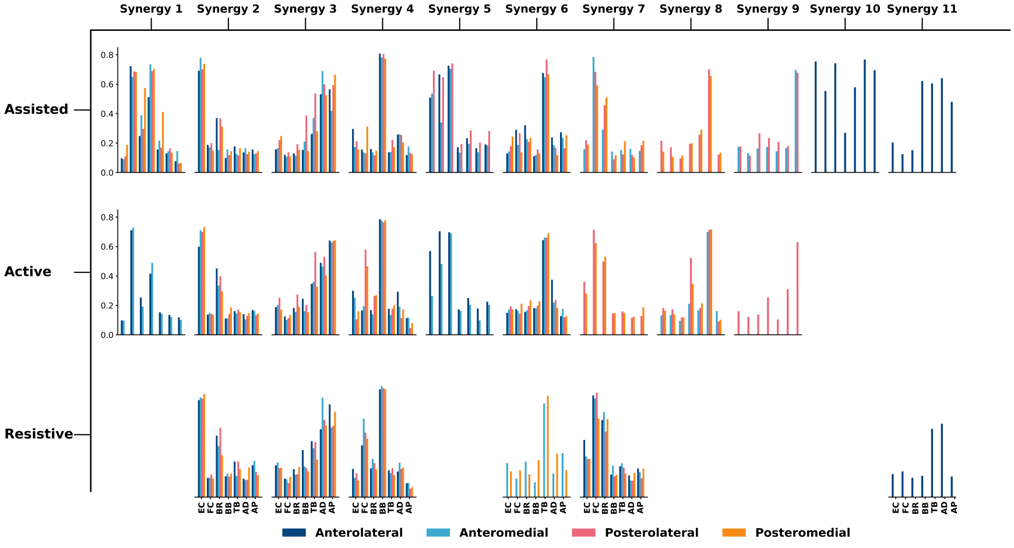
Fig. S10 Classification and labeling of muscle synergies based on dominant muscle features. Synergy modules were extracted from the clustering results of healthy participants across different training modes and movement directions. The dominant muscle characteristics of each synergy were identified, and the extracted reference synergies were systematically categorized and labeled as Synergy 1-11 for consistent description and comparison across tasks and participants.

Table S1. Covariate-adjusted comparisons of V_{raw}, $\overline{\text{CR}}$, and DS among different UE-RAT modes.

 |  | Anterolateral |  | Posterolateral |  | Anteromedial |  | Posteromedial
 | Mode | Adj.Mean | Group (Adj. P) | Adj.Mean | Group (Adj. P) | Adj.Mean | Group (Adj. P) | Adj.Mean | Group (Adj. P)
V_{raw} | Assisted | 0.780 | Ac vs As (<0.01*) | 0.822 | Ac vs As (<0.01*) | 0.803 | Ac vs As (<0.01*) | 0.750 | Ac vs As (-)
V_{raw} | Active | 0.700 | Re vs Ac (1.00) | 0.757 | Re vs Ac (<0.01*) | 0.742 | Re vs Ac (0.01*) | 0.714 | Re vs Ac (-)
V_{raw} | Resistive | 0.713 | Re vs As (0.04*) | 0.675 | Re vs As (<0.01*) | 0.705 | Re vs As (<0.01*) | 0.723 | Re vs As (-)
CR | Assisted | 0.556 | Ac vs As (<0.01*) | 0.575 | Ac vs As (<0.01*) | 0.672 | Ac vs As (-) | 0.652 | Ac vs As (<0.01*)
CR | Active | 0.639 | Re vs Ac (1.00) | 0.677 | Re vs Ac (<0.01*) | 0.700 | Re vs Ac (-) | 0.724 | Re vs Ac (1.00)
CR | Resistive | 0.652 | Re vs As (<0.01*) | 0.752 | Re vs As (<0.01*) | 0.714 | Re vs As (-) | 0.723 | Re vs As (<0.01*)
DS | Assisted | 0.962 | Ac vs As (0.03*) | 0.965 | Ac vs As (<0.01*) | 0.846 | Ac vs As (0.240) | 0.962 | Ac vs As (<0.01*)
DS | Active | 0.580 | Re vs Ac (1.00) | 0.355 | Re vs Ac (1.00) | 0.599 | Re vs Ac (0.663) | 0.423 | Re vs Ac (1.00)
DS | Resistive | 0.533 | Re vs As (0.02*) | 0.265 | Re vs As (<0.01*) | 0.463 | Re vs As (0.035*) | 0.517 | Re vs As (<0.01*)
Note: Adj. Mean indicates the covariate-adjusted marginal mean estimated by ANCOVA. Group (Adj. P) represents Bonferroni-adjusted pairwise comparisons between training modes. “-” indicates that the main effect of UE-RAT mode was not statistically significant, and therefore post hoc pairwise comparisons were not performed. * indicates Bonferroni-adjusted P < 0.05.

Table S2 Post hoc pairwise comparisons of V_{variability} across training weeks in the active mode estimated by linear mixed-effects models.
 |  | Active
Anterolateral |  |  |  |  | Posterolateral |  |  | Anteromedial |  |  | Posteromedial
 | Coef |  | z | P | Coef | z | P | Coef | z | P | Coef | z | P
Intercept | 0.627 |  | 22.779 | - | 0.571 | 26.57 | - | 0.571 | 24.959 | - | 0.523 | 16.234 | -
W2 vs W1 | -0.108 |  | -4.029 | <0.001* | -0.048 | -1.716 | 0.086 | -0.102 | -3.236 | 0.001 | -0.078 | -1.718 | 0.086
W3 vs W2 | -0.043 |  | -1.6 | 0.110 | -0.033 | -1.193 | 0.233 | -0.031 | -0.994 | 0.32 | -0.006 | -0.131 | 0.896
W4 vs W3 | -0.018 |  | -0.672 | 0.502 | -0.019 | -0.688 | 0.492 | -0.017 | -0.546 | 0.585 | -0.009 | -0.205 | 0.838
W4 vs W1 | -0.168 |  | -6.301 | <0.001* | -0.1 | -3.596 | <0.001* | -0.15 | -4.775 | <0.001* | -0.094 | -2.054 | 0.040*

Table S3 Post hoc pairwise comparisons of V_{variability} across training weeks in the resistive mode estimated by linear mixed-effects models.

 |  | Resistive
Anterolateral |  |  |  |  | Posterolateral |  |  | Anteromedial |  |  | Posteromedial
 | Coef |  | z | P | Coef | z | P | Coef | z | P | Coef | z | P
Intercept | 0.579 |  | 32.283 | - | 0.551 | 24.567 | - | 0.527 | 32.817 | - | 0.539 | 32.023 | -
W2 vs W1 | -0.035 |  | -2.649 | 0.008* | -0.086 | -3.425 | 0.001* | -0.049 | -3.299 | 0.001* | -0.096 | -4.294 | <0.001*
W3 vs W2 | -0.056 |  | -4.2 | <0.001* | 0.007 | 0.29 | 0.772 | -0.019 | -1.309 | 0.190 | -0.012 | -0.547 | 0.584
W4 vs W3 | -0.031 |  | -2.34 | 0.019* | -0.061 | -2.421 | 0.015* | -0.008 | -0.542 | 0.588 | -0.036 | -1.602 | 0.109
W4 vs W1 | -0.122 |  | -9.189 | <0.001* | -0.139 | -5.557 | <0.001* | -0.076 | -5.151 | <0.001* | -0.144 | -6.443 | <0.001*

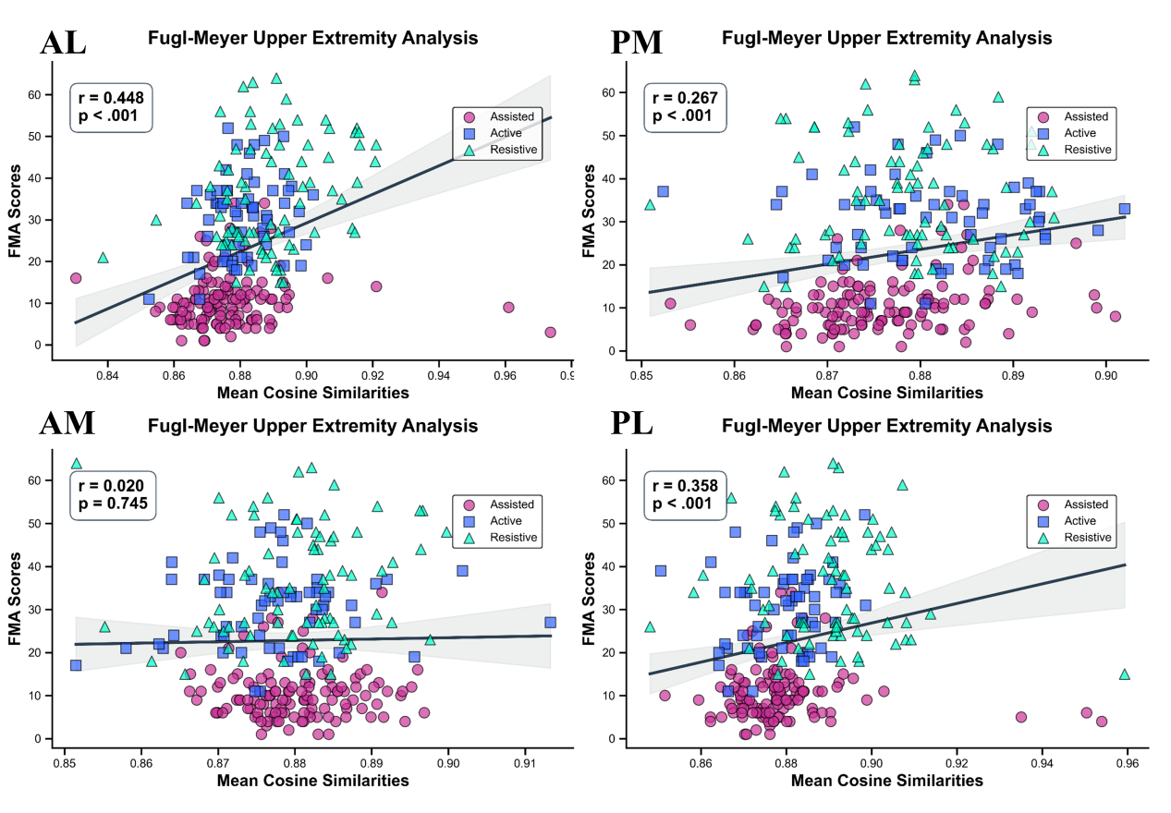
Fig. S11 Correlation between cosine similarity and clinical motor function (FMA-UE). Scatter plots depict the relationship between cosine similarity and FMA-UE scores for all movement directions. Spearman correlation coefficients (r) and statistical significance (p-values) are indicated. Solid lines represent the fitted trend lines for visualization.

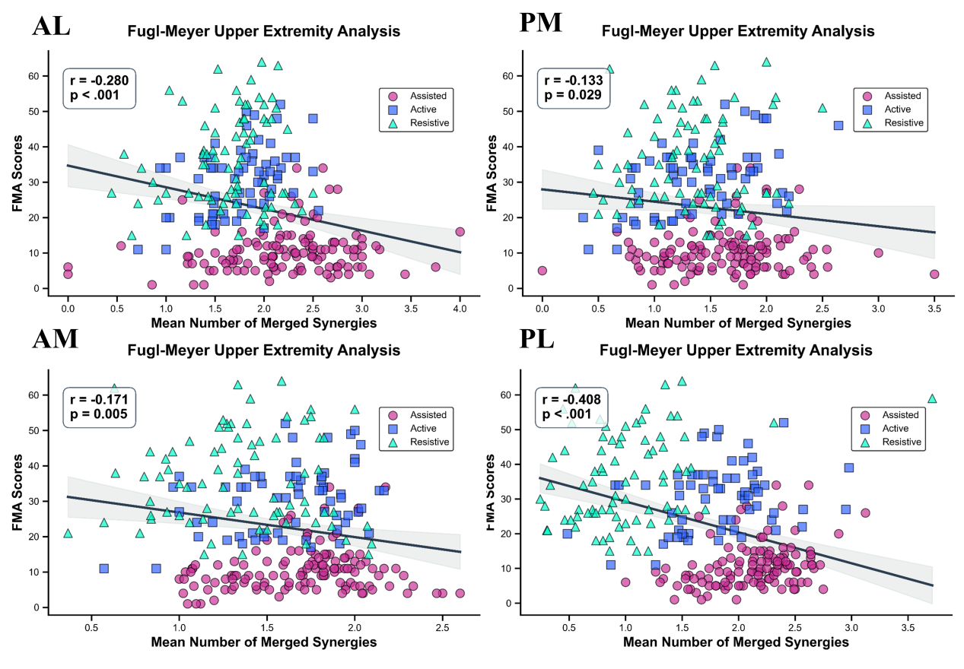
Fig. S12 Correlation between the number of merged synergies and clinical motor function (FMA-UE). Scatter plots illustrate the relationship between the number of merged synergies and FMA-UE scores across the four movement directions. Spearman correlation coefficients (r) and corresponding P values are indicated. Solid lines represent the fitted trend lines for visualization.

Table S4 Results of analysis of covariance (ANCOVA) examining the effects of UE-RAT mode and covariates on V_{raw} across four movement directions

 | Anterolateral |  |  |  |  | Posterolateral |  |  |  |  | Anteromedial |  |  |  |  | Posteromedial
 | SS |  | F | P |  | SS |  | F | P |  | SS | F |  | P |  | SS |  | F |  | P
Mode | 0.135 | 4.970 |  |  | 0.008* | 0.436 | 35.731 |  |  | 0.000* | 0.174 |  | 16.205 |  | 0.000* | 0.027 | 1.943 |  | 0.145
Gender | 0.045 | 3.648 |  |  | 0.057 | 0.011 | 1.776 |  |  | 0.183 | 0.017 |  | 3.276 |  | 0.071 | 0.045 | 6.377 |  | 0.012*
Affected Side | 0.001 | 0.019 |  |  | 0.888 | 0.016 | 2.649 |  |  | 0.104 | 0.029 |  | 5.386 |  | 0.021* | 0.001 | 0.101 |  | 0.751
Stroke Type | 0.001 | 0.047 |  |  | 0.828 | 0.001 | 0.001 |  |  | 0.968 | 0.002 |  | 0.341 |  | 0.559 | 0.001 | 0.072 |  | 0.787
FMA-UE | 0.390 | 28.575 |  |  | 0.000* | 0.078 | 12.894 |  |  | 0.001* | 0.061 |  | 11.231 |  | 0.001* | 0.127 | 17.906 |  | 0.000*
Age | 0.086 | 6.3384 |  |  | 0.012* | 0.082 | 13.521 |  |  | 0.001* | 0.120 |  | 22.324 |  | 0.000* | 0.132 | 18.615 |  | 0.000*

 | Anterolateral |  |  | Posterolateral |  |  | Anteromedial |  |  | Posteromedial
 | SS | F | P | SS | F | P | SS | F | P | SS | F | P
Mode | 0.184 | 10.792 | 0.000* | 0.578 | 37.281 | 0.000* | 0.032 | 2.661 | 0.071 | 0.121 | 7.481 | 0.001*
Gender | 0.011 | 1.298 | 0.255 | 0.051 | 6.477 | 0.011* | 0.063 | 10.524 | 0.001* | 0.139 | 17.319 | 0.000*
Affected Side | 0.082 | 9.621 | 0.002* | 0.001 | 0.002 | 0.974 | 0.002 | 0.262 | 0.608 | 0.029 | 3.606 | 0.058
Stroke Type | 0.001 | 0.017 | 0.895 | 0.007 | 0.976 | 0.323 | 0.036 | 6.039 | 0.014* | 0.096 | 11.997 | 0.001*
FMA-UE | 0.003 | 0.365 | 0.546 | 0.046 | 5.962 | 0.015* | 0.013 | 2.214 | 0.137 | 0.007 | 0.951 | 0.330
Age | 0.027 | 3.152 | 0.077 | 0.051 | 6.515 | 0.011* | 0.042 | 6.971 | 0.008* | 0.004 | 0.531 | 0.467
Table S5 Results of analysis of covariance (ANCOVA) examining the effects of UE-RAT mode and covariates on $\overline{\text{CR}}$ across four movement directions

