Supplementary Material: Exergames
Game Name | Main Trained Functions | Training Goals | Task/Instruction
Simple   | Psychomotor speed | The training game “Simple” trains the attentional focus - the ability to concentrate and focus on stimuli. It also trains the psychomotor processing speed and responsiveness, i.e. to process and react to sensory stimuli as quickly as possible. | Below are four circles. One of them will turn red. As soon as a circle turns red, take a step in that direction as quickly as possible.
Birds  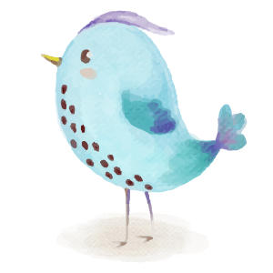 | Selective attention | The training game "Birds" trains selective attention - the ability to react to certain (relevant) stimuli and to be able to ignore others (irrelevant). | Return the feather in the middle to the correct bird. To do this, take a step to the bird that matches the displayed feather. Take the steps as quickly as possible.
Ski  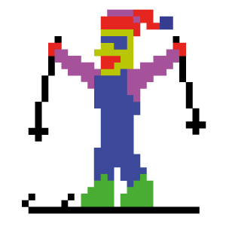 | Balance control and weight shifting | The training game "Ski" trains balance control as well as weight shifting. | Control the skier by shifting your weight. Avoid trees, stones and snow monsters!
Hexagon  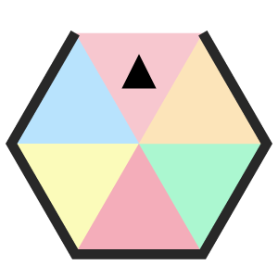 | Visuospatial orientation and mental rotation | The training game "Hexagon" trains spatial cognition, visuo-spatial orientation and mental rotation. | Dodge the walls of the hexagon with steps to the left and right.
Targets   | Divided attention, planning, foot placement accuracy and timing | The training game “Targets” trains forward thinking and targeted reaction with correct timing. | Hit the flying balls in the middle of the targets with one step in the respective direction.
Divided   | Divided attention | The training game “Divided” trains the divided attention - the ability to process and react to several stimuli simultaneously, especially when the stimuli are presented in different modalities (visual, auditory, tactile). | Below are four circles. One of them will turn red. As soon as a circle turns red, take a step in that direction as quickly as possible. You will also hear sounds. With a high tone you take a step forward, with a low tone you take a step backwards.
Simon   | Short-term memory/memory span | The training game “Simon” trains the short-term memory - the ability to remember information (e.g., sequences) at short notice. | In the following, a tone is assigned to each answer key/step direction. You will be shown a sequence of steps/tones, which you must copy in the correct order. The sequence of steps/tones begins with one element and will then become longer and longer. If you make a mistake, a new sequence begins (start with one element).
Flexi   | Cognitive flexibility | The training game “Flexi” trains cognitive flexibility - the ability to alternate attention allocation between different stimuli and concepts. | A: There is a number in the middle of the screen. In addition, other numbers appear around. Your task is, starting from the number in the middle, to take a step in the direction of the next higher number.  B: In addition, a figure appears around the number. A step must be taken in the direction of the next higher number with the opposite pattern.
Lumina   | Static balance, relaxation | The Lumina training game trains the static balance with the main focus on recovery and relaxation. The gentle flying through different worlds is accompanied by relaxing music. Through the targeted weight shifting in all four directions, the fine control of balance is balance is promoted. | Stand hip-width apart on the exercise area. With slight shifting your body weight you steer the firefly to the right or left. You can change the flight altitude upwards if you shift your weight on your heels. The firefly moves downwards when you stand on your tips of your feet. Dots of light can be collected, which appear on the flight path.
Habitats  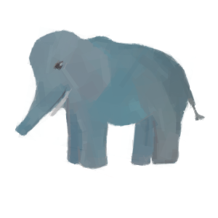 | Selective attention and inhibition | The training game "Habitats" trains selective attention - the ability to react to certain stimuli and to be able to ignore other stimuli. Provoked reactions must be suppressed. | Animals move across the four landscapes in the picture. If an animal does not appear in its usual environment, take a step in this direction. Do not try to disturb animals in their natural habitat.
Rocket   | Cardiovascular fitness | The training game "Rocket" trains the cardiovascular system through short, high-intensity stepping bouts. | Take steps on the training plate to fly the rocket through the universe. A green arrow in front of the rocket indicates that you should increase your stepping speed. A red bar behind the rocket indicates that you are too fast and should slow down your stepping speed.
Ladybug  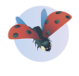 | Weight shifting and action planning | The training game «Ladybug» trains forward thinking action planning and static balance. | Stand in the center with your feet more than hip-width apart. Control the ladybug by leaning only to the right and left. Your goal is to collect the flowers and avoid obstacles. Some flowers glisten in the dew. Focus on them to get a bonus.
Cloudy   | Static balance | The training game "Cloudy" trains static balance and fine adjustment of movement control. It requires the targeted and controlled shifting of the body's center of gravity. Moreover, basic attentional functions are trained. | Water the thirsty flowers. Move the rain cloud over the flowerpots by taking steps to the right or left side. Be careful with the steps, a light tap is enough.  Tip: Try to water the bonus flower, which is shown below.
Sam’s Garden  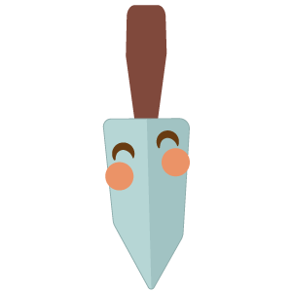 | Dynamic balance | The training game "Sam’s Garden" trains various aspects of coordination and balance as well as cognition.  Motor functions: dynamic balance and coordination of the lower extremities (based on the processes of daily walking), goal-oriented movement in space  Cognitive functions: In addition to basic attention, the game requires simultaneous processing of a relatively complex virtual environment with multiple target stimuli, higher brain functions are required. | Harvest the vegetables in the garden and weed using the shovel. By walking around on the plate, you move the shovel to the place where the vegetables or weeds are.  Vegetables: Remain on the vegetables until they are harvested.  Weeds: Jump on the weeds until they disappear.  Tip: Try to harvest the bonus vegetables, which are shown below.
Evolve  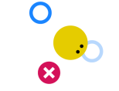 | Static balance, selective attention | The training game Evolve trains the control and various aspects of cognition such as selective attention - the ability to react to certain stimuli and ignore other stimuli, as well as thinking ahead and action planning. | Blue rings, red dots, and a yellow figure are displayed on the screen. By shifting the center of pressure, the yellow figure can be controlled to catch the blue rings while avoiding the red dots.
  Drops | Action planning,  orientation | The training game “Drops” trains  thinking, visual-spatial orientation and mental rotation skills. | Colored drops fall as a pair from above. When drops land near a drop of the same color, they join together to form a group. Gather groups of four or more drops to create space and score points. Step left or right to move the pair sideways. Step forward to rotate the pair. Step backward  to make it fall faster. You get more points if several groups dissolve when you place a single pair of drops.
Snake   | Action planning,  orientation | The training game “Snake” trains the  planning and orientation ability in a room (2D) (visual-spatial orientation). | A snake is displayed on the  screen which has to be  controlled by stepping on the  four plates. The aim is to “feed” the snake with as many red squares as possible which are also displayed on the  screen. The snake can also move beyond the edge of the screen.
Flaneur   | Endurance | The “Flaneur” training game is a simple  endurance training. | This game is a virtual walking tour with a street view. Steps on the middle plate have to be made to go for a walk through Zurich. The faster the steps are made, the faster the virtual walking speed.
React   | Psychomotor speed | The training game “React” trains reaction and is basically a faster version of the game “Simple” | Step as quickly as possible toward a yellow dot before it disappears.
Arrows   | Task-switching, Inhibition | The training game “Arrows” requires strong focus and trains inhibition and task switching | Watch the arrows and decide quickly:  - When they leave a trail, step where they move.  - When they leave no trail, step where they point.

