Figure S1. Computational prediction of lncRNAs in HSV-1 infected HFF cells
The computational strategy of predicting of function of lncRNAs in HSV-1 infected HFF cells.

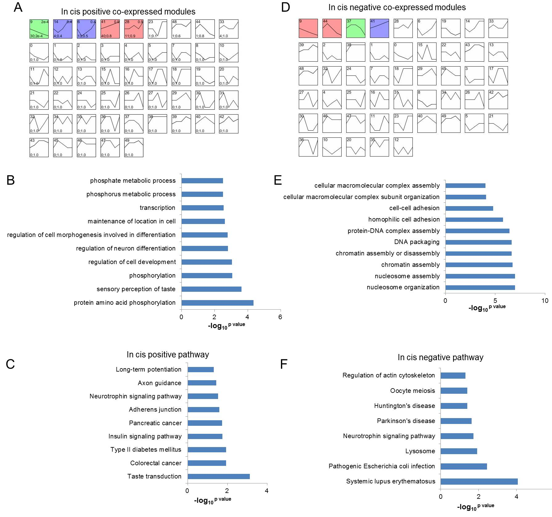
Figure S2. The predicted function of lncRNAs based on co-expressed modules in cis
a. there were 5 significant co-expressed modules in positive regulatory model, p value≤0.05. b-c. GO analysis and pathway analysis of PCGss co-expressed with lncRNAs, p value≤0.05; d. there were 4 significant co-expressed modules in negative regulatory model, p value≤0.05. e-f. GO analysis and pathway analysis of PCGs co-expressed with lncRNAs, p value≤0.05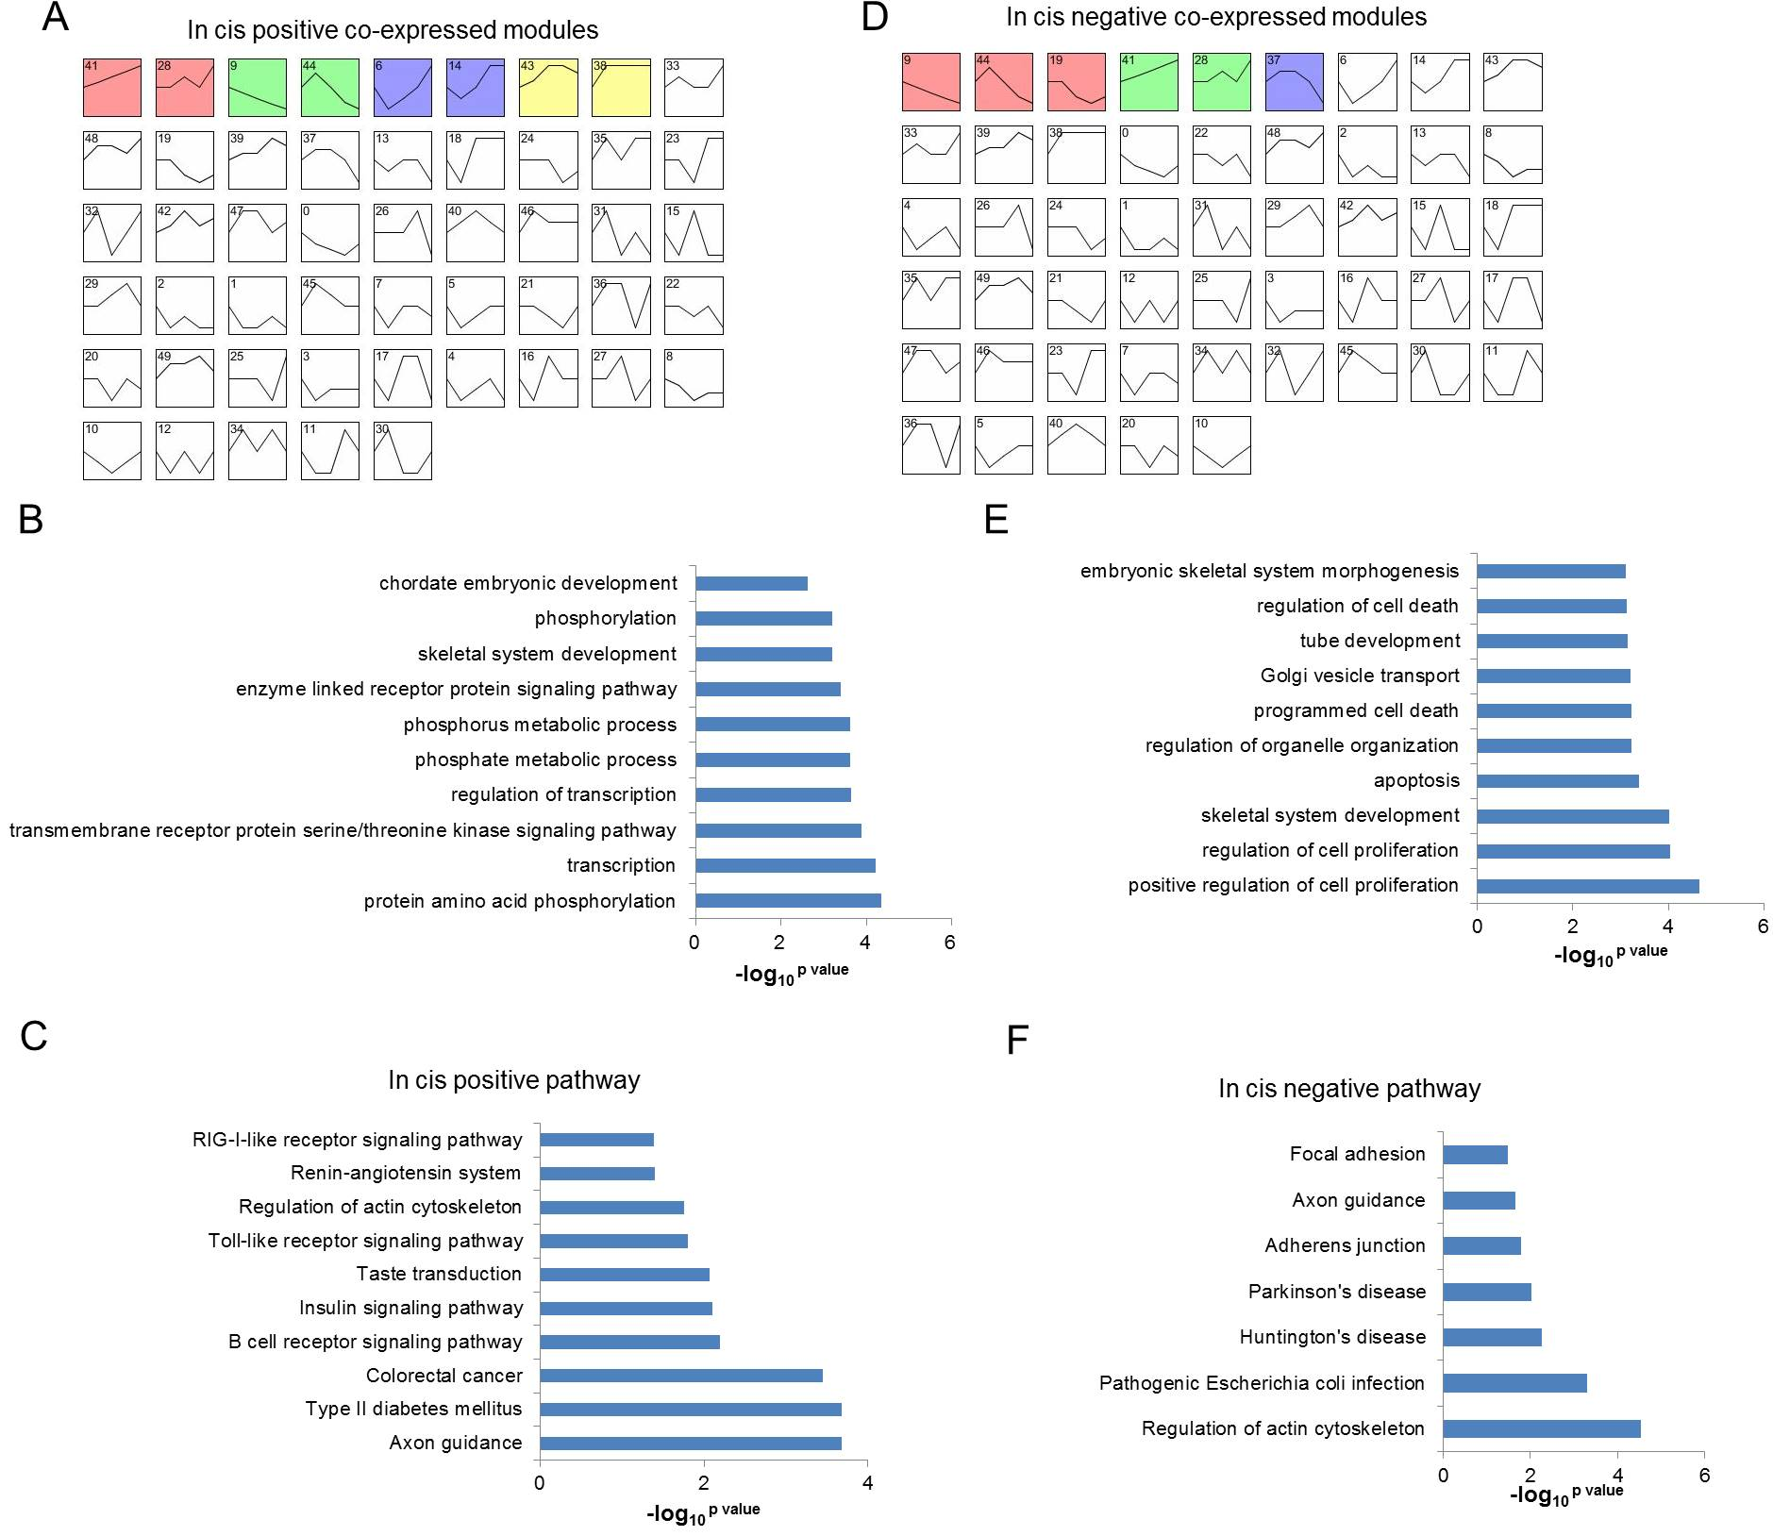
Figure S3. The predicted function of lncRNAs based on co-expressed modules in trans
a. there were 8 significant co-expressed modules in positive regulatory model, p value≤0.05. b-c. GO analysis and pathway analysis of PCGss co-expressed with lncRNAs, p value≤0.05; d. there were 6 significant co-expressed modules in negative regulatory model, p value≤0.05. e-f. GO analysis and pathway analysis of PCGs co-expressed with lncRNAs, p value≤0.05

