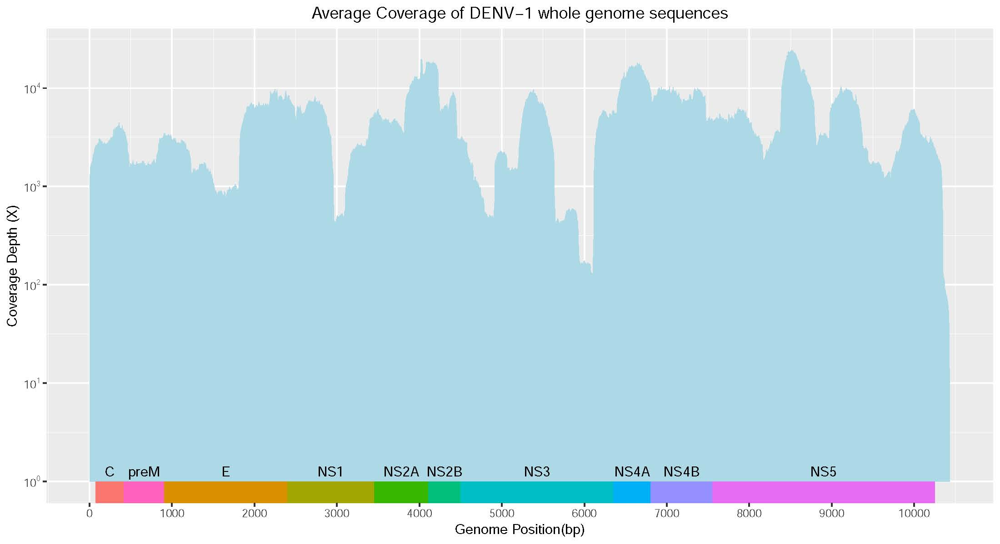

Figure S1: Representative depth of coverage plots for DENV1 circulated in Vietnam 2017. The 72 DENV1 virus were sequenced on the MiSeq platform at a high depth of coverage. The smallest value falls to around 300x and the maximum value reaches to more than 20.000x.

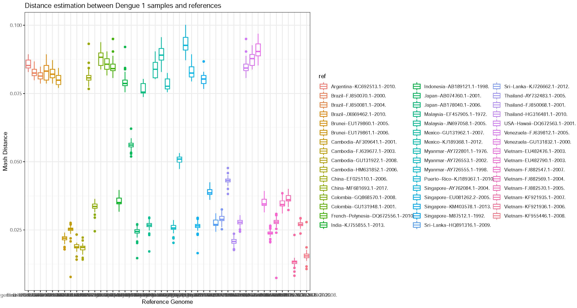

Figure S2: The distance estimation between Dengue type 1 samples and references. The box chart depicts the distribution position of the data (respectively from bottom to top). On each stripe, there is a box that represents the overall distance of each sample in the whole set of D1 samples with each of 47 references. The distance between Dengue type 1 sample and references was measure by Mash-distance.

