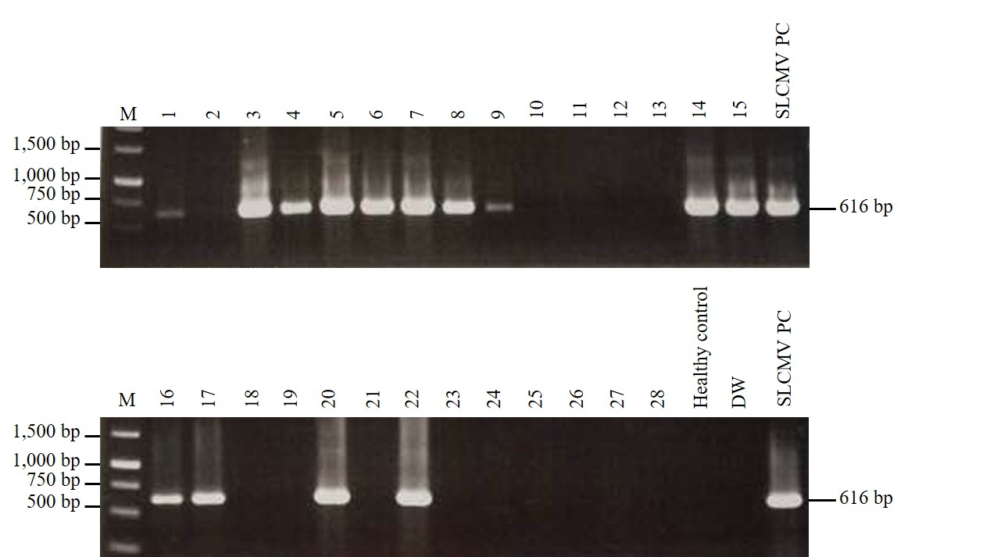

Additional file 3 Fig. S2. Agarose gel electrophoreses showing representative results of SLCMV detection in field-collected samples by PCR using SLCMV-specific primers. Lane M: 1 kb DNA ladder (Thermo Fisher Scientific, USA); Lane 1-28: field-collected cassava leaf samples; DW: distilled water; SLCMV PC: SLCMV positive control. Arrow indicates the size of target PCR product (616-bp).

