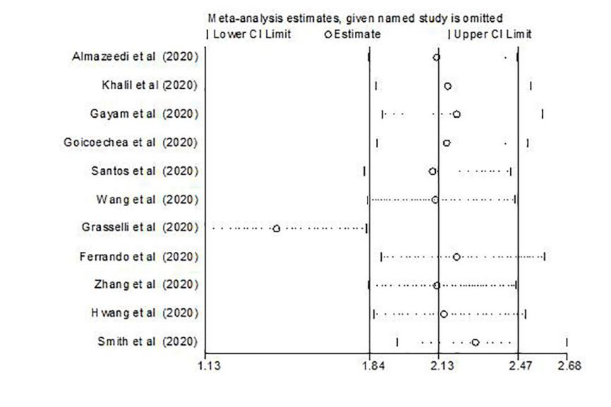
Figure S1: Sensitivity analysis demonstrating the association of dyslipidemia with COVID-19 mortality. Abbreviations: COVID-19, coronavirus disease; CI, confidence interval

