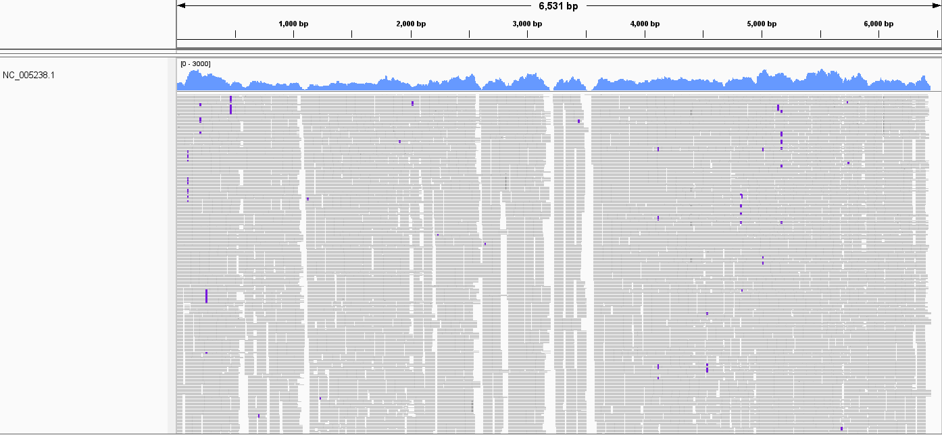
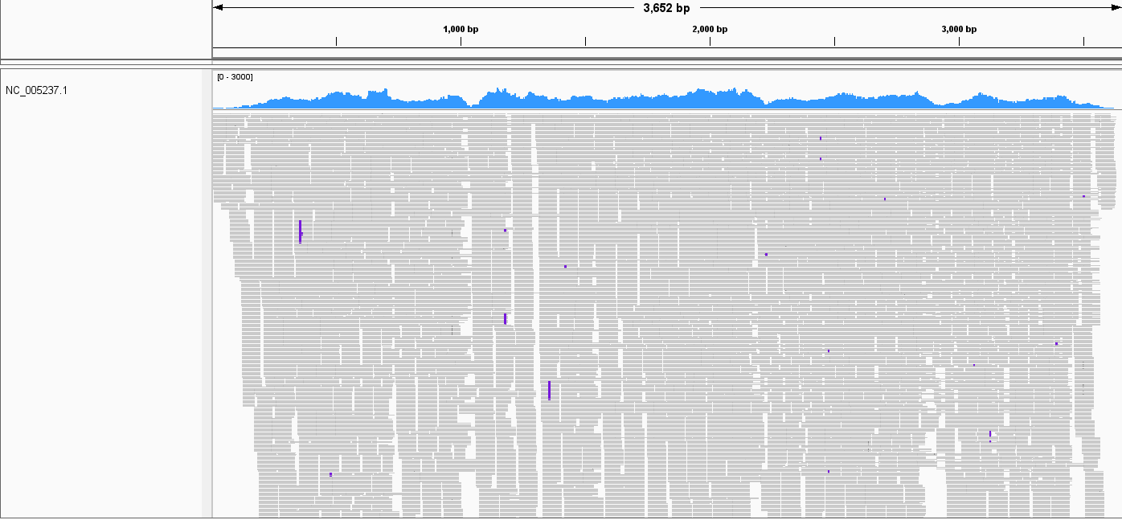
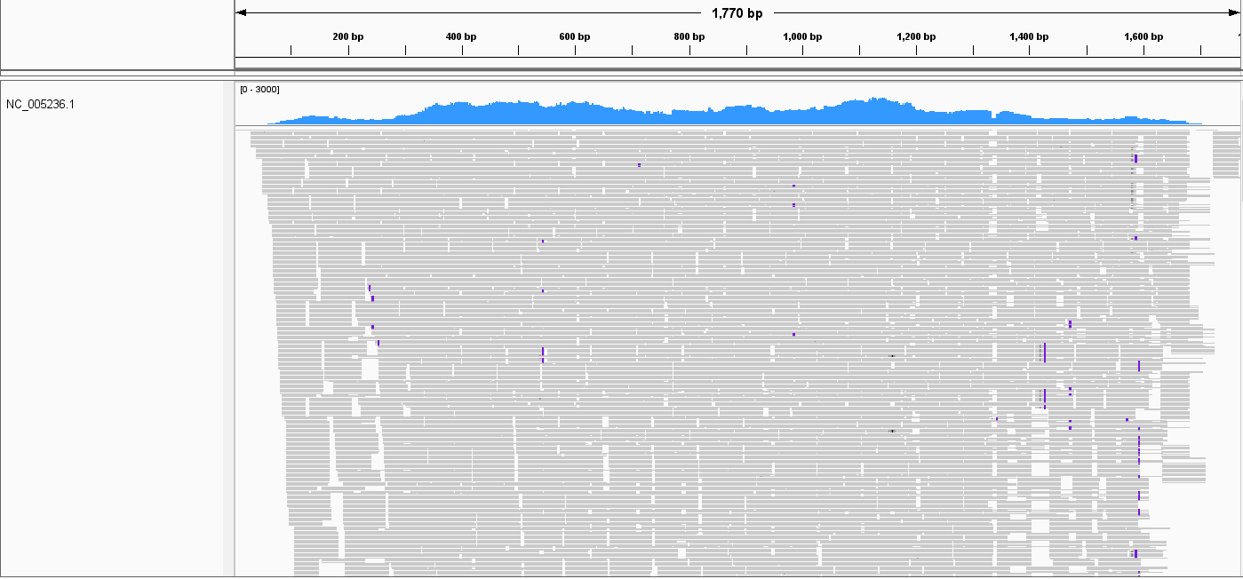
Supplementary Figure 1 SEOV sequences detected by mNGS and mapped to an SEOV reference genome (S segment: NC_005236.1, M segment: NC_005237.1, L segment: NC_005238.1). The horizontal axis is the position of the reference sequence, the blue area is the coverage depth of mNGS sequence, and the gray part is the sequence reads

