SUPPLEMENTARY FIGURES

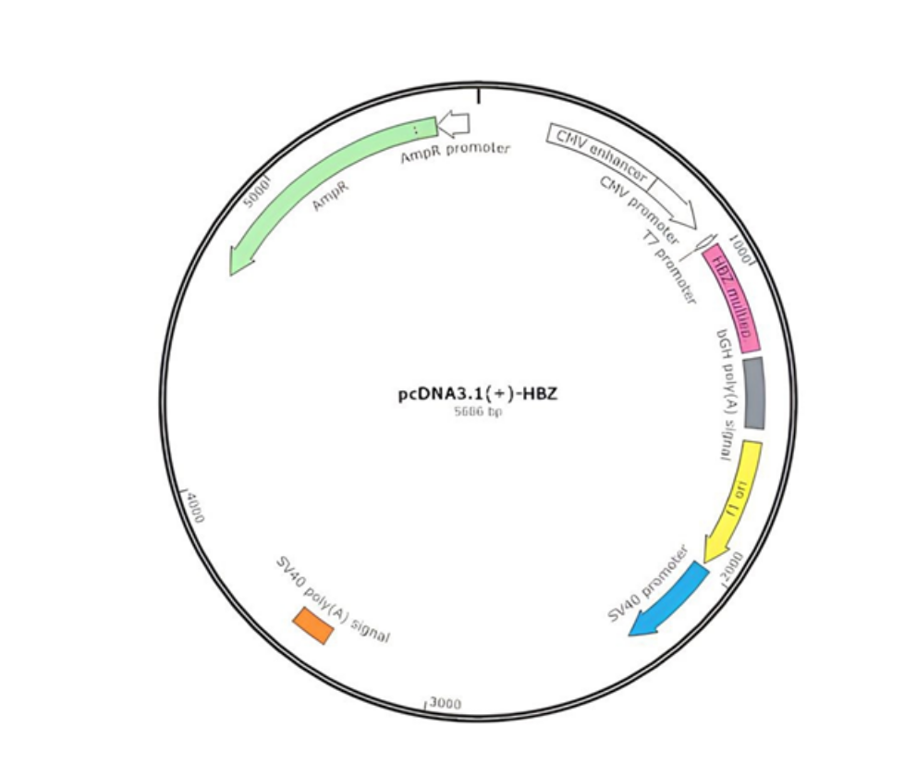

FIGURE S1: Design of the recombinant pcDNA3.1(+)-HBZ. Illustrative figure of the pcDNA3.1(+)-HBZ plasmid used in the immunization assays presenting the HBZ multiepitope sequence.

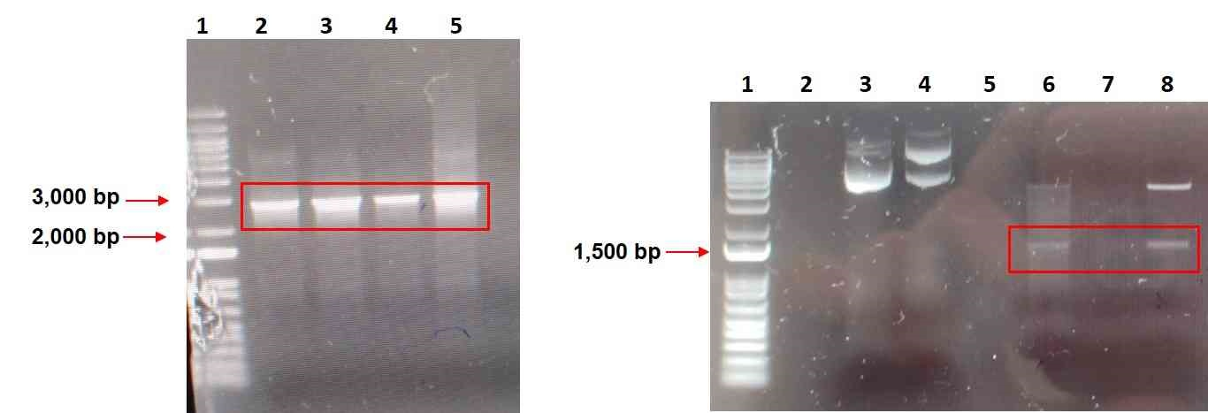
A
B

FIGURE S2: Selection of transforming colonies of pcDNA3.1(+)-HBZ plasmid by PCR and enzymatic restriction. A: PCR – 1: Ladder 1 Kb (Invitrogen); 2 to 5: Mini-preparations of pcDNA3.1(+)-HBZ. Expected fragment (2,702 bp) that encodes the HBZ construction; B: Enzyme restriction - 1: Ladder 1 Kb Invitrogen; 3 and 4: Control plasmid not digested; 6 and 8: Plasmid samples double digested with NheI and SmaI. Expected fragment (1,437 bp) that encodes the HBX-multiepitope protein.

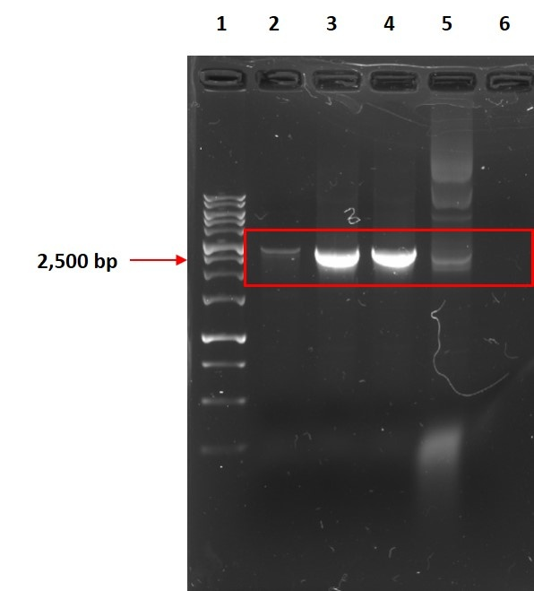

FIGURE S3: FIGURE S3: Endotoxin purified pcDNA3.1(+)-HBZ. PCR product. 1: Ladder 1 Kb (Bioron); 2 to 4: PCR product of pcDNA3.1(+)-HBZ multiepitope endotoxin purified. Expected fragment (2,702 bp) that encodes the HBZ construction. 5: Positive control - Mini-prep of pcDNA3.1(+)-HBZ. 6: Negative control.

