Supplementary Material

Lower HBV DNA level is associated more severe liver fibrosis in HBeAg-positive chronic hepatitis B with normal alanine transaminase

Table S1. Comparison of clinical features between patients with and without significant fibrosis.
Table S2. Comparison of liver fibrosis degree in different age subgroups.
Table S3. Spearman correlation analysis of HBV DNA levels with liver fibrosis.
Table S4. Comparison of liver fibrosis degrees among different HBV DNA subgroups for HBeAg-positive CHB patients with normal ALT with one measurement and at least two measurements.
Table S5. Comparison of clinical features of HBeAg-positive CHB patients with normal ALT with one measurement and at least two measurements.
Figure S1. Flow chart of patient selection.
Figure S2. Comparison of significant fibrosis and cirrhosis proportions among different HBV DNA subgroups in patients with different age.
Table S1. Comparison of clinical features between patients with and without significant fibrosis.
Variables | Without significant fibrosis (n=555) | With significant fibrosis (n=67) | P value
Age (yr) | 33.0 (29.0, 38.0) | 41.0 (31.0, 54.0) | <0.001
Male (%) | 308 (55.5) | 52 (77.6) | 0.001
PLT (×10⁹/L) | 208.0 (173.0, 249.0) | 150.0 (88.0, 199.0) | <0.001
Neutrophils (×10⁹/L) | 3.2 (2.4, 4.2) | 3.0 (2.0, 3.7) | 0.009
Lymphocytes (×10⁹/L) | 1.8 (1.5, 2.2) | 1.6 (1.2, 2.2) | 0.025
ALT (U/L) | 23.8 (19.4, 29.0) | 25.6 (21.0, 31.0) | 0.075
AST (U/L) | 21.7 (19.0, 25.0) | 26.0 (20.9, 43.0) | <0.001
ALP (U/L) | 63.6 (54.0, 76.8) | 82.0 (62.6, 96.3) | <0.001
GGT (U/L) | 16.5 (12.7, 22.0) | 20.5 (15.7, 51.8) | <0.001
Tbil (μmol/L) | 11.8 (8.5, 15.3) | 15.8 (11.9, 22.0) | <0.001
ALB (g/L) | 44.4 (42.1, 46.0) | 42.9 (38.1, 45.8) | 0.004
GLB (g/L) | 28.4 (25.9, 31.3) | 28.0 (25.6, 31.9) | 0.610
HBsAg (log₁₀ IU/mL) | 4.7 (4.4, 4.8) | 4.3 (3.2, 4.6) | <0.001
HBeAg (log₁₀ S/CO) | 3.2 (3.1, 3.2) | 2.7 (1.9, 3.2) | <0.001
HBV DNA (log₁₀ IU/mL) | 7.8 (7.3, 8.1) | 7.1 (6.5, 7.7) | <0.001
HBV DNA range |  |  | <0.001
6-7 log₁₀ IU/mL | 88 (15.9) | 29 (43.3)
7-8 log₁₀ IU/mL | 292 (52.6) | 32 (47.8)
≥8 log₁₀ IU/mL | 175 (31.5) | 6 (9.0)
ALB, albumin; ALP, alkaline phosphatase; ALT, alanine transaminase; AST, aspartate aminotransferase; HBeAg, hepatitis B e antigen; HBsAg, hepatitis B surface antigen; HBV, hepatitis B virus; GGT, gamma-glutamyl transpeptidase; GLB, globulin; PLT, platelet; Tbil, total bilirubin.
Table S2. Comparison of liver fibrosis degree in different age subgroups.
Variables | All patients (n=622) | 6 ≤HBV DNA <7 log₁₀ IU/mL (n=117) | 7 ≤HBV DNA <8 log₁₀ IU/mL (n=324) | HBV DNA ≥8 log₁₀ IU/mL (n=181) | P value
Age<35 yr and ≥35 yr
Age <35 yr, No. | 376 | 48 | 206 | 122
APRI | 0.25 (0.21, 0.31) | 0.24 (0.19, 0.33) | 0.25 (0.21, 0.32) | 0.26 (0.20, 0.30) | 0.816
Significant liver fibrosis (≥1.5) | 2 (0.5) | 0 | 2 (1.0) | 0 | 0.436
Cirrhosis (≥2.0) | 1 (0.3) | 0 | 1 (0.5) | 0 | 0.661
Missing, No. | 0 | 0 | 0 | 0 | -
FIB-4 | 0.62 (0.50, 0.78) | 0.69 (0.51, 0.84) | 0.62 (0.49, 0.78) | 0.62 (0.51, 0.75) | 0.694
Significant liver fibrosis (≥3.25) | 1 (0.3) | 0 | 1 (0.5) | 0 | 0.661
Cirrhosis (≥6.5) | 0 | 0 | 0 | 0 | -
Missing, No. | 0 | 0 | 0 | 0 | -
Liver stiffness (kPa) | 5.5 (4.4, 6.6) | 6.2 (3.3, -z) | 5.6 (4.4, 6.6) | 5.5 (4.4, 6.5) | 0.965
Significant liver fibrosis (≥8.0) | 9 (8.9) | 0 | 5 (10.6) | 4 (7.8) | 0.764
Cirrhosis (≥11.0) | 3 (3.0) | 0 | 1 (2.1) | 2 (3.9) | 0.832
Missing, No. | 275 | 45 | 159 | 71 | -
Liver biopsy
Significant liver fibrosis (S ≥2) | 15 (37.5) | 5 (83.3) | 8 (33.3) | 2 (20.0) | 0.032
Cirrhosis (S4) | 1 (2.5) | 1 (16.7) | 0 | 0 | 0.055
Missing, No. | 336 | 42 | 182 | 112 | -
Age ≥35 yr, No. | 246 | 69 | 118 | 59
APRI | 0.30 (0.23, 0.42) | 0.42 (0.31, 0.89) | 0.29 (0.23, 0.39) | 0.25 (0.21, 0.32) | <0.001
Significant liver fibrosis (≥1.5) | 7 (2.8) | 5 (7.2) | 2 (1.7) | 0 | 0.028
Cirrhosis (≥2.0) | 3 (1.2) | 1 (1.4) | 2 (1.7) | 0 | 0.613
Missing, No. | 0 | 0 | 0 | 0 | -
FIB-4 | 1.03 (0.74, 1.54) | 1.76 (1.04, 3.06) | 0.99 (0.77, 1.35) | 0.80 (0.68, 1.10) | <0.001
Significant liver fibrosis (≥3.25) | 24 (9.8) | 16 (23.2) | 8 (6.8) | 0 | <0.001
Cirrhosis (≥6.5) | 7 (2.8) | 5 (7.2) | 2 (1.7) | 0 | 0.028
Missing, No. | 0 | 0 | 0 | 0 | -
Liver stiffness (kPa) | 6.0 (4.8, 7.4) | 7.7 (5.4, 11.7) | 6.1 (4.9, 7.7) | 5.5 (4.6, 6.2) | 0.076
Significant liver fibrosis (≥8.0) | 10 (19.6) | 5 (50.0) | 5 (20.8) | 0 | 0.007
Cirrhosis (≥11.0) | 5 (9.8) | 2 (20.0) | 3 (12.5) | 0 | 0.200
Missing, No. | 195 | 59 | 94 | 42 | -
Liver biopsy
Significant liver fibrosis (S ≥2) | 9 (34.6) | 3 (60.0) | 6 (35.3) | 0 | 0.170
Cirrhosis (S4) | 2 (7.7) | 1 (20.0) | 1 (5.9) | 0 | 0.477
Missing, No. | 220 | 64 | 101 | 55 | -
Age<40 yr and ≥40 yr
Age <40 yr, No. | 475 | 65 | 260 | 150
APRI | 0.26 (0.21, 0.32) | 0.27 (0.21, 0.34) | 0.25 (0.21, 0.32) | 0.26 (0.21, 0.30) | 0.297
Significant liver fibrosis (≥1.5) | 3 (0.6) | 0 | 3 (1.2) | 0 | 0.287
Cirrhosis (≥2.0) | 2 (0.4) | 0 | 2 (0.8) | 0 | 0.436
Missing, No. | 0 | 0 | 0 | 0 | -
FIB-4 | 0.66 (0.52, 0.84) | 0.70 (0.54, 0.94) | 0.65 (0.52, 0.83) | 0.65 (0.52, 0.80) | 0.249
Significant liver fibrosis (≥3.25) | 2 (0.4) | 0 | 2 (0.8) | 0 | 0.436
Cirrhosis (≥6.5) | 1 (0.2) | 0 | 1 (0.4) | 0 | 0.661
Missing, No. | 0 | 0 | 0 | 0 | -
Liver stiffness (kPa) | 5.6 (4.4, 6.7) | 6.7 (4.0, 7.6) | 5.6 (4.5, 6.8) | 5.5 (4.4, 6.5) | 0.643
Significant liver fibrosis (≥8.0) | 11 (9.0) | 0 | 7 (11.5) | 4 (7.0) | 0.570
Cirrhosis (≥11.0) | 4 (3.3) | 0 | 2 (0.8) | 2 (3.5) | 0.930
Missing, No. | 353 | 61 | 199 | 93 | -
Liver biopsy
Significant liver fibrosis (S ≥2) | 17 (35.4) | 6 (85.7) | 9 (31.0) | 2 (16.7) | 0.007
Cirrhosis (S4) | 2 (4.2) | 2 (28.6) | 0 | 0 | 0.002
Missing, No. | 427 | 58 | 231 | 138 | -
Age ≥40 yr, No. | 147 | 52 | 64 | 31
APRI | 0.33 (0.24, 0.50) | 0.50 (0.33, 1.13) | 0.33 (0.24, 0.43) | 0.24 (0.21, 0.32) | <0.001
Significant liver fibrosis (≥1.5) | 6 | 5 (9.6) | 1 (1.6) | 0 | 0.040
Cirrhosis (≥2.0) | 2 | 1 (1.9) | 1 (1.6) | 0 | 0.752
Missing, No. | 0 | 0 | 0 | 0 | -
FIB-4 | 1.30 (0.94, 2.14) | 2.27 (1.27, 4.59) | 1.16 (0.95, 1.72) | 0.94 (0.68, 1.14) | <0.001
Significant liver fibrosis (≥3.25) | 23 | 16 (30.8) | 7 (10.9) | 0 | <0.001
Cirrhosis (≥6.5) | 6 | 5 (9.6) | 1 (1.6) | 0 | 0.040
Missing, No. | 0 | 0 | 0 | 0 | -
Liver stiffness (kPa) | 6.0 (4.9, 8.5) | 8.3 (5.1, 12.6) | 5.8 (5.0, 10.0) | 5.5 (4.6, 6.3) | 0.188
Significant liver fibrosis (≥8.0) | 8 | 5 (55.6) | 3 (30.0) | 0 | 0.019
Cirrhosis (≥11.0) | 4 | 2 (22.2) | 2 (20.0) | 0 | 0.260
Missing, No. | 117 | 43 | 54 | 20 | -
Liver biopsy
Significant liver fibrosis (S ≥2) | 7 | 2 (50.0) | 5 (41.7) | 0 | 0.468
Cirrhosis (S4) | 1 | 0 | 1 (8.3) | 0 | 0.767
Missing, No. | 129 | 48 | 52 | 29 | -
APRI, AST to PLT ratio index; FIB-4, fibrosis index based on 4 factors; HBV, hepatitis B virus.
Table S3. Spearman correlation analysis of HBV DNA levels with liver fibrosis.
 | All patients |  | Age <30 yr |  | Age ≥30 yr |  | Age <35 yr |  | Age ≥35 yr |  | Age <40 yr |  | Age ≥40 yr
 | Rho | P value | Rho | P value | Rho | P value | Rho | P value | Rho | P value | Rho | P value | Rho | P value
APRI | -0.226 | <0.001 | -0.062 | 0.441 | -0.272 | <0.001 | -0.044 | 0.392 | -0.402 | <0.001 | -0.076 | 0.097 | -0.476 | <0.001
FIB-4 | -0.244 | <0.001 | -0.105 | 0.195 | -0.287 | <0.001 | -0.056 | 0.281 | -0.412 | <0.001 | -0.086 | 0.061 | -0.501 | <0.001
Liver stiffness (kPa) | -0.158 | 0.051 | 0.137 | 0.377 | -0.248 | 0.010 | -0.001 | 0.989 | -0.358 | 0.010 | -0.056 | 0.524 | -0.352 | 0.056
Fibrosis stage | -0.287 | 0.020 | - | - | - | - | - | - | - | - | - | - | - | -
APRI, AST to PLT ratio index; FIB-4, fibrosis index based on 4 factors.
Table S4. Comparison of liver fibrosis degrees among different HBV DNA subgroups for HBeAg-positive CHB patients with normal ALT with at least two measurements.
Variables | All patients (n=134) | 6 ≤HBV DNA <7 log₁₀ IU/mL  (n=15) | 7 ≤HBV DNA <8 log ₁₀ IU/mL (n=73) | HBV DNA ≥8 log ₁₀ IU/mL (n=46) | P value
Age (yr) | 32.0 (29.0, 37.0) | 35.0 (31.0, 43.0) | 33.0 (29.0, 37.0) | 32.0 (28.0, 36.0) | 0.178
Male (%) | 63 (47.0) | 9 (60.0) | 35 (47.9) | 19 (41.3) | 0.440
PLT (×10⁹/L) | 212.5 (179.8, 244.3) | 189.0 (160.0, 230.0) | 209.0 (181.5, 243.5) | 225.5 (182.0, 256.8) | 0.194
ALT (U/L) | 23.1 (19.1, 27.1) | 25.0 (16.5, 30.0) | 23.9 (19.4, 27.8) | 21.5 (19.1, 25.9) | 0.348
AST (U/L) | 22.1 (19.0, 25.0) | 24.0 (20.1, 27.0) | 21.1 (18.6, 24.2) | 22.9 (19.6, 25.3) | 0.099
HBsAg (log₁₀ IU/mL) | 4.7 (4.5, 4.9) | 4.4 (4.1, 4.5) | 4.7 (4.5, 4.9) | 4.8 (4.6, 4.9) | <0.001
HBeAg (log₁₀ S/CO) | 3.2 (3.1, 3.2) | 3.1 (2.8, 3.2) | 3.1 (3.1, 3.2) | 3.2 (3.1, 3.2) | 0.254
HBV DNA (log₁₀ IU/mL) | 7.8 (7.6, 8.1) | 6.6 (6.3, 6.8) | 7.7 (7.6, 7.9) | 8.2 (8.1, 8.2) | <0.001
APRI | 0.26 (0.22, 0.33) | 0.30 (0.26, 0.44) | 0.25 (0.21, 0.31) | 0.26 (0.22, 0.33) | 0.056
FIB-4 | 0.69 (0.57, 0.97) | 0.88 (0.72, 1.15) | 0.67 (0.55, 0.90) | 0.71 (0.57, 1.02) | 0.034
Liver stiffness (kPa) | 5.6 (4.6, 6.6) | 6.3 (4.9, 7.0) | 5.8 (4.6, 6.8) | 5.5 (4.7, 6.4) | 0.814
ALT, alanine transaminase; APRI, AST to PLT ratio index; AST, aspartate aminotransferase; FIB-4, fibrosis index based on 4 factors; HBeAg, hepatitis B e antigen; HBsAg, hepatitis B surface antigen; HBV, hepatitis B virus; PLT, platelet.
Table S5. Comparison of clinical features of HBeAg-positive CHB patients with normal ALT with one measurement and at least two measurements.
Variables | One measurement (n=488) | At least two measurements (n=134) | P value
Age (yr) | 33.0 (30.0, 40.0) | 32.0 (29.0, 37.0) | 0.115
Male (%) | 297 (60.9) | 63 (47.0) | 0.004
PLT (×10⁹/L) | 201.0 (165.0, 244.5) | 212.5 (179.8, 244.3) | 0.066
Neutrophils (×10⁹/L) | 3.2 (2.4, 4.2) | 3.1 (2.4, 4.0) | 0.844
Lymphocytes (×10⁹/L) | 1.8 (1.4, 2.1) | 1.9 (1.5, 2.2) | 0.087
ALT (U/L) | 24.0 (20.0, 29.9) | 23.1 (19.1, 27.1) | 0.033
AST (U/L) | 22.0 (19.4, 25.9) | 22.1 (19.0, 25.0) | 0.777
ALP (U/L) | 66.0 (54.7, 81.0) | 61.4 (53.5, 71.9) | 0.018
GGT (U/L) | 17.4 (13.1, 24.0) | 15.1 (12.5, 20.5) | <0.001
Tbil (μmol/L) | 12.3 (8.6, 16.1) | 11.8 (9.0, 15.2) | 0.466
ALB (g/L) | 44.2 (41.6, 46.0) | 44.6 (42.8, 46.2) | 0.035
GLB (g/L) | 28.2 (25.7, 31.3) | 29.3 (26.2, 31.6) | 0.140
HBsAg (log₁₀ IU/mL) | 4.6 (4.3, 4.8) | 4.7 (4.5, 4.9) | <0.001
HBeAg (log₁₀ S/CO) | 3.1 (3.0, 3.2) | 3.1 (3.1, 3.2) | 0.407
HBV DNA (log₁₀ IU/mL) | 7.7 (7.2, 8.0) | 7.8 (7.6, 8.1) | 0.002
HBV DNA range |  |  | 0.029
6-7 log₁₀ IU/mL | 102 (20.9) | 15 (11.2)
7-8 log₁₀ IU/mL | 251 (51.4) | 73 (54.5)
≥8 log₁₀ IU/mL | 135 (27.7) | 46 (34.3)
APRI | 0.27 (0.22, 0.35) | 0.26 (0.22, 0.33) | 0.212
FIB-4 | 0.73 (0.55, 1.05) | 0.69 (0.57, 0.97) | 0.322
Liver stiffness (kPa) | 5.7 (4.6, 6.9) | 5.6 (4.6, 6.6) | 0.780
ALB, albumin; ALP, alkaline phosphatase; ALT, alanine transaminase; AST, aspartate aminotransferase; HBeAg, hepatitis B e antigen; HBsAg, hepatitis B surface antigen; HBV, hepatitis B virus; GGT, gamma-glutamyl transpeptidase; GLB, globulin; PLT, platelet; Tbil, total bilirubin.
Figure S1. Flow chart of patient selection.

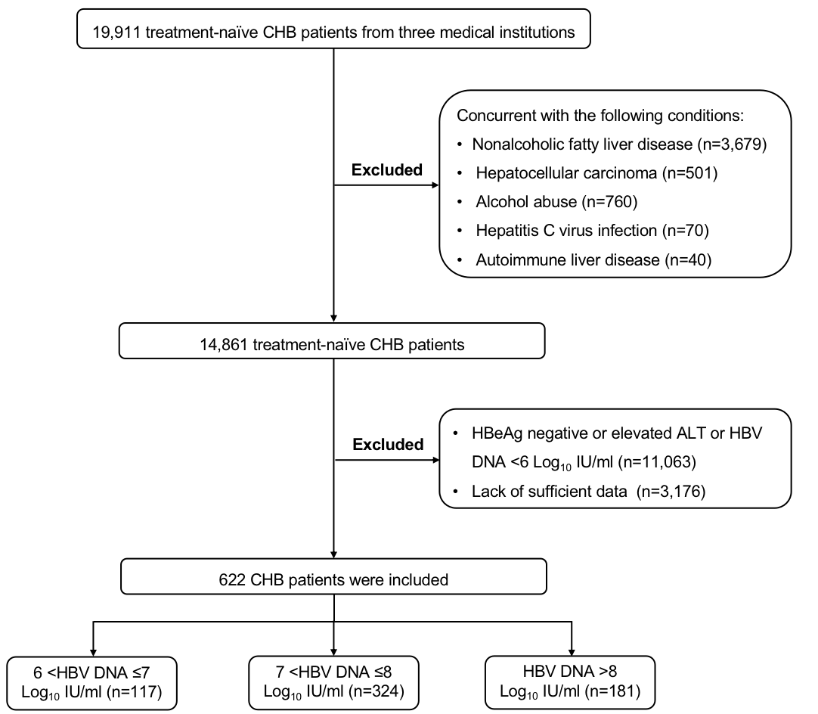
Figure S2. Comparison of significant fibrosis and cirrhosis proportions among different HBV DNA subgroups in patients with different age.

