Table S2. Univariable and multivariable results based on the ordinal logistic model for identifying predictors for long COVID.
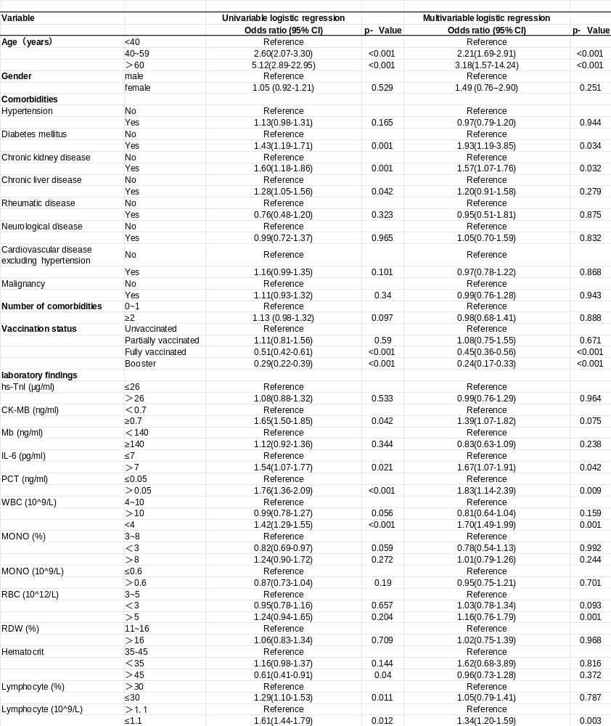

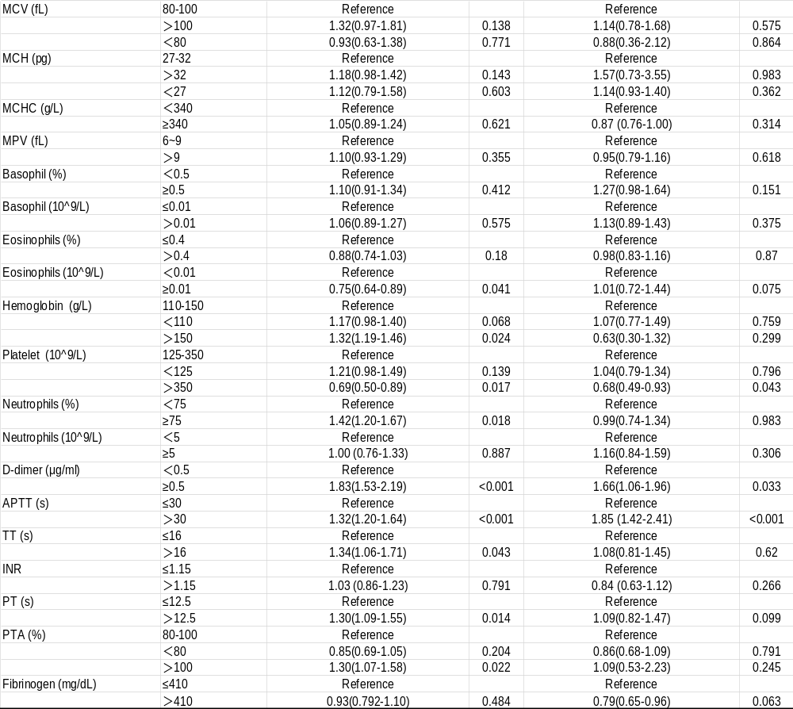

Abbreviations: hs-TnI, High sensitivity Troponin I; CK-MB, creatine kinase-MB; Mb, myoglobin; IL-6, interleukin 6; PCT, Procalcitonin; WBC, white blood cell; MONO, monocyte; RBC, red blood cell; RDW, Red blood cell distribution width; Hct, hematocrit; LYM, lymphocyte; MCV, mean corpuscular volume; MCH, mean corpuscular hemoglobin; MCHC, mean corpuscular hemoglobin concentration; MPV, mean platelet volume; APTT, Activated partial thromboplastin time; TT, thrombin time; INR, international normalized ratio; PT, prothrombin time; PTA, Prothrombin time activity.

