Supplementary Material

Figure S1. Association of PTX3 plasma levels (ng/mL) and sex. Data are shown as median and interquartile range. Statistical significance was determined using Mann-Whitney U test.

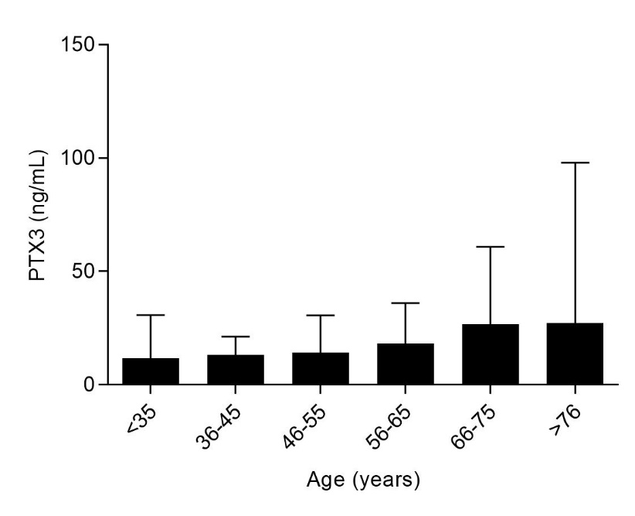
Figure S2. Association of PTX3 plasma levels (ng/mL) and age (years). Data are shown as median and interquartile range. Statistical significance was determined using Kruskal-Wallis test (p=0.008).

Figure S3. Receiver operating characteristic curve (ROC) analysis for laboratory variables as predictors for coronavirus disease 2019 (COVID-19) death according to (A) male sex and (B) female sex.
Legend – aPTT: activated partial thromboplastin time; AST: aspartate aminotransferase; AUC: area under the curve; INR: international normalized ratio; PTX3: pentraxin 3.

Figure S4. Receiver operating characteristic curve (ROC) analysis for laboratory variables as predictors for coronavirus disease 2019 (COVID-19) death according to age (A) ≤53 years old, and (B) >53 years old.
Legend – aPTT: activated partial thromboplastin time; AST: aspartate aminotransferase; AUC: area under the curve; INR: international normalized ratio; PTX3: pentraxin 3.

