Table S1. Antibiotic susceptibility pattern of methicillin resistant Staphylococcus aureus (MRSA) isolates from different clinical samples.

Staphylococcus isolates | 1 | 2 | 3 | 4 | 5 | 6 | 7 | 8 | 9 | 10 | 11 | 12 | 13 | 14 | 15 | 16 | 17 | 18 | 19 | 20 | 21 | 22 | 23 | 24 | 25
Benzylpenicillin | R | R | R | R | R | R | R | R | R | R | R | R | R | R | R | R | R | R | R | R | R | R | R | R | R
Cefoxitin | R | R | R | R | R | R | R | R | R | R | R | R | R | R | R | R | R | R | R | R | R | R | R | R | R
Ampicillin | R | R | R | R | R | R | R | R | R | R | R | R | R | R | R | R | R | R | R | R | R | R | R | R | R
Amikacin | S | R | S | S | R | S | R | R | R | S | S | S | S | R | S | S | R | S | S | R | R | R | R | S | S
Vancomycin | S | S | S | S | S | S | S | S | S | S | S | S | S | S | S | S | S | S | S | S | S | S | S | S | S
Ciprofloxacin | S | R | S | S | R | S | S | R | R | S | S | S | S | S | R | S | R | S | S | S | R | R | R | S | R
Erythromycin | R | S | S | S | R | S | S | R | R | R | R | R | S | S | R | R | R | S | S | S | R | S | R | R | S
Linezolid | S | S | S | S | S | S | S | S | S | S | S | S | S | S | S | S | S | S | S | S | S | S | S | S | S
Clindamycin | R | S | S | S | R | S | S | R | R | R | R | R | S | S | R | R | R | S | S | S | R | S | R | R | S
Gentamycin | S | R | S | R | R | S | R | R | R | S | S | S | R | R | S | R | R | S | S | R | R | R | R | S | S
Qxacillin | R | R | R | R | R | R | R | R | R | R | R | R | R | R | R | R | R | R | R | R | R | R | R | R | R
Levofloxacin | S | R | S | S | R | S | S | R | R | S | S | S | S | S | R | S | R | S | S | S | R | R | R | S | R
Tetracycline | S | R | R | S | R | S | R | R | R | S | S | S | R | R | S | R | R | R | R | R | R | R | R | S | S
Tigecycline | S | S | S | S | S | S | S | S | S | S | S | S | S | S | S | S | S | S | S | S | S | S | S | S | S
Rifampicin | S | I | S | S | I | S | S | R | R | S | S | S | S | S | S | R | S | S | S | S | R | I | S | S | S
Teicoplanin | S | S | S | S | S | S | S | S | S | S | S | S | S | S | S | S | S | S | S | S | S | S | S | S | S
Trimethoprim/  Sulfamrthoxazole | R | S | S | S | S | S | S | S | S | S | R | R | S | S | R | S | S | R | R | S | S | S | R | S | S

*R: complete resistance, S: susceptible,I: Intermediated

Table S2: The efficiency of plating of phage vB_SauP_ASUmrsa123.
No. of MRSA strain | EOP | EOP after calculation | PFU / ml
ST1 ATCC OQ564500.1(Host) | 1.0 | 1.0 | 10⁹
ST 2 | - | - | -
ST 3 | ( 7 × 10⁻¹) | 0.7 | 10⁸
ST 4 | (1.3× 10⁻⁴) | 0.00013 | 10⁴
ST 5 | (7× 10⁻⁷) | 0.0000007 | 10²
ST 6 | (3.0× 10⁻¹) | 0.3 | 10⁸
ST 7 | (7.5 ×10⁻²) | 0.075 | 10⁶
ST 8 | - | - | -
ST 9 | - | - | -
ST 10 | (3.8 ×10⁻⁶) | 0.0000038 | 10³
ST 11 | (6× 10⁻¹) | 0.6 | 10⁸
ST 12 | 1.0 | 1.0 | 10⁹
ST 13 | (2.5×10⁻² ) | 0.025 | 10⁷
ST 14 | (7.5×10⁻² ) | 0.075 | 10⁷
ST 15 | (3.0×10⁻² ) | 0.03 | 10⁷
ST 16 | - | - | -
ST 17 | - | - | -
ST 18 | 1.0 | 1.0 | 10⁹
ST 19 | (6.3 ×10⁻¹) | 0.63 | 10⁸
ST 20 | (5×10⁻² ) | 0.05 | 10⁷
ST 21 | - | - | -
ST 22 | - | - | -
ST 23 | - | - | -
ST 24 | - | - | -
ST 25 | - | - | -

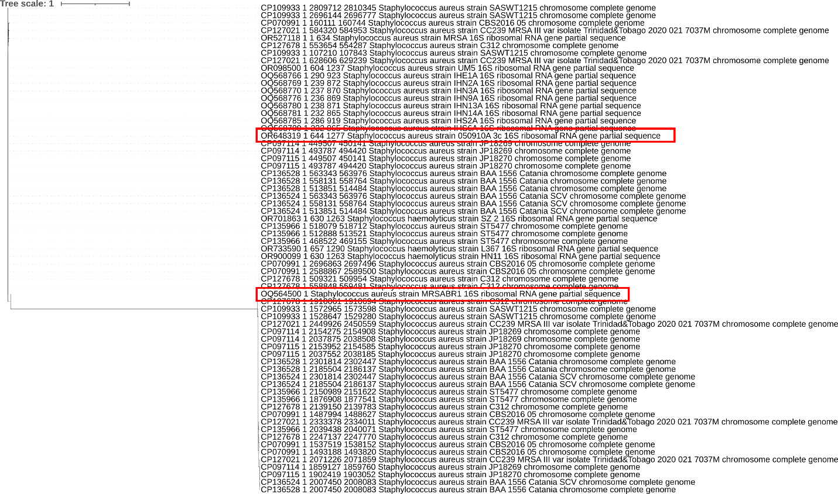
Figure S1: 16S rRNA Phylogenetic relationship of the two S. aureus MRSA host bacteria OQ564500 and OR527118 with other S. aureus isolates in GenBank database.
Table S3: Phage vB_SauP_ASUmrsa123 genes predicted functions.
Type | Location | Start | Stop | Strand | Function
CDS | Staphylococcus_165+90 | 165 | 254 | + | hypothetical protein
CDS | Staphylococcus_488-210 | 488 | 279 | - | hypothetical protein
CDS | Staphylococcus_575+132 | 575 | 706 | + | inner core protein
CDS | Staphylococcus_719+174 | 719 | 892 | + | arstotzka protein
CDS | Staphylococcus_972+126 | 972 | 2136 | + | major head protein
CDS | Staphylococcus_2152+975 | 2152 | 3126 | + | upper collar protein
CDS | Staphylococcus_3245+279 | 3245 | 3884 | + | Phage lower collar protein
CDS | Staphylococcus_3898+852 | 3898 | 5733 | + | Putative major teichoic acid biosynthesis protein C
CDS | Staphylococcus_5852+279 | 5852 | 6525 | + | Phage lysin, N-acetylmuramoyl-L-alanine amidase (EC 3.5.1.28)
CDS | Staphylococcus_6660+225 | 6660 | 7293 | + | Phage tail fiber
CDS | Staphylococcus_7466+126 | 7466 | 7591 | + | Phage minor tail protein
CDS | Staphylococcus_7649+105 | 7719 | 8899 | + | Phage tail fiber
CDS | Staphylococcus_9422+420 | 9422 | 9841 | + | Phage holin
CDS | Staphylococcus_9819+231 | 9819 | 11259 | + | CHAP domain-containing protein
CDS | Staphylococcus_11919-552 | 13718 | 11680 | - | DNA polymerase (EC 2.7.7.7), phage-associated
CDS | Staphylococcus_13811-138 | 14476 | 13586 | - | terminase
CDS | Staphylococcus_14988-90 | 14988 | 14899 | - | hypothetical protein
CDS | Staphylococcus_15363-258 | 15363 | 15106 | - | hypothetical protein
CDS | Staphylococcus_15345+132 | 15345 | 15476 | + | hypothetical protein
CDS | Staphylococcus_15914-189 | 15914 | 15726 | - | hypothetical protein
CDS | Staphylococcus_16192-177 | 16192 | 16016 | - | hypothetical protein
CDS | Staphylococcus_16611-270 | 16611 | 16342 | - | Single stranded DNA-binding protein, phage-associated
CDS | Staphylococcus_16895-111 | 16895 | 16785 | - | hypothetical protein
CDS | Staphylococcus_17154-255 | 17154 | 16900 | - | hypothetical protein

