H1N1 HA gene | H1N1 NA gene | H3N2 HA | H3N2 NA
EPI_ISL_19288002 | EPI_ISL_19288002 | EPI_ISL_19287905 | EPI_ISL_19287905
EPI_ISL_19288000 | EPI_ISL_19290528 | EPI_ISL_19287998 | EPI_ISL_18667508
EPI_ISL_19290528 | EPI_ISL_19288000 | EPI_ISL_18667554 | EPI_ISL_19287998
EPI_ISL_19288001 | EPI_ISL_19288001 |  | EPI_ISL_18667554
EPI_ISL_18651856 | EPI_ISL_18651856
EPI_ISL_18667474 | EPI_ISL_18667506
EPI_ISL_18667506 | EPI_ISL_18667474
EPI_ISL_18667468 | EPI_ISL_18667468
EPI_ISL_18667405 | EPI_ISL_18667404
EPI_ISL_19290526 | EPI_ISL_18667469
EPI_ISL_18667557 | EPI_ISL_18667405
EPI_ISL_19290527 | EPI_ISL_19290526
EPI_ISL_18667558 | EPI_ISL_18667556
EPI_ISL_19290525 | EPI_ISL_19290527
 | EPI_ISL_18667557
 | EPI_ISL_18667558
 | EPI_ISL_19290525
Supplementary data
Supplementary table.1: Accession numbers of HA and NA sequences of H1N1 and H3N2 included in the analysis
Supplementary table.2: Positions of the mutations and gene functions in 2024 H1N1 sequences from Sri Lanka
Mutation | Impact | Protein structure
I96T | Viral oligomerization interfaces, binding small ligand(s), a T-cell epitope presented by MHC molecules, antibody recognition sites | Helix
T120A | Binding small ligand(s), viral oligomerization interfaces, antibody recognition sites | Beta strand
A139D | Antigenic drift / escape mutant, viral oligomerization interfaces, binding small ligand(s), antibody recognition sites | Adjacent to turn
G339X | Viral oligomerization interfaces, binding small ligand(s), antibody recognition sites | NA
K156X | Antibody recognition sites, binding small ligand(s), viral oligomerization interfaces | Prior to beta strand, in between two beta strands
T278S | Binding small ligand(s), viral oligomerization interfaces | In between two beta strands

Supplementary table.3: Clinical characteristics of the influenza A positive patients (n= 49) from the study
 | N=49 (%)
Age (median, IQR) | 12, 5 to 44
Male  Female | 28 (57.1%)  21 (42.8%)
Fever | 32 (65.3%)
Cough | 34 (69.3%)
Rhinorrhea | 27 (55.1%)
Sore Throat | 19 (38.7%)
Dyspnea | 20 (40.8%)

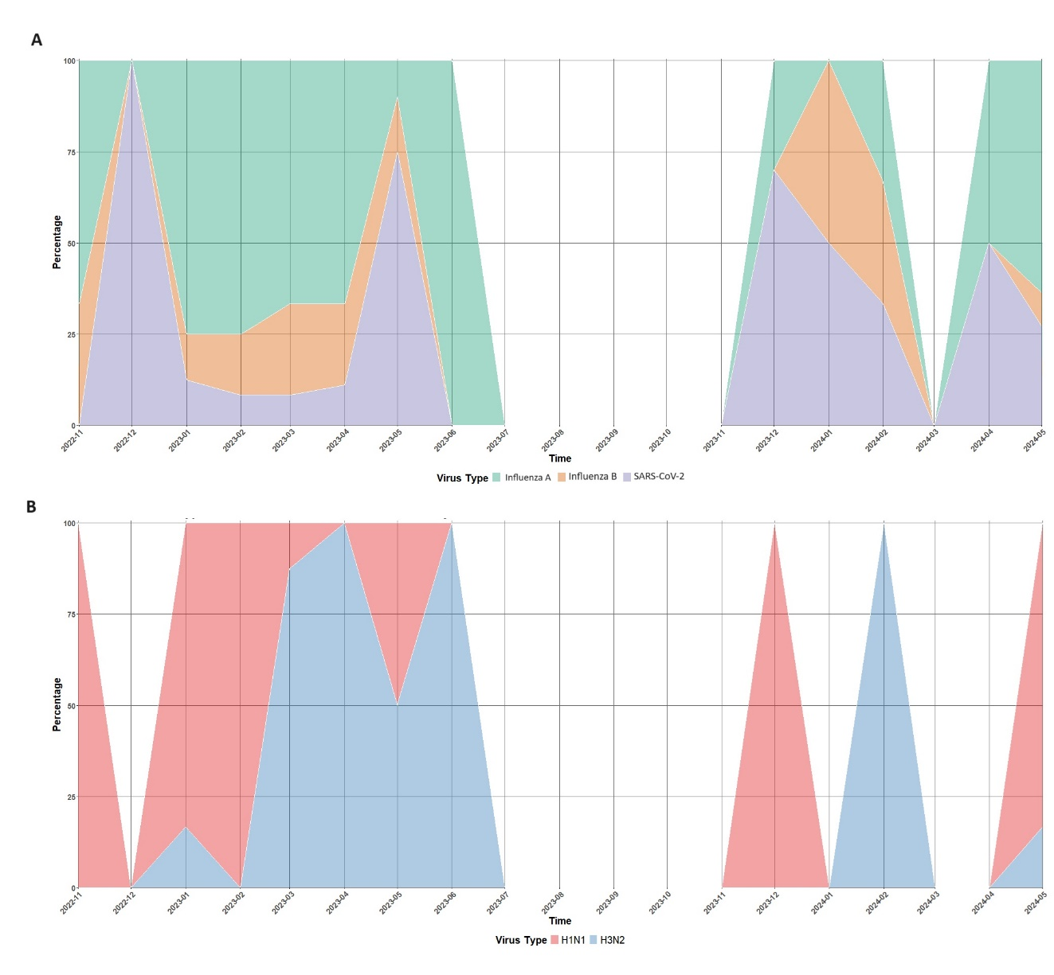
Supplementary figure.1: (A) Monthly trend of Influenza A, Influenza B, and SARS-CoV-2 from November 2022 to May 2024. (B) Influenza Subtype distribution from November 2022 to May 2024

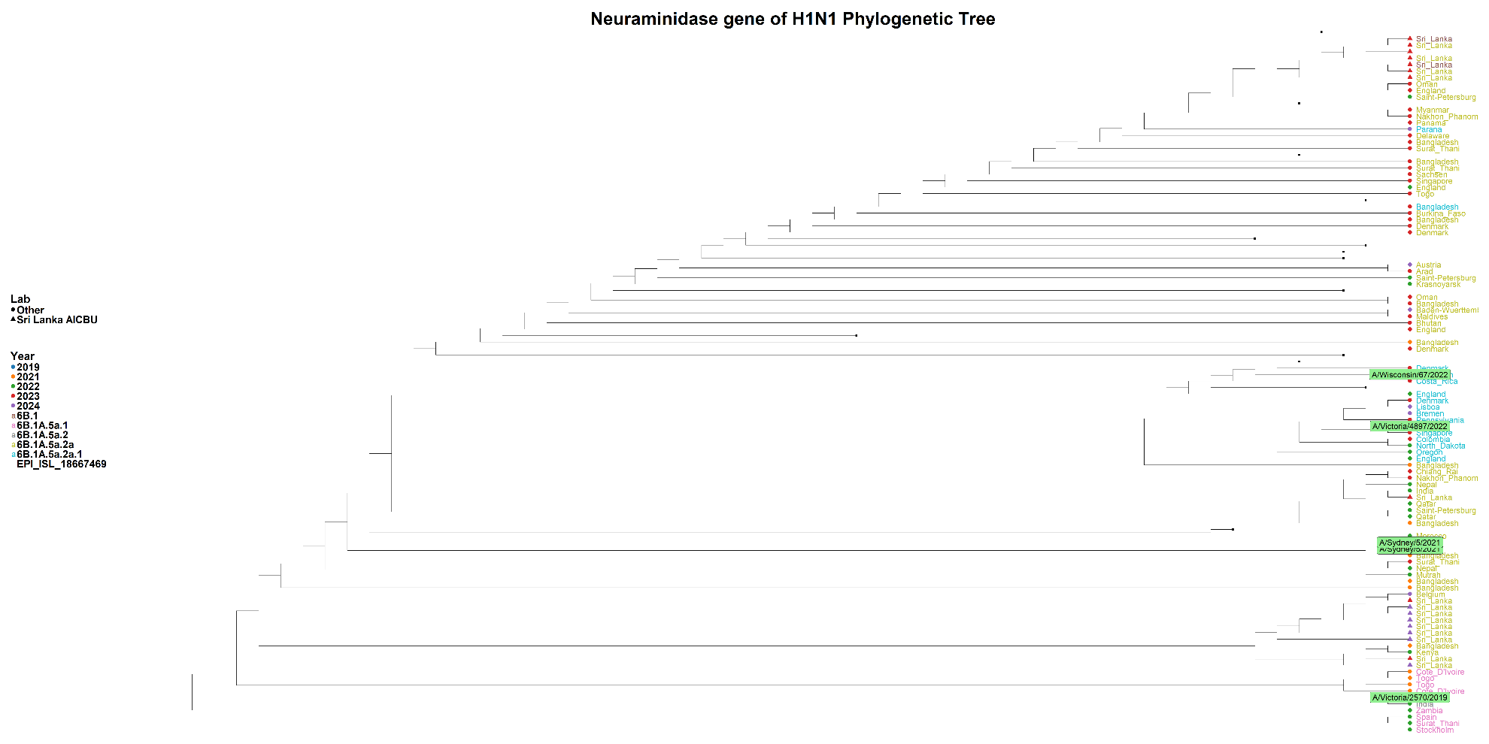
Supplementary figure.2: Phylogenetic tree of the H1N1 NA gene (Sequences generated in the AICBU lab are represented by triangles, while other sequences are depicted as circles)

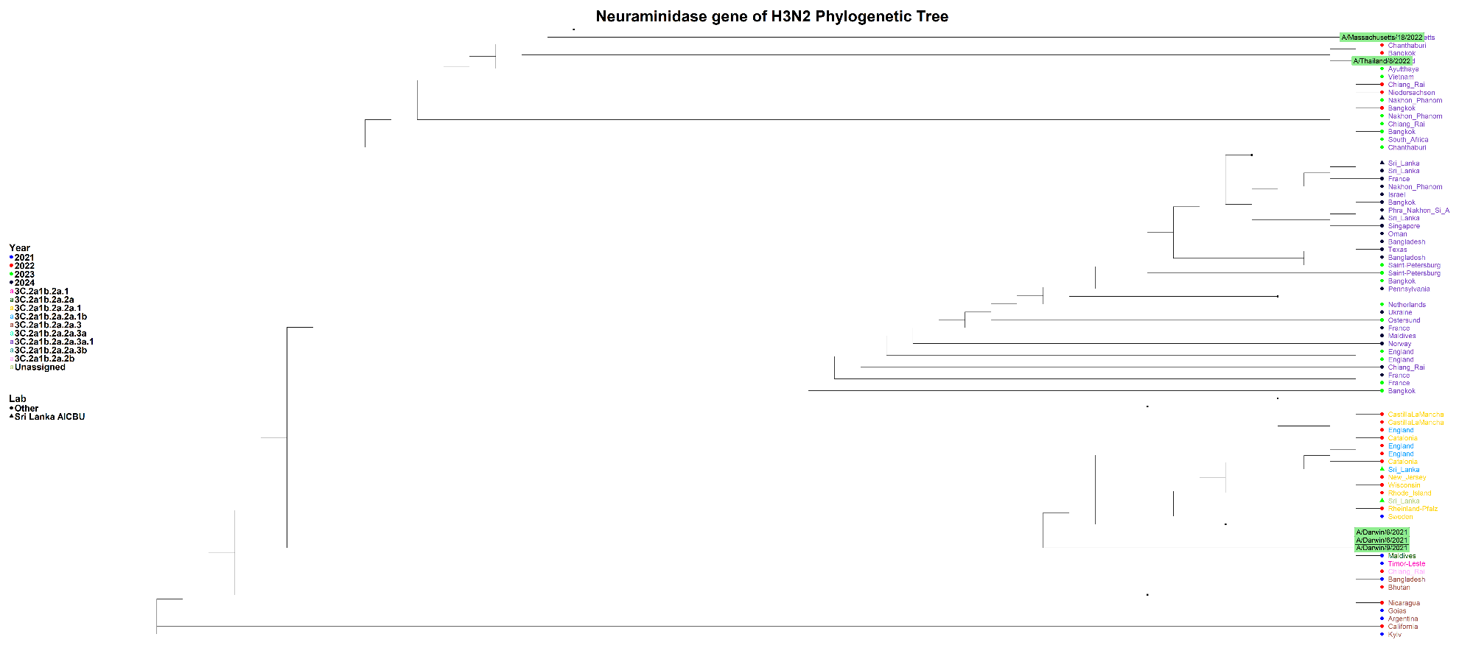

Supplementary figure.3: Phylogenetic tree of the H3N2 NA gene (Sequences generated in the AICBU lab are represented by triangles, while other sequences are depicted as circles)
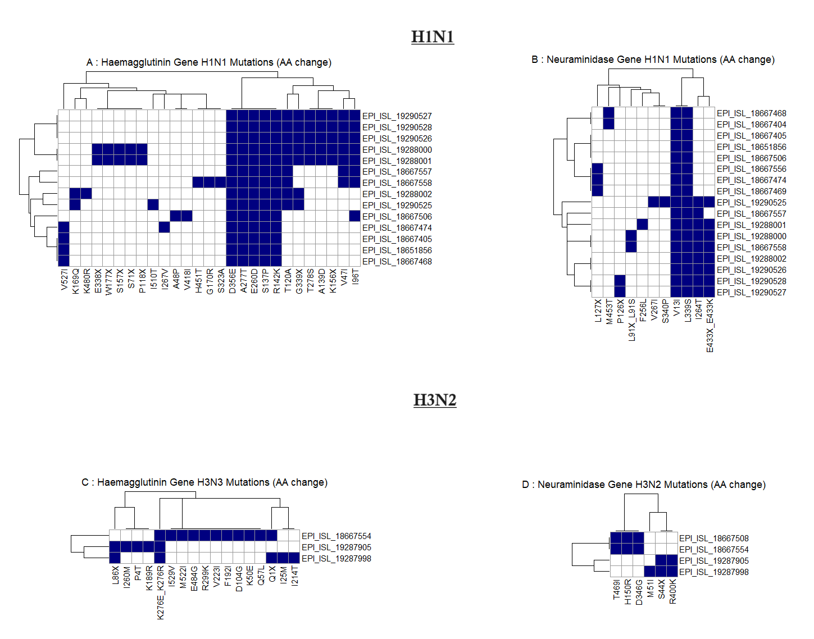
Supplementary figure.4: Heatmap of amino acid substitutions in the Hemagglutinin (HA) and Neuraminidase (NA) genes of Influenza A H1N1 and H3N2 viruses. The reference strain A/Wisconsin/67/2022 was used for H1N1, and A/Massachusetts/18/2022 was used for H3N2. (Panels A and B illustrate mutations in the HA and NA genes of H1N1, respectively, while Panels C and D depict mutations in the HA and NA genes of H3N2. Each row corresponds to an individual virus sequence, identified by its GISAID EPI_ISL accession number, and each column represents specific amino acid positions where mutations have been identified. Blue squares indicate the presence of a mutation, while white squares indicate its absence.)

