Supplementary Materials

Table S1. Descriptive epidemiology of PED in two reported farms, Karnataka, India
Pig Farms | Year of reporting | Total number of pigs | Number of cases | Number of deaths | Morbidity  (%) | Mortality  (%) | Case fatality  (%) | Clinical signs*
Farm-1 | 2022 | 350 | 200 | 01 | 57.1 | 0.2 | 0.5 | Yellow watery diarrhoea, vomiting, anorexia, and signs of abdominal pain
Farm-2 | 2023 | 450 | 250 | 40 | 55 | 8 | 16
- Clinical signs were similar in both the farms

Table S2. Detailed information on PEDV sequences used in S1 phylogenetic analysis,
Sl. No. | Sequence ID | Country | Year | Genotype | Virus
 | KJ662670 | South Korea | 2013 | G2a | PEDV
 | KJ588062 | South Korea | 2014 | G2a | PEDV
 | KR011758 | France | 2014 | G2a | PEDV
 | KR265806 | USA | 2014 | G2a | PEDV
 | KX663806 | USA | 2013 | G2a | PEDV
 | LC063186 | Japan | 2014 | G2a | PEDV
 | KX982562 | Vietnam | 2012 | G2a | PEDV
 | KF452323 | USA | 2012 | G2a | PEDV
 | KF267450 | USA | 2013 | G2a | PEDV
 | ON618257 | China | 2020 | G2a | PEDV
 | KC196272 | China | 2011 | G2a | PEDV
 | ON419538 | China | 2019 | G2a | PEDV
 | KX698751 | China | 2012 | G2a | PEDV
 | PP066295 | India | 2023 | - | PEDV
 | PP066294 | India | 2023 | - | PEDV
 | PP066293 | India | 2023 | - | PEDV
 | PP066292 | India | 2022 | - | PEDV
 | PP066291 | India | 2022 | - | PEDV
 | PP066290 | India | 2022 | - | PEDV
 | PP066289 | India | 2022 | - | PEDV
 | PP066288 | India | 2022 | - | PEDV
 | PP066287 | India | 2022 | - | PEDV
 | JX489155 | China | 2011 | G2b | PEDV
 | JX188454 | China | 2011 | G2b | PEDV
 | KC140102 | China | 2012 | G2b | PEDV
 | KX982564 | Vietnam | 2013 | G2b | PEDV
 | GU937797 | Switzerland | 2010 | G1a | PEDV
 | AF353511 | Switzerland | 2001 | G1a | PEDV
 | LT906832 | Germany | 1987 | G1a | PEDV
 | EF185992 | China | 2006 | G1a | PEDV
 | KC189944 | China | 2012 | G1b | PEDV
 | KC210146 | China | 2008 | G1b | PEDV
 | KC910491 | China | 2008 | G1b | PEDV
 | JQ023162 | South Korea | 2011 | G1b | PEDV
 | DQ811787 | USA | 2006 | - | PRCV

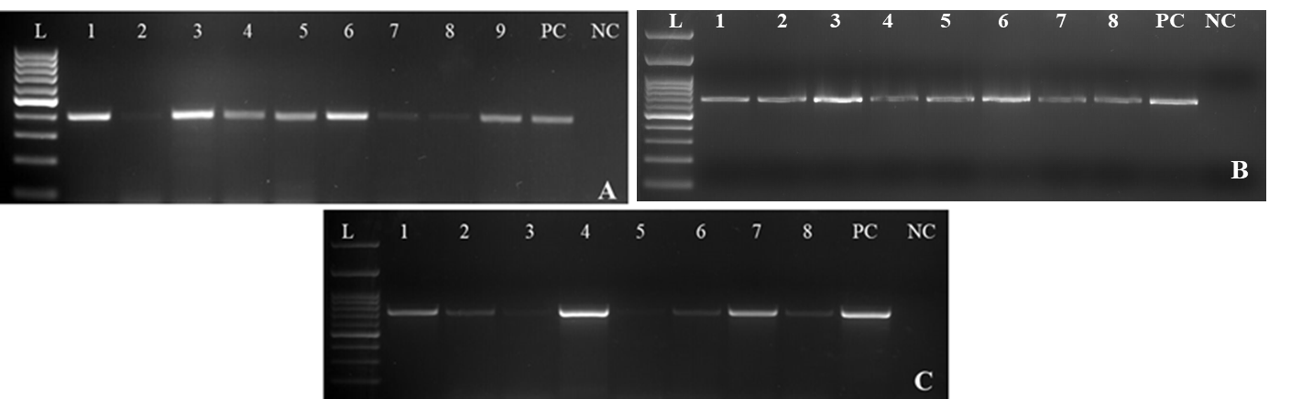
Fig. S1. Agarose gel image showing the results of faecal samples screened by RT-PCR. A. N gene (amplicon size-394bp) 1-9: Faecal samples, B. S gene (amplicon size-651bp), 1-8: Faecal samples and C. M gene (amplicon size-675bp) of PEDV, 1-8: Faecal samples. L: 100bp ladder, 1-8: Faecal samples PC: Positive PCR control, NC: Non template control

