Supporting Information

Rapid Visual Detection of Monkeypox Virus by One-Step LAMP-CRISPR/Cas12b assay

Table of contents
Table S1. Primers designed in our study.
Table S2. The gRNAs designed in our study.
Table S3. Comparison of our method with the existing MPXV isothermal amplification visual molecular detection methods.
Figure S1. The linearity of the one-step LAMP-CRISPR/Cas12b assay.
Figure S2. Endpoint visual detection results of 113 clinical samples.

Table S1. Primers designed in our study.
Name | Type | Sequence(5’-3’)
PS1 | F3 | AGAAGCGAGAAGTTAATAAAGC
PS1 | B3 | TCAAAAGACTTATGATCCTCTCT
PS1 | FIP | ACCAACGAGGAGGAGTATCGTTTCTGTATGATCTTCAACGTAGT
PS1 | BIP | CTACGACAATGGATGCTGATACACCATTGATTTTTCGCGGGATAC
PS1 | LF | GGAGCTGTAAACCATAGC
PS1 | LB | GGCCTACAGATTCTGATG
PS2 | F3 | GTATGATCTTCAACGTAGTGC
PS2 | B3 | AGGGTTAACACCTTTCCAAT
PS2 | FIP | CCGTGTATCAGCATCCATTGTGGTTTACAGCTCCAACGAT
PS2 | BIP | GCTATAATAGATGATGTATCCCGCGCGGAATAACATCATCAAAAGACTT
PS2 | LF | ACCAACGAGGAGGAGT
PS2 | LB | AAAAATCAATGAGAGAGGATCA
PS3 | F3 | GTTTACAGCTCCAACGATAC
PS3 | B3 | TCCTAGTTATTTGACAGTACTCAT
PS3 | FIP | CGCGGGATACATCATCTATTATAGCCCTCCTCGTTGGTCTACG
PS3 | BIP | AGTCTTTTGATGATGTTATTCCGGTAATAACGGTGACAGGGTTA
PS3 | LF | GCCGTGTATCAGCATCCATTGT
PS4 | F3 | ACGGCCTACAGATTCTGAT
PS4 | B3 | ACTGATTCAATACGAAAAGACC
PS4 | FIP | ACCGGAATAACATCATCAAAAGACTTGATGCTATAATAGATGATGTATCC
PS4 | BIP | TATTGGAAAGGTGTTAACCCTGTCAATCTCTCCTAGTTATTTGACAGTA
PS4 | LF | GATCCTCTCTCATTGATTTTTCGCG
PS5 | F3 | TCTTTTGATGATGTTATTCCGG
PS5 | B3 | TGCATTATTTTTAGCATCTCGTT
PS5 | FIP | ACGAAAAGACCAATCTCTCCTAGTTTTTATTGGAAAGGTGTTAACCCT
PS5 | BIP | GAATCAGTGGGGCCTAGTAACTCTTTCCATCTGCCTTATCGA
PS5 | LF | GACAGTACTCATTAATAACGGTGAC
PS5 | LB | TATGCCTGTGTAGACATTGACG

Table S2. The gRNAs designed in our study.
gRNA1 | GUCUAGAGGACAGAAUUUUUCAACGGGUGUGCCAAUGGCCACUUUCCAGGUGGCAAAGCCCGUUGAGCUUCUCAAAUCUGAGAAGUGGCACGACAGUACUCAUUAAUAACG(TTT)
gRNA2 | GUCUAGAGGACAGAAUUUUUCAACGGGUGUGCCAAUGGCCACUUUCCAGGUGGCAAAGCCCGUUGAGCUUCUCAAAUCUGAGAAGUGGCACACAGUACUCAUUAAUAACGG(TTG)
gRNA3 | GUCUAGAGGACAGAAUUUUUCAACGGGUGUGCCAAUGGCCACUUUCCAGGUGGCAAAGCCCGUUGAGCUUCUCAAAUCUGAGAAGUGGCACUUCCGGUUAAAAAAAUUA(TTA)
gRNA4 | GUCUAGAGGACAGAAUUUUUCAACGGGUGUGCCAAUGGCCACUUUCCAGGUGGCAAAGCCCGUUGAGCUUCUCAAAUCUGAGAAGUGGCACGUAUUGAAUCAGUGGGGCCU (TTC)
gRNA5 | GUCUAGAGGACAGAAUUUUUCAACGGGUGUGCCAAUGGCCACUUUCCAGGUGGCAAAGCCCGUUGAGCUUCUCAAAUCUGAGAAGUGGCACACAGGCAUAAAAUGUAGGAG (TAC)
The underlined letters represent the spacer sequences of gRNA. The text in parentheses represents the PAM sequence.

Table S3. Comparison of our method with the existing MPXV isothermal amplification visual detection methods.
Target gene | Detection method | LOD | Clinical validation | Reference*
F3L | LAMP-CRISPR/Cas12b | 6.5copiesps/reaction | 113 human samples | Our method
ATI | LAMP-LFB | 12.5copies/reaction | simulated clinical samples | [14]
F3L&B6R | Colorimetric LAMP | 137 copies/mL | simulated clinical samples | [15]
N4R | Colorimetric LAMP | 120copies/reaction | 15 human samples | [16]
A4L& N1R | Colorimetric LAMP | 6.25copies/μL | 3 human samples | [17]
F3L &N4R | Colorimetric LAMP | 10copies/μL | simulated clinical samples | [18]
A27L&F3L | Colorimetric LAMP | 20copies/reaction | simulated clinical samples | [19]
N3R& N4R | RPA-Cas12a | 10copies/reaction | 1 human sample | [20]
ATI&D14L | LAMP-CRISPR/Cas12b-LFB | 10copies/reaction | simulated clinical samples | [21]
B7R | RPA-Cas12a | 15copies/μL | simulated clinical samples | [22]
F3L | RAA-Cas12a-LFB  -LFB | 10⁴copies/μL | ND | [23]
F3L | RPA-Cas13a | 2.5copies/reaction | 102 human samples | [24]
LOD, limit of detection; LFB, lateral flow biosensor;RPA, recombinase polymerase amplification; RAA, recombinase aided amplification; ND,Not Done. * References, please refer to the main manuscript.

Figure S1. The linearity of the one-step LAMP-CRISPR/Cas12b assay. R²=0.932, Slope=-2.198, y-int=18.43. Hollow circles indicate standard quantitative monkeypox nucleic acid. All standards were conducted in triplicate. tt, threshold time.

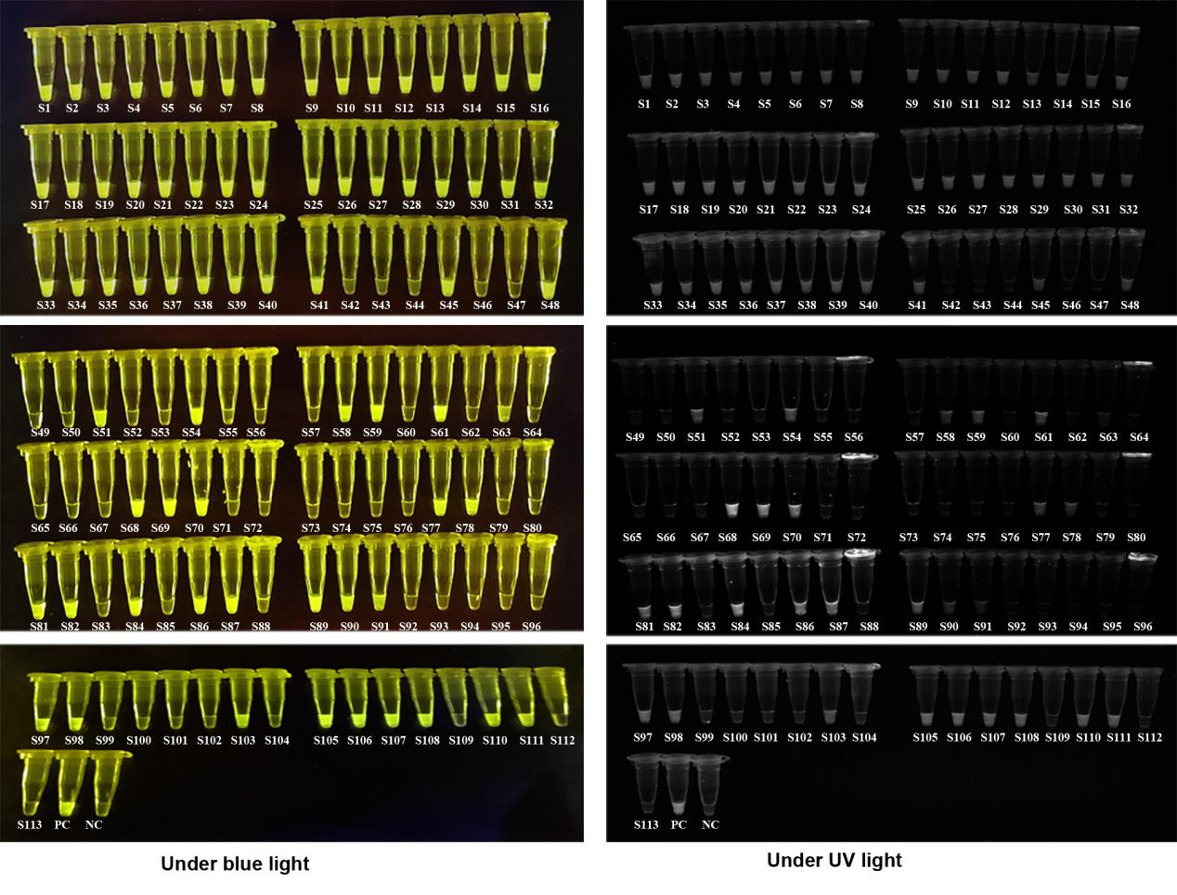

Figure S2. Endpoint visual detection results of 113 clinical samples after 40 min incubation. PC, positive controls. NC, negative control. S1-S113, clinical samples 1-113.

