Additional Figures
Fig. S1. Scatter plots show the stability of the causal effect of immune cells on post-viral fatigue syndrome

Fig. S2. The “leave-one-out” method indicates the stability of the causal effect of immune cells on post-viral fatigue syndrome

Fig. S3. Scatter plots show the stability of the causal effect of post-viral fatigue syndrome on immune cells.

Fig. S4. The “leave-one-out” method indicates the stability of the causal effect of post-viral fatigue syndrome on immune cells.

Fig. S1. Scatter plots show the stability of the causal effect of immune cells on post-viral fatigue syndrome.

Fig. S2. The “leave-one-out” method indicates the stability of the causal effect of immune cells on post-viral fatigue syndrome

Fig. S3. Scatter plots show the stability of the causal effect of post-viral fatigue syndrome on immune cells.
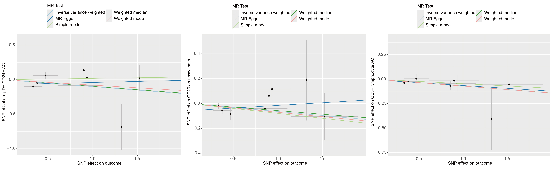
Fig. S4. The “leave-one-out” method indicates the stability of the causal effect of post-viral fatigue syndrome on immune cells.
