Figure legends
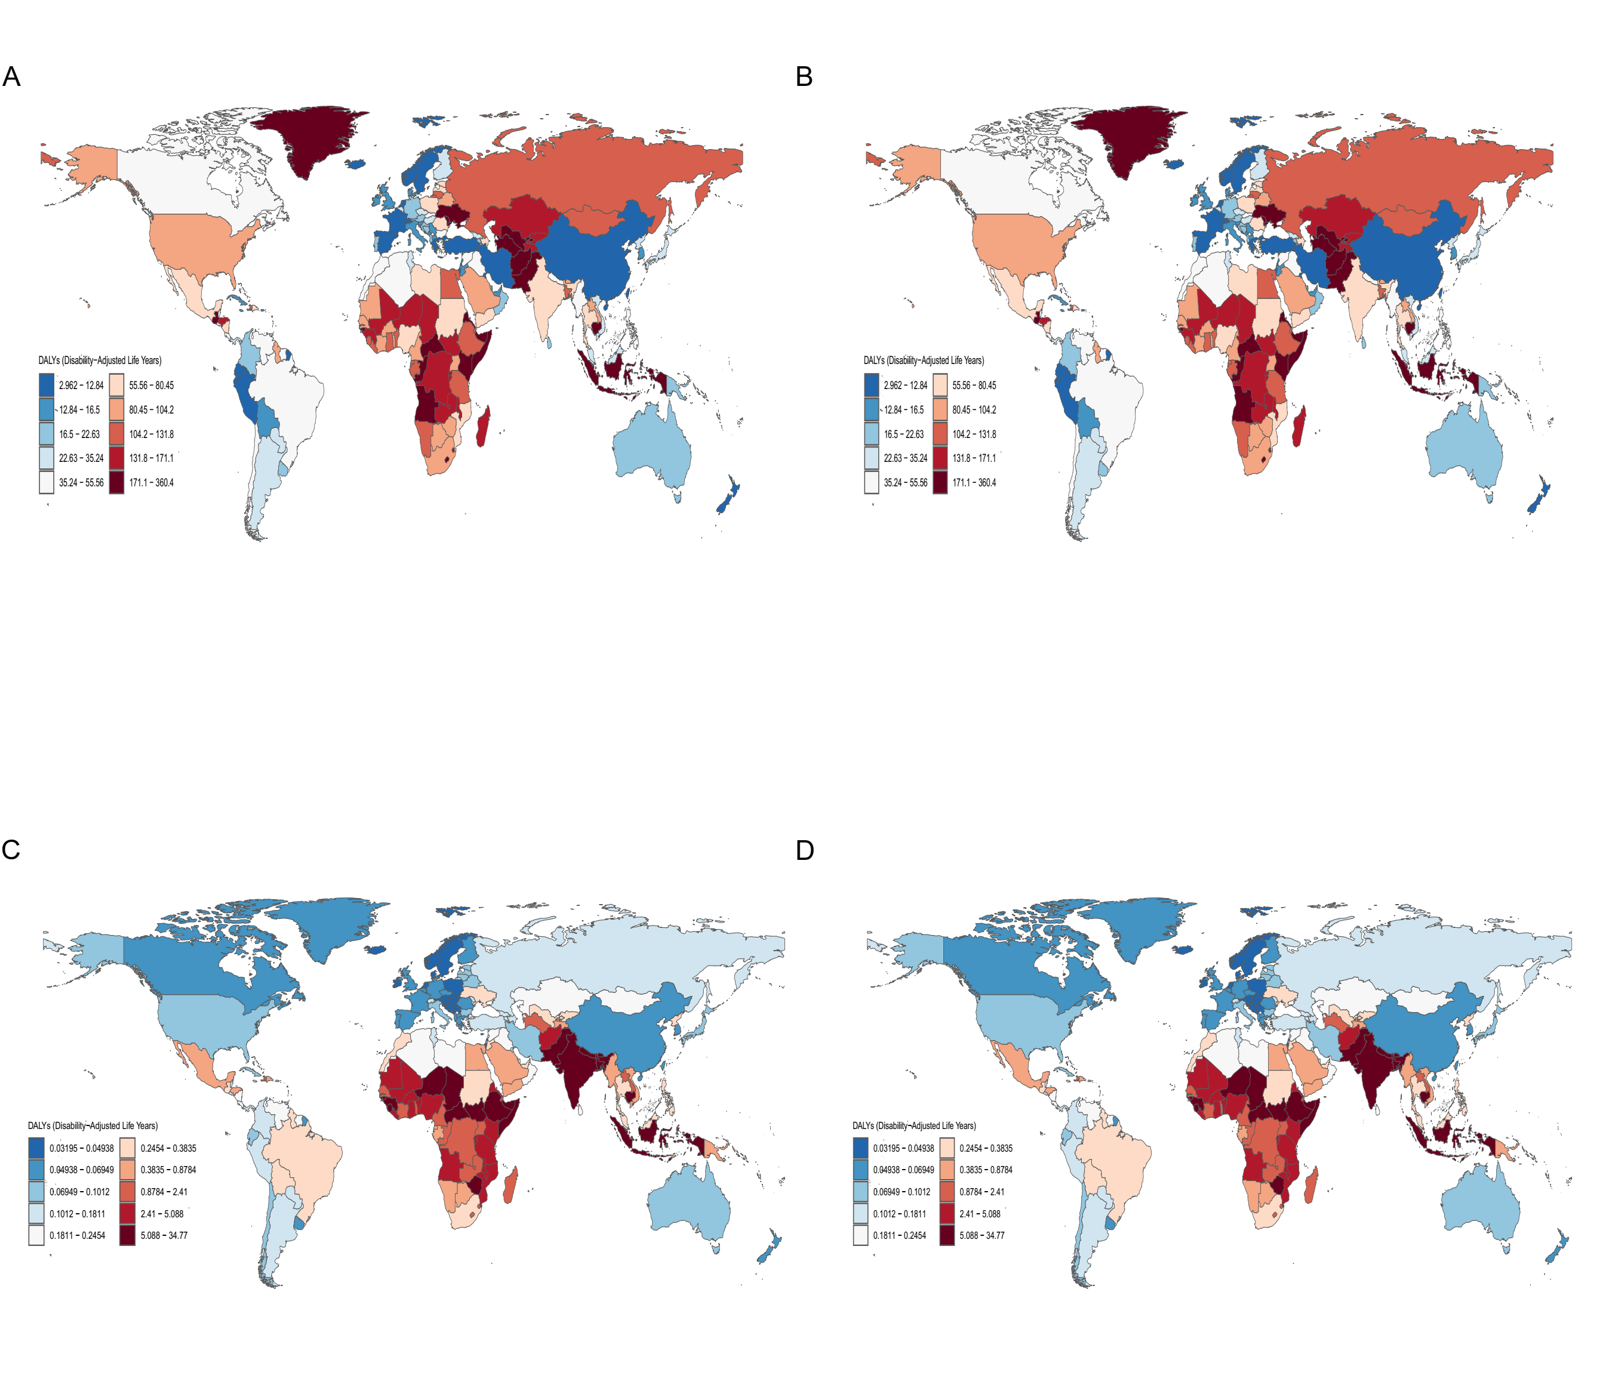 Supplementary Figure 1: Global heat maps illustrating the disease burden of acute and chronic hepatitis C virus (HCV) infection among women aged 15-49 years in 2021A: Age-Standardized DALY Rate (ASDR) for Chronic Hepatitis C in 2021;B: Estimated Annual Percentage Change (EAPC) in Chronic Hepatitis C DALY Rates, 1990–2021;C: Age-Standardized DALY Rate (ASDR) for Acute Hepatitis C in 2021;D: Estimated Annual Percentage Change (EAPC) in Acute Hepatitis C DALY Rates, 1990–2021.

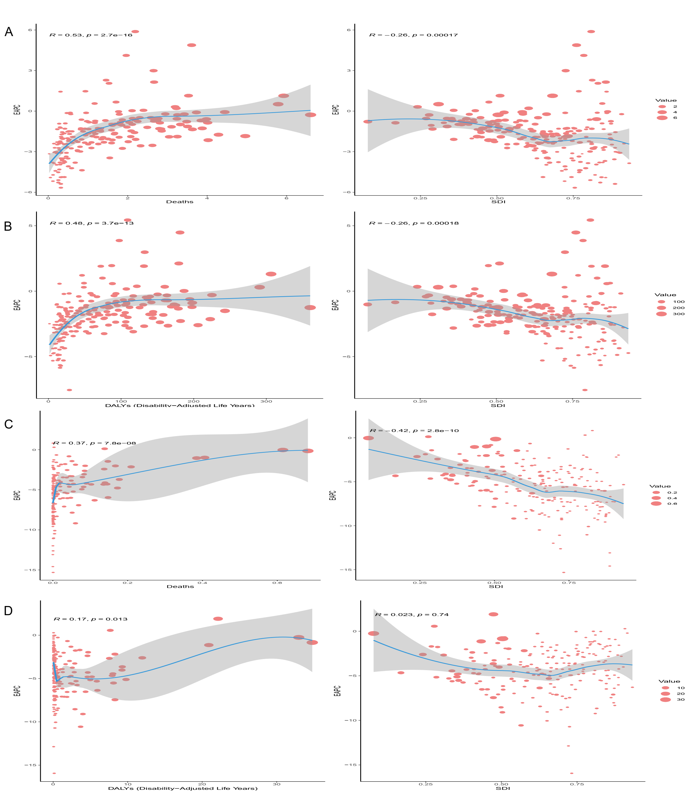

Supplementary Figure 2:
A:Association of EAPC with ASMR and SDI in chronic hepatitis C in 2021
B:Association of EAPC with ASDR and SDI in chronic hepatitis C in 2021
C:Association of EAPC with ASMR and SDI in acute hepatitis C in 2021
D:Association of EAPC with ASDR and SDI in acute hepatitis C in 2021

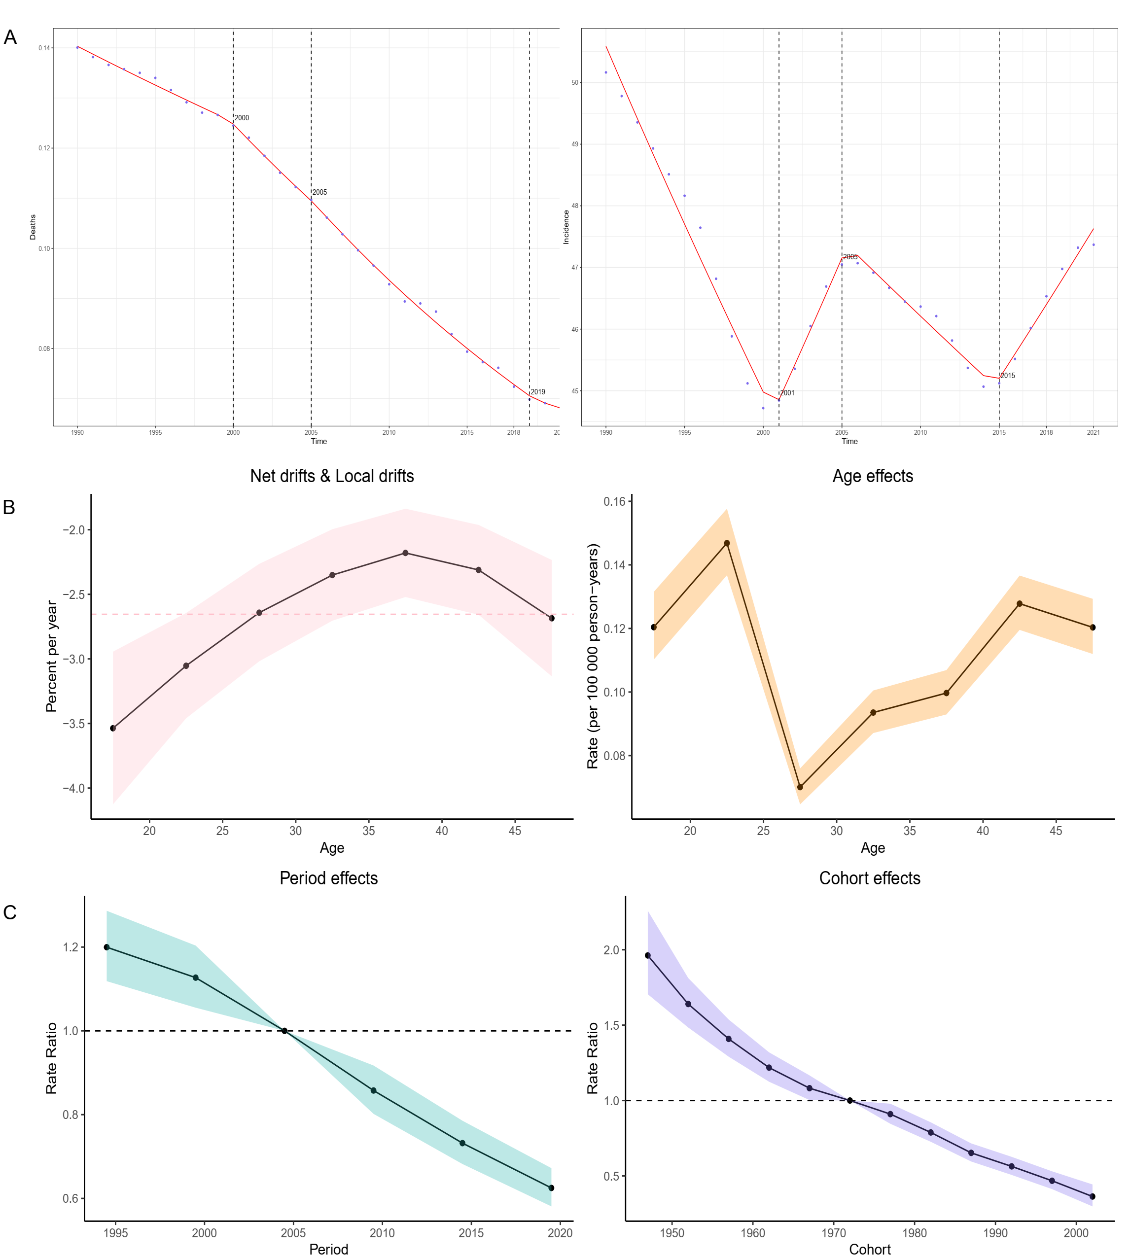
Supplementary Figure 3:A. Trends in Mortality and Incidence (1990-2021)Line plots illustrating the Average Annual Percentage Change (AAPC) for mortality (left panel) and incidence (right panel) of acute hepatitis C among women of reproductive age (15-49 years) from 1990 to 2021. These plots provide a visual representation of the overall temporal trends in disease burden over the three-decade period.B & C. Age-Period-Cohort (APC) Analysis of acute Hepatitis C Temporal Drifts: The top left panel displays net and local drifts, with values greater than zero indicating an increasing trend in the burden of acute hepatitis C. Age Effects: The top right panel examines how different age groups within the reproductive age range contribute to the burden of acute hepatitis C. Period and Cohort Rate Ratios: The bottom panel presents rate ratios for period and cohort effects; values greater than one suggest an increased burden of acute hepatitis C associated with specific periods or birth cohorts.

Supplementary Table 1. Incidence、Prevalence、Death、DALY rate of Chronic hepatitis C among women aged 15-49 years Between 1990 and 2021 at the Global and Regional Level
 | Incidence |  |  |  | Prevalence |  |  |  | Death |  |  |  | DALY rate
 | ASIR-1990 | ASIR-2021 | APC | EAPC | ASIR-1990 | ASIR-2021 | APC | EAPC | ASIR-1990 | ASIR-2021 | APC | EAPC | ASIR-1990 | ASIR-2021 | APC | EAPC
Global | 33.156  (17.656,54.894) | 29.921  (15.986,49.299) | -6.503  (-12.698,-1.214) | -0.273  (-0.360,-0.185) | 2233.253  (1763.064,2753.864) | 1735.267  (1344.929,2164.566) | -20.744  (-23.444,-17.884) | -0.837  (-0.952,-0.722) | 1.905(1.357,2.535) | 1.417(1.014,1.885) | -13.066(-28.966,6.697) | -0.984(-1.115,-0.853) | 97.815(69.392,131.017) | 74.071(52.548,99.315) | -13.674(-29.664,5.765) | -0.931(-1.067,-0.795)
SDI
High SDI | 26.208  (14.467,42.208) | 22.566  (12.384,36.354) | -10.202  (-15.203,-5.491) | -0.528  (-0.702,-0.354) | 1004.940  (781.776,1259.308) | 872.222  (667.595,1103.395) | -10.144  (-13.254,-6.819) | -0.515  (-0.622,-0.408) | 1.116(0.827,1.455) | 0.882(0.667,1.120) | -9.455(-15.805,-2.630) | -0.694(-0.776,-0.613) | 56.035(41.441,73.189) | 44.138(33.219,56.234) | -11.057(-17.116,-4.194) | -0.713(-0.789,-0.636)
High-middle SDI | 24.828  (12.880,41.908) | 19.735  (10.405,33.084) | -16.857  (-26.470,-8.924) | -0.963  (-1.152,-0.774) | 2119.378  (1674.464,2616.403) | 1440.631  (1118.178,1791.311) | -29.351  (-32.293,-26.237) | -1.442  (-1.663,-1.221) | 0.853(0.587,1.171) | 0.702(0.471,1.001) | 12.173(-3.053,29.681) | -0.562(-1.020,-0.101) | 42.549(29.183,58.576) | 35.371(23.623,50.441) | 9.936(-4.924,26.876) | -0.491(-0.944,-0.037)
Middle SDI | 29.116  (15.027,49.293) | 26.184  (13.804,43.516) | -7.093  (-17.980,2.758) | -0.293  (-0.421,-0.164) | 2467.137  (1951.413,3040.950) | 1717.078  (1334.940,2133.947) | -27.877  (-30.859,-24.461) | -1.241  (-1.467,-1.013) | 1.756(1.282,2.306) | 0.989(0.728,1.318) | -26.746(-41.010,-7.974) | -1.966(-2.029,-1.903) | 90.233(65.720,118.766) | 51.180(37.410,68.662) | -28.878(-42.398,-11.368) | -1.946(-2.012,-1.880)
Low-middle SDI | 45.133  (24.374,73.755) | 35.045  (18.547,58.089) | -18.760  (-25.465,-12.595) | -0.558  (-0.803,-0.313) | 2733.472  (2159.796,3363.374) | 2014.877  (1552.298,2516.169) | -24.641  (-27.666,-21.670) | -0.880  (-1.020,-0.740) | 3.603(2.454,4.994) | 2.384(1.641,3.284) | -25.751(-47.163,0.480) | -1.334(-1.523,-1.145) | 186.614(126.391,260.654) | 125.216(85.617,173.650) | -25.909(-47.069,-0.172) | -1.301(-1.497,-1.104)
Low SDI | 56.410  (29.833,93.535) | 49.841  (26.711,81.663) | -11.354  (-15.764,-6.873) | -0.430  (-0.467,-0.392) | 3022.478  (2349.933,3770.008) | 2410.594  (1864.624,3015.041) | -20.383(-22.900,-17.600) | -0.725  (-0.844,-0.605) | 3.279(2.227,4.508) | 2.335(1.568,3.276) | -25.978(-40.433,-8.549) | -1.241(-1.432,-1.050) | 165.896(111.665,229.751) | 120.269(80.228,169.887) | -24.748(-39.334,-6.703) | -1.177(-1.377,-0.976)
Regions
East Asia | 19.023  (9.381,34.078) | 10.840  (4.984,19.848) | -41.747  (-54.281,-29.773) | -2.452  (-2.908,-1.994) | 2608.025  (2076.544,3219.014) | 1362.867  (1050.738,1707.347) | -46.136  (-49.521,-43.055) | -2.586  (-3.113,-2.055) | 0.610(0.398,0.893) | 0.133(0.081,0.207) | -66.134(-76.765,-48.079) | -5.114(-5.260,-4.968) | 30.096(19.589,43.935) | 6.743(4.182,10.502) | -66.621(-76.730,-49.526) | -5.016(-5.159,-4.874)
Southeast Asia | 33.916  (17.268,58.773) | 32.442  (16.679,55.021) | -4.143  (-14.193,5.315) | -0.109  (-0.152,-0.065) | 3341.376  (2657.044,4087.673) | 2617.498  (2062.439,3209.627) | -19.709  (-23.039,-15.998) | -0.822  (-0.900,-0.743) | 4.361(2.833,6.316) | 2.334(1.654,3.248) | -33.608(-53.894,-4.811) | -2.052(-2.114,-1.990) | 226.178(146.813,327.657) | 120.597(84.907,168.693) | -36.216(-55.335,-7.558) | -2.080(-2.154,-2.006)
Oceania | 20.448  (9.923,37.158) | 21.375  (10.429,38.559) | 5.849  (-2.601,15.248) | 0.170  (0.134,0.205) | 2695.799  (2143.965,3304.832) | 2817.509  (2222.656,3490.365) | 5.489  (-3.675,15.061) | -0.011  (-0.100,0.079) | 0.940(0.422,1.752) | 0.558(0.283,0.957) | -32.636(-52.775,-0.045) | -1.815(-2.019,-1.612) | 47.961(21.465,89.737) | 28.608(14.460,49.323) | -33.424(-53.397,-1.935) | -1.809(-2.012,-1.606)
Central Asia | 43.703  (22.664,75.582) | 47.803  (24.291,83.679) | 8.906  (-3.863,21.419) | 0.366  (0.291,0.442) | 5590.480  (4527.935,6755.482) | 6145.910  (4938.906,7491.315) | 11.296  (3.839,18.910) | 0.354  (0.181,0.527) | 2.608(1.497,3.957) | 2.808(1.592,4.336) | 38.757(16.103,65.654) | -0.098(-0.624,0.430) | 132.886(75.660,202.876) | 143.091(80.677,222.100) | 34.176(11.166,61.186) | -0.116(-0.650,0.421)
Central Europe | 16.985  (8.391,29.491) | 13.602  (6.800,23.273) | -16.807  (-23.898,-9.830) | -0.596  (-0.660,-0.533) | 1173.742  (909.479,1461.033) | 858.612  (657.406,1080.860) | -24.292  (-27.630,-21.252) | -0.916  (-0.990,-0.841) | 1.301(0.787,1.977) | 0.997(0.664,1.431) | -4.202(-17.586,13.814) | -1.470(-1.764,-1.175) | 64.651(39.020,98.471) | 49.157(32.644,70.641) | -6.769(-19.644,10.518) | -1.482(-1.764,-1.200)
Eastern Europe | 25.116  (12.721,43.815) | 30.868  (15.906,52.388) | 22.867  (11.726,33.323) | 0.838  (0.623,1.053) | 1884.782  (1450.279,2359.992) | 2268.857  (1757.017,2847.603) | 24.044  (17.694,31.890) | 0.728  (0.435,1.022) | 0.709(0.470,1.014) | 2.526(1.642,3.741) | 357.964(279.935,457.864) | 4.170(2.888,5.468) | 35.073(23.074,50.295) | 126.005(81.541,186.951) | 352.898(276.868,452.688) | 4.232(2.928,5.553)
High-income Asia Pacific | 45.663  (26.075,71.542) | 22.763  (12.460,36.974) | -44.021  (-49.425,-38.396) | -3.523  (-4.444,-2.594) | 959.296  (715.702,1252.529) | 579.726  (421.515,767.795) | -34.908  (-38.331,-31.672) | -2.927  (-3.971,-1.871) | 0.870(0.694,1.100) | 0.416(0.331,0.529) | -40.844(-45.301,-35.057) | -2.248(-2.492,-2.004) | 44.402(35.122,56.392) | 21.482(16.943,27.303) | -41.575(-45.992,-35.940) | -2.203(-2.446,-1.958)
Australasia | 27.554  (14.297,46.570) | 22.993  (11.500,40.236) | -14.173  (-26.578,-0.061) | -0.258  (-0.463,-0.052) | 1360.989  (1049.754,1714.009) | 1063.744  (753.365,1430.621) | -20.708  (-31.183,-9.126) | -0.783  (-0.957,-0.608) | 0.483(0.314,0.656) | 0.396(0.257,0.542) | -7.268(-18.265,4.728) | -0.220(-0.401,-0.038) | 24.364(15.693,33.198) | 19.708(12.712,27.055) | -9.648(-19.786,1.532) | -0.291(-0.463,-0.120)
Western Europe | 25.974  (14.073,42.213) | 19.206  (10.198,31.624) | -21.664  (-27.791,-15.870) | -0.951  (-1.022,-0.880) | 954.970  (733.454,1208.641) | 742.613  (552.538,960.448) | -18.913  (-22.774,-15.213) | -0.682  (-0.762,-0.602) | 0.995(0.623,1.480) | 0.304(0.187,0.463) | -63.789(-67.200,-60.586) | -4.111(-4.304,-3.917) | 49.472(30.973,73.487) | 15.136(9.258,23.072) | -64.257(-67.699,-61.237) | -4.111(-4.297,-3.924)
Southern Latin America | 19.519  (10.335,32.255) | 16.129  (8.646,26.309) | -13.335  (-24.838,-2.508) | -0.202  (-0.405,0.001) | 666.259  (503.708,858.077) | 548.275  (413.864,703.778) | -14.752  (-21.563,-8.320) | -0.321  (-0.470,-0.173) | 1.756(1.099,2.409) | 0.595(0.372,0.834) | -61.676(-65.713,-56.930) | -2.702(-3.191,-2.209) | 86.828(54.092,119.689) | 29.634(18.394,41.737) | -61.761(-65.594,-57.247) | -2.684(-3.177,-2.189)
High-income North America | 19.508  (10.271,32.123) | 20.641  (11.263,33.606) | 7.066  (-1.544,16.755) | 0.337  (0.121,0.554) | 766.084  (578.905,982.197) | 749.573  (564.398,963.987) | -0.901  (-4.127,2.536) | -0.013  (-0.139,0.114) | 1.501(1.192,1.813) | 1.687(1.315,2.084) | 19.587(11.917,26.921) | 0.623(0.466,0.780) | 75.640(59.670,91.620) | 83.989(65.081,104.161) | 16.636(9.278,23.707) | 0.572(0.431,0.715)
Caribbean | 40.335  (20.820,68.514) | 36.862  (19.192,62.973) | -3.949  (-11.717,4.523) | -0.312  (-0.387,-0.237) | 2121.037  (1648.076,2669.987) | 1895.363  (1468.225,2368.616) | -7.522  (-11.952,-3.185) | -0.384  (-0.425,-0.344) | 1.620(0.882,2.603) | 1.115(0.557,1.910) | -17.711(-39.849,6.588) | -1.337(-1.607,-1.066) | 82.411(44.613,132.735) | 56.957(28.296,97.968) | -19.118(-41.094,5.381) | -1.294(-1.565,-1.024)
Andean Latin America | 25.119  (12.937,42.609) | 21.133  (11.056,35.590) | -11.553  (-21.540,-3.013) | -0.504  (-0.631,-0.376) | 1163.587  (886.210,1477.193) | 981.366  (746.840,1249.451) | -11.664  (-16.494,-7.178) | -0.507  (-0.629,-0.384) | 0.594(0.267,1.112) | 0.214(0.093,0.415) | -55.157(-67.422,-37.777) | -3.506(-3.734,-3.278) | 29.722(13.288,55.677) | 10.663(4.616,20.822) | -56.091(-67.681,-39.422) | -3.503(-3.728,-3.278)
Central Latin America | 41.377  (21.750,68.566) | 36.952  (19.776,60.812) | -8.615  (-18.384,0.986) | 0.127  (-0.121,0.375) | 2233.952  (1734.215,2796.124) | 1749.585  (1341.532,2223.322) | -17.913  (-21.550,-13.611) | -0.443  (-0.639,-0.247) | 2.781(2.240,3.304) | 1.359(1.002,1.778) | -35.486(-46.241,-25.067) | -2.642(-2.867,-2.417) | 139.286(111.690,166.410) | 67.953(49.840,89.260) | -37.342(-47.734,-27.378) | -2.647(-2.874,-2.420)
Tropical Latin America | 55.034  (28.605,92.377) | 48.379  (25.889,79.911) | -7.437  (-15.633,0.922) | 0.286  (-0.152,0.726) | 2619.851  (1989.237,3337.779) | 2226.746  (1672.085,2861.019) | -10.055  (-14.046,-5.184) | -0.069  (-0.406,0.269) | 1.806(1.530,2.121) | 0.738(0.607,0.885) | -48.899(-52.862,-44.461) | -2.989(-3.146,-2.831) | 94.286(79.434,110.910) | 37.981(31.082,45.679) | -51.127(-54.957,-46.781) | -3.043(-3.190,-2.896)
North Africa and Middle East | 101.204  (58.692,158.924) | 66.805  (37.846,105.351) | -24.427  (-33.729,-15.505) | -1.097  (-1.259,-0.935) | 3064.614  (2402.351,3825.451) | 1999.283  (1486.608,2578.409) | -28.142  (-32.507,-23.496) | -1.402  (-1.493,-1.311) | 2.431(1.599,3.353) | 1.079(0.644,1.580) | -43.520(-57.744,-22.674) | -2.438(-2.516,-2.360) | 122.175(79.641,169.557) | 55.006(32.675,81.070) | -44.251(-57.831,-23.953) | -2.403(-2.474,-2.331)
South Asia | 20.464  (10.051,36.061) | 17.127  (8.364,29.989) | -14.500  (-19.929,-9.137) | -0.310  (-0.638,0.020) | 1678.961  (1311.722,2097.722) | 1248.494  (956.018,1569.762) | -24.612  (-28.093,-21.336) | -0.660  (-0.935,-0.384) | 2.904(1.969,4.133) | 2.090(1.337,3.045) | -20.153(-49.130,14.378) | -1.142(-1.397,-0.886) | 152.003(102.366,217.627) | 111.823(71.170,163.432) | -19.687(-47.954,14.219) | -1.078(-1.349,-0.806)
Central Sub-Saharan Africa | 105.242  (56.317,171.949) | 93.507  (50.934,150.801) | -9.560  (-19.032,2.345) | -0.491  (-0.547,-0.435) | 4661.858  (3615.330,5830.028) | 3731.079  (2892.038,4658.280) | -19.722  (-25.735,-13.634) | -0.763  (-0.870,-0.657) | 4.029(2.260,6.407) | 3.165(1.681,5.261) | -17.476(-42.623,18.972) | -0.677(-0.757,-0.596) | 203.932(113.877,326.011) | 161.661(85.164,271.288) | -17.156(-43.005,20.508) | -0.644(-0.725,-0.563)
Eastern Sub-Saharan Africa | 70.448  (37.912,115.925) | 57.241  (31.035,92.799) | -17.242  (-21.179,-12.640) | -0.746  (-0.804,-0.687) | 2779.148  (2130.966,3519.671) | 2225.743  (1703.023,2819.832) | -19.063  (-21.855,-16.347) | -0.762  (-0.824,-0.699) | 3.789(2.427,5.430) | 2.645(1.749,3.749) | -24.841(-44.189,4.741) | -1.401(-1.511,-1.291) | 188.415(119.885,271.048) | 133.402(87.525,190.463) | -24.111(-43.683,6.324) | -1.357(-1.466,-1.249)
Southern Sub-Saharan Africa | 38.678  (20.372,64.220) | 39.660  (21.014,65.311) | 8.190  (-1.679,17.751) | 0.092  (-0.030,0.213) | 1663.887  (1265.753,2118.835) | 1693.360  (1288.932,2159.124) | 6.612  (1.561,12.073) | 0.031  (-0.119,0.181) | 2.652(1.789,3.753) | 1.737(1.143,2.531) | -22.799(-45.743,5.168) | -0.615(-1.471,0.249) | 138.591(93.076,196.840) | 87.344(56.749,128.533) | -27.006(-48.614,-0.046) | -0.784(-1.689,0.130)
Western Sub-Saharan Africa | 63.363  (32.472,108.651) | 53.983  (28.280,90.823) | -14.897  (-18.957,-10.125) | -0.598  (-0.675,-0.522) | 4622.209  (3608.187,5727.931) | 3245.222  (2515.561,4064.957) | -29.876  (-32.226,-27.389) | -1.227  (-1.383,-1.072) | 2.866(1.629,4.563) | 1.939(1.116,3.100) | -28.138(-47.004,-6.156) | -1.092(-1.164,-1.019) | 144.128(81.548,230.695) | 98.148(56.100,157.796) | -28.107(-47.191,-6.382) | -1.071(-1.143,-1.000)

Supplementary Table 2. Incidence、Prevalence、Death、DALY rate of Acute hepatitis C among women aged 15-49 years Between 1990 and 2021 at the Global and Regional Level.
 | Incidence |  |  |  | Prevalence |  |  |  | Death |  |  |  | DALY rate
 | ASIR-1990 | ASIR-2021 | APC | EAPC | ASIR-1990 | ASIR-2021 | APC | EAPC | ASIR-1990 | ASIR-2021 | APC | EAPC | ASIR-1990 | ASIR-2021 | APC | EAPC
Global | 5.466(2.962,8.865) | -2.074(-8.883,4.449) | -0.164(-0.268,-0.061) | 0.140(0.023,0.254) | 0.068(0.022,0.132) | -48.282(-66.776,22.831) | -2.478(-2.629,-2.327) | 7.891(1.376,14.251) | 3.857(1.294,7.467) | -49.796(-67.224,14.892) | -2.477(-2.655,-2.299) | 5.466(2.962,8.865) | -2.074(-8.883,4.449) | -0.164(-0.268,-0.061) | 0.140(0.023,0.254) | 0.068(0.022,0.132)
SDI
High SDI | 4.078(2.256,6.436) | -6.948(-12.327,-1.675) | -0.426(-0.611,-0.241) | 0.007(0.005,0.010) | 0.001(0.000,0.001) | -89.980(-93.619,-80.431) | -10.014(-11.338,-8.670) | 0.418(0.279,0.626) | 0.087(0.050,0.154) | -77.734(-86.667,-64.992) | -6.594(-7.514,-5.666) | 4.078(2.256,6.436) | -6.948(-12.327,-1.675) | -0.426(-0.611,-0.241) | 0.007(0.005,0.010) | 0.001(0.000,0.001)
High-middle SDI | 3.511(1.855,5.768) | -15.292(-25.378,-7.190) | -0.934(-1.136,-0.731) | 0.032(0.014,0.054) | 0.005(0.002,0.009) | -84.558(-93.212,-51.808) | -6.490(-6.652,-6.329) | 1.840(0.844,3.060) | 0.311(0.161,0.587) | -82.749(-91.663,-51.541) | -5.993(-6.144,-5.842) | 3.511(1.855,5.768) | -15.292(-25.378,-7.190) | -0.934(-1.136,-0.731) | 0.032(0.014,0.054) | 0.005(0.002,0.009)
Middle SDI | 4.617(2.451,7.590) | -6.163(-17.337,3.890) | -0.277(-0.410,-0.144) | 0.086(0.024,0.149) | 0.027(0.012,0.048) | -66.420(-79.902,26.912) | -3.814(-3.920,-3.708) | 4.945(1.421,8.519) | 1.589(0.772,2.794) | -67.205(-80.077,20.624) | -3.702(-3.798,-3.606) | 4.617(2.451,7.590) | -6.163(-17.337,3.890) | -0.277(-0.410,-0.144) | 0.086(0.024,0.149) | 0.027(0.012,0.048)
Low-middle SDI | 6.914(3.809,11.201) | -8.622(-16.310,-0.625) | -0.257(-0.439,-0.075) | 0.349(0.037,0.648) | 0.159(0.040,0.335) | -51.850(-72.181,38.680) | -2.500(-2.732,-2.268) | 19.099(2.206,35.220) | 8.625(2.269,18.281) | -53.626(-73.090,28.651) | -2.557(-2.813,-2.301) | 6.914(3.809,11.201) | -8.622(-16.310,-0.625) | -0.257(-0.439,-0.075) | 0.349(0.037,0.648) | 0.159(0.040,0.335)
Low SDI | 8.777(4.772,14.258) | -10.572(-14.900,-5.850) | -0.416(-0.452,-0.380) | 0.444(0.022,1.147) | 0.157(0.022,0.328) | -65.202(-77.271,-8.429) | -3.808(-4.113,-3.503) | 24.647(1.425,64.155) | 8.638(1.330,17.999) | -65.709(-77.752,-12.054) | -3.836(-4.148,-3.523) | 8.777(4.772,14.258) | -10.572(-14.900,-5.850) | -0.416(-0.452,-0.380) | 0.444(0.022,1.147) | 0.157(0.022,0.328)
Regions
East Asia | 1.952(0.911,3.527) | -39.941(-52.992,-27.401) | -2.410(-2.884,-1.933) | 0.040(0.010,0.082) | 0.001(0.000,0.001) | -97.620(-99.005,-85.901) | -13.949(-14.703,-13.188) | 2.220(0.598,4.443) | 0.069(0.041,0.120) | -96.486(-98.525,-83.091) | -12.591(-13.415,-11.759) | 1.952(0.911,3.527) | -39.941(-52.992,-27.401) | -2.410(-2.884,-1.933) | 0.040(0.010,0.082) | 0.001(0.000,0.001)
Southeast Asia | 5.667(2.922,9.459) | -4.093(-14.236,5.396) | -0.108(-0.151,-0.064) | 0.244(0.071,0.550) | 0.050(0.023,0.092) | -78.608(-89.129,-14.601) | -5.539(-5.819,-5.259) | 14.236(4.241,31.840) | 2.884(1.373,5.231) | -79.782(-89.904,-22.508) | -5.611(-5.902,-5.318) | 5.667(2.922,9.459) | -4.093(-14.236,5.396) | -0.108(-0.151,-0.064) | 0.244(0.071,0.550) | 0.050(0.023,0.092)
Oceania | 3.732(1.830,6.822) | 5.858(-2.957,15.230) | 0.170(0.135,0.206) | 0.077(0.008,0.238) | 0.014(0.002,0.047) | -80.398(-90.307,-61.138) | -5.912(-6.092,-5.731) | 4.217(0.468,12.669) | 0.817(0.134,2.602) | -79.203(-89.562,-57.734) | -5.658(-5.839,-5.476) | 3.732(1.830,6.822) | 5.858(-2.957,15.230) | 0.170(0.135,0.206) | 0.077(0.008,0.238) | 0.014(0.002,0.047)
Central Asia | 8.532(4.398,14.893) | 11.320(-1.550,24.475) | 0.404(0.343,0.465) | 0.074(0.049,0.105) | 0.005(0.003,0.008) | -93.230(-95.921,-88.821) | -9.185(-9.550,-8.818) | 4.327(2.942,6.079) | 0.394(0.250,0.617) | -90.948(-94.380,-85.050) | -8.095(-8.519,-7.670) | 8.532(4.398,14.893) | 11.320(-1.550,24.475) | 0.404(0.343,0.465) | 0.074(0.049,0.105) | 0.005(0.003,0.008)
Central Europe | 2.503(1.266,4.248) | -12.357(-19.671,-4.487) | -0.510(-0.558,-0.462) | 0.002(0.001,0.002) | 0.000(0.000,0.000) | -81.093(-86.999,-71.041) | -4.762(-5.340,-4.180) | 0.125(0.079,0.190) | 0.050(0.027,0.094) | -58.663(-72.497,-42.564) | -2.546(-2.825,-2.266) | 2.503(1.266,4.248) | -12.357(-19.671,-4.487) | -0.510(-0.558,-0.462) | 0.002(0.001,0.002) | 0.000(0.000,0.000)
Eastern Europe | 5.484(2.843,9.132) | 24.984(13.078,36.089) | 0.864(0.658,1.071) | 0.011(0.007,0.017) | 0.001(0.001,0.003) | -84.662(-91.066,-72.090) | -5.920(-7.787,-4.016) | 0.649(0.411,0.973) | 0.154(0.087,0.274) | -74.912(-84.819,-59.371) | -4.313(-5.762,-2.842) | 5.484(2.843,9.132) | 24.984(13.078,36.089) | 0.864(0.658,1.071) | 0.011(0.007,0.017) | 0.001(0.001,0.003)
High-income Asia Pacific | 4.275(2.400,6.742) | -39.715(-45.160,-33.634) | -3.200(-4.089,-2.302) | 0.005(0.003,0.009) | 0.000(0.000,0.000) | -96.272(-97.671,-93.987) | -13.623(-15.390,-11.820) | 0.363(0.227,0.594) | 0.068(0.032,0.138) | -78.883(-88.233,-68.013) | -7.486(-8.751,-6.202) | 4.275(2.400,6.742) | -39.715(-45.160,-33.634) | -3.200(-4.089,-2.302) | 0.005(0.003,0.009) | 0.000(0.000,0.000)
Australasia | 4.958(2.584,8.364) | 7.380(-6.288,24.220) | 0.377(0.250,0.504) | 0.003(0.002,0.005) | 0.000(0.000,0.001) | -84.859(-90.893,-74.363) | -6.736(-8.376,-5.067) | 0.226(0.139,0.339) | 0.089(0.043,0.174) | -57.891(-73.138,-40.005) | -3.160(-3.982,-2.331) | 4.958(2.584,8.364) | 7.380(-6.288,24.220) | 0.377(0.250,0.504) | 0.003(0.002,0.005) | 0.000(0.000,0.001)
Western Europe | 3.456(1.838,5.608) | -19.308(-25.755,-13.373) | -0.891(-0.951,-0.831) | 0.002(0.001,0.003) | 0.000(0.000,0.000) | -87.687(-90.733,-81.702) | -8.495(-9.647,-7.328) | 0.168(0.111,0.250) | 0.059(0.029,0.117) | -62.386(-74.664,-48.062) | -4.019(-4.483,-3.554) | 3.456(1.838,5.608) | -19.308(-25.755,-13.373) | -0.891(-0.951,-0.831) | 0.002(0.001,0.003) | 0.000(0.000,0.000)
Southern Latin America | 2.862(1.569,4.607) | -11.942(-23.937,-0.774) | -0.175(-0.381,0.031) | 0.006(0.002,0.013) | 0.001(0.001,0.002) | -74.608(-86.678,-51.783) | -4.026(-4.267,-3.785) | 0.358(0.167,0.728) | 0.115(0.068,0.188) | -66.110(-81.476,-40.747) | -3.092(-3.315,-2.868) | 2.862(1.569,4.607) | -11.942(-23.937,-0.774) | -0.175(-0.381,0.031) | 0.006(0.002,0.013) | 0.001(0.001,0.002)
High-income North America | 3.663(2.011,5.869) | 8.840(0.037,19.039) | 0.366(0.157,0.576) | 0.006(0.005,0.008) | 0.001(0.001,0.001) | -88.401(-91.247,-84.779) | -11.230(-13.685,-8.705) | 0.351(0.264,0.463) | 0.083(0.050,0.142) | -75.805(-83.950,-64.600) | -7.386(-9.057,-5.684) | 3.663(2.011,5.869) | 8.840(0.037,19.039) | 0.366(0.157,0.576) | 0.006(0.005,0.008) | 0.001(0.001,0.001)
Caribbean | 6.436(3.366,10.748) | -3.952(-11.445,4.521) | -0.312(-0.387,-0.237) | 0.011(0.004,0.022) | 0.007(0.003,0.017) | -23.440(-56.253,34.264) | -1.270(-1.435,-1.104) | 0.663(0.296,1.303) | 0.483(0.219,1.004) | -20.921(-50.109,24.193) | -1.004(-1.139,-0.869) | 6.436(3.366,10.748) | -3.952(-11.445,4.521) | -0.312(-0.387,-0.237) | 0.011(0.004,0.022) | 0.007(0.003,0.017)
Andean Latin America | 3.691(1.938,6.160) | -11.534(-21.522,-2.677) | -0.504(-0.631,-0.376) | 0.012(0.006,0.021) | 0.002(0.001,0.004) | -77.233(-87.235,-55.578) | -5.676(-5.923,-5.427) | 0.696(0.359,1.196) | 0.179(0.098,0.301) | -72.230(-82.586,-51.972) | -4.837(-5.049,-4.624) | 3.691(1.938,6.160) | -11.534(-21.522,-2.677) | -0.504(-0.631,-0.376) | 0.012(0.006,0.021) | 0.002(0.001,0.004)
Central Latin America | 6.487(3.452,10.496) | -8.125(-18.072,1.272) | 0.134(-0.114,0.383) | 0.014(0.010,0.020) | 0.004(0.003,0.006) | -63.780(-75.081,-43.207) | -4.609(-5.473,-3.736) | 0.862(0.599,1.162) | 0.319(0.231,0.452) | -58.439(-70.525,-38.039) | -3.678(-4.344,-3.007) | 6.487(3.452,10.496) | -8.125(-18.072,1.272) | 0.134(-0.114,0.383) | 0.014(0.010,0.020) | 0.004(0.003,0.006)
Tropical Latin America | 8.714(4.710,14.128) | -4.498(-13.243,4.511) | 0.346(-0.077,0.771) | 0.008(0.006,0.012) | 0.002(0.002,0.003) | -65.606(-77.822,-54.675) | -3.626(-4.251,-2.997) | 0.564(0.394,0.802) | 0.253(0.168,0.405) | -51.235(-67.294,-37.347) | -2.185(-2.639,-1.729) | 8.714(4.710,14.128) | -4.498(-13.243,4.511) | 0.346(-0.077,0.771) | 0.008(0.006,0.012) | 0.002(0.002,0.003)
North Africa and Middle East | 13.669(8.091,20.897) | -11.335(-22.313,-0.138) | -0.681(-0.853,-0.508) | 0.036(0.005,0.165) | 0.004(0.001,0.017) | -88.032(-93.223,-53.692) | -7.611(-7.923,-7.298) | 2.111(0.495,8.788) | 0.382(0.172,1.107) | -79.405(-88.204,-35.457) | -5.725(-6.040,-5.409) | 13.669(8.091,20.897) | -11.335(-22.313,-0.138) | -0.681(-0.853,-0.508) | 0.036(0.005,0.165) | 0.004(0.001,0.017)
South Asia | 3.125(1.560,5.415) | -10.641(-16.179,-5.022) | -0.238(-0.553,0.077) | 0.380(0.017,0.753) | 0.214(0.043,0.453) | -40.015(-66.606,258.056) | -1.803(-2.098,-1.507) | 20.582(1.002,40.945) | 11.616(2.402,24.882) | -41.499(-66.939,230.267) | -1.807(-2.138,-1.475) | 3.125(1.560,5.415) | -10.641(-16.179,-5.022) | -0.238(-0.553,0.077) | 0.380(0.017,0.753) | 0.214(0.043,0.453)
Central Sub-Saharan Africa | 16.320(9.025,26.139) | -9.553(-19.093,2.453) | -0.491(-0.546,-0.435) | 0.137(0.012,0.756) | 0.034(0.007,0.112) | -75.161(-89.790,-15.152) | -4.399(-4.820,-3.976) | 7.632(0.898,41.033) | 2.028(0.560,6.249) | -73.269(-89.434,-13.731) | -4.165(-4.566,-3.762) | 16.320(9.025,26.139) | -9.553(-19.093,2.453) | -0.491(-0.546,-0.435) | 0.137(0.012,0.756) | 0.034(0.007,0.112)
Eastern Sub-Saharan Africa | 10.059(5.487,16.014) | -16.699(-20.703,-11.986) | -0.737(-0.798,-0.676) | 0.328(0.014,0.789) | 0.107(0.016,0.236) | -66.290(-81.176,21.950) | -4.191(-4.458,-3.923) | 17.785(0.947,42.710) | 5.930(0.996,12.967) | -65.878(-80.472,12.956) | -4.121(-4.386,-3.855) | 10.059(5.487,16.014) | -16.699(-20.703,-11.986) | -0.737(-0.798,-0.676) | 0.328(0.014,0.789) | 0.107(0.016,0.236)
Southern Sub-Saharan Africa | 6.929(3.691,11.341) | 8.256(-1.661,17.803) | 0.093(-0.028,0.214) | 0.098(0.019,0.255) | 0.076(0.019,0.193) | -16.253(-59.067,88.485) | 1.350(0.093,2.622) | 5.493(1.165,14.200) | 4.320(1.118,10.854) | -18.556(-59.833,79.364) | 1.366(0.129,2.619) | 6.929(3.691,11.341) | 8.256(-1.661,17.803) | 0.093(-0.028,0.214) | 0.098(0.019,0.255) | 0.076(0.019,0.193)
Western Sub-Saharan Africa | 9.425(4.949,15.919) | -14.890(-19.127,-10.015) | -0.598(-0.674,-0.522) | 0.691(0.132,2.147) | 0.071(0.029,0.159) | -89.649(-94.041,-72.243) | -7.886(-8.293,-7.478) | 39.492(7.717,122.048) | 4.165(1.739,9.254) | -89.477(-93.986,-71.894) | -7.833(-8.241,-7.424) | 9.425(4.949,15.919) | -14.890(-19.127,-10.015) | -0.598(-0.674,-0.522) | 0.691(0.132,2.147) | 0.071(0.029,0.159)

Supplementary Table 3: Top 20 countries or regions ranked by highest age-standardized mortality rate (ASMR) for chronic HCV in 2021, including ASIR, ASPR, ASMR, DALY rates, and EAPC values from 1990 to 2021.
Country | Incidence |  | Prevalence |  | Death |  | DALYs
 | ASIR-2021 | EAPC | ASPR-2021 | EAPC | ASMR-2021 | EAPC | ASDR-2021 | EAPC
Pakistan | 27.23（13.10，49.05） | -0.14（-0.2，-0.06） | 2888.47（2143.08，3689.71） | -0.162（-0.238，-0.088） | 6.6（3.89,10.38） | -0.19（-0.59，0.62） | 360.36（211.72，568.35） | -0.18（-0.59,0.62）
Turkmenistan | 50.22（25.26，89.72） | 0.09（-0.04,0.27） | 6896.14（5519.64，8446.69） | 0.019（-0.101,0.139） | 5.93（3.07,9.67） | 0.97（0.44，1.66） | 306.54（157.67，501.11） | 0.89（0.39,1.55）
Central African Republic | 92.43（50.23，148.95） | -0.03（-0.15,0.13） | 3452.75（2663.01，4352.09） | -0.099（-0.174，-0.005） | 5.79（2.78,10.23） | 0.14（-0.31,0.91） | 290.82（139.35，517.41） | 0.13（-0.3,0.89）
Moldova | 36.79（17.55，66.04） | - | 2517.34（1957.34，3144.33） | - | 4.96（2.68,8.05） | -0.19（-0.33，-0.05） | 243.11（131.05，394.85） | -
Congo | 92.47（49.92，151.85） | -0.03（-0.17,0.15） | 3337.32（2567.38，4264.59） | -0.153（-0.229，-0.074） | 4.44（1.76,8.72） | 0.11（-0.36,0.94） | 225.13（89.56，442.02） | 0.09（-0.37,0.89）
Indonesia | 38.51（19.71，65.49） | 0.01（-0.11,0.13） | 2767.58（2158.09，3428.47） | -0.199（-0.243，-0.157） | 4.28（2.95,6.20） | -0.35（-0.57,0.01） | 222.8（152.98，324.25） | -0.38（-0.58，-0.03）
Cambodia | 38.67（18.49，70.61） | -0.01（-0.15,0.17） | 4868.07（3835.25，5982.81） | -0.285（-0.364，-0.192） | 4.02（1.84,7.20） | -0.43（-0.69，-0.06） | 205.98（94.01，369.99） | -0.44（-0.69，-0.09）
Eritrea | 64.74（34.62，106.01） | -0.08（-0.2,0.08） | 2235.11（1703.76，2853.56） | -0.171（-0.246，-0.09） | 4.01（1.9,7.15） | -0.18（-0.52,0.37） | 198.51（93.99，354.93） | -0.17（-0.52,0.39）
Greenland | 26.99（14.47，43.59） | -0.08（-0.23,0.08） | 857.45（653.54，1100.13） | -0.068（-0.149,0.021） | 3.98（2.19,6.51） | -0.17（-0.49,0.23） | 197.49（108.39，324.26） | -0.18（-0.49,0.21）
Angola | 97.43（53.58，160.14） | -0.17（-0.28,0.02） | 3732.43（2877.71，4693.42） | -0.285（-0.354，-0.219） | 3.88（1.93,6.78） | -0.33（-0.58,0.04） | 197.67（97.91，347.64） | -0.32（-0.58,0.05）
Guinea-Bissau | 49.84（26.60，82.18） | -0.11（-0.24,0.04） | 2318.37（1774.59，2911.02） | -0.255（-0.326，-0.177） | 3.85（1.57,7.07） | -0.19（-0.49,0.26） | 194.62（79.35，359.07） | -0.19（-0.47,0.27）
Kenya | 56.59（29.91，93.96） | -0.01（-0.068,0.071） | 2300.53（1746.32，2952.38） | -0.063（-0.102，-0.022） | 3.73（1.99,6.66） | 0.09（-0.28,0.72） | 186.76（99.23，334.36） | 0.09（-0.28,0.69）
Guatemala | 54.28（27.05，92.69） | -0.15（-0.28,0.03） | 2836.26（2174.04，3543.53） | -0.313（-0.399,-0.202） | 3.63（2.29,5.12） | -0.39（-0.52，-0.25） | 181.9（114.11，257.29） | -0.41（-0.53，-0.27）
Ukraine | 34.09（17.42，58.61） | 0.24（0.11,0.39） | 2650.54（2040.62，3328.87） | 0.397（0.273,0.527） | 3.61（1.83,6.3） | 4.06（1.81,6.85） | 181.16（91.48，315.29） | 4.08（1.82,6.84）
Lesotho | 50.82（25.60，85.86） | 0.12（-0.04,0.3） | 2108.36（1605.48，2695.80） | 0.0393（-0.071,0.144） | 3.53（1.41,6.94） | 0.23（-0.52,2.44） | 179.48（71.75，353.8） | 0.25（-0.5,2.45）
Afghanistan | 98.07（55.06，157.62） | -0.04（-0.17,0.13） | 2957.46（2261.09，3774.09） | -0.164（-0.237，-0.091） | 3.51（1.02,7.70） | -0.34（-0.65,0.09） | 178.93（52.62，389.69） | -0.32（-0.63,0.13）
Somalia | 70.22（36.69，118.51） | -0.12（-0.22,0.03） | 2945.29（2249.76，3741.38） | -0.101（-0.179，-0.0016） | 3.48（1.44,6.74） | -0.25（-0.59,0.25） | 172.99（71.22，335.28） | -0.24（-0.59,0.25）
Uzbekistan | 53.23（26.42，95.91） | 0.098（-0.09，0.34） | 6953.59（5561.34，8479.67） | 0.133（-0.0086,0.298） | 3.43（1.89,5.39） | 0.25（-0.02,0.65） | 175.53（96.67，277.26） | 0.21（-0.06,0.59）
Malawi | 55.84（29.91，93.20） | -0.195（-0.309，-0.056） | 2111.01（1614.59，2669.23） | -0.265（-0.333，-0.196） | 3.33（1.61,5.84） | -0.27（-0.54,0.15） | 169.13（80.7，299.1） | -0.26（-0.54,0.18）
South Sudan | 57.10（30.61，95.25） | -0.053（-0.172,0.078） | 2258.57（1725.59，2882.87） | -0.09（-0.172，-0.0018） | 3.25（1.47,6.17） | 0.11（-0.35,0.94） | 163.15（73.52，310.96） | 0.09（-0.34,0.88）

Supplementary Table 4: Top 20 countries or regions ranked by highest age-standardized mortality rate (ASMR) for acute HCV in 2021, including ASIR, ASPR, ASMR, DALY rates, and EAPC values from 1990 to 2021.
Country | Incidence |  | Prevalence |  | Death |  | DALYs
 | ASIR-2021 | EAPC | ASPR-2021 | EAPC | ASMR-2021 | EAPC | ASDR-2021 | EAPC
Pakistan | 48.1091（23.3138，86.1320） | 0.0046（-0.0702，0.0899） | 5.551（2.69，9.9383） | 0.00459（-0.07019，0.0899） | 0.682（0.083，1.627） | -0.2254（-0.5947，4.3949） | 34.774（4.3646，83.3875） | -0.21269（-0.5829,4.0972）
Turkmenistan | 106.2504（56.4377，176.7724） | -0.1171（-0.2239，0.0289） | 12.2597（6.512，20.3968） | -0.1171（-0.2239,0.0289） | 0.615（0.0092，2.572） | -0.1661（-0.7446,1.0363） | 32.9643（0.6705，138.408） | -0.1579（-0.7317,0.9856）
Central African Republic | 81.8221（42.7684，136.6809） | 0.2212（0.0483，0.4680） | 9.441（4.9348，15.7709） | 0.2212（0.0483，0.4680） | 0.4059（0.0852，1.0742） | -0.0974（-0.5904,1.8658） | 22.1312（4.6816，58.4614） | -0.12374251（-0.6051,1.6794）
Moldova | 18.6848（9.9568，31.0514） | -0.0783（-0.1739,0.0376） | 2.1559（1.1489，3.5828） | -0.0783（-0.1739,0.0376） | 0.3846（0.0268，1.0662） | -0.3206（-0.7593,8.3001） | 20.8905（1.478，58.6299） | -0.3464（-0.7611,7.0643）
Congo | 86.7973（44.3992，147.2857） | -0.0047（-0.1277,0.1276） | 10.0151（5.1229，16.9945） | -0.0047（-0.1277,0.1276） | 0.2093（0.0246，0.5902） | -0.5586（-0.7889,0.3177） | 11.9563（1.5191，33.6613） | -0.5515（-0.788,0.2751）
Indonesia | 20.9801（11.0772，34.0831） | -0.2131（-0.3353，-0.0742） | 2.4207（1.2781，3.9327） | -0.2131（-0.3353，-0.0742） | 0.1776（0.0186，0.4852） | -0.6805（-0.8616,2.9003） | 9.2337（1.0088，25.5183） | -0.6963（-0.8637,2.5233）
Cambodia | 75.4289（40.1728，122.0647） | -0.1139（-0.2381,0.0394） | 8.7033（4.6353，14.0844） | -0.1139（-0.2381,0.0395） | 0.1728（0.0294，0.4846） | -0.8188（-0.9212，-0.3872） | 9.7761（1.7209，27.3598） | -0.8226（-0.9233，-0.3872）
Eritrea | 30.3783（14.4833，54.2067） | 0.0738（-0.0867,0.2964） | 3.5052（1.6712，6.2546） | 0.0738（-0.0867,0.2964） | 0.1672（0.0155，0.4972） | -0.5632（-0.8449,3.0725） | 9.2744（0.8974，27.5213） | -0.5826（-0.8552,2.7599）
Greenland | 58.5092（28.2756，106.0429） | -0.0054（-0.1452,0.1625） | 6.751（3.2626，12.2357） | -0.0054（-0.1452,0.1625） | 0.1476（0.0279，0.5104） | -0.8689（-0.9496，-0.4524） | 8.2929（1.6314，28.3495） | -0.8746（-0.9499，-0.4611）
Angola | 24.6851（12.314，43.0125） | -0.1466（-0.2131，-0.0862） | 2.8483（1.4209，4.9629） | -0.1466（-0.2130，-0.0862） | 0.1471（0.0339，0.3304） | -0.4596（G50.7072，2.1449） | 8.2853（1.9819，18.8722） | -0.4707（-0.7098,1.9733）
Guinea-Bissau | 86.5154（46.6707，141.1576） | -0.2914（-0.3371，-0.2429） | 11.3021（6.1177，18.5207） | -0.2914（-0.3371，-0.2429） | 0.1451（0.011，0.3716） | -0.7563（-0.9089，-0.0527） | 8.0995（0.744，20.6402） | -0.7502（-0.9053，-0.0858）
Kenya | 83.5925（43.6055，143.3215） | -0.1112（-0.2127,0.0252） | 9.6453（5.0314，16.5371） | -0.1112（-0.2127,0.0252） | 0.1394（0.0255，0.4178） | -0.7647（-0.8909，-0.2653） | 8.01879（1.5652，24.0495） | -0.7619（-0.8922，-0.2529）
Guatemala | 86.3946（46.7225，143.5651） | -0.0533（-0.1708,0.0829） | 9.9686（5.3911，16.5652） | -0.0533（-0.1708,0.0829） | 0.1385（0.0063，0.4185 | 0.202（-0.4632,2.1924） | 7.6641（0.498，23.0868） | 0.1729（-0.4766，2.1437）
Ukraine | 139.8217（75.5688，221.1962） | -0.0276（-0.1547,0.1263） | 16.1333（8.7195，25.5226） | -0.0276（-0.1547,0.1263） | 0.1373（0.0114，0.4875） | -0.5743（-0.8473,0.239） | 7.5402（0.8193，26.4992） | -0.5712（-0.8364,0.2146）
Lesotho | 86.0901（43.8555，152.1909） | -0.1054（-0.2184,0.00095） | 9.9335（5.0602，17.5605） | -0.1054（-0.2184,0.00096） | 0.1357（0.0116，0.3765） | -0.7721（-0.9021，-0.4263） | 7.9244（0.8203，21.6294） | -0.7662（-0.9018，-0.3825）
Afghanistan | 35.0913（16.5444，65.2231） | 0.0745（-0.0821,0.2457） | 4.04899（1.9089，7.5257） | 0.0745（-0.0821,0.2457） | 0.1117（0.0171，0.3052） | -0.8375（-0.9309，-0.5617） | 5.9384（0.9538，16.0192） | -0.8368（-0.9279，-0.5626）
Somalia | 58.3013（30.276，97.3117） | 0.0087（-0.1081,0.1264） | 6.727（3.4934，11.2283） | 0.0087（-0.1081,0.1264） | 0.1027（0.0449，0.1917） | -0.7648（-0.8938，-0.0203） | 5.8536（2.6221，10.8502） | -0.7815（-0.9021，-0.1212）
Uzbekistan | 75.8696（39.7848，131.5776） | -0.0899（-0.1939,0.0471） | 8.75418（4.5905，15.182） | -0.0899（-0.1939,0.0471） | 0.0899（0.0194，0.2482） | -0.7863（-0.9221，-0.1684） | 5.19789（1.2083，14.1728） | -0.7841（-0.9258，-0.1216）
Malawi | 85.622（45.7331，141.2499） | -0.0083（-0.0681，0.0727） | 9.8794（5.2768，16.2981） | -0.0083（-0.0681,0.0727） | 0.0864（0.0239，0.1719） | -0.4949（-0.7039,1.299） | 4.6916（1.3767，9.2604） | -0.5006（-0.7034,0.9841）
South Sudan | 97.9512（53.0203，160.5130） | -0.0759（-0.2049,0.0803） | 11.3021（6.1177，18.5207） | -0.0759（-0.2049,0.0803） | 0.0849（0.0095，0.2353） | -0.5703（-0.8273,0.7957） | 4.6007（0.6578，12.5159） | -0.5622（-0.8155,0.5252）

Supplementary Table 5: Age-Period-Cohort (APC) Model Fit for Acute Hepatitis C Among Women Aged 15-49 Years Globally (1990-2021)

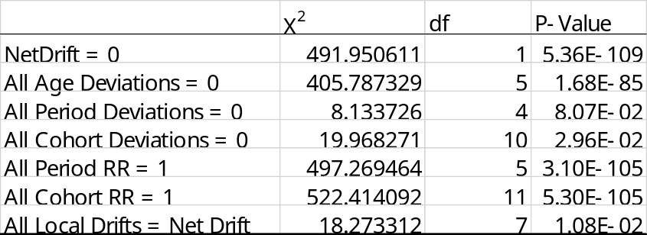

Supplementary Table 6: Age-Period-Cohort (APC) Model Fit for Chronic Hepatitis C Among Women Aged 15-49 Years Globally (1990-2021)

