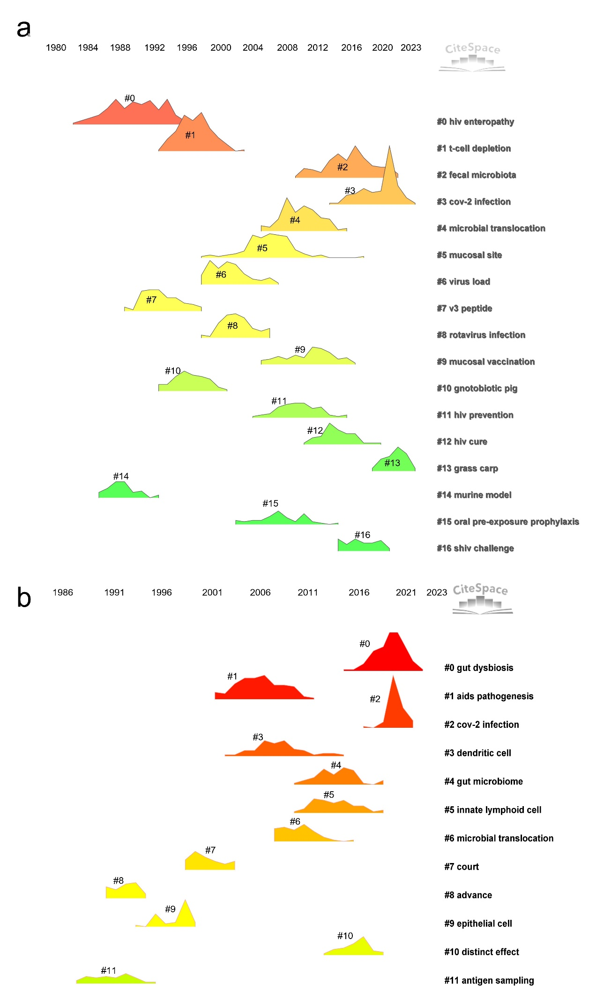
Figure S1 Temporal evolution of reference co-citation clusters by publication type. Peaks indicated key thematic clusters.
a Research articles
b Review articles
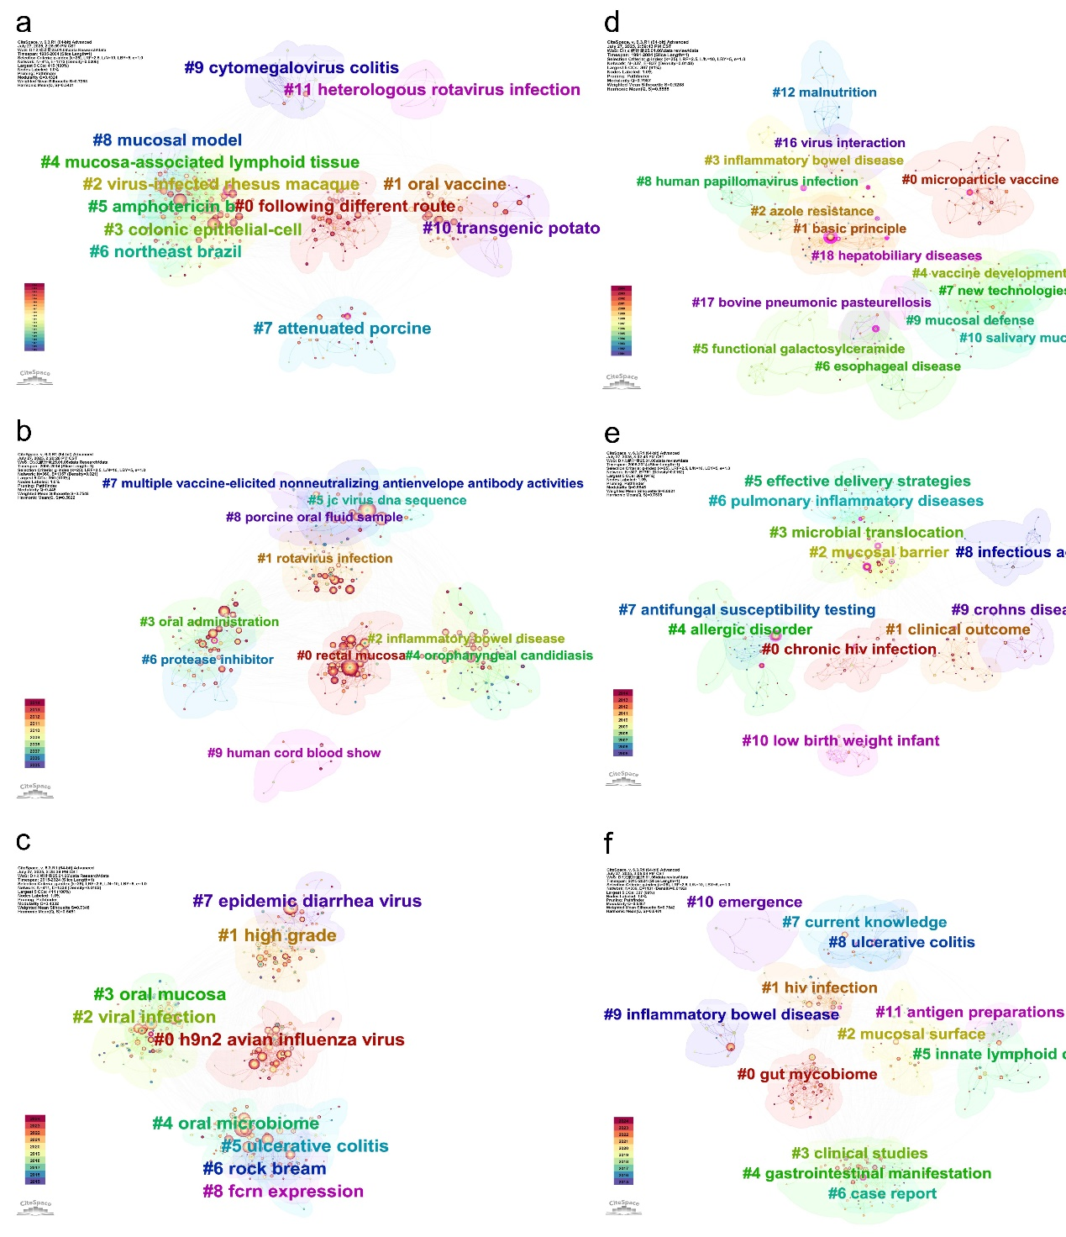
Figure S2 Thematic keyword clusters across three time periods, categorized by publication type. Cluster visualization format matched Figure 5a.
For research articles:
1985–2004 (a): Focus centered on individual pathogens and early immunization strategies, including clusters such as "#9 cytomegalovirus colitis", "#11 rotavirus", and "#1 oral vaccine".
2005–2014 (b): Emphasis shifted to translational delivery, with "#1 rotavirus" and "#2 IBD" as dominant themes, and bridging clusters like "#3 oral administration" connecting immunization to disease.
2015–2024 (c): Increasing integration of mucosal ecosystem concepts, linking "#0 H9N2 avian influenza virus" to "#7 epidemic diarrhea virus," and converging topics such as "#3 oral mucosa", "#2 viral infection", "#4 oral microbiome", and "#5 ulcerative colitis".
For review articles:
1985–2004 (d): Early clusters focused on foundational immunological concepts, including "#0 microparticle vaccine" and "#1 basic principle", alongside disease-specific topics.
2005–2014 (e): Emergence of translational themes, such as "#2 mucosal barrier" that bridged mechanistic insights with clinical relevance.
2015–2024 (f): Cross-disciplinary integration became prominent, exemplified by the co-evolution of "#4 oral microbiome" and "#5 ulcerative colitis”, and the rise of ecological topics like "#0 gut mycobiome".
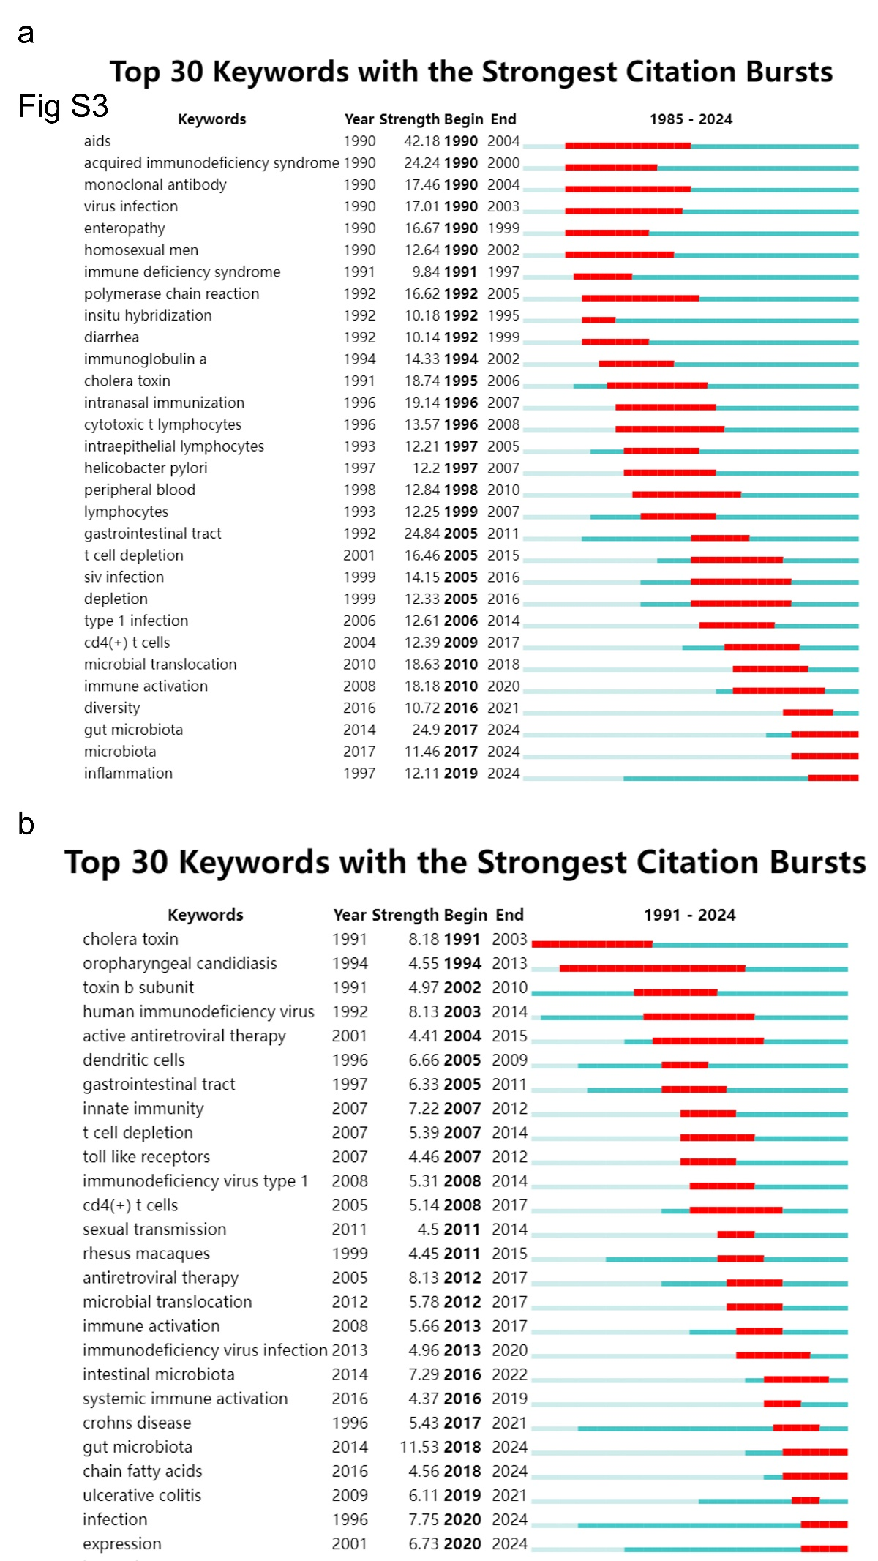
Figure S3 Citation burst analysis of the top 25 keywords by publication type. Format consistent with Figure 6.
In research articles (a), "AIDS" (1990-2004, strength 42.18) and "monoclonal antibody" (1990-2004, lasting for 14 years) were the most prominent early bursts, reflecting the initial emphasis on HIV and immunological responses. Recent bursts include "inflammation" (2020-2024, strength 19.3) and "gut microbiota" (2014-2024, strength 24.9), highlighting a thematic shift toward mucosal immunology and microbial ecology. Notably, "microbial translocation" (2009-2019) served as a transitional keyword bridging historical and modern focuses, while sustained terms like "gastrointestinal tract" indicate persistent anatomical relevance.
In contrast, review articles (b) exhibited longer and more conceptually anchored bursts. "Cholera toxin" (1991-2003) persisted for 12 years, reflecting foundational immunological theories, while "microbial translocation" (2009-2019) bridged mechanistic developments. Keywords such as "gut microbiota" (2014-2024) and "microbiota" (2019-2024) displayed longer burst durations than their research counterparts, suggesting growing conceptual consolidation.

