Supplementary Figure Legends
Supplementary figure 1. APMV-1 sequences obtained from Nepal are demonstrated to be genotype VII.2. Maximum-likelihood phylogenetic tree of the F-gene from global, pre-defined APMV-1 sequences, with each sequence named. Sequences are coloured red for isolates from this study and black for all other sequences.
Supplementary figure 2. Maximum-likelihood analysis of APMV-1 sequences obtained from Nepal genotype VII.2 sequences. Maximum-likelihood phylogenetic tree of the F-gene from the Nepalese isolates and pre-defined genotype VII.2 isolates with each sequence named. Nepalese sequences from this study are coloured red, genotype VII.2 sequences are coloured black, and the root sequence is coloured orange.
Supplementary figure 3. APMV-1 sequences designated genotype VII.2 are closely related to previous strains detected in Southern Asia. Treetime analysis of APMV-1 F-gene sequences previously identified as genotype VII.2 scaled to year of collection. Tips and branches are coloured by region of origin.

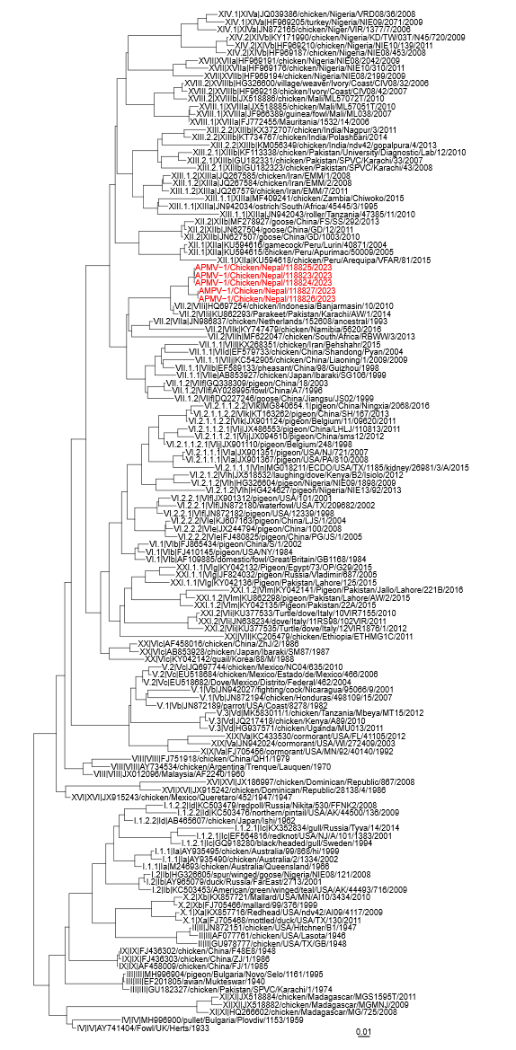
Supplementary figure 1. APMV-1 sequences obtained from Nepal are demonstrated to be genotype VII.2

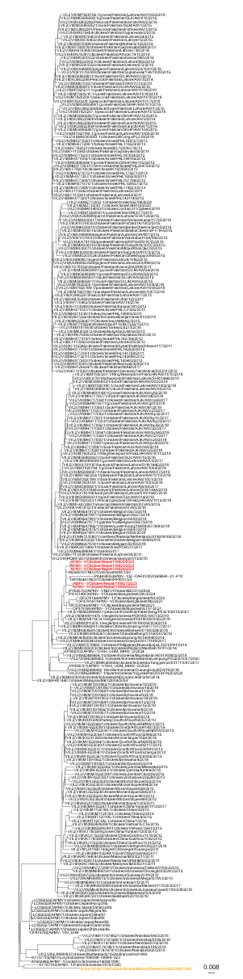
Supplementary figure 2. Maximum-likelihood analysis of APMV-1 sequences obtained from Nepal genotype VII.2 sequences

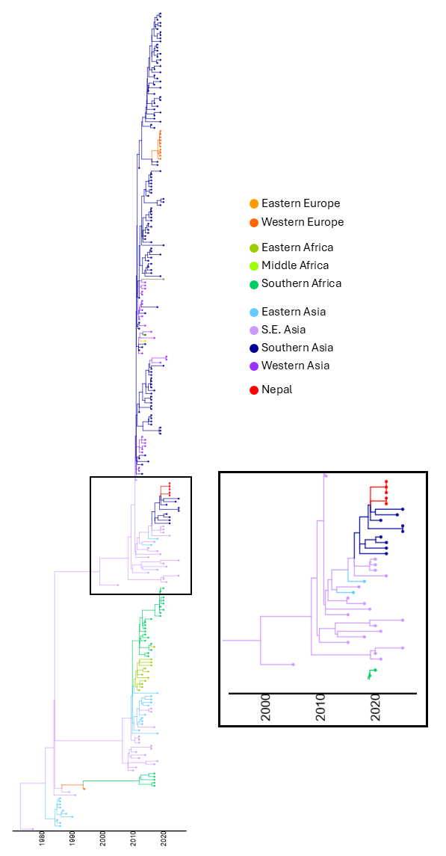
Supplementary figure 3. APMV-1 sequences designated genotype VII.2 are closely related to previous strains detected in Southern Asia.

Table S1: Bayesian Analysis
 | PS | SS
Relaxed Constant Population | -15524.0728868146 | -15538.372012795
Relax Bayesian SkyRide | -15597.5333797471 | -15616.4331827995
Strict Constant Population | -15660.2475826918 | -15675.2851739637
Strict Bayesian SkyRide | -15705.9235473661 | -15726.4804458805

