Supplementary Materials

Identification and comparison of the RNA structures in the 5’- and 3’-terminal genomic regions across four coronavirus genera by SHAPE analysis

Hsuan-Wei Hsu¹, Pei-Chi Hsu¹, Yu Teng¹, Meilin Wang², Feng-Cheng Hsieh¹, Chun-Chun Yang¹, Hung-Yi Wu^{1*}

1 Graduate Institute of Veterinary Pathobiology, College of Veterinary Medicine, National Chung Hsing University, Taichung 40227, Taiwan
2 Department of Microbiology and Immunology, School of Medicine,
Chung-Shan Medical University and Clinical Laboratory, Chung-Shan Medical University Hospital, Taichung 40201, Taiwan

*Corresponding Author
Corresponding Footnote: Graduate Institute of Veterinary Pathobiology, College of Veterinary Medicine, National Chung Hsing University, Taichung 40227, Taiwan
Telephone: 886-4-22840369; Fax: 886-4-22862073
Email: hwu2@dragon.nchu.edu.tw

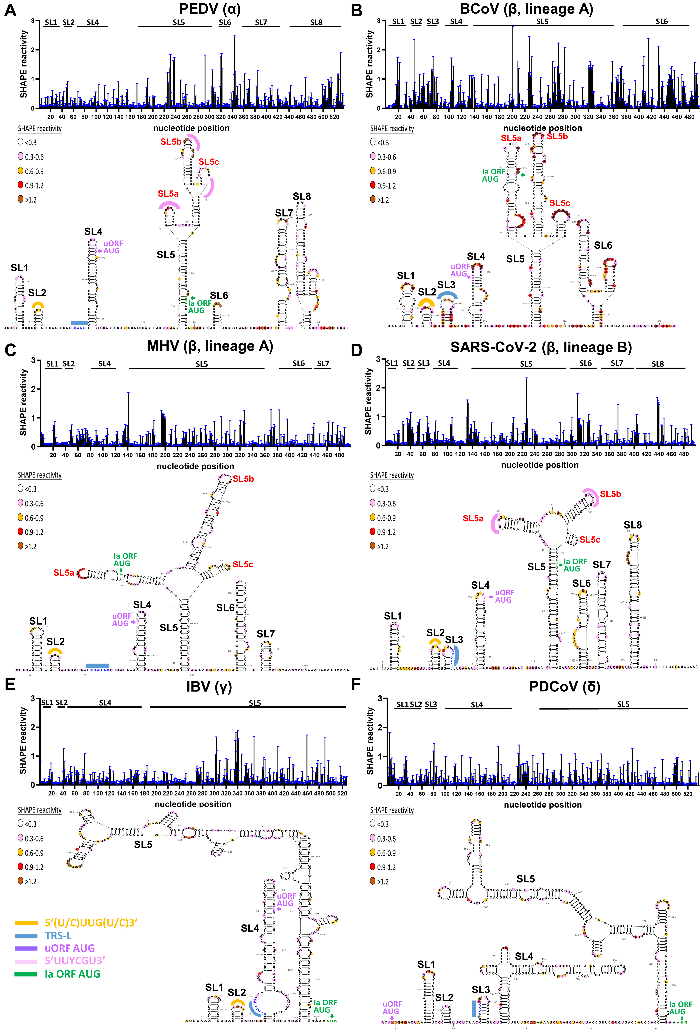
Fig. S1. The RNA structures determined by SHAPE analysis in the 5’-terminal genomic regions of representative α, β, γ and δ coronaviruses. (A) Porcine epidemic diarrhea virus (PEDV, α coronavirus), (B) bovine coronavirus (BCoV, β coronavirus, lineage A), (C) murine hepatitis virus (MHV, β coronavirus, lineage A), (D) severe acute respiratory syndrome coronavirus 2 (SARS-CoV-2, β coronavirus, lineage B), (E) infectious bronchitis virus (IBV, γ coronavirus) and (F) porcine deltacoronavirus (PDCoV, δ coronavirus). Upper panel: SHAPE reactivity profiles of the 5’-terminal RNA structures. The mean SHAPE reactivity with standard deviation is shown here. The mean SHAPE reactivity obtained from three independent experiments is shown in Fig. 1. A value on the y-axis smaller than 0.3 indicates unreactive nucleotides. Nucleotide positions in the 5’-terminal region of the genome are indicated on the x axis. Lower panel: The 5’-terminal RNA structure in which the SHAPE reactivity of nucleotides is represented using a colored scale. The sequence 5’(U/C)UUG(U/C)3’ in the loop region of SL2 in α, β and γ coronaviruses is indicated in orange. The transcription-regulatory sequence (TRS) is indicated in blue. The start codon of the upstream open reading frame (uORF) is indicated in purple. The RSM sequence 5’UUYCGU3’ in the loop region of SL5 in PEDV (α coronavirus) and SARS-CoV-2 (β coronavirus, lineage B) is indicated in pink. The start codon of open reading frame 1a is indicated in green. L, loop; S, stem.

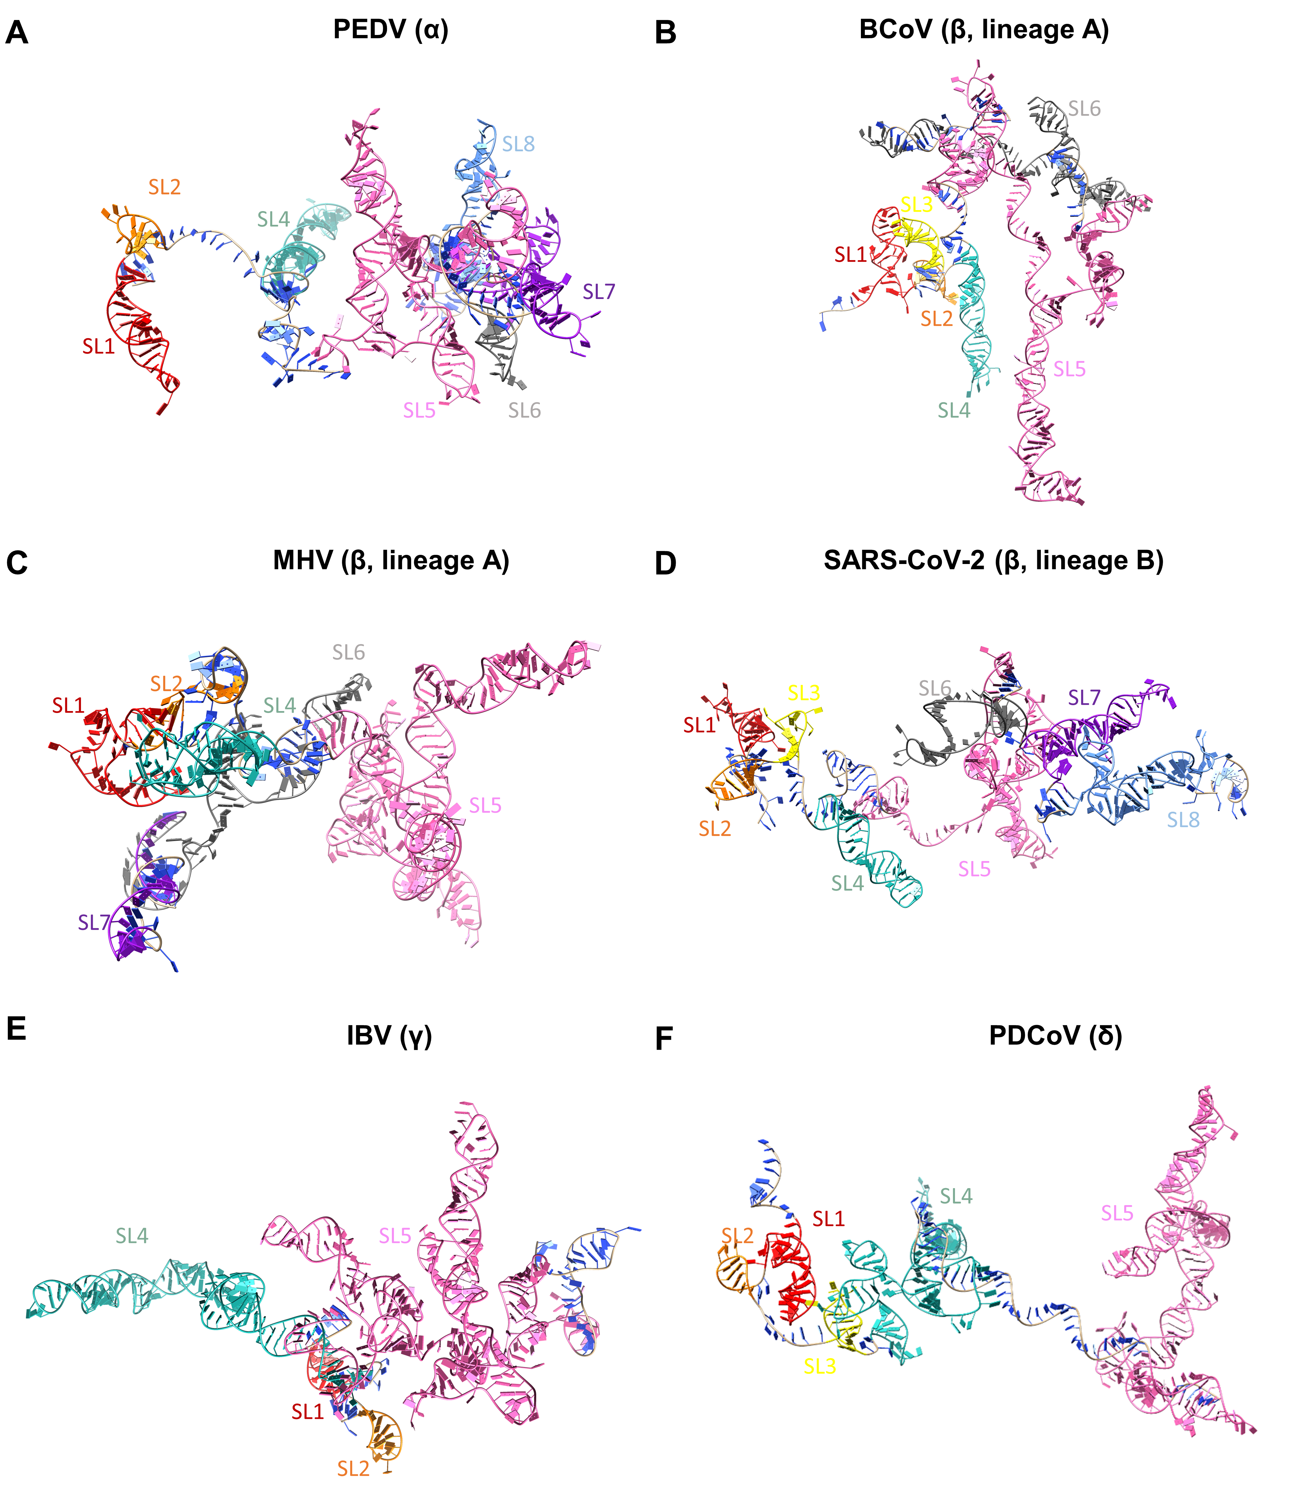
Fig. S2. 3D RNA structures consisting of SLs 1, 2, 3 (if any), 4 and 5 as well as the RNA structures (such as SL6, SL7 or SL8, if any) downstream of SL5 in the 5’-terminal genomic regions of the representative α, β, γ and δ coronaviruses predicted by RNAComposer. (A) Porcine epidemic diarrhea virus (PEDV, α coronavirus), (B) bovine coronavirus (BCoV, β coronavirus, lineage A), (C) murine hepatitis virus (MHV, β coronavirus, lineage A), (D) severe acute respiratory syndrome coronavirus 2 (SARS-CoV-2, β coronavirus, lineage B), (E) infectious bronchitis virus (IBV, γ coronavirus) and (F) porcine deltacoronavirus (PDCoV, δ coronavirus). The consensus RNA SL structures determined by SHAPE analysis in each 3D RNA structure are labeled with different colors: SL1 is red; SL2 is orange; SL3 is yellow; SL4 is light sea green; and SL5 is pink. In addition, SL6 is dim gray; SL7 is purple; SL8 is cornflower blue. The nonstem region is blue.
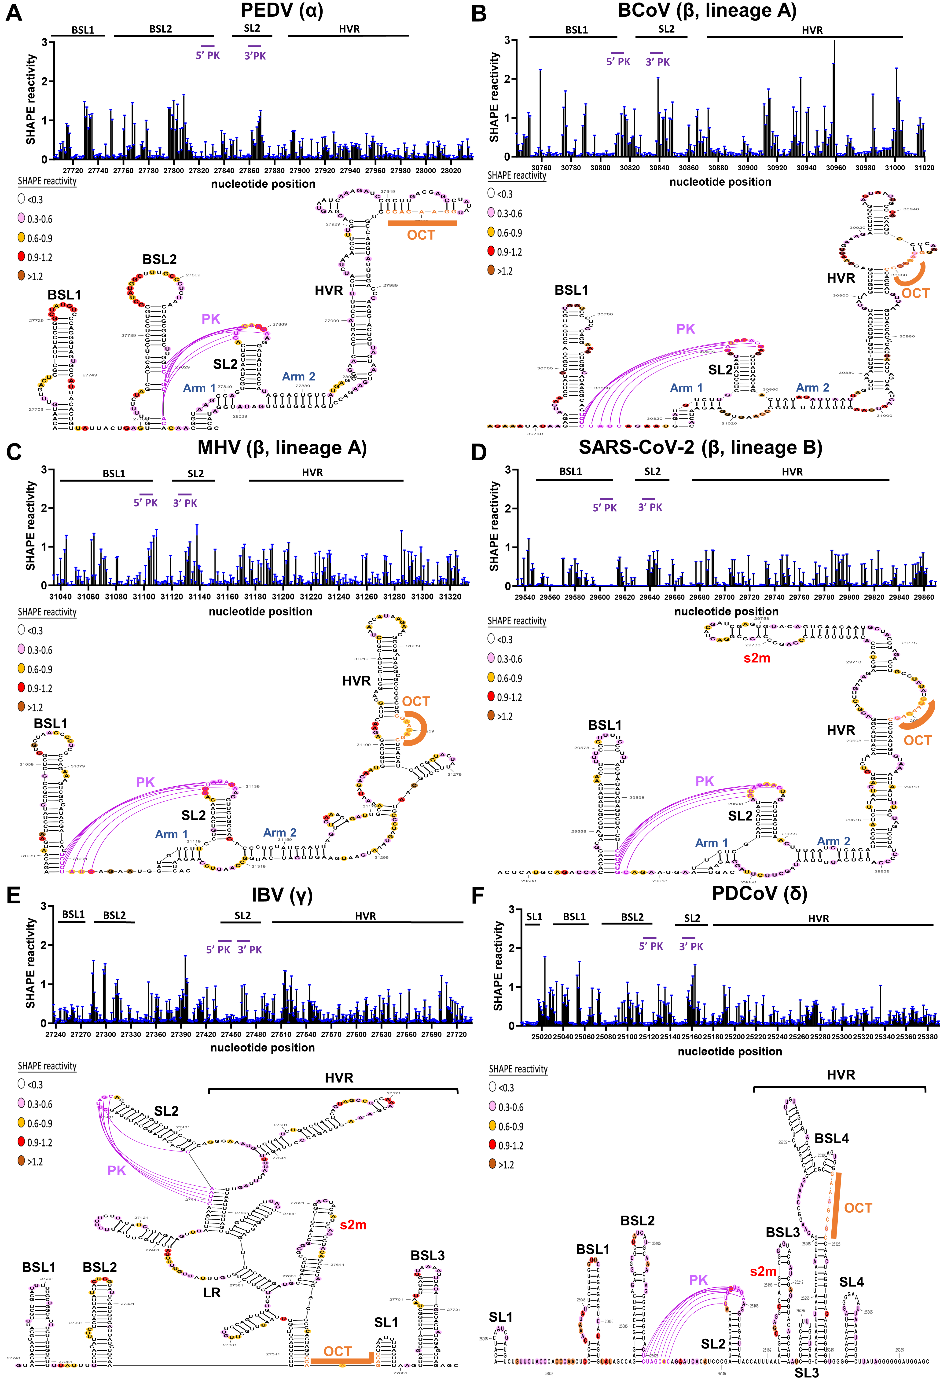

Fig. S3. The RNA structures determined by SHAPE analysis in the 3’-terminal genomic regions of representative α, β, γ and δ coronaviruses. (A) Porcine epidemic diarrhea virus (PEDV, α coronavirus), (B) bovine coronavirus (BCoV, β coronavirus, lineage A), (C) murine hepatitis virus (MHV, β coronavirus, lineage A), (D) severe acute respiratory syndrome coronavirus 2 (SARS-CoV-2, β coronavirus, lineage B), (E) infectious bronchitis virus (IBV, γ coronavirus) and (F) porcine deltacoronavirus (PDCoV, δ coronavirus). Upper panel: SHAPE reactivity profiles of the 3’-terminal RNA structures. The mean SHAPE reactivity with standard deviation is shown here. The mean SHAPE reactivity obtained from three independent experiments is shown in Fig. 4. A value on the y-axis smaller than 0.3 indicates unreactive nucleotides. Nucleotide positions at the 3’-terminal region of the genome are indicated on the x axis. The 5’ PK and 3’ PK, colored in purple, indicate the potential nucleotides involved in the formation of the PK structure. Lower panel: The 3’-terminal RNA structure in which the SHAPE reactivity of nucleotides is represented using a colored scale. The conserved octanucleotide is colored orange. The purple lines indicate base-pairing to form S1 of the PK structure. PK, pseudoknot; L, loop; S, stem.

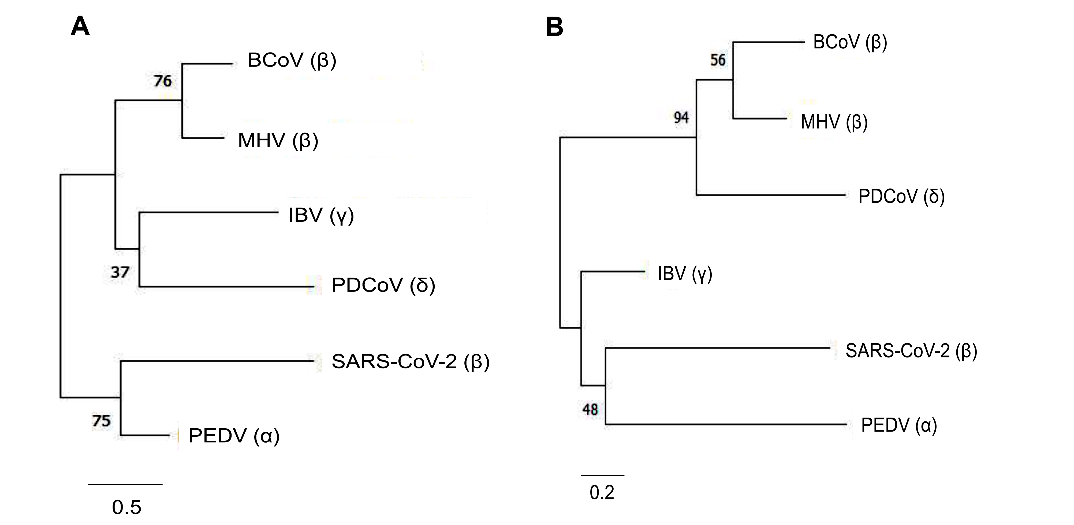
Fig. S4. Phylogenetic analysis of nucleotide sequences in the 5’- and 3’-terminal genomic regions of the representative α, β, γ and δ coronaviruses, including PEDV (α), BCoV (β), MHV (β), SARS-CoV-2 (β), IBV (γ) and PDCoV (δ). The phylogenetic tree was constructed using the maximum likelihood method with a bootstrap of 1,000. Numbers at the internal nodes indicate likelihood-based branch support values.

Table S1. Oligonucleotides used in this study.
Oligonucleotides ª | Polarity | Sequence (5’→3’)
T7_Leader (‒) | + | TAATACGACTCACTATAGGGGATTGTGAGCGATTTGC
PGEMNdeI (-) | + | GAGAGTGCACCATATGCGGTGTG
PGEM2341 (-) | + | ATGACGGTGAAAACCTCTGA
BCV29774 (+) | ‒ | GCATGCGGTCCTGTTCCAAGATAG
DI reverse (+) | ‒ | CACAGGAAACAGCTATGACC
T7-MHV-L (-) | + | TAATACGACTCACTATAGGGGTATAAGAGTGATTG
T7-MHV-L (+) | ‒ | CAATCACTCTTATACCCCTATAGTGAGTCGTATTA
MHV498-BCVN (-) | + | TCAACTATGATGGCAATGTCTTTTACTCCT
MHV498-BCVN (+) | ‒ | AGGAGTAAAAGACATTGCCATCATAGTTGA
SARSCoV2-439A (-) | + | AGAAGTTGAAAAAGGCGTTTTGCCT
SARSCoV2-439A (+) | ‒ | AGGCAAAACGCCTTTTTCAACTTCT
T7-PEDV5’UTR (-) | + | TAATACGACTCACTATAGGGACTTAAAGAGATTTTCTATC
T7-PEDV5’UTR (+) | ‒ | GATAGAAAATCTCTTTAAGTCCCTATAGTGAGTCGTATTA
PEDV535-BCVN (-) | + | TGGATACTTTTAATAGCCGCATGTCTTTTACTCCTGGTAA
PEDV535-BCVN (+) | ‒ | TTACCAGGAGTAAAAGACATGCGGCTATTAAAAGTATCCA
T7-IB5’UTR (-) | + | TAATACGACTCACTATAGGGACTGAAAATAGATATTAATA
T7-IB5’UTR (+) | ‒ | TATTAATATCTATTTTCAGTCCCTATAGTGAGTCGTATTA
IB527-BCVN (+) | ‒ | CCAGGAGTAAAAGACATGTTGTCACTGTCTATTG
BCV 29397 (-) | + | ATGTCTTTTACTCCTGGTAAGCAA
T7-PDCoV5’UTR (+) | ‒ | CTATAATTTTTATCTTTAGTCCCCATGTCCCTATAGTGAGTCGTATTA
BM65A (+) | ‒ | TTTTTTTTTTTTTTTTTTTTTTTTTTTTTTTTTTTTTTTTTTTTTTTTTTTTTTTTTTTTTTTTTGTGATTCTTCC
BCV 30428 (+) | ‒ | TATTTCTGAGGTGTCTTCAGTATAGGGCTC
BCVL20 (-) | + | GATTGTGAGCGATTTGCGTGC
MHVL18 (-) | + | CCGTACGTACCCTCTCAACTC
SARS2L16 (-) | + | CCTTCCCAGGTAACAAACCAACCAAC
PEDVPTL8 (-) | + | GAGATTTTCTATCTACGGATAG
IBVL37 (-) | + | GCCTTGCGCTAGATTTC
PDCoVL5 (-) | + | GGGGACTAAAGATAAAAATTATAGC
DI 1260 (-) | + | GGCAAGGATGCCACTAAGCCACAG
DI reverse (+) | ‒ | CACAGGAAACAGCTATGACC
MHV end-MluI (+) | ‒ | TTAAATTTAACGCGTGTGATTCTTCCAATT
SARS-CoV2 end-MluI (+) | ‒ | TTAAATTTAACGCGTGTCATTCTCCTAAGA
PEDV end-MluI (+) | ‒ | GGGAAACCCACGCGTGCGTATCCATATCAACAC
a. The positive and negative symbols in the oligonucleotide names indicate the polarities of the nucleic acids to which the oligonucleotides anneal.

Table S1. Oligonucleotides used in this study. (Cont.)
Oligonucleotides ª | Polarity | Sequence (5’→3’)
IBV end-MluI (+) | ‒ | GGGAAACCCACGCGTGCTCTAACTCTATACTAGCC
PDCoV end-MluI (+) | ‒ | ACTGACTGACACGCGTGCTCCATCCCCCCT
DI 3’ (+) | ‒ | CGGGATCCGTCGACACGCGTTTTTTTTTTTTTTTTTTTT
BCV 3’UTR2 (+) | ‒ | CTTGTCGGCAATTACTTCCGCAAG
BCV 30891 (+) | ‒ | CACACAAAACTTTCAACTAATTAATCTATA
MHV 31179 (+) | ‒ | AATCTCTTTCAACTAATTGATACAGG
MHV 31292 (+) | ‒ | GGGCATTGCAGGAATAG
SARS-CoV-2 29670 (+) | ‒ | GTGAGATTAAAGTTAACTACATCTACTT
SARS-CoV-2 29870 (+) | ‒ | GTCATTCTCCTAAGAAGCTA
PED 27897 (+) | ‒ | CTCATGACAGTGCTATGGTA
PED 28038 (+) | ‒ | GCGTATCCATATCAACACCG
IB 27493 (+) | ‒ | ATTTCCCTGGCGATAGACAT
IB 27740 (+) | ‒ | TGCTCTAACTCTATACTAGC
PDCoV 25183 (+) | ‒ | TAAATGGTATAATCAACCTTCTAGCACTG
PDCoV 25392 (+) | ‒ | GCTCCATCCCCCCTATAAGC
BCV3’-5A-cassette (+) | ‒ | GAACCGGACCGAAGCCCGATTTGGATCCGGCGAACCGGATCGATTTTTGTGATTCTTCCAATT
PEDV3’-5A-cassette (+) | ‒ | GAACCGGACCGAAGCCCGATTTGGATCCGGCGAACCGGATCGATTTTTGCGTATCCATATCAA
SARS3’-5A-cassette (+) | ‒ | GAACCGGACCGAAGCCCGATTTGGATCCGGCGAACCGGATCGATTTTTGTCATTCTCCTAAGA
IBV3’-5A-cassette (+) | ‒ | GAACCGGACCGAAGCCCGATTTGGATCCGGCGAACCGGATCGATTTTTGCTCTAACTCTATAC
PDCoV3’-5A-cassette (+) | ‒ | GAACCGGACCGAAGCCCGATTTGGATCCGGCGAACCGGATCGATTTTTGCTCCATCCCCCCTA
T7-cas-BCV-leader (-) | + | TAATACGACTCACTATAGGGCCTTCGGGCCAAGATTGTGAGCGATTT
T7-cas-MHV-leader (-) | + | TAATACGACTCACTATAGGGCCTTCGGGCCAAGTATAAGAGTGATTG
T7-cas-PEDV-leader (-) | + | TAATACGACTCACTATAGGGCCTTCGGGCCAAACTTAAAGAGATTTT
T7-cas-SARS-leader (-) | + | TAATACGACTCACTATAGGGCCTTCGGGCCAAATTAAAGGTTTATAC
T7-cas-PDCoV-leader (-) | + | TAATACGACTCACTATAGGGCCTTCGGGCCAAACATGGGGACTAAAG
T7-cas-IBV-leader (-) | + | TAATACGACTCACTATAGGGCCTTCGGGCCAAACTGAAAATAGATAT
a. The positive and negative symbols in the oligonucleotide names indicate the polarities of the nucleic acids to which the oligonucleotides anneal.
Table S2. Oligonucleotides used in this study.
Oligonucleotides ª | Polarity | Sequence (5’→3’)
6-FAM-DI-580 (+) | ‒ | CAAACCCATGGTCCATCCATT
JOE-DI-580 (+) | ‒ | CAAACCCATGGTCCATCCATT
6-FAM-3Linker (+) | ‒ | GAACCGGACCGAAGCCCGATTTGG
JOE-3Linker (+) | ‒ | GAACCGGACCGAAGCCCGATTTGG
a. The positive and negative symbols in the oligonucleotide names indicate the polarities of the nucleic acids to which the oligonucleotides anneal.

Table S3. Illustration of potential long-range RNA-RNA interactions in 5’-terminal genomic regions by complementary base pairing.
a. The nucleotide position is indicated in red.

Table S4. Illustration of potential long-range RNA-RNA interactions in 3’-terminal genomic regions by complementary base pairing.
a. Sequences colored purple indicate base pairing involved in pseudoknot formation.
b. The nucleotide position is indicated in red.

