Figure legends
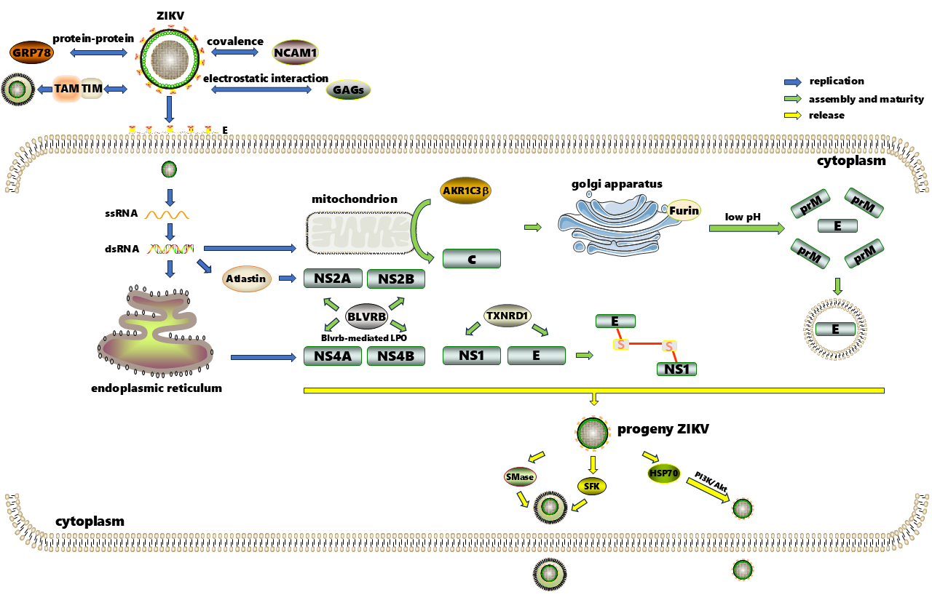
Fig.1 Flow diagram of ZIKV infection of host cells.
Swarms of ZIKV particles exist in the process of entry, replication, assembly, maturity and release. ZIKV first entered the host through various interactions or molecular modifications. After being translated by EMC, various ZIKV proteins were assembled and matured by Atlastin, AKRIC3β, BLVRB, TXNRD1, Furin and other molecules. After the formation of virulence, the progeny ZIKV is released by EVs or directly through the membrane.

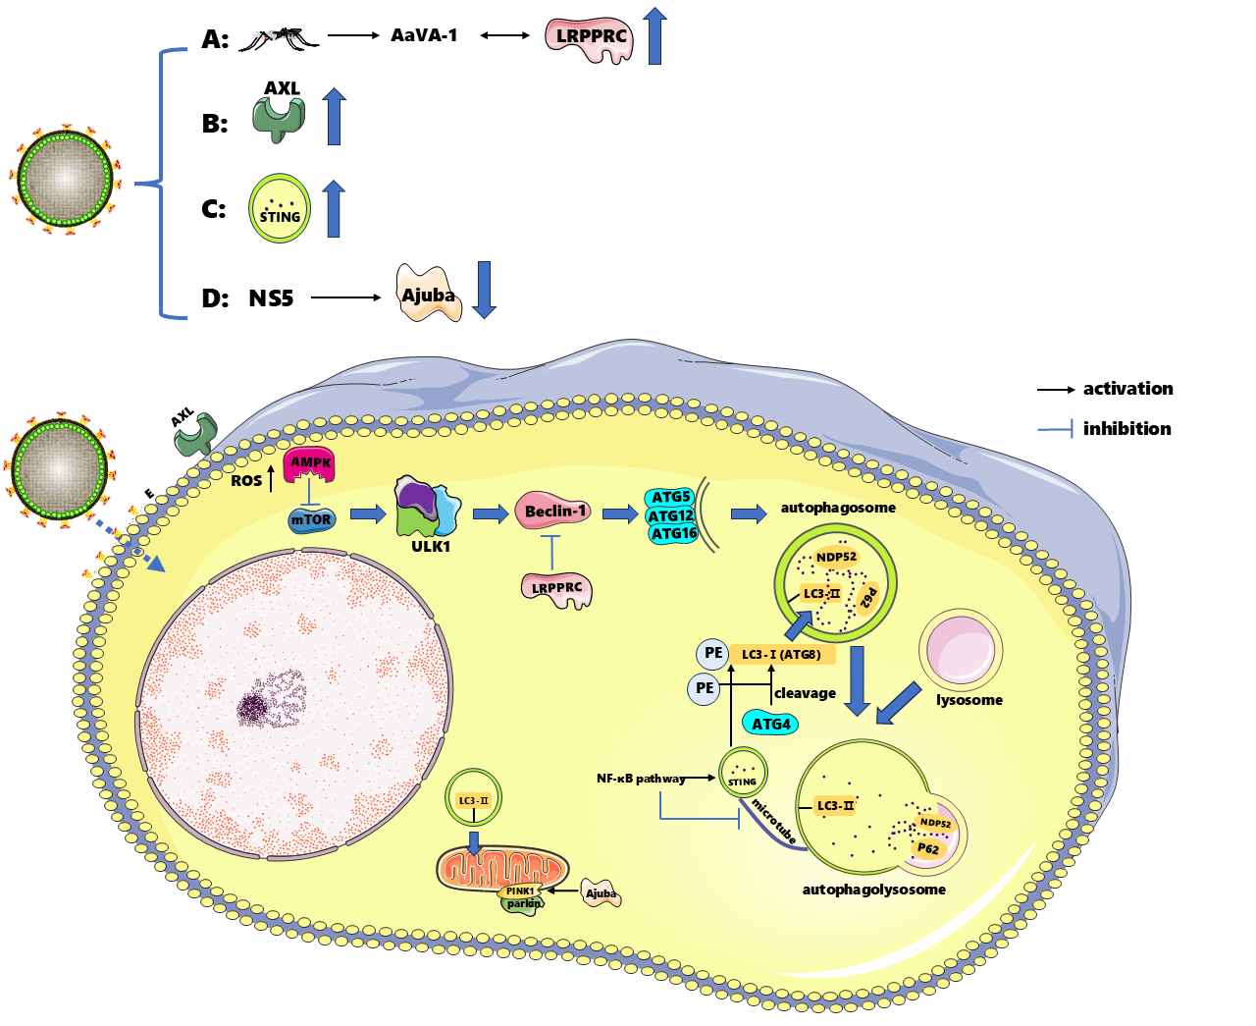
Fig.2 Role of autophagy in ZIKV invasion of host cells.
ZIKV invasion upregulates LRPPRC expression, which further leads to negative regulation of Beclin-1, and inhibits downstream autophagosome formation. (B) As a results of ZIKV infection, up-regulation of AXL activity facilitates the ROS-AMPK-mTOR-ULK1/2 pathway, and ROS stimulates AMPK to regulate mTOR inactivation and initiate subsequent autophagy. (C) STING is not only a regulatory factor, but is also recognized by the host as a substance to be degraded. Following ZIKV infection, exists an increase in the protein transcribed by STING. The NF-κB pathway promotes the synthesis of LC3-I to enhance autophagy flux, while blocking the formation of microtube and cutting off the transport route of STING to autophagolysosome. (D) ZIKV NS5 protein and PINK1 compete to bind Ajuba, reducing parkin recruitment to the membrane and weakening the intensity of mitophagy.

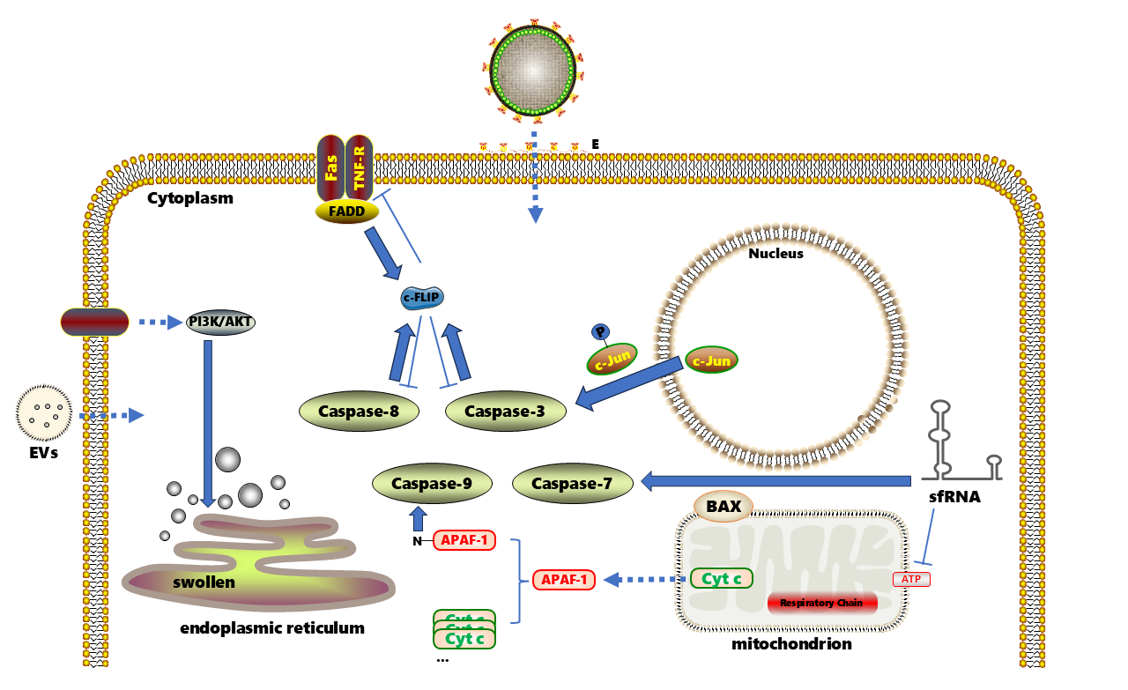
Fig.3 Multiple pathways induced by ZIKV regulate apoptosis
ZIKV invasion maintains internal biological homeostasis and promotes ZIKV colonization by regulating classical/nonclassical apoptotic pathways of host cells. In the intrinsic apoptosis pathway, the up-regulation of pro-apoptotic protein BAX on the mitochondrial membrane gradually initiates caspase cascade effect. In the extrinsic death receptor pathway, multiple molecules compete to bind c-FLIP at the same time to cope with the crisis of ZIKV invasion. In paratosis and apoptosis mimicries, ZIKV-mediated PI3K/AKT pathway promotes ER swelling and necrosis to ensure ZIKV colonization. ZIKV infection can change the composition of EVs in order to dynamically adjust the degree of host apoptosis.

