Supplemental Table 1: Viruses utilized in this study
Virus Name | Abbreviation | GenBank ID
Akhmeta virus | AKMV | MH607141
Batpox virus | Batpox | PP711852
Borealpox virus | BRPV | MN240300
Cowpox virus_Germany_1998_2 | CPXV-GER98 | HQ420897
Cowpox virus_Brighton Red | CPXV-BR | AF482758
Cowpox virus_Finland2000_Man | CPXV-Fin2000 | HQ420893
Deerpox virus | Deerpox | MF966153
Ectromelia virus | ECTV | NC_004105
Monkeypox virus_ (Clade Ia) | MPXV Ia | n/a
Monkeypox virus_ (Clade Ib) | MPXV Ib | n/a
Monkeypox virus_USA_2003_44 | MPXV IIa | DQ011153
Monkeypox virus_ USA_2022_MA001 | MPXV IIb | ON563414
Raccoonpox virus | Raccoonpox | NC_027213
Skunkpox virus | Skunkpox | NC_031038
Taterapox virus | TATV | NC_008291
Vaccinia virus_Modified Vaccinia Ankara | VACV-MVA | AY603355
Vaccinia virus_Western Reserve | VACV-WR | AY243312
Variola virus_V68-258 | VARV-Banu | DQ437581
Volepox virus | Volepox | NC_031033

Supplemental Table 2: Pilot study samples and test results
Supplemental Table 3: Blind study samples and results

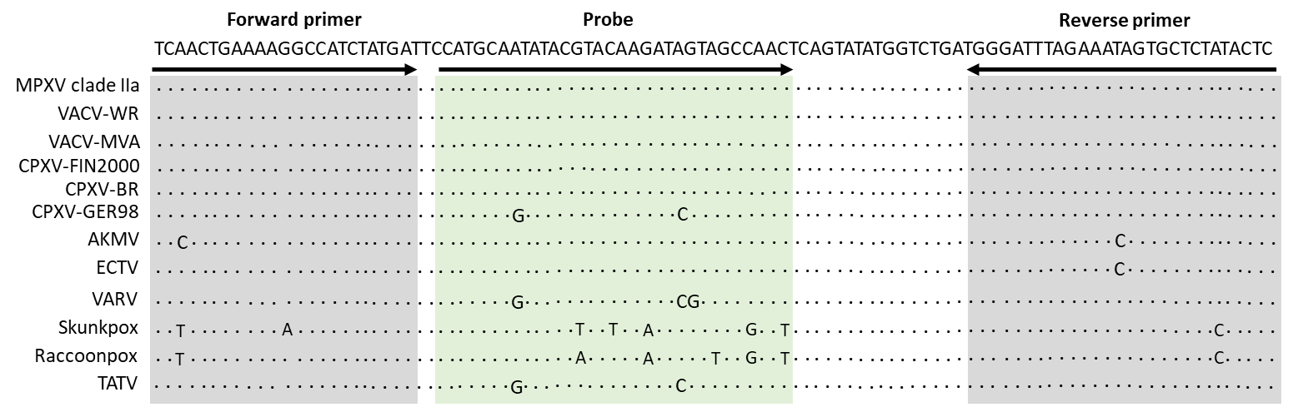
Supplemental Figure 1. Alignment of NVAR-OPXV (E9L) primers and probe with orthopoxviral DNA. The primers and probe for each are aligned with the targeted sequence of orthopoxviral species. E9L target gene is presented as found in the genome on the reverse strand. Volepox, deerpox, batpox, tanapox are not shown (6+ mismatches on any target sequence). MPXV clades Ia, Ib, and IIa are not included. Primer sequences are Forward (TCAACTGAAAAGGCCATCTATGA) Probe (CCATGCAATATACGTACAAGATAGTAGCCAAC), and Reverse (GAGTATAGAGCACTATTTCTAAATCCCA).

Supplemental Figure2. Differences observed in MPXV positive sample Ct values between the lab-based Clade II (extraction) and T-COR 8 (extraction free) testing based on (A) age and (B) days post rash/symptom onset. The presumed false positive test, inconclusive, or invalid results were excluded from analysis. No significant difference was observed between groups based on age. Samples collected at 11+ days had a higher Ct in lab based Clade II testing than on the T-COR 8.

Supplemental Figure 3. Analytic Sensitivity assessment using synthetic DNA on the T-COR 8. Synthetic DNA containing Armored DNA Quant ™ MPOX/Non-Variola Orthopox (Bio-techne, Minneapolis, USA) was serially diluted and tested using the MPXV/NVAR-OPXV assay and resulsting Ct Values. The lowest detected genome equivalents was 16 copies (Ct 34.6) for MPXV assay and 50 copies (Ct 34.1) for NVAR-OPXV assay. Data shared by Tetracore, Inc.

