Supplementary Information for Zhao, et al.
Title: Comparative Study of BBB-Crossing AAV Capsids for Central Nervous System Delivery Efficiency
The PDF file includes:
Supplemental Methods, Supplemental figures.
Supplemental Methods
Single Amino Acid-Mutated Capsid Plasmid Construction
In this study, based on the previously used capsid plasmids AAV9, BI-hTFR1, CNSRCV300, and PHP.eB, we introduced a point mutation (N→D) at amino acid position 270 of the capsid protein coding sequence. The specific construction method was as follows: first, the original plasmids were double-digested with the restriction enzymes AflII and BsiWI; then, a synthesized DNA duplex fragment containing the target mutation site (changing codon AAT for asparagine to GAC for aspartic acid at position 270) (synthesized by Genewiz) was assembled with the digested vector using the NEBuilder® HiFi DNA Assembly Master Mix system via homologous recombination. Finally, all four capsid plasmids carrying the N270D mutation were successfully obtained for subsequent experiments.
TUNEL staining
Frozen sections of mouse liver tissues were prepared and subjected to TUNEL staining following the manufacturer’s instructions of the in situ cell death detection kit. After permeabilization, sections were incubated with TUNEL reaction mixture at 37 ℃ for 1 h in the dark, followed by thorough washing with PBS. Sections were co-stained for green EGFP fluorescence and Cy3-labeled red TUNEL apoptotic signals, and nuclei were counterstained with DAPI. Fluorescent images were captured from randomly selected fields under a laser scanning confocal microscope to evaluate the level of cell apoptosis in brain tissues.

Supplemental figures
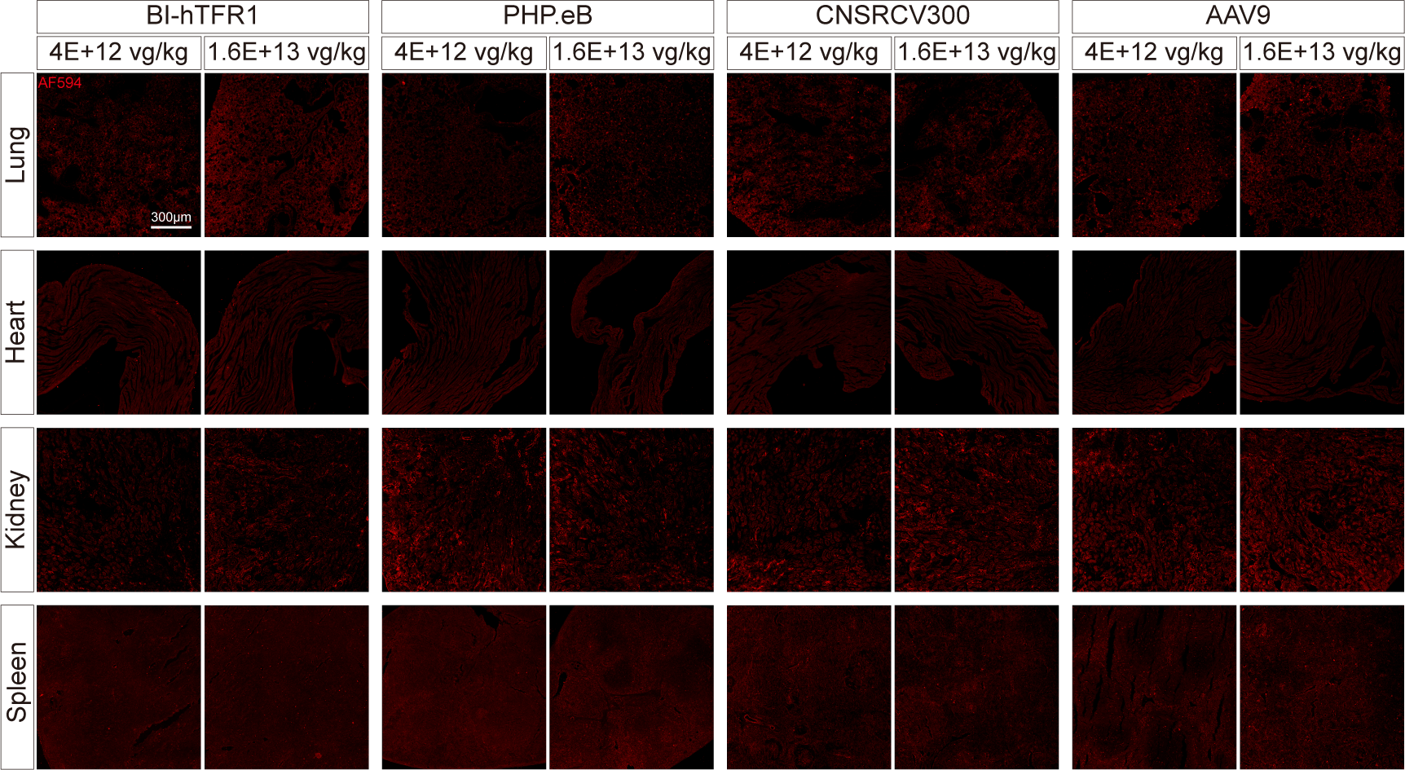
Supplementary Figure 1. EGFP expression and immunofluorescence imaging of hSyn-driven AAV in peripheral tissues of adult mice. Immunofluorescence imaging of EGFP protein in peripheral tissues (lung, heart, kidney and spleen) from mice receiving tail vein injection of four hSyn-containing AAV capsids (BI-hTFR1, PHP.eB, CNSRCV300, AAV9). AF594 (red) fluorescence signals originate from secondary antibodies targeting EGFP. Two injection doses (4×10¹² vg/kg and 1.6×10¹³ vg/kg) were applied for each group; scale bar = 300 μm.
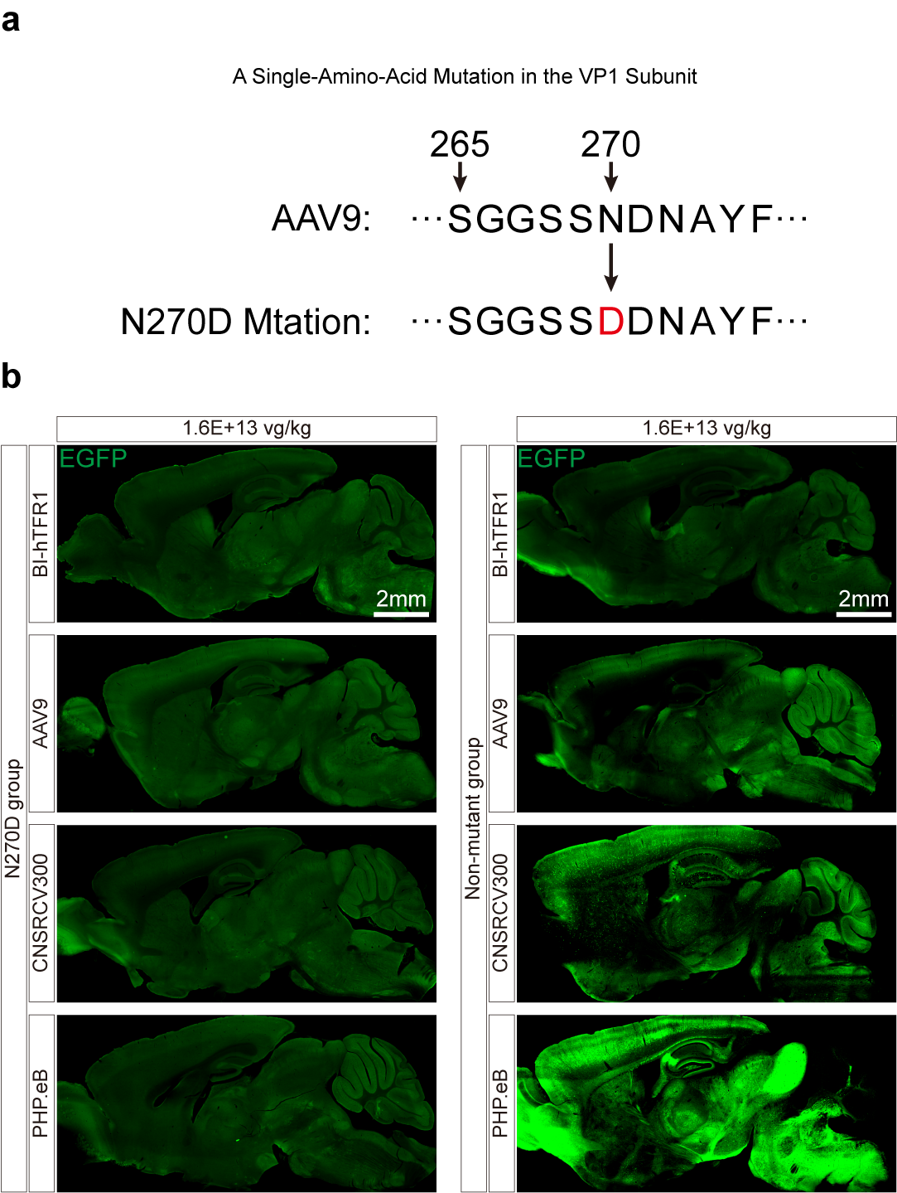
Supplementary Figure 2. Brain transduction of AAV capsids following single-amino-acid mutation in the VP1 subunit of neurotropic variants. (a) Schematic of the single amino acid substitution introduced at residue 270 (N→D) in the VP1 subunit of an AAV9 derived neurotropic capsid. (b) After packaging into viral particles, the mutant capsid was intravenously injected into adult C57BL/6J mice. EGFP reporter expression in the brain was assessed 28 days post injection. Representative EGFP fluorescence micrographs (green signal) of brain sections are displayed; the left panel shows the N270D mutant group, and the right panel represents the Non-mutant control group (n = 4 per group). All images of the non-mutant control group are derived from Figure 4. Scale bars are marked in each image.
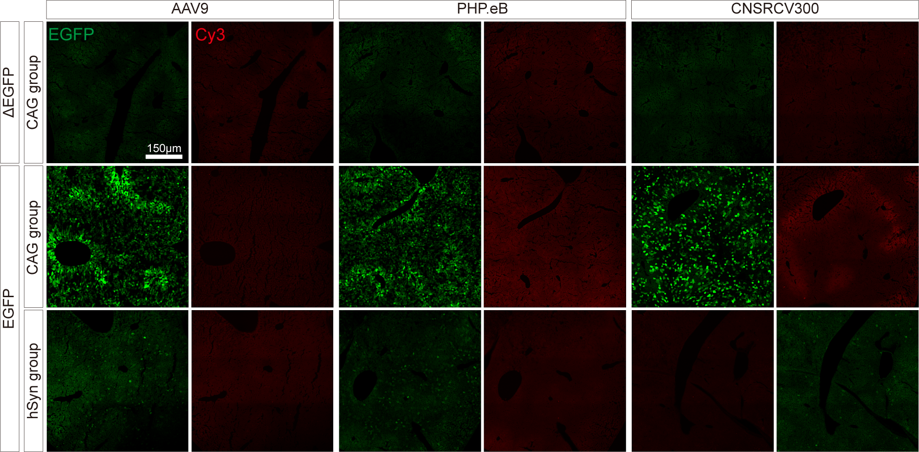
Supplementary Figure 3. TUNEL staining detection of high-efficiency BBB-penetrating AAV capsids used in this study. Representative EGFP and TUNEL (Cy3) fluorescence micrographs of mouse brain transduced with AAV9, PHP.eB or CNSRCV300 under CAG or hSyn promoters. Top row: ΔEGFP blank control; middle row: CAG group; bottom row: hSyn group. EGFP signal marks AAV-transduced cells, and Cy3 fluorescence labels apoptotic cells. Scale bar, 150 μm.

Supplementary Figure 4. Serial detection of serum hepatic injury biomarkers after systemic AAV administration. Serum levels of AST (a), ALT (b), and ALP (c) were measured at day 0, 7, 14 and 21 post-injection in mice receiving different AAV variants. No obvious elevation of liver enzymes was observed across all experimental groups during the observation period. Data are presented as mean ± SEM.

