Supplemental Materials

CPE assay. SH-SY5Y cells were seeded at 70% confluency in 96-well cell culture plates. Viral stocks were diluted to 10⁴ PFU/mL in infection media. Diluted virus (50μL) was transferred to the cell culture plates and incubated at 37°C. After nine days, 20μL of 5mg/mL MTT (3-(4,5-dimethylthiazol-2-yl)-2,5-diphenyltetrazolium bromide) cell stain was added to each well and incubated at 37°C for three hours. Media was removed, and cells were washed twice with PBS. 100μL of 1:2 DMSO:EtOH was added to solubilize the MTT crystals and incubated overnight in the dark at 4°C. Absorbance was measured at a wavelength of 490nm with background subtraction. Absorbance is normalized to negative control wells on each plate and calculated as a percent cytopathic effect (CPE).

Supplemental Figures

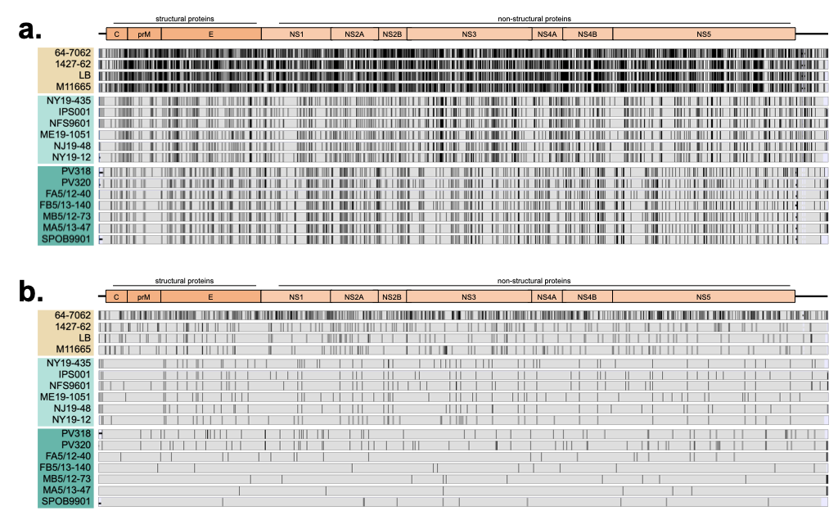

Supplemental Figure 1. Nucleotide alignment of viruses. Nucleotide alignment of entire genome sequences. a) All 17 viruses aligned together. b) Viruses within each lineage/clade (LI – beige, LII NE – light turquoise, LII MW – turquoise) were aligned to the others in the lineage/clade. Lines represent nucleotide differences.

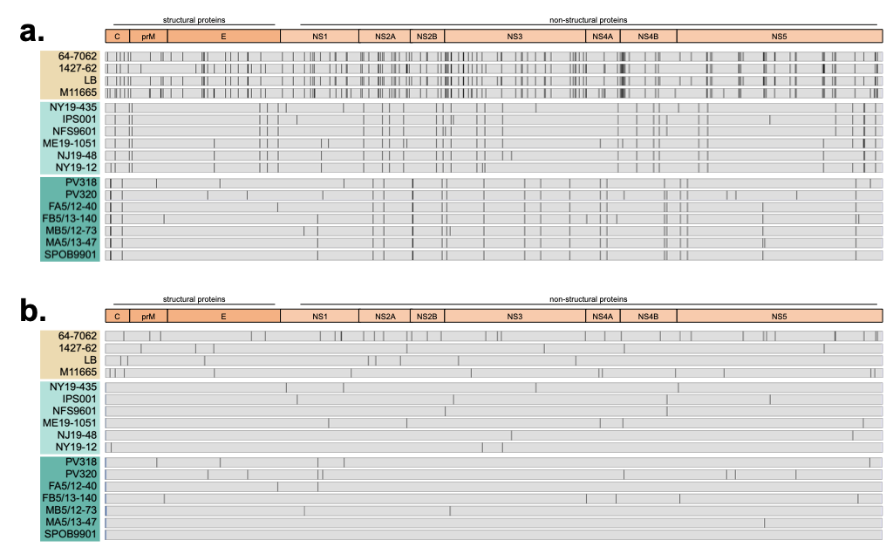
Supplemental Figure 2. Amino acid alignment of viruses. Amino acid alignment of entire coding sequences. a) All 17 viruses aligned together. b) Viruses within each lineage/clade (LI – beige, LII NE – light turquoise, LII MW – turquoise) were aligned to the others in the lineage/clade. Lines represent amino acid differences.

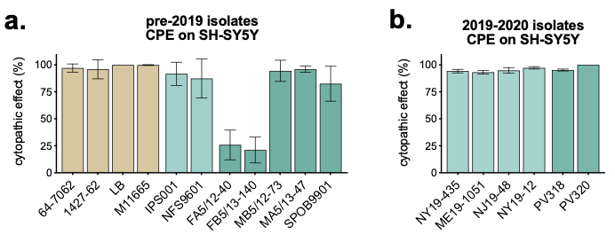
Supplemental Figure 3. CPE of SH-SY5Y cells. SH-SY5Y cells were inoculated with a) pre-2019 isolates or b) 2019-2020 isolates, incubated for nine days, and stained with MTT, and absorbance measured, and normalized to uninfected control wells (n = 6 replicates per virus, mean ± SD).

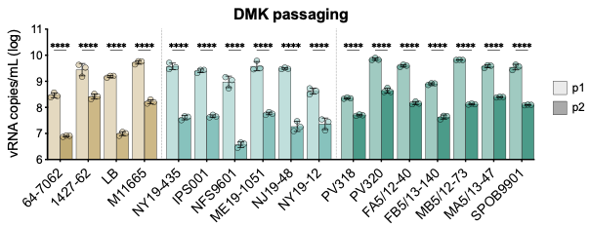
Supplemental Figure 4. Comparison of DMK passages 1 and 2. Passage 1 (lighter color) and 2 (darker color) viral RNA levels from Figure 6a-b (n = 3, mean ± SD). Two-way ANOVA with Šídák's multiple comparisons test (***p<0.0001).

