Figure S1. Ad_{mer} distribution analysis . The method used is the same as that was described in Figure 5. (a and b) Admer/total Ad ratio obtained after densitometric analysis. Data are represented as boxplots. Panel a) diet effect, Panel b) training effect, * p<0.05; ** p<0.001, HF vs SF, Mann-Whitney rank sum test.
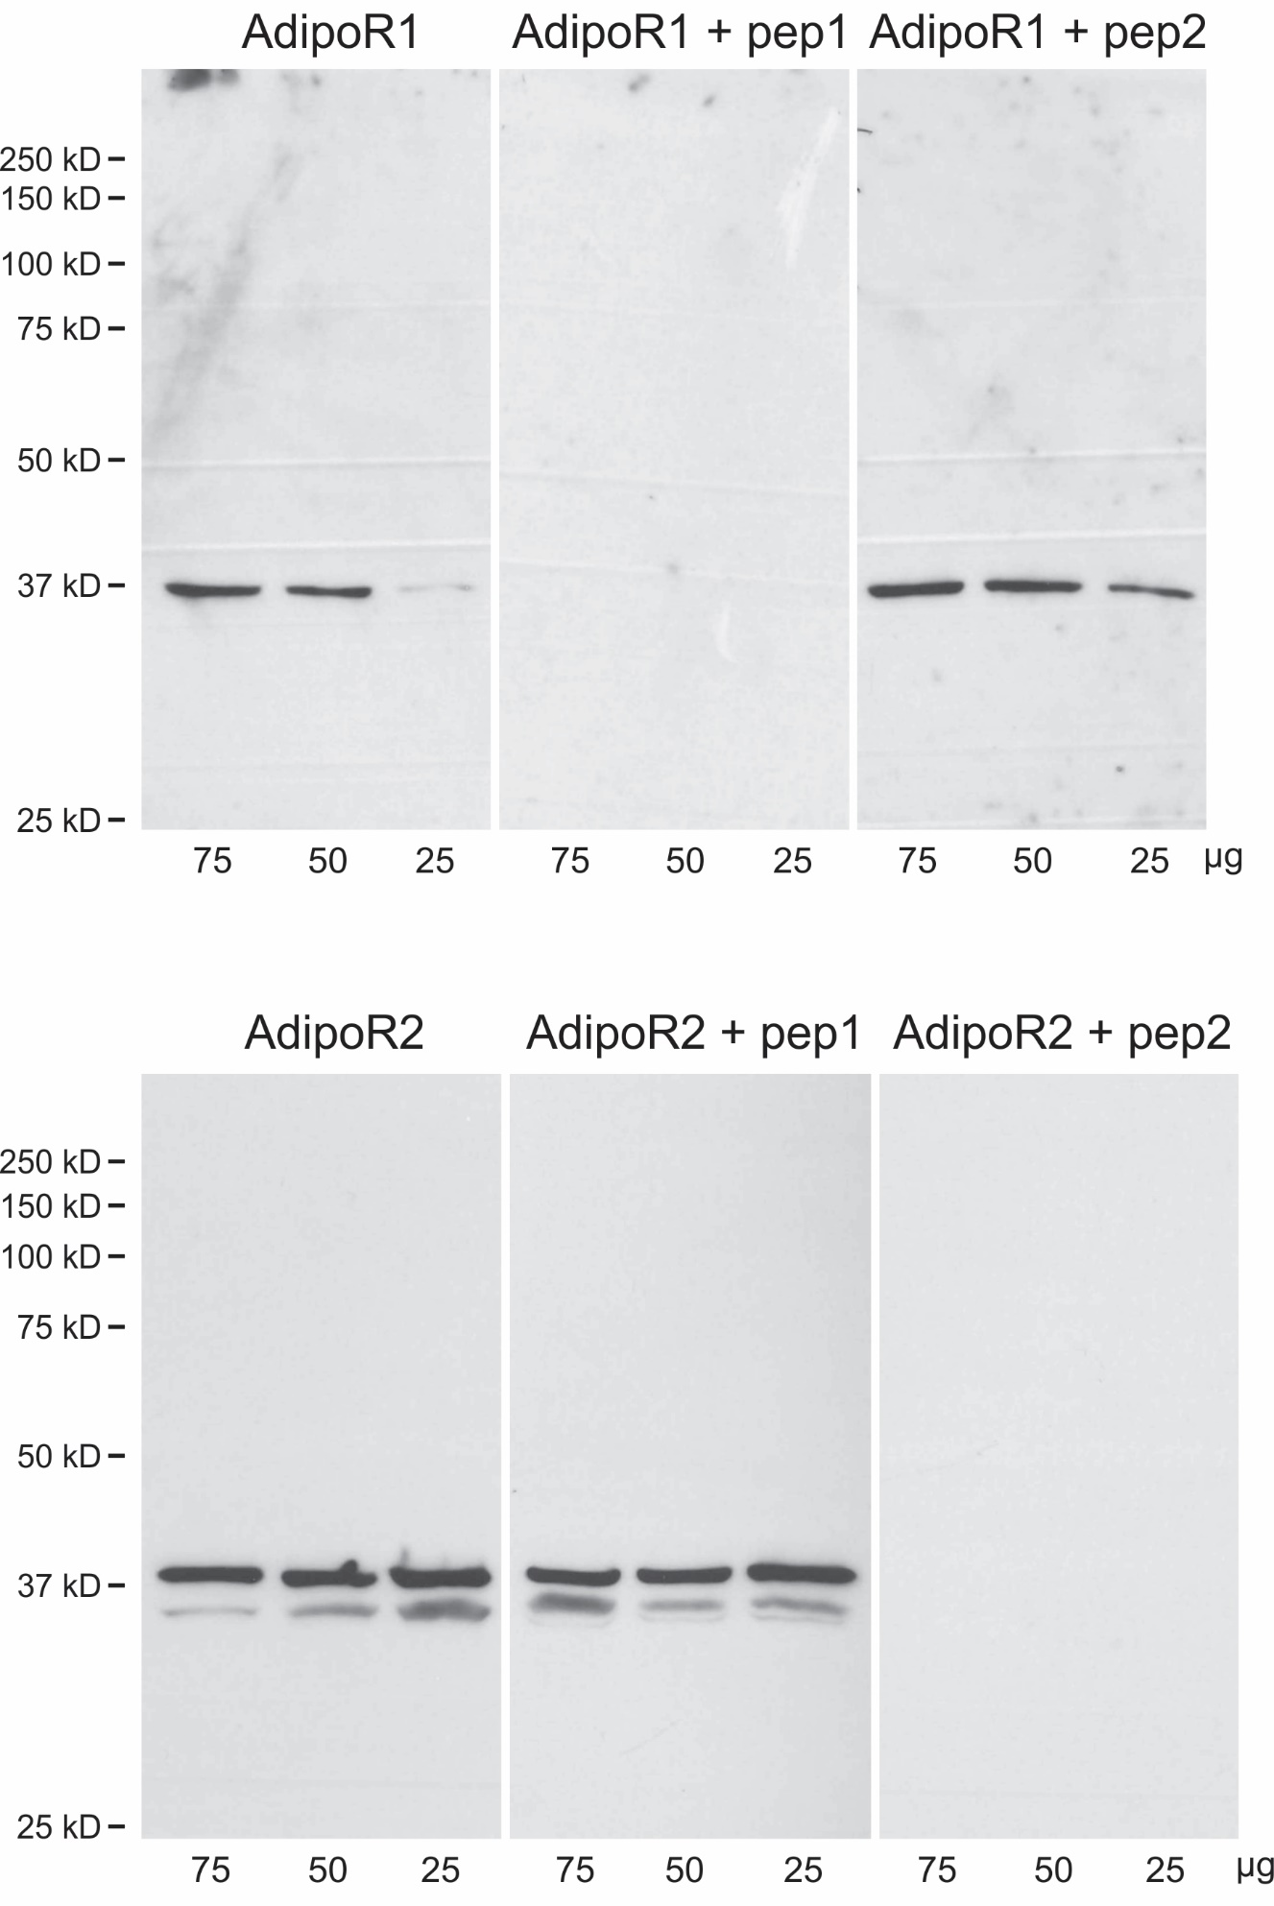
Figure S2. Evaluation of the specificity and cross-reactivity of AdipoR antibodies by WB: peptide (pep) competition assay.
Table S1. 70% of the maximal running velocity of trained groups represented as mean ± SEM
SFT group | 16.7 ± 0.4 m/min
HFT group | 16.3 ± 0.3 m/min

Table S2. The imaging parameters for the 3D FISP sequence
repetition time | 3.4 ms
echo time | 1.7 ms
flip angle | 20° for muscle images and 45° for fat images
matrix size | 256x192x92
field of view | 5x3x3 cm
spatial resolution | 195x156x326 µm

Table S3. Primer sequences used in RTqPCR analysis
Target genes | Primer sequences
Adiponectin | Forward: 5’ – GTTGCAAGCTCTCCTGTTCC – 3’  Reverse: 5’ – TCTCCAGGAGTGCCATCTCT – 3’
GAPDH | Forward: 5’ – CTGCACCACCAACTGCTTAG - 3’  Reverse: 5’ – CTTCTGAGTGGCAGTGATGG - 3’

