Additional file 2:
Figure S2 Histomorphological alterations of adipose tissue in juvenile mice subjected to fasting and refeeding

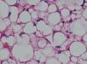
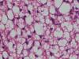
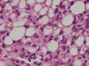
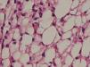
F12
Con
F24
F48
F72
R12
R24
R48
R72
ingWAT
eWAT
mWAT
iBAT
J
K
L
M
A

B

C
D
I
E
F
G
H

The effects of fasting and refeeding on histomorphological alterations of various adipose tissues in juvenile mice(A-I). The average area of adipocytes (μm²) in every 100-mm² area range of various adipose tissues were quantified using Image Pro Plus software (J-M) (n = 6-8). Scale bar represents 100 μm, all data are presented as the mean ± SEM. * p<0.05; ** p<0.01; *** p<0.001 compared with control (one-way ANOVA).

