Additional file 1
Additional file 1:Table S1. Plasma concentration of vitamin D binding protein at its different genotypes, mg/L
 | Total, P = 0.06 |  |  | Male, P = 0.45 |  |  | Female, P = 0.11
Genotypes | Mean ± SD | n |  | Mean ± SD | n |  | Mean ± SD | n
1s/1s | 239.0 ± 29.8 | 465 |  | 239.3 ± 28.7 | 212 |  | 238.7 ± 30.8 | 253
1f/1f | 241.3 ± 30.0 | 214 |  | 243.7 ± 29.8 | 98 |  | 239.3 ± 30.1 | 116
2/2 | 236.5 ± 26.0 | 228 |  | 239.2 ± 26.0 | 88 |  | 234.8 ± 26.0 | 140
1s/1f | 240.5 ± 28.6 | 666 |  | 239.8 ± 28.9 | 261 |  | 240.9 ± 28.3 | 405
1s/2 | 237.2 ± 27.3 | 434 |  | 239.1 ± 25.9 | 182 |  | 235.8 ± 28.2 | 252
1f/2 | 236.6 ± 26.5 | 634 |  | 236.9 ± 26.3 | 278 |  | 236.4 ± 26.8 | 356
Total | 238.5 ± 28.0 | 2641 |  | 239.2 ± 27.6 | 1119 |  | 238.0 ± 28.3 | 1522

Supplementary data
Additional file 1: Table S2. Metabolic parameters regarding glucose and lipids in male subjects grouped by the genotypes of vitamin D binding protein gene ¹
Parameters ² | rs4588C/C  (GC1/1) | rs4588C/A  (GC1/2) | rs4588A/A  (GC2/2) | Overall P-value
n | 571 | 460 | 88
Plasma 25OHD, nmol/L | 64.9 ± 16.3 ª | 61.8 ± 14.7 ^{b} | 58.9 ± 11.8 ^{b} | < 0.01
Body mass index, kg/m² | 24.5 ± 2.9 | 24.2 ± 2.9 | 24.5 ± 3.1 | 0.26
FPG, mmol/L | 5.49 ± 0.87 | 5.55 ± 1.18 | 5.41 ± 1.02 | 0.37
HDLC, mmol/L | 1.38 ± 0.21 | 1.37 ± 0.21 | 1.37 ± 0.22 | 0.84
LDLC, mmol/L | 2.93 ± 0.54 | 2.92 ± 0.54 | 2.84 ± 0.55 | 0.37
Triglycerides, mmol/L | 1.85 ± 1.53 | 1.94 ± 1.91 | 2.11 ± 3.02 | 0.42
Total cholesterol, mmol/L | 5.13 ± 0.91 | 5.08 ± 0.91 | 5.06 ± 0.89 | 0.60
¹ Data are means ± SD, and differ with different superscript letters, P < 0.05.
² Abbreviations: 25OHD, 25-hydroxyvitamin D; FPG, fasting plasma glucose; HDLC, plasma high-density lipoprotein cholesterol; LDLC, plasma low-density lipoprotein cholesterol.

Supplementary data
Additional file 1: Table S3. Partial correlation analysis on 25OHD and interested variants ¹
Variant 1 | Variant 2 | P-value | Correlation | Adjusted factors
25OHD | Age | < 0.01 | 0.08 | BMI, education, gender, sampling month, smoking status, sunscreen usage, sunshine exposure time, and total VD intakes
25OHD | BMI | 0.14 | -0.03 | age, education, gender, sampling month, smoking status, sunscreen usage, sunshine exposure time, and total VD intakes
25OHD | Sunshine exposure time | 0.09 | 0.03 | age, BMI, education, gender, sampling month, smoking status, sunscreen usage, and total VD intakes
25OHD | VDBP | 0.39 | -0.017 | age, BMI, education, gender, sampling month, smoking status, sunscreen usage, sunshine exposure time, and total VD intakes
¹ Abbreviations: 25OHD, 25-hydroxyvitamin D; BMI, body mass index; VD, vitamin D; VDBP, vitamin D binding protein.

Supplementary data
A
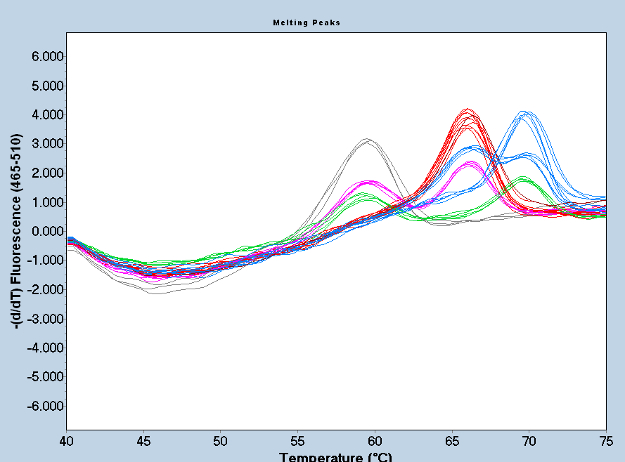
Temperature (°C)
Melting Peaks
B
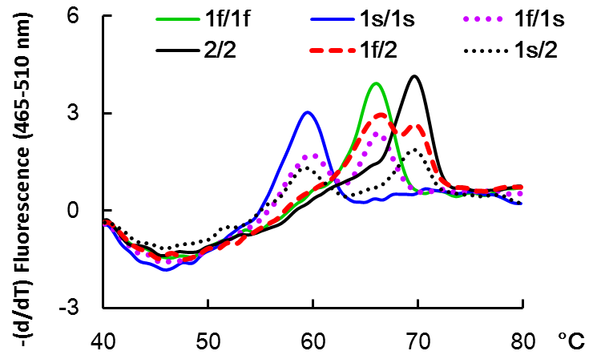
Additional file 1: Figure S1. Typical genotyping graph of 6 genotypes in vitamin D binding protein gene analyzed by molecular beacon probe-based qPCR method. For the samples tested on a 96-well plate, the melting curves generated by the Roche 480II software (LC480II SW1.5) (A) and the typical curves generated by Excel using the exported data (B) were illustrated.

