Additional file
Table S1. The main component of rats’ diet for two groups.
Components | Low zinc diet group | Normal zinc diet group
Energy, kcal/kg | 3766 | 3766
Protein (Egg white)calories accounts for, % | 17 | 17
Fat calories account for, % | 14 | 14
Carbohydrate calories account for, % | 69 | 69
protein(Egg white), % | 16 | 16
fat, % | 6 | 6
Carbohydrate, % | 66 | 66
Mineral content (g/kg):
Calcium carbonate | 357 | 357
Potassium phosphate | 196 | 196
Potassium citrate | 70.78 | 70.78
Potassium sulfate | 46.6 | 46.6
Magnesium oxide | 24 | 24
Sodium chloride | 74 | 74
Cupric carbonate | 0.3 | 0.3
1%Potassium iodate | 0.01 | 0.01
Ferric citrate | 6.06 | 6.06
Manganous carbonate | 0.63 | 0.63
sodium carbonate | 0.01025 | 0.01025
Zinc carbonate | 0 | 1.65
Chromium potassium sulfate | 0.275 | 0.275
ammonium molybdate | 0.00795 | 0.00795
Boric acid | 0.0815 | 0.0815
Sodium fluoride | 0.0635 | 0.0635
Sucrose | 222.676 | 221.026
Total | 998.4942 | 998.4942
Vitamin content:
Vitamin A, IU/g | 4.0 | 4.0
Vitamin D, IU/g | 1.0 | 1.0
Vitamin E, IU/kg | 81.6 | 81.6
Vitamin K, ppm | 0.29 | 0.29
Thiamine, ppm | 6.1 | 6.1
Riboflavin, ppm | 6.7 | 6.7
niacin, ppm | 30 | 30
Pantothenic acid, ppm | 16 | 16
Folic acid, ppm | 2.1 | 2.1
Pyridoxine, ppm | 5.8 | 5.8
Biotin, ppm | 0.2 | 0.2
Vitamin B-12, mcg/kg | 29 | 29
Choline chloride, ppm | 1.25 | 1.25
Ascorbic acid, ppm | 0 | 0

Table S2. The concentrations of 16 elements in serum of rats
Elements | NZG | PZG | LZG
Zn mg/l | 2.11±0.35 | 2.16±0.37 | 1.83±0.10*
Ca mg/l | 127.10±11.15 | 129.02±12.37 | 143.26±7.01*
Mg mg/l | 47.69±5.07 | 48.34±5.30 | 50.57±2.79
Cu mg/l | 1.68±0.10 | 1.61±0.14 | 1.59±0.18
Na g/l | 3.37±0.15 | 3.33±0.15 | 3.33±0.17
K mg/l | 156.15±12.16 | 157.30±16.82 | 157.18±12.81
Al mg/l | 9.73±1.60 | 9.11±1.02 | 9.28±1.20
Fe mg/l | 22.95±3.34 | 22.90±2.68 | 22.34±2.60
Cr g/l | 10.19±2.63 | 9.01±1.92 | 9.90±2.18
Mn μg/l | 391.18±58.91 | 356.42±42.11 | 372.92±51.38
As μg/l | 21.73±1.37 | 21.84±0.99 | 21.46±0.95
Se μg/l | 448.91±31.12 | 440.53±42.76 | 446.22±38.64
Ag μg/l | 4.84±0.70 | 4.97±0.93 | 3.96±1.02*
Ba μg/l | 263.20±39.63 | 264.30±38.43 | 259.26±36.86
Pb μg/l | 58.10±9.24 | 53.25±14.35 | 50.72±14.91
Sn μg/l | 153.03±52.31 | 105.88±94.83 | 177.78±34.26
*: P＜0.05,LZG vs NZG and PZG.

Table S3. The concentrations of 16 elements in feces of rats
Elements | NZG | PZG | LZG
Zn μg/g | 268.23±38.17 | 268.38±21.38 | 20.66±6.03*
Ca mg/g | 10.21±2.68 | 10.12±3.05 | 1.62±1.03*
Mg mg/g | 1.76±0.37 | 1.62±0.38 | 3.59±1.04*
Cu μg/g | 53.5±7.48 | 52.94±7.45 | 82.00±8.90*
Na mg/g | 3.76±0.84 | 3.32±0.89 | 3.37±0.92
K mg/g | 1.85±0.43 | 2.16±0.38 | 3.24±0.73*
Al μg/g | 101.70±9.44 | 108.13±6.05 | 100.14±22.51
Fe mg/g | 0.59±0.07 | 0.54±0.14 | 0.87±0.21*
Cr mg/g | 55.55±12.36 | 57.92±8.59 | 66.14±16.73
Mn μg/L | 127.69±16.50 | 130.10±11.60 | 170.05±23.98*
As μg/g | 0.05±0.06 | 0.07±0.09 | 0.11±0.12
Se mg/g | 0.91±0.13 | 0.90±0.15 | 1.35±0.26*
Ag μg/g | 0.02±0.01 | 0.03±0.01 | 0.04±0.02*
Ba μg/g | 4.47±0.57 | 4.81±1.03 | 4.5±0.82
Pb μg/g | 0.89±0.35 | 0.70±0.17 | 0.91±0.38
Sn μg/g | 0.46±0.19 | 0.63±0.34 | 0.63±0.28
*: P＜0.05,LZG vs NZG and PZG.

Table S4. The concentrations of 16 elements in urine of rats
Elements | NZG | PZG | LZG
Zn mg/l | 8.11±2.53 | 9.44±2.69 | 4.28±1.09*
Ca g/l | 0.94±0.37 | 0.92±0.32 | 0.33±0.21*
Mg mg/l | 422.21±144.08 | 488.80±157.73 | 124.32±66.43*
Cu mg/l | 1.66±0.17 | 1.77±0.20 | 1.50±0.17*
Na g/l | 3.11±1.02 | 2.92±1.10 | 1.66±0.43*
K g/l | 3.96±1.08 | 4.18±0.52 | 3.13±0.74*
Al mg/l | 10.90±2.21 | 10.73±2.63 | 10.35±1.68
Fe mg/l | 29.63±4.46 | 29.51±4.62 | 27.79±6.39
Cr g/l | 3.44±0.49 | 3.48±0.49 | 3.06±0.35*
Mn μg/l | 593.38±139.31 | 588.25±158.26 | 506.09±166.77
As μg/l | 67.41±5.04 | 67.93±7.37 | 57.30±9.03*
Se μg/l | 342.78±72.56 | 306.38±117.69 | 250.47±69.75*
Ag μg/l | 5.97±1.18 | 5.91±1.39 | 5.94±0.84
Ba μg/l | 321.58±52.58 | 304.96±56.97 | 298.01±50.3
Pb μg/l | 130.13±18.91 | 130.05±12.07 | 125.69±22.57
Sn μg/l | 25.03±5.31 | 25.42±4.63 | 25.78±6.34
*: P＜0.05,LZG vs NZG and PZG.

Table S5. The concentrations of 16 elements in liver of rats
Elements | NZG | LZG
Zn μg/g | 60.22±5.46 | 47.26±2.89*
Ca μg/g | 133.00±10.41 | 22.11±6.74*
Mg μg/g | 307.92±11.43 | 274.29±26.99*
Cu μg/g | 9.44±0.60 | 7.62±1.02*
Na μg/g | 776.67±19.82 | 802.14±107.00
K mg/g | 4.01±0.24 | 3.44±0.42*
Al μg/g | 21.00±3.84 | 19.42±2.85
Fe μg/g | 334.08±62.76 | 367.50±56.01
Cr μg/g | 8.30±0.77 | 7.69±0.28
Mn μg/g | 4.06±0.24 | 4.05±0.39
As μg/g | 0.53±0.50 | 0.88±0.57
Se μg/g | 1.29±0.13 | 0.83±0.13*
Ag ng/g | 12.67±1.54 | 12.86±2.67
Ba ng/g | 482.33±109.68 | 398.33±26.39
Pb μg/g | 5.64±3.09 | 6.03±3.38
Sn μg/g | 0.32±0.21 | 0.33±0.13
*: P＜0.05,LZG vs NZG.

Table S6.The excretion of 12elements in feces and urine
 | Feces |  |  |  | Urine
 | NZG | PZG | LZG |  | NZG | PZG | LZG
Zn (μg) | 502.66±71.52 | 481.47±38.353 | 29.52±8.62*# |  | 70.72±23.66 | 70.09±19.94 |  | 32.93±8.38*#
Ca (mg) | 19.13±5.02 | 18.151±5.474 | 2.31±1.48*# |  | 8.25±3.41 | 6.83±2.36 |  | 2.52±1.58*#
Mg (mg) | 3.29±0.7 | 2.907±0.689 | 4.6±2.14*# |  | 3.77±1.26 | 3.63±1.17 |  | 0.92±0.51*#
Cu(μg) | 100.26±14.02 | 94.97±13.363 | 117.18±12.71*# |  | 14.41±1.61 | 13.15±1.47 |  | 11.49±1.32*#
Se(μg) | 1705.89±245.36 | 1619.743±261.03 | 1934.5±366.04# |  | 2.97±0.63 | 2.66±0.87 |  | 1.92±0.53*#
K (mg) | 3.46±0.8 | 3.882±0.68 | 4.64±1.05* |  | 35±9.65 | 31.01±3.84 |  | 23.99±5.63*#
Na (mg) | 7.05±1.58 | 6.185±1.602 | 4.82±1.31*# |  | 27.85±8.72 | 21.69±8.17 |  | 12.74±3.33*#
Cr (mg) | 104.1±23.15 | 103.902±15.403 | 94.52±23.9 |  | 29.93±4.37 | 25.87±3.63* |  | 23.56±2.66*#
As (ng) | 185.71±70.81 | 258.755±128.339 | 221.74±163.24 |  | 583.97±46.04 | 504.22±54.73 |  | 436.13±69.15*#
Ag (ng) | 46.28±12.92 | 59.561±10.961 | 51.17±20.72 |  | 51.24±10.83 | 43.9±10.29 |  | 45.6±6.46*
Fe(μg) | 1004.42±125.82 | 967.971±242.915 | 1250.15±305.5*# |  | 252.19±37.31 | 219.05±34.29* |  | 215.43±48.95*
Mn(μg) | 239.3±30.92 | 233.398±20.808 | 230.85±63.76 |  | 4.97±1.1 | 4.37±1.17 |  | 3.92±1.28*
*: P＜0.05,LZG vs NZG ;#: P＜0.05,LZG vs PZG.

Table S7. The difference of urine and fecal excretion of 12 elements between LZG and NZG
 | Fecal excretion  (LZG-NZG) | Urine excretion  (LZG-NZG) | Total excretion  (Fecal excretion+ Urine excretion)
Zn(μg) | -473.14 | -37.79 | -510.93
Ca(mg) | -16.82 | -5.73 | -22.55
Mg(mg) | 1.31 | -2.85 | -1.54
Cu(μg) | 16.92 | -2.92 | 14
Se(μg) | 228.61 | -1.05 | 227.56
K(mg) | 1.18 | -11.01 | -9.83
Na(mg) | -2.23 | -15.11 | -17.34
Cr(mg) | -9.58 | -6.37 | -15.95
As(ng) | 36.03 | -147.84 | -111.81
Ag(ng) | 4.89 | -5.64 | -0.75
Fe (μg) | 145.73 | -36.76 | 108.97
Mn (μg) | -8.45 | -1.05 | -9.5

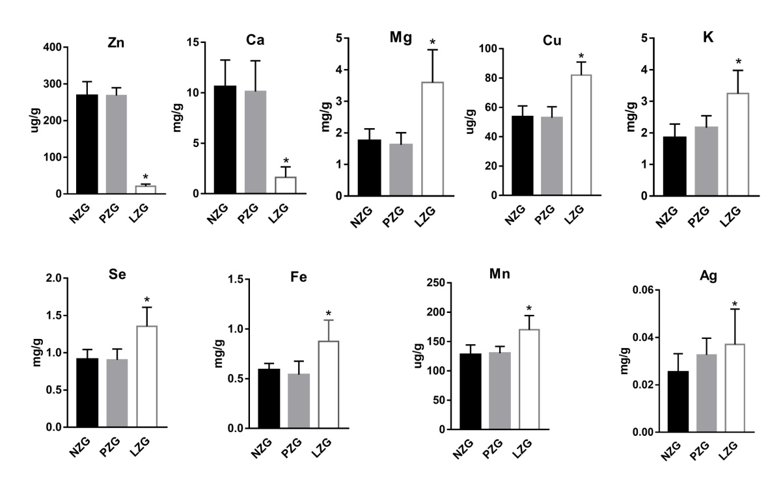

Figure S1 Concentrations of three minerals and trace elements in feces between three groups *: P＜0.05 LZG vs NZG and PZG.

Figure S2 Concentrations of three minerals and trace elements in urine between three groups *: P＜0.05 LZG vs NZG and PZG.

Figure S3 Concentrations of three minerals and trace elements in liver between three groups *: P＜0.05 LZG vs NZG and PZG.

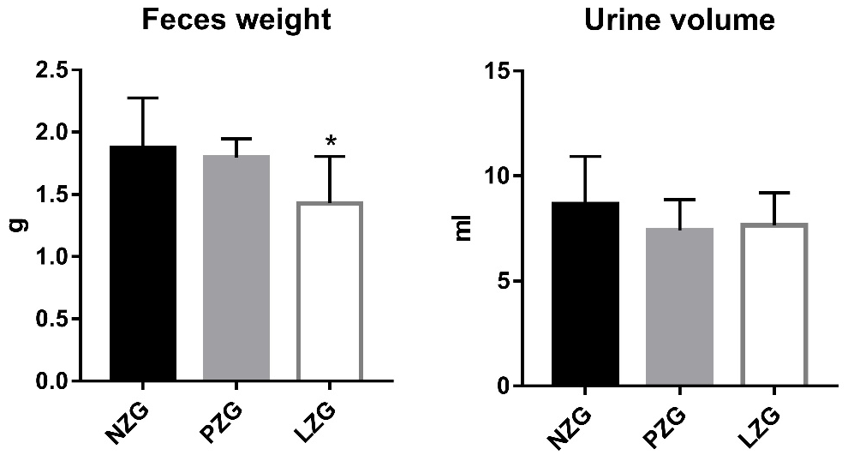
Figure S4. Feces weight and Urine volume of Rats
*: P＜0.05, LZG vs NZG and PZG.

