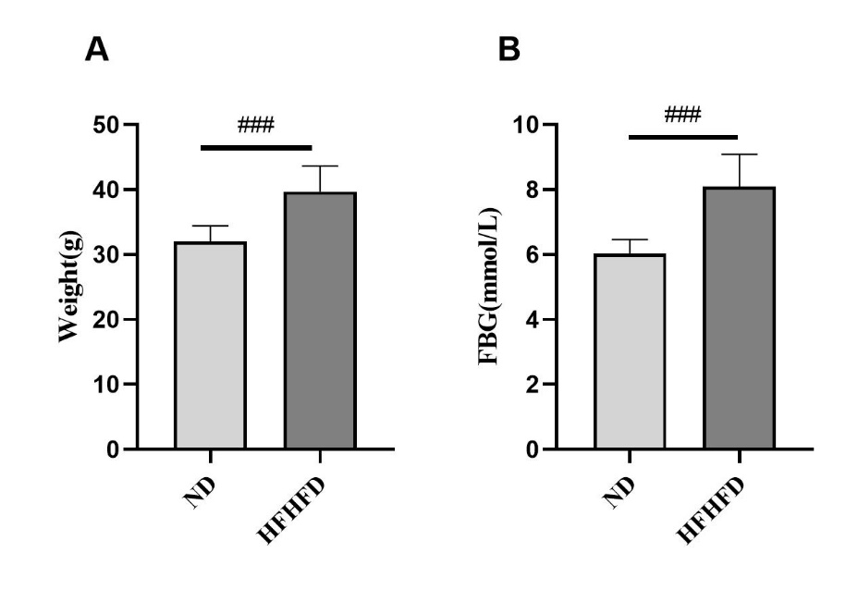
Fig.S1 (A) Body weight and (B) fasting blood glucose (FBG) after 12 weeks of high-fat-high-fructose diet (HFHFD) feeding. ###P＜0.001 vs. ND group.

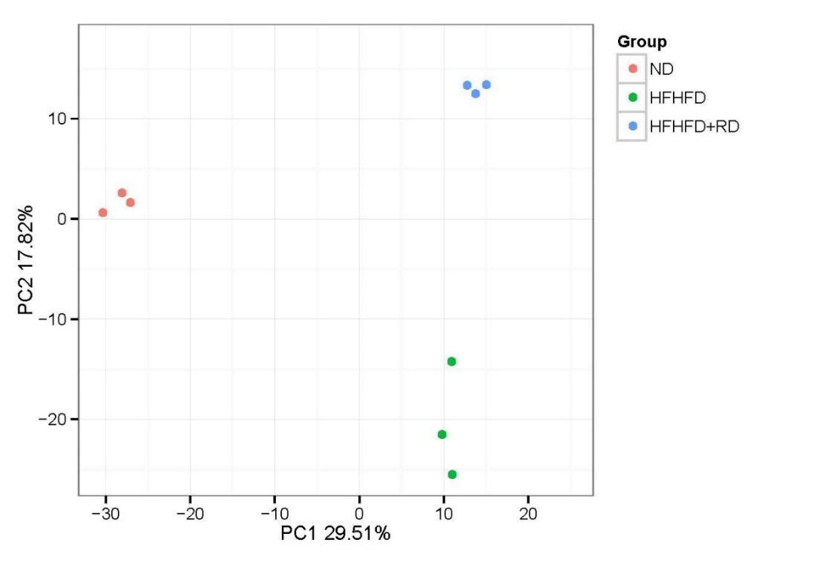
Fig.S2 The principal coordinates analysis (PCoA).
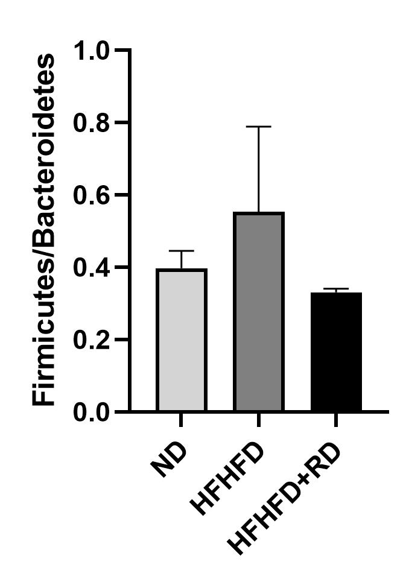
Fig.S3 The ratio of Firmicutes/Bacteroidetes in three groups.

